Software Requirements Specification
for
ChatApp
Version 1.0 approved
Prepared by Marco Galatanu
Laurentiu Moloman
Rares Petrisor
Andrei Zacordonet

27.05.2024
Table of Contents
Table of Contents ii
1. Introduction 1
1.1 Purpose 1
1.2 Document Conventions 1
1.3 Intended Audience and Reading Suggestions 1
1.4 Product Scope 1
1.5 References 1
2. Overall Description 1
2.1 Product Perspective 1
2.2 Product Functions 2
2.3 User Classes and Characteristics 2
2.4 Operating Environment 2
2.5 Design and Implementation Constraints 2
2.6 User Documentation 2
2.7 Assumptions and Dependencies 2
3. External Interface Requirements 2
3.1 User Interfaces 2
3.2 Hardware Interfaces 3
3.3 Software Interfaces 3
3.4 Communications Interfaces 3
4. System Features 3
4.1 User Registration 3
4.2 User Login 4
4.3 Chat Selection 4
4.4 Messaging 5
5. Other Nonfunctional Requirements 5
5.1 Performance Requirements 5
5.2 Safety Requirements 5
5.3 Security Requirements 5
5.4 Software Quality Attributes 6
5.5 Business Rules 6
6. Other Requirements 6
6.1 Server Component 6
6.2 Client Component 7
6.3 Database 7
7. Appendix A: Glossary 7
8. Appendix B: Analysis Models 8
9. Appendix C: User Interface Mockups 16
10. Appendix D: Database Schema 18
11. Appendix E: Code Analysis 19

Introduction

Purpose
The purpose of this document is to specify the requirements for the Chat Application, which is developed in C#. The application will provide a simple platform for real-time text communication between users.

Document Conventions
This document follows standard formatting for software development, using third-person, passive voice, and clear, grammatically correct text.

Intended Audience and Reading Suggestions
This document is intended for software developers, testers, and project managers involved in the development of the Chat Application. It provides detailed specifications for implementing the software.

Product Scope
The Chat Application allows users to register, login, select active chats, and send and receive messages in real-time.

References
- ISO/IEC/IEEE 29148:2018 Systems and software engineering
- IEEE Std 830-1998: IEEE Recommended Practice for Software Requirements Specifications
- Microsoft .NET Framework Documentation
- MySQL 8.0 Reference Manual
- C# Programming Guide
- Design Patterns: Elements of Reusable Object-Oriented Software

Overall Description

Product Perspective
The Chat Application is a standalone software product that integrates with existing user authentication systems and network infrastructure. It leverages C#, the .NET framework for development, and MySQL for data storage.

Product Functions
The major functions include:

- User registration
- User login
- Chat selection
- Messaging with active users

User Classes and Characteristics
The application is designed for general users who need to communicate in real-time. It aims to be user-friendly and accessible to users with varying levels of technical expertise.

Operating Environment
The Chat Application will run on Windows operating systems with the .NET Framework installed. It requires an internet connection for real-time communication.

Design and Implementation Constraints
Constraints include:

- Compliance with the .NET Framework
- Security protocols for data transmission
- Integration with MySQL database

User Documentation
User documentation will include a brief online help guide available within the application.

Assumptions and Dependencies
Dependencies include:

- Reliable internet connection for real-time messaging
- .NET Framework for development and deployment
- MySQL database for storing user data

External Interface Requirements

User Interfaces
The user interface will include:

- A registration screen for new users
- A login screen for user authentication
- A main chat window for displaying active chats
- A chat window for displaying messages with the selected user

Hardware Interfaces
The application requires standard hardware interfaces, including a keyboard and mouse for user input and a display monitor. The application should run on any Linux/Windows computer that has .NET framework and MySQL database installed.

Software Interfaces
The application will interface with:

- .NET Framework
- Network libraries for handling communication
- MySQL database for storing and retrieving user data

Communications Interfaces
The application will use standard internet protocols for communication, ensuring secure data transmission between sockets.

System Features

User Registration

Description and Priority
- Users must be able to register by providing a unique username, email address and phone number.This is a high-priority feature.

Stimulus/Response Sequences
- Stimulus: User navigates to the registration page.
- Response: The system displays the registration form.

- Stimulus: User enters a username and password and submits the registration form.
- Response: The system checks the database to ensure the username is not already taken.

- Stimulus: The username is unique.
- Response: The system stores the new user's credentials in the database and confirms registration success.

- Stimulus: The username is already taken.
- Response: The system displays an error message indicating the username is already in use.

Functional Requirements
- The system shall provide a registration form.
- The system shall store the user's credentials securely in a MySQL database.
- The system shall check if a user is already registered to prevent duplicate accounts.

User Login

Description and Priority
- Users must be able to login with their username and password. This is a high-priority feature.

Stimulus/Response Sequences
- Stimulus: User navigates to the login page.
- Response: The system displays the login form.

- Stimulus: User enters their username and password and submits the login form.
- Response: The system checks the database to authenticate the user's credentials.

- Stimulus: The credentials are valid.
- Response: The system grants access to the user and redirects to the main chat window.

- Stimulus: The credentials are invalid.
- Response: The system displays an error message indicating incorrect username or password.

Functional Requirements
- The system shall provide a login form.
- The system shall authenticate the user's credentials against the MySQL database.

Chat Selection

Description and Priority
- Users must be able to select an active chat from a list of available contacts or chat rooms. This is a medium-priority feature.

Stimulus/Response Sequences
- Stimulus: User logs in and navigates to the main chat window.
- Response: The system displays a list of active chats or contacts.

- Stimulus: User selects a chat from the list.
- Response: The system opens the chat window for the selected contact or chat room.

Functional Requirements
- The system shall display a list of active chats.
- The system shall allow users to select an active chat.

Messaging

Description and Priority
- Users must be able to send and receive messages in real-time. This is a high-priority feature.

Stimulus/Response Sequences
- Stimulus: User types a message in the chat window and hits send.
- Response: The system sends the message to the server.

- Stimulus: Server receives the message.
- Response: The server routes the message to the recipient.

- Stimulus: Recipient's client receives the message.
- Response: The system displays the received message in the chat window in real-time.

- Stimulus: User receives a new message notification.
- Response: The system highlights the chat or provides a notification indicating a new message.

Functional Requirements
- The system shall allow users to send text messages.
- The system shall display received messages in real-time.

Other Nonfunctional Requirements

Performance Requirements
- The application must support real-time messaging with minimal latency.

Safety Requirements
- The application must ensure data integrity and provide mechanisms to recover from failures.

Security Requirements
- The application must use secure protocols for data transmission and protect user information from unauthorized access.

Software Quality Attributes
- The software must be reliable, maintainable, and user-friendly. It should also be portable across different versions of Windows operating systems.

Business Rules

Unique Usernames

- Rule: Each registered username must be unique across the system.
- Reason: To ensure that each user can be uniquely identified and to avoid conflicts during user authentication and messaging.

Password Requirements

- Rule: Passwords must meet the following criteria: at least 8 characters in length, contain at least one uppercase letter, one lowercase letter, one numeric digit, and one special character.
- Reason: To enhance security and protect user accounts from unauthorized access.

Inactive Session Timeout

- Rule: Users will be automatically logged out after 30 minutes of inactivity.
- Reason: To protect user accounts and personal data by reducing the risk of unauthorized access from unattended devices.

User Behavior

- Rule: Users must adhere to the platform's code of conduct, which includes no harassment, hate speech, or inappropriate content.
- Reason: To maintain a safe and respectful environment for all users.

Other Requirements

Server Component
The server component handles user authentication, message routing, and database interactions. It uses the Chain of Responsibility design pattern to process requests in a flexible and decoupled manner.

Responsibilities:
- Authenticate users during login.
- Route messages between clients.
- Store and retrieve user data from the MySQL database.

Client Component
The client component includes different user controls for each view of the application, such as registration, login, chat selection, and messaging.

Responsibilities
- Provide user interfaces for registration, login, chat selection, and messaging.
- Send user data to the server for registration and login.
- Display messages in real-time.

Database
A MySQL database is used to store user credentials and other necessary data for the application.

Responsibilities
- Store user registration data securely.
- Validate login credentials.
- Ensure data integrity and availability.

Appendix A: Glossary
- SRS: Software Requirements Specification
- UI: User Interface
- DB: Database
- C#: A programming language developed by Microsoft
- MySQL: An open-source relational database management system
- .NET Framework: A software framework developed by Microsoft
- Chain of Responsibility: A design pattern used to pass a request along a chain of handlers

Appendix B: Analysis Models
- Use Case Diagrams: To show the interactions between users and the system.
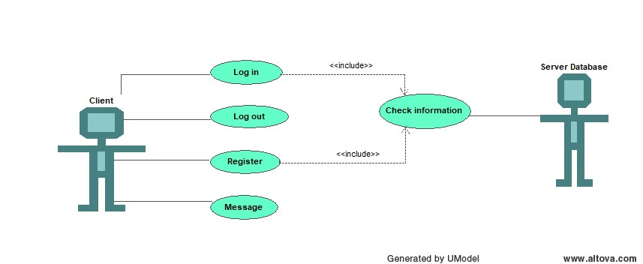

- Class Diagrams: To represent the structure of the system by showing its classes, attributes, methods, and the relationships between objects.

ChatApp Class Diagram:

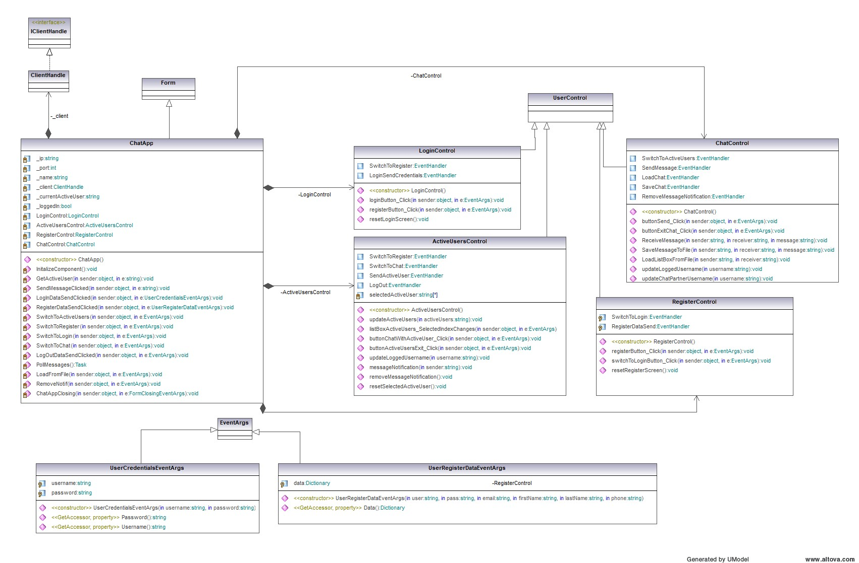
ClientHandler Class Diagram:
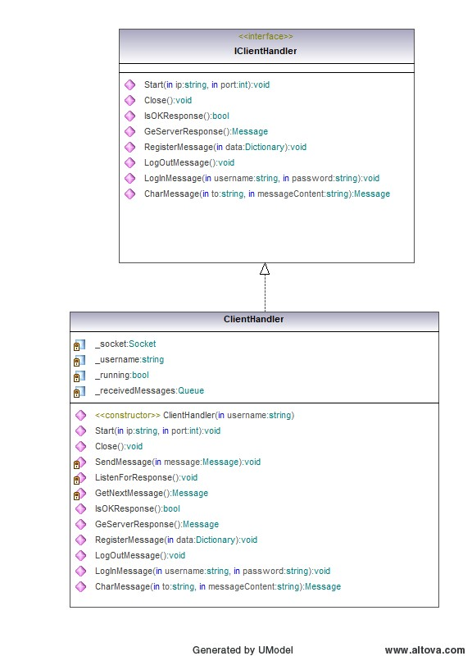
Message Class Diagram:
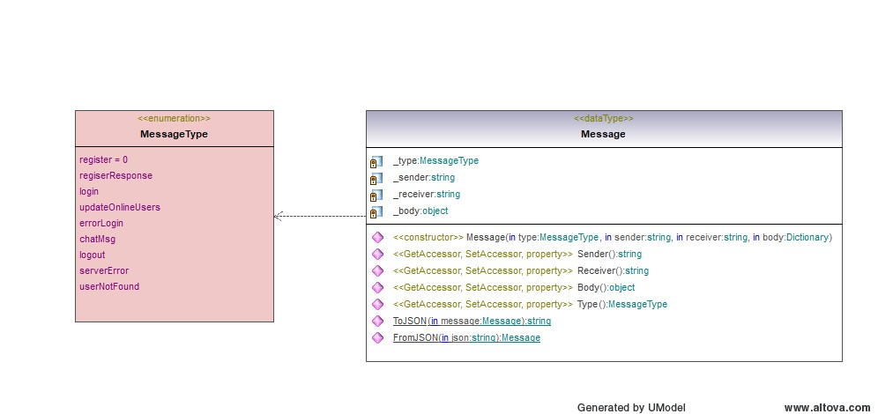

Server Class Diagram:
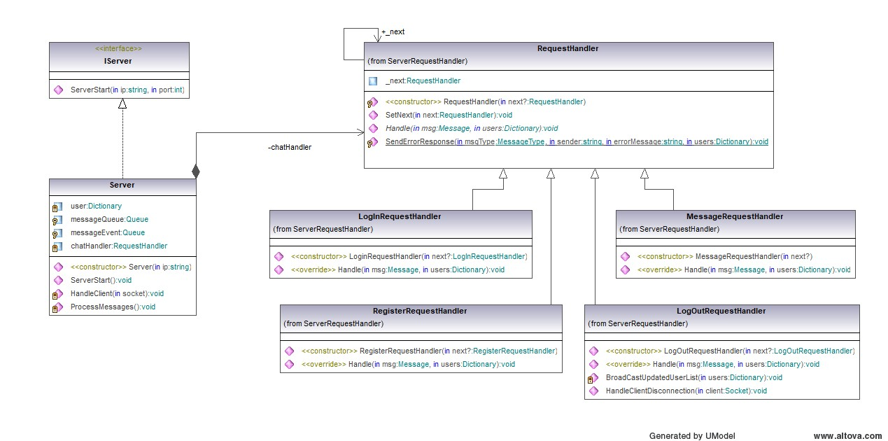

- Sequence Diagrams: To illustrate how objects interact in a particular scenario of a use case.

Connection Sequence Diagram:
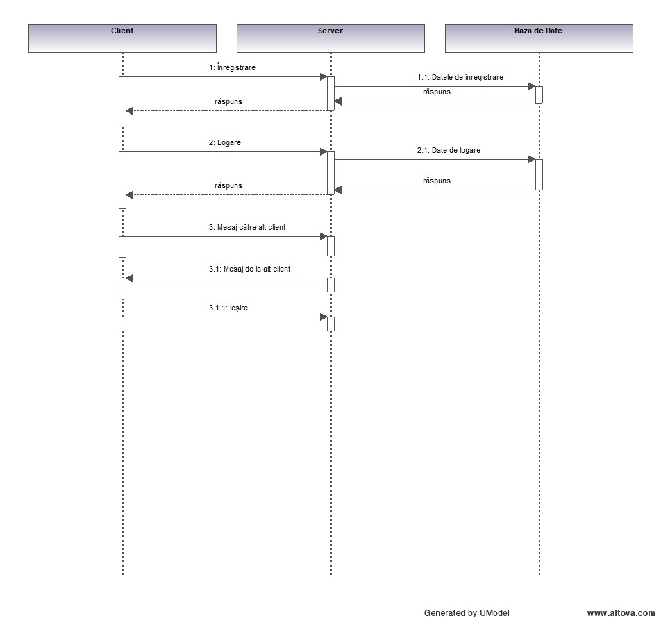
Messaging Sequence Diagram:

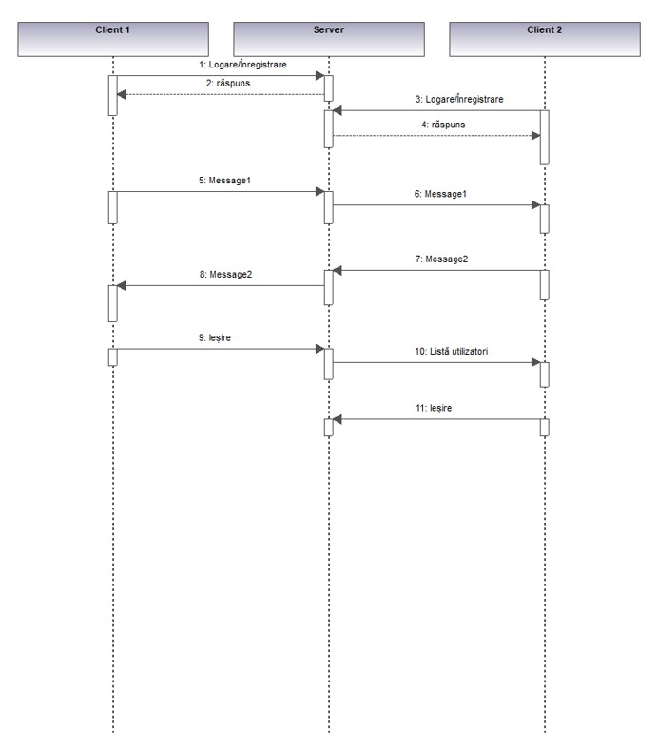
- Activity Diagrams: To represent the dynamic aspects of the system by illustrating the flow of control or data from one activity to another. Activity diagrams depict the sequence of activities, including parallel and conditional branches, decision points, and synchronization bars, providing a clear visualization of the workflow or business process within the system.

Login:
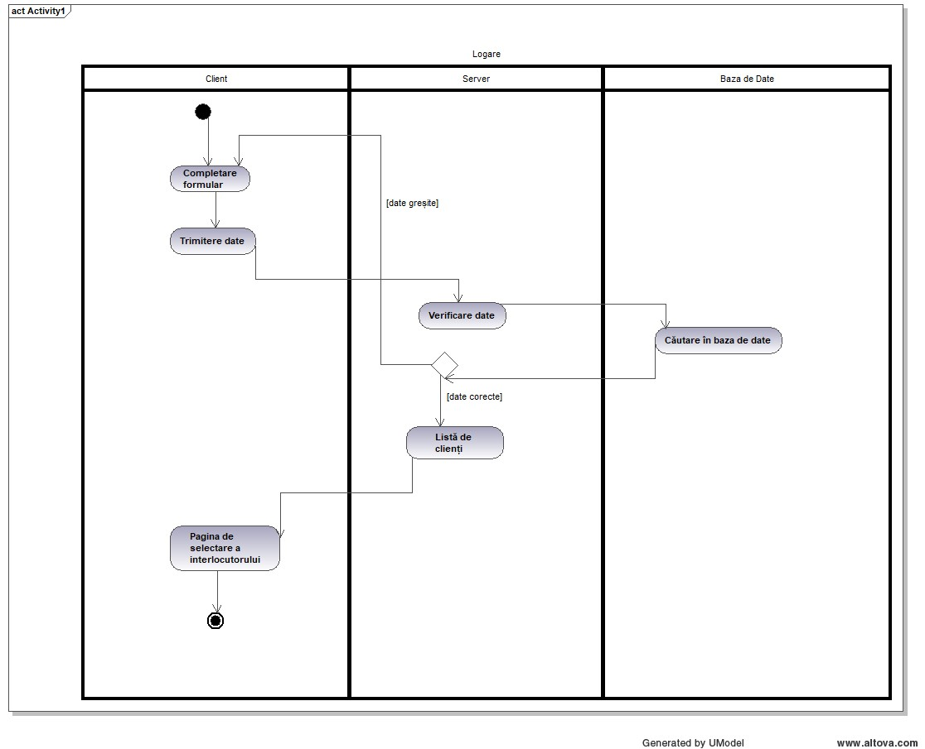

Logout:

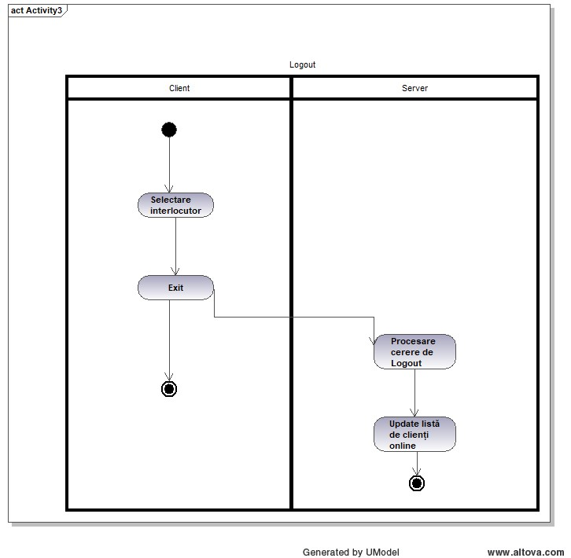

Register:

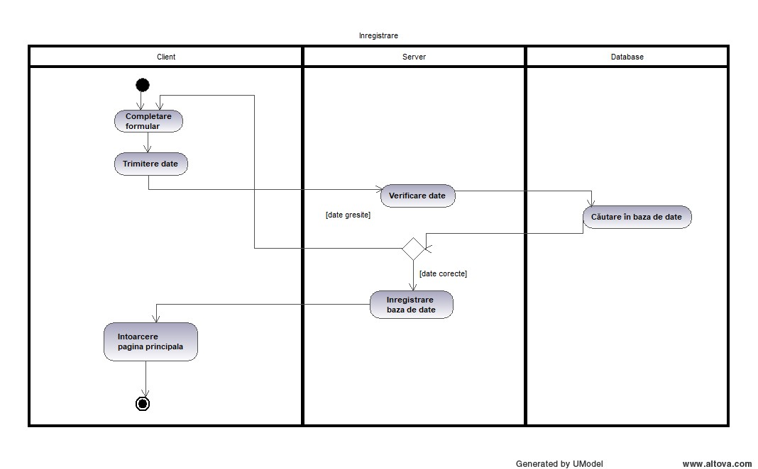

Message:

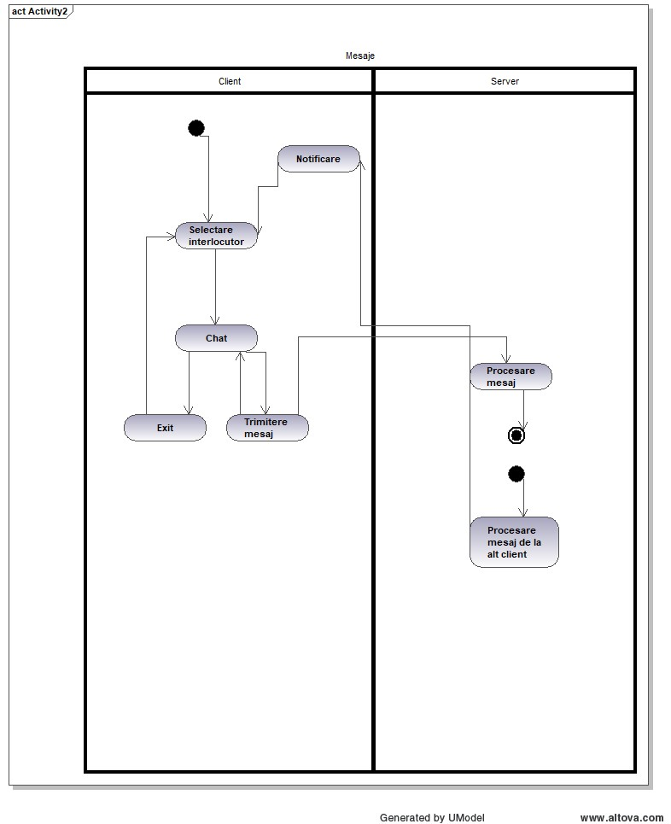

Appendix C: User Interface Mockups
- Login Screen Mockup
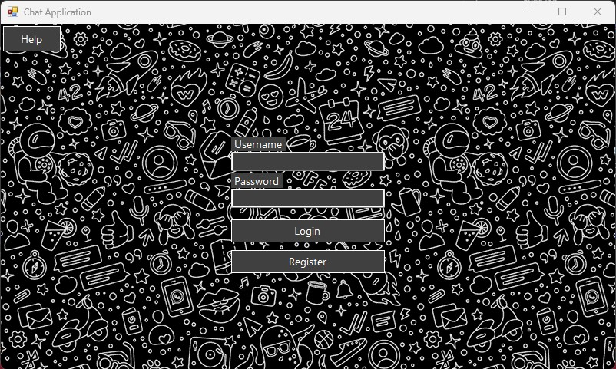

- Registration Screen Mockup
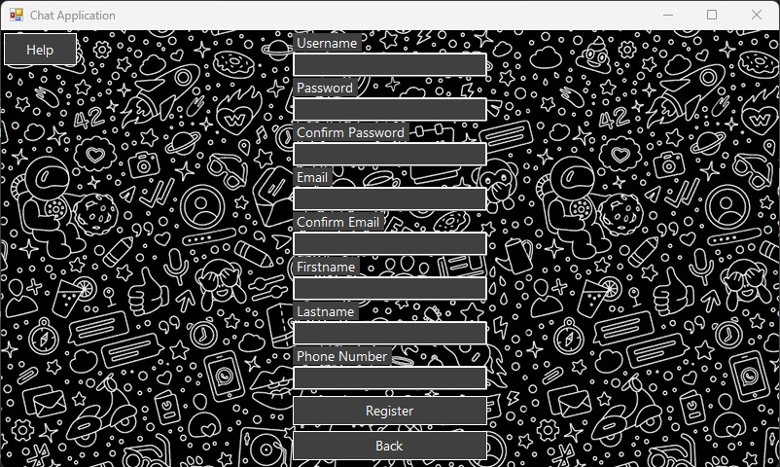

- Chat Selection Screen Mockup
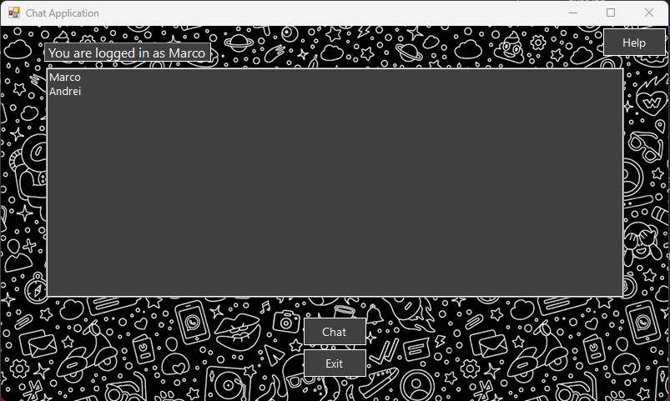

- Messaging Screen Mockup
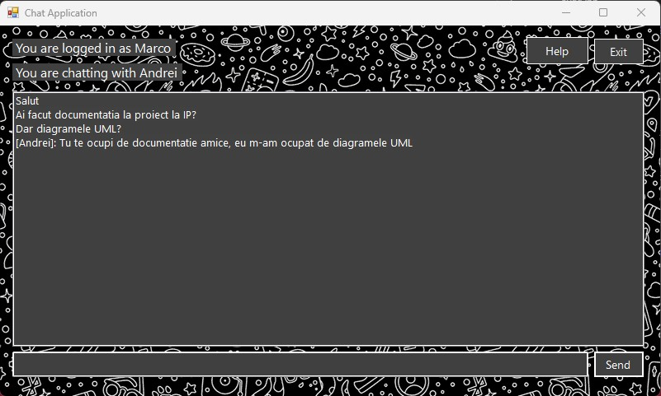

Appendix D: Database Schema
- Tables: Description of tables and their fields

- Relationships: Description of relationships between tables

- Indexes: Any indexes used for optimizing queries

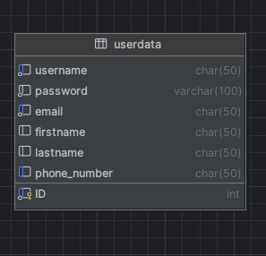

Appendix E: Code Analysis
- Client Handling on the server side:

The HandleClient function manages client connections and processes messages by continuously receiving data from the client socket. It converts the received data to a string, parses it into a Message object, and skips invalid JSON. The function updates the users dictionary with the sender's socket if not already present, sending an error if the sender is already logged in. It then enqueues the message and signals that a new message is available. Errors like SocketException and ObjectDisposedException are logged, and the loop terminates on these exceptions.

/// <summary>
/// Handles client connections and processes incoming messages.
/// </summary>
/// <param name="clientSocket">The socket associated with the connected client.</param>
private void HandleClient(Socket clientSocket)
{
byte[] buffer = new byte[1024];

while (true)
{
try
{
int receivedBytes = clientSocket.Receive(buffer);
if (receivedBytes == 0)
{
Console.WriteLine($"received 0 bytes");
break; // Client disconnected
}

string receivedText = Encoding.UTF8.GetString(buffer, 0, receivedBytes);
Message message;
try
{
message = Message.FromJson(receivedText);
}
catch (Exception ex)
{
Console.WriteLine($"Invalid JSON: {ex.Message}");
continue;
}

lock (users)
{
if (!users.ContainsKey(message.Sender))
{
//users[message.Sender] = clientSocket;
users.Add(message.Sender, clientSocket);
Console.WriteLine(string.Join(", ", users.Select(kv => $"{kv.Key}")));
}
else
{
if (message.Type == MessageType.Login)
{

Message msg = new Message(MessageType.ErrorLogin, "", message.Sender, new Dictionary<string, string> { { "Error message", "User deja autentificat!" } });
clientSocket.Send(Encoding.UTF8.GetBytes(Message.ToJson(msg)));
}
}
}

messageQueue.Enqueue(message);
messageEvent.Set(); // Signal that a new message is available
}
catch (SocketException e)
{
Console.WriteLine($"ia de aici tata");
Console.WriteLine($"SocketException: {e.Message}");
break;
}
catch (ObjectDisposedException e)
{
Console.WriteLine($"ObjectDisposedException: {e.Message}");
break;
}
}
}

