实验编号：实验004
实验题目：新的迭代面向对象设计
实验日期：2026-05-06
实验内容：
用户需求：
小强要离校外出实习，找了好友小雨帮忙，并告诉了华经理。小强简单介绍了背景、进展，把程序都教给了小雨。特别告诉小雨，华经理对程序没有清晰、完整的想象，经常增加新的功能，有时候会改变一些需求。小雨正刚刚学完面向对象技术，正想练习一下，就参考小强的描述和程序，重新编写程序。

分析：
- “把程序都教给了小雨……”：其实是第2章的程序示例。Public class Exercise ……
- “华经理对程序没有清晰、完整的想象，经常增加新的功能”：需求经常在改变，更应该注意“高内聚、低耦合”的设计原则，抽象出对象，减少类、对象的改变对整体程序的冲击；
- “学完面向对象技术，正想练习一下”：应该使用Java程序，加入类的设计。

实验报告：

Git地址：https://github.com/Beyond-Software-Engineer/Calculator.git

- 构建并运行P69案例设计一，要求：（a）包含BinaryOperation类（b）包含Exercise3_1类（c）补全缺失代码
- 画出UML类关系图（可以拍照、vscode、visio等作图）

- 案例设计一的完整代码：
import random

from Sys_admin.main.src.addition import Addition
from Sys_admin.main.src.equation import Equation
from Sys_admin.main.src.subtraction import Subtraction

class ExerciseCollection:
def __init__(self,scale,upper_restriction = 100,lower_restriction = 0):
self.scale = scale
self.upper_restriction = upper_restriction
self.lower_restriction = lower_restriction
self.exercise_collection = []
self.result_set = []

def generate_exercise_collection(self):

equation = Equation()

while len(self.exercise_collection) < self.scale:
choice = random.randint(0,1)
if choice == 0:
equation = Addition(upper_restriction=self.upper_restriction,lower_restriction=self.lower_restriction)
elif choice == 1:
equation = Subtraction(upper_restriction=self.upper_restriction,lower_restriction=self.lower_restriction)
else:
print("没有对应的等式")

equation.generate_equation()
if equation.check_restriction():
if self.dedupe_collection(equation):
self.exercise_collection.append(equation)
else:
pass
else:
pass

for i in range(0,self.scale):
self.result_set.append(self.exercise_collection[i].calculate_result())

def generate_addition_collection(self):

while len(self.exercise_collection) < self.scale:

equation = Addition(upper_restriction= self.upper_restriction,lower_restriction= self.lower_restriction)
equation.generate_equation()

if equation.check_restriction():
if self.dedupe_collection(equation):
self.exercise_collection.append(equation)
else:
pass
else:
pass

for i in range(0,self.scale):
self.result_set.append(self.exercise_collection[i].calculate_result())

def generate_substraction_collection(self):

while len(self.exercise_collection) < self.scale:

equation = Subtraction(upper_restriction=self.upper_restriction,lower_restriction=self.lower_restriction)
equation.generate_equation()

if equation.check_restriction():
if self.dedupe_collection(equation):
self.exercise_collection.append(equation)
else:
pass
else:
pass

for i in range(0,self.scale):
self.result_set.append(self.exercise_collection[i].calculate_result())

def output_exercise_collection_to_string(self):
for i in range(0,self.scale):
self.exercise_collection[i].to_string()

def output_exercise_collection_as_string(self):
for i in range(0,self.scale):
self.exercise_collection[i].as_string()

def output_result_set(self):
for i in range(0,self.scale):
self.exercise_collection[i].full_string()

def dedupe_collection(self,equation):
scale = len(self.exercise_collection)

for i in range(0,scale):
if equation.check_same_equation(self.exercise_collection[i]):
return False

return True

if __name__ == "__main__":
exercise_collection = ExerciseCollection(50,100)
exercise_collection.generate_exercise_collection()
# exercise_collection.output_exercise_collection()
exercise_collection.output_result_set()

from abc import abstractmethod

class Equation:
def __init__(self,first_param = None,operator = None,second_param = None,upper_restriction = None,lower_restriction = None):
self.first_param = first_param
self.operator = operator
self.second_param = second_param
self.upper_restriction = upper_restriction
self.lower_restriction = lower_restriction

@abstractmethod
def calculate_result(self):
pass

@abstractmethod
def generate_equation(self):
pass

def check_restriction(self):
if self.first_param > self.upper_restriction :
return False
if self.first_param < self.lower_restriction:
return False
if self.second_param > self.upper_restriction:
return False
if self.second_param < self.lower_restriction:
return False
if self.calculate_result() > self.upper_restriction:
return False
if self.calculate_result() < self.lower_restriction:
return False
return True

def get_left_operand(self):
return self.first_param

def get_right_operand(self):
return self.second_param

def get_operator(self):
return self.operator

def to_string(self):
print(f"{self.first_param} {self.operator} {self.second_param} ")

def as_string(self):
print(f"{self.first_param} {self.operator} {self.second_param} = ")

def full_string(self):
print(f"{self.first_param} {self.operator} {self.second_param} = {self.calculate_result()}")

def check_same_equation(self,equation):
if self.operator != equation.operator:
return False
else:
if self.first_param == equation.first_param :
if self.second_param == equation.second_param:
return True
else:
return False
elif self.first_param == equation.second_param:
if self.second_param == equation.first_param:
return True
else:
return False
return False

import random
import sys

from Sys_admin.main.src.equation import Equation

class Subtraction(Equation):
def __init__(self,first_param = None,second_param = None,upper_restriction = None,lower_restriction = None):
super().__init__(first_param,'-',second_param,upper_restriction,lower_restriction)

def calculate_result(self):
return self.first_param - self.second_param

def generate_equation(self):

self.operator = '-'

self.first_param = random.randint(self.lower_restriction,self.upper_restriction)
self.second_param = random.randint(self.lower_restriction,self.upper_restriction)

return self

if __name__ == "__main__":
exercise_collection = Subtraction(upper_restriction=100,lower_restriction= 0)
exercise_collection.generate_equation()
exercise_collection.as_string()

from Sys_admin.main.src.equation import Equation
import random
import sys

class Addition(Equation):
def __init__(self, first_param = None, second_param = None,upper_restriction = None,lower_restriction = None):
super().__init__(first_param,'+',second_param,upper_restriction,lower_restriction)

def calculate_result(self):
return self.first_param + self.second_param

def generate_equation(self):

self.operator = '+'

self.first_param = random.randint(self.lower_restriction,self.upper_restriction)
self.second_param = random.randint(self.lower_restriction,self.upper_restriction)

return self

if __name__ == "__main__":
exercise_collection = Addition(upper_restriction=100,lower_restriction=0)
exercise_collection.generate_equation()
exercise_collection.as_string()

- UML类关系图
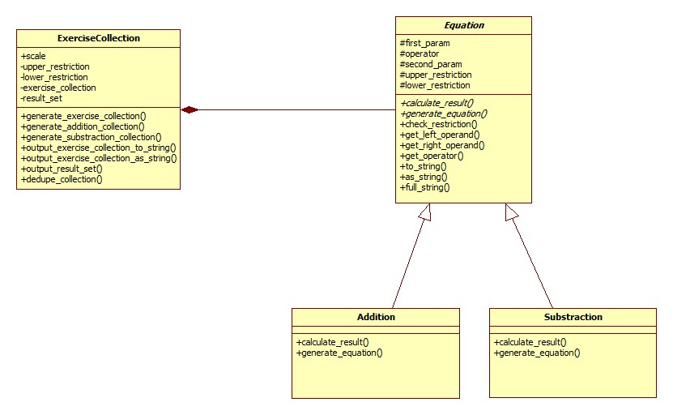

参考文献：
1.
2.

