实验编号：实验006
实验题目：使用Junit进行自动化测试
实验日期：2026-05-13
实验内容：

https://pan.baidu.com/disk/main#/transfer/send?surl=ABcAAAAAABRn0w

安装Junit插件，进行自动化软件测试。使用步骤如下：
- 安装JUnitGenerator V2.0。目前最新版本已更新到4.0，可以选择最新版本。
- 方法一：通过网络安装
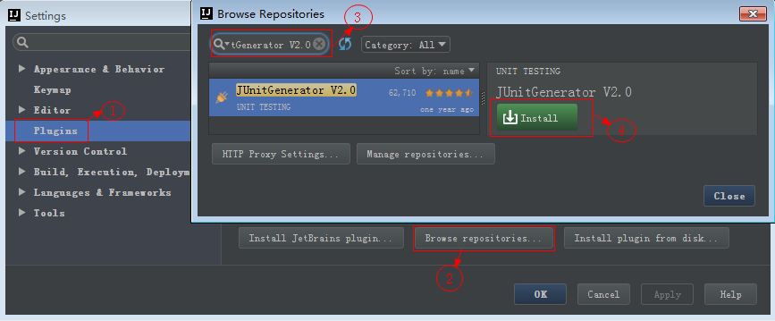
- 方法二：手动下载插件安装。插件下载：https://plugins.jetbrains.com/idea/plugin/3064-junitgenerator-v2-0 。安装如下图所示：
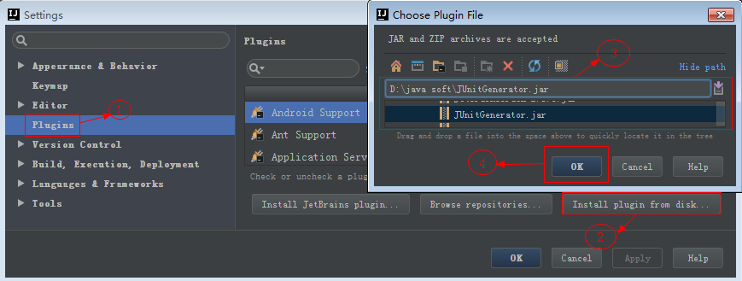
- 安装完成重启IDEA，即可使用。

- 修改配置
修改Output Path为：${SOURCEPATH}/../../test/java/${PACKAGE}/${FILENAME}，Default Template选择JUnit 4。
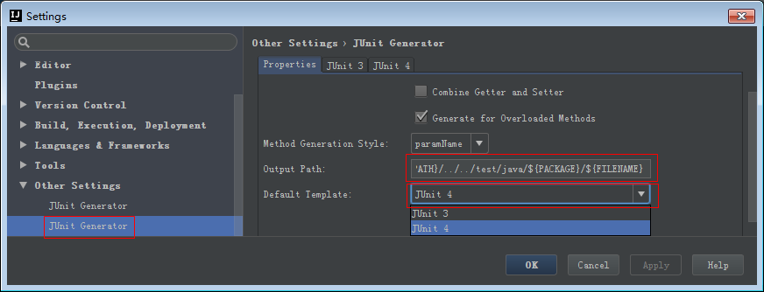

- 生成测试测试用例
在待编写测试的java类源码块上按快捷键Ctrl + Shift + T，根据需要修改相关测试用例。
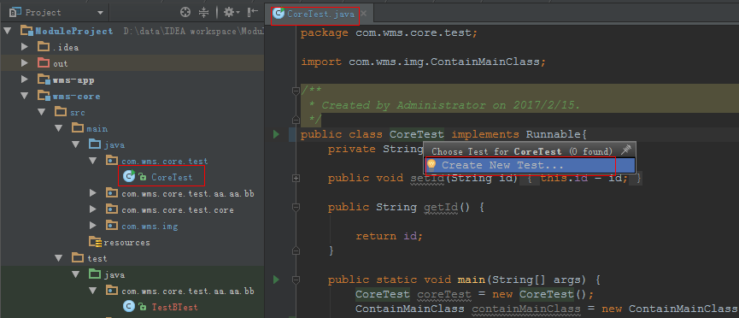

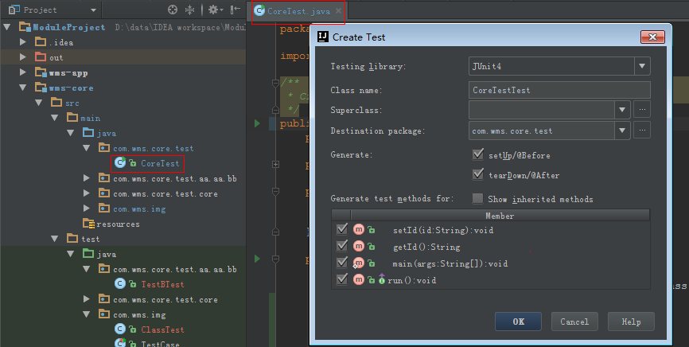

- 在测试类中执行程序，并进行测试。

实验报告：
- 安装Junit，并成功生成测试类；

from Sys_admin.main.src.addition import Addition
from Sys_admin.main.src.equation import Equation
from Sys_admin.main.src.subtraction import Subtraction

def test_check_same_equation():
test_equation1 :Equation = Addition(15,33,0,100)
test_equation2 :Equation = Addition(15,33,0,100)
test_equation3 :Equation = Addition(33,15,0,100)

assert test_equation1.check_same_equation(test_equation2) == True ,"完全相同的等式被检查失败"
assert test_equation1.check_same_equation(test_equation3) == True ,"交换左右操作数的等式被检查失败"

def test_check_restriction():
test_restriction1 :Equation= Addition(105,15,0,100)
test_restriction2 :Equation= Addition(-2,1,0,100)

assert test_restriction1.check_restriction() == False ,"检查加法超出规定上限的约束失败"
assert test_restriction2.check_restriction() == False,"检查加法超出规定下限的约束失败"

test_restriction3 :Equation= Subtraction(105,4,0,100)
test_restriction4 :Equation= Subtraction(-2,1,0,100)

assert test_restriction3.check_restriction() == False ,"检查减法超出规定上限的约束失败"
assert test_restriction4.check_restriction() == False,"检查减法超出规定下限的约束失败"

def test_calculate_result():
test_calculate1 :Equation = Addition(70,30)
test_calculate2 :Equation = Subtraction(100,1)
test_calculate3 :Equation = Subtraction(100,0)

assert test_calculate1.calculate_result() == 100 ,"等式的加法计算结果出错"
assert test_calculate2.calculate_result() == 99 ,"等式的减法计算结果出错"
assert test_calculate3.calculate_result() == 100 ,"等式的加法计算出错"

- 测试案例设计二中的AdditionOperation类，给出测试用例，将测试结果截图粘贴在下方；
测试代码如下
from Sys_admin.main.src.addition import Addition

def test_calculate_result():
test_calculate1 = Addition(10,20)
test_calculate2 = Addition(100,2)
test_calculate3 = Addition(-15,2)

assert test_calculate1.calculate_result() == 30 ,"加法的计算结果函数错误"
assert test_calculate2.calculate_result() == 102 ,"加法的计算结果函数错误"
assert test_calculate3.calculate_result() == -13 ,"加法的计算结果函数错误"
Pytest的测试用例如下
序号 | 测试数据 | 预期结果 | 实际结果
1 | 10，20 | 30 | 30
2 | 100，2 | 102 | 102
3 | -15，2 | -13 | -13

结果截图如下：
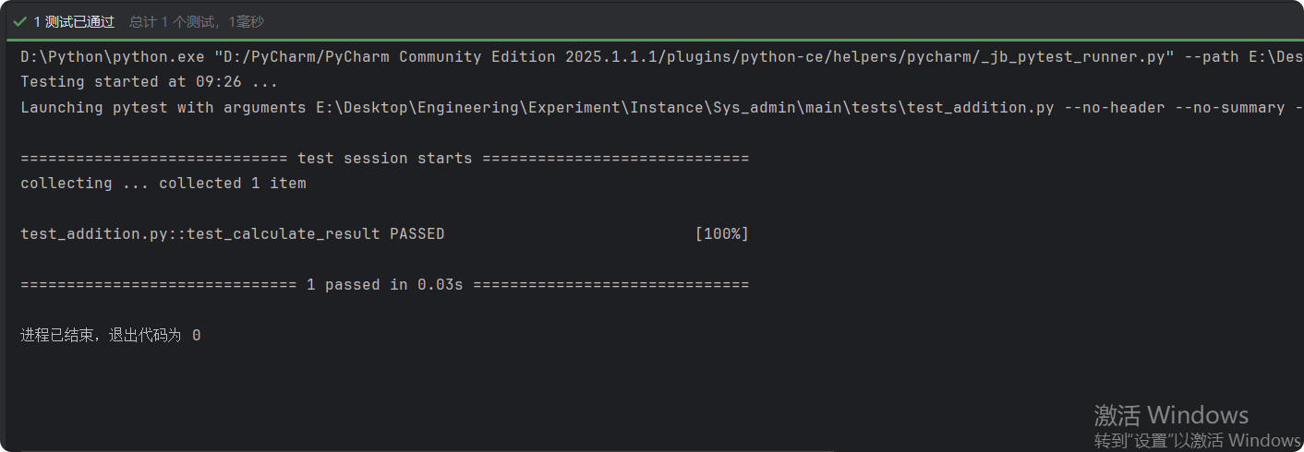

- 按照教材83页代码创建一个测试项目JunitDemo，创建一个BinaryOperation类，包含Construct方法，创建Junit测试并使用如下的测试用例：
序号 | 测试数据 | 预期结果 | 实际结果
1 | 70,30,’+’ | 100 | 100
2 | 100,1,’-’ | 99 | 99
3 | 100,0,’-’ | 99 | 100
测试结果粘贴如下：
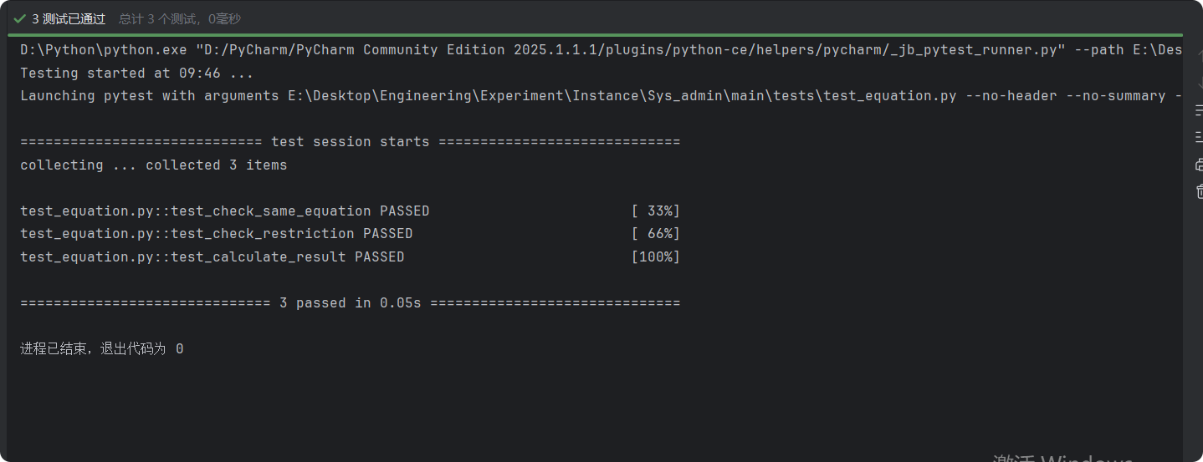
测试代码如下：
from Sys_admin.main.src.addition import Addition
from Sys_admin.main.src.equation import Equation
from Sys_admin.main.src.subtraction import Subtraction

def test_check_same_equation():
test_equation1 :Equation = Addition(15,33,0,100)
test_equation2 :Equation = Addition(15,33,0,100)
test_equation3 :Equation = Addition(33,15,0,100)

assert test_equation1.check_same_equation(test_equation2) == True ,"完全相同的等式被检查失败"
assert test_equation1.check_same_equation(test_equation3) == True ,"交换左右操作数的等式被检查失败"

def test_check_restriction():
test_restriction1 :Equation= Addition(105,15,0,100)
test_restriction2 :Equation= Addition(-2,1,0,100)

assert test_restriction1.check_restriction() == False ,"检查加法超出规定上限的约束失败"
assert test_restriction2.check_restriction() == False,"检查加法超出规定下限的约束失败"

test_restriction3 :Equation= Subtraction(105,4,0,100)
test_restriction4 :Equation= Subtraction(-2,1,0,100)

assert test_restriction3.check_restriction() == False ,"检查减法超出规定上限的约束失败"
assert test_restriction4.check_restriction() == False,"检查减法超出规定下限的约束失败"

def test_calculate_result():
test_calculate1 :Equation = Addition(70,30)
test_calculate2 :Equation = Subtraction(100,1)
test_calculate3 :Equation = Subtraction(100,0)

assert test_calculate1.calculate_result() == 100 ,"等式的加法计算结果出错"
assert test_calculate2.calculate_result() == 99 ,"等式的减法计算结果出错"
assert test_calculate3.calculate_result() == 100 ,"等式的加法计算出错"

