**Shiksha**  Project Work / Dissertation



**Submitted by:**  Tanu Kaushik (21020570055)

Kundan (21020570022)

Rachit Parashar (21020570042)

Lokesh (21020570024)

BSc (H) Computer Science –VI -SEM, 3 Year

**Submitted to:**

Dr.Kamlesh Kumar Raghuvanshi Sir

Ramanujan College

**Table of content**

|  |  |  |
| --- | --- | --- |
| Serial Number | Contents | Page  Number |
| 1. | Overview | 6 |
| 2. | Background study | 7 |
| 3. | Problem statement | 8 |
| 4. | Scope and objectives | 16 |
| 5. | Purpose of project | 17 |
| 6. | Requirement analysis project feasibility   * Functional * Hardware * Software * Performance * security | 19  19  25  25  26  27 |
| 7. | Design and modeling | 32 |

|  |  |  |
| --- | --- | --- |
| 8. | Automation | 39 |
| 9. | Testing | 40 |
| 10. | Conclusion | 41 |
| 11. | Reference | 43 |

**Certificate**

This is to certify that Tanu Kaushik, Kundan , Rachit Parashar, Lokesh the students of BSc. (H) Computer Science, Ramanujan college of Delhi University have made the project titled “Shiksha” in their individual capacities under my supervision for the fulfillment of VI Semester practical examination.

***(Dr. Kamlesh*** ***kr.Raghuvanshi)***

**Acknowledgement**

We extend our profound gratitude to our project guide Dr. Kamlesh kr. Raghuvanshi, for his interest, guidance and suggestions throughout the course of the project. We feel honored and privileged to work under him. He shared his vast pool of knowledge with us that helped us steer through all the difficulties with ease. This project would not have been possible without his guidance, and we would like to thank him for everything he has done for us.

**Tanu Kaushik**

**Rachit Parashar**

**Kundan**

**Lokesh**

**Abstract:**

Shiksha is an innovative online platform designed to revolutionize the way teachers connect with learners by offering a diverse array of courses. With Siksha, educators can effortlessly create and sell their courses, whether they are paid or free, to a global audience of eager students. This dynamic application provides a seamless interface for both instructors and learners, facilitating easy course creation, enrollment, and interaction. Siksha aims to empower educators to share their expertise with the world while providing learners with unparalleled access to high-quality educational content. Join Siksha today and embark on a journey of knowledge exchange and enrichment.

**Overview**

Siksha is an online platform that serves as a marketplace for educators to sell their courses to learners worldwide. Through Siksha, teachers can offer a wide range of courses spanning various subjects and levels of expertise. These courses may be offered on a paid or free basis, catering to different learners' needs and preferences. The platform provides a user-friendly interface for both instructors and students to create, manage, and enroll in courses, fostering a dynamic learning community.

**Background Study**

The conception of Siksha stems from the evolving landscape of education, characterized by the growing demand for accessible, high-quality learning resources and the emergence of digital platforms as key facilitators of education. The project is grounded in a thorough understanding of the following key factors:

Educational Trends: The project acknowledges the shift towards online learning and the increasing popularity of e-learning platforms. With advancements in technology and the widespread availability of the internet, learners seek flexible and convenient ways to acquire new skills and knowledge.

Market Analysis: Extensive market research reveals a significant demand for platforms that connect educators with learners, allowing teachers to monetize their expertise and learners to access diverse learning opportunities. Competitor analysis highlights the strengths and weaknesses of existing platforms, informing the development of unique features and value propositions for Siksha.

Educator Needs: Through consultations with educators and subject matter experts, the project identifies the challenges faced by teachers in monetizing their courses and reaching a broader audience. Insights gathered from these discussions shape the design and functionality of Siksha, ensuring it meets the needs and preferences of educators.

Learner Preferences: Surveys and feedback from potential learners provide valuable insights into their preferences regarding course content, pricing models, user experience, and interaction features. Understanding learner expectations allows Siksha to tailor its offerings to meet diverse learning needs and preferences.

Technological Feasibility: A comprehensive assessment of available technologies, frameworks, and development tools determines the feasibility of implementing key features and functionalities within the Siksha platform. Consideration is given to scalability, security, performance, and compatibility across different devices and operating systems.

Regulatory and Legal Considerations: The project takes into account relevant regulations and legal requirements governing online education, intellectual property rights, data protection, and financial transactions. Compliance with these regulations is essential to ensure the legality and integrity of the Siksha platform.

By conducting a thorough background study encompassing these key areas, the Siksha project aims to lay a solid foundation for the development of a robust and innovative platform that empowers educators and enriches the learning experiences of learners worldwide.

**Problem Statement**

In the rapidly evolving landscape of education, traditional barriers to accessing quality learning resources persist, hindering both educators and learners. Despite the proliferation of online learning platforms, significant challenges remain for teachers seeking to monetize their expertise and for learners navigating a fragmented marketplace of courses. Current platforms often lack the flexibility, transparency, and community engagement necessary to foster meaningful connections between educators and learners. As a result, educators struggle to reach a wider audience and generate sustainable income from their courses, while learners face difficulty in discovering relevant, high-quality content tailored to their needs and preferences. The lack of a comprehensive, user-centric platform that facilitates seamless interactions between educators and learners hampers the advancement of online education and perpetuates inefficiencies in the distribution of knowledge. Therefore, there is a pressing need for a dynamic, inclusive platform like Siksha that empowers educators to sell their courses, whether paid or free, while providing learners with a curated selection of diverse, high-quality educational resources. By addressing these challenges, Siksha aims to democratize education, foster a vibrant learning community, and unlock the full potential of online learning for educators and learners worldwide.

**Scope and objectives**

The scope of the Siksha project encompasses the development of an online platform that enables teachers to create, publish, and monetize their courses while providing learners with access to high-quality educational content. The primary objectives of the project include:

* **Creation of a User-Friendly Platform:** Develop an intuitive and user-friendly interface for both teachers and learners to easily navigate the platform, create courses, and enroll in classes.
* **Course Management:** Implement features for teachers to upload course content, set pricing (if applicable), manage enrollments, and track student progress.
* **Payment Integration:** Integrate secure payment gateways to facilitate transactions between instructors and learners for paid courses.
* **Community Engagement:** Foster a vibrant learning community by facilitating interactions between teachers and students through features such as discussion forums, messaging, and Q&A sessions.
* **Quality Assurance:** Ensure the quality and reliability of courses by implementing mechanisms for course reviews, ratings, and feedback.
* **Scalability and Performance:** Design the platform to accommodate growth and scalability, ensuring optimal performance even with increased user activity and course offerings.
* **Marketing and Promotion:** Develop strategies for marketing and promoting the Siksha platform to attract both educators and learners, thereby expanding the user base and enhancing the platform's visibility.

By achieving these objectives within the defined scope, the Siksha project aims to empower educators to monetize their expertise while providing learners with convenient access to a diverse range of educational resources.

**Purpose of project:**

The purpose of the Siksha project is to create an inclusive and dynamic online platform where educators can effortlessly offer and monetize their courses, whether they choose to sell them or offer them for free. Siksha aims to empower teachers by providing them with the tools and resources they need to share their knowledge and expertise with a global audience. By facilitating seamless course creation, management, and distribution, Siksha enables educators to reach a wider audience and generate sustainable income from their teaching efforts. Additionally, Siksha seeks to enrich the learning experiences of students by offering a diverse range of high-quality courses tailored to their interests and learning objectives. Through innovative features such as community engagement, interactive learning tools, and transparent pricing models, Siksha fosters a vibrant learning ecosystem where educators and students can connect, collaborate, and thrive. Ultimately, Siksha aspires to democratize education, making it accessible to learners of all backgrounds and empowering educators to make a meaningful impact in the field of online learning.

**Requirement analysis project feasibility**

**Functional requirements**

Functional Requirements of the Siksha App:

1. User Registration and Authentication:

- Users (teachers and students) should be able to register and create accounts.

- Authentication mechanisms should be in place to ensure secure access to the platform.

2. Course Creation and Management:

- Teachers should be able to create, upload, and manage their courses.

- Course creation should include options for adding course descriptions, curriculum, multimedia content (videos, presentations), assignments, quizzes, and assessments.

- Teachers should be able to categorize and tag their courses for easy discoverability.

3. Course Discovery and Enrollment:

- Students should be able to browse, search, and filter courses based on categories, topics, ratings, and pricing.

- Students should be able to enroll in courses of their choice, either for free or by making a payment.

4. Payment Integration:

- The app should support secure payment processing for paid courses, including integration with popular payment gateways.

- Payment options should include credit/debit cards, digital wallets, and other relevant payment methods.

5. User Profiles and Dashboards:

- Users should have personalized profiles where they can view their enrolled courses, progress, achievements, and other relevant information.

- Teachers should have access to a dashboard for managing their courses, tracking enrollment, and monitoring student progress.

6. Progress Tracking and Reporting:

- Both teachers and students should be able to track course progress, completion status, and performance metrics.

- Teachers should have access to analytics and reporting tools to monitor course performance and student engagement.

**HARDWARE REQUIREMENT**

Here's minimum requirements to manage Shiksha app :

● 20 GB HDD 256 MB RAM

● Pentium IV Processor

● Input Devices: Keyboard, Mouse

● Output Devices: Monitor

**SOFTWARE REQUIREMENT**

Here’s minimum software requirements to operate and use shikha application

Operating System: Window XP and above Browsers: Chrome or any other latest web page supporting browser.

**Performance**

Response Time: The app should respond promptly to user interactions such as course browsing, enrollment, and content creation. Aim for response times of under 1 second for most actions to provide a smooth user experience.

Concurrency: The app should support multiple concurrent users performing various actions simultaneously, such as uploading courses, enrolling in classes, and accessing course materials. Optimize database queries, caching mechanisms, and resource allocation to handle concurrent user requests efficiently.

Optimized Media Streaming: If the app includes video-based courses, optimize media streaming to minimize buffering and loading times. Use adaptive bitrate streaming and content preloading to deliver smooth playback experiences even on slower internet connections.

**Security**

Ensuring the security of the Shiksha app is paramount to protect user data, prevent unauthorized access, and maintain trust among users. Here are some security measures that should be implemented:

1. Secure Authentication and Authorization:

- Implement strong authentication mechanisms, such as multi-factor authentication (MFA), to verify the identity of users during login.

- Use industry-standard encryption protocols (e.g., SSL/TLS) to secure communication channels between the app and the server.

- Enforce role-based access control (RBAC) to restrict access to sensitive functionalities and data based on users’ roles and permissions.

2. Secure Payment Processing:

- Integrate with reputable payment gateways that comply with Payment Card Industry Data Security Standard (PCI DSS) requirements.

- Implement tokenization or encryption of payment card data to prevent unauthorized access to sensitive financial information.

- Regularly audit payment processing systems and conduct vulnerability assessments to identify and address security risks.

3. Secure Software Development Practices:

- Follow secure coding practices and guidelines to mitigate common security vulnerabilities, such as injection attacks, cross-site scripting (XSS), and authentication bypass.

- Conduct regular code reviews and static code analysis to identify and remediate security flaws early in the development lifecycle.

- Keep third-party libraries and dependencies up to date to patch known vulnerabilities and security issues.

By implementing these security measures, the Shiksha app can mitigate security risks and protect the confidentiality, integrity, and availability of user data, fostering trust and confidence among educators and learners using the platform.

**MODELING AND DESIGN**

Home Page



Login page



Create courses Section

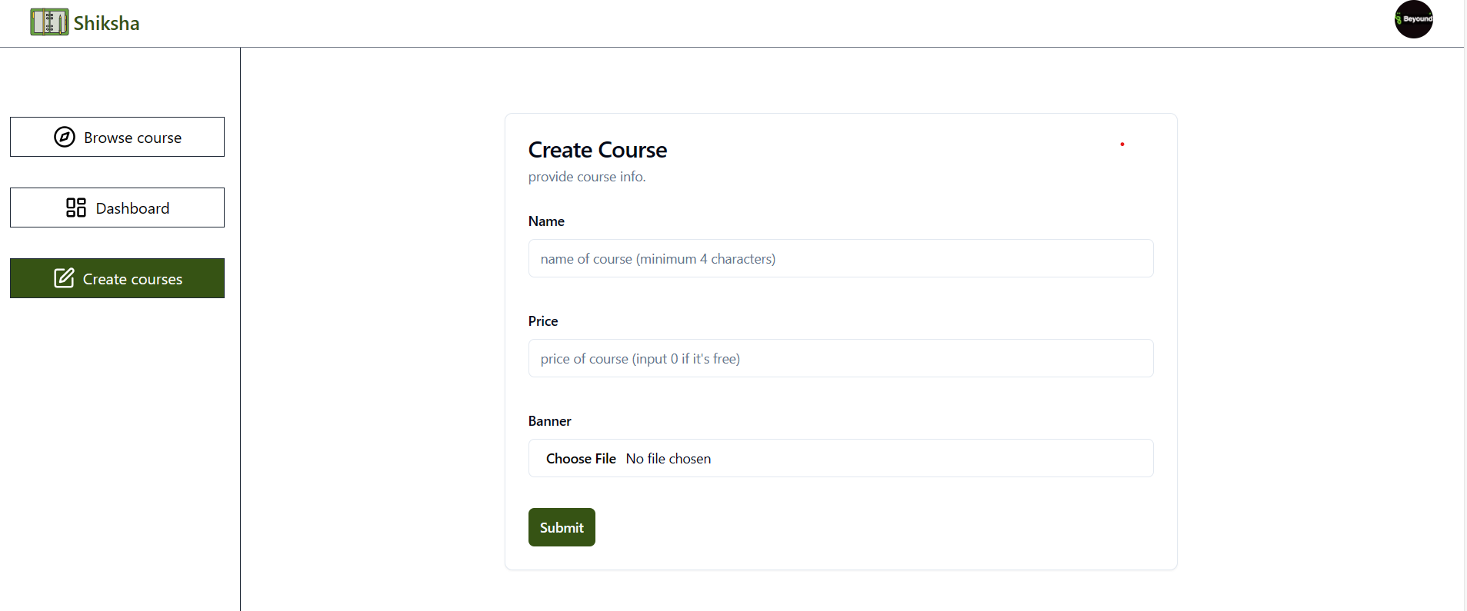

Add chapters button



Adding chapters

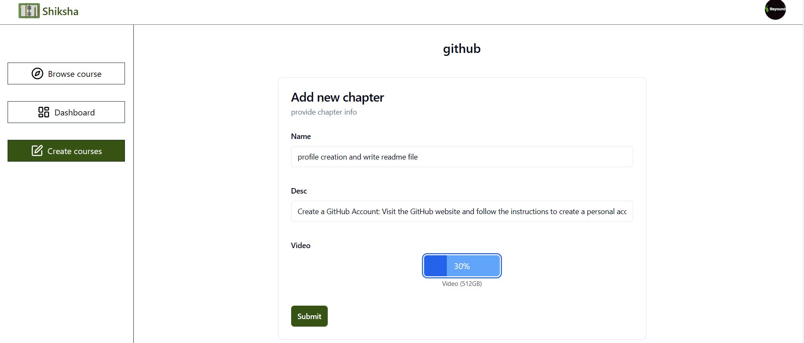

Course created with Chapters



If you want to buy course, then choose on the course and click on buy course button



Pay course fee by a payment gateway named **stripe**

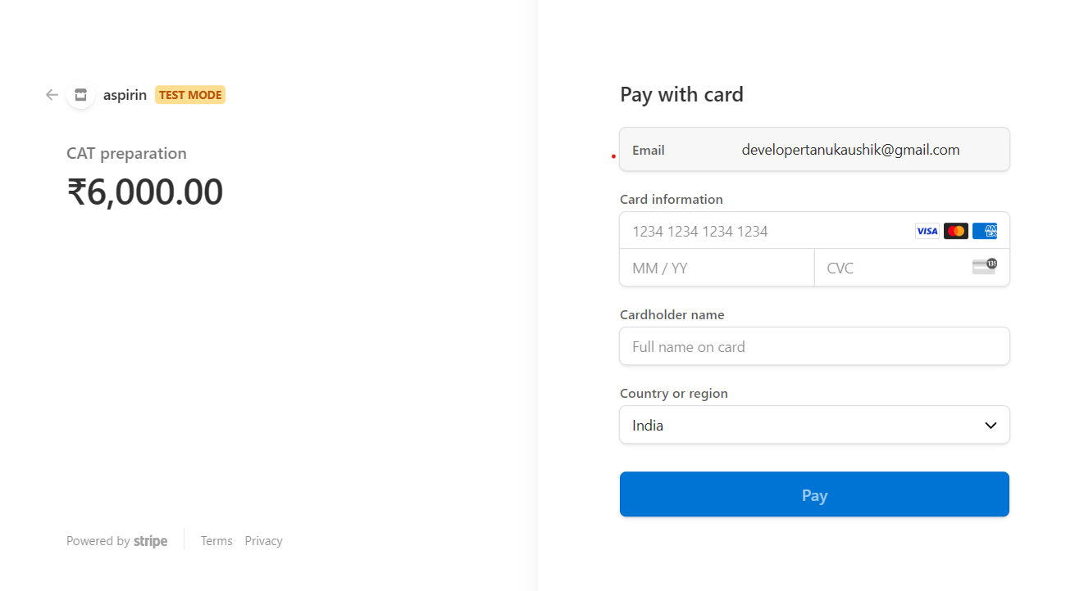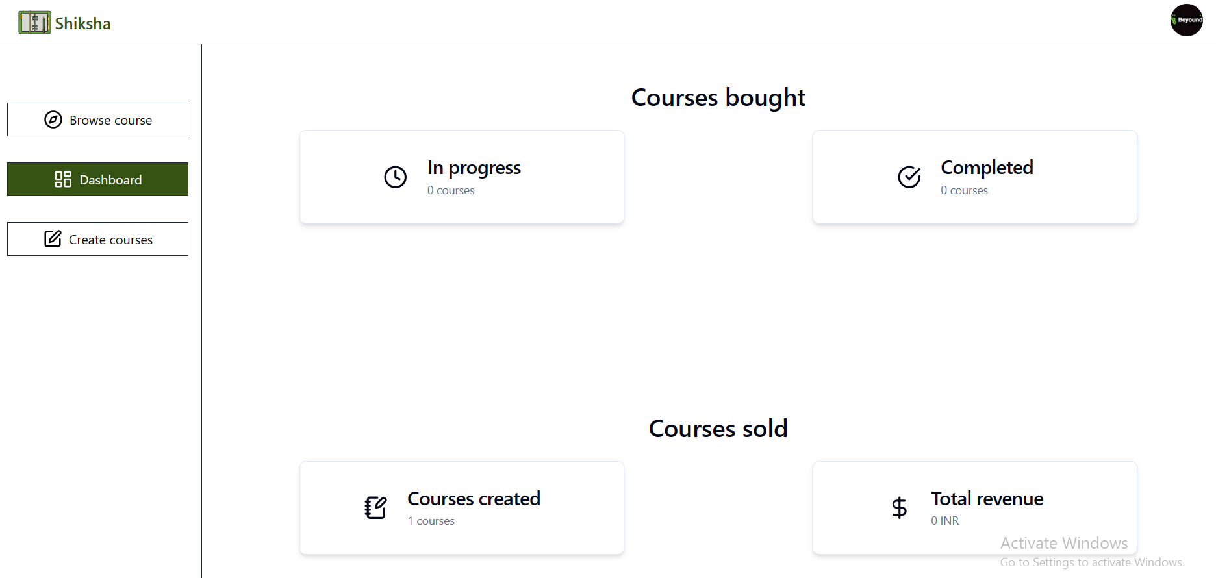

Er diagram to represent logging system

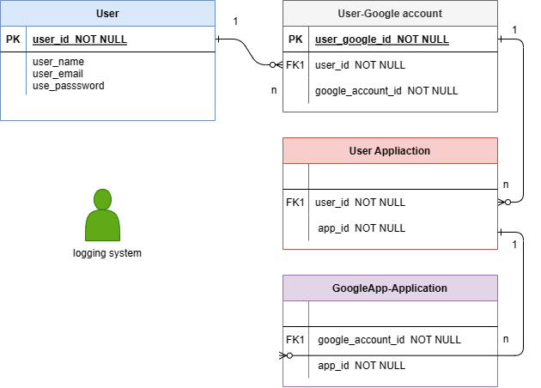

Basic design of project

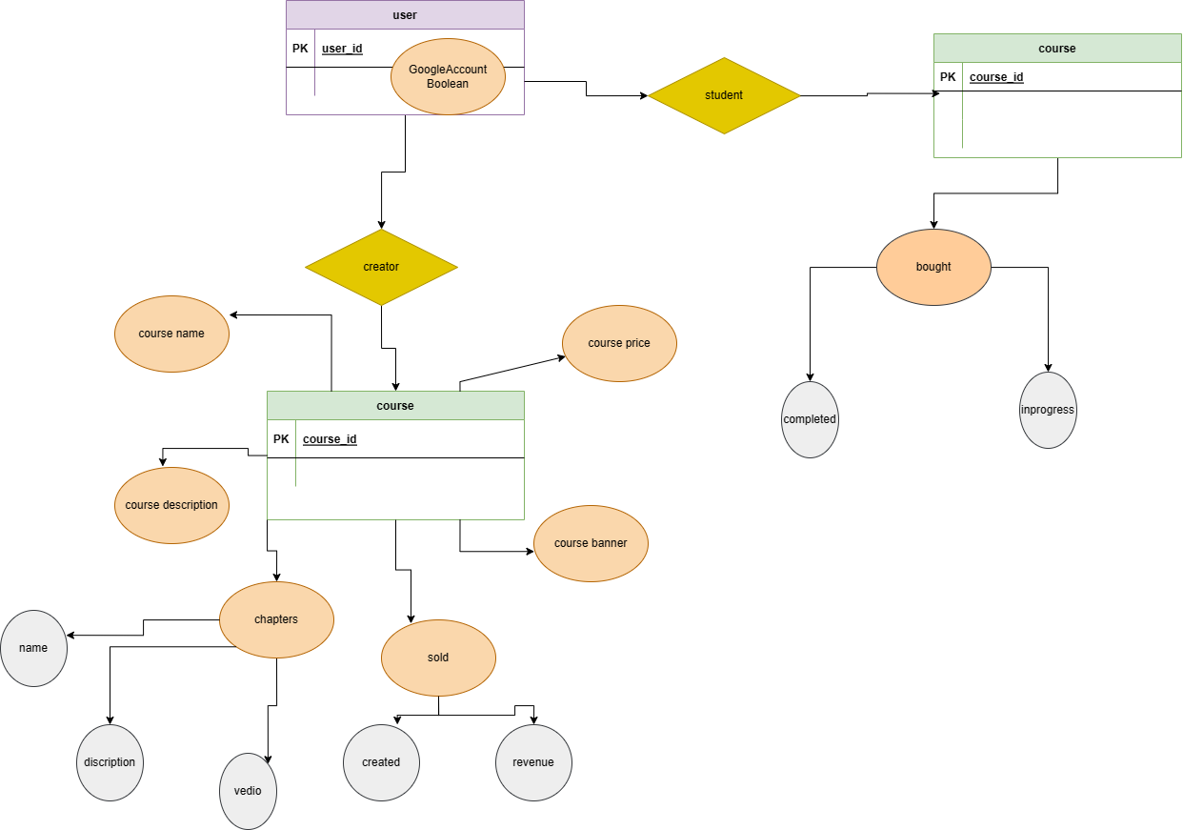

**Automation**

The automated feature of Shiksha is a testament to the platform’s commitment to efficiency and user empowerment. By minimizing the time and effort required to create and purchase courses, Shiksha ensures that users can focus on what truly matters: learning and teaching. The intuitive design allows for quick course creation, enabling educators to share their knowledge without getting bogged down by complex processes. Similarly, learners benefit from the ability to instantly access a wide array of courses, making education more accessible and convenient than ever before. This automation not only enhances the user experience but also fosters a dynamic educational environment.

**Testing**

* **User Registration and Authentication:** Verify that users can successfully register as teachers or students and authenticate their accounts securely [[1](https://www.shiksha.com/online-courses/free-online-courses-certificates)].
* **Course Creation and Management:** Test the functionality for teachers to create, upload, and manage courses, ensuring all course details are accurately captured and saved [[4](https://www.shiksha.com/online-courses/software-testing-course-course-anall5)].
* **Course Discovery and Enrollment:** Validate the course search and filter features for students, ensuring they can easily discover courses based on categories, topics, and pricing [[2](https://www.shiksha.com/online-courses/qa-and-testing-courses-certification-training-st621)].
* **Payment Integration:** Test the payment processing functionality for purchasing paid courses, ensuring secure transactions and proper handling of payment failures [[3](https://www.shiksha.com/online-courses/government-certification-certification)].
* **User Profiles and Dashboards:** Verify that users have access to personalized profiles and dashboards displaying enrolled courses, progress, and other relevant information.
* **Progress Tracking and Reporting:** Test progress tracking features to ensure accurate tracking of course progress, completion status, and performance metrics.

**Source Code:** [0xMishra/shiksha: shiksha is a service to sell courses. (github.com)](https://github.com/0xMishra/shiksha)

**Conclusion**

In conclusion, Shiksha represents a transformative step forward in the realm of online education, offering a vibrant platform where educators, professors, and anyone passionate about sharing knowledge can connect with eager learners worldwide. Through a seamless interface and robust feature set, Shiksha empowers instructors to create and distribute courses, whether offered for free or through paid enrollment, thereby democratizing access to quality education resources. By fostering a dynamic learning community and promoting collaboration between teachers and students, Shiksha not only facilitates the dissemination of knowledge but also cultivates a culture of lifelong learning and personal growth. Join Shiksha today and embark on a journey of discovery, enlightenment, and limitless possibilities.

Future Scope:

a. In future we will update our system continuously

b. We will develop more feature

c. Live schedule meeting option etc.

**Reference**:

(1.) When developing an app like Shiksha, which enables teachers and educators to share courses for free or for a fee with students or learners, various references and inspirations can be drawn from existing platforms in the e-learning and online education sector.

(2.) Software Engineering, A Practitioner’s Approach Eighth Edition by Roger S. Pressman

(3.) Aggarwal, K. K., & Singh, Y. (2007). Software Engineering. 3rd edition.