Neural Networks Final Project by Beytullah Paytar – B2280.060064
Selected Paper: “Machine Learning Based Heart Disease Prediction: A Study for Home Personalized Care”
Authors: Goutam Kumar Sahoo, Keerthana Kanike, Santos Kumar Das, Poonam Singh
Conference: 2022 IEEE 32nd International Workshop on Machine Learning for Signal Processing (MLSP), 22-25 August 2022, Xi'an, China
DOI: https://doi.org/10.1109/MLSP55214.2022.9943373
Link: https://ieeexplore.ieee.org/document/9943373
Method Summary and Model Description
This paper proposes a framework for an "At-Home Personalized Care System" designed to predict the risk of cardiovascular disease (CVD) using patient physiological data. The methodology follows a standard data mining pipeline:
- Data Acquisition: Collecting patient vitals and medical history.
- Preprocessing: Handling missing values and normalizing numerical features.
- Exploratory Data Analysis (EDA): Visualizing feature distributions to understand risk factors.
- Modeling: Training multiple supervised machine learning classifiers to distinguish between healthy patients and those with heart disease.
- Evaluation: Comparing models based on Accuracy, Precision, Recall, and F1-Score to identify the most reliable algorithm for deployment.
Model & Algorithm Description: To ensure a comprehensive reproduction and comparison, this project implemented the same seven supervised learning algorithms used in the original study:
- Logistic Regression (LR): A linear model that estimates the probability of a binary outcome using the logistic function.
- K-Nearest Neighbor (KNN): A non-parametric method that classifies a sample based on the majority class of its k closest neighbors in the feature space.
- Support Vector Machine (SVM): Finds the optimal hyperplane that separates data points of different classes with the maximum margin.
- Naive Bayes (NB): A probabilistic classifier based on Bayes' theorem, assuming strong (naive) independence between features.
- Decision Tree (DT): A tree-structured model that splits data into branches based on feature values to reach a decision.
- Random Forest (RF): An ensemble learning method that constructs multiple decision trees during training and outputs the mode of the classes (classification) to reduce overfitting.
- eXtreme Gradient Boosting (XGBoost): An advanced gradient boosting library designed for speed and performance, which builds an ensemble of weak prediction models (typically decision trees).

Dataset Description
This study utilizes two primary data sources to reproduce the original paper's findings and test real-world generalization:
1. UCI Machine Learning Repository – Cleveland Heart Diseases Dataset: The original paper relies on the UCI Cleveland Heart Disease dataset (303 records).
Link: https://archive.ics.uci.edu/dataset/45/heart+disease
Features: It contains 13 clinical attributes: Age, Sex, Chest Pain Type (cp), Resting Blood Pressure (trestbps), Cholesterol (chol), Fasting Blood Sugar (fbs), Resting Electrocardiogram (restecg), Max Heart Rate (thalach), Exercise Angina (exang), ST Depression (oldpeak), Slope (slope), plus Number of Major Vessels (ca) and Thalassemia (thal).
Target: Binary classification (0 = Healthy, 1 = Heart Disease).
2. UCI Machine Learning Repository – Hungarian Heart Disease Dataset: In the paper's introduction, the authors cite the work of Bhatt et al., who achieved an accuracy of 82.3% using the Hungarian dataset. To evaluate these claims and test the performance of my own models against these historical benchmarks, I included the Hungarian data (also from the UCI repository) in my experimental loop. This allowed me to analyze how different classification techniques respond to different data distributions and quality levels.
3. Kaggle – Heart Disease Dataset (Comprehensive): To test the model on a larger scale, I utilized the Heart Statlog Cleveland Hungary Final dataset from Kaggle (1,190 records).
Link: https://www.kaggle.com/datasets/sid321axn/heart-statlog-cleveland-hungary-final
This dataset contains data from multiple international sources, including Cleveland (Cleveland, Hungary, Switzerland, Long Beach VA, Stalog (Heart) Data Set). It shares the same features as the Cleveland dataset, but excludes plus Number of Major Vessels (ca) and Thalassemia (thal).
Preprocessing:
To provide a comprehensive evaluation of the proposed method, I implemented a code that generated six dataset variations.
1. Data Cleaning & Variations: The following six variations were prepared to isolate specific data quality issues and benchmarking goals:
D1: Hungarian (All dropped): In this version, the “ca” and “thal” columns were removed due to excessive missingness (almost all of it were “?”). Any remaining rows with missing values were dropped. (The worst one so far.)
D2: Hungarian (Dropped Columns + Imputation): The “ca” and “thal” columns were still dropped, but missing values in the remaining 11 columns were filled using Mean Imputation (SimpleImputer). This tests if retaining patient records (via imputation) outweighs the noise of estimated values.
D3: Hungarian (All Imputation): The “ca” and “thal” columns were kept this time, and their extensive missing values were filled with the mean. This experiment tests the hypothesis that these specific features are so biologically significant that even a weak (imputed) signal improves model performance. (Which greatly did.)
D4: Cleveland (Dropped “ca” and “thal” columns): The “ca” and “thal” columns were voluntarily dropped from the clean Cleveland dataset. This reduces the feature count to 11, enabling a fair comparison with the Hungarian D1/D2 datasets, and the Kaggle dataset.
D5: Cleveland (Normal): No columns were dropped. Only rows with missing values (“?”) were removed. This dataset (13 features) is the version used in the IEEE paper, serving as the ground truth for validating my results against the authors' claims.
D6: Kaggle: Column names were standardized to match the UCI format. Unlike the raw datasets, this version’s targets were already binary, requiring no additional transformation.
2. Normalization: Because different features use different units (e.g., Age in years vs. Cholesterol in mg/dl), I applied Standard Scaling. This process adjusts all numerical values so they share a common scale without distorting the differences in the ranges of values. This is essential for models like KNN and SVM, which rely on calculating distances between data points.
3. Target Encoding: The original UCI datasets (Cleveland and Hungarian) define the target variable with integer values from 0 (Healthy) to 4 (Severe Disease). However, the referenced IEEE paper treats the problem as a binary classification task (Healthy vs. Diseased). So, I applied a transformation function (lambda x: 1 if x > 0 else 0) to map all disease presence indicators (values 1–4) to a single positive class (1), while keeping 0 as the negative class.
Implementation Details
1. Hardware:
Computer: Casper Excalibur G770 Gaming Laptop, OS: Ubuntu Linux 24.04.3 LTS, CPU: Intel® Core™ i7-12650H, Memory: 16 GB RAM, GPU: NVIDIA GeForce RTX 3050 Mobile (4GB VRAM), IDE: PyCharm Professional Edition, Python Version: 3.12
2. Libraries and Dependencies:
The project’s libraries are managed via a “requirements.txt” file.
- pandas & numpy: For structured data manipulation and numerical operations.
- scikit-learn: The primary framework for model implementation, data splitting, and metrics calculation.
- xgboost: Used for the eXtreme Gradient Boosting classifier.
- seaborn & matplotlib: Used for generating high-resolution Confusion Matrices and Learning Curves.
- ucimlrepo: Used to programmatically fetch the most recent versions of the UCI datasets.
- flask & flask-cors: For the deployment of the model via a RESTful API.
- joblib: Used for saving the trained models for use in the web application.
3. Training Setup and Hyperparameters
I implemented a training loop across all 6 dataset variations and 7 algorithms.
Data Handling:
Splitting: Every dataset was split into 80% Training and 20% Testing using “train_test_split”.
Reproducibility: A random_state=42 was used across all splits and model initializations to ensure that my results can be independently verified.
Imputation: For the Hungarian experiments (D2 and D3), SimpleImputer(strategy='mean') was used to handle missing values.
Scaling: StandardScaler was applied to normalize the feature space. This is important for distance-based models like KNN and SVM, as it ensures that features with larger numerical ranges (e.g., Cholesterol) do not disproportionately influence the model compared to smaller ones (e.g., Age).
Algorithm Implementation: I imported and initialized the following seven models from sklearn and xgboost:
- LogisticRegression(max_iter=1000)
- KNeighborsClassifier()
- SVC(probability=True)
- GaussianNB()
- DecisionTreeClassifier()
- RandomForestClassifier(n_estimators=100)
- XGBClassifier()
4. Results
Reproduction: Cleveland Standard Dataset (D5)
On the Cleveland dataset, my reproduction efforts yielded high performance across all models. While the original paper identified Random Forest (RF) as the superior model with 90.16% accuracy, my implementation found that Naive Bayes (NB) actually outperformed it with an accuracy of 91.67%, followed by Random Forest (RF) and Support Vector Machine (SVM), with accuracies of 88.33%.

The paper’s results:
Model | Accuracy (%) | Precision (%) | Recall (%) | F1-Score (%)
Logistic Regression | 88.52 | 82.85 | 96.66 | 89.23
KNN | 83.60 | 81.25 | 86.66 | 83.87
SVM | 83.60 | 76.31 | 96.66 | 85.29
Naive Bayes | 75.40 | 67.44 | 96.66 | 79.45
Decision Tree | 78.68 | 77.41 | 80.00 | 78.68
Random Forest | 90.16 | 83.33 | 100.00 | 90.90
XGBoost | 88.52 | 84.84 | 93.33 | 88.88

My Results (Cleveland Normal):
Model | Accuracy (%) | Precision (%) | Recall (%) | F1-Score (%)
Logistic Regression | 86.67 | 83.33 | 83.33 | 83.33
KNN | 83.33 | 81.82 | 75.00 | 78.26
SVM | 88.33 | 86.96 | 83.33 | 85.11
Naive Bayes | 91.67 | 95.24 | 83.33 | 88.89
Decision Tree | 78.33 | 68.97 | 83.33 | 75.47
Random Forest | 88.33 | 84.00 | 87.50 | 85.71
XGBoost | 83.33 | 75.00 | 87.50 | 80.77
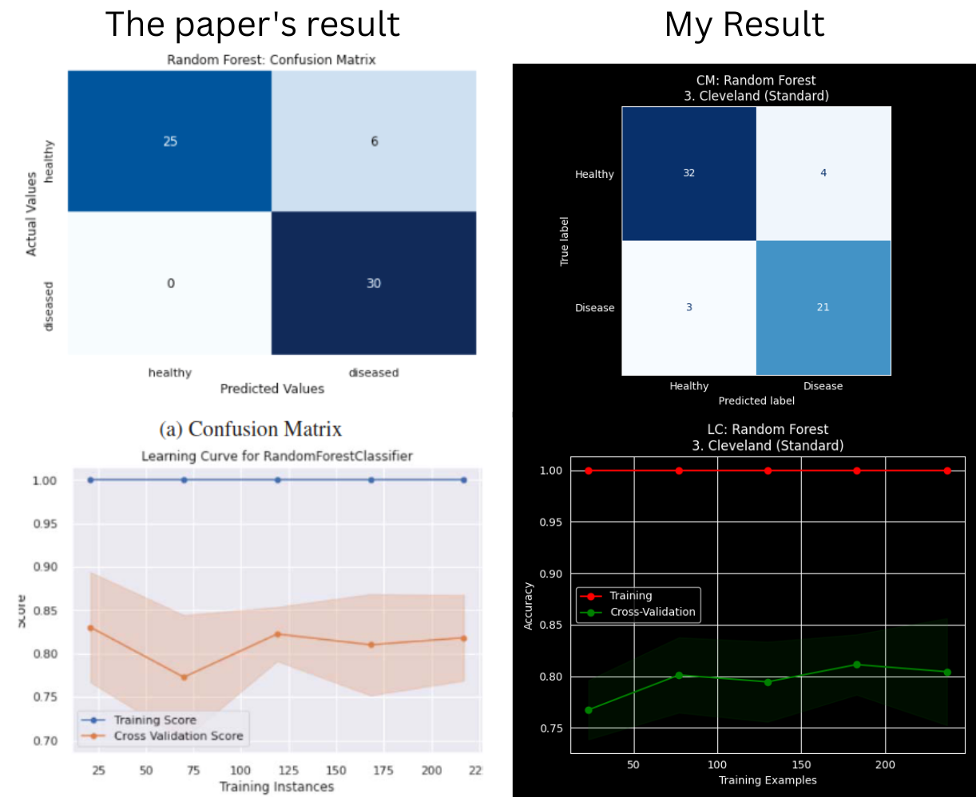

The Bigger Kaggle Dataset:
The Kaggle dataset provided the best results due to its larger sample size (1,190 records). Random Forest claimed its title as the overall best model here. RF achieved a project-high 94.54% accuracy.
Model | Accuracy (%) | Precision (%) | Recall (%) | F1-Score (%)
Logistic Regression | 86.13 | 87.12 | 87.79 | 87.45
KNN | 88.66 | 87.14 | 93.13 | 90.04
SVM | 89.08 | 86.71 | 94.66 | 90.51
Naive Bayes | 85.71 | 86.47 | 87.79 | 87.12
Decision Tree | 90.34 | 93.55 | 88.55 | 90.98
Random Forest | 94.54 | 93.38 | 96.95 | 95.13
XGBoost | 92.86 | 92.54 | 94.66 | 93.58
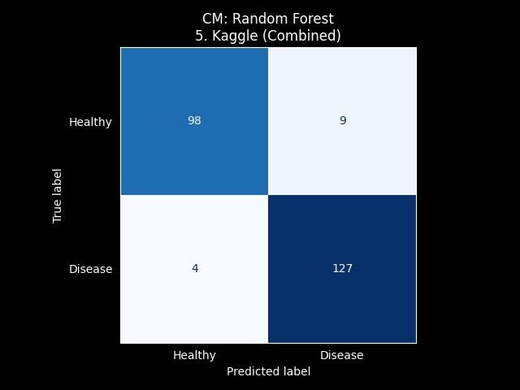

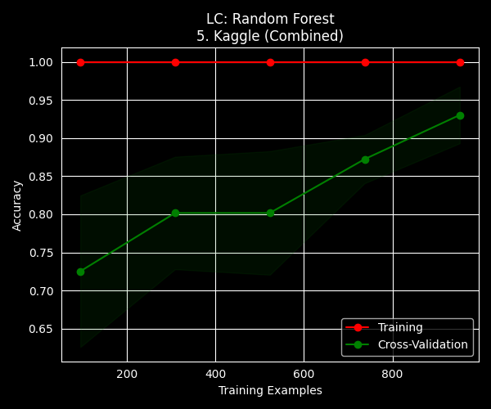
The worst accuracy: D1 - Hungarian (All dropped), Naive Bayes
This dataset represents the most aggressive form of data reduction, where all patients with missing values were removed and two columns (ca and thal) were deleted entirely. This resulted in a significantly smaller sample size, causing simpler probabilistic models like Naive Bayes to fail to find a meaningful pattern, leading to the lowest accuracy recorded in the entire study (47.37%).
Model | Accuracy (%) | Precision (%) | Recall (%) | F1-Score (%)
Logistic Regression | 73.68 | 73.33 | 91.67 | 81.48
KNN | 78.95 | 78.57 | 91.67 | 84.62
SVM | 78.95 | 75.00 | 100.00 | 85.71
Naive Bayes | 47.37 | 100.00 | 16.67 | 28.57
Decision Tree | 78.95 | 83.33 | 83.33 | 83.33
Random Forest | 73.68 | 73.33 | 91.67 | 81.48
XGBoost | 63.16 | 64.71 | 91.67 | 75.86

Overall Accuracy Heatmap:
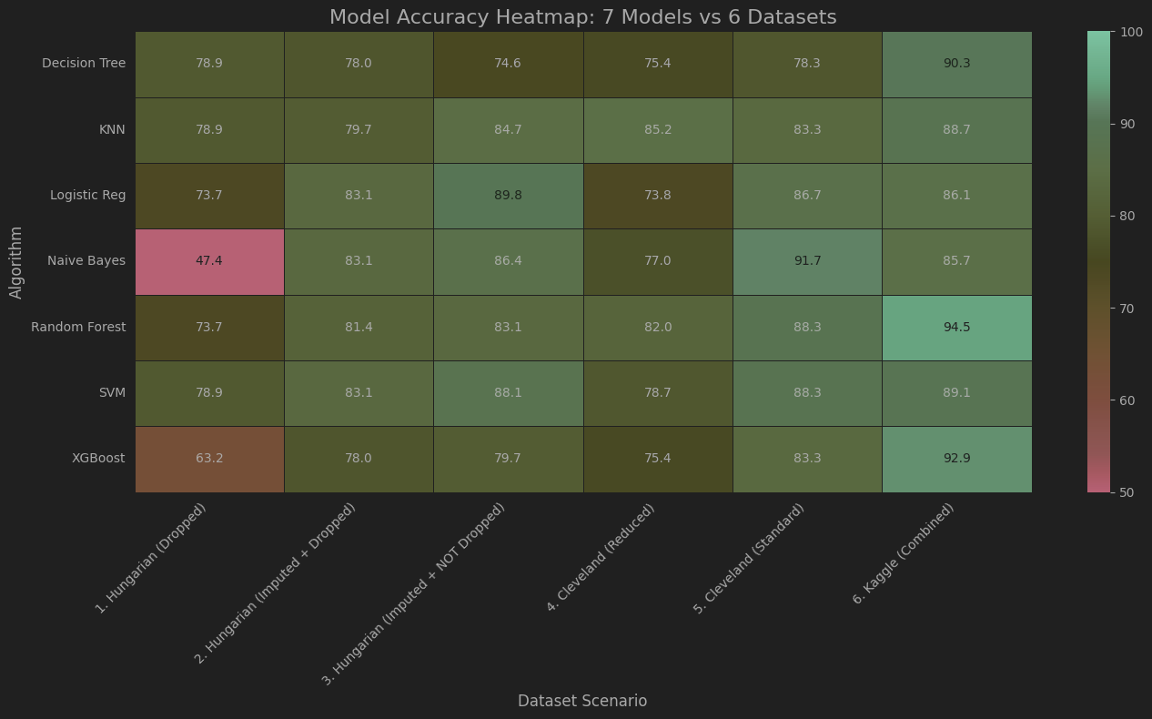
Implementation Details
The source code, datasets, some images, the notebook, and a demo web app are hosted on GitHub.
GitHub Link: https://github.com/Beytullahp42/HeartDiseasePrediction-ML
Repository Structure:
- 42x4.ipynb: The primary research notebook containing the comprehensive experimental loop for all model-dataset combinations
- app.py: The Flask backend that serves model predictions via a RESTful API to the frontend.
- index.html: The web interface for the system prototype.
- train_model.py: A script to train the final Random Forest model on the Kaggle dataset and export it as a model file.
- images/: A directory containing some generated Confusion Matrices and Learning Curves used in this report.
- requirements.txt: A list of all necessary Python libraries.

How to Run the Project Locally
To execute the project on a local machine, follow these steps:
- Clone the Repository:
$ git clone https://github.com/Beytullahp42/HeartDiseasePrediction-ML
$ cd HeartDiseasePrediction-ML
- Ensure Python 3.12 is installed, then create and activate a virtual environment:
$ python3 -m venv venv
$ source venv/bin/activate
- Install Dependencies:
$ pip install -r requirements.txt
- Examine or run the “42x4.ipynb” Jupyter Notebook
- Launch the Web Application: Start the Flask server and navigate to the local host address provided by Flask. (The existing model should be imported from GitHub. If not, the “app.py” script should check the existence of the model, and if the model doesn’t exist, it should run the “train_model.py” script to create the model.)
$ python app.py

Conclusion: This project implements a framework for heart disease prediction, directly reproducing the methodology of Sahoo et al. while extending the research through multi-dataset stress testing and real-world deployment.
Key Findings and Model Performance
Validation of the Original Study: The reproduction on the Cleveland Standard dataset (D5) confirmed the effectiveness of supervised learning, with Naive Bayes and Random Forest achieving high accuracies of 91.67% and 88.33%, respectively. This closely aligns with the paper's reported champion, Random Forest at 90.16%.
Scalability on Big Data: The transition to the larger Kaggle dataset (D6) demonstrated that model reliability scales with data volume. On this 1,190-record set, Random Forest reached a project-high 94.54% accuracy with a high Recall score, proving its suitability for critical healthcare diagnostics.
Data Strategy Insights: The Hungarian dataset experiments (D1–D3) provided a vital lesson in data engineering: imputation is superior to deletion. Retaining high-missingness features like ca and thal through mean imputation improved performance by nearly 16% compared to dropping them, proving these "super-features" contain essential biological signals even when sparse.
Limitations: While the models performed exceptionally well, the high variance observed in the Cleveland dataset's learning curves suggests that results are still sensitive to smaller patient samples.
In conclusion, the integration of advanced algorithms like XGBoost and Random Forest with robust preprocessing strategies provides a reliable foundation for heart disease prediction. The success of the 94.54% accurate Kaggle model in the web application environment justifies the authors' vision of reducing hospital burdens by providing patients with accurate, early-stage cardiac risk assessments at home.

