RTEU COMPUTER ENGINEERING DEPARTMENT
CEN322-Internet of Things Final Report

This report contains 2 parts. Each part is worth 50 points, totaling 100 points. Good luck.

Question No | Part1 | Part2 | TOTAL
Points | 50 | 50 | 100

OVERALL EVALUATION
Part No | Topic | LO | Max Points | Earned Points
1 | IoT System Architecture and Hardware–Software Components | LO.1, LO.2 | 50
2 | ESP32-S3 Based System Design and Wireless Sensor Integration | LO.1, LO.2 | 50
TOTAL |  |  | 100

Project Assignment Format

Cover Page
- Project Title
- Student's Name and Surname
- Student Number
- Date

Table of Contents
- Introduction
- Project Description and Objectives
- Methods and Materials Used
- Arduino Codes and Explanations
- Results and Discussion
- Conclusion
- Appendices (if any)
- References



RECEP TAYYIP ERDOGAN UNIVERSITY
FACULTY OF ENGINEERING AND ARCHITECTURE
COMPUTER ENGINEERING DEPARTMENT

CEN322 – Internet of Things
2025-2026 Spring

Project Title
Local LLM - Powered Voice First Aid Assistant
Due Date
02.06.2026

Student Name- Surname
Beyza Aydın
Ahmet Bera Çelik

Student No
221401054
221401014

Instructor
Asst. Prof. Dr. Yıldıran Yılmaz

RIZE
2026

🔹 PART 1 – SYSTEM EXPLANATION (LO1 – 50%)

1. Introduction
We built an offline voice assistant for basic first-aid help as our CEN322 IoT project. The ESP32-S3 board records speech with an INMP441 microphone, reads heart rate and SpO₂ from a MAX30102 when the user puts a finger on the sensor, and drives an 8-LED NeoPixel ring to show what the system is doing. A PC connected by USB serial does the heavy work: Faster-Whisper turns speech into text, Llama 3.2 (through Ollama) writes a short answer, and Piper TTS sends audio back so a MAX98357A module can play it on a small speaker. Nothing in this chain needs Wi‑Fi or the internet; everything runs on our own machine and the board on the desk.

We picked this because in a real emergency people often panic and do not remember simple steps like pressure on a wound or calling emergency services. Phone apps that use the cloud need a good connection, take time, and are not ideal when someone is talking about an injury or health problem. Our setup is meant for a classroom demo: you describe what happened in English, optionally get vitals from the sensor, and hear a short reply in a few seconds. We are not building a hospital device—the README and the AI prompt both say to call real emergency services and that this is only general information for the course.

We chose this topic because it let us use real hardware (I2S mic and speaker, I2C pulse oximeter, LEDs) and still try local AI without paying for APIs. The ESP32-S3 DevKit we have has no extra PSRAM, so running Whisper or a big language model on the chip was not realistic; splitting the job between the board and the PC matched the assignment and what we had at home (a laptop with a GPU for Ollama). We also wanted to practice a proper serial protocol with sync bytes and CRC, and to have something we could wire on a breadboard and show working end to end in class.

2. Project Description and Objectives
Our CEN322 project is a fully local voice first-aid assistant built around an ESP32-S3 board and a laptop on the same desk. The microcontroller captures speech with an INMP441 I2S microphone, can estimate heart rate and blood oxygen from a MAX30102 when the user places a finger on the sensor, and uses an eight-LED WS2812B NeoPixel ring to show whether the system is idle, recording, processing, or playing back an answer. A MAX98357A amplifier drives a small 4 Ω speaker so the user hears the reply on the device itself. The heavy work does not run on the ESP32: our DevKitM-1 has no extra PSRAM, so recorded audio is sent to the PC over a high-speed USB–serial UART link in encrypted frames. On the computer, Faster-Whisper turns the recording into English text, Llama 3.2 (via local Ollama) writes a short first-aid response, and Piper TTS converts that text back into speech that streams to the board for playback. Recording is started and stopped from a Python GUI on the PC, not with a wake word or fixed commands like “turn on the light.” The user describes what happened in plain English; the model answers with general first-aid steps only. The README and the AI system prompt both state that this is an academic classroom demo, not a hospital device, and that real emergencies require calling professional emergency services.

The hardware side includes an ESP32-S3-DevKitM-1-N8 as the main controller, the INMP441 microphone, the MAX98357A and speaker for output, the MAX30102 pulse oximeter on I2C, and the NeoPixel ring for status. The PC is part of the system: it runs the graphical interface and all AI modules. We wired the modules on a breadboard using the pin map from our design notes (for example microphone on GPIO 2, 41, 42; amplifier on 5, 6, 7; sensor on I2C pins 8 and 9; NeoPixel data on GPIO 38). On the software side, firmware is written in ESP-IDF with FreeRTOS tasks for audio capture and playback, sensor sampling, LED patterns, and UART protocol handling. The link uses a binary frame format with a sync word and CRC16; audio and sensor payloads are AES-encrypted as required by the course. The PC application connects over serial, offers a “Read vitals” step before or during the demo, and runs the pipeline from speech-to-text through the local language model to text-to-speech.

Our goals were chosen to match what we could actually demonstrate, not a template wake-word demo. First, everything must work without Wi‑Fi or cloud APIs: inference stays on the ESP32 plus the local PC. Second, we wanted a complete path from spoken description to spoken answer in English within a few seconds after the user stops recording, so a classroom audience can see it work once. Third, the serial link and audio path had to be stable enough for demo day—correct sample rate, no garbled playback, and vitals that at least look reasonable when the finger is on the sensor. Fourth, the user should always see what the system is doing, through LED colours and the GUI transcript. Fifth, we kept safety limits in the prompt: no drug doses, no firm diagnosis, and a reminder to call emergency services. Wake-word detection on the chip and a larger medical knowledge base were in our original plan but left as future work; the submitted system is the button/GUI-triggered, LLM-based first-aid assistant described above.

3. System Architecture

3.1 Overall IoT Architecture (Offline)
Our project is an offline IoT setup built from two cooperating parts on the same desk, not a single chip that does everything. The device layer is the ESP32-S3-DevKitM-1-N8 with the INMP441 microphone, the MAX98357A amplifier and small speaker, the MAX30102 pulse oximeter, and the eight-LED WS2812B ring. That board handles real-time jobs: sampling audio when the PC asks, reading vitals from the finger sensor, showing state on the LEDs, and playing back the answer. We do not use Wi-Fi, MQTT, or any cloud service for the application, so there is no network layer in the usual IoT sense. The link between the “thing” and the “brain” is only a USB–UART serial cable at 921600 baud; the laptop acts as a local edge gateway on the desk. The application logic is split. On the ESP32 we run audio in and out, sensor sampling, LED patterns, a state machine, and a framed protocol with CRC and AES on audio and sensor data. On the PC we run the GUI plus Faster-Whisper, Ollama with Llama 3.2, and Piper TTS. Recording starts and stops from the PC application, not from a wake word on the microcontroller.
Block diagram:
PC GUI (Connect, Read vitals, Start/Stop record) → ESP32-S3 (state machine + NeoPixel status) ← INMP441 (I2S audio in) ← MAX30102 (I2C vitals) → ESP32 → AES-framed UART ↑ → PC → [on Stop] Faster-Whisper → text → Ollama / Llama 3.2 → first-aid reply → Piper TTS → PCM → AES-framed UART ↓ → ESP32 → MAX98357A (I2S) → speaker; NeoPixel follows idle → recording → processing → speaking → idle. There is no continuous keyword spotting and no comparison with stored command templates on the chip.

3.2 Hardware Explanation
The ESP32-S3 is the field device. It captures voice through the INMP441 on I2S at 16 kHz mono and sends encrypted audio chunks to the PC while recording. It does not run TensorFlow Lite, Whisper, or the language model. When the PC sends synthesized speech back, the firmware queues the chunks and drives the MAX98357A on a second I2S bus; we use the stereo 32-bit slot format the ESP-IDF driver needs so playback is not too fast or distorted. The MAX30102 on I2C provides raw PPG data; our firmware computes heart rate and SpO₂ estimates in software and can send them in encrypted sensor frames, usually after the user presses “Read vitals” in the GUI. The NeoPixel ring on GPIO 38 shows whether the system is idle, recording, thinking, or speaking. We chose the INMP441 because digital I2S audio is cleaner on a breadboard than an analog mic, the MAX98357A because it takes I2S directly without a separate DAC, and the pulse oximeter so the PC model can mention vitals carefully in its reply. Our DevKitM-1-N8 has no extra PSRAM, so large AI models cannot run on the chip; that is why the ESP32 stays an I/O and protocol node and the PC does the heavy inference. No Wi-Fi is needed for normal operation. Power for the amplifier and LEDs comes from 5 V on the USB bus; the microphone and sensor use 3.3 V.

3.3 Software Explanation
We developed the firmware with ESP-IDF (approved by the instructor), not Arduino IDE. FreeRTOS tasks handle UART receive and transmit, microphone capture during recording, playback from a queue, sensor reads, LED animations, and periodic heartbeat frames. The main code uses a state machine with IDLE, RECORDING, PROCESSING, SPEAKING, and ERROR. Messages on the wire use sync bytes 0xAA and 0x55, length, type, payload, and CRC16; audio and sensor payloads are AES-256-CBC encrypted as required by the course. On the PC we use Python 3 with a Tkinter GUI, pyserial at 921600 baud, faster-whisper for offline speech-to-text, a local HTTP call to Ollama for Llama 3.2, and piper-tts for offline speech synthesis, with pycryptodomex matching the firmware crypto. We do not use network libraries for the demo path. During development we often use two USB ports on the board: one UART bridge for the binary protocol to the GUI and a separate USB-serial-JTAG port only for monitor logs, so debug text does not break the data stream. When the user stops recording, the PC transcribes the buffer, builds a prompt with the last valid vitals if any, gets a short English reply, synthesises audio, and sends it down in real-time chunks so the ESP32 playback queue does not overflow.

3.4 Network and Communication
The system is completely offline for grading and classroom demo: no API keys, no cloud STT or LLM, and the ESP32 radio is not used for the application. The only communication between device and computer is the high-speed UART binary protocol over USB. All speech recognition, language-model inference, and text-to-speech run on the local PC; Ollama listens on localhost and models are stored on disk. The ESP32 never performs command template matching or wake-word detection. Open-vocabulary English is understood on the PC after recording ends. That split matches the assignment idea that processing may run on the ESP32-S3 or on a local PC, and it matches our hardware limits while still delivering a full voice first-aid demonstration.

🔹 PART 2 – DESIGN & IMPLEMENTATION (LO2 – 50%)

4. Materials and Tools Used
For this project we used only components we already had for the course breadboard setup, plus a laptop as the local AI host. Everything was wired on a 400-point breadboard; no custom PCB was made. The list below matches what we actually built and demonstrated, not the generic wake-word template.

4.1 Hardware
The table lists each physical part, the model we used, and how many we needed. The ESP32 board is the DevKitM-1-N8 variant (8 MB flash, no extra PSRAM), which is why heavy models run on the PC. We use an eight-LED NeoPixel ring for status, not a single red LED. The MAX30102 is included because vitals are part of our first-aid flow.
Component | Model / specification | Qty.
Microcontroller board | ESP32-S3-DevKitM-1-N8 (ESP32-S3, 8 MB flash, no PSRAM) | 1
I2S digital microphone | INMP441 MEMS module | 1
I2S Class-D amplifier | MAX98357A breakout | 1
Speaker | 4 Ω, 3 W, ~40 mm (BTL to amplifier + and −) | 1
Pulse oximeter module | MAX30102 (GY-style breakout, I2C) | 1
Status LEDs | WS2812B × 8 NeoPixel ring | 1
Series resistor (NeoPixel data) | 330 Ω (220–470 Ω acceptable) | 1
Breadboard | 400 tie-points | 1
Jumper wires | Male–male / male–female, as needed | —
USB cables | UART/flash + native USB (data + log ports on DevKit) | 2
Host computer | Laptop (GPU used for Faster-Whisper / Ollama in practice) | 1
We powered the microphone and MAX30102 from 3.3 V and the amplifier and NeoPixel from 5 V (VBUS). A small logic-level converter (BSS138, 4-channel) was available in our kit but we did not use it on the NeoPixel data line because it is too slow for WS2812 timing; the ring is driven directly from GPIO 38 as in our wiring notes. Optional parts mentioned in our design report (Schottky diode on NeoPixel 5 V, extra bulk capacitor on the LED supply) can improve stability but were not always required for the demo to work.

4.2 Software
On the microcontroller we used Espressif ESP-IDF (v5.5.x), built and flashed with idf.py from the firmware/ folder, usually with VS Code and the ESP-IDF extension. The firmware uses the standard ESP-IDF drivers for I2S, I2C, UART, and RMT (NeoPixel), plus mbedtls for AES-256-CBC on protocol payloads. We did not use Arduino IDE or TensorFlow Lite Micro in the submitted system; wake-word training was left as future work.
On the PC we used Python 3 in a virtual environment under pc/. Main packages are pyserial for the UART bridge, faster-whisper for offline speech-to-text, requests to call Ollama on localhost, piper-tts for offline speech synthesis, and pycryptodomex for AES matching the ESP32. The user interface is Tkinter (gui.py). Models are stored locally (for example Faster-Whisper small.en and a Piper English voice under pc/models/). Ollama runs Llama 3.2 3B (ollama pull llama3.2:3b) with no API keys. We do not use cloud STT, cloud LLM, or MQTT/Wi-Fi libraries in the application path. For testing we also used small helper scripts (for example TTS smoke tests and a raw UART sniffer), but the graded demo is gui.py plus the ESP-IDF firmware.
Tools for development included idf.py build flash on the UART port, idf.py monitor on the USB-serial-JTAG port for logs, Git for version control, and Audacity or similar only informally to check microphone recordings during bring-up. No online services are required during a classroom run once models and Ollama are installed on the laptop.

5. Circuit Design
We designed the circuit in Wokwi and the live project link is provided in the submitted wokwi/project_link.txt. A screenshot of the simulation is shown in Figure 5.1. Because Wokwi does not have dedicated library parts for the INMP441, MAX98357A, or MAX30102, we used stand-in components that preserve the correct GPIO connections: a slide potentiometer represents the INMP441 microphone data line, a buzzer represents the speaker and amplifier output, and an MPU6050 module represents the MAX30102 pulse oximeter on the I2C bus. The ESP32-S3-DevKitC-1 is used in the simulator because the DevKitM-1 variant is not available in the Wokwi library; the GPIO numbers and code are identical between the two. The NeoPixel ring is the only part that simulates correctly in Wokwi, and the sketch.ino file drives it through the same GPIO 38 pin used on the physical breadboard.
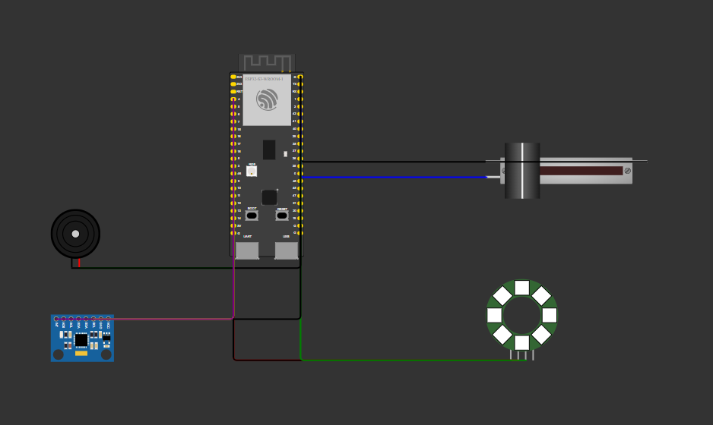
Figure 5.1 — Wokwi circuit diagram
The pin connections below match our firmware (firmware/main/config.h) and the physical breadboard exactly. They differ from the assignment template because our system uses two separate I2S buses (one for the microphone, one for the amplifier), a pulse oximeter instead of a single LED, and a NeoPixel ring for status.

ESP32-S3 Pin | Component / Signal | Description
3.3 V | INMP441 VDD | Microphone supply
GND | INMP441 GND | Common ground
GND | INMP441 L/R | Left channel select (never left floating)
GPIO 2 | INMP441 SD | I2S data from microphone
GPIO 41 | INMP441 SCK | I2S bit clock
GPIO 42 | INMP441 WS | I2S word select
5 V (VBUS) | MAX98357A VIN | Amplifier supply
GND | MAX98357A GND | Common ground
GPIO 5 | MAX98357A BCLK | I2S bit clock to amplifier
GPIO 6 | MAX98357A LRC | I2S word select
GPIO 7 | MAX98357A DIN | I2S data to amplifier
GPIO 10 | MAX98357A SD | Soft mute / shutdown control
MAX98357A OUT+ / OUT− | Speaker terminals | BTL output (neither terminal to GND)
3.3 V | MAX30102 VIN | Sensor supply
GND | MAX30102 GND | Common ground
GPIO 8 | MAX30102 SDA | I2C data
GPIO 9 | MAX30102 SCL | I2C clock
GPIO 4 | MAX30102 INT | Data-ready interrupt
5 V (VBUS) | WS2812B VCC | NeoPixel ring supply
GND | WS2812B GND | Common ground
GPIO 38 | WS2812B DIN (via 330 Ω) | NeoPixel data
The microphone and amplifier use two independent I2S buses so that recording and playback can be configured separately at 16 kHz. The MAX98357A does not share clock lines with the INMP441. Power for the amplifier and NeoPixel ring comes from the 5 V VBUS pin; the microphone and sensor are powered from 3.3 V. No wake word detection or pre-recorded audio clips in flash are used; the ESP32 streams microphone audio to the PC and plays back TTS audio received from the PC over UART.
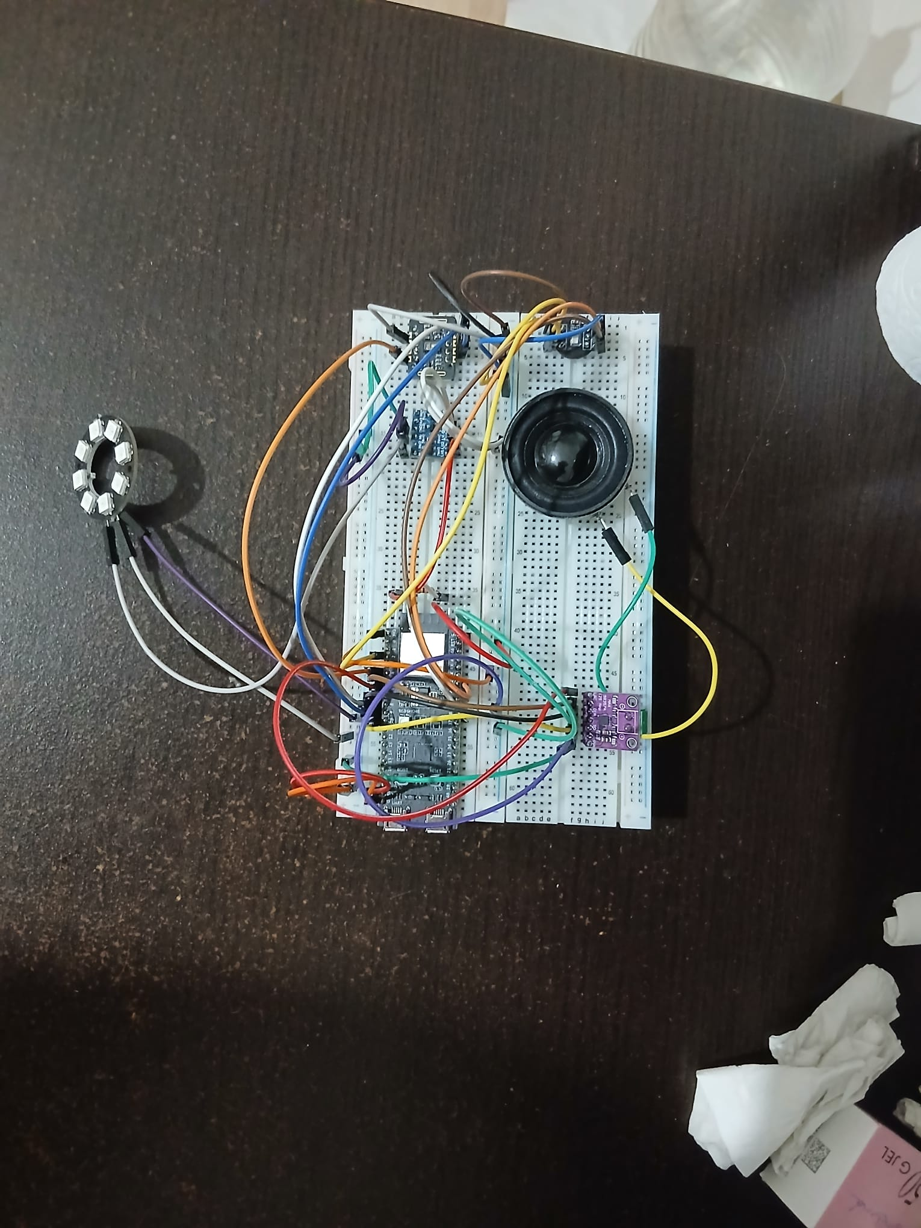

Figure 5.2 — Physical prototype

6. Arduino Codes and Explanation
The assignment template refers to “Arduino code,” but our working firmware is an ESP-IDF project in the firmware/ folder (with the instructor’s approval). We do not use setup() / loop() or TensorFlow Lite wakeword code on the chip. Instead, app_main() starts FreeRTOS tasks, and the PC application in pc/gui.py runs the speech and language models. The snippets below are taken from our real project; line numbers may shift slightly in the repository, but the logic is the same.

6.1 Program Structure
On the ESP32, app_main() replaces setup(). It initialises NVS, the state machine, the protocol parser, AES crypto, I2S for the INMP441 and MAX98357A, I2C for the MAX30102, the NeoPixel driver, and UART to the PC. It then creates tasks for UART transmit and receive, microphone capture, sensor updates during recording, audio playback from a queue, LED animation, heartbeat frames, and error recovery. There is no loop(); each task runs forever with short delays.

When the PC sends MSG_START_RECORD, the firmware moves from IDLE to RECORDING, starts the microphone task streaming encrypted AUDIO_UP chunks, and sets the NeoPixel to the recording pattern. MSG_STOP_RECORD stops capture and sets PROCESSING while the PC runs Whisper, Llama, and Piper. Incoming AUDIO_DOWN frames are decrypted and queued; the first chunk switches the state to SPEAKING and starts I2S output. After PLAYBACK_END, playback stops and the system returns to IDLE. A separate path handles MSG_READ_SENSOR when the user measures vitals from the GUI.

On the PC, the Tkinter app connects to the serial port, waits for a crypto-capability frame, and pre-warms Whisper in a background thread. “Start recording” and “Stop and analyze” map to the same start/stop commands. The analyse step runs in a worker thread: stop recording and collect PCM, transcribe, call Ollama with the last valid vitals, stream Piper audio to the ESP32 at real-time pacing, then send playback end.

6.2 Code Snippet Examples
Example 1 — PC commands start and stop recording (ESP32, C)
static void start_recording(void)
{
if (fsm_get_state() != STATE_IDLE) {
return;
}
fsm_set_state(STATE_RECORDING);
audio_in_start();
led_strip_set_pattern(STATE_RECORDING);
send_status(STATE_RECORDING, 0);
}

static void on_frame_received(uint8_t type, const uint8_t *payload, size_t len, void *ctx)
{
switch (type) {
case MSG_START_RECORD:
start_recording();
break;
case MSG_STOP_RECORD:
stop_recording();
break;
/* ... AUDIO_DOWN, PLAYBACK_END, etc. ... */
}
}
What it does: The ESP32 does not listen for a wake word. Recording begins only when the PC sends a protocol command. The state machine and LEDs stay in sync with the GUI.
Why it is needed: Our board has no push-to-talk button in the final demo; the PC is the user interface. This also keeps all speech understanding on the laptop where Whisper and Llama can run.

Example 2 — Streaming microphone data to the PC (ESP32, C)
static void task_audio_in(void *arg)
{
int16_t samples[AUDIO_CHUNK_SAMPLES];
while (1) {
if (fsm_get_state() == STATE_RECORDING) {
size_t got = 0;
if (audio_in_read_chunk(samples, AUDIO_CHUNK_SAMPLES, &got) == ESP_OK && got > 0) {
queue_frame(MSG_AUDIO_UP, (uint8_t *)samples, got * sizeof(int16_t), true);
}
}
vTaskDelay(pdMS_TO_TICKS(5));
}
}
What it does: While RECORDING is active, the task reads 16 kHz mono PCM from the INMP441 in small chunks, encrypts them, and enqueues framed messages for UART transmit.
Why it is needed: The ESP32 cannot run Whisper locally; it must ship audio to the PC quickly and steadily so the full utterance is available after the user presses Stop.

Example 3 — Framed protocol with CRC (shared idea, C on device)
esp_err_t protocol_frame_pack(uint8_t type, const uint8_t *payload, size_t payload_len,
uint8_t *out, size_t out_cap, size_t *out_len)
{
out[0] = PROTO_SYNC0; /* 0xAA */
out[1] = PROTO_SYNC1; /* 0x55 */
out[2] = (payload_len >> 8) & 0xFF;
out[3] = payload_len & 0xFF;
out[4] = type;
memcpy(out + 5, payload, payload_len);
uint16_t crc = protocol_crc16(out + 4, 1 + payload_len);
/* append CRC16 big-endian */
...
}
What it does: Every message has a fixed sync word, length, type byte, payload, and CRC16-CCITT so the PC and ESP32 stay aligned even if bytes are lost briefly.
Why it is needed: Raw serial bytes would be fragile at 921600 baud with audio traffic. Framing is part of a reliable course demo and works together with AES on audio and sensor payloads.

Example 4 — Full local pipeline on the PC (Python)
def work() -> None:
pcm = self.bridge.stop_recording()
vitals = self._measured_vitals if self._measured_vitals.valid else self.bridge.last_vitals()
text = stt.transcribe(pcm) or "I need first aid help"
reply = llm.generate(text, vitals)
for chunk in tts.synthesize_stream(reply):
self.bridge.send_audio_down(chunk)
self.bridge.send_playback_end()

What it does: After recording stops, the PC transcribes English speech with Faster-Whisper, asks Llama 3.2 through local Ollama for a short first-aid reply (using stored vitals if available), synthesises speech with Piper, and sends audio back to the ESP32 for the MAX98357A.
Why it is needed: This is the core “intelligence” of the project. It replaces template ideas such as energy-based command matching and pre-recorded “light on” clips in flash. The system understands open descriptions (“heavy bleeding,” “choking”) instead of only three fixed commands.

What we do not implement (template vs our project)
We do not load a TFLite wake-word model, record a fixed two seconds after “Hey Assistant,” or play canned responses from PROGMEM. That design would fit a simple light switch; our goal is an offline first-aid voice assistant with an LLM on the PC. Wake-word on the ESP32 remains possible future work (Edge Impulse) but is not in the submitted firmware.
Submission note for LMS: Submit the firmware/ ESP-IDF project and pc/Python sources as required by the instructor; mention in the report that ESP-IDF was used instead of a single .ino file. Optional: include a short wokwi/sketch.ino only for the simulator, while grading follows firmware/main/main.c and pc/gui.py.

7. Results and Discussion
In our tests the system works end-to-end for the course demo. After connecting the PC GUI to the ESP32 UART port, we can read vitals with a finger on the MAX30102, start recording in English, stop and analyse, and hear a short first-aid reply on the speaker within a few seconds. The NeoPixel ring changes colour for idle, recording, processing, and speaking, which made it easy to show the state to the class. We did not implement "Hey Assistant" or wake-word detection on the chip; recording is started from the PC, so our success criterion is reliable GUI-driven capture and playback, not keyword accuracy above 85%. In a quiet room, Whisper usually produced a sensible transcript for clear speech; when the user mumbled or spoke very quietly, the text was sometimes wrong and the LLM still answered with general safe advice because of the system prompt. That was acceptable for an academic prototype but not for a real emergency product.
The INMP441 gives clean 16 kHz mono I2S data once wiring and sample rate were correct. We initially tried a higher sample rate and the playback path sounded wrong until we fixed 16 kHz and the stereo 32-bit slot format on the MAX98357A output. Sensor data is more nuanced. The MAX30102 raw FIFO readings are real, but our current firmware estimates heart rate and SpO₂ with a simplified placeholder calculation (modulo-based approximation), not a calibrated PPG peak-detection algorithm. The displayed values are reasonable-looking demo numbers; they respond to the presence of a finger on the sensor but should not be treated as medically accurate. We pass them to the LLM with an explicit note in the prompt that they are estimates for demonstration only. Proper PPG analysis (peak detection, red/IR ratio for SpO₂) is listed as future work. So the sensor is useful for demonstrating that vitals can be part of the first-aid flow, but we do not claim clinical accuracy for the submitted firmware.
There are no network issues in the IoT sense because we do not use Wi-Fi, MQTT, or cloud APIs during operation. The only link is USB–serial at 921600 baud between the board and the laptop. Ollama runs on localhost; Whisper and Piper use local model files. The practical "connection" problems were serial-port related: choosing the correct COM port (data UART vs USB-JTAG log port), occasional need to reconnect after reflashing, and making sure the binary stream was not mixed with monitor logs on the same port. Once we used the CP210x data port for the GUI and the separate JTAG port only for idf.py monitor, communication was stable for demo runs.
Several engineering problems appeared during development. First, we tried USB-OTG CDC for PC communication, but on Windows reads failed with a generic CDC error, so we moved the protocol to UART through the on-board USB–UART bridge. That was a major architectural change but made the demo reliable. Second, audio playback sometimes sounded like chipmunk speech or went silent until we standardised on 16 kHz and the correct I2S TX format for the amplifier. Third, when the PC sent TTS audio too fast, the ESP32 playback queue overflowed and chunks were dropped; pacing sends at roughly real-time fixed that. Fourth, the DevKitM-1 has no PSRAM, which confirmed that Whisper and Llama must stay on the PC; we also saw high stack use in a heartbeat task and increased task stack size to stop resets after boot. Fifth, on the PC, GPU Whisper needed the cuBLAS DLL on PATH on Windows; without it the code fell back to CPU, which still worked but was slower. Sixth, for vitals we learned to measure before recording rather than trusting samples taken while the user is speaking away from the sensor. Seventh, the NeoPixel ring was sometimes unstable at 5 V logic levels; we drove data from 3.3 V GPIO with limited brightness, which was enough for status indication.
We solved these issues in the firmware and PC code that we submitted, not with wake-word muting or flash-stored PCM phrases. Command understanding is not amplitude thresholding on the ESP32; it is open-vocabulary speech recognition and an LLM on the PC. Echo from the speaker into the microphone can still happen physically on the breadboard, but we do not record while the ESP32 is in the speaking state, which reduces the worst cases. For future work we could add on-device wake word (Edge Impulse / TFLite Micro), better acoustic isolation, calibrated SpO₂, or a small offline knowledge base (RAG) so answers are more repeatable. For CEN322, the current system meets our goal: a fully local, voice-based first-aid demonstration with real hardware, honest limits, and a stable classroom demo path.

8. Conclusion
We met the main objectives we set for this CEN322 project, even though the final system is not the simple wake-word light-switch example from the assignment template. We built a fully local voice first-aid assistant: the ESP32-S3 captures speech and sensor data, shows status on a NeoPixel ring, and plays answers on an I2S speaker, while a nearby PC runs Faster-Whisper, Llama 3.2 through Ollama, and Piper TTS with no cloud APIs or API keys. Recording and analysis are triggered from our GUI over a UART protocol with framing, CRC, and AES on audio and sensor payloads. In classroom tests we could connect, read plausible vitals when the finger was on the MAX30102, describe a situation in English, and hear a short, sensible first-aid reply within a few seconds. That satisfies our goal of an offline, demonstrable IoT edge device plus local PC “brain,” and it matches the course idea that processing may run on the ESP32-S3 or on a local computer. We were honest in the report and in the software that the device is an academic demo only, not a medical product.

We did not achieve wake-word detection on the microcontroller or recognition of three fixed commands like “turn on the light.” Those were in the original template but not in our submitted firmware. Splitting work between the board and the laptop because of missing PSRAM was a necessary design choice, not a failure. If we count success as a working end-to-end pipeline with real hardware and local AI, then yes, we achieved our objectives.

Several improvements are realistic for future semesters or extra time. On the ESP32, an Edge Impulse or TensorFlow Lite Micro model could add a wake word so recording does not depend on the PC buttons. The MAX30102 path could be calibrated against a reference oximeter and motion handling could be improved. On the PC, a small retrieval layer (RAG) over trusted first-aid text could make answers more consistent than prompt-only Llama output, while keeping everything offline. Audio quality could benefit from better mechanical layout (microphone farther from the speaker, shielding) and optional noise suppression before Whisper. For communication, we could revisit USB-CDC if driver issues are solved, or add a simple wireless link only if the course still allows fully local inference. A printed enclosure and clearer wiring would also help demo reliability.

Overall, the project taught us ESP-IDF multitasking, I2S and I2C peripherals, a binary device–PC protocol, and how to integrate modern local AI tools under tight hardware limits. We are satisfied with what we demonstrated in class; the next step would be polish and optional wake-word or knowledge-base features, not replacing the core idea of an offline voice first-aid assistant.

9. Appendices
Appendix A contains the complete embedded firmware as an ESP-IDF project in the firmware/ directory (source files under firmware/main/). We did not submit a single Arduino .ino file for the working system; ESP-IDF was used with instructor approval. Optional simulation code may appear under wokwi/.

Appendix B is the Wokwi circuit diagram. A screenshot is included in Section 5 (Figure 5.1). The live project link is: https://wokwi.com/projects/464462040095424513 (also in wokwi/project_link.txt).

Appendix C is the README file (README.md at the project root). It describes wiring, flashing the ESP32, installing the PC environment, running gui.py, and testing the end-to-end voice first-aid flow.

10. References
- https://github.com/Beyzaydinn/LifeLine
- https://wokwi.com/projects/464462040095424513

