VELTRIX SPORTS

Complete Project Documentation

Version: 1.0
Date: August 29, 2026
Status: Documentation Complete

TABLE OF CONTENTS
- 1. Project Overview
- 2. System Architecture
- 3. Database Design
- 4. API Documentation
- 5. Feature Specifications
- 6. Authentication Flow
- 7. Training Plan Module
- 8. Events Module
- 9. Ticketing Module
- 10. Payment Flow
- 11. Device Integration
- 12. Screen Navigation
- 13. Deployment Guide
- 14. Testing Strategy
- 15. Security Checklist
- 16. Performance Optimization
- 17. Team Workflow
- 18. Risk Assessment
- 19. Cost Breakdown
- 20. Diagrams Index

1. PROJECT OVERVIEW

1.1 Project Summary
Project Name | Veltrix Sports
Type | Coaching, Events & Ticketing Platform
Platforms | Android, iOS, Web
Timeline | 2-12 weeks (MVP to Full Product)
Team Size | 5-10 developers
Budget | ₹43,750 - ₹56,28,000

1.2 Three Core Verticals
Training Plan (B2B & B2C): Running, Cycling, Triathlon plans with AI generation and device sync
Events: Event listing, registration, ticketing, live tracking, and results
Ticketing Marketplace: Self-serve organizer, public marketplace, QR check-in, commission system

1.3 Technical Stack
Layer | Technology
Frontend | Flutter 3.41.9, Dart 3.11.5
State Management | BLoC
Navigation | GoRouter
Backend | Node.js/Express
Database | PostgreSQL (AWS RDS)
Cache | Redis (ElastiCache)
Payments | Razorpay

2. SYSTEM ARCHITECTURE
The system follows a layered architecture with the following components:
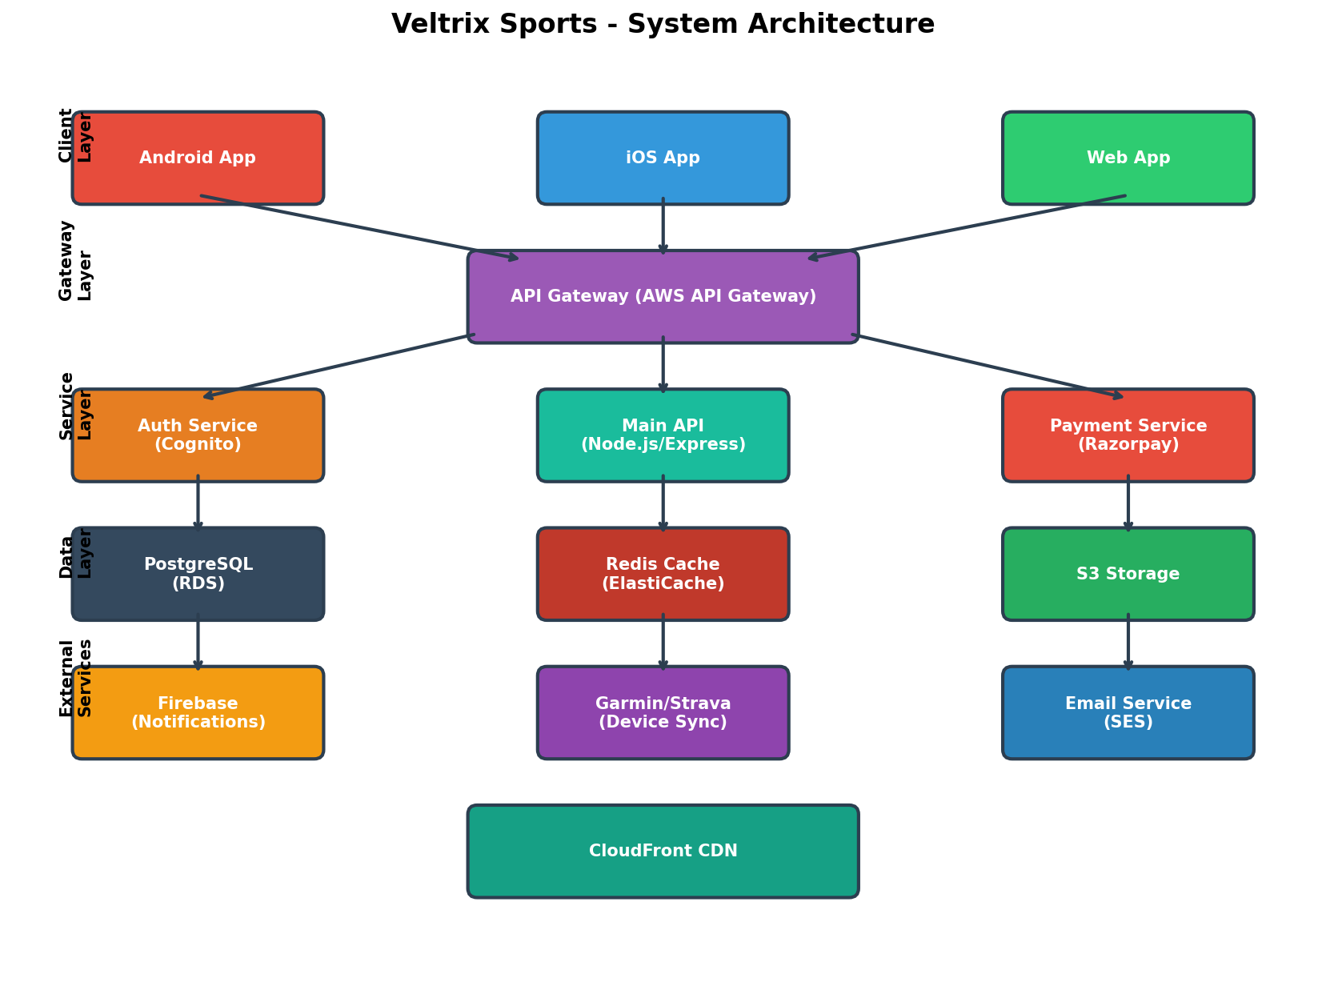

2.1 Architecture Layers
- Client Layer: Android App, iOS App, Web App (Flutter)
- Gateway Layer: AWS API Gateway with rate limiting
- Service Layer: Auth Service (Cognito), Main API (Node.js), Payment Service (Razorpay)
- Data Layer: PostgreSQL (RDS), Redis Cache (ElastiCache), S3 Storage
- External Services: Firebase (Notifications), Garmin/Strava (Device Sync), AWS SES (Email)

3. DATABASE DESIGN
The database consists of 24 tables with the following key entities:
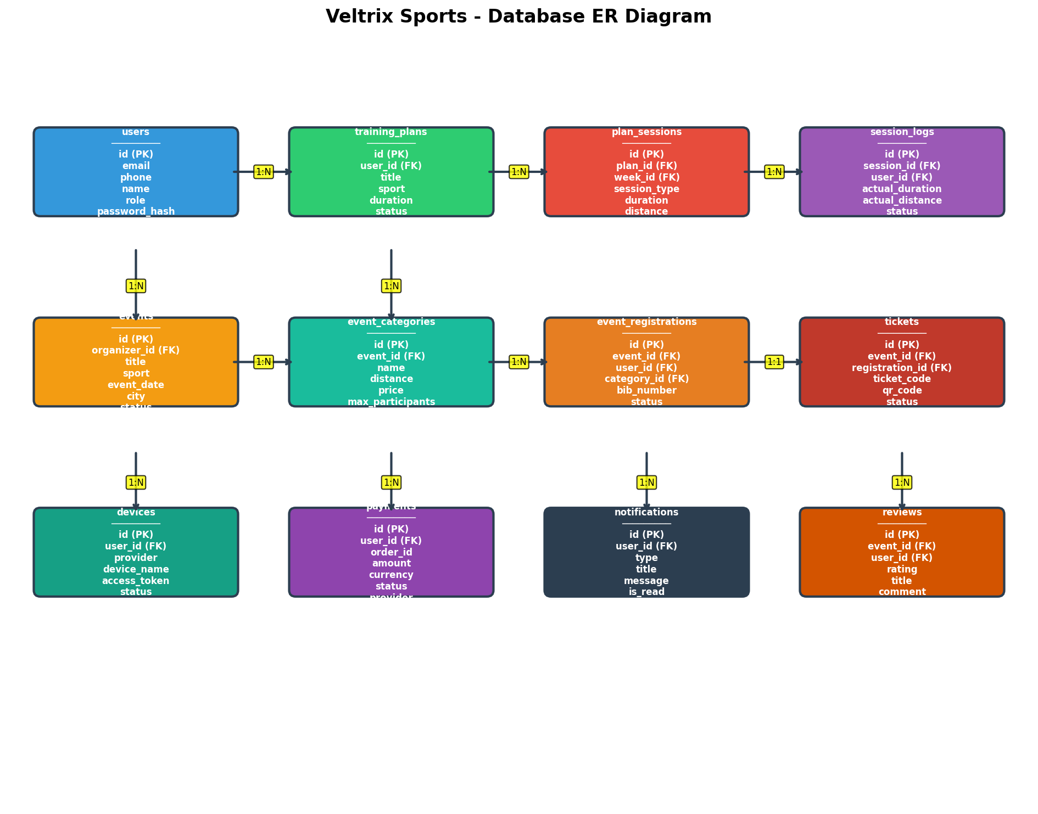

3.1 Core Tables
- users - User accounts and profiles
- training_plans - Workout plans
- plan_sessions - Individual workout sessions
- session_logs - Completed session records
- events - Sports events
- event_categories - Event types/distances
- event_registrations - Event signups
- tickets - Purchased tickets
- devices - Connected fitness devices
- payments - Transaction records
- notifications - User alerts
- reviews - Event ratings

4. API DOCUMENTATION
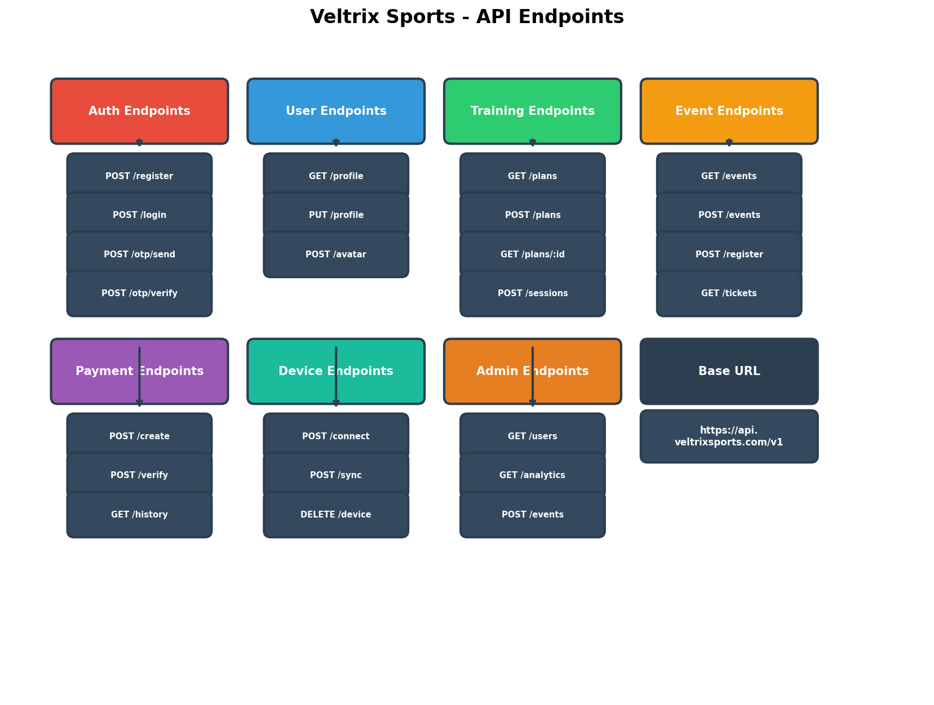

4.1 Base Configuration
- Base URL: https://api.veltrixsports.com/v1
- Protocol: HTTPS
- Format: JSON
- Authentication: Bearer Token (JWT)
- Timeout: 30 seconds
- Rate Limit: 100 requests/minute

4.2 Authentication Endpoints
- POST /auth/register - Register new user
- POST /auth/login - User login
- POST /auth/otp/send - Send OTP to phone
- POST /auth/otp/verify - Verify OTP
- POST /auth/refresh - Refresh JWT token
- POST /auth/forgot-password - Reset password

4.3 Training Plan Endpoints
- GET /plans - Get user plans
- POST /plans/generate - Create AI plan
- GET /plans/{planId} - Get plan details
- PUT /plans/{planId} - Update plan
- DELETE /plans/{planId} - Delete plan
- POST /sessions/{sessionId}/complete - Log session

4.4 Event Endpoints
- GET /events - List events
- GET /events/{eventId} - Get event details
- POST /events/{eventId}/register - Register for event
- GET /events/registrations - Get user registrations

4.5 Payment Endpoints
- POST /payments/create - Create payment order
- POST /payments/verify - Verify payment
- GET /payments - Get payment history

5. FEATURE SPECIFICATIONS
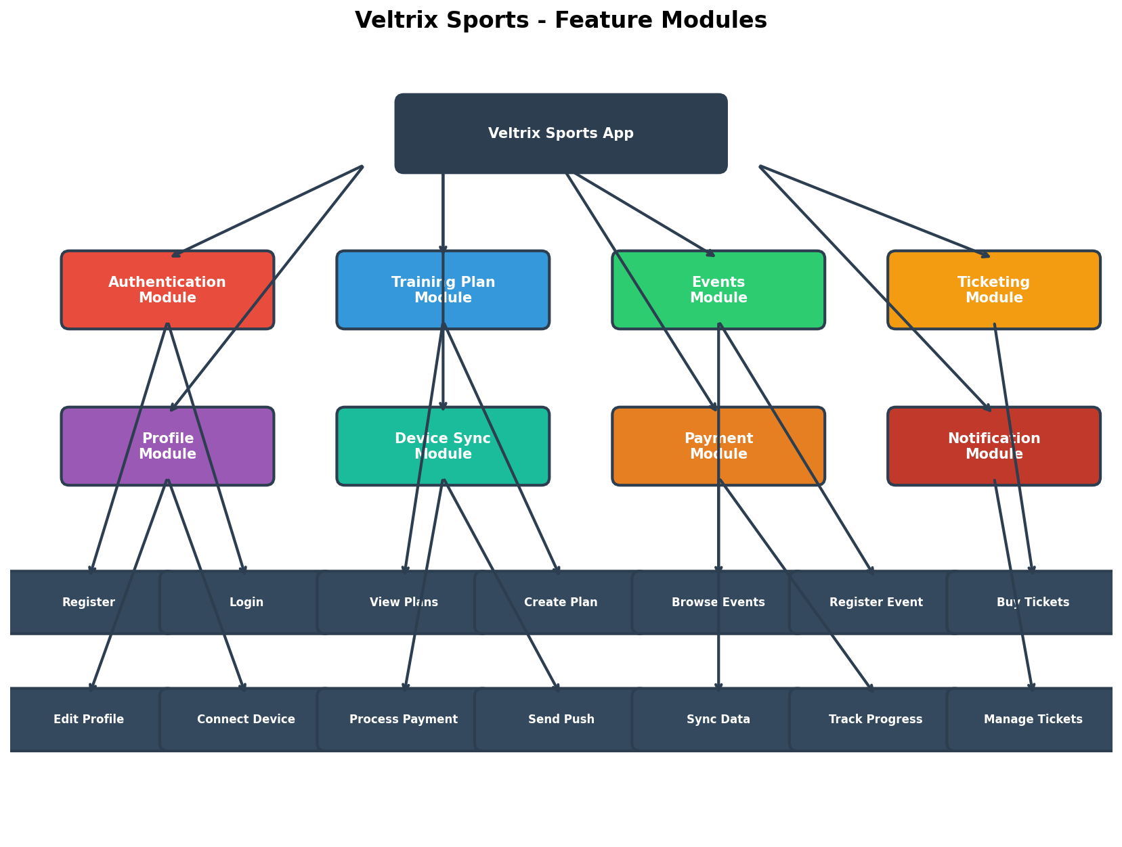

5.1 Feature Summary
Module | Features | P0 | P1
Authentication | 4 | 3 | 1
Training Plan | 6 | 4 | 2
Events | 4 | 3 | 1
Ticketing | 4 | 0 | 3
Profile | 4 | 0 | 4
Total | 26 | 10 | 11

6. AUTHENTICATION FLOW
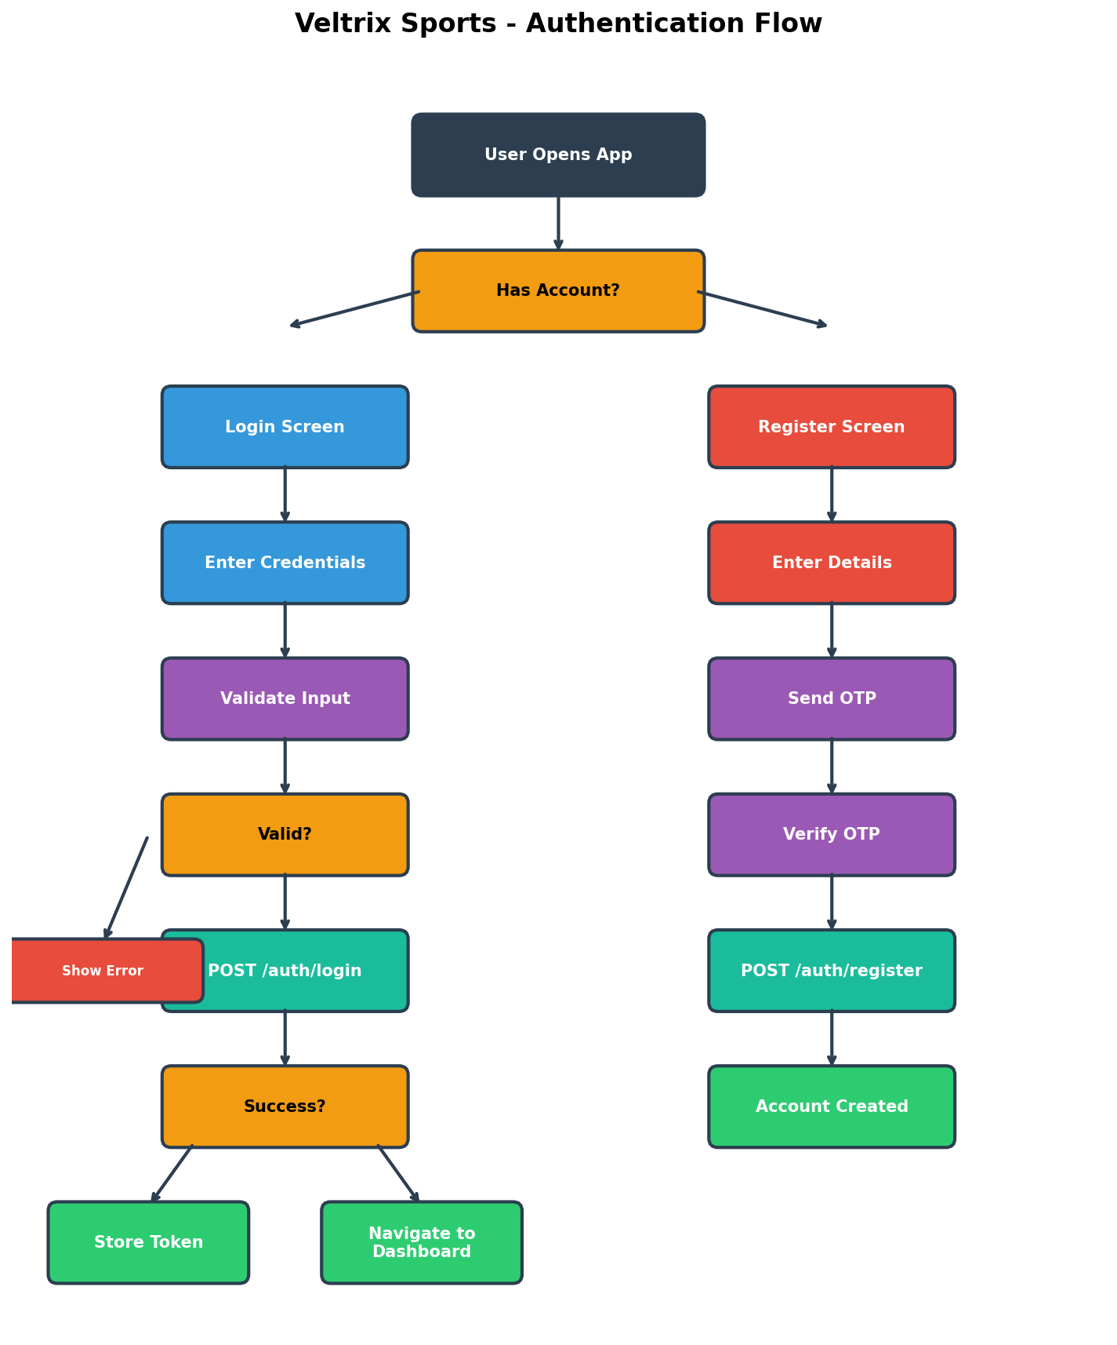

The authentication flow includes:
- User opens app → Splash screen
- Decision: Has account?
- No → Register Screen → Enter details → Send OTP → Verify → Account created
- Yes → Login Screen → Enter credentials → Validate → API call → Store token → Dashboard
- Security: JWT tokens, password hashing, account lockout, OTP expiry

7. TRAINING PLAN MODULE
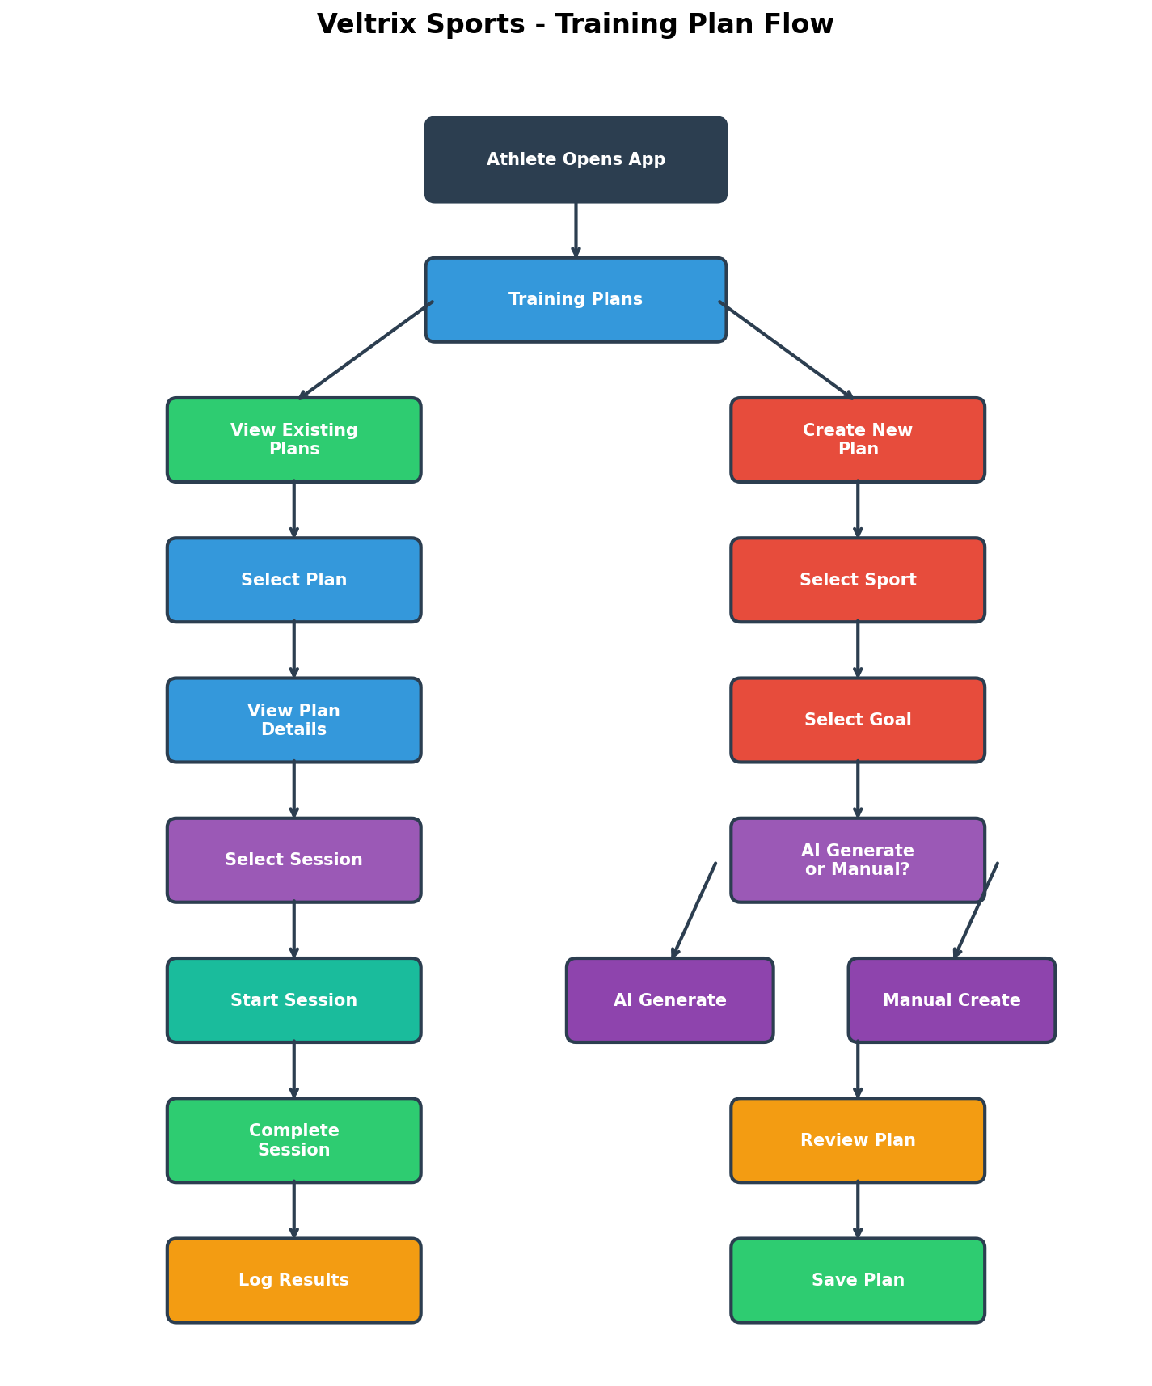

7.1 Plan Creation Flow
- Select Sport → Running, Cycling, Triathlon
- Select Goal → 5K, 10K, Half Marathon, Marathon
- AI Generate or Manual?
- Review Plan → Preview weekly schedule
- Save Plan → Add to user's plans

7.2 Session Completion
- Select Session → View details
- Start Session → Begin tracking
- Complete Session → Log actual metrics
- Log Results → Save to database

8. EVENTS MODULE
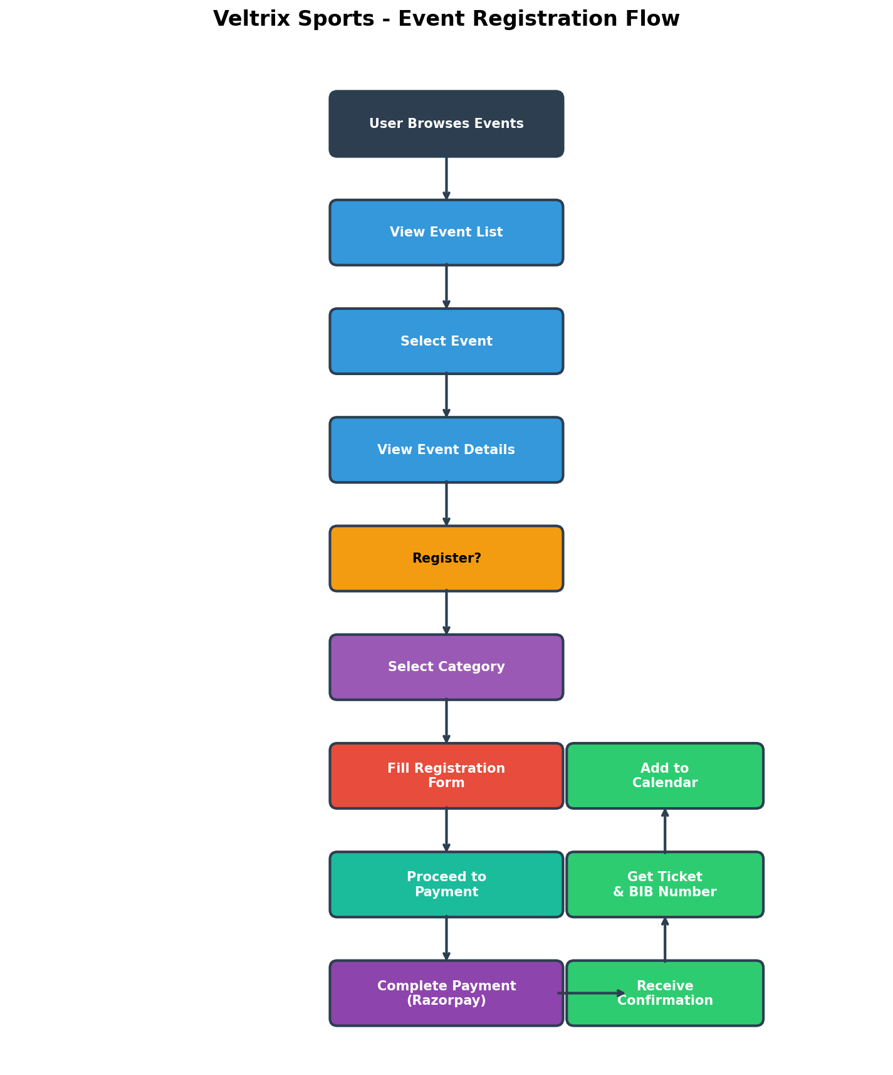

8.1 Event Discovery
- Browse Events → View event list
- Filter/Search → By sport, city, date
- Select Event → View details
- Register → Proceed to registration

8.2 Registration Process
- Select Category → Choose distance/type
- Fill Form → Personal information
- Emergency Contact → Required for safety
- Medical Info → Blood group, conditions
- Proceed to Payment → Complete registration

9. TICKETING MODULE
The ticketing module includes:
- Marketplace: Browse available tickets
- Filter by city/sport
- Sort by price/date
- Purchase Flow: Select quantity → Apply promo → Payment → Confirmation
- QR Check-in: Camera scanning, ticket validation

10. PAYMENT FLOW
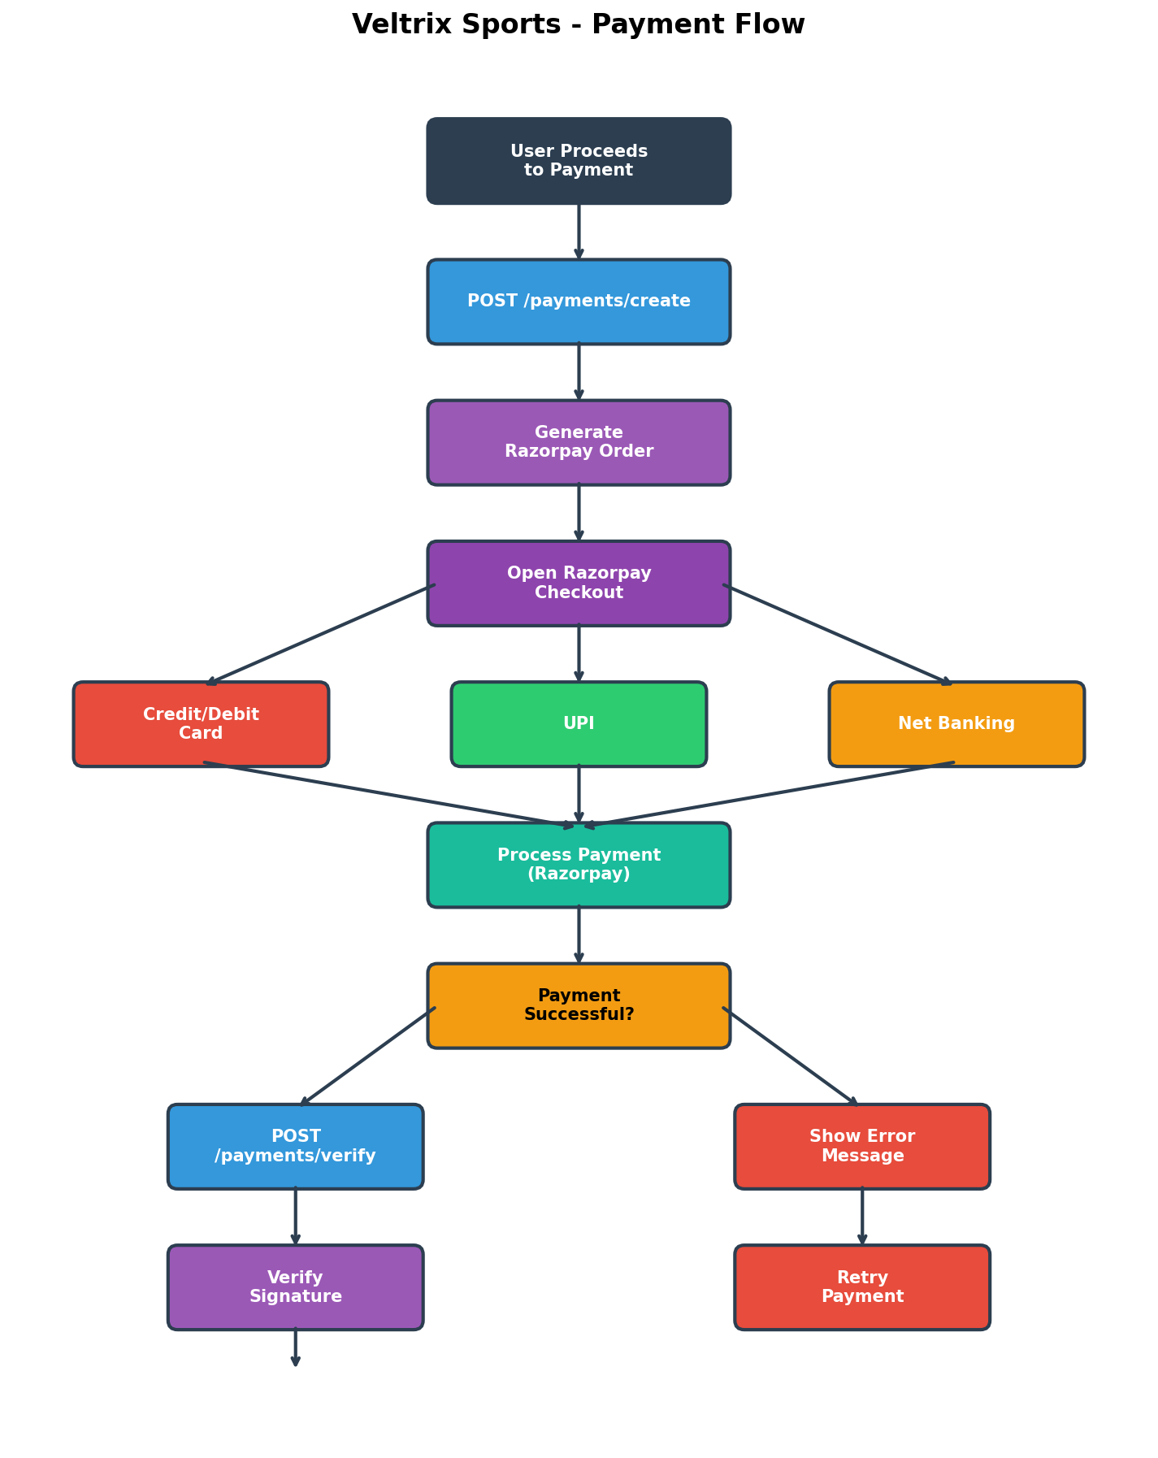

10.1 Payment Process
- User proceeds to payment
- Create Razorpay order
- Open Razorpay checkout
- Select payment method
- Process payment
- Verify signature
- Capture payment
- Send confirmation
- Generate ticket

10.2 Security
- PCI DSS compliant (via Razorpay)
- Signature verification
- Idempotency keys
- No card details stored

11. DEVICE INTEGRATION
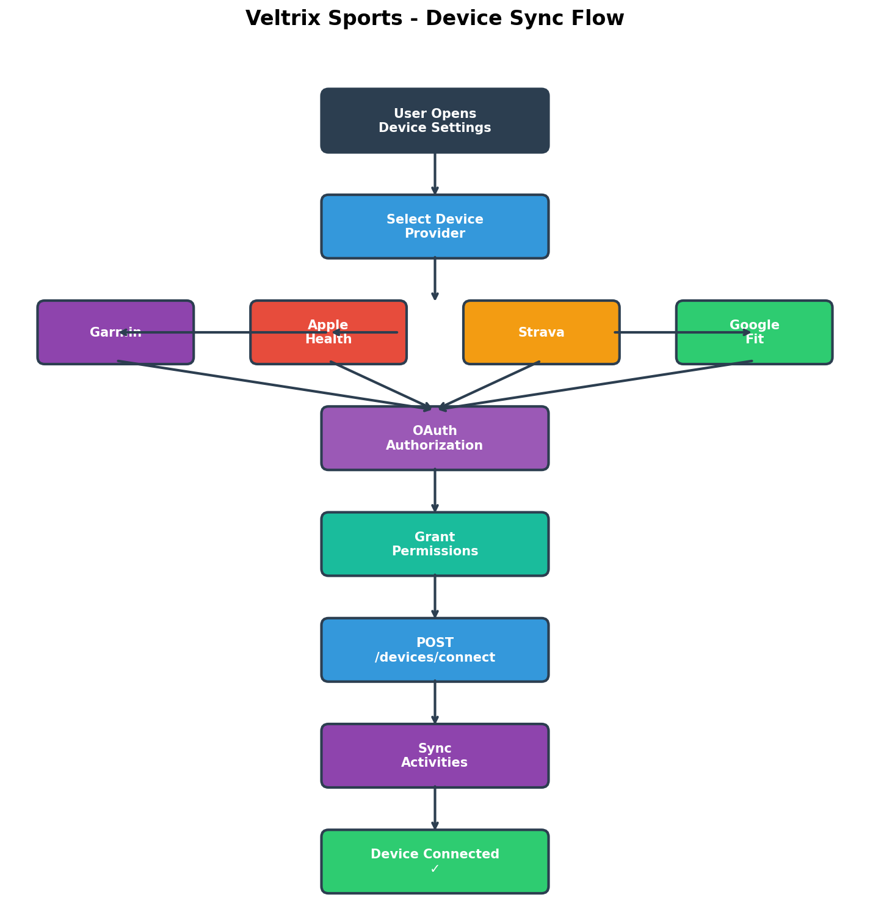

11.1 Supported Devices
Device | Provider | Data Synced
Garmin | Garmin Connect | Activities, Heart Rate
Apple Watch | Apple Health | Workouts, Health Data
Strava | Strava API | Activities, Routes
Wear OS | Google Fit | Activities, Health Data

12. SCREEN NAVIGATION
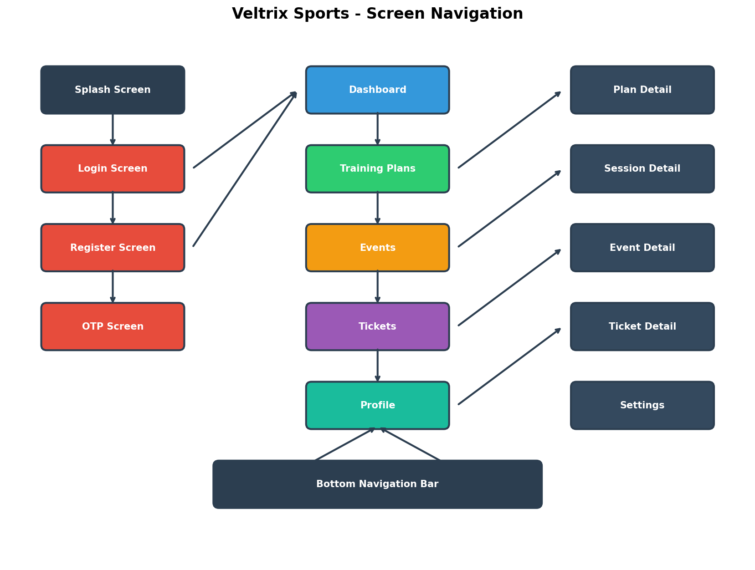

The app has 15+ screens organized as:
- Auth: Splash, Login, Register, OTP
- Main: Dashboard, Training Plans, Events, Tickets, Profile
- Detail: Plan Detail, Session Detail, Event Detail, Ticket Detail, Settings
- Bottom Navigation: 5 main tabs

13. DEPLOYMENT GUIDE
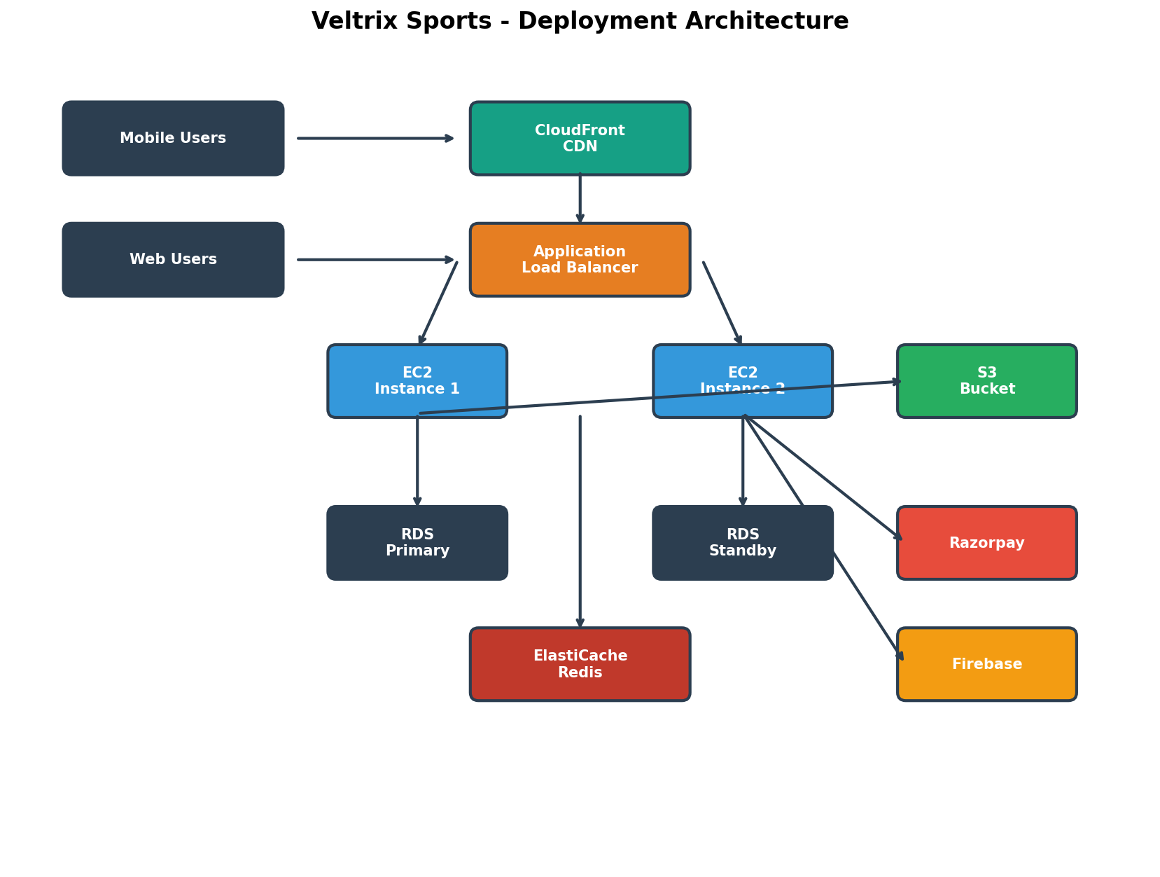

13.1 AWS Services
Service | Purpose | Config
CloudFront | CDN | Global
ALB | Load Balancing | Multi-AZ
EC2 | Compute | t3.small × 2
RDS | Database | PostgreSQL
ElastiCache | Caching | Redis
S3 | Storage | Encrypted
Cognito | Auth | User pools
Razorpay | Payments | PCI Compliant
Firebase | Notifications | FCM

14. TESTING STRATEGY

14.1 Test Pyramid
- Unit Tests (70%): BLoC, Repository, Use Case, Model tests
- Integration Tests (20%): API, Database, Firebase integration
- E2E Tests (10%): Login, Registration, Training, Event flows

14.2 Coverage Target
80% minimum code coverage required

15. SECURITY CHECKLIST

15.1 Authentication
☐ OAuth 2.0 implemented
☐ JWT tokens used
☐ Token expiry configured
☐ Secure password hashing
☐ Account lockout enabled

15.2 Data Protection
☐ HTTPS enforced
☐ Database encryption
☐ S3 encryption enabled
☐ Sensitive data encrypted
☐ No secrets in code

15.3 API Security
☐ Input validation
☐ SQL injection prevented
☐ XSS attacks prevented
☐ Rate limiting enabled
☐ CORS configured

16. PERFORMANCE OPTIMIZATION

16.1 Targets
Metric | Target
App Load Time | < 2 seconds
API Response Time | < 500ms
Frame Rate | 60 FPS
Memory Usage | < 200MB

17. TEAM WORKFLOW

17.1 Agile Process
- Sprint Duration: 2 weeks
- Daily Standup: 9:30 AM
- Sprint Planning: Monday, 10:00 AM
- Sprint Review: Friday, 3:00 PM
- Retrospective: Friday, 4:00 PM

17.2 Git Strategy
- main → production
- develop → integration
- feature/* → new features
- bugfix/* → bug fixes
- hotfix/* → urgent fixes

18. RISK ASSESSMENT
Risk | Probability | Impact | Score | Mitigation
Scope Creep | High | High | 8/10 | Clear MVP scope
Timeline Delays | High | High | 8/10 | Buffer time
API Integration | High | Medium | 6/10 | Abstraction layer
Performance | Medium | High | 6/10 | Optimization
Security | Low | Critical | 4/10 | Security audits

19. COST BREAKDOWN

19.1 MVP (2 Weeks)
Item | Cost
Development Tools | ₹0
AWS (Free Tier) | ₹0
Team (5 people) | ₹43,750-87,500

19.2 Full Product (3 Months)
Item | Cost
Development Tools | ₹8,700
AWS Services | ₹24,600
Team (9 people) | ₹4,95,000-9,90,000

20. ALL DIAGRAMS
Below are all 12 diagrams embedded in this document:

System Architecture


Database ER Diagram


Authentication Flow


Training Plan Flow


Event Registration Flow


Payment Flow


Device Sync Flow


Feature Modules


API Endpoints


Screen Navigation


Data Flow
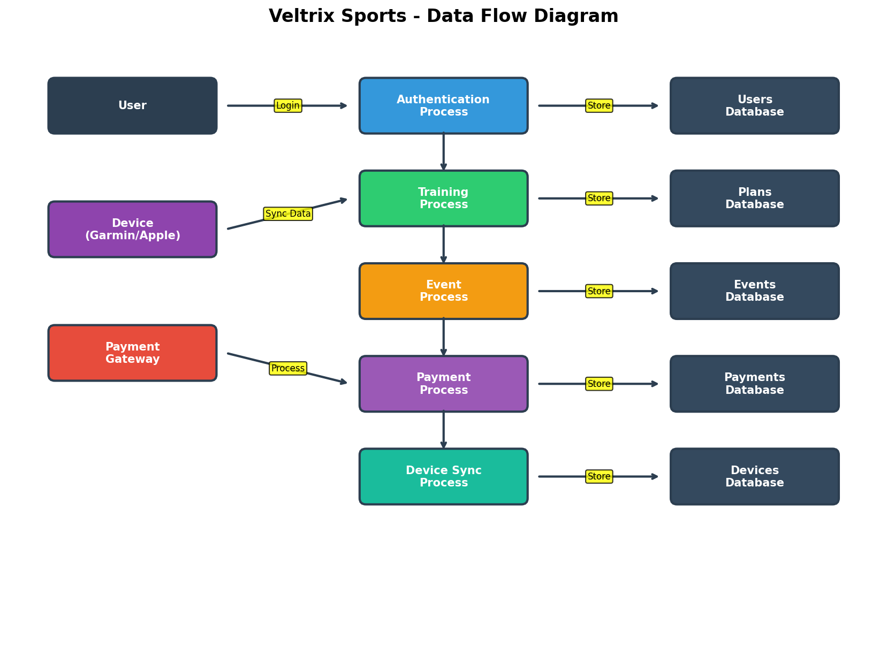

Deployment Architecture


