Required libraries:
LWJGL http://lwjgl.org/installation.php, opencsv (custom opencsv library included with source), slick-util, and jbox2d.

Final Project Proposal

Alan Tai and Benjamin Roye

For the final project we wish to use a data set from the Post-Secondary Universe Survey of 2010 to see which colleges are the best in terms of quality and cost. We decided to do this because, although we are already in college, we know someone who is entering college or is going to enter a college in the future. And they are bound to ask us which college is best for X budget because we have been through the college life and, apparently, we are just supposed to know.

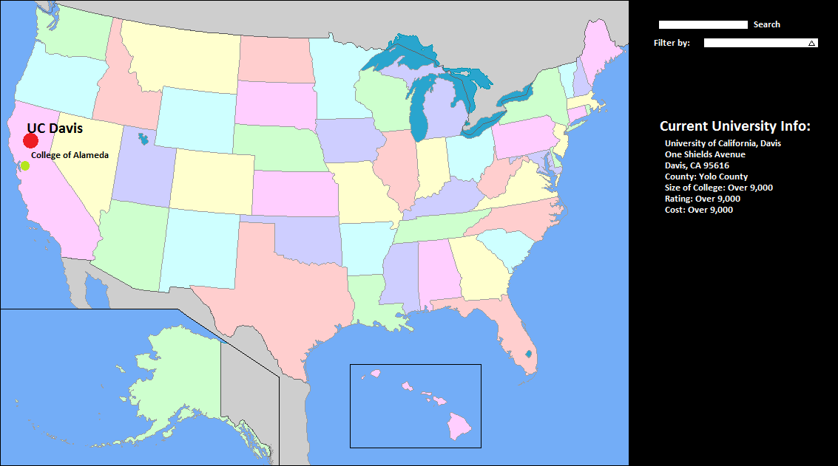

With this dataset, we are going to create a visualization with the US map. Within the US map we will try to plot the locations of each university. This will be done with a circular point. The size of this point will then scale according to size of the university. The color will change from green to red to show its affordability. Green being the least amount of money and red being the most amount of money for tuition. We will also label these points. Since there are so many schools, the labels and points may overlap. To work around this, we will lower the transparency levels of the schools that have a lower quality of education. We will allow users to zoom in and out. Users will be able to click on the individual points to see the overall information. Users will also be able to filter out schools that offer no grants (higher out-of-pocket cost) or filter out schools that have below a certain rating.

We intend to use OpenGL with a minimal java wrapper layer (LWJGL) to enable 3D exploration of the visualization. Alan will be focusing on implementing the visual channels such that the user can readily understand the data presented. Ben will be focusing on rendering a 2D SVG of the United States in 3D as well as zoom and pan functionality that makes the visualization easy to navigate.

What we actually did was draw a map of the United States with Hawaii and Alaska left out of the picture because it would cause mapping of universities to be incorrect. The right side has a set of filter options along with a list of available colleges and universities for viewing. Selecting a filter option would filter this list. Unfortunately there were a ton of bugs associated with simply toggling the filter option, so the filter checkboxes simply filter those options out. Re-enabling them requires a click on the reset button at the top right. Also, there are a ton of universities and colleges, so there is a scroll bar available for scrolling through the list. If a user wants to select an item from the list, they can do so by clicking it. Clicking it allows for more information of the college/university to be visible.

The map shows two different entities. Cubes represent public schools and pyramids represent private schools. These two entities are colored similar variations of some colors, so they could be distinguishable. Red represents four year colleges or universities. Yellow represents two year colleges or universities. Green represents less than two year colleges or universities.
Filter Options
The user can filter by types of college: less than two year college, two year college, or four or more year college. The user can also filter by more options by clicking the “More Filter Options” button. This reveals an extra menu which allows the user to filter by: colleges that offer medical degrees, public colleges, private colleges, historically black colleges, colleges in cities, colleges in suburbs, colleges in towns, and colleges in rural areas. Clicking on the “More Filter Options” will be able to hide this menu.

Division of Work
Since Benjamin Roye was more experienced in coding in OpenGL and the usage of the LWJGL wrapper, he created the map along with the college entities. Benjamin Roye created the zoom, pan, and rotate functionality. Benjamin Roye mapped the longitude and latitude values to the screen for a 3D visualization. Benjamin also created the base framework for Alan Tai to develop on. Alan Tai created the entire filter bar on the right and mapped mouse clicks to them for user interaction. This includes the list of universities and colleges along with the scrollable aspect of the list (and the scroll bar). Alan Tai also parsed the CSV file and stored it into an array and a linked list. The array contains the full data set while the linked list was the filtered data set. Alan Tai contributed to approximately 40 percent of the work and Benjamin Roye contributed approximately 60 percent of the work. This percentage scale is based on the difficulty of the parts that each person has done.

Difficulties
We wanted to make the visualization look nice, but there were so many errors along the way that we did not quite have time to make everything look visually pleasing. For example, Benjamin Roye wanted the click interaction of the school to zoom into the location and pan it with nice animations. We also wanted a box to pop up at the point of clicking to display the information. The buttons could have been designed nicely. The list could have changed the cursor to show a hand to show that it is clickable. Also wanted the name of the institutions to be visible on the map. It would have been nice to shade in the pyramids so that the pyramids would be more easily distinguishable to cubes. Unfortunately, the data set was not too descriptive on some of the variables, so that it was not entirely clear what different codes for aid meant and such. Also, we were unable to map mouse interactions with the entities that are drawn on the map because we would have to find the 3D projection of the mouse position and compare it to the 3D projection of the displayed entity. Then we would have to calculate the offset because there is no implementation of a “camera.” The whole map is treated as a moving object or “hero” as the code describes it. We did try to implement it, but it just did not work. The OpenGL java framework does seem a little buggy. When trying to set an array to null it would cause the program to crash even though there was appropriate null error checking involved.

Start Screen:
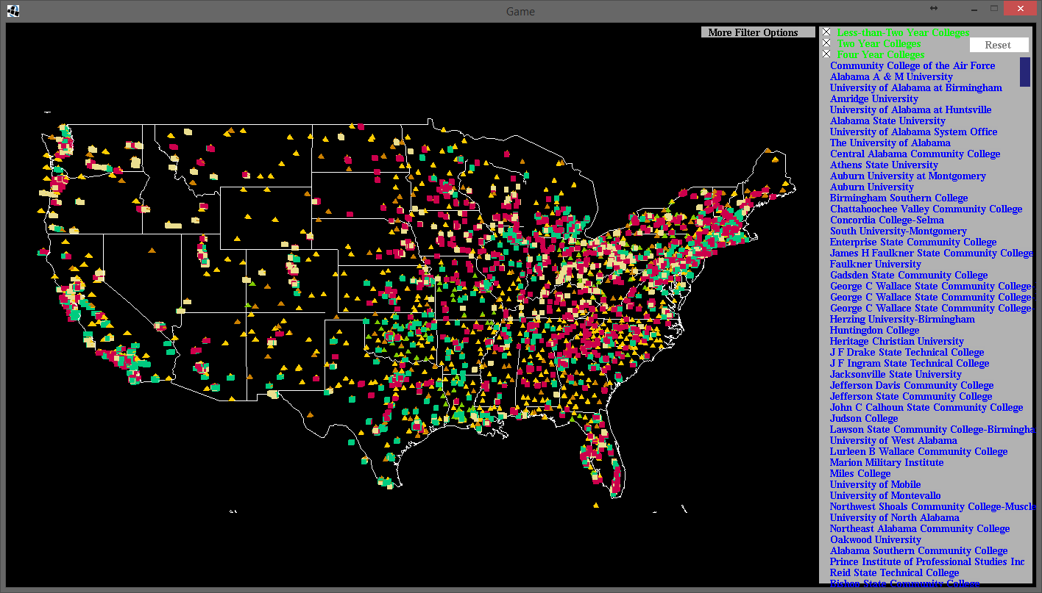

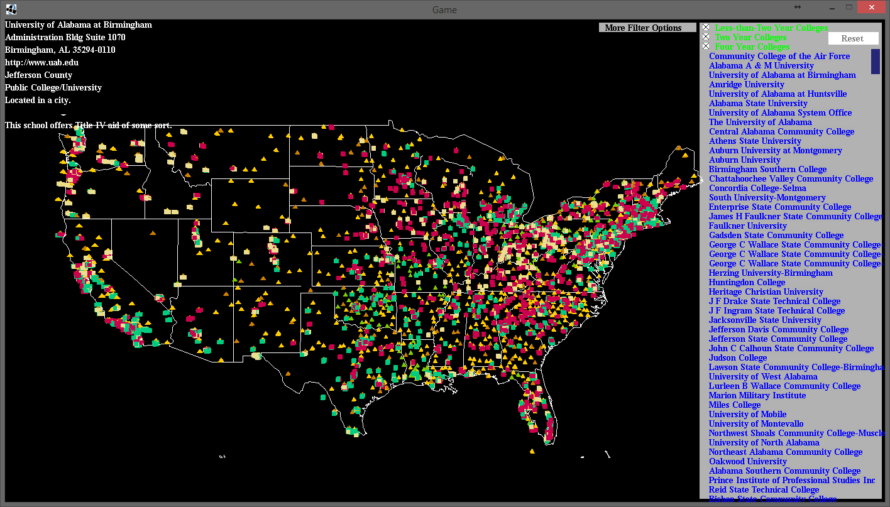
Clicking on the university or college name from the list on the right shows some information on the top left.

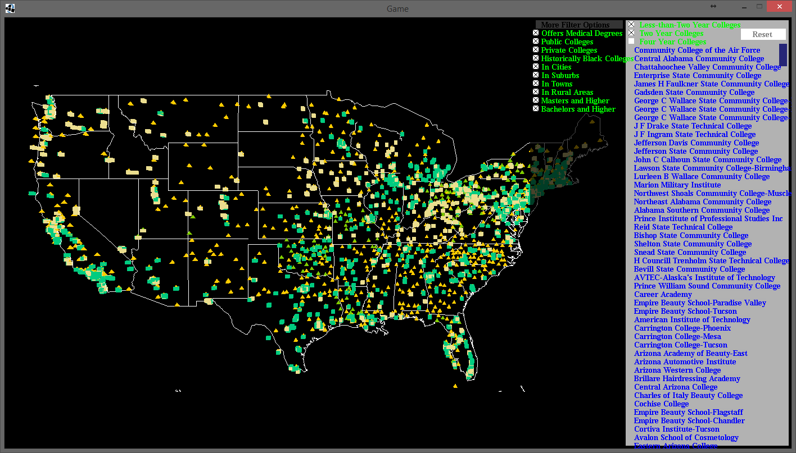
This shows the results filtering out the Four Year Colleges. The list on the right is different from before as well.

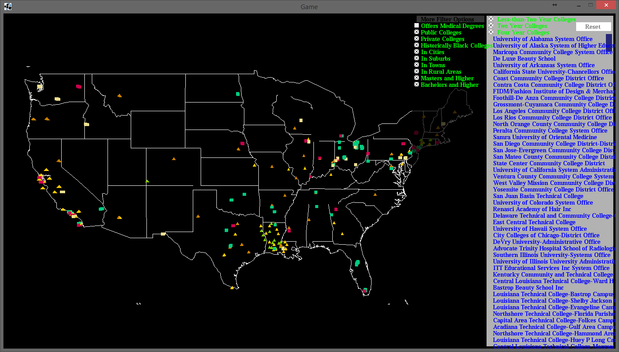
Most of the colleges or universities seem to offer some sort of medical degree.

