Maintaining “local” links for Directgov / Businesslink /GOV.UK

The Local Directgov (LDG) application contains links to Local Authority service pages that are used by Directgov, Businesslink and GOV.UK to deep link into Council web sites. These links are maintained by Local Authority web teams via an easy-to-use web-based administration system.
Automatic emails are sent to Local Authority web teams (nominally the web portal officer) by the LDG system when links are broken, so that they can be fixed. Every night the LDG application checks all the links held in its database by sending out requests to council servers for the pages on councils sites. When the request is made to the web server, a status code is returned.
Some common status codes are:
- 200 - the server successfully returned the page
- 404 - the requested page doesn't exist
- 503 - the server is temporarily unavailable
So when LDG checks a link and receives a 404 status code rather than a 200 status code it knows the link is broken.
An ISP will return a standard 404 page to the user. However, it is much better for you to create custom 404 pages that will help your users to find the information they are seeking, encouraging them to explore your site further.
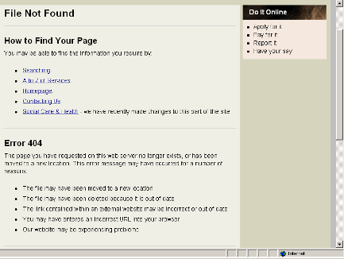

The screen shot above appears to be a good example of a custom 404 page. But looks can be deceiving. In this particular example, the council’s web server returns a 200 status code so that search engines and spiders (such as LDG) do not pick up on the fact that the link is broken. When you develop custom 404 pages please ensure that your web server returns a 404 status code to complement the custom page.

To know whether your council is currently returning 200 status codes for broken link pages, go to - http://bit.ly/J3JCYN

Useful links

http://www.google.com/support/webmasters/bin/answer.py?hl=en&answer=40132

http://www.google.com/support/webmasters/bin/answer.py?hl=en&answer=93641

Check the http headers for a web page:

http://404checker.com/404-checker

http://tools.seobook.com/server-header-checker/

