


How to ensure you have a valid 404 page

How GOV.UK links to council websites

The Local Directgov (LDG) application contains links to Local Authority service pages – these are used by GOV.UK to deep-link into council web sites.

Council web teams maintain these links via an easy-to-use, web-based administration system.

How the system checks whether links are broken

Automatic emails are sent to council web teams (normally the web portal officer) by the LDG system when links are broken, so they can be fixed.

How does the system know? Every night, the LDG application checks all the links held in its database by sending out requests to council servers for the pages on councils’ sites. When the request is made to the web server, a status code is returned.

Some common status codes are:

- 200 - the server successfully returned the page
- 404 - the requested page doesn't exist
- 503 - the server is temporarily unavailable

When LDG checks a link and receives a 404 status code rather than a 200 status code, it knows the link is broken.

Personalising your 404 page

An ISP will return a standard 404 page to the user. However, it is much better for you to create custom 404 pages that help your users find the information they are looking for, encouraging them to explore your site further.

When you develop custom 404 pages, please make sure that your web server returns a 404 status code to complement the custom page.

Making sure your 404 is really a 404

The screen shot below appears to be a good example of a custom 404 page. But looks can be deceiving!

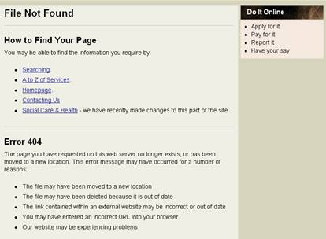

In this example,

the council’s web server returns a 200 status code, so that search engines and spiders (such as LDG) don’t pick up on the fact that the link is broken.

Useful links

More information about http status codes:
https://support.google.com/webmasters/answer/40132?hl=en

How to create a useful 404 page:
https://support.google.com/webmasters/answer/93641?hl=en

404 checkers – check your HTTP status codes:
http://404checker.com/404-checker
http://tools.seobook.com/server-header-checker/

