
TWITTER IN 10 : Handout

This workshop is designed to introduce you to Twitter. It covers 3 basic topics:
- A few minutes on what Twitter is, its tone and its outreach potential
- A few minutes on its language: #, @, RT, etc
- A few minutes of getting people tweeting

What’s it all about?
- Essentially, Twitter is a news feed where you can follow what people are chatting about in real time
- People put ‘tweets’ on the newsfeed – max 140 characters including spaces
- You follow people or organisations who share your interests and their tweets appear on your news feed.
- You hope that people follow you back, so you build an audience to read your tweets
- You can share photos and links (and there are ways to make long links short using bitly.com, ow.ly and tinyurl.com)

Why use Twitter?
- Monitor what people are discussing in your interest area
- Engage people in your interest area by sharing news, or inviting feedback/ advice
- Short quick messages
- Highly mobile. Simple format suits smart phone use on the go.
- Connect people in your network/ grow your network
- Can have Twitter events, e.g. the Foreign and Commonwealth Office (FCO) have live Twitter conversations

Tone:
- Informal, personable

The Essentials:
- Your Twitter name begins with an @
- Quote or refer to people using their Twitter name, and this shows them what you wrote (it’s a tag that increases the likelihood that others will see your tweet)
- Topics are marked with #. To increase likelihood of conversing with people in your interest area, include a # in your tweet.
- RT denotes ‘re-tweet. It means you are quoting someone else. You can also re-tweet someone by clicking on the re-tweet button under their tweet.

Myth-busting/ House-keeping
- You need to be technically savvy – NO. Just read the home page and understand @, # and RT
- Only your followers can read your tweets – NO! Twitter is 100% public, so never write something private or potentially offensive, as it could come back to haunt you
- You could lose your job for imprudent tweets – this is TRUE
- As such, it’s good to include a note on your profile: ‘Tweets are my own and do not represent xxxx. Retweets are not necessarily endorsements…’
- You may need permission from your council to set up a council-related Twitter account.
9-10 minutes - MAKE A COMMITMENT!
- Dedicate 5 minutes, 3 times a day to scanning Twitter for information relevant to you.
- Follow people in your network
- Observe interesting hashtags and keep a note of them
- Search a few words in the top right search bar and see what comes up
- Re-tweet things that look interesting
- When you’re ready and you want to get a conversation started or news out, try tweeting. Remember the essential symbols, #topic, @name, .@name (direct message) and RT.

Account set-up help:
- Go to www.Twitter.com and click on the sign-up link
- Fill out the form
- Note your Twitter username (which will begin with an @), password and contact email address
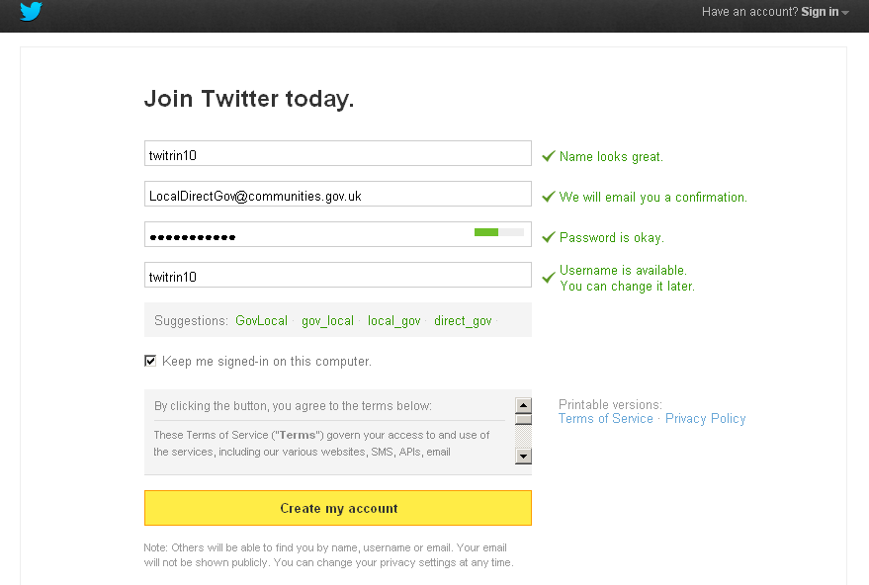

- You then land here:

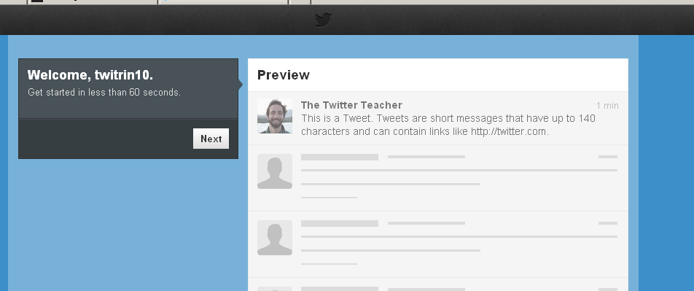

The latest tweets from
the people you’re following appear in real time, new tweets coming in on top.►

- Follow the tour by clicking on the next button when you’ve read enough
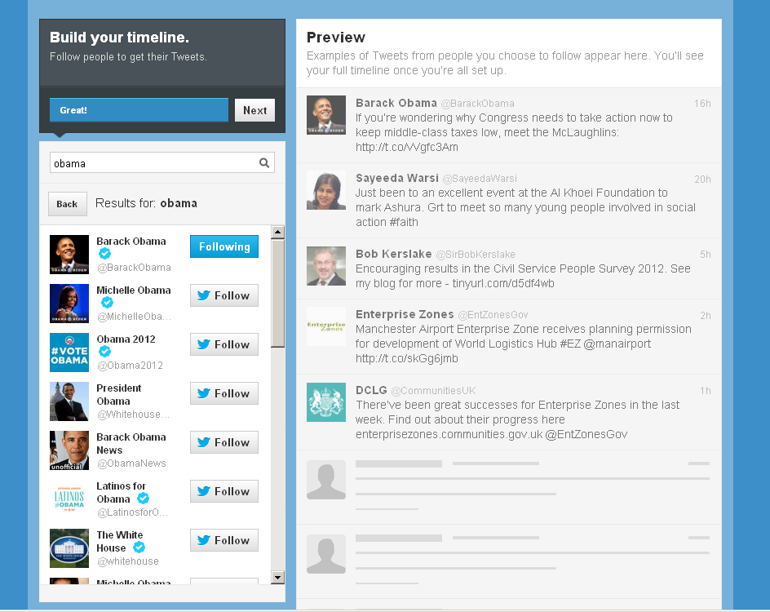

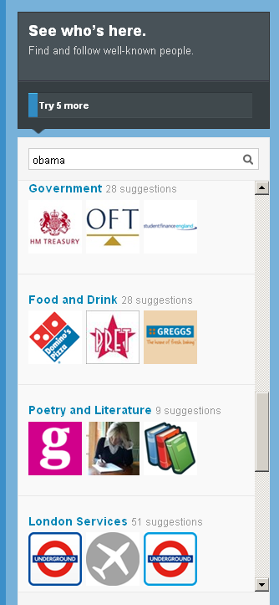

If you reach this point setting up your account, and you don’t want to know more, just go to the main URL: Twitter.com, or click on the confirmation link from your inbox.

