How to capture a user journey

Choosing a user journey

You can choose any journey you want. To give you some ideas, here are some popular user journeys from GOV.UK to local authority websites:

- School term and holiday dates  - Apply for an older person's bus pass  - Pay your Council Tax  - Apply for council housing  - Blue Badge scheme: information from your council  - Apply for a primary school place  - Apply for a Council Tax discount  - Get on the electoral register  - Apply for free school meals  - Find out your rubbish collection day | - Housing Benefit information from your council  - Apply for Council Tax Reduction  - Apply for a disabled person's bus pass  - Apply for special collection of large waste items  - Apply for a dropped kerb  - Find a community support group or organisation  - Report a noise nuisance to your council  - Apply to adopt a child through your council  - Find out where Blue Badge holders can park  - Courses and qualifications for 14 to 19 year olds

Putting your user journey in a word document

On the next page is an example of a user journey created for a Really Useful Day. Here’s the way I did it:

- I formatted a word doc as A3 (it’s easier to fit long web pages onto the page).
- I searched on www.google.co.uk for “Complain about Herefordshire Council”, clicking the 1st search result from the council.
- When I landed on Herefordshire’s website, I pressed ‘Print Screen’ and pasted it into my word document as step 1 of my journey.
  - ‘Print Screen’ works for short pages.
  - For long pages, you can either ‘Print Screen’ at various points going down the page, then crop them all and overlap them – or you can use software / a website that captures the full screen. I used http://ctrlq.org/screenshots/ because my work PC doesn’t let me download any software.
- I continued copying and pasting the pages of the journey, clearly labelling them as step 1, 2, 3, etc.
- I used the ‘Picture’ toolbar’s crop tool to trim off any unnecessary space, so I could expand the screen print as large as possible.

Some tips

- Be honest. Screen print every step of your journey – even if it involves pictures of annoying pop ups, or dead-ends that force you to use your website’s search box.
- If you have an incredibly long journey (one I did was 15 steps long), shrink them down and group them on the same page to save paper.

Customer journey: Complain about your council
Local authority: Herefordshire
Page on local authority website: Step 1 of 2

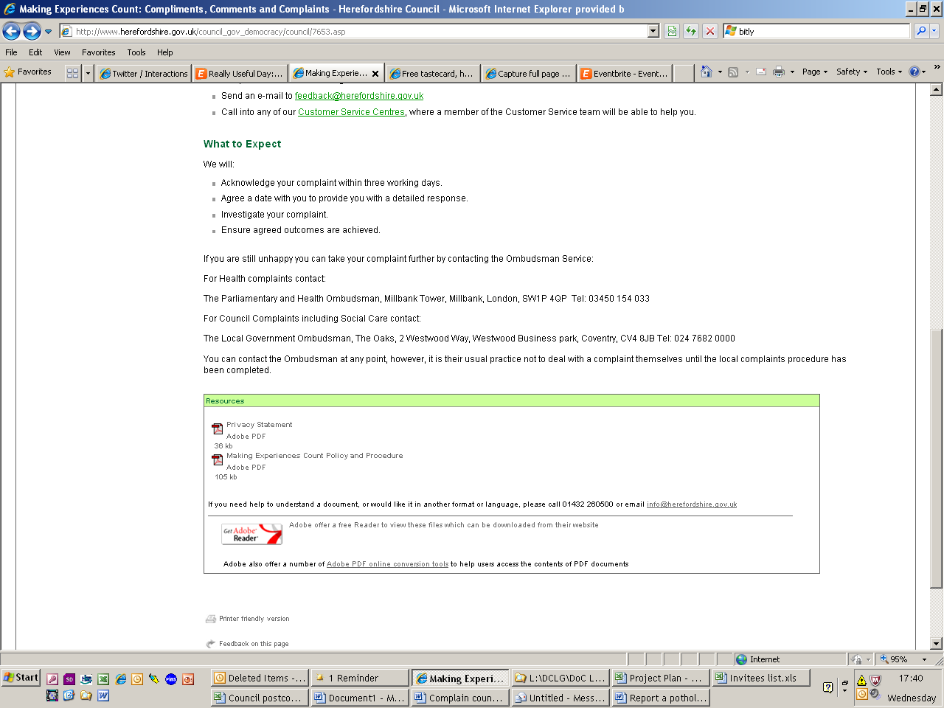
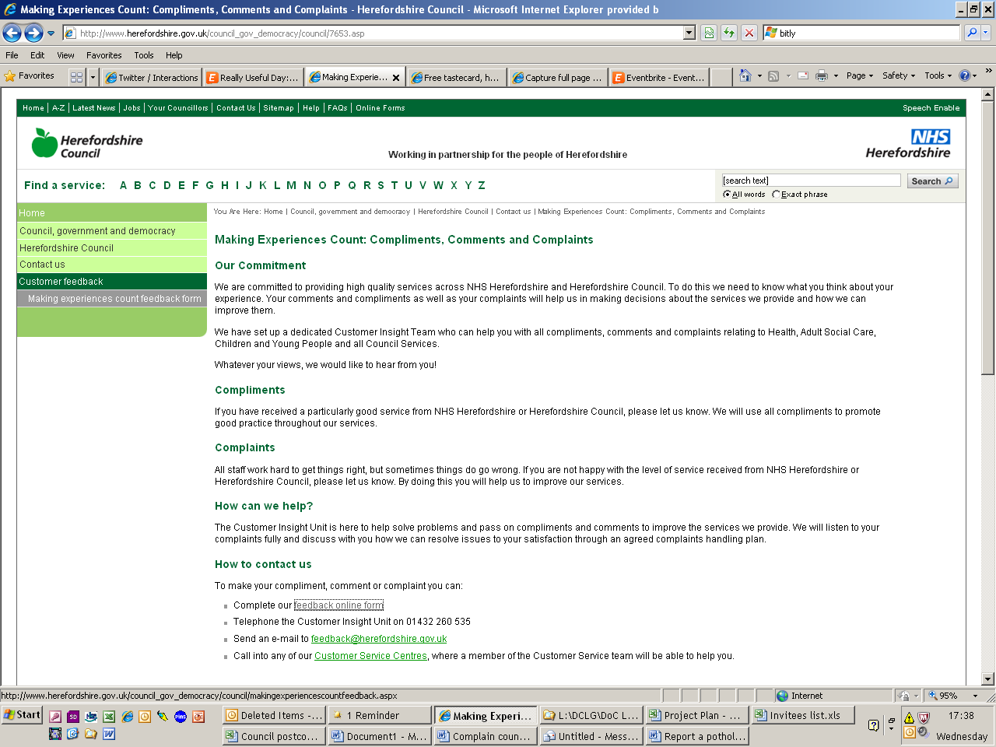

I clicked here

Customer journey: Complain about your council
Local authority: Herefordshire
Page on local authority website: Step 2 of 2

