Customer journey: Pay my council tax – MENDIP COUNCIL
How I got to this page: From GOV.UK, using the postcode BA4 5BT
Page on local authority website: Page 1 of 3

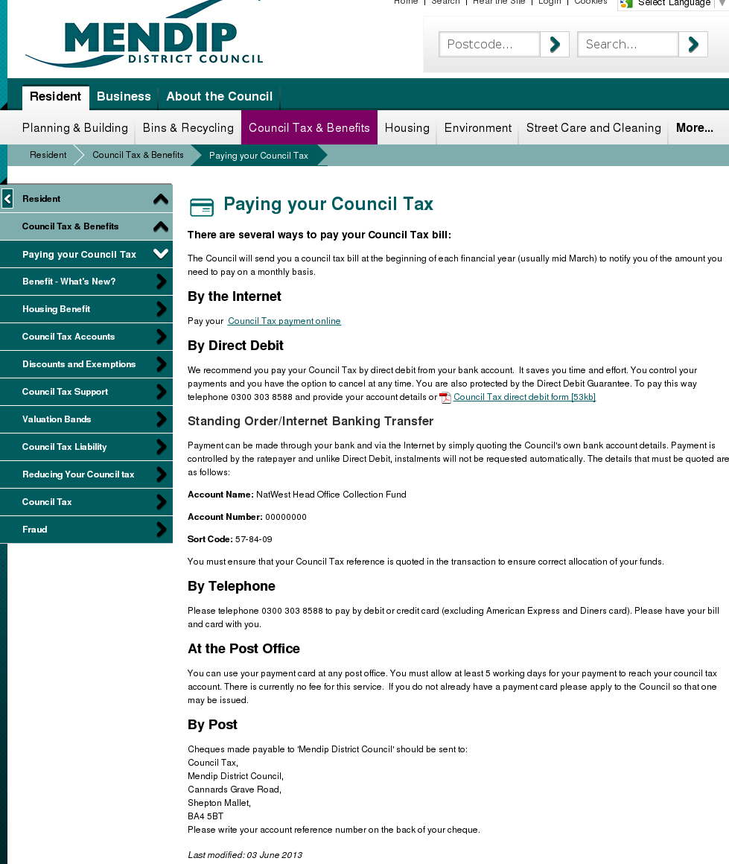

I clicked here

I clicked here
Customer journey: Pay my council tax – MENDIP COUNCIL
How I got to this page: From GOV.UK, using the postcode BA4 5BT
Page on local authority website: Page 2 of 3
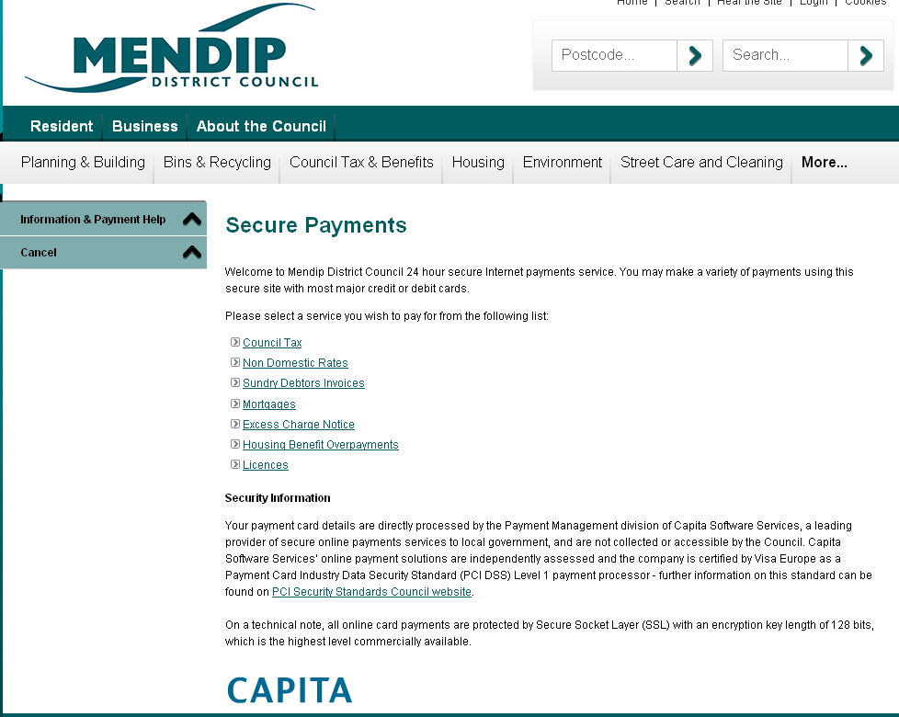

I clicked here

Page 3 of 3
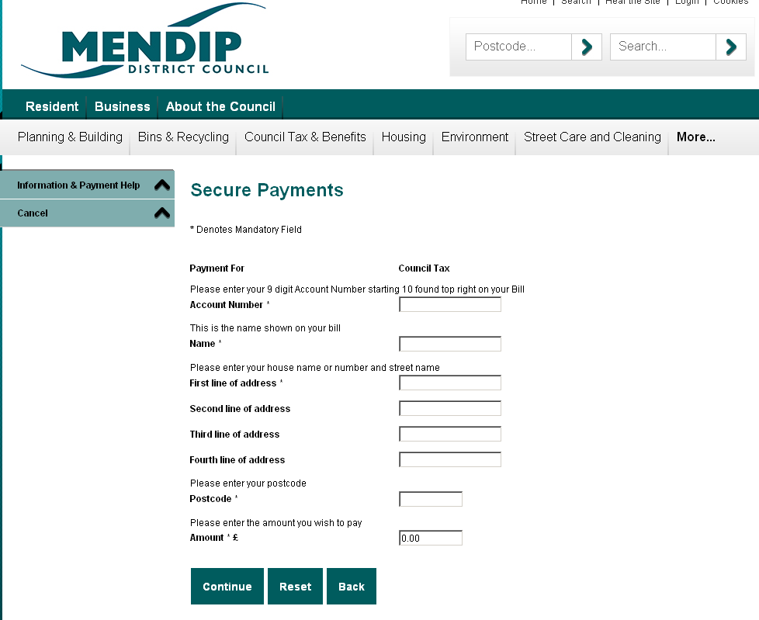

Customer journey: Pay my council tax – FOREST OF DEAN COUNCIL
How I got to this page: From GOV.UK, using the postcode GL16 8HG
Page on local authority website: Page 1-2 of 2
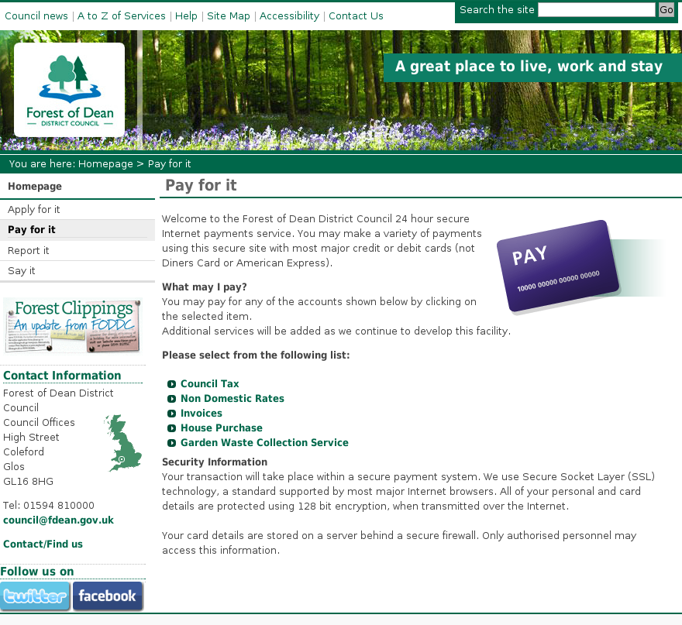
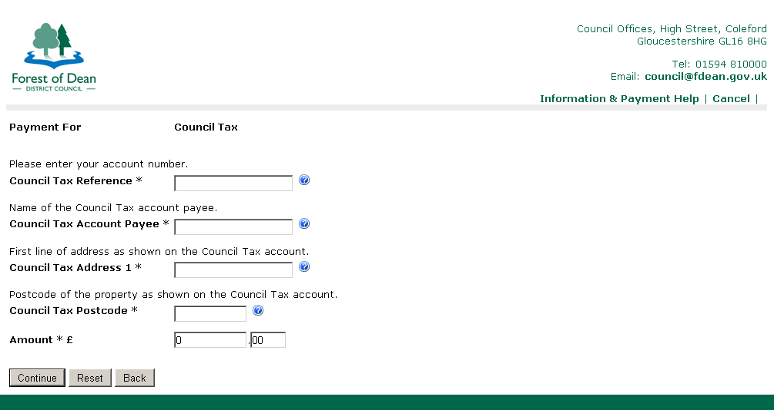
Page 2
I clicked here
Customer journey: Pay my council tax – HULL COUNCIL
How I got to this page: From GOV.UK, using the postcode HU1 2AA
Page on local authority website: Page 1 of 6
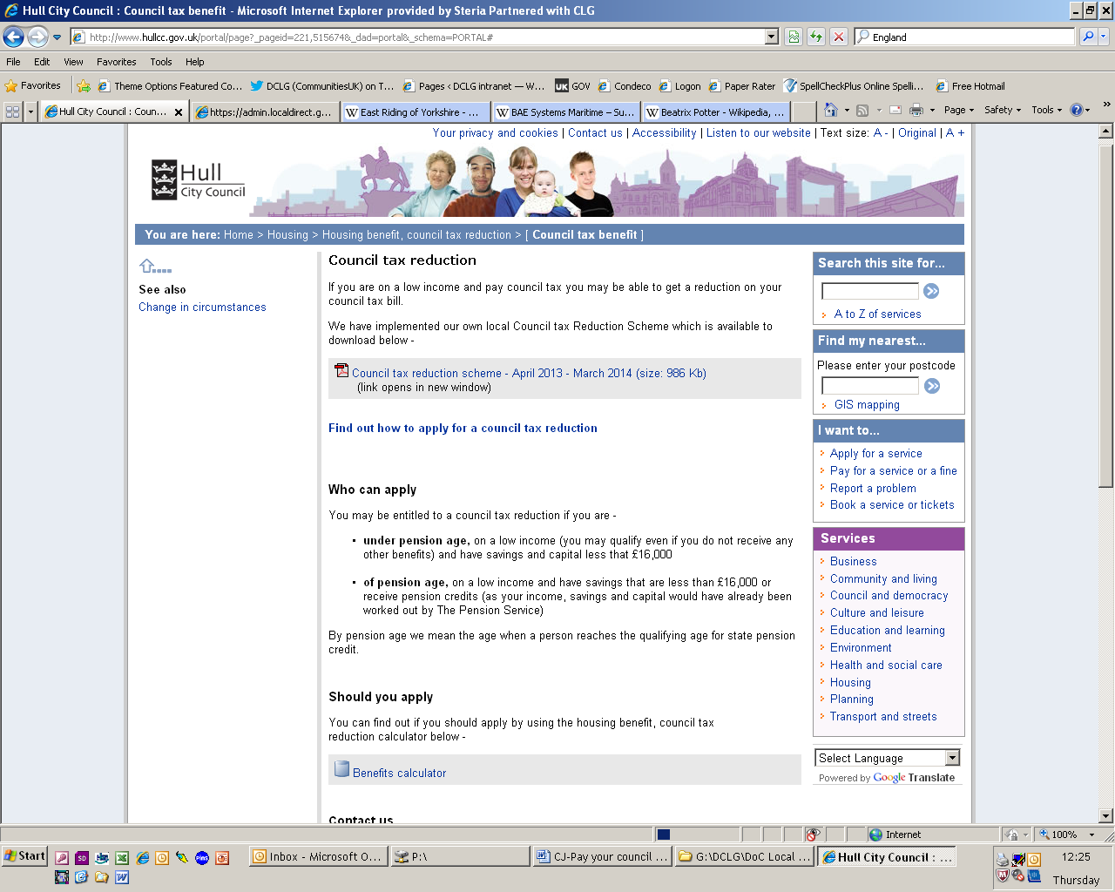
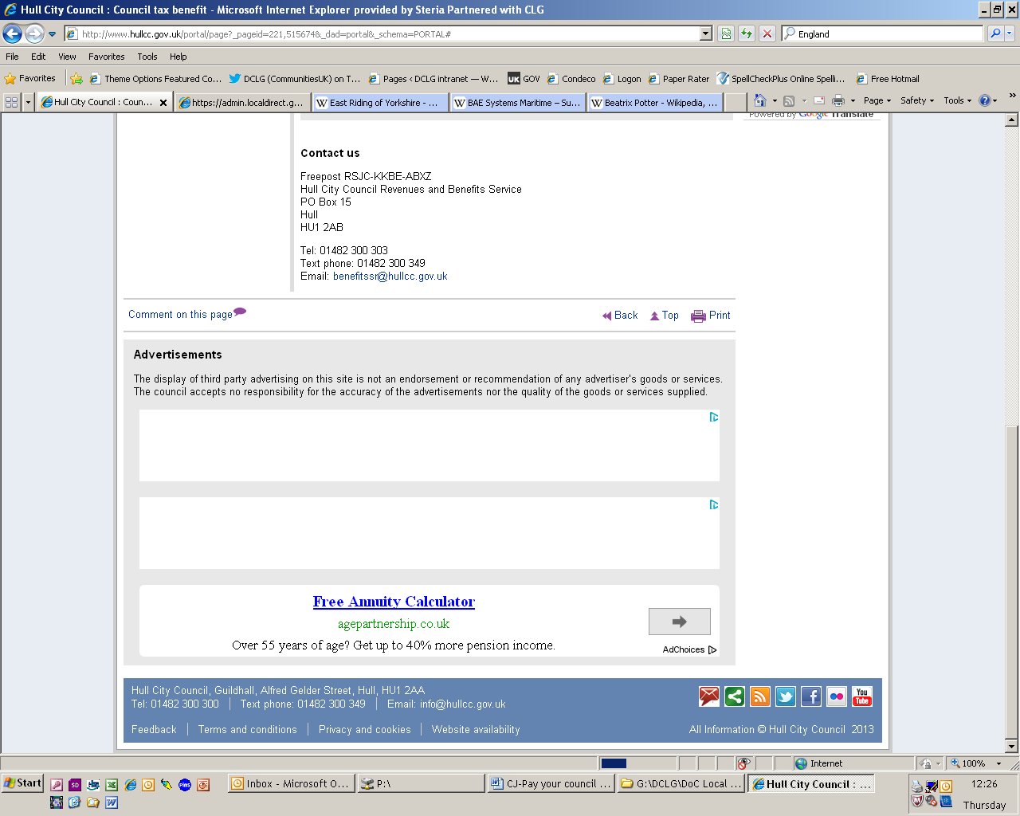

It took me to the wrong page, so I searched for “Pay my Council Tax”

Customer journey: Pay my council tax – HULL COUNCIL
How I got to this page: From GOV.UK, using the postcode HU1 2AA
Page on local authority website: Page 2 of 6
I clicked here
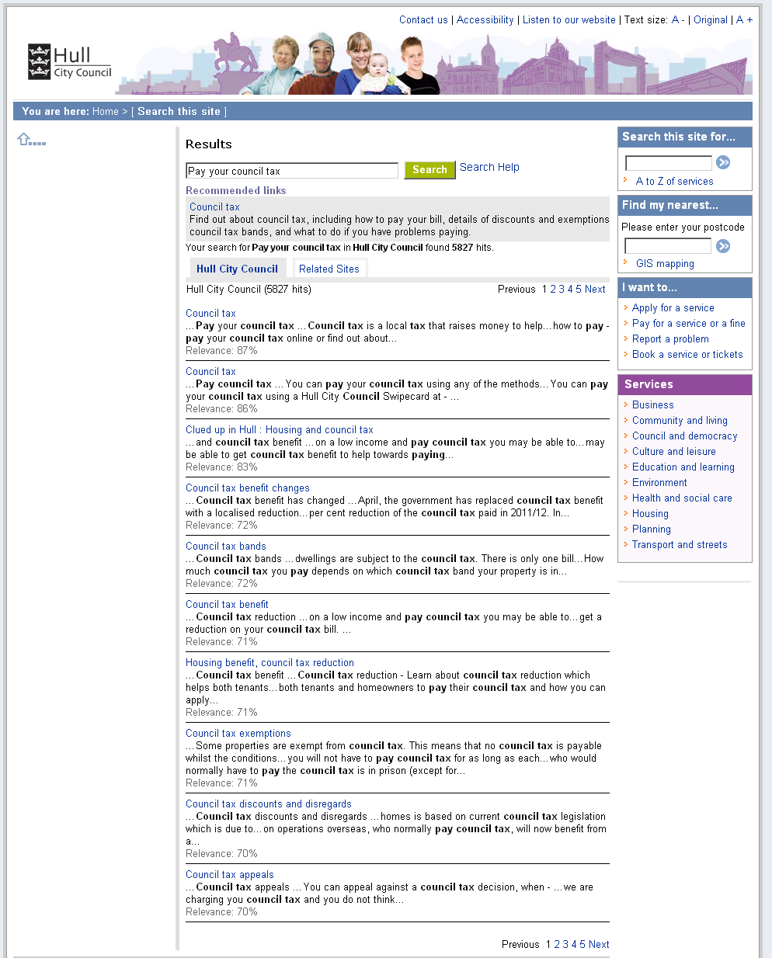

Customer journey: Pay my council tax – HULL COUNCIL
How I got to this page: From GOV.UK, using the postcode HU1 2AA
Page on local authority website: Page 3 of 6
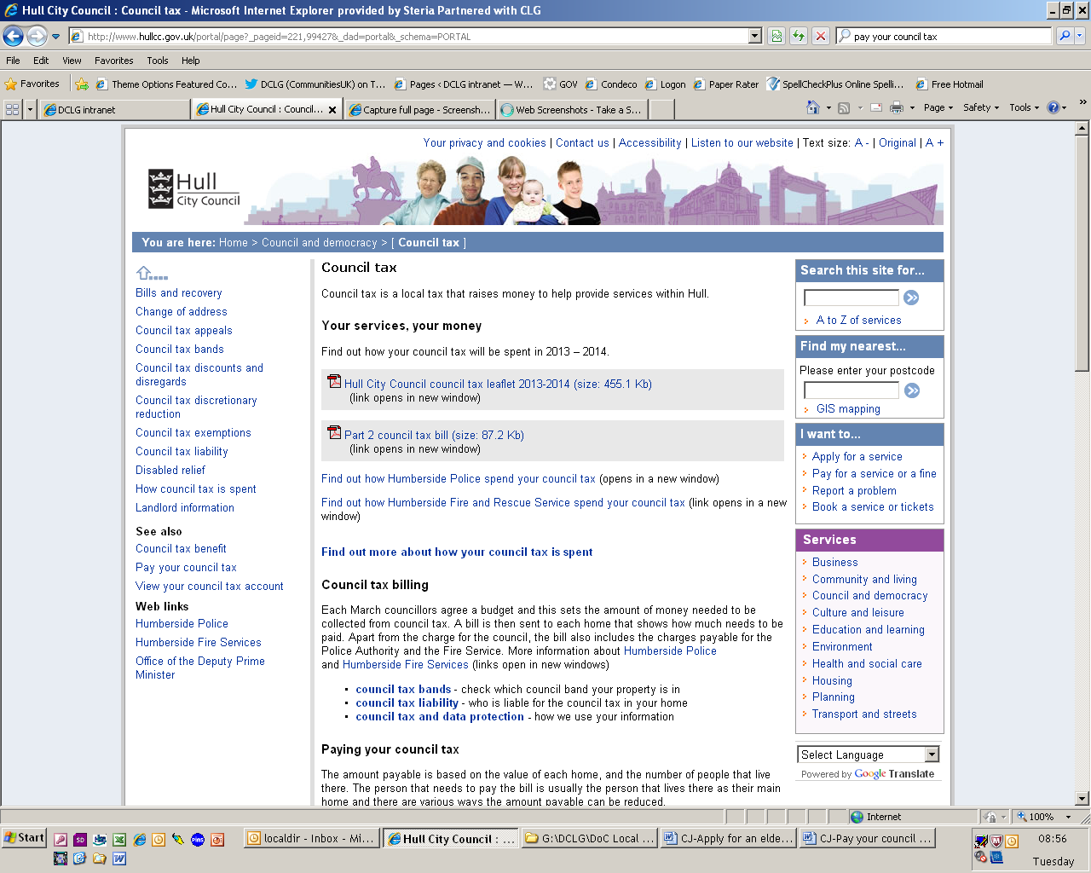
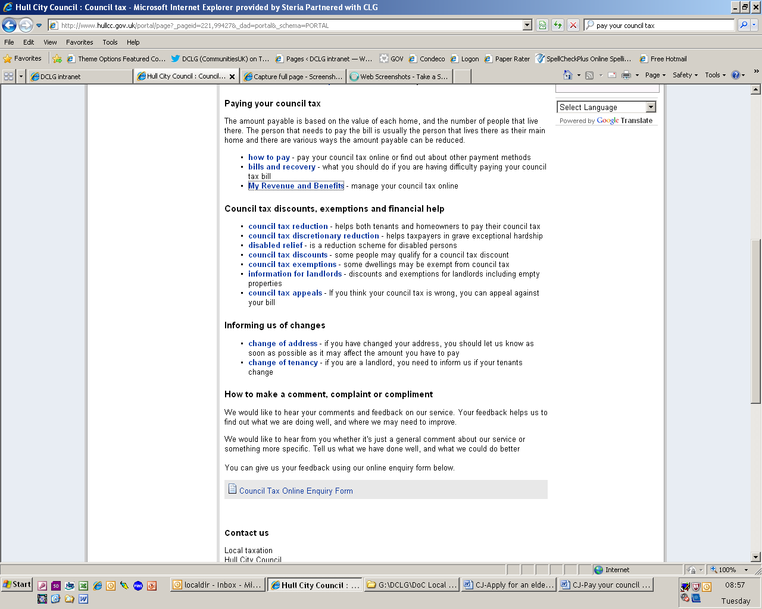
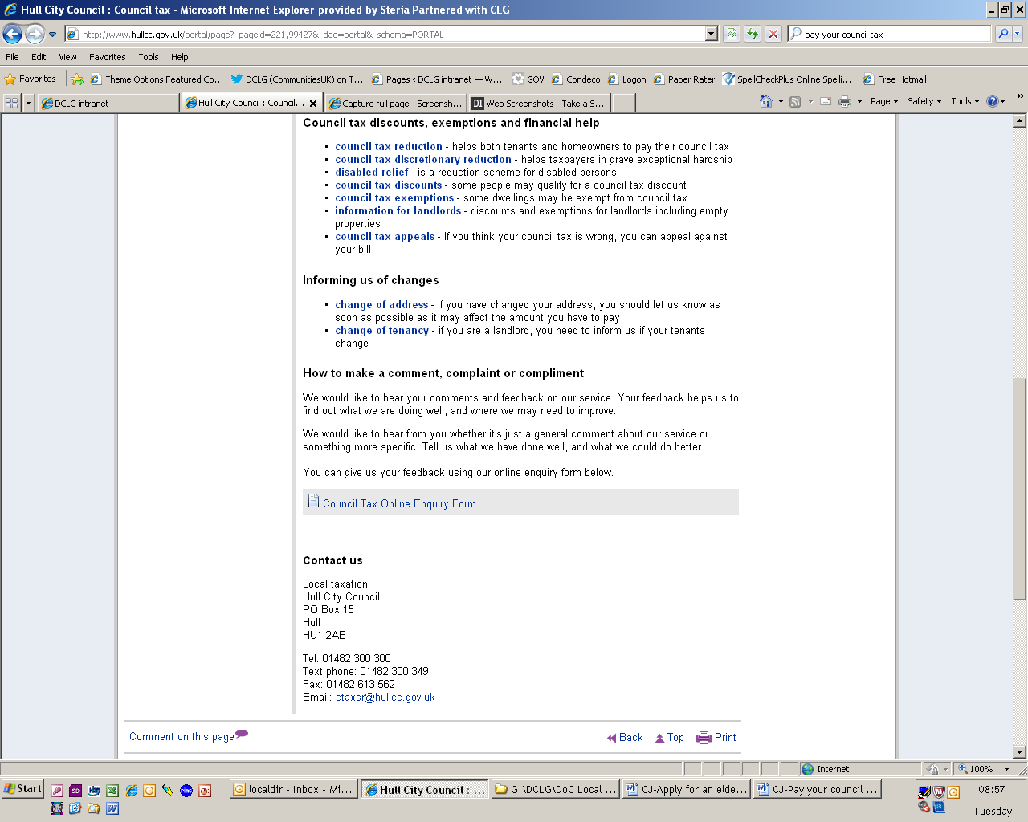

I clicked here

Customer journey: Pay my council tax – HULL COUNCIL
How I got to this page: From GOV.UK, using the postcode HU1 2AA
Page on local authority website: Page 4 of 6
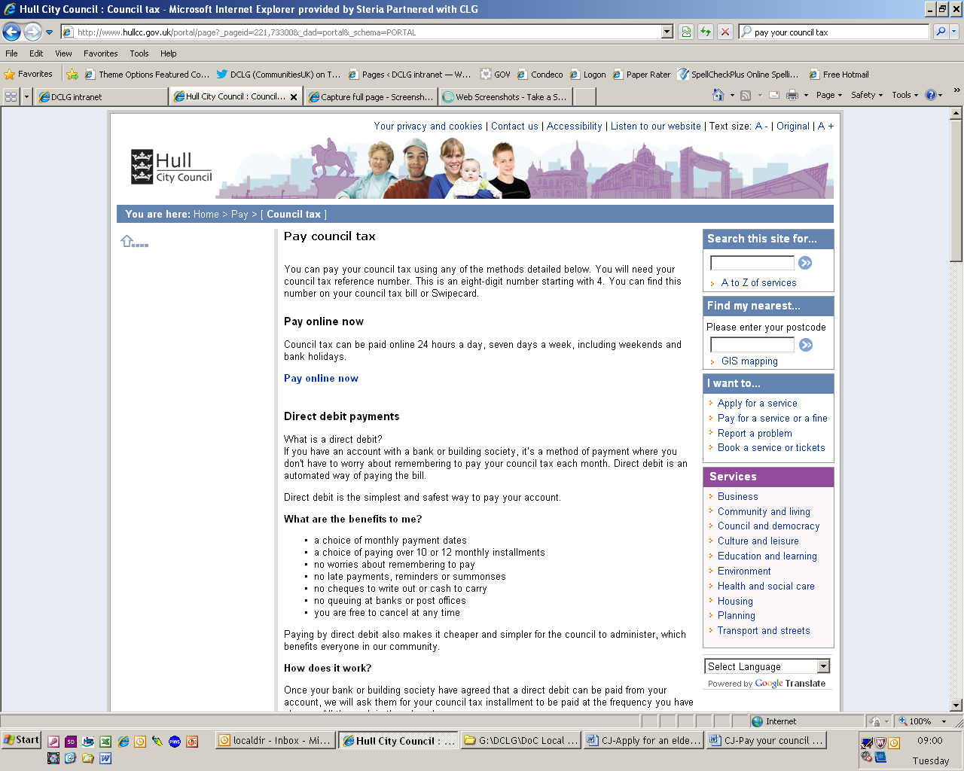
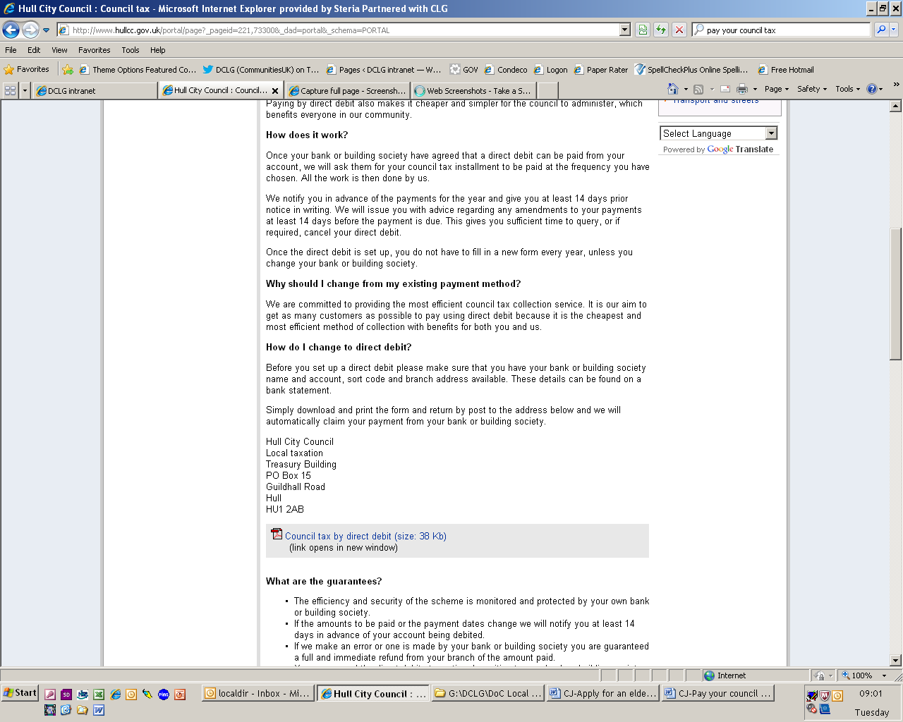

I clicked here

Customer journey: Pay my council tax – HULL COUNCIL
How I got to this page: From GOV.UK, using the postcode HU1 2AA
Page on local authority website: Page 5-6 of 6
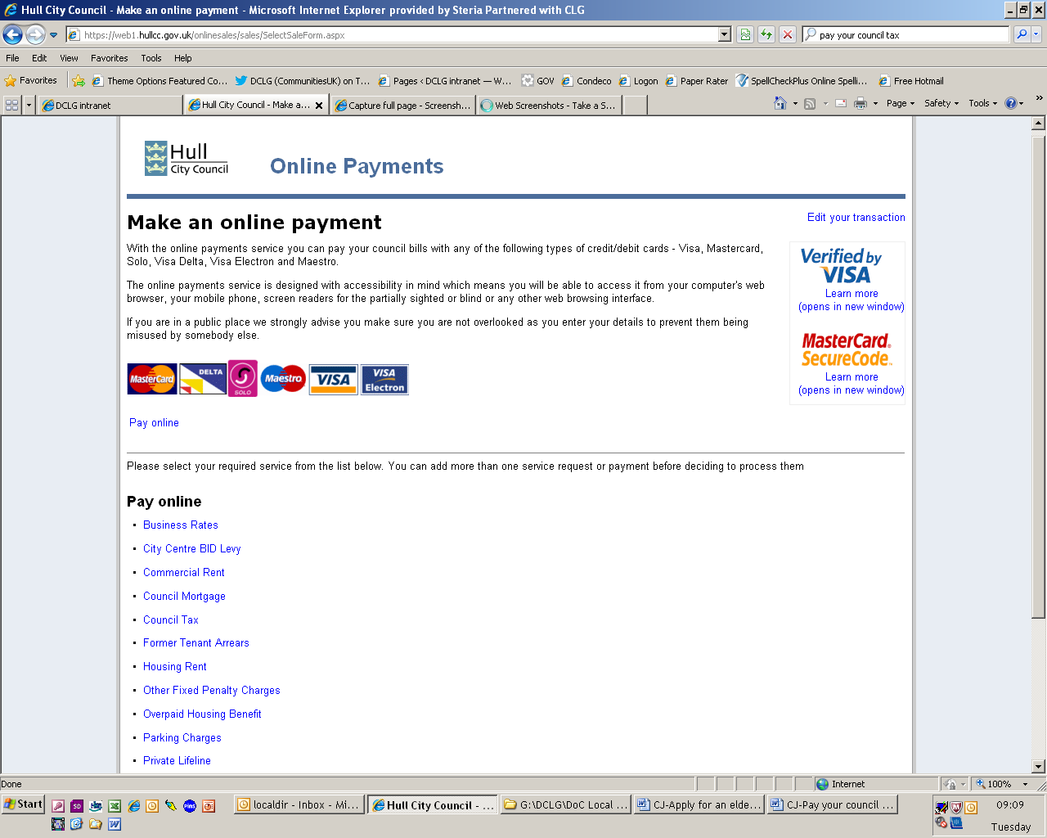
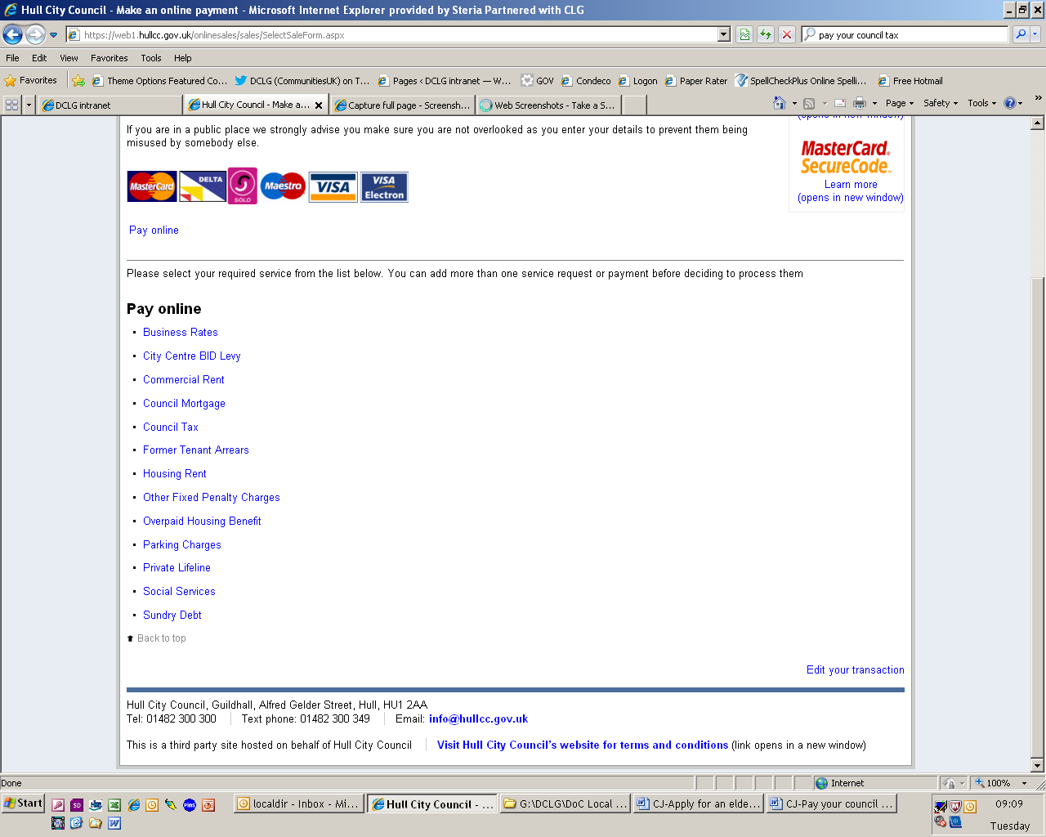

I clicked here

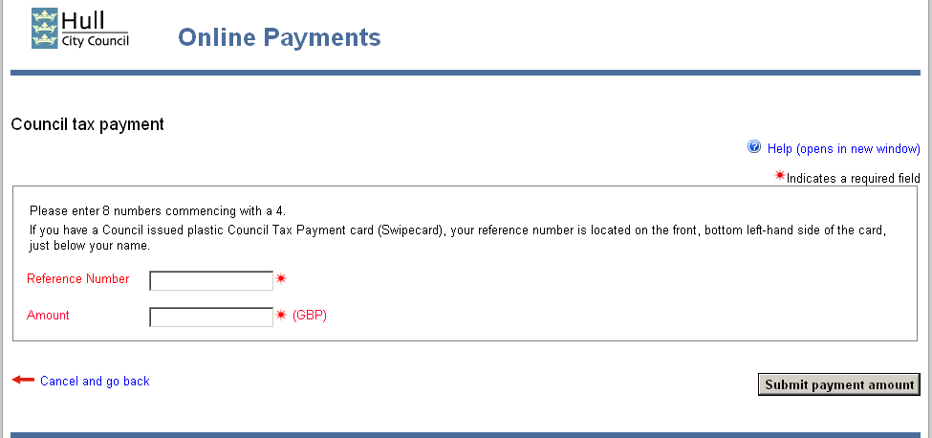
Page 6

