Customer journey: Get on the electoral register – LEEDS CITY COUNCIL
How I got to this page: From GOV.UK, using the postcode LS26 8HN
Page on local authority website: Page 1 of 3
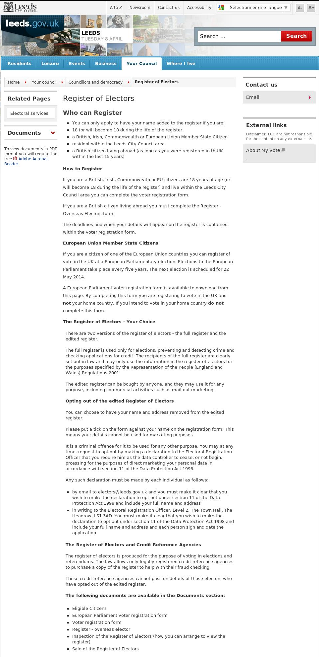

I clicked here
Customer journey: Get on the electoral register – LEEDS CITY COUNCIL
How I got to this page: From GOV.UK, using the postcode LS26 8HN
Page on local authority website: Page 2-3 of 3
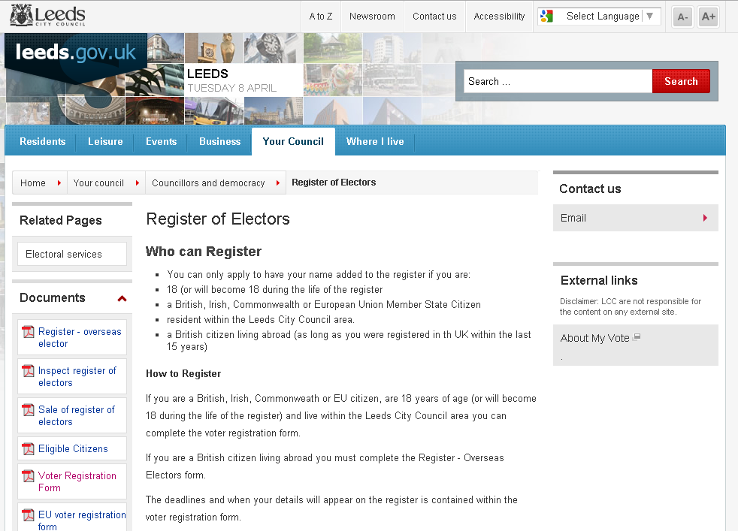

I clicked here

Page 3 of 3

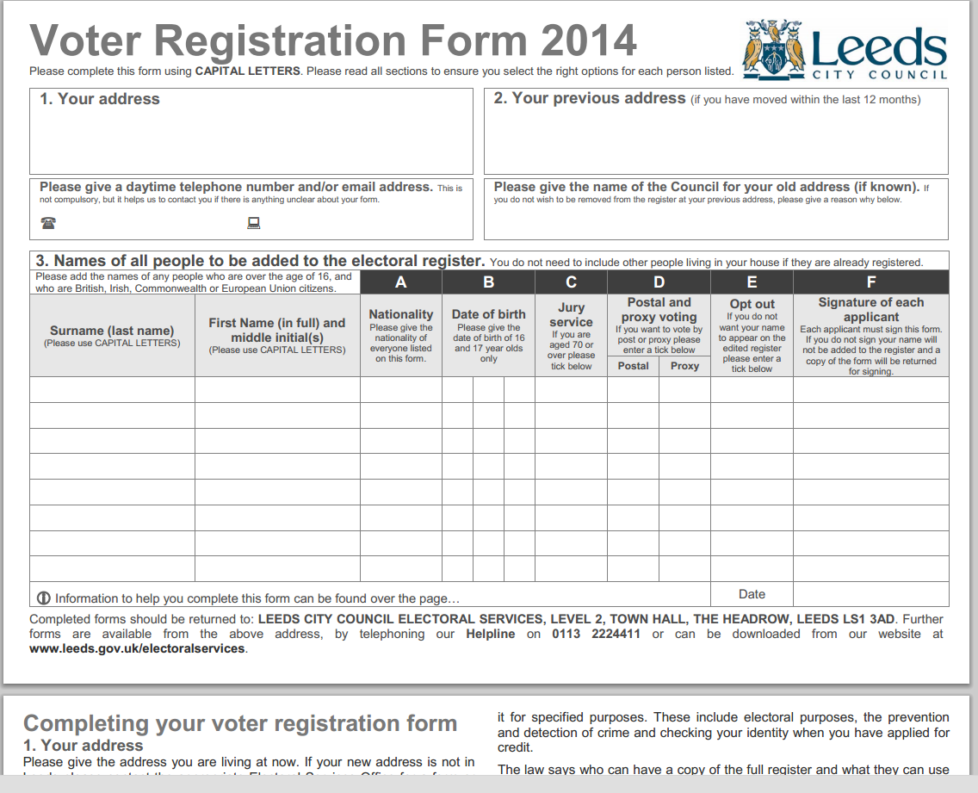

2 pages long
Customer journey: Get on the electoral register – BROADLAND DISTRICT COUNCIL
How I got to this page: From GOV.UK, using the postcode NR7 0DU
Page on local authority website: Page 1 of 1
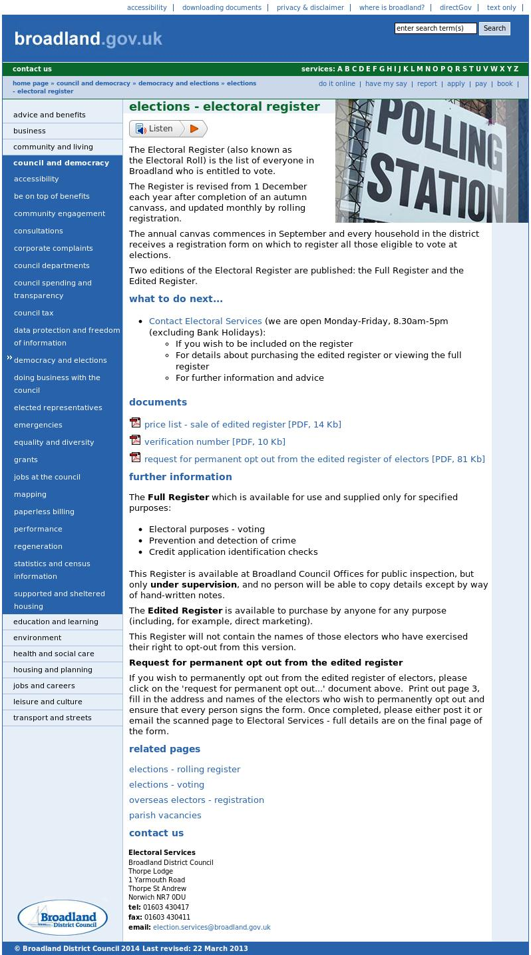
I clicked here

I clicked here – I was jumped to the bottom of the page
I arrived here
Customer journey: Get on the electoral register – OXFORD CITY COUNCIL
How I got to this page: From GOV.UK, using the postcode OX1 BX
Page on local authority website: Page 1 of 8
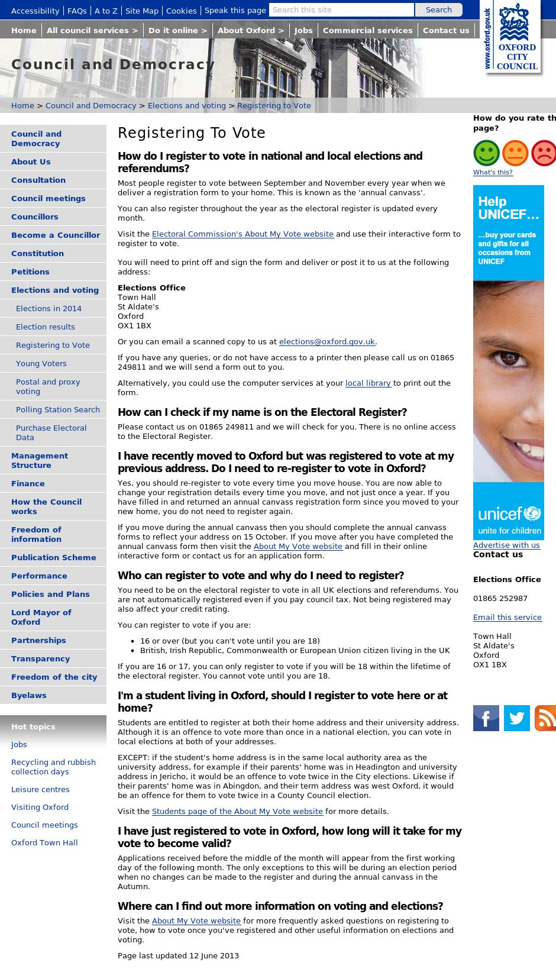

I clicked here

Customer journey: Get on the electoral register – OXFORD CITY COUNCIL
How I got to this page: From GOV.UK, using the postcode OX1 BX
Page on local authority website: Page 2 of 8
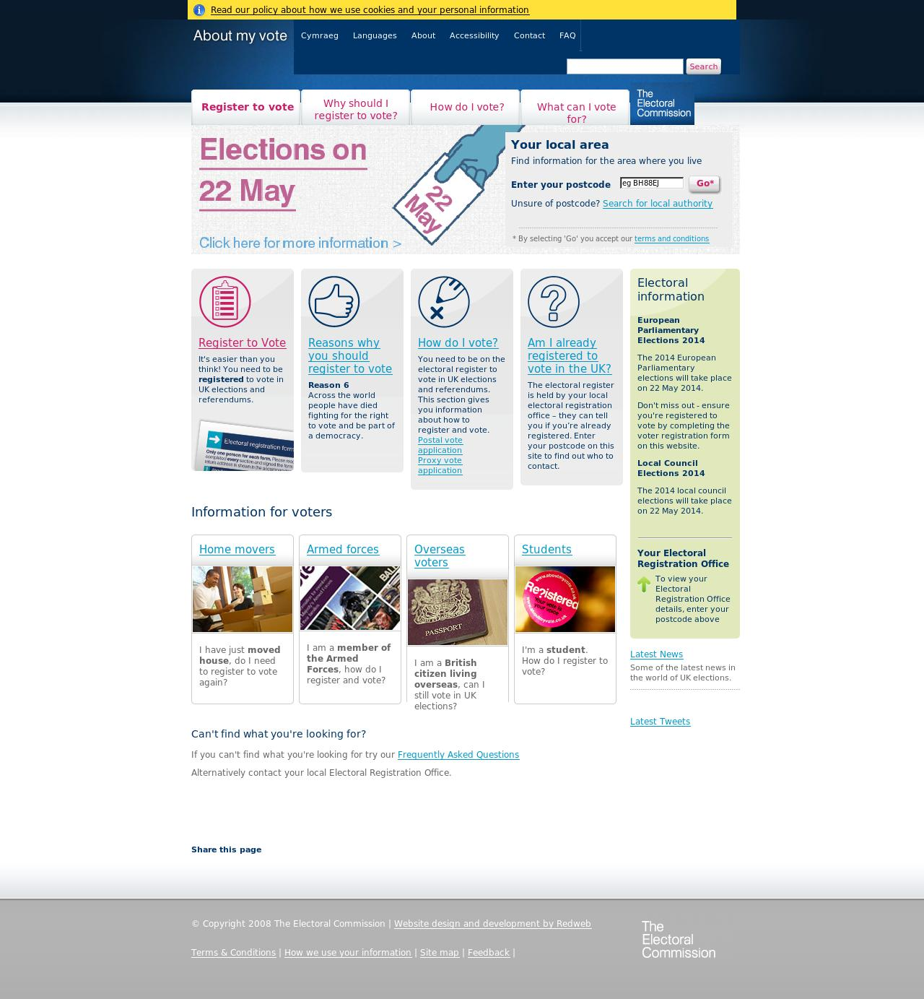
I clicked here
Customer journey: Get on the electoral register – OXFORD CITY COUNCIL
How I got to this page: From GOV.UK, using the postcode OX1 BX
Page on local authority website: Page 3 of 8
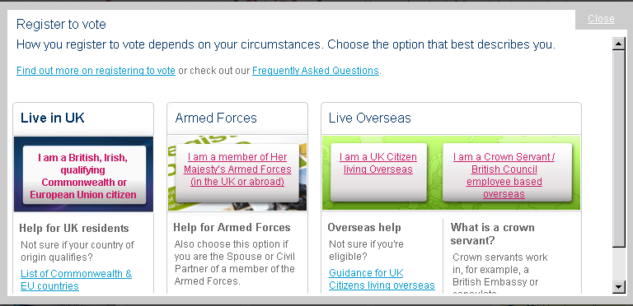

I clicked here

Page 4 of 8
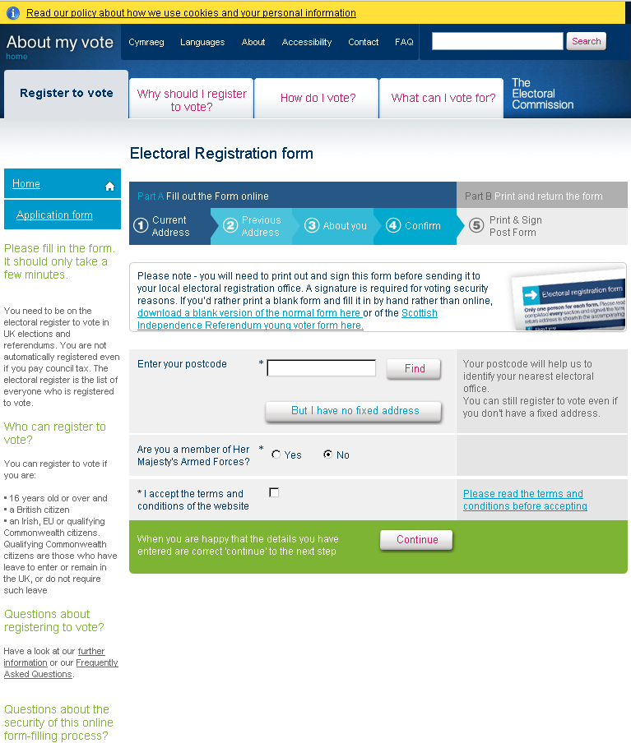

I entered my postcode

Customer journey: Get on the electoral register – OXFORD CITY COUNCIL
How I got to this page: From GOV.UK, using the postcode OX1 BX
Page on local authority website: Page 5 of 8
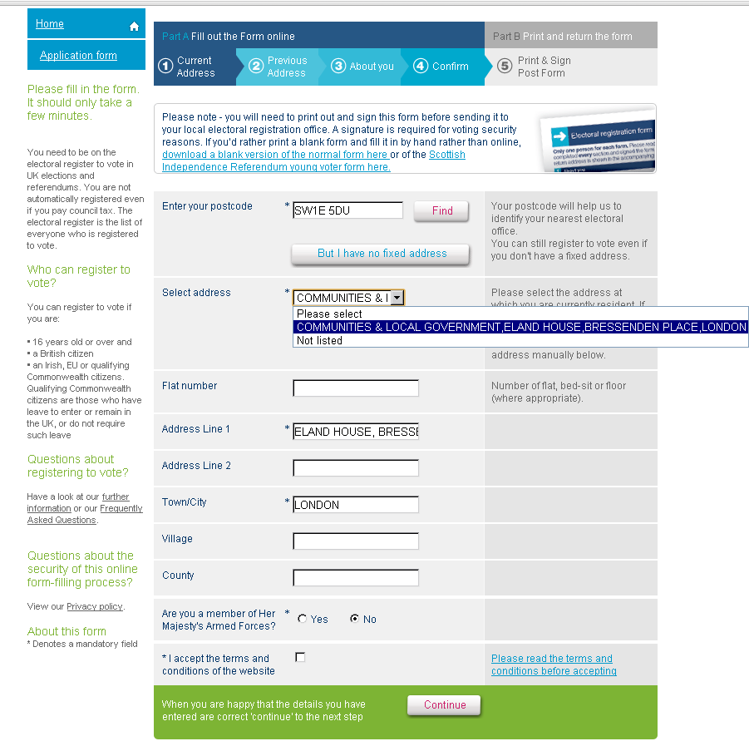

I selected my address

Page 6 of 8
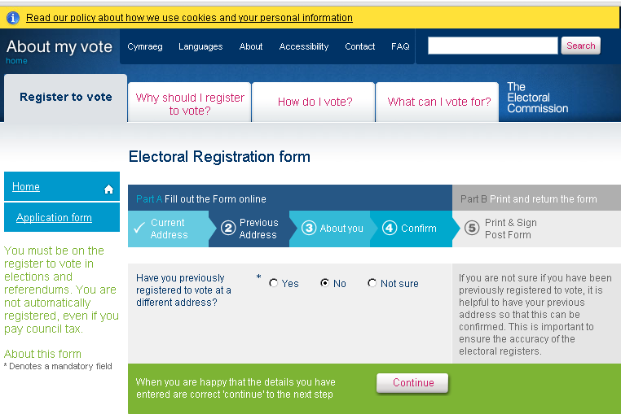

I clicked here

Customer journey: Get on the electoral register – OXFORD CITY COUNCIL
How I got to this page: From GOV.UK, using the postcode OX1 BX
Page on local authority website: Page 7 of 8
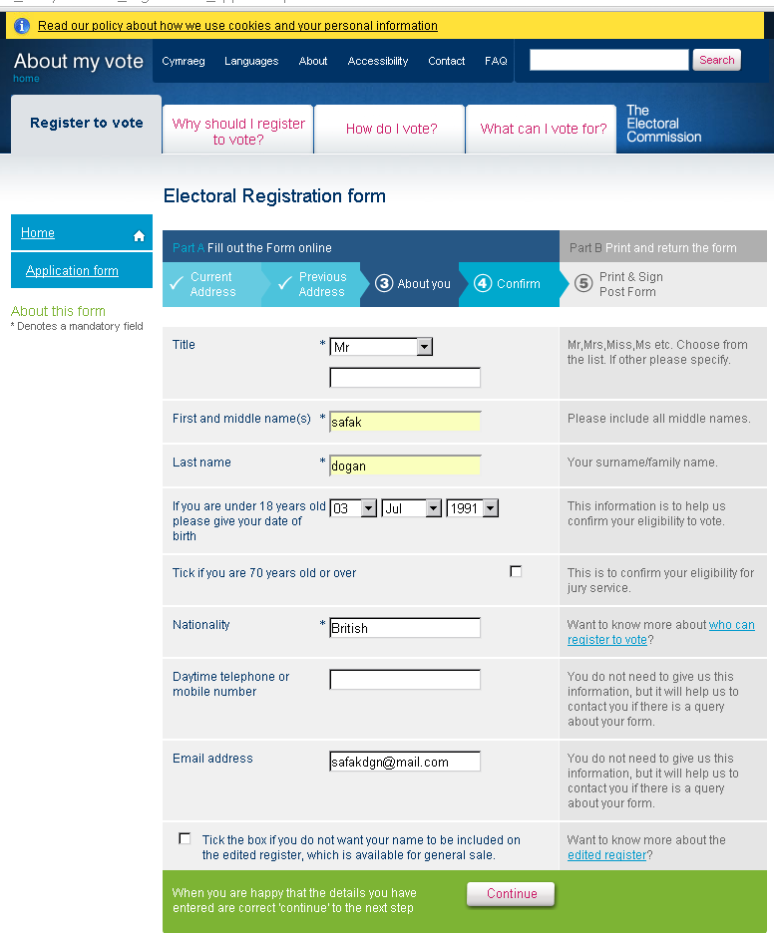

I filled in my details then hit continue

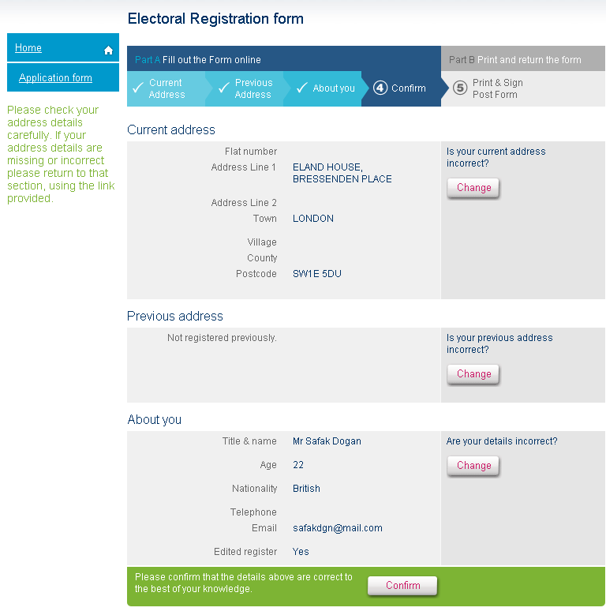
Page 8 of 8

