Customer journey: Apply for a job at your local council – HARTLEPOOL
How I got to this page: From GOOGLE, using the search term ‘Apply job at Hartlepool council’
Page on local authority website: Page 1 of 4

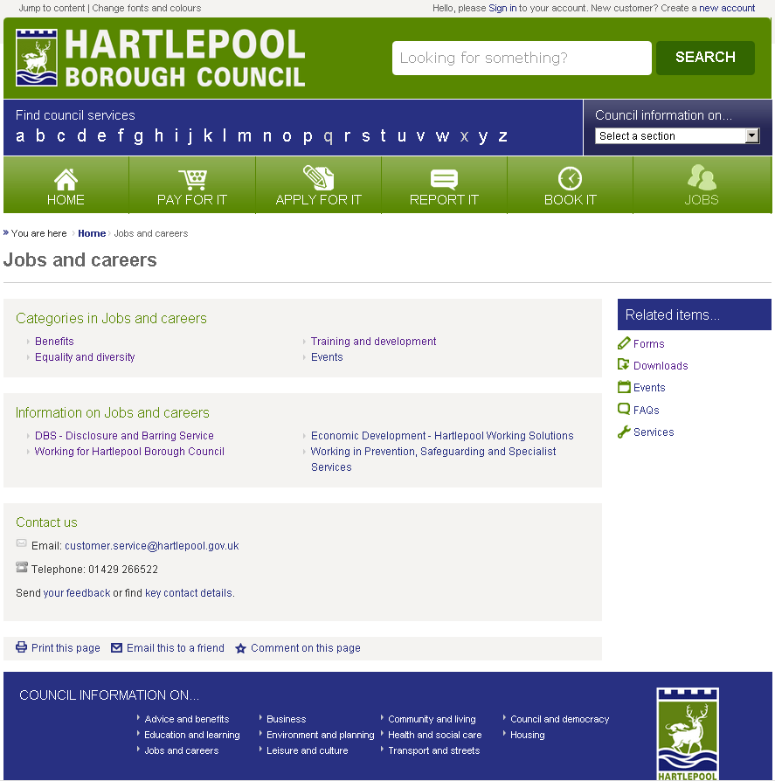
Unsure where to click. Tried clicking here.
Customer journey: Apply for a job at your local council – HARTLEPOOL
How I got to this page: From GOOGLE, using the search term ‘Apply job at Hartlepool council’
Page on local authority website: Page 2 of 4

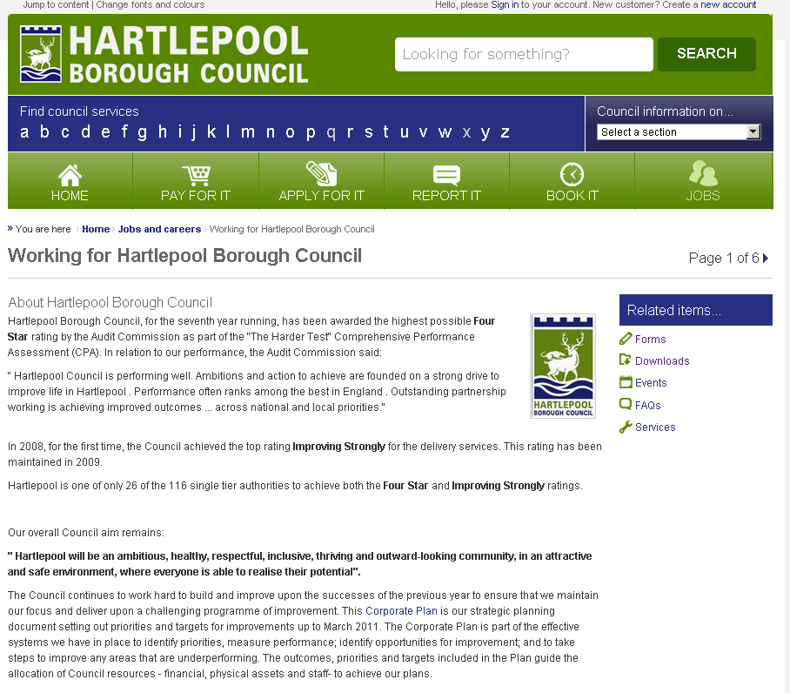
No jobs here so went back to previous page and clicked on ‘Benefits’
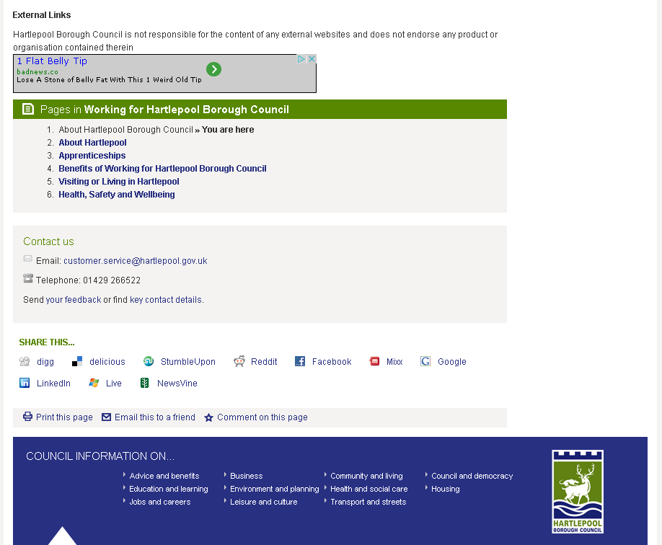

Customer journey: Apply for a job at your local council – HARTLEPOOL
How I got to this page: From GOOGLE, using the search term ‘Apply job at Hartlepool council’
Page on local authority website: Page 3 of 4

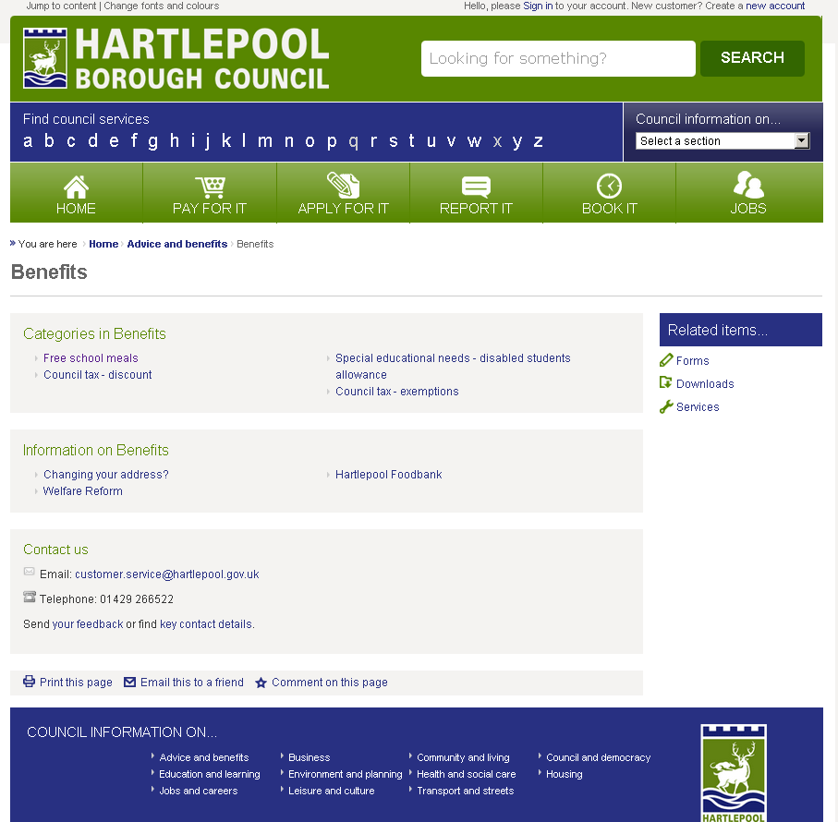
Wrong page, so went back to previous page and clicked on ‘Equality and diversity’
Customer journey: Apply for a job at your local council – HARTLEPOOL
How I got to this page: From GOOGLE, using the search term ‘Apply job at Hartlepool council’
Page on local authority website: Page 4 of 4

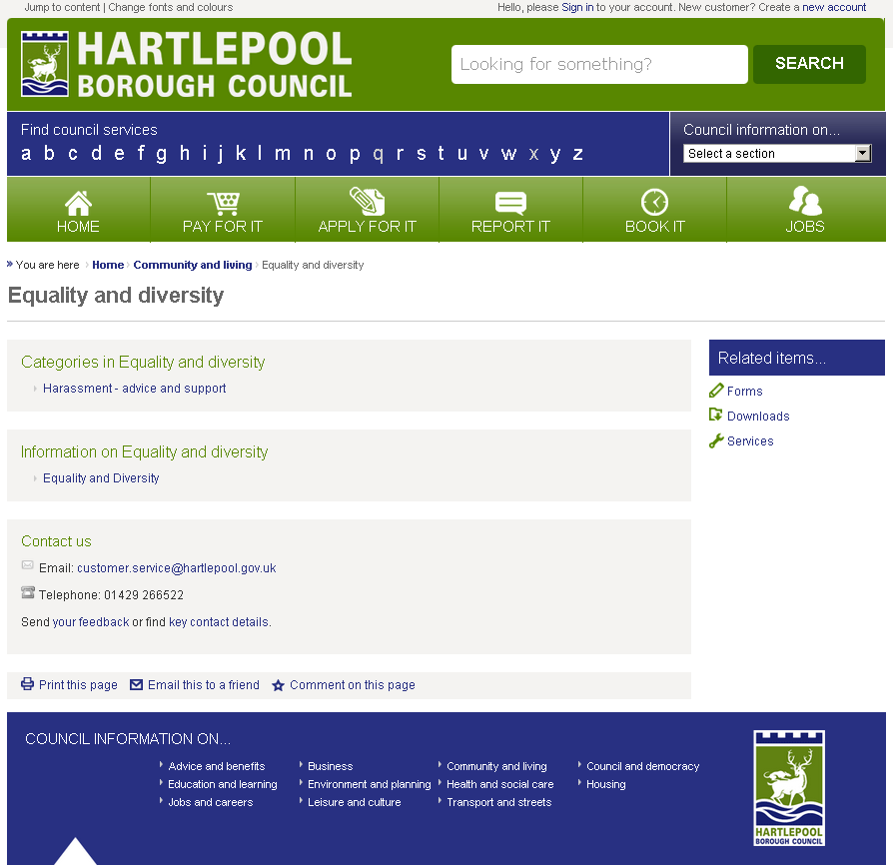
Came to conclusion there are no jobs at Hartlepool!

Customer journey: Apply for a job at your local council – LIVERPOOL
How I got to this page: From GOOGLE, using the search term ‘Apply job at Liverpool council’
Page on local authority website: Page 1 of 4

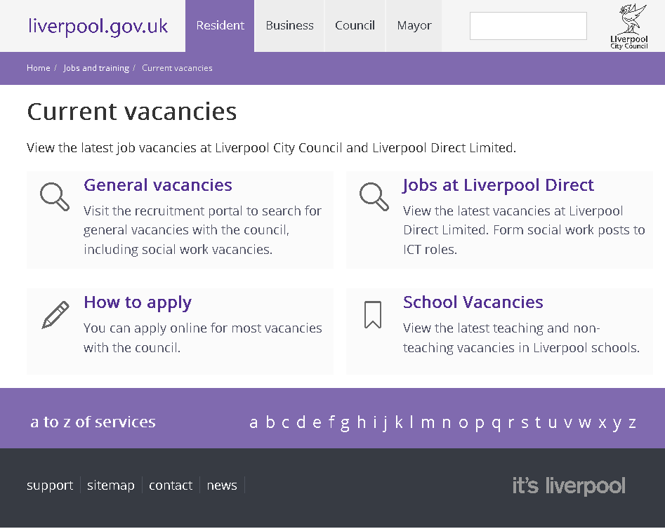
I clicked here

Customer journey: Apply for a job at your local council – LIVERPOOL
How I got to this page: From GOOGLE, using the search term ‘Apply job at Liverpool council’
Page on local authority website: Page 2 of 4

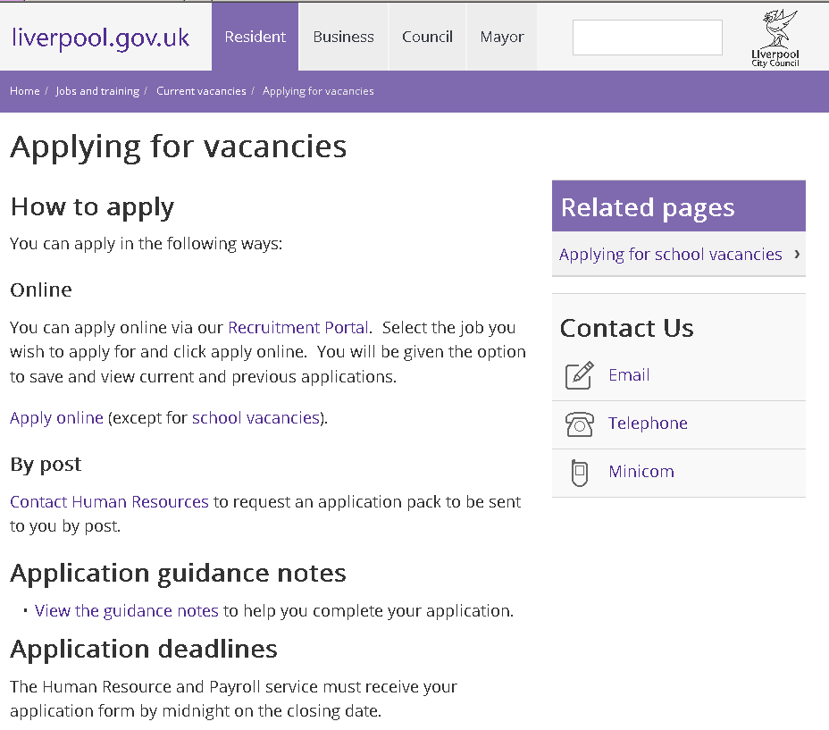
I clicked here

Customer journey: Apply for a job at your local council – LIVERPOOL
How I got to this page: From GOOGLE, using the search term ‘Apply job at Liverpool council’
Page on local authority website: Page 3 of 4

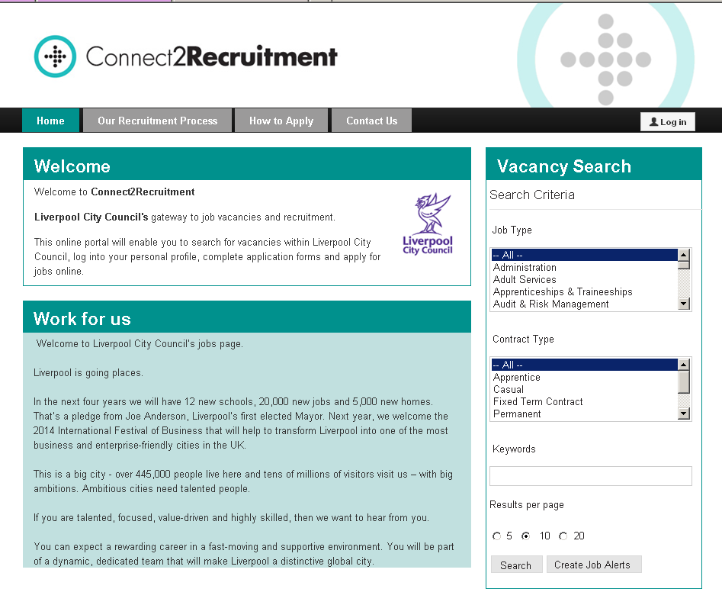
I clicked on search

Customer journey: Apply for a job at your local council – LIVERPOOL
How I got to this page: From GOOGLE, using the search term ‘Apply job at Liverpool council’
Page on local authority website: Page 4 of 4

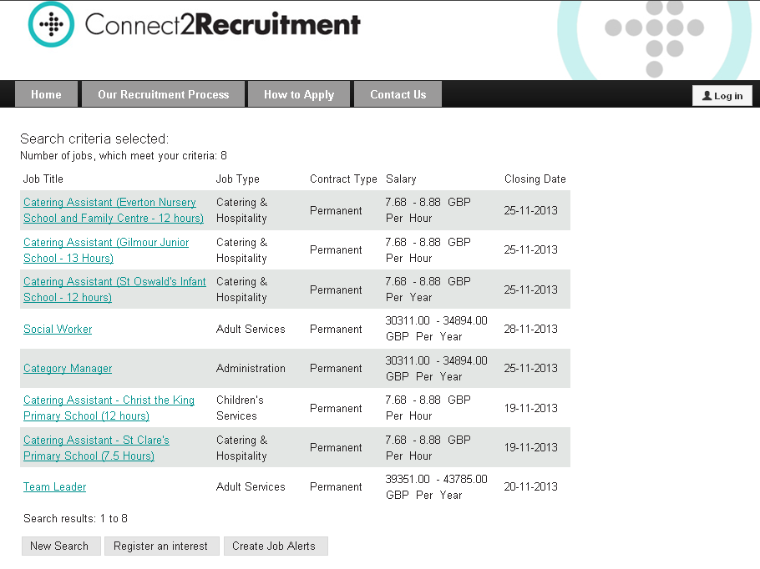
Customer journey: Apply for a job at your local council – STOCKPORT
How I got to this page: From GOOGLE, using the search term ‘Apply job at Stockport council’
Page on local authority website: Page 1 of 1

