Customer journey: Apply for a taxi licence – ST ALBANS COUNCIL
How I got to this page: From GOOGLE, using the search term ‘Apply taxi licence st albans’
Page on local authority website: Page 1 of 2

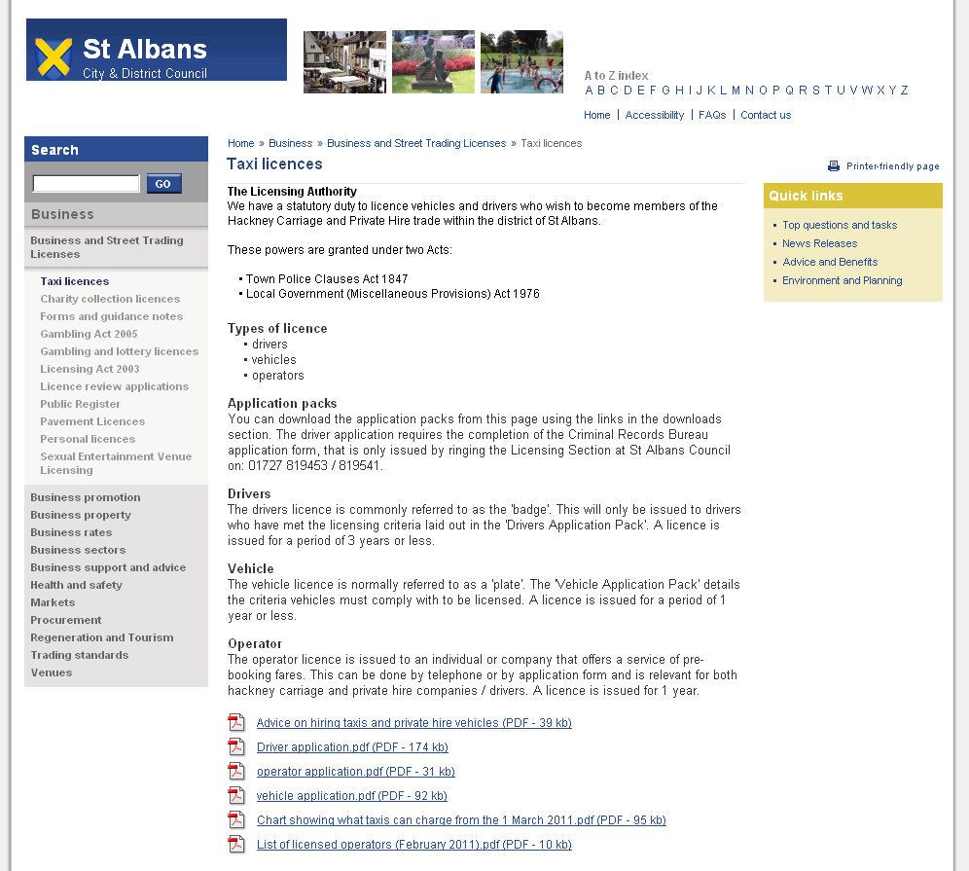
Which would you choose?
Customer journey: Apply for a taxi licence – ST ALBANS COUNCIL
How I got to this page: From GOOGLE, using the search term ‘Apply taxi licence st albans’
Page on local authority website: Page 2 of 2

I clicked on ‘Driver application pdf’

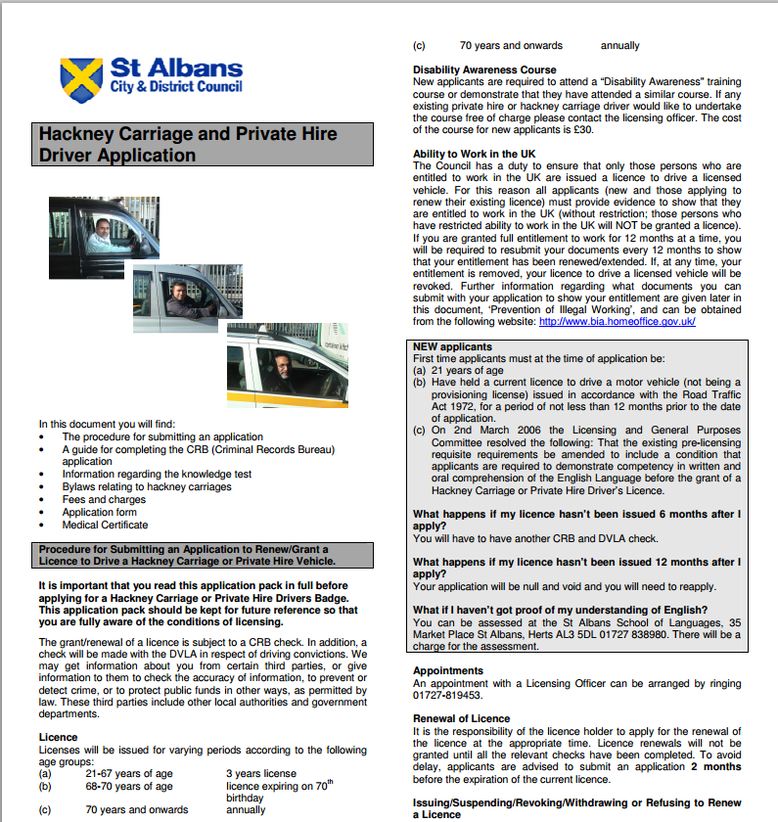
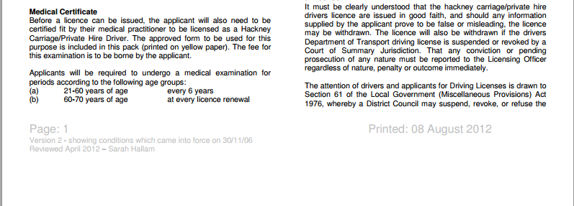
This document carries on for another 17 pages
Customer journey: Apply for a taxi licence – BIRMINGHAM COUNCIL
How I got to this page: From GOOGLE, using the search term ‘Apply taxi licence birmingham’
Page on local authority website: Page 1 of 3

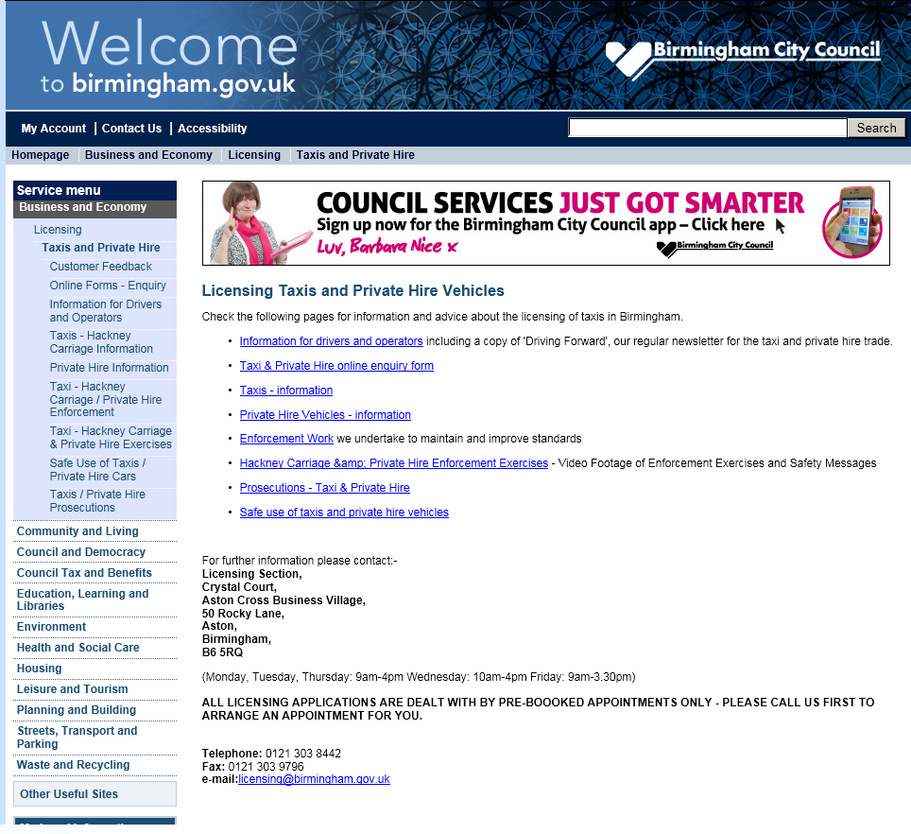
It’s so difficult to know what to choose, I’d be tempted just to phone or email (details at bottom of page).

In the end, I clicked ‘Information for drivers and operators’

Customer journey: Apply for a taxi licence – BIRMINGHAM COUNCIL
How I got to this page: From GOOGLE, using the search term ‘Apply taxi licence birmingham’
Page on local authority website: Page 2 of 3

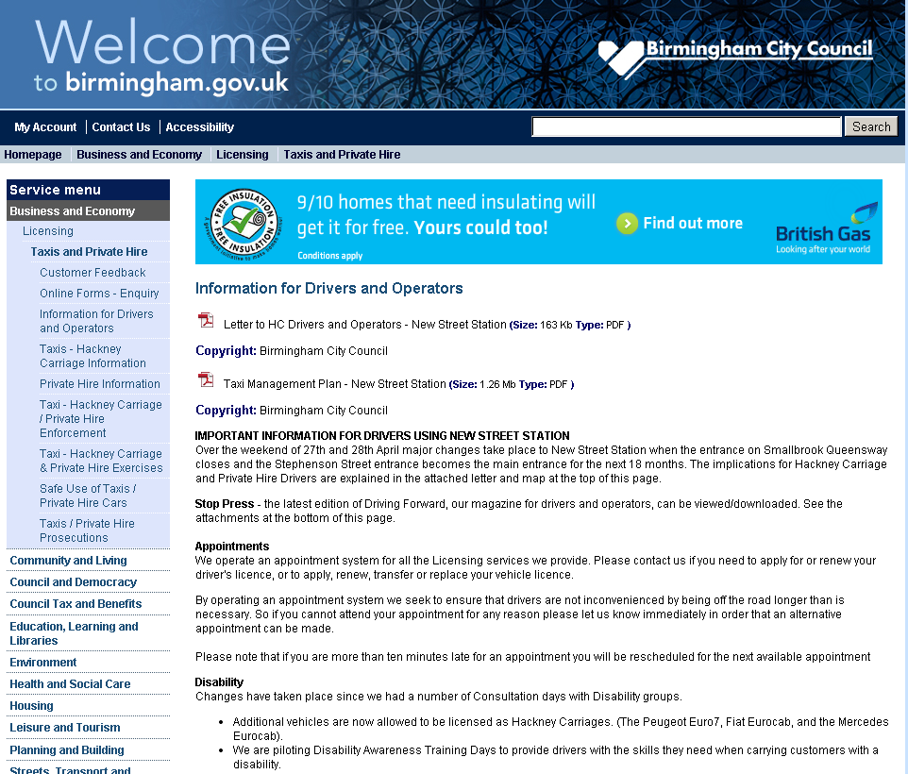
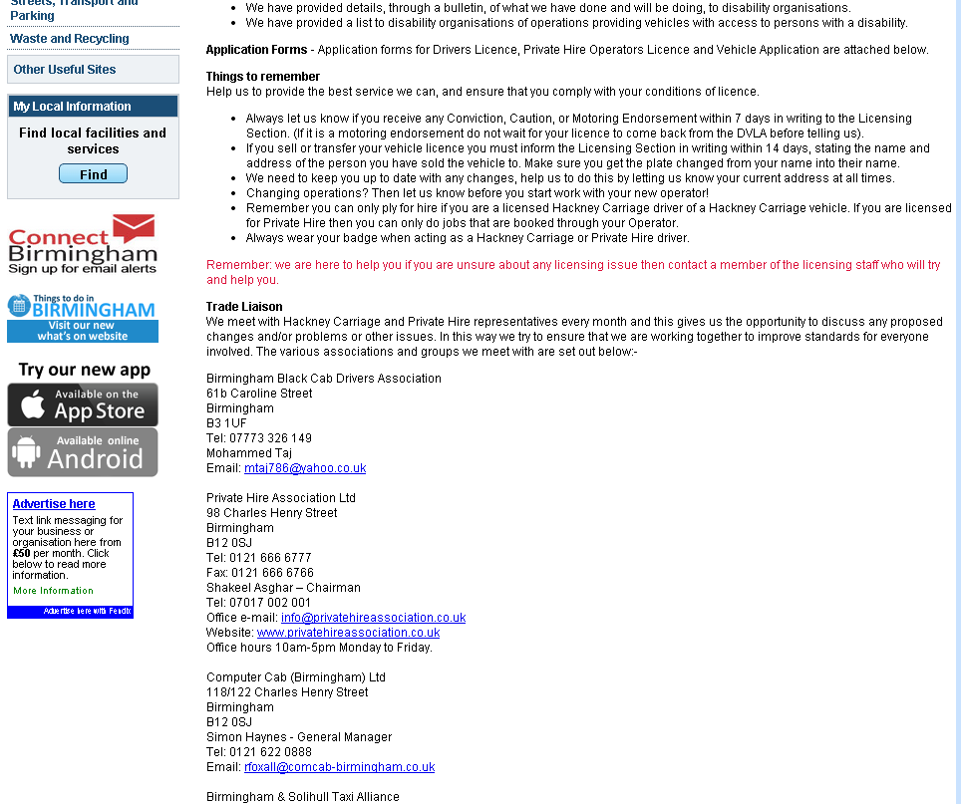

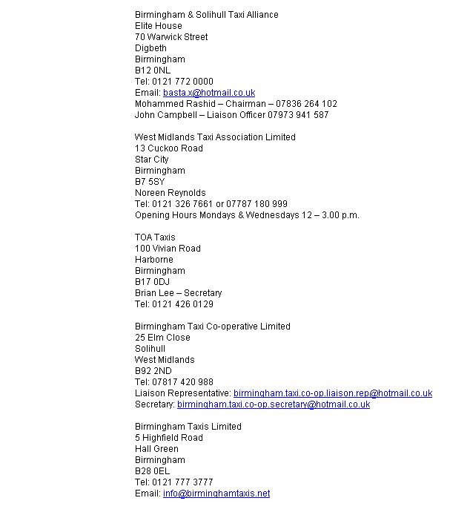
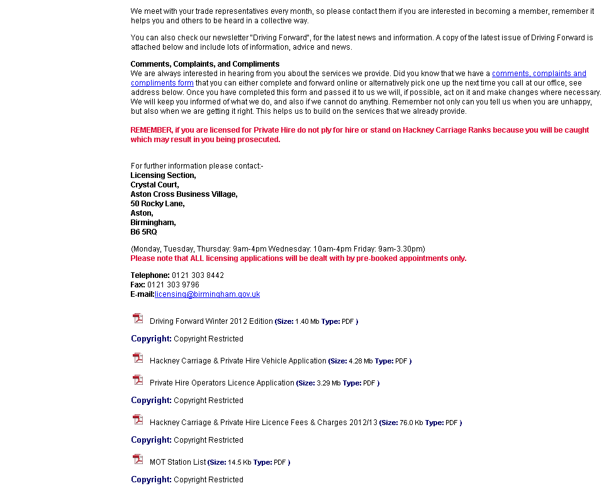
I clicked here
Customer journey: Apply for a taxi licence – BIRMINGHAM COUNCIL
How I got to this page: From GOOGLE, using the search term ‘Apply taxi licence birmingham’
Page on local authority website: Page 3 of 3

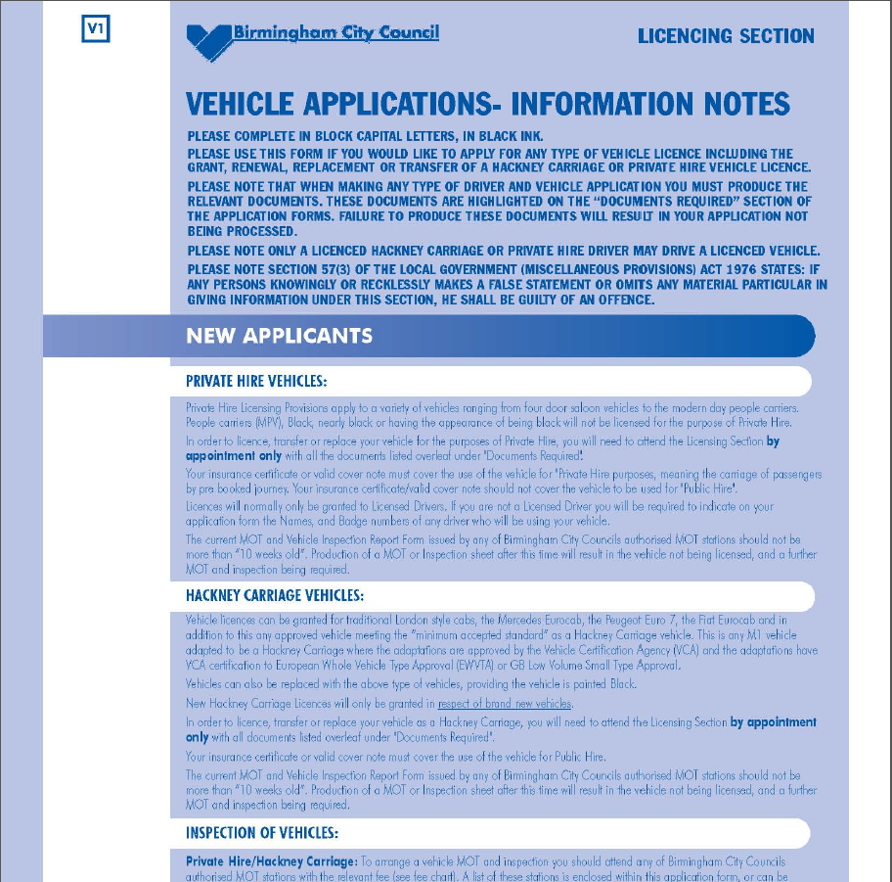
This document carries on for another 11 pages
Customer journey: Apply for a taxi licence – MELTON MOWBRAY COUNCIL
How I got to this page: From GOOGLE, using the search term ‘Apply taxi licence melton mowbray’
Page on local authority website: Page 1 of 3

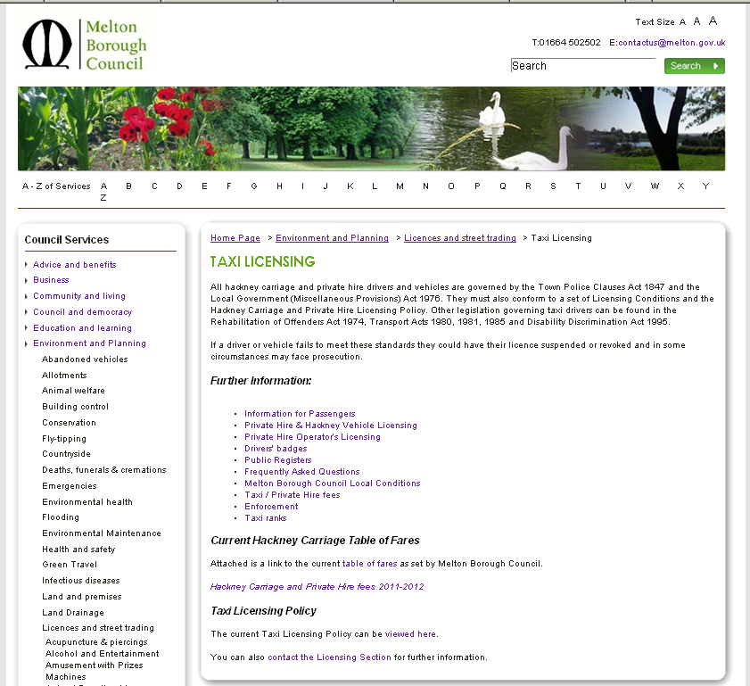
I clicked here
Customer journey: Apply for a taxi licence – MELTON MOWBRAY COUNCIL
How I got to this page: From GOOGLE, using the search term ‘Apply taxi licence melton mowbray’
Page on local authority website: Page 2 of 3

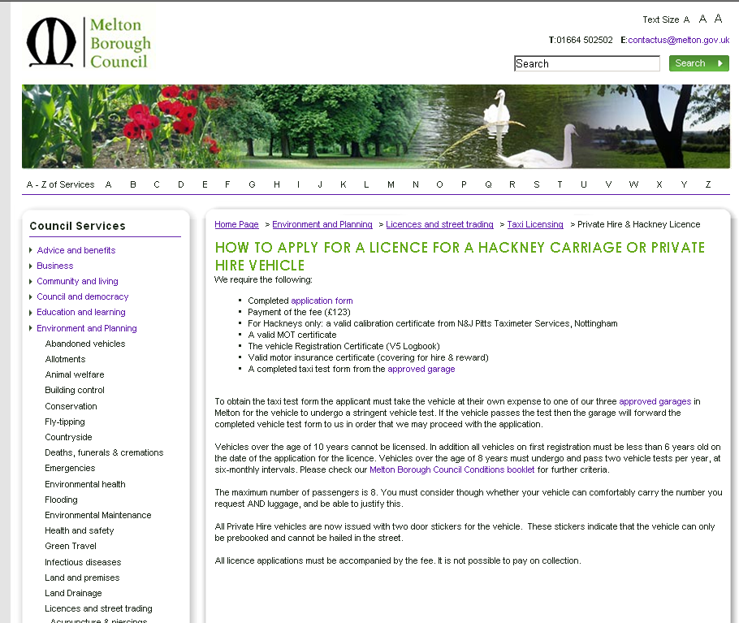
I clicked here

Customer journey: Apply for a taxi licence – MELTON MOWBRAY COUNCIL
How I got to this page: From GOOGLE, using the search term ‘Apply taxi licence melton mowbray’
Page on local authority website: Page 3 of 3

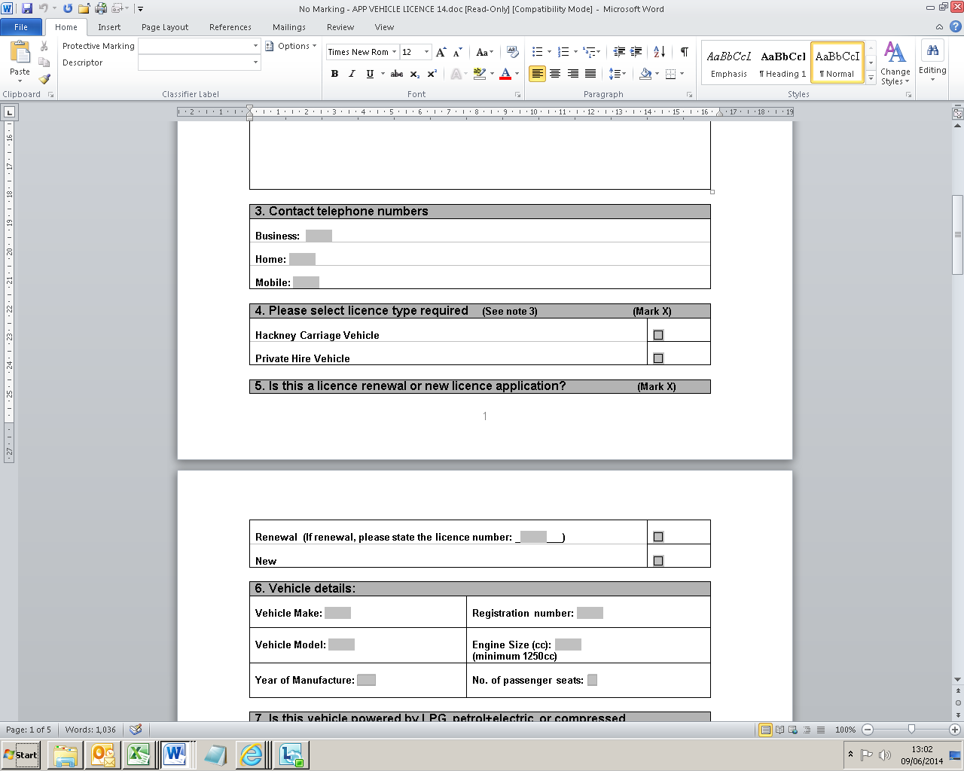
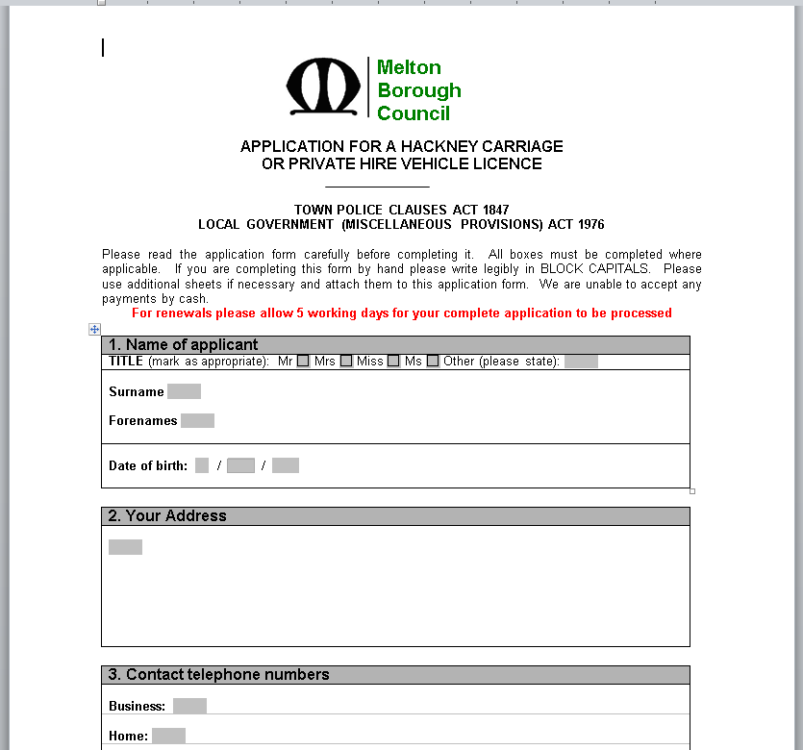
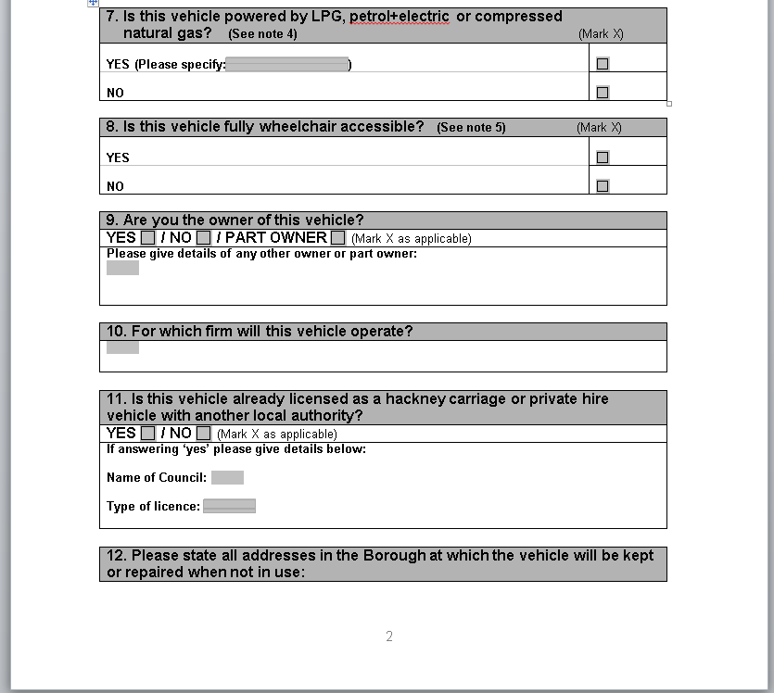
This document carries on for another 3 pages
This document carries on for another 3 pages

