Customer journey: Apply for an older person's bus pass – CALDERDALE COUNCIL
How I got to this page: From GOV.UK, using postcode HX1 1UJ
Page on council website: Page 1 of 1

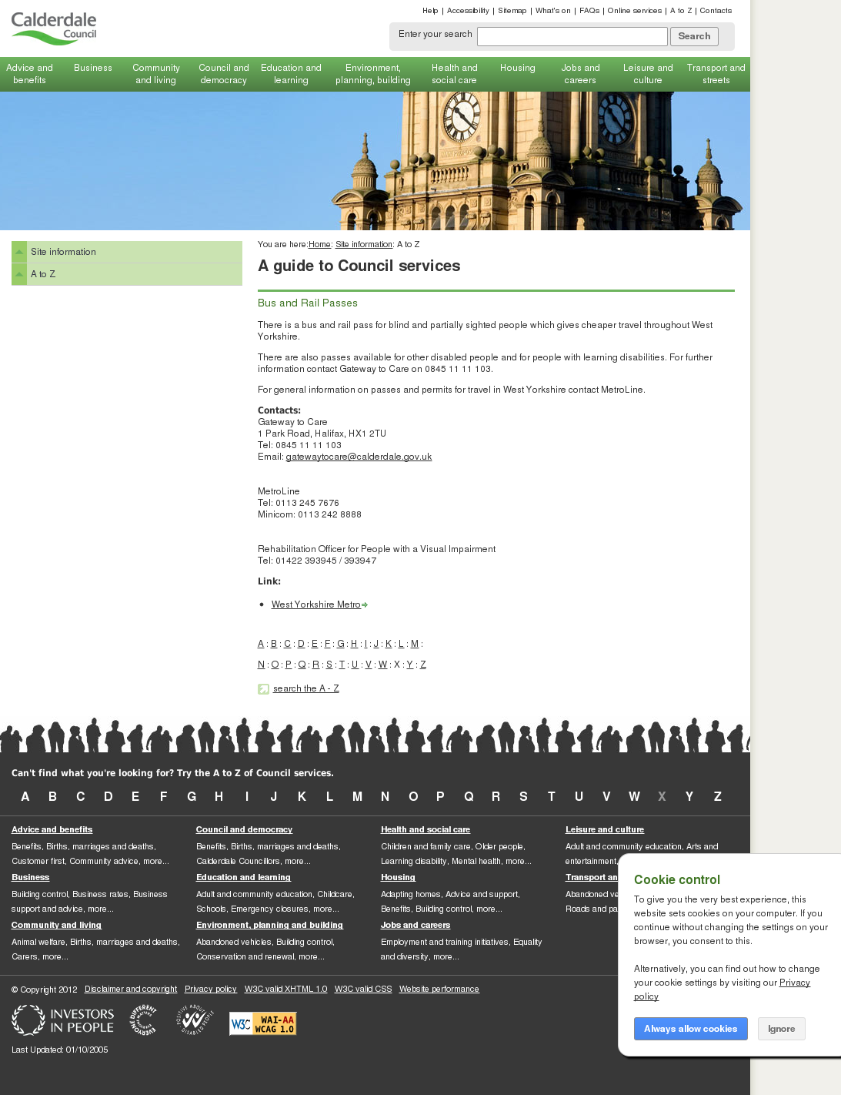

Customer journey: Apply for an older person's bus pass – CITY OF YORK
How I got to this page: From GOV.UK, using postcode YO1 7DU
Page on council website: Page 1 of 3

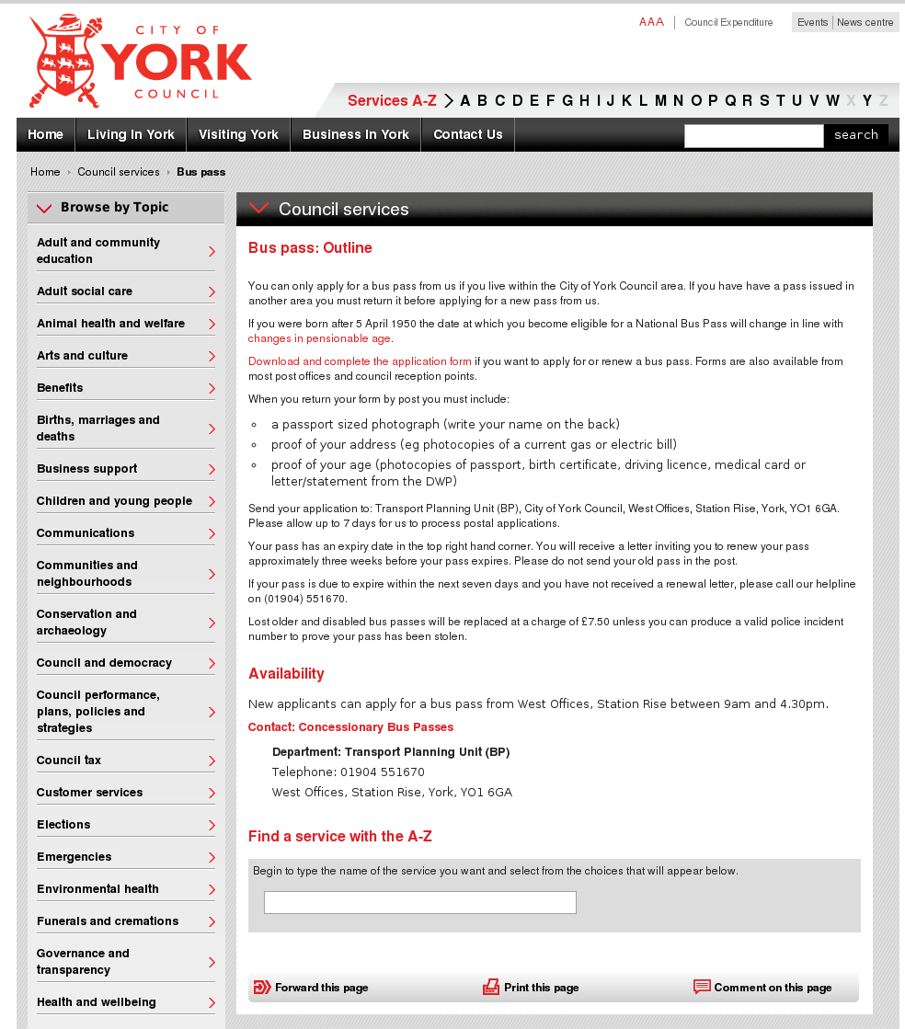

I clicked here

Customer journey: Apply for an older person's bus pass – CITY OF YORK
How I got to this page: From GOV.UK, using postcode YO1 7DU
Page on council website: Page 2 of 3
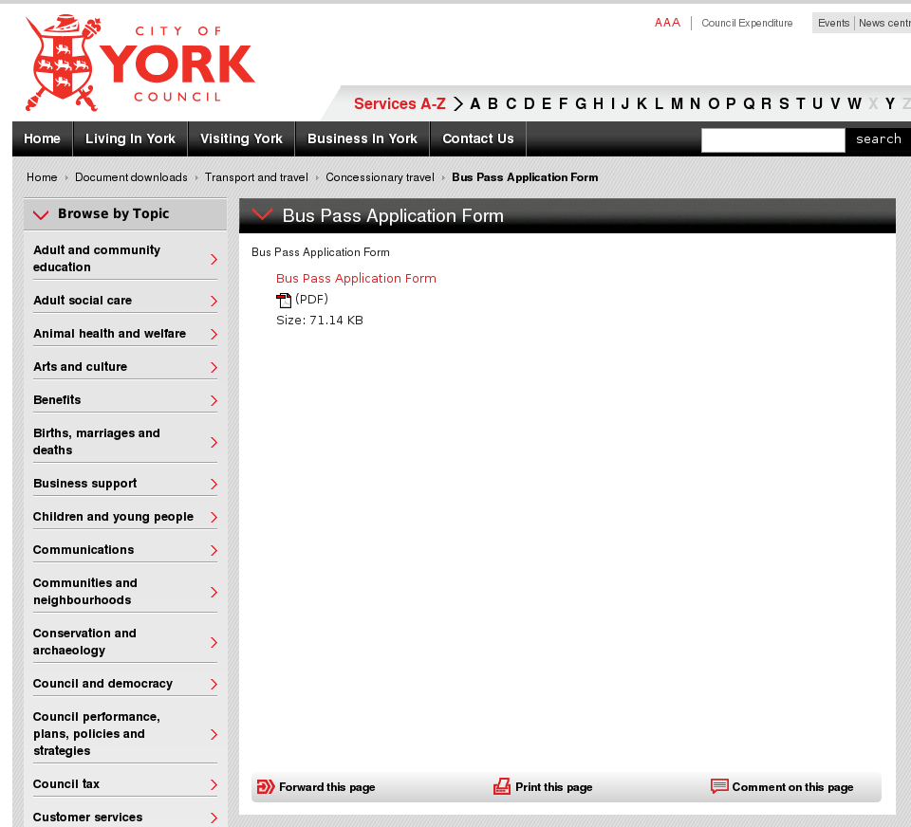

I clicked here

Customer journey: Apply for an older person's bus pass – CITY OF YORK
How I got to this page: From GOV.UK, using postcode YO1 7DU
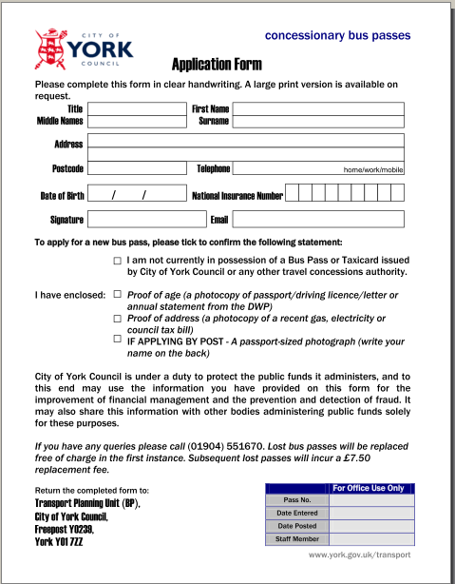
Page on council website: Page 3 of 3

Customer journey: Apply for an older person's bus pass – BIRMINGHAM CITY COUNCIL
How I got to this page: From GOV.UK, using postcode B1 1BB
Page on council website: Page 1 of 5
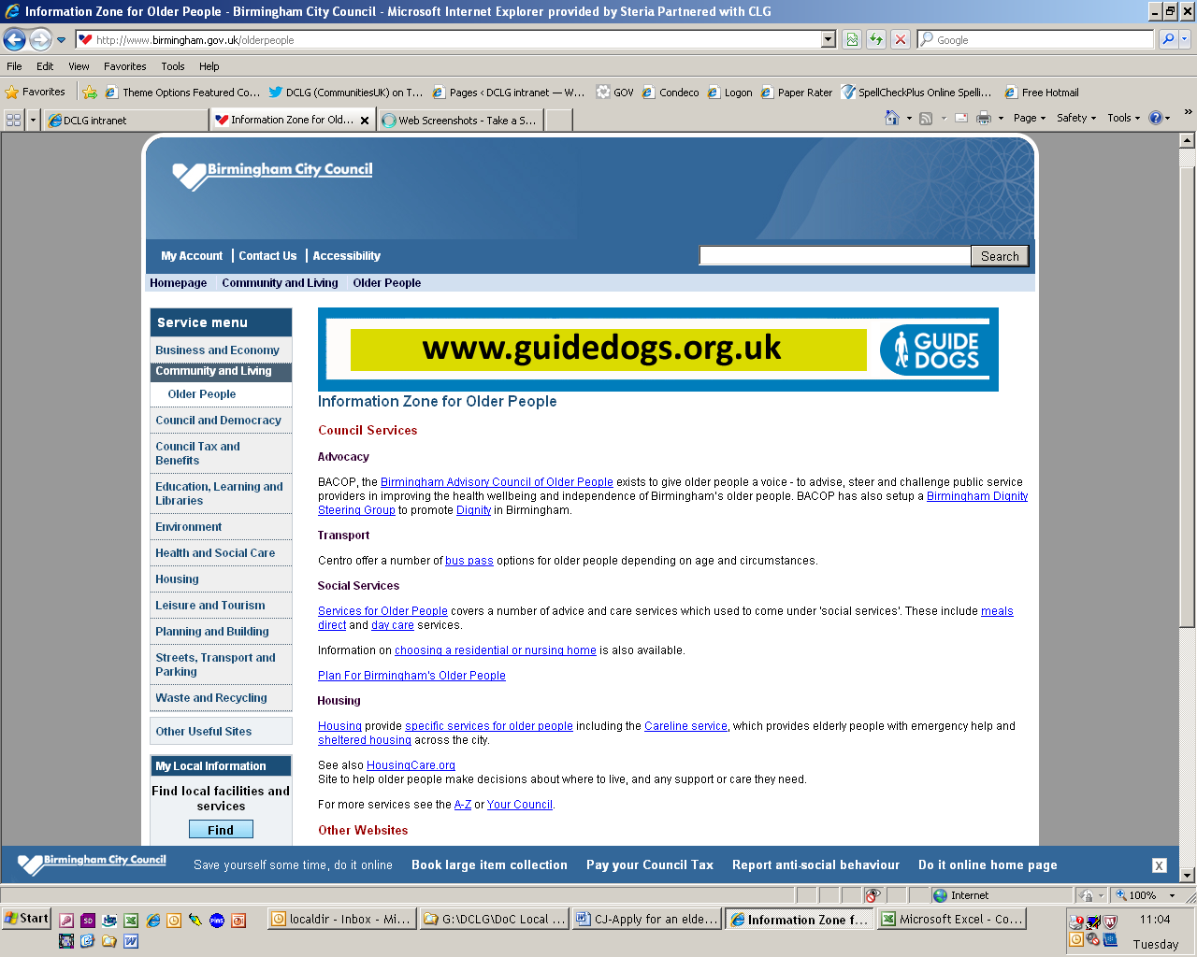
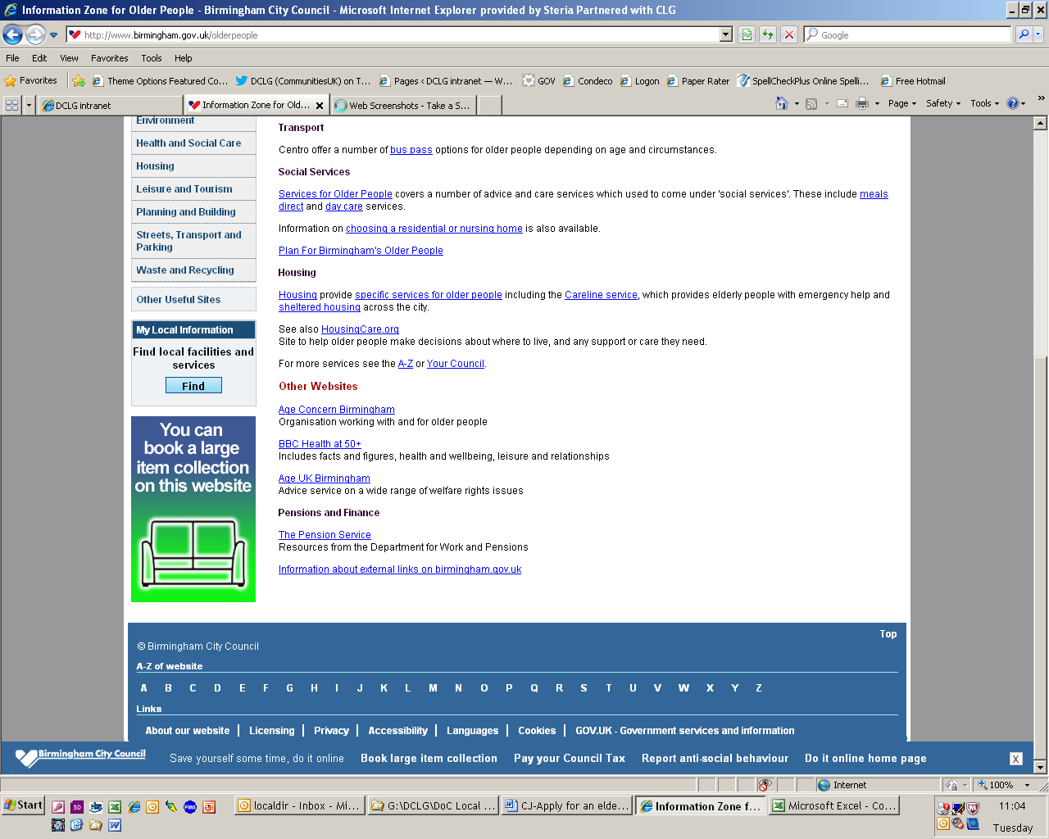

I clicked here

Customer journey: Apply for an older person's bus pass – BIRMINGHAM CITY COUNCIL
How I got to this page: From GOV.UK, using postcode B1 1BB
Page on council website: Page 2 of 5

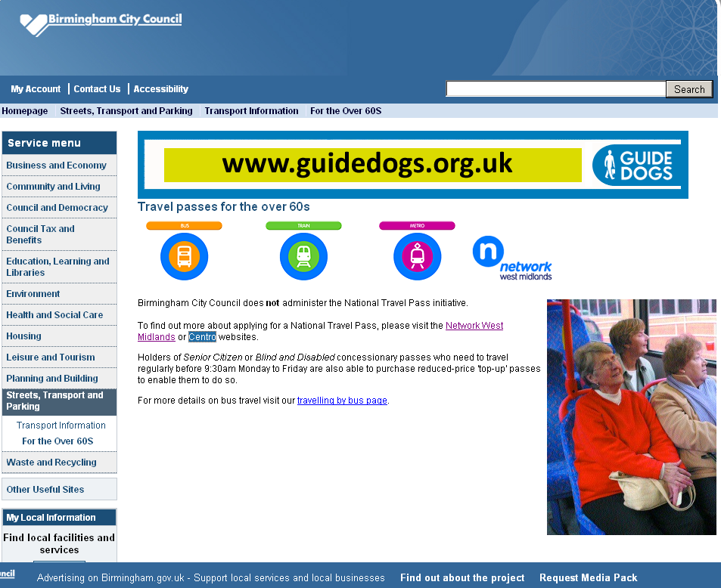

I clicked here

Customer journey: Apply for an older person's bus pass – BIRMINGHAM CITY COUNCIL
How I got to this page: From GOV.UK, using postcode B1 1BB
Page on council website: Page 3 of 5

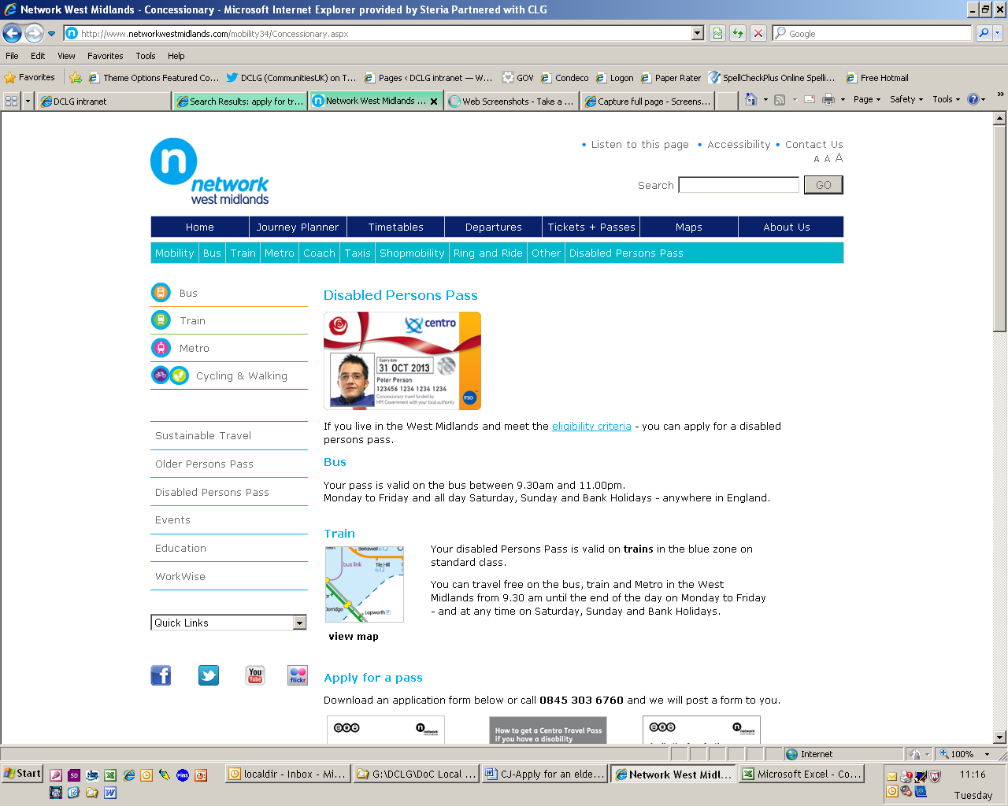
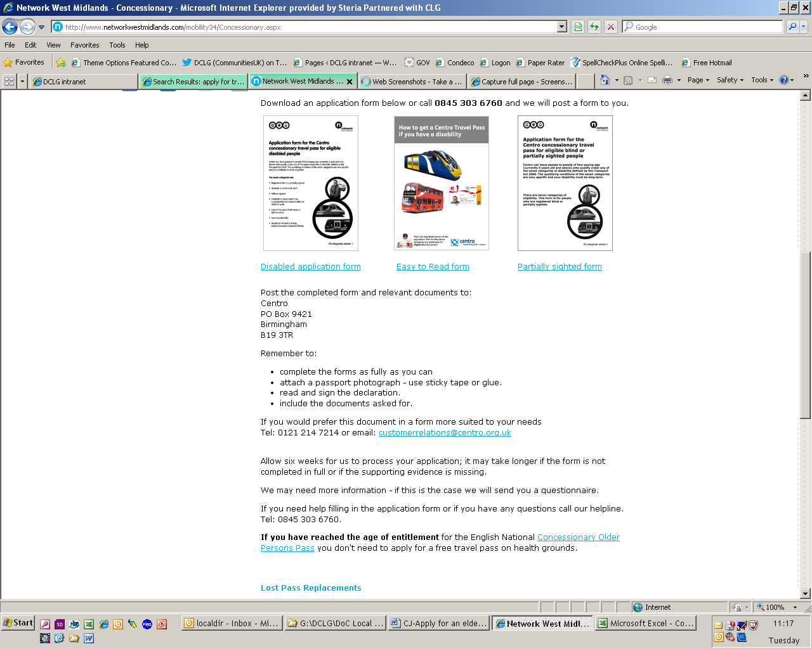

I clicked here

Customer journey: Apply for an older person's bus pass – BIRMINGHAM CITY COUNCIL
How I got to this page: From GOV.UK, using postcode B1 1BB
Page on council website: Page 4 of 5

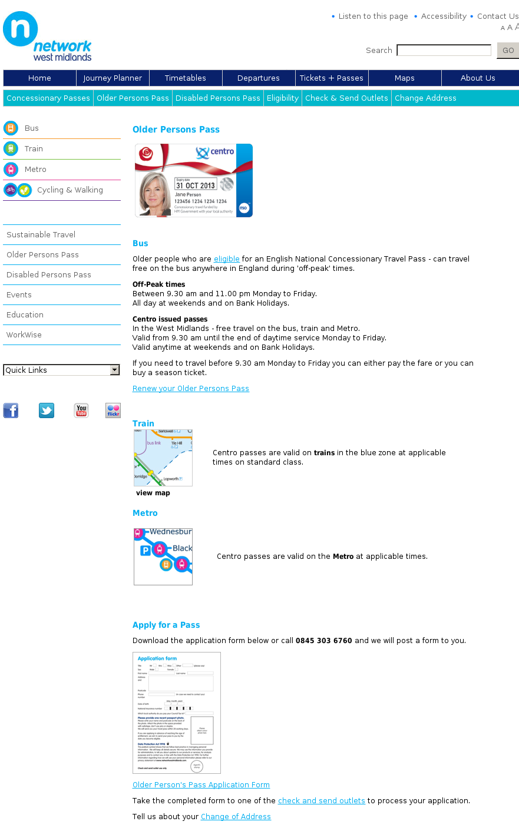

I clicked here

Customer journey: Apply for an older person's bus pass – BIRMINGHAM CITY COUNCIL
How I got to this page: From GOV.UK, using postcode B1 1BB
Page on council website: Page 5 of 5

