Customer journey: Apply to adopt a child through your council – NORFOLK COUNCIL
How I got to this page: From GOV.UK, using the postcode NR1 2DH
Page on local authority website: Page 1 of 6

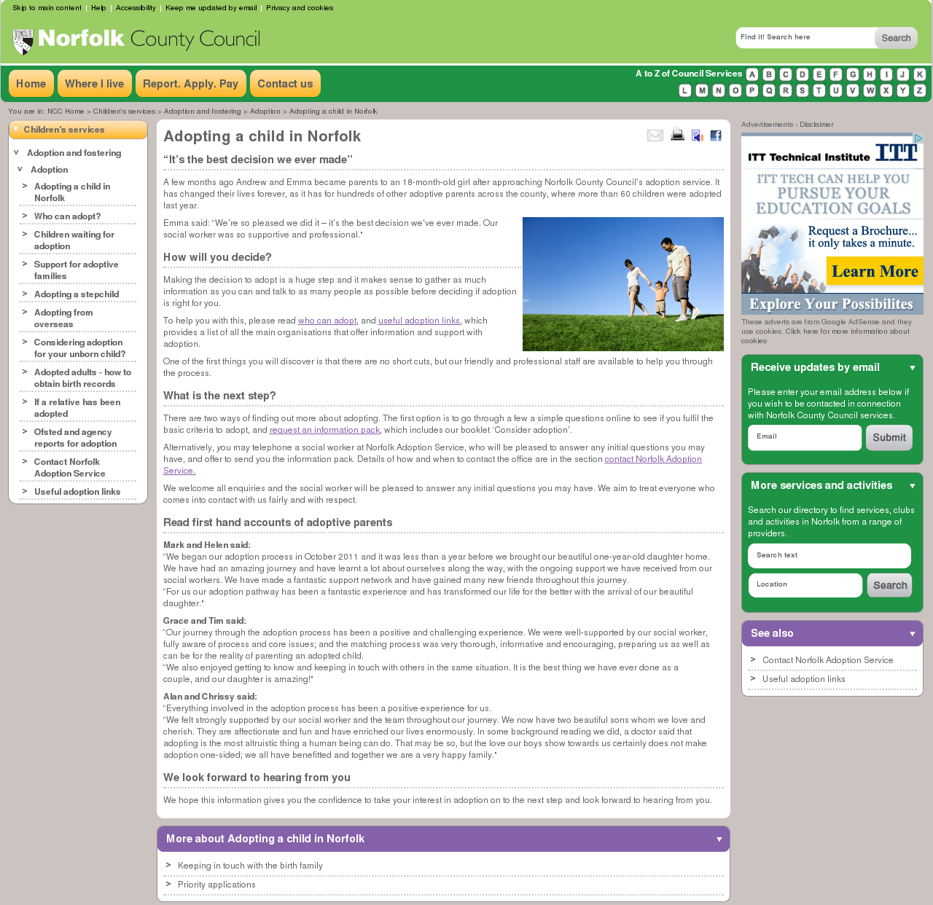
I clicked here
Customer journey: Apply to adopt a child through your council – NORFOLK COUNCIL
How I got to this page: From GOV.UK, using the postcode NR1 2DH
Page on local authority website: Page 2-3 of 6

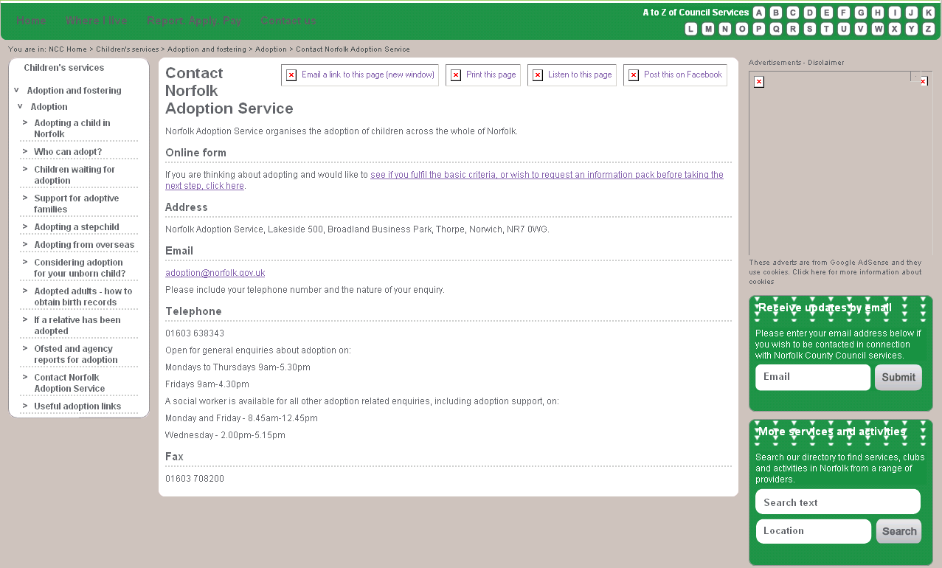

I clicked here

Page 3 of 6

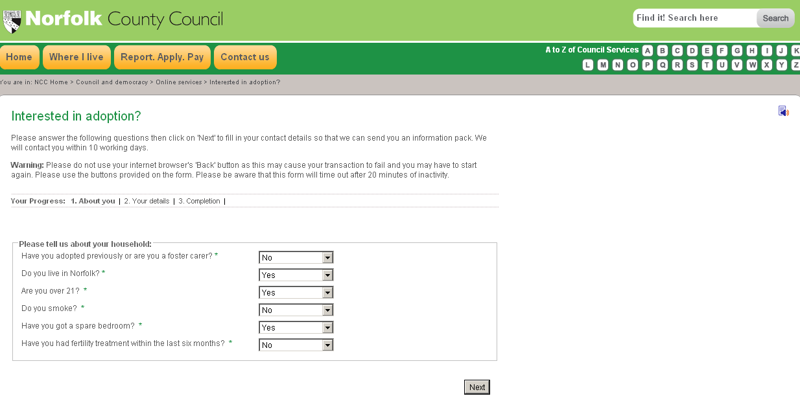
I clicked here
Customer journey: Apply to adopt a child through your council – NORFOLK COUNCIL
How I got to this page: From GOV.UK, using the postcode NR1 2DH
Page on local authority website: Page 4-5 of 6
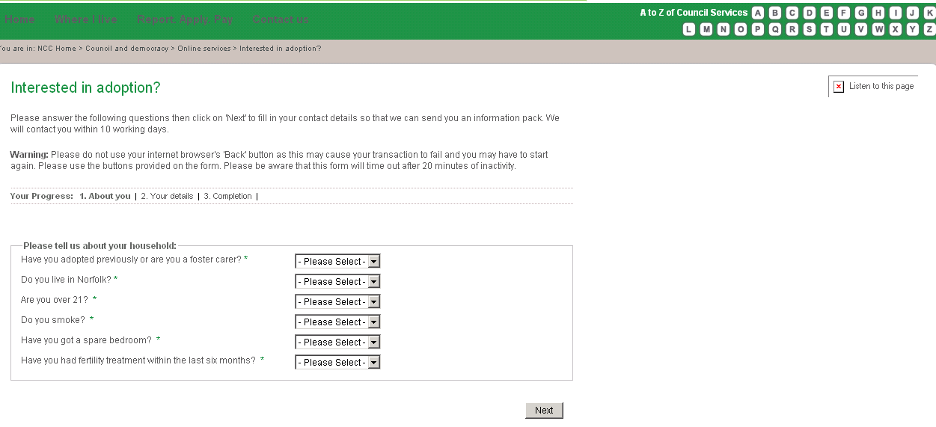

I clicked here

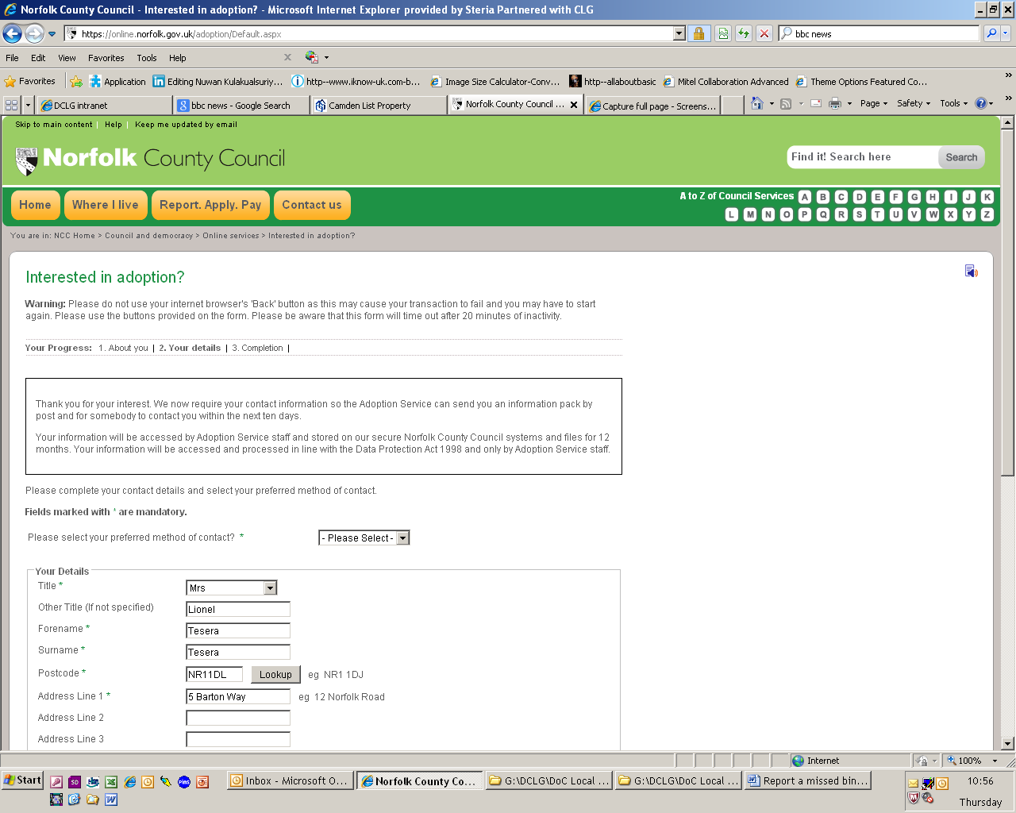
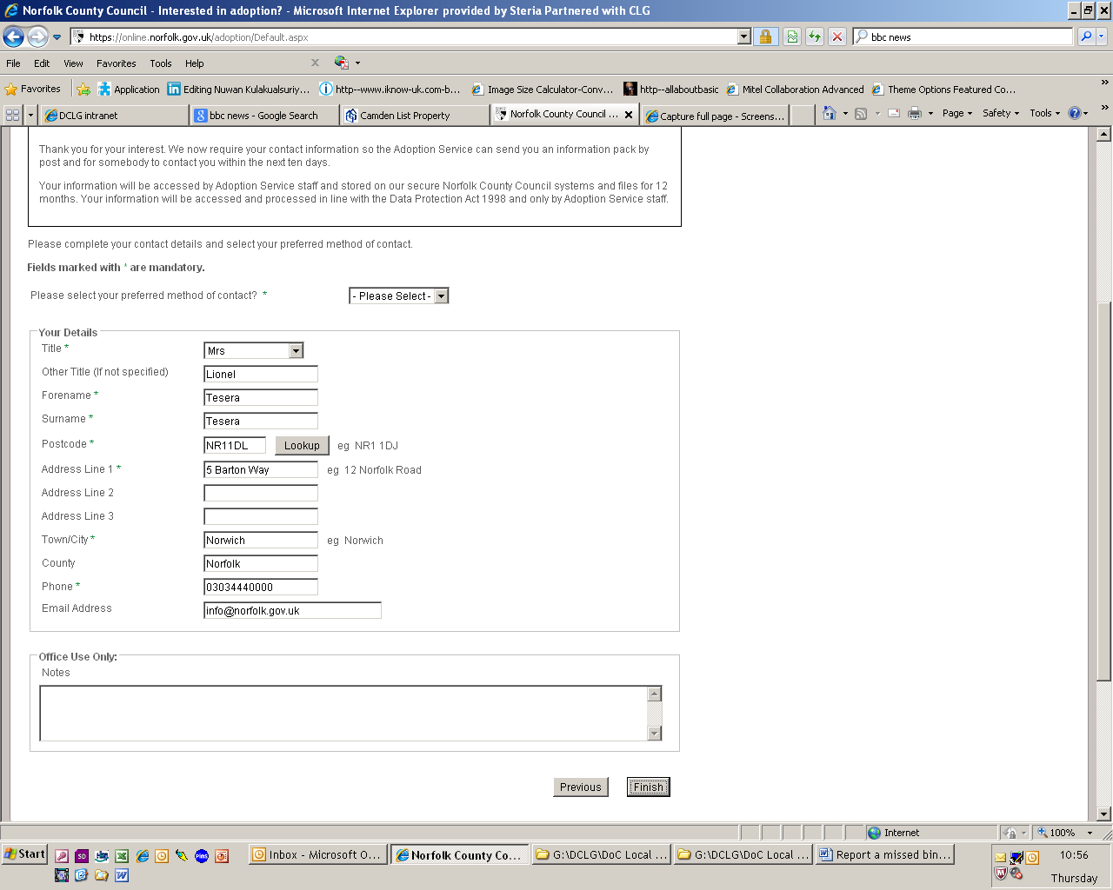
Page 5 of 6

I clicked here
Customer journey: Apply to adopt a child through your council – NORFOLK COUNCIL
How I got to this page: From GOV.UK, using the postcode NR1 2DH
Page on local authority website: Page 6 of 6

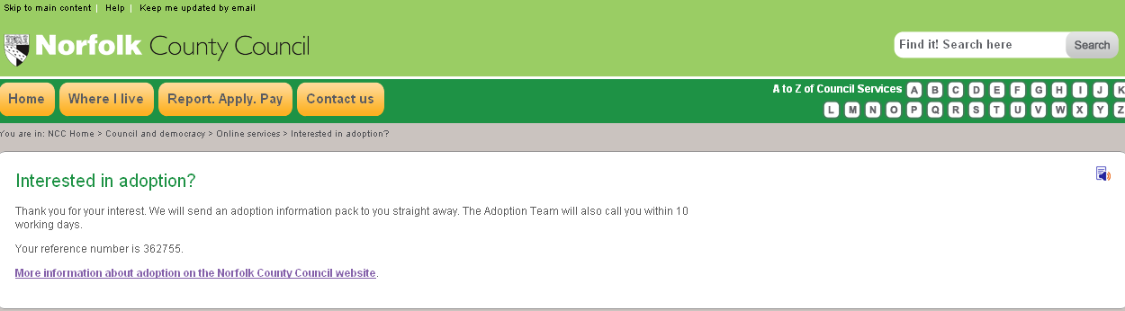

Landed on wrong page, so I typed here “Report a missed bin collection”

Customer journey: Apply to adopt a child through your council – CAMDEN COUNCIL
How I got to this page: From GOV.UK, using the postcode NW2 3LX
Page on local authority website: Page 1 of 15
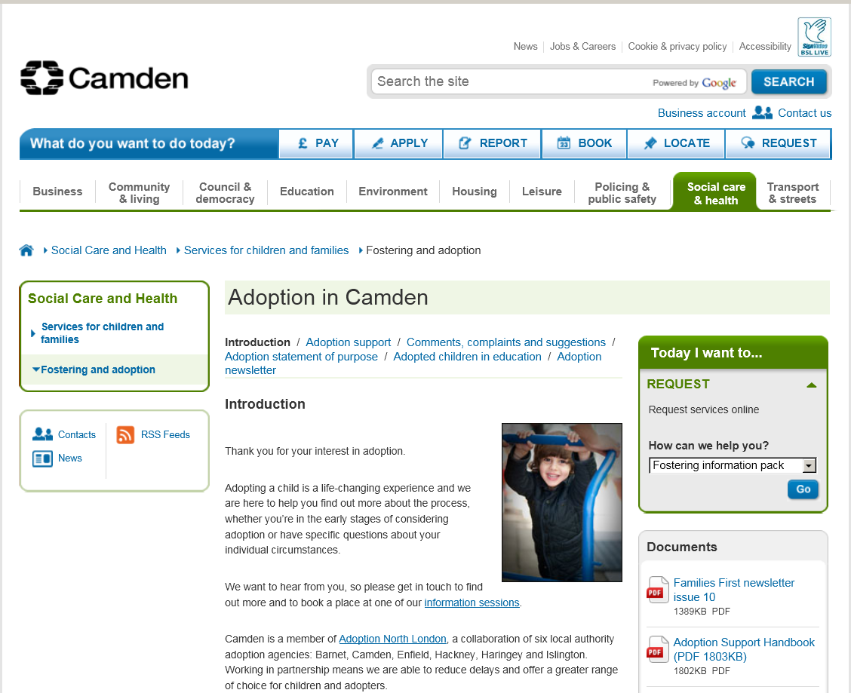

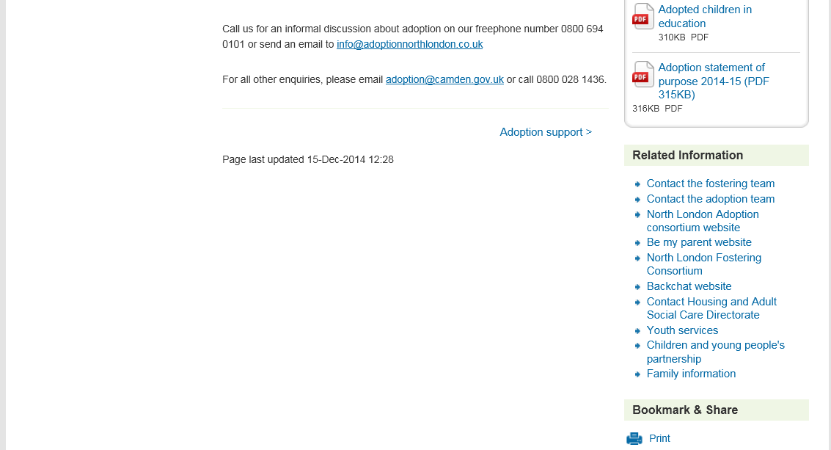
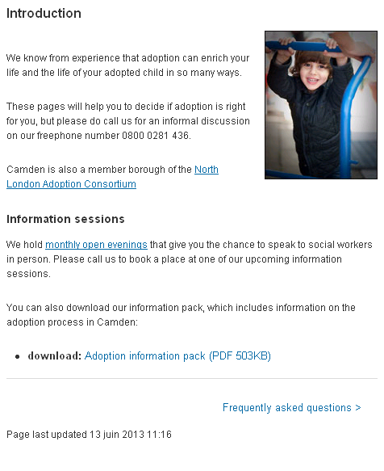
I clicked here
Customer journey: Apply to adopt a child through your council – CAMDEN COUNCIL
How I got to this page: From GOV.UK, using the postcode NW2 3LX
Page on local authority website: Page 2-4 of 15
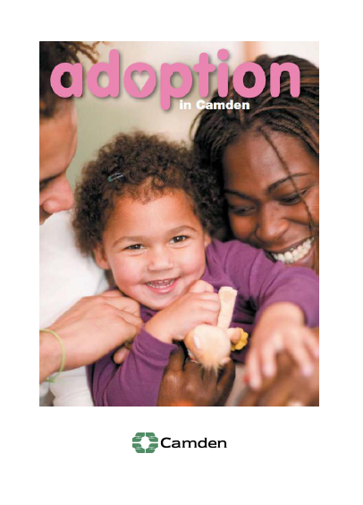

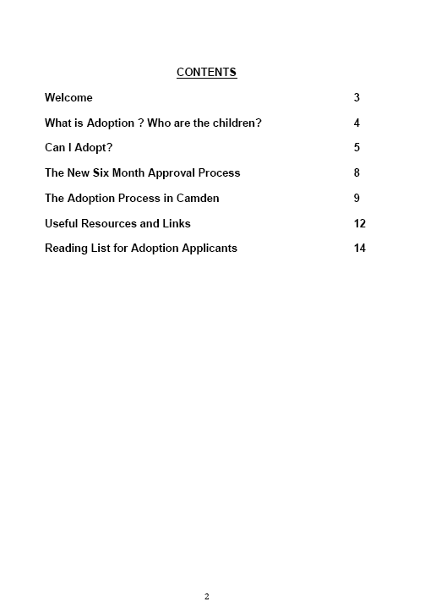

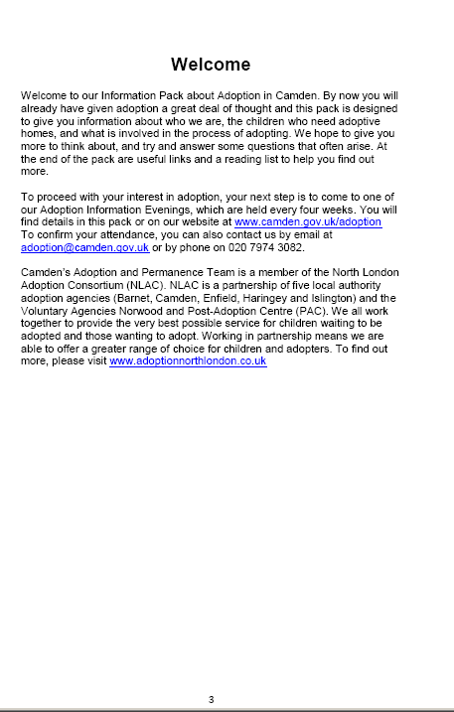

Document carries on for 15 pages

Customer journey: Apply to adopt a child through your council – NORTH SOMERSET COUNCIL
How I got to this page: From GOV.UK, using the postcode BS23 1UJ
Page on local authority website: Page 1 of 4

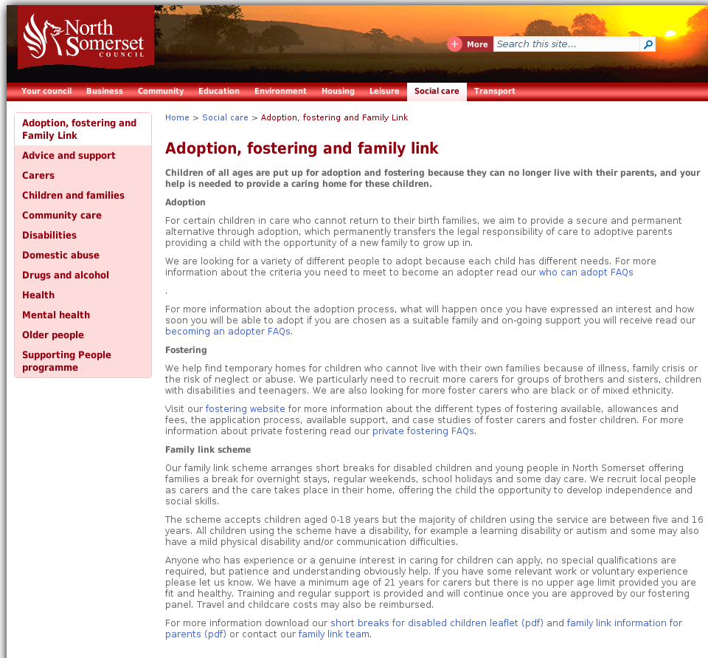

I clicked here

Customer journey: Apply to adopt a child through your council – NORTH SOMERSET COUNCIL
How I got to this page: From GOV.UK, using the postcode BS23 1UJ
Page on local authority website: Page 2 of 4
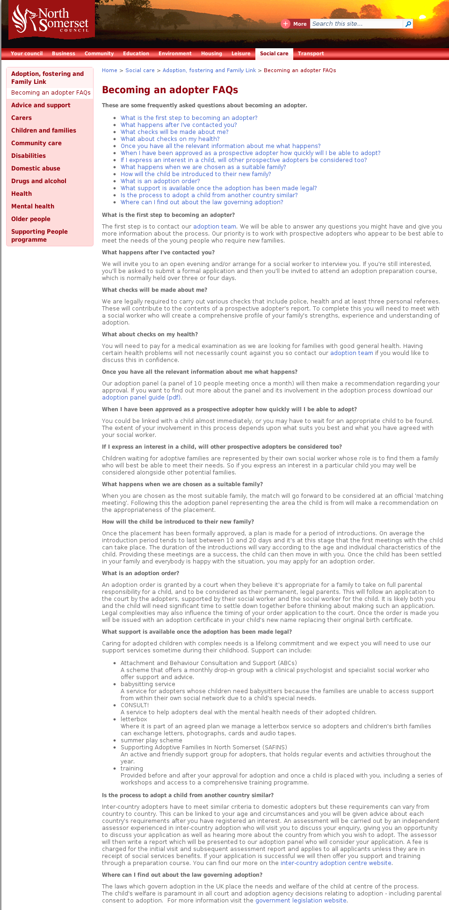

I clicked here

Customer journey: Apply to adopt a child through your council – NORTH SOMERSET COUNCIL
How I got to this page: From GOV.UK, using the postcode BS23 1UJ
Page on local authority website: Page 3-4 of 4
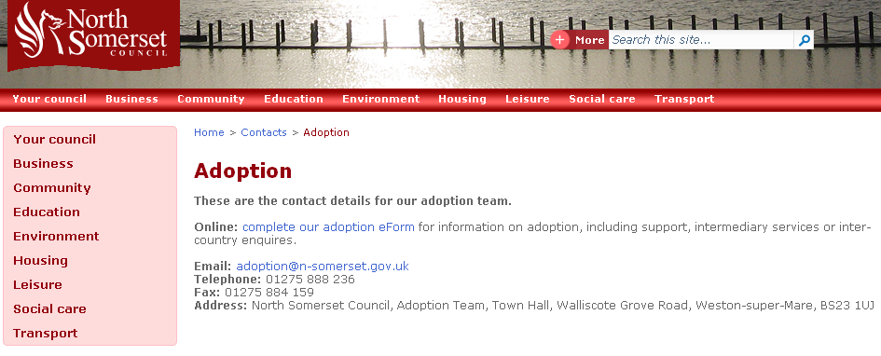

I clicked here

Page 4 of 4
