Customer journey: Complain about your council – MOLE VALLEY DISTRICT COUNCIL
How I got to this page: From GOV.UK, using the postcode RH4 1SJ
Page on local authority website: Page 1 of 3

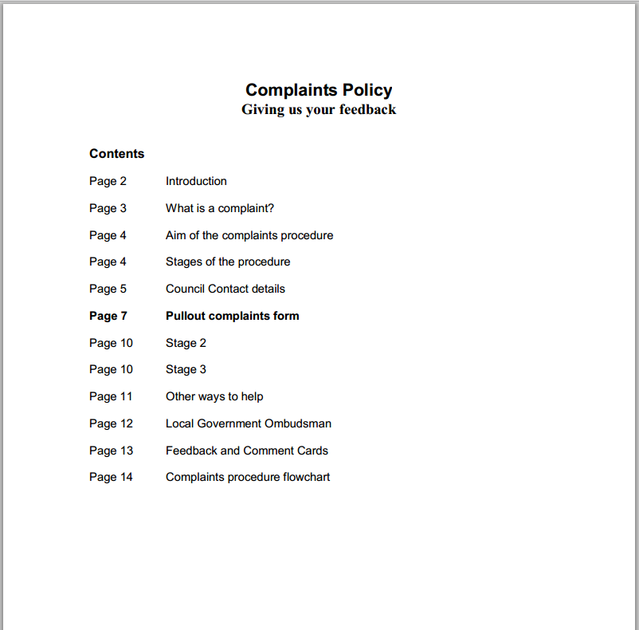

I landed on a 14-page PDF: “Complaints Policy”

Pages 7-8 were a pullout complaints form – see next 2 pages

Customer journey: Complain about your council – MOLE VALLEY DISTRICT COUNCIL
How I got to this page: From GOV.UK, using the postcode RH4 1SJ
Page on local authority website: Page 2 of 3

Page 7 of the “Complaints Policy”

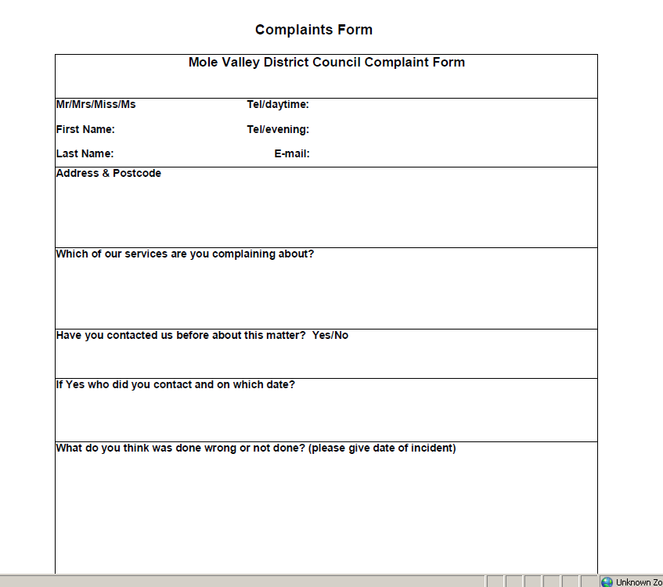

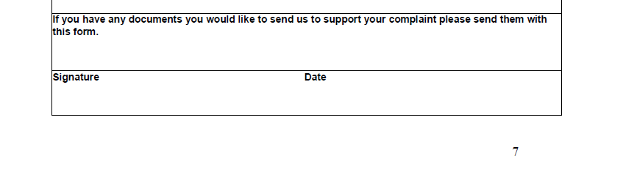
Customer journey: Complain about your council – MOLE VALLEY DISTRICT COUNCIL
How I got to this page: From GOV.UK, using the postcode RH4 1SJ
Page on local authority website: Page 3 of 3

Page 8 of the “Complaints Policy”

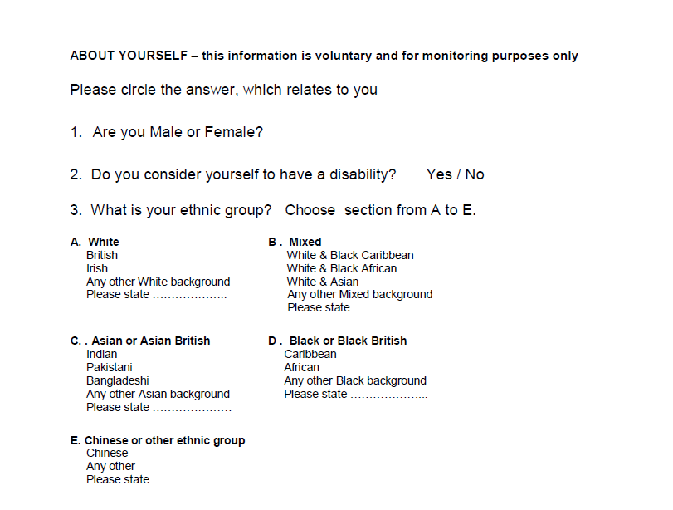
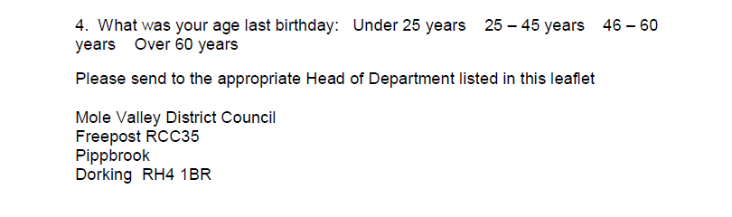

Customer journey: Complain about your council – GOSPORT BOROUGH COUNCIL
How I got to this page: From GOV.UK, using the postcode PO12 1EB
Page on local authority website: Page 1 of 4

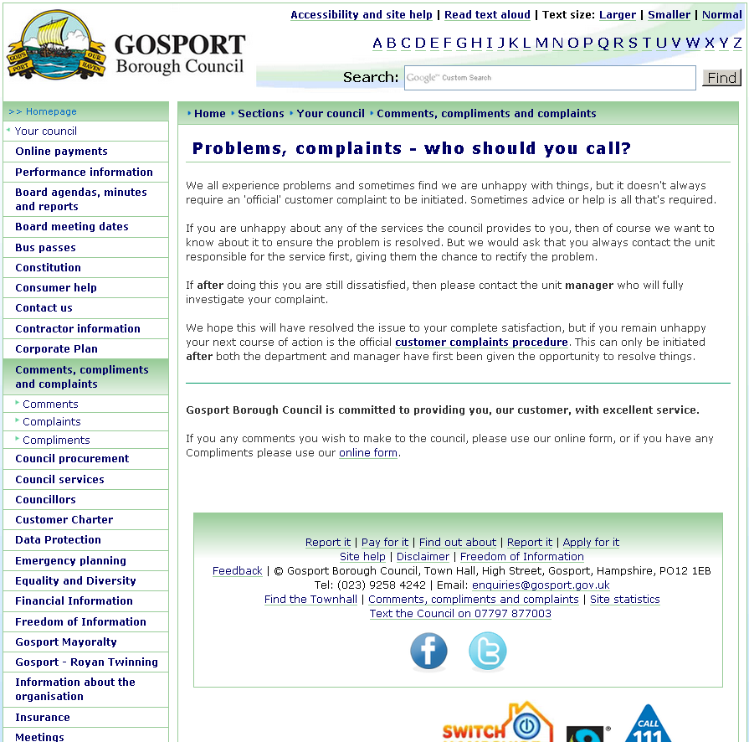
I clicked here

I clicked here
Customer journey: Complain about your council – GOSPORT BOROUGH COUNCIL
How I got to this page: From GOV.UK, using the postcode PO12 1EB
Page on local authority website: Page 2 of 4

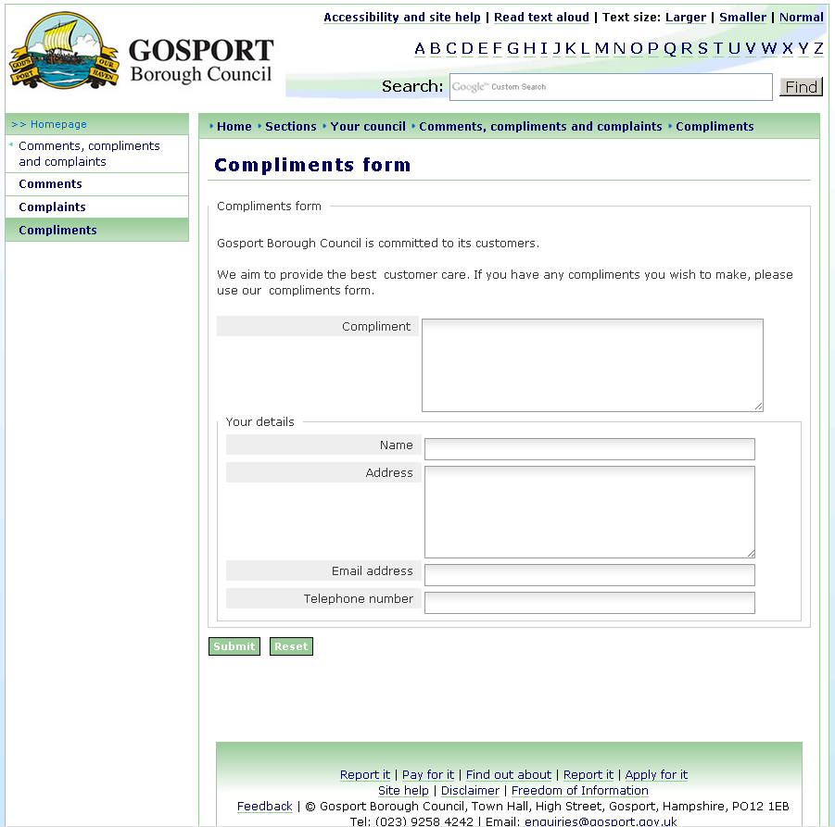
Oops – wrong page. I went back to previous page and clicked on ‘Customer Complaints Procedure’

Customer journey: Complain about your council – GOSPORT BOROUGH COUNCIL
How I got to this page: From GOV.UK, using the postcode PO12 1EB
Page on local authority website: Page 3 of 4

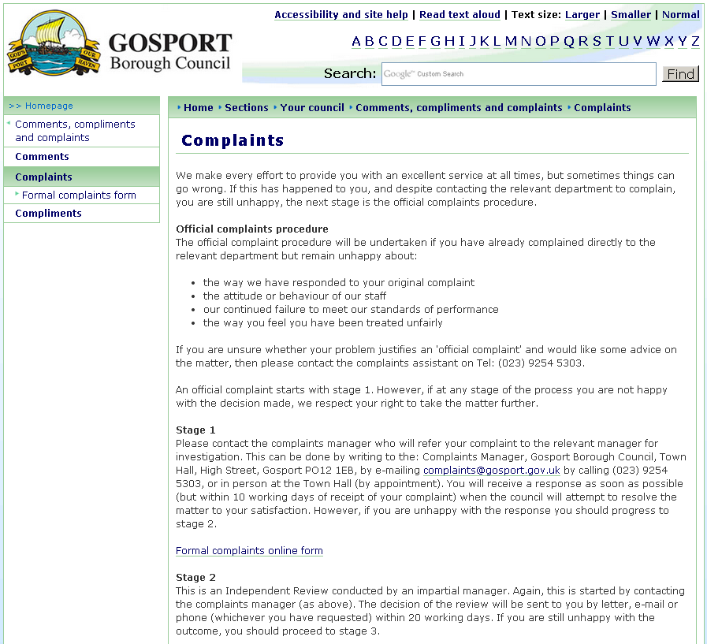
I clicked here
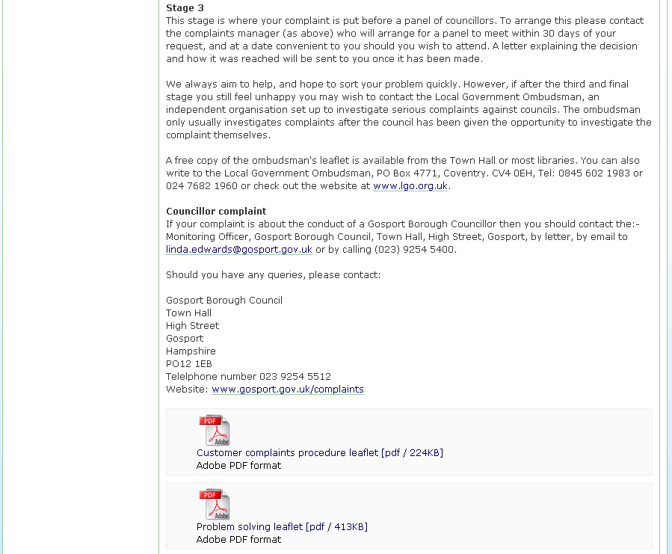
Customer journey: Complain about your council – GOSPORT BOROUGH COUNCIL
How I got to this page: From GOV.UK, using the postcode PO12 1EB
Page on local authority website: Page 4 of 4

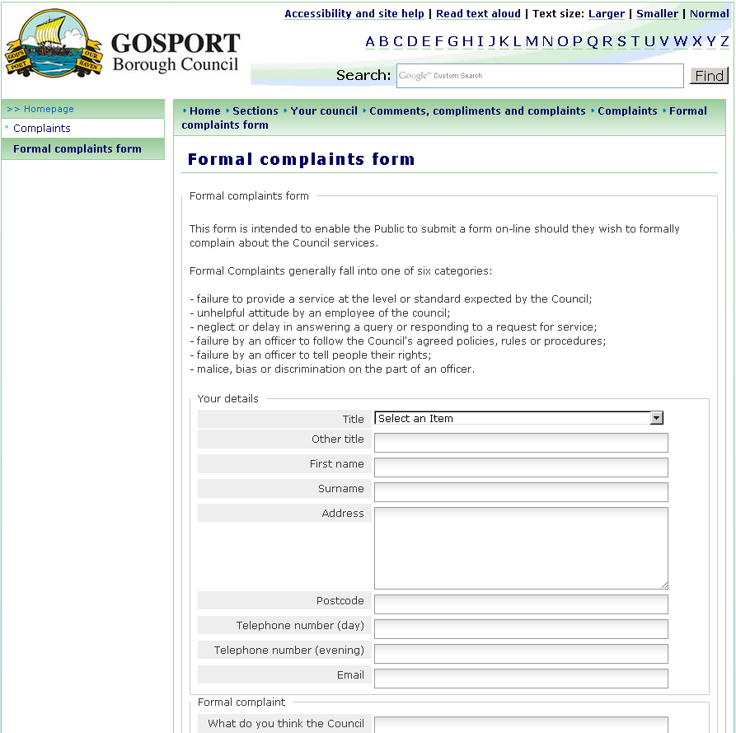
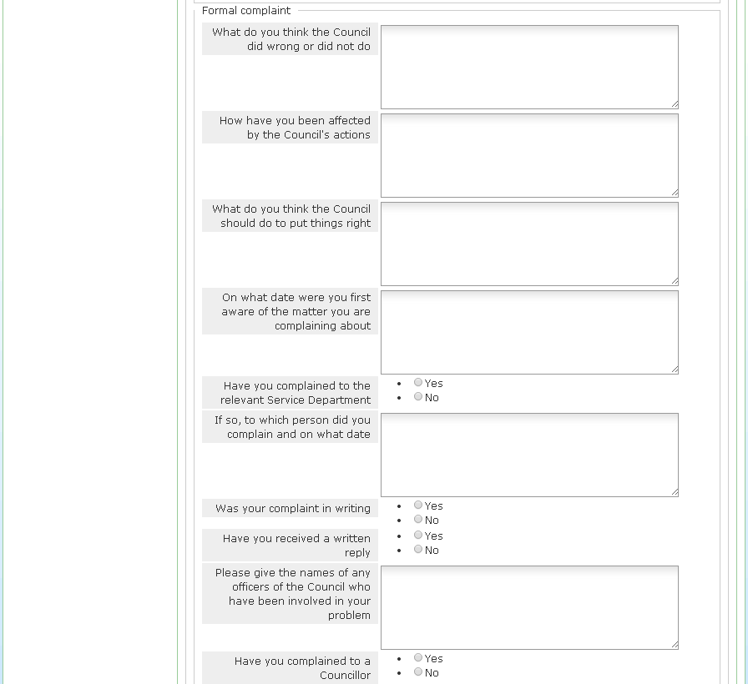
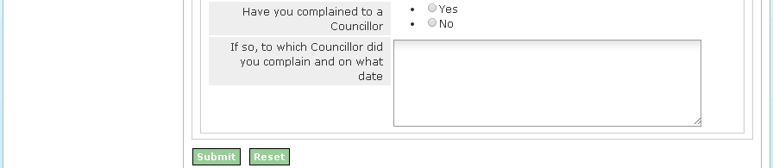

Customer journey: Complain about your council – ISLINGTON COUNCIL
How I got to this page: From GOV.UK, using the postcode N1 1XR
Page on local authority website: Page 1-2 of 5
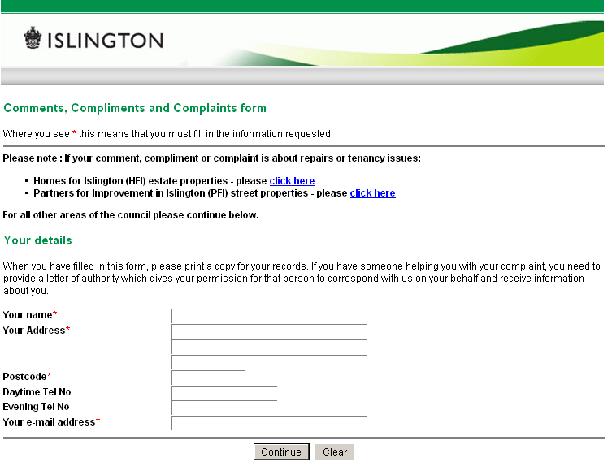
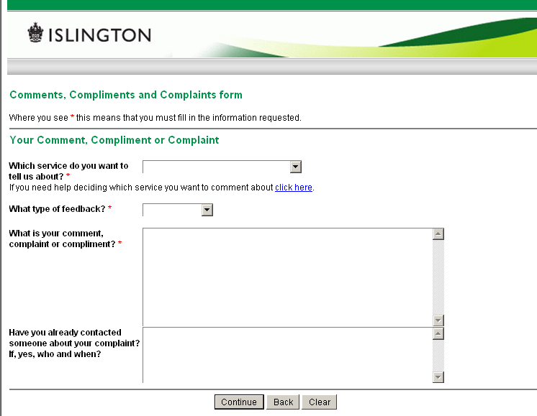

Page 2 of 5

Customer journey: Complain about your council – ISLINGTON COUNCIL
How I got to this page: From GOV.UK, using the postcode N1 1XR
Page on local authority website: Page 3 of 5
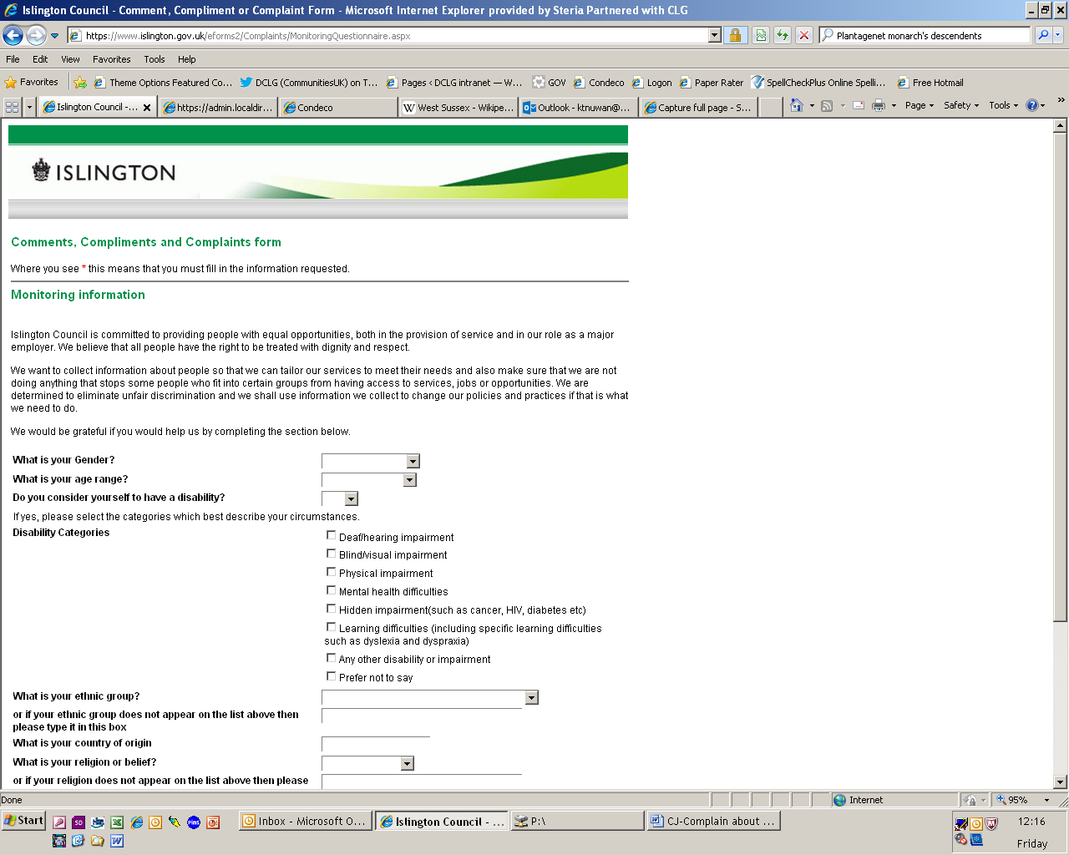
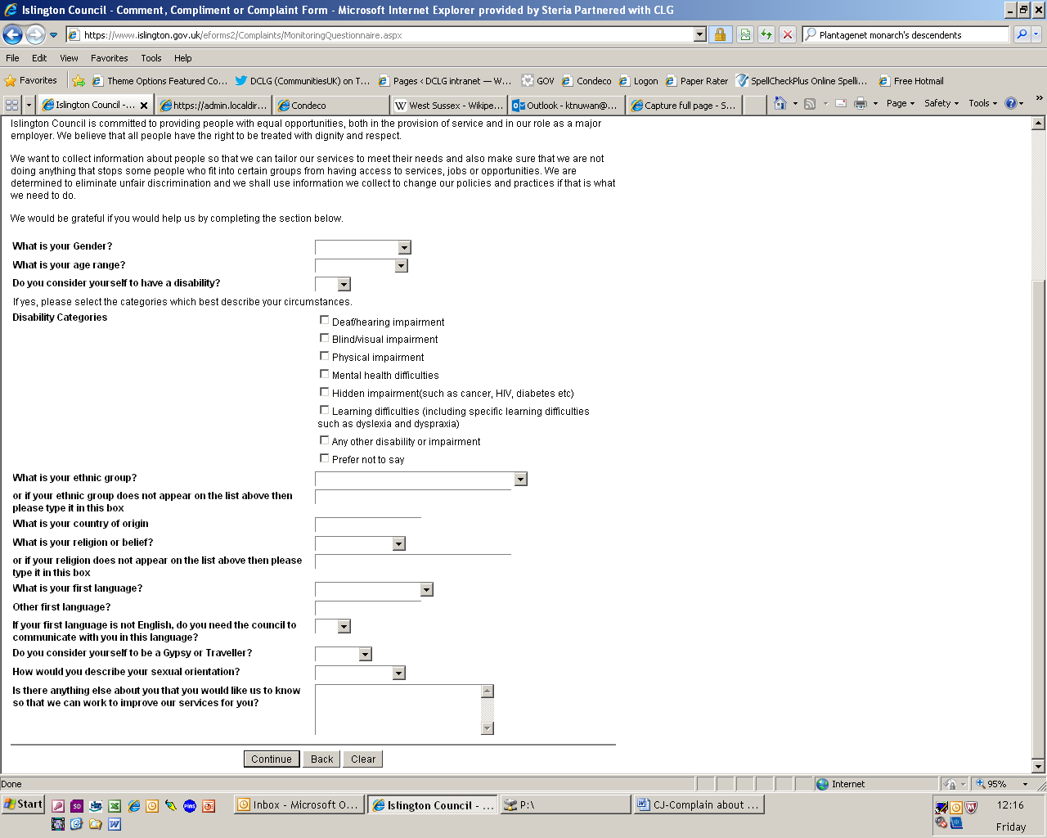

Customer journey: Complain about your council – ISLINGTON COUNCIL
How I got to this page: From GOV.UK, using the postcode N1 1XR
Page on local authority website: Page 4 of 5
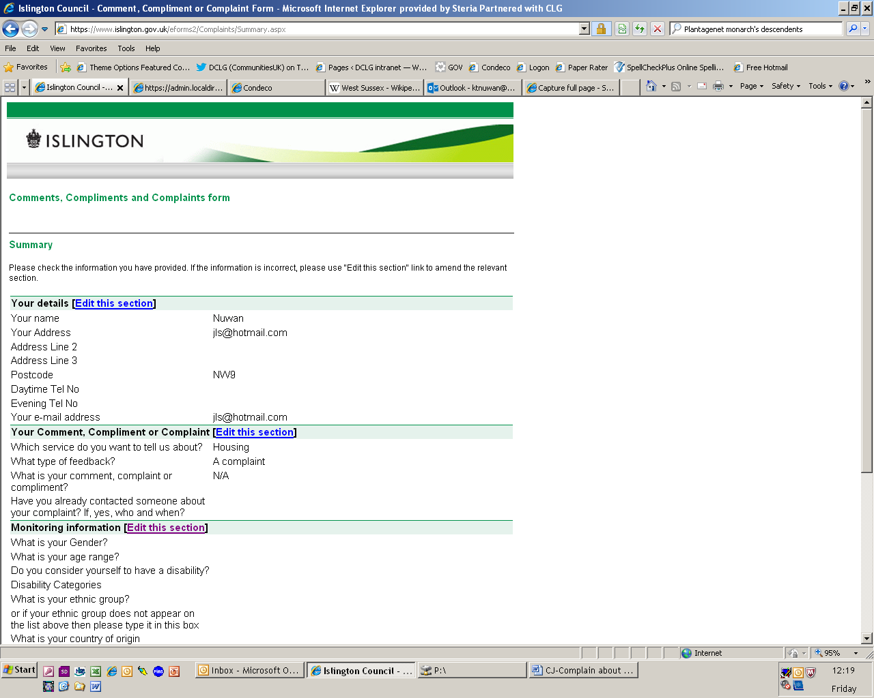
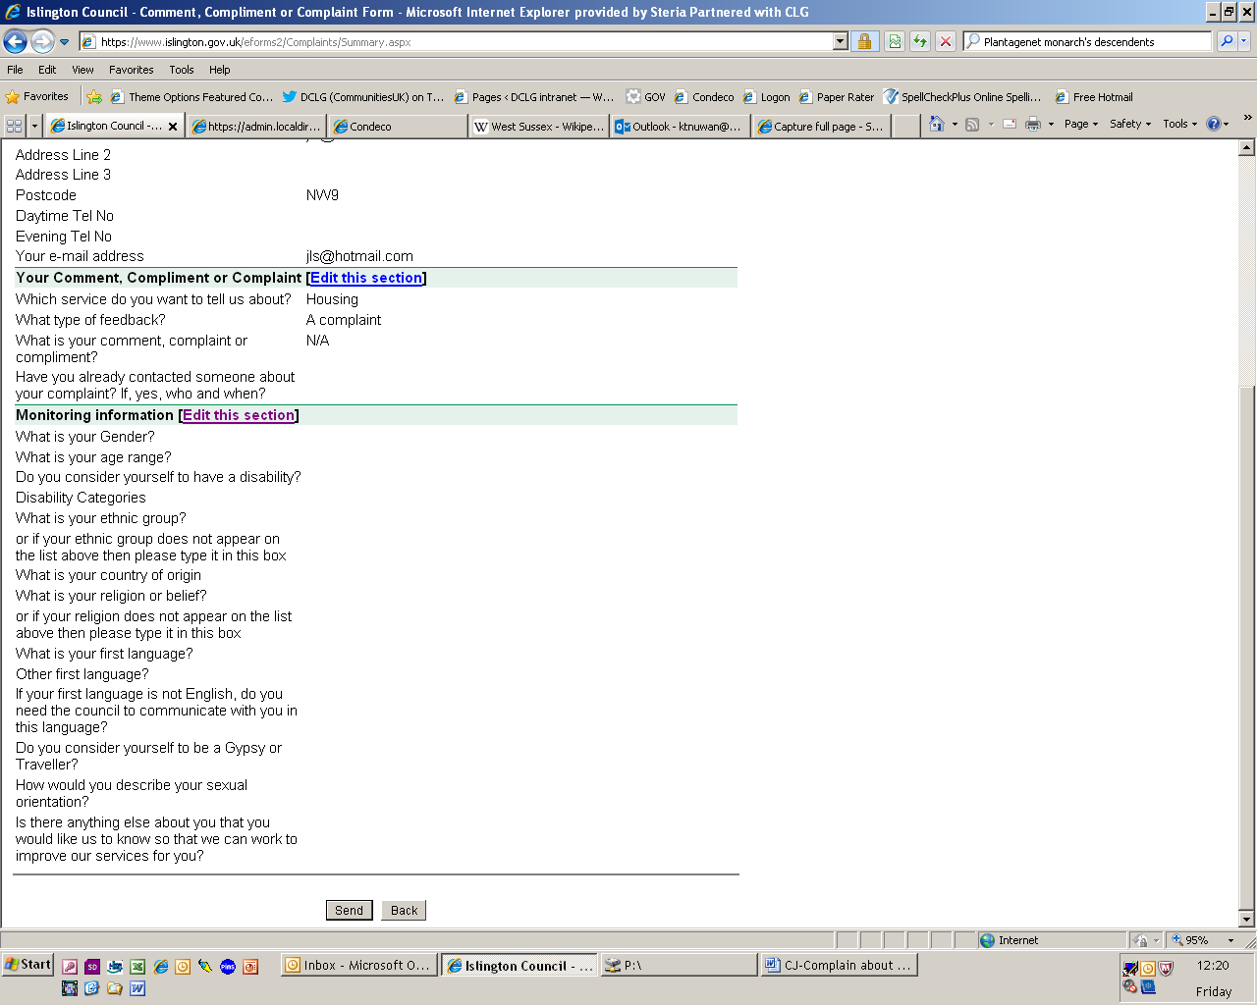

Customer journey: Complain about your council – ISLINGTON COUNCIL
How I got to this page: From GOV.UK, using the postcode N1 1XR
Page on local authority website: Page 5 of 5

