Customer journey: Local services disrupted by severe weather – BRISTOL CITY COUNCIL
How I got to this page: From GOV.UK, using the postcode BS1 2QJ
Page on local authority website: Page 1 of 1

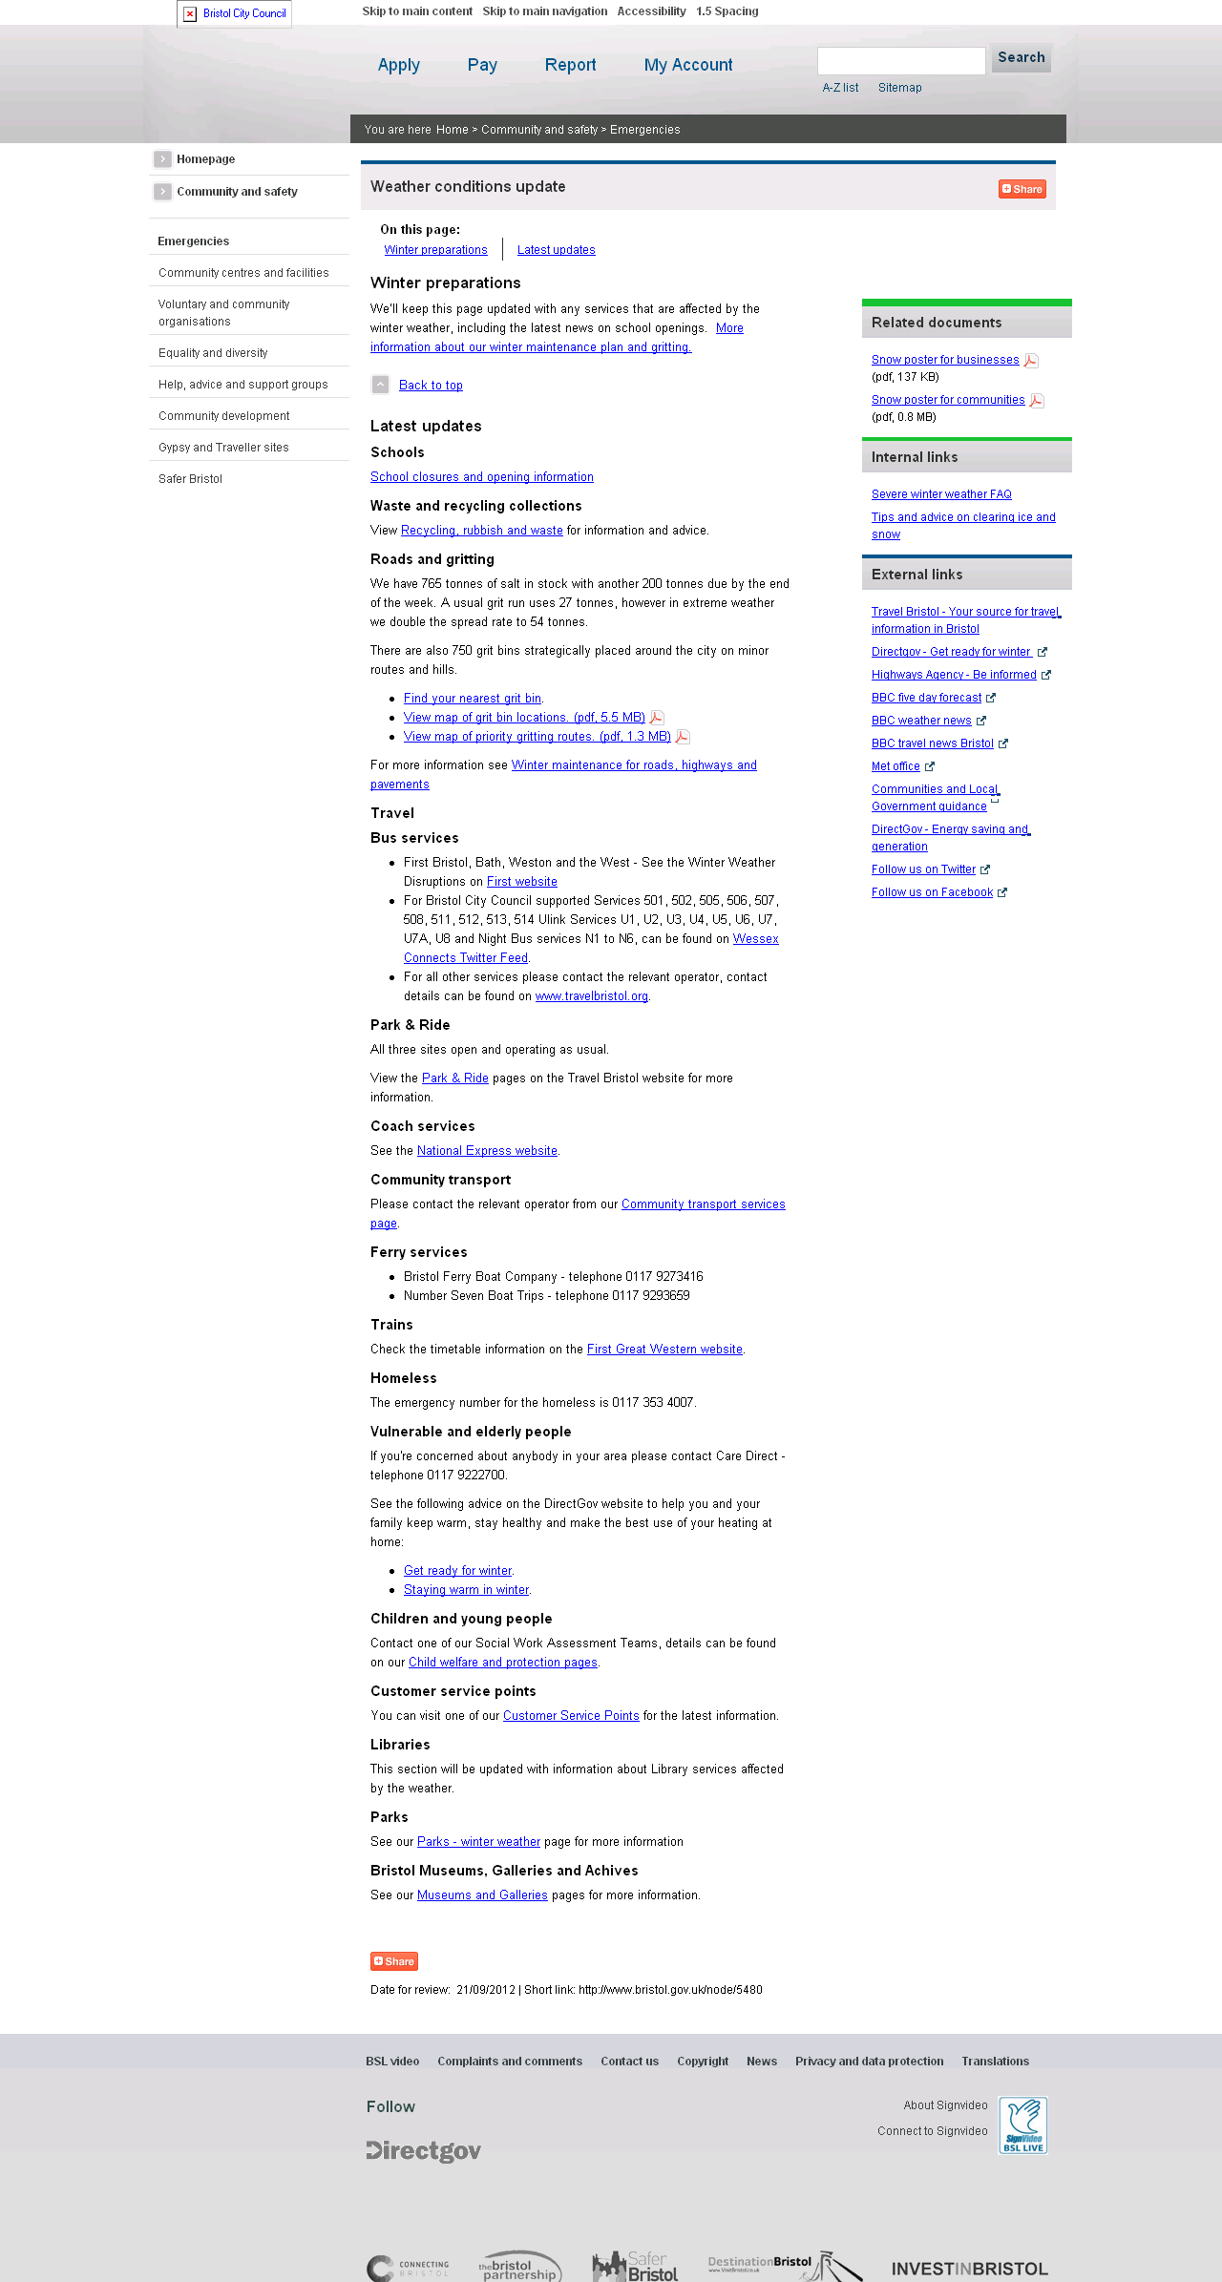
Customer journey: Local services disrupted by severe weather – LONDON BOROUGH OF RICHMOND
How I got to this page: From GOV.UK, using the postcode TW9 2ND
Pg on council website: Page 1 of 2

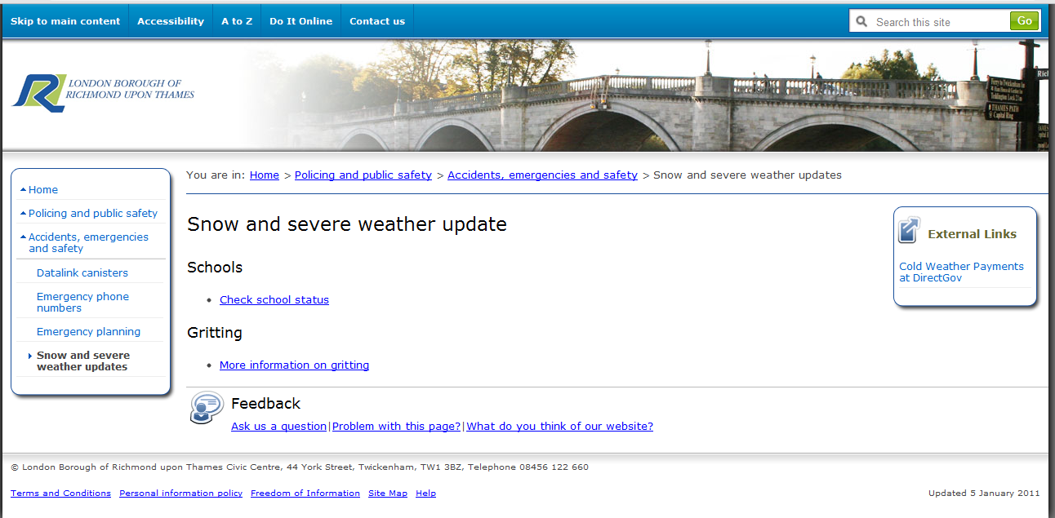

Customer journey: Local services disrupted by severe weather – LONDON BOROUGH OF RICHMOND
How I got to this page: From GOV.UK, using the postcode TW9 2ND
Pg on council website: Page 2 of 2 (first link on page 1 of journey)

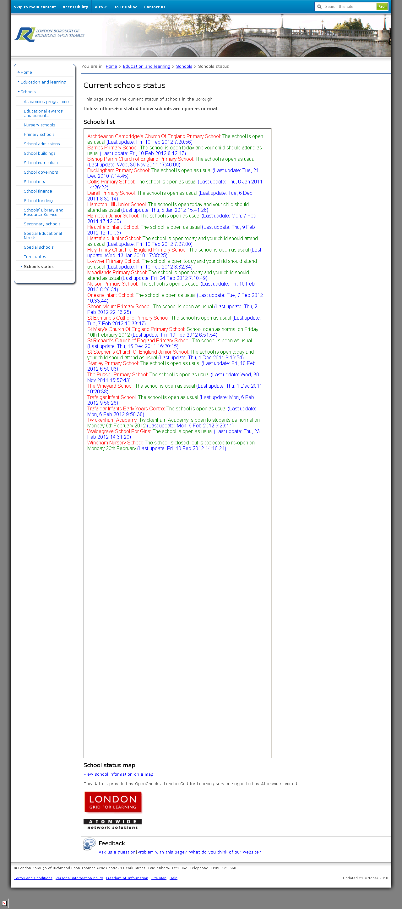
Customer journey: Local services disrupted by severe weather – LONDON BOROUGH OF RICHMOND
How I got to this page: From GOV.UK, using the postcode TW9 2ND
Pg on council website: Page 2 of 2 (second link on page 1 of journey)

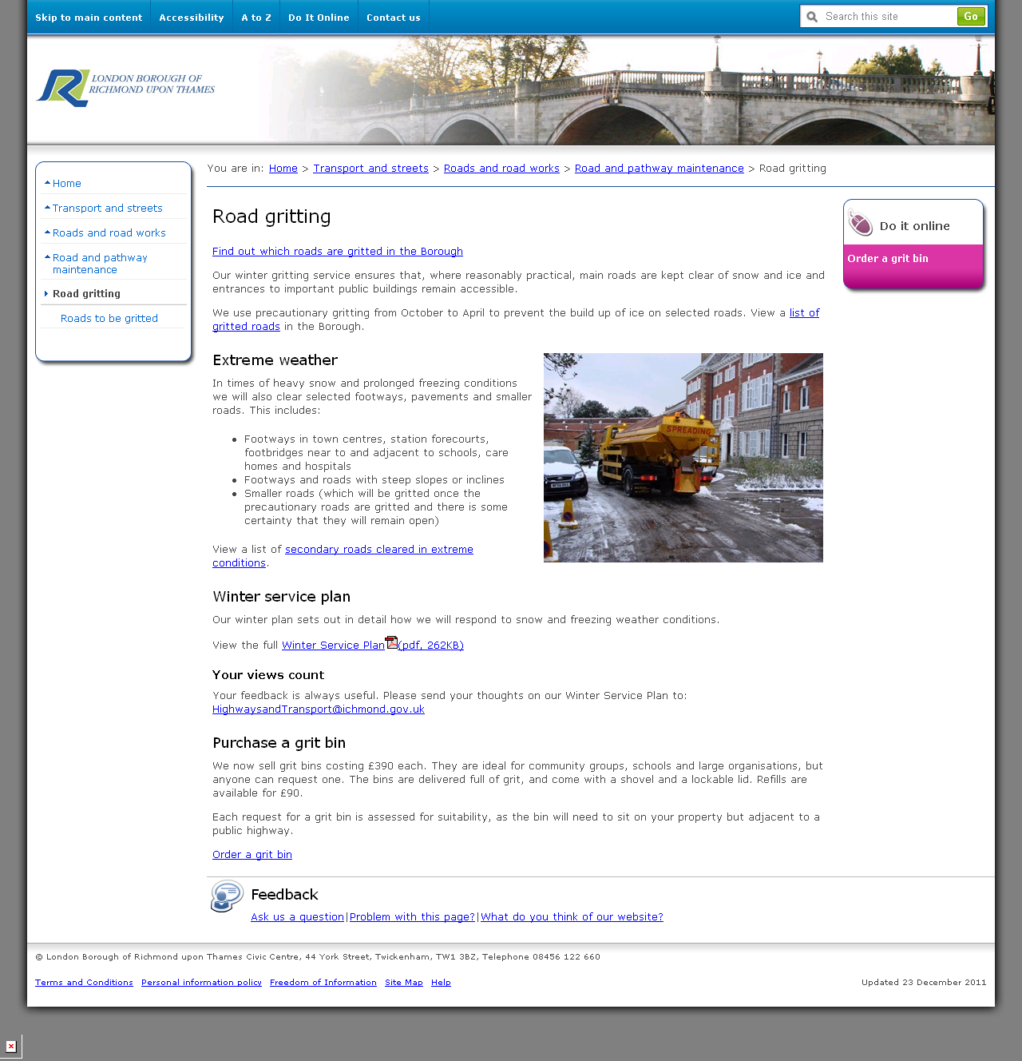

Customer journey: Local services disrupted by severe weather – GLOUCESTERSHIRE COUNCIL
How I got to this page: From GOV.UK, using the postcode GL1 2EQ
Pg on council website: Page 1 of 2

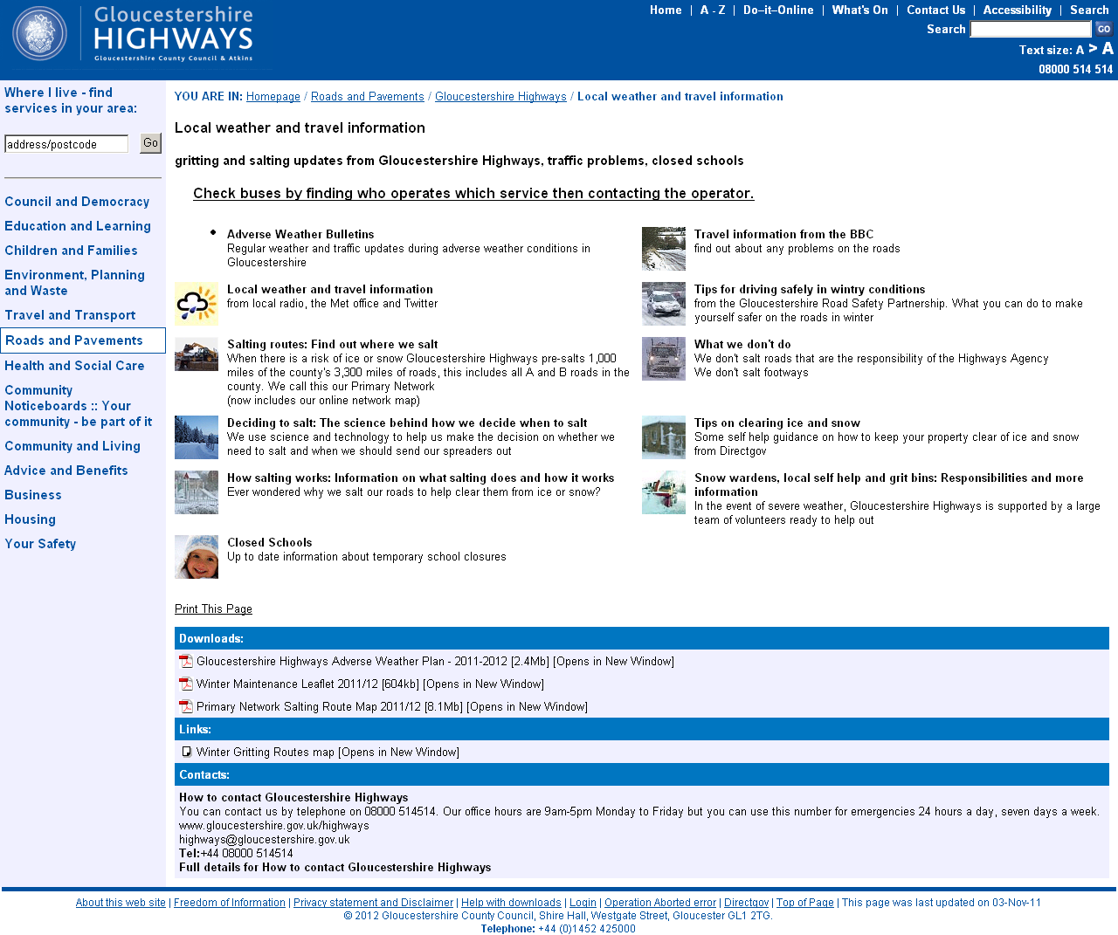

Customer journey: Local services disrupted by severe weather – GLOUCESTERSHIRE COUNCIL
How I got to this page: From GOV.UK, using the postcode GL1 2EQ
Pg on council website: Page 2 of 2

