Customer journey: Pay a parking fine – MALVERN HILLS COUNCIL
How I got to this page: From Google, using search term ‘Pay parking fine malvern’ & clicking 1st search result
Page on local authority website: Page 1 of 2
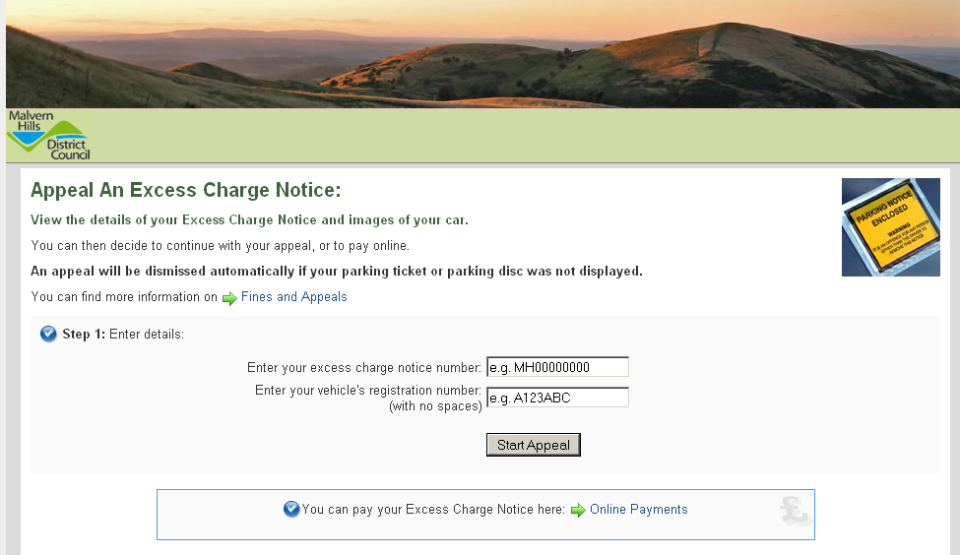
I clicked here

Customer journey: Pay a parking fine – MALVERN HILLS COUNCIL
How I got to this page: From Google, using search term ‘Pay parking fine malvern’ & clicking 1st search result
Page on local authority website: Page 2 of 2
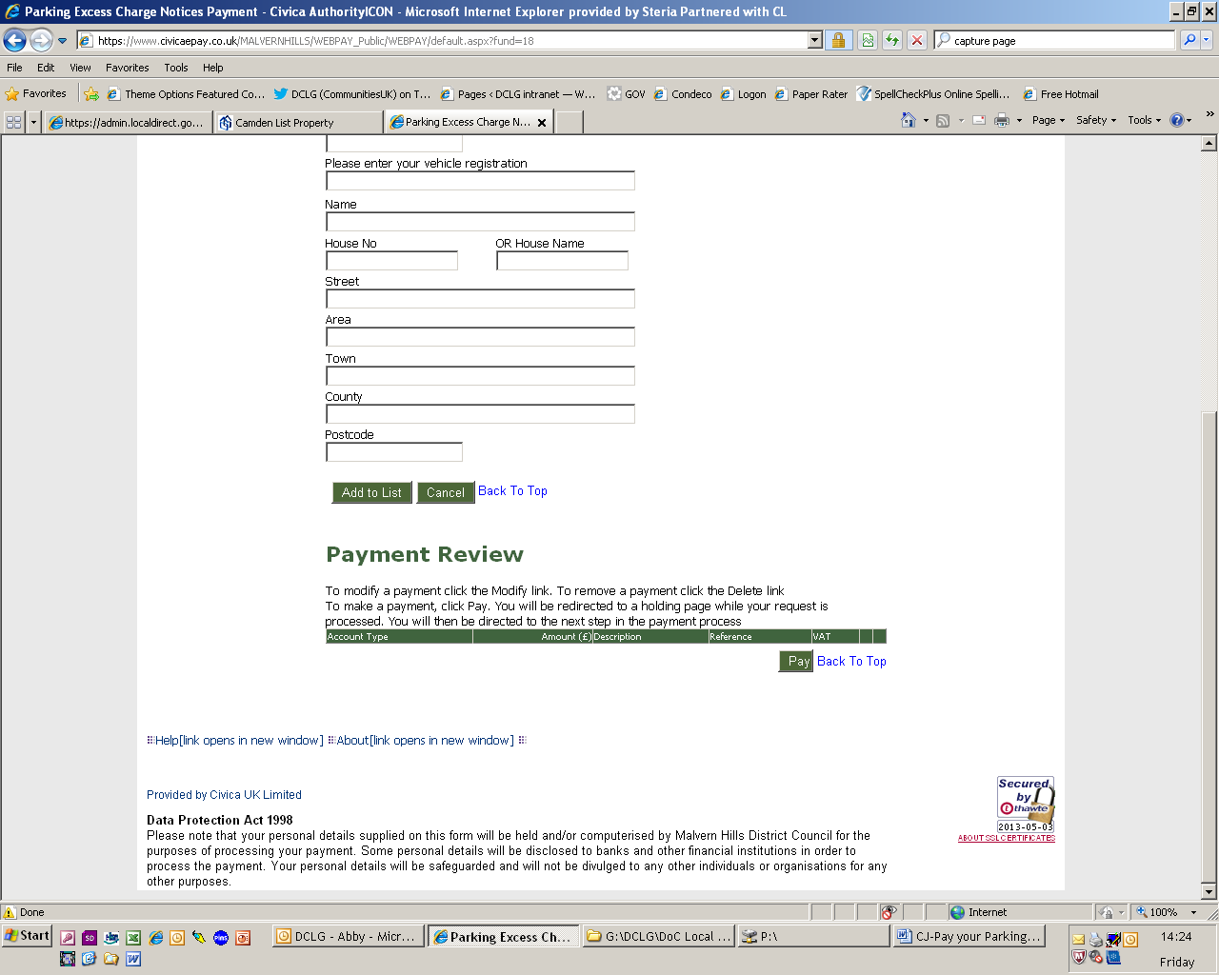
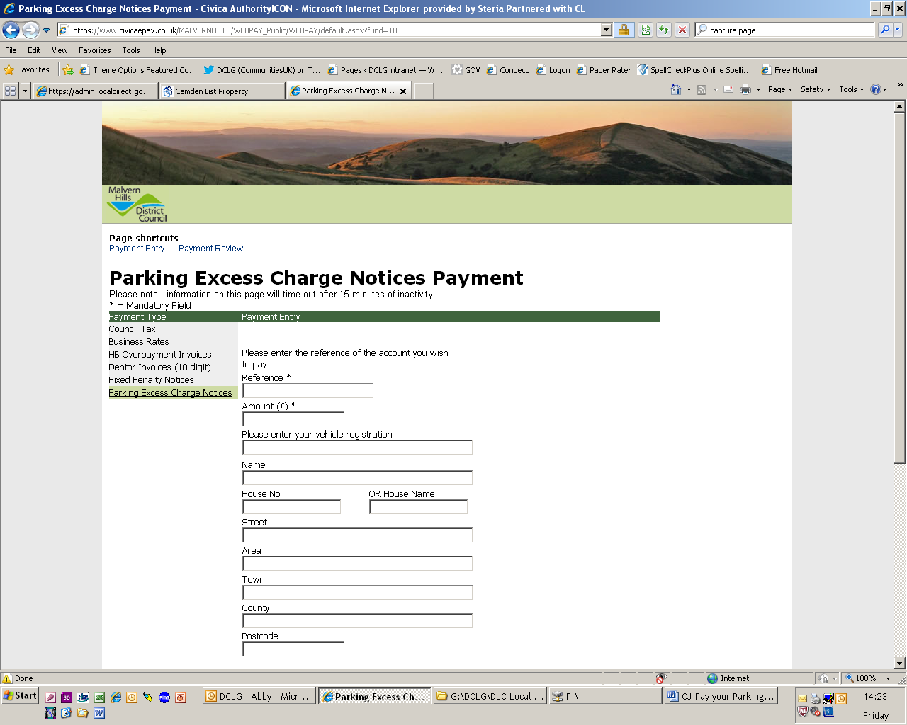

Customer journey: Pay a parking fine – BARROW-IN-FURNESS COUNCIL
How I got to this page: From Google, using search term ‘Pay parking fine barrow’ & clicking 1st search result
Page on local authority website: Page 1 of 4

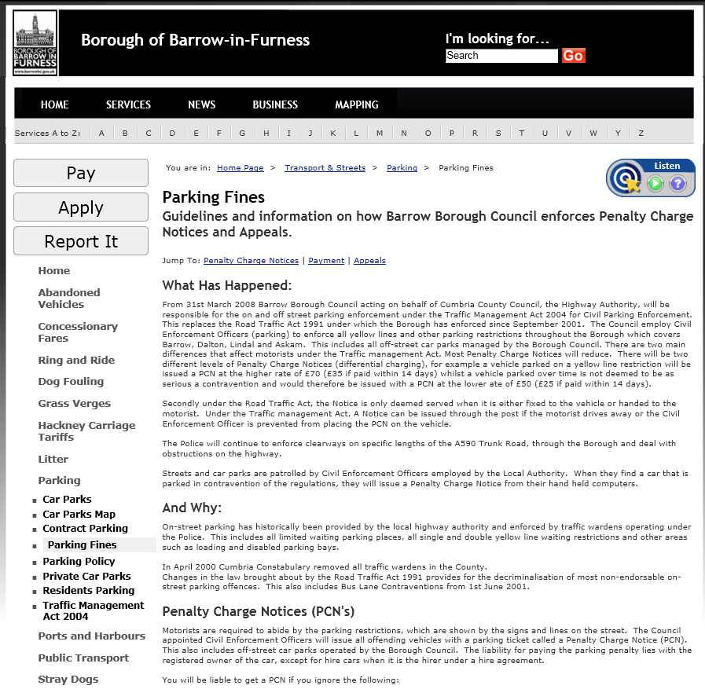
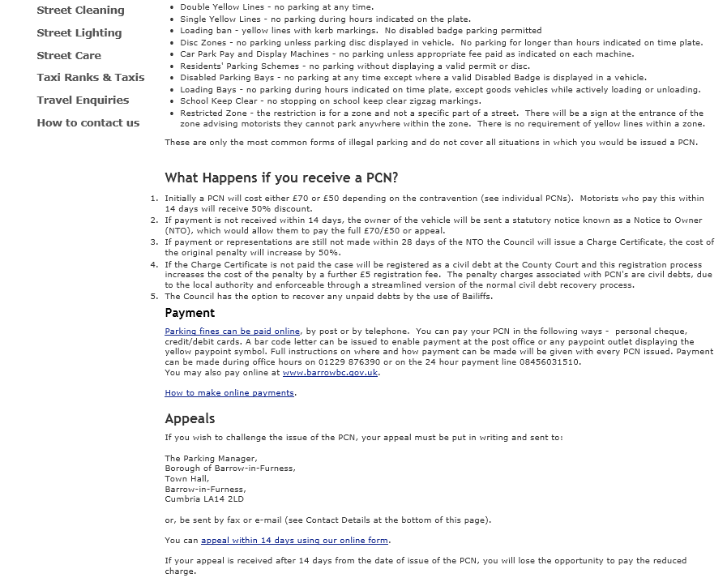
I clicked here
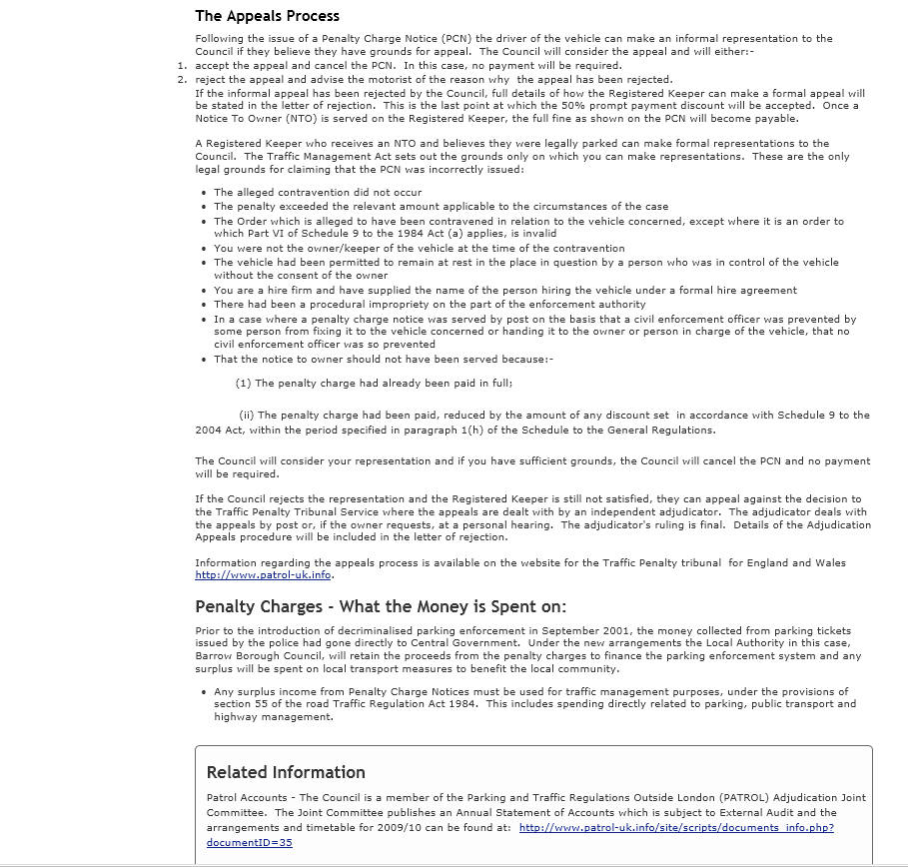

Customer journey: Pay a parking fine – BARROW-IN-FURNESS COUNCIL
How I got to this page: From Google, using search term ‘Pay parking fine barrow’ & clicking 1st search result
Page on local authority website: Page 2 of 4

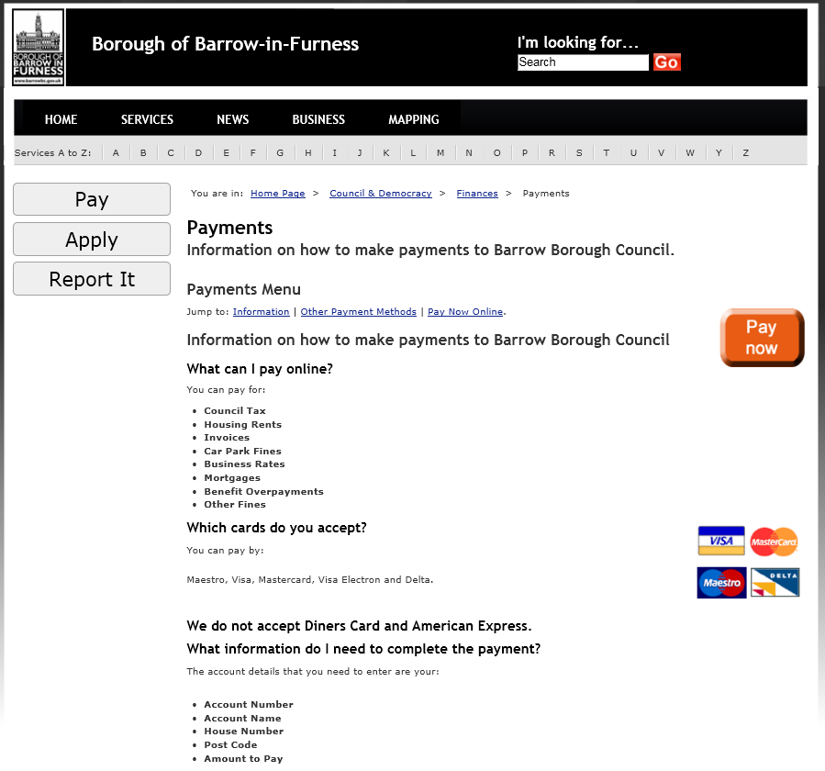
I clicked here
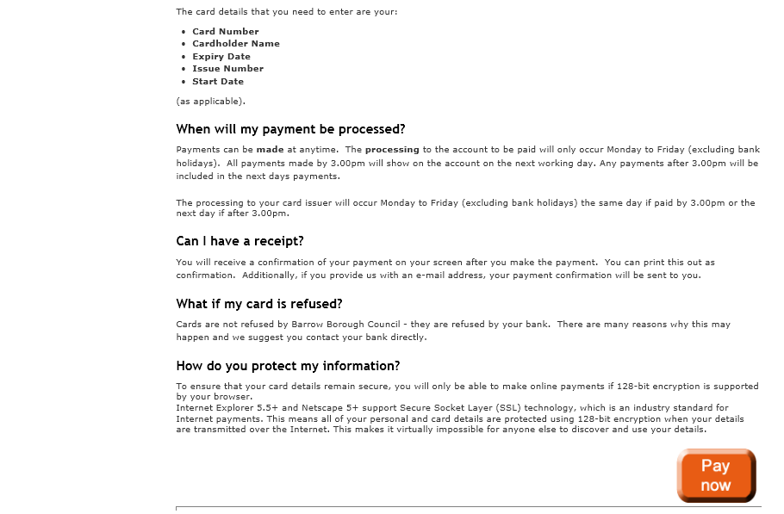
Customer journey: Pay a parking fine – BARROW-IN-FURNESS COUNCIL
How I got to this page: From Google, using search term ‘Pay parking fine barrow’ & clicking 1st search result
Page on local authority website: Page 3 of 4

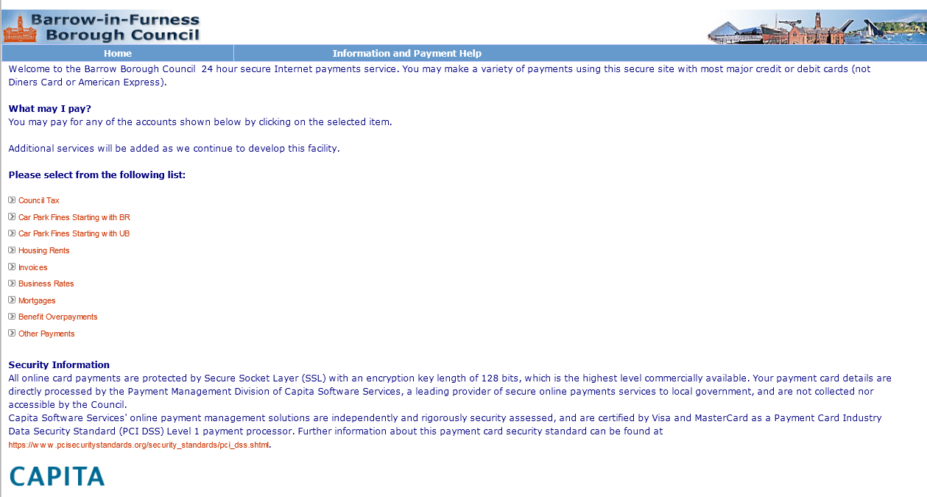
I clicked here

Customer journey: Pay a parking fine – BARROW-IN-FURNESS COUNCIL
How I got to this page: From Google, using search term ‘Pay parking fine barrow’ & clicking 1st search result
Page on local authority website: Page 4 of 4

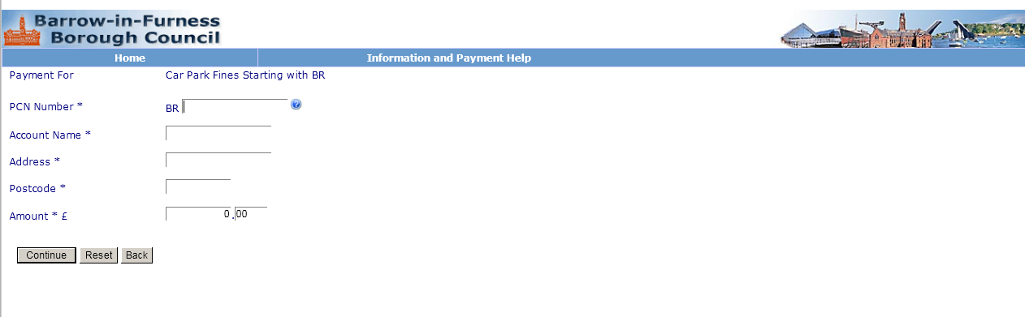

Customer journey: Pay a parking fine – CAMDEN COUNCIL
How I got to this page: From Google, using search term ‘Pay parking fine camden’ & clicking 1st search result
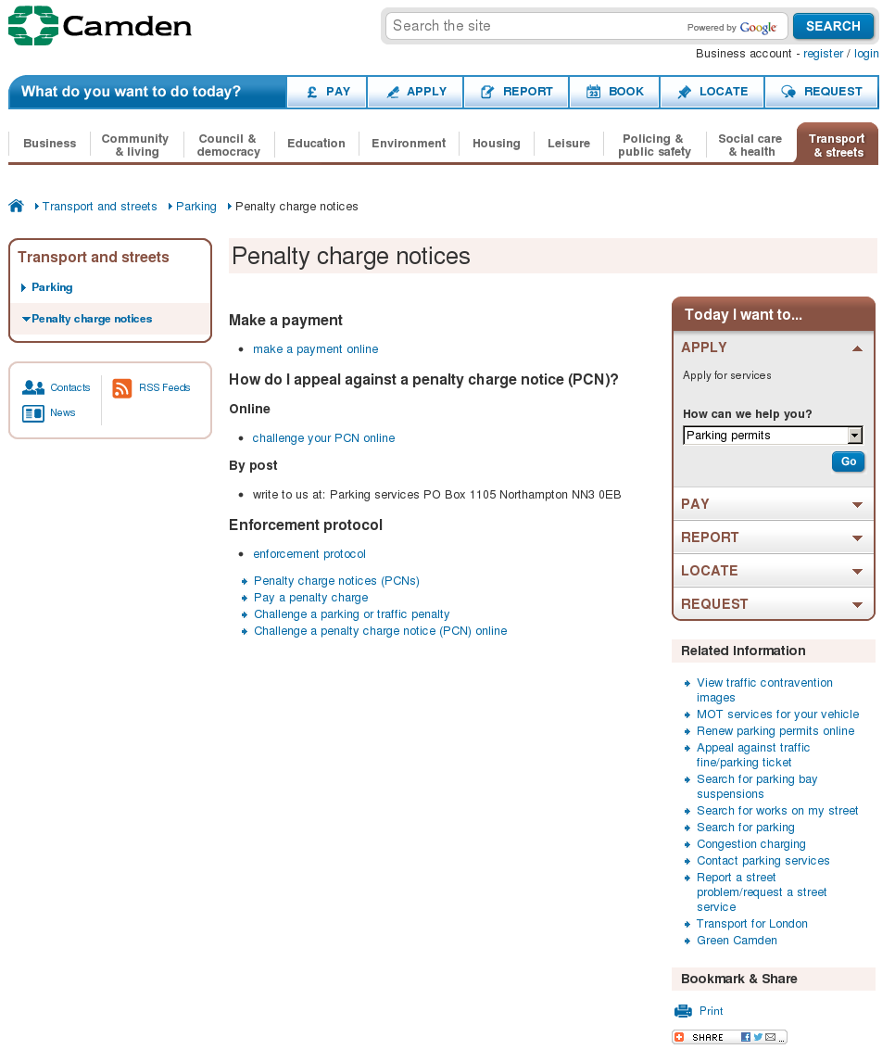
Page on local authority website: Page 1 of 3
I clicked here

Customer journey: Pay a parking fine – CAMDEN COUNCIL
How I got to this page: From Google, using search term ‘Pay parking fine camden’ & clicking 1st search result
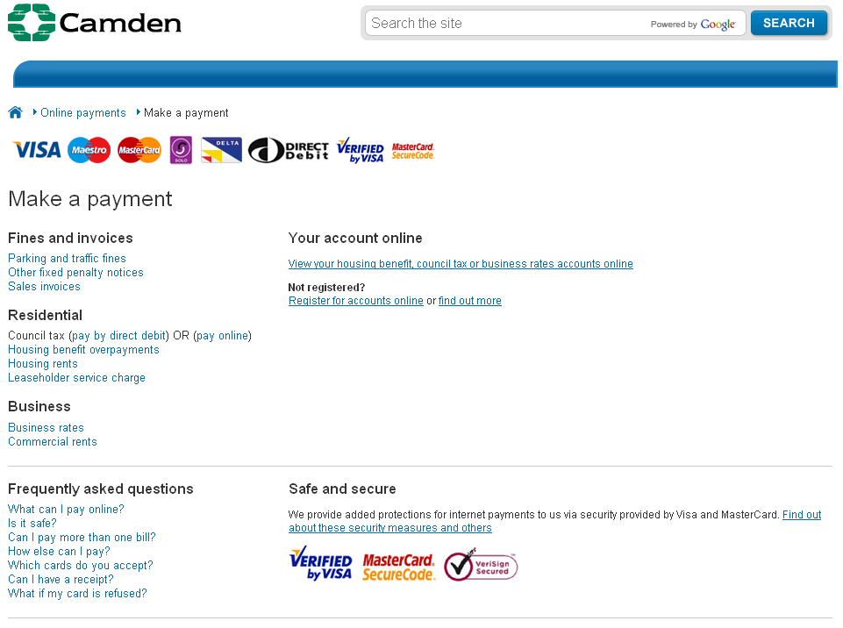
Page on local authority website: Page 2–3 of 3
I clicked here
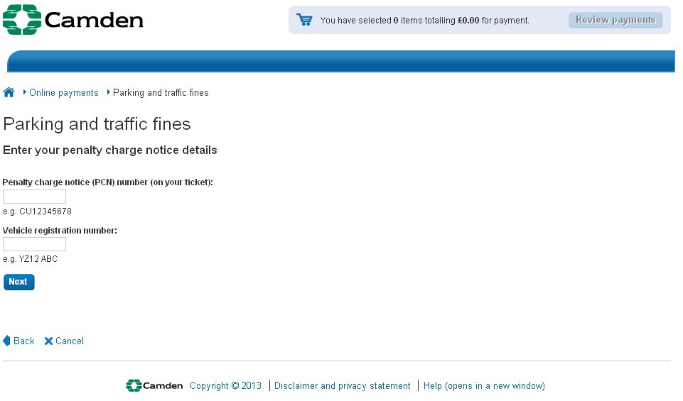
Page 3 of 3

