Customer journey: Renew your parking permit – DORSET COUNCIL
How I got to this page: From GOOGLE, using the search term ‘Renew parking permit Dorset’
Page on local authority website: Page 1+2 of 5

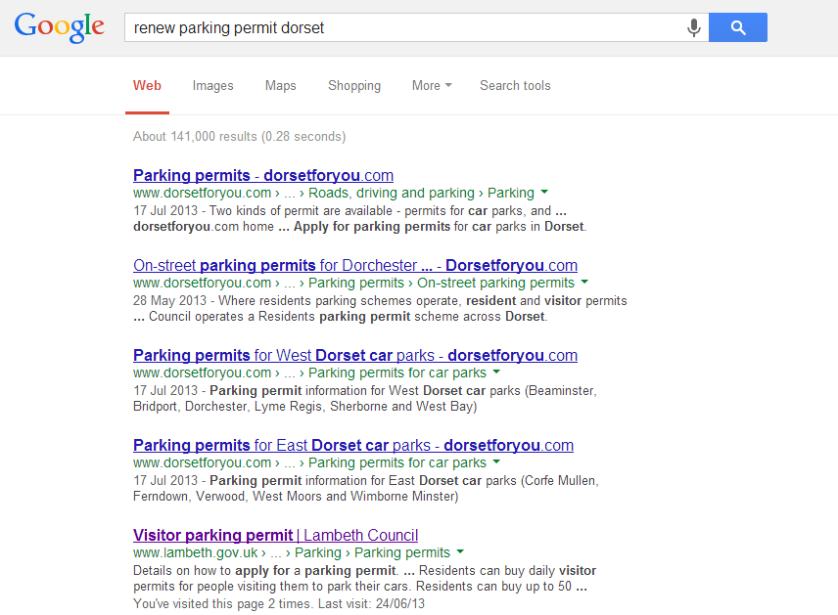
I clicked here

Page 2 of 5

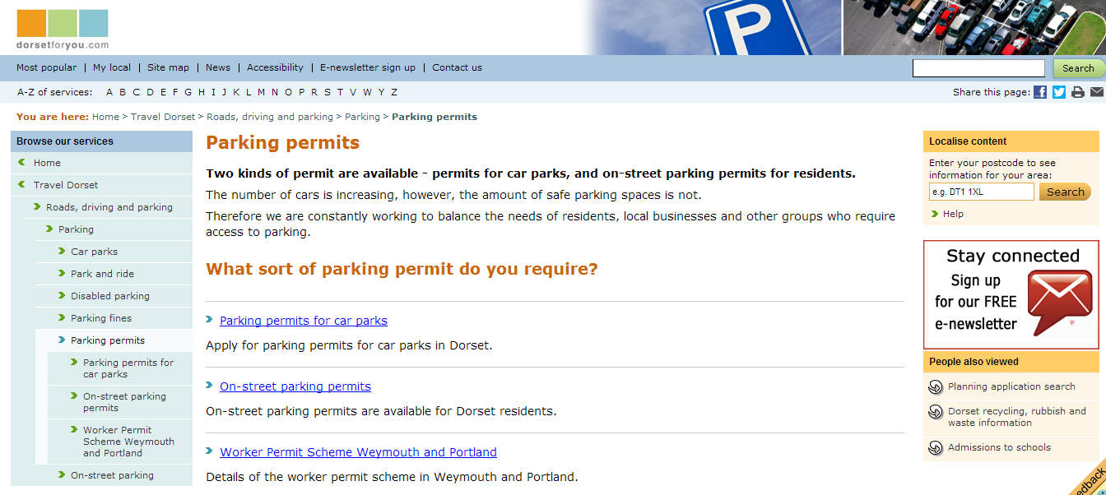
I clicked here

Customer journey: Renew your parking permit – DORSET COUNCIL
How I got to this page: From GOOGLE, using the search term ‘Renew parking permit Dorset’
Page on local authority website: Page 3+4 of 5

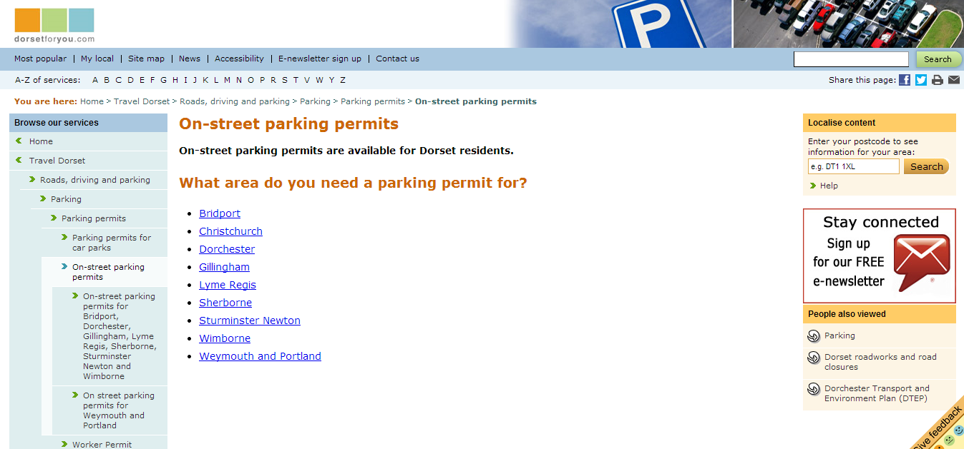
I clicked here

Page 4 of 5

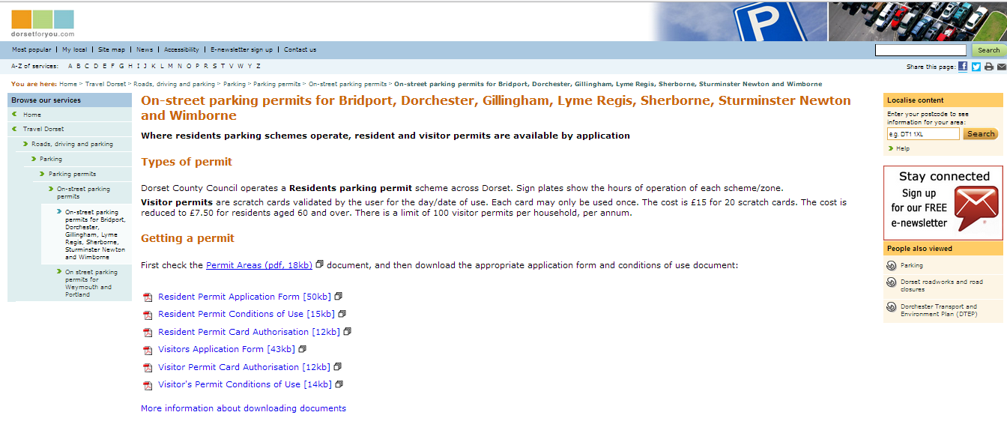
I clicked here

Customer journey: Renew your parking permit – DORSET COUNCIL
How I got to this page: From GOOGLE, using the search term ‘Renew parking permit Dorset’
Page on local authority website: Page 5 of 5

PAGE 1 OF PDF PAGE 2 OF PDF
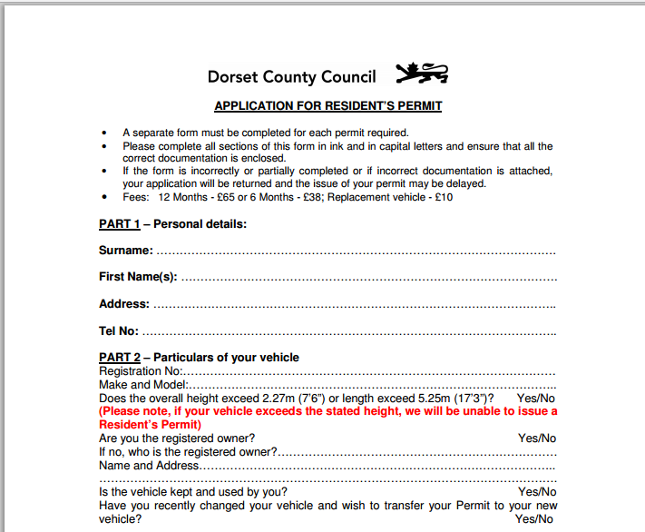
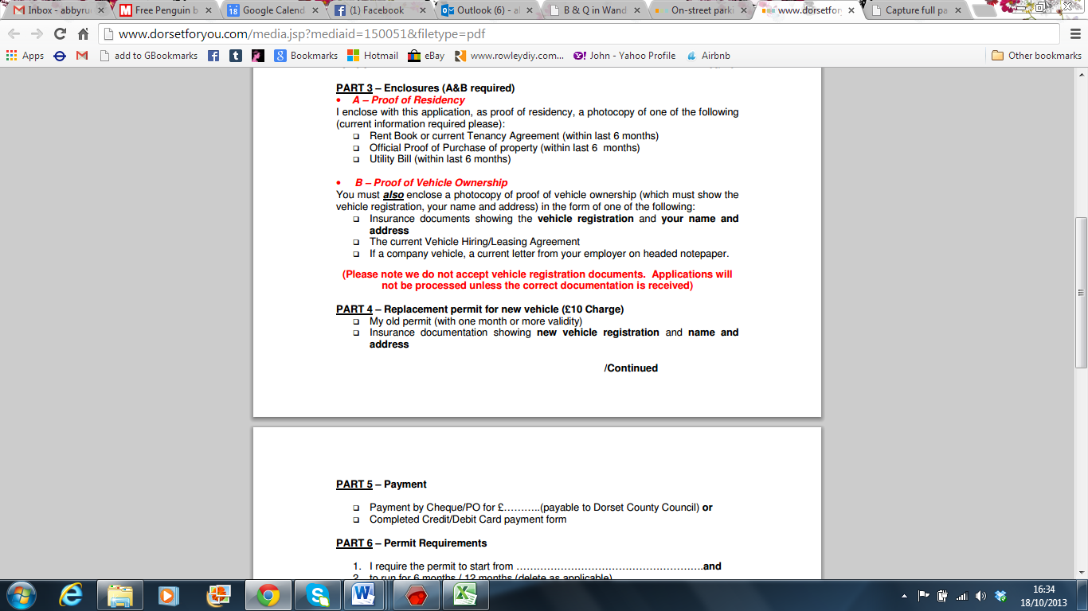

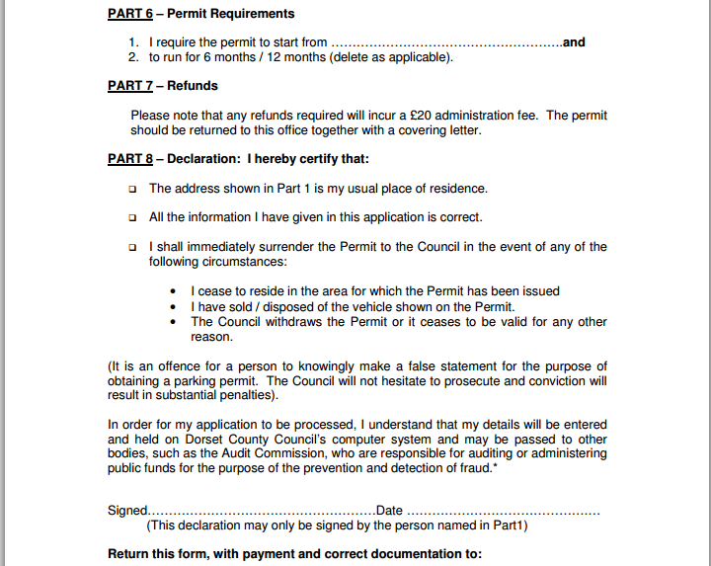

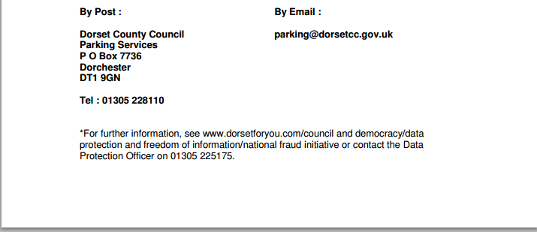
Customer journey: Renew your parking permit – BRADFORD COUNCIL
How I got to this page: From GOOGLE, using the search term ‘Renew parking permit Bradford’
Page on local authority website: Page 1 of 4

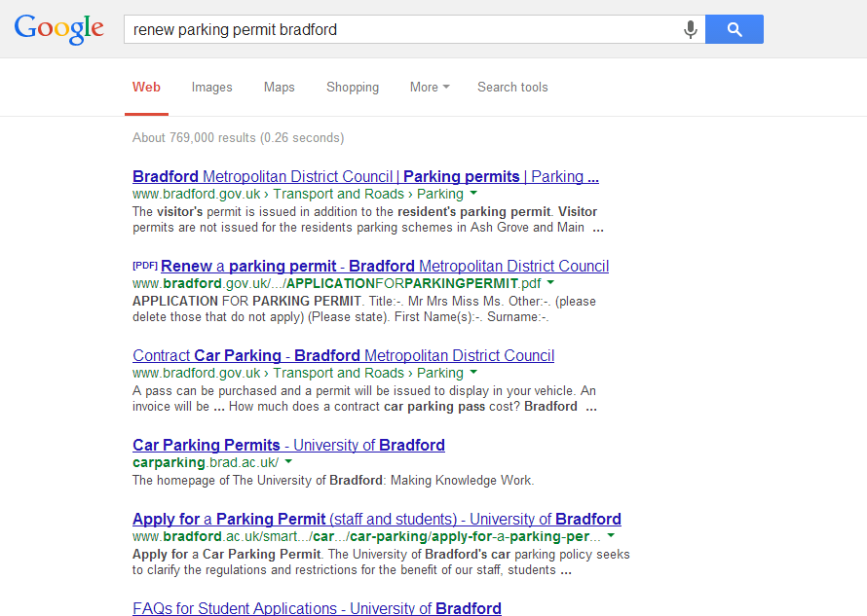
I clicked here

Customer journey: Renew your parking permit – BRADFORD COUNCIL
How I got to this page: From GOOGLE, using the search term ‘Renew parking permit Bradford’
Page on local authority website: Page 2 of 4

PAGE 1 OF PDF

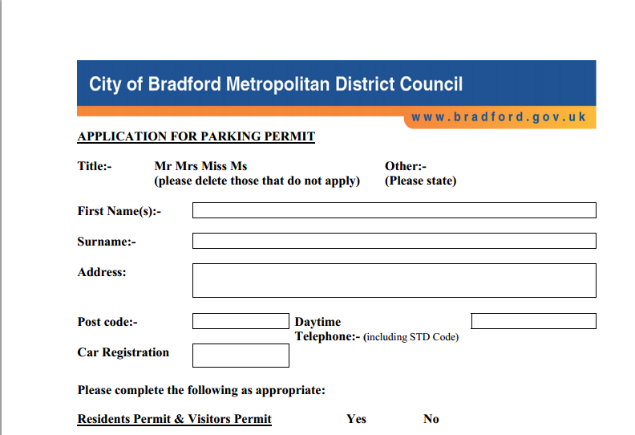
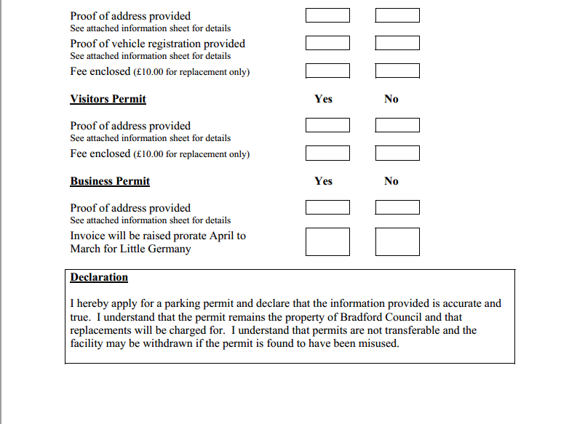

Customer journey: Renew your parking permit – BRADFORD COUNCIL
How I got to this page: From GOOGLE, using the search term ‘Renew parking permit Bradford’
Page on local authority website: Page 3 of 4

PAGE 2 OF PDF

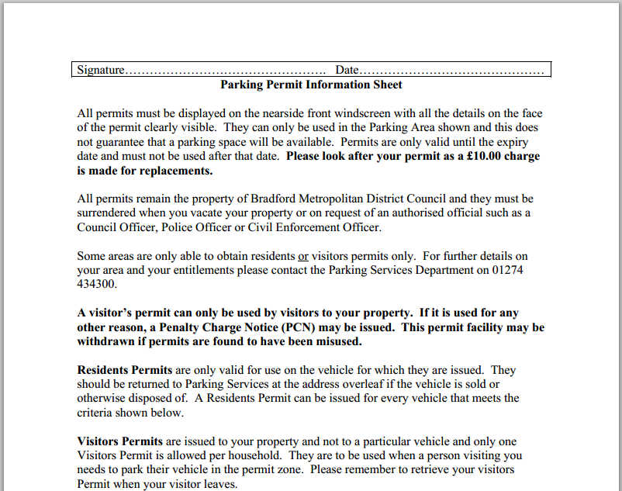
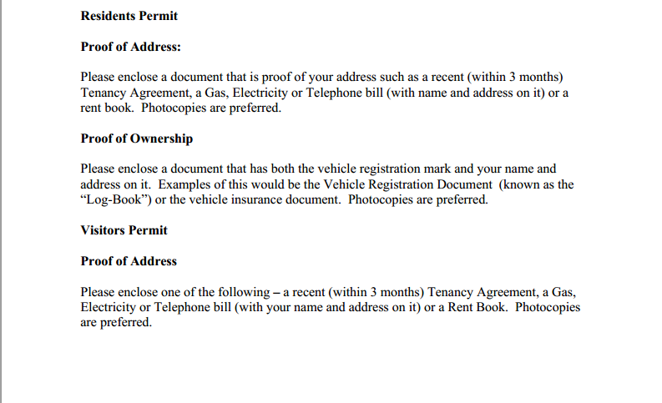
Customer journey: Renew your parking permit – BRADFORD COUNCIL
How I got to this page: From GOOGLE, using the search term ‘Renew parking permit Bradford’
Page on local authority website: Page 4 of 4

PAGE 3 OF PDF

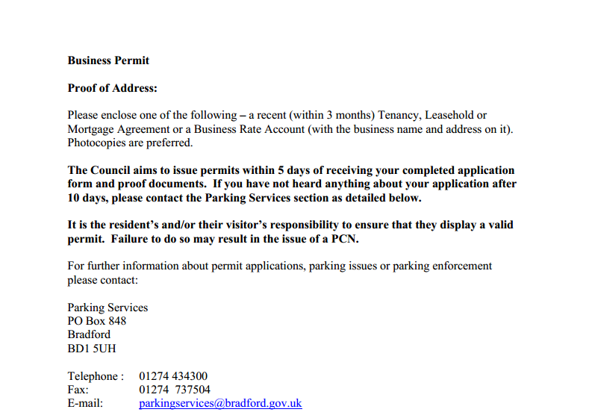
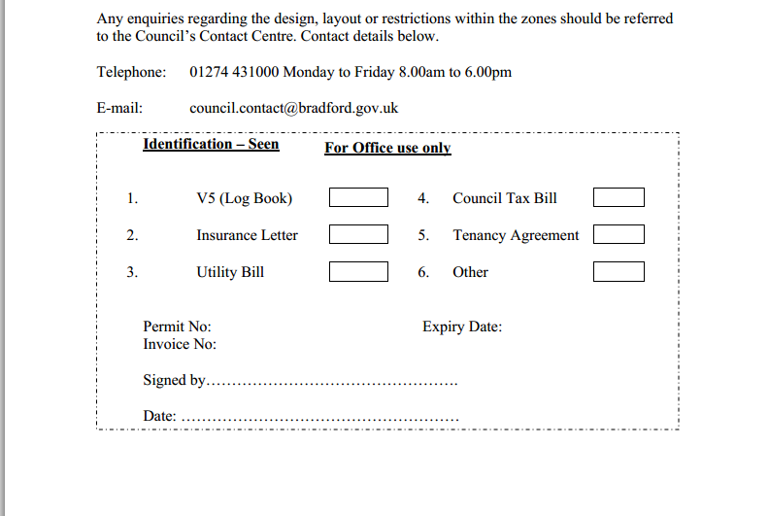

Customer journey: Renew your parking permit – WESTMINSTER COUNCIL
How I got to this page: From GOOGLE, using the search term ‘Renew parking permit Westminster’
Page on local authority website: Page 1 of 3

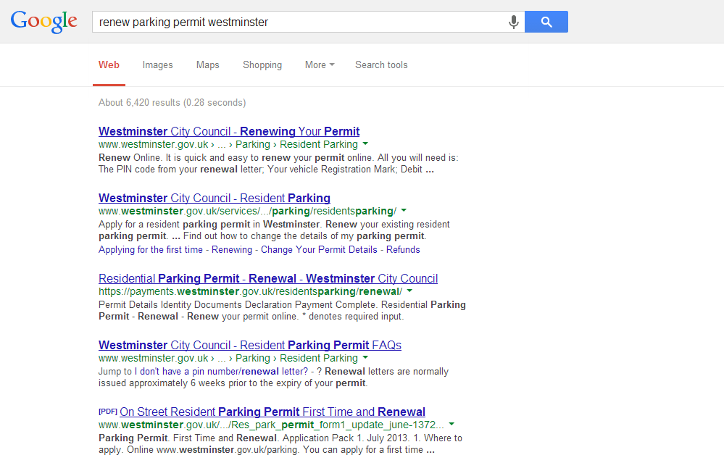
I clicked here

Customer journey: Renew your parking permit – WESTMINSTER COUNCIL
How I got to this page: From GOOGLE, using the search term ‘Renew parking permit Westminster’
Page on local authority website: Page 2 of 3

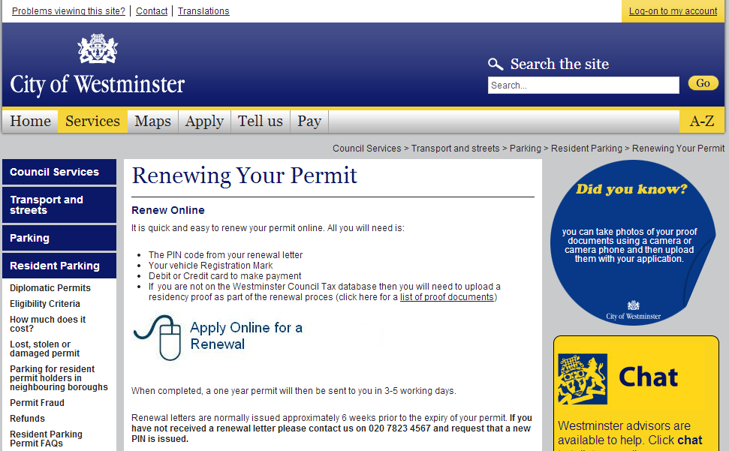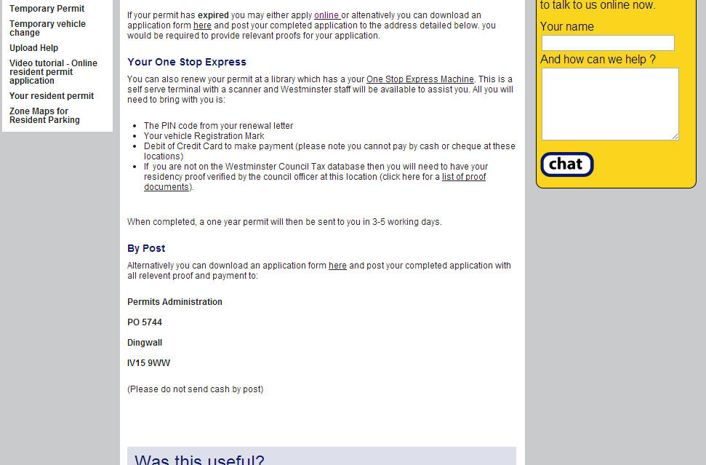
I clicked here
Customer journey: Renew your parking permit – WESTMINSTER COUNCIL
How I got to this page: From GOOGLE, using the search term ‘Renew parking permit Westminster’
Page on local authority website: Page 3 of 3

