Customer journey: Report a missed bin collection – KING’S LYNN & WEST NORFOLK
How I got to this page: From Google, using search term ‘Report missed bin King’s Lynn’ & clicking 1st search result
Page on local authority website: Page 1 of 2

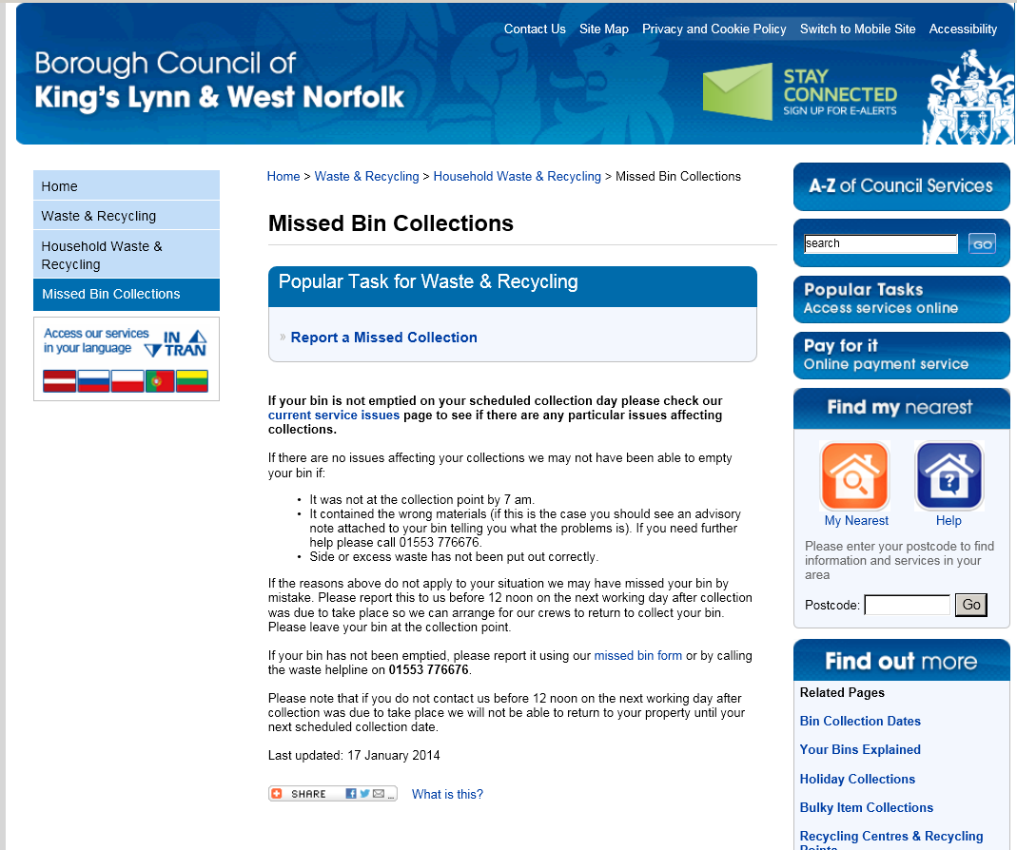
I clicked here
I clicked here
Customer journey: Report a missed bin collection – KING’S LYNN & WEST NORFOLK
How I got to this page: From Google, using search term ‘Report missed bin King’s Lynn’ & clicking 1st search result
Page on local authority website: Page 2 of 2
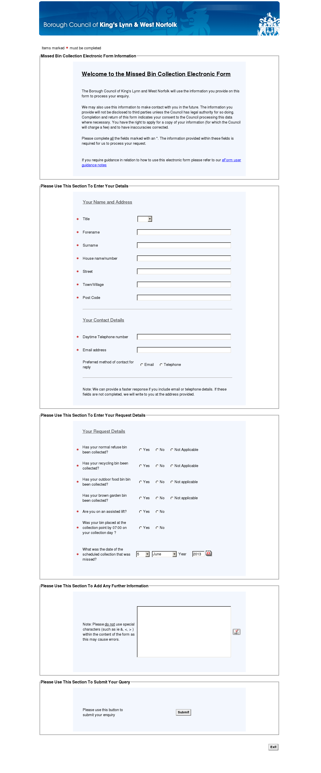
Customer journey: Report a missed bin collection – CHICHESTER
How I got to this page: From Google, using search term ‘Report missed bin Chichester’ & clicking 1st search result
Page on local authority website: Page 1 of 1
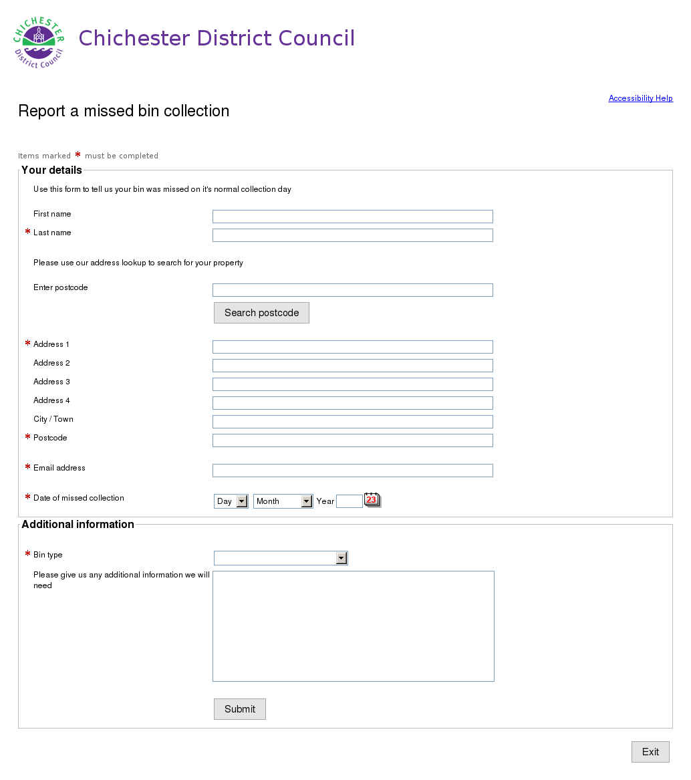

Customer journey: Report a missed bin collection – PORTSMOUTH COUNCIL
How I got to this page: From Google, using search term ‘Report missed bin portsmouth’ & clicking 1st search result
Page on local authority website: Page 1 of 6

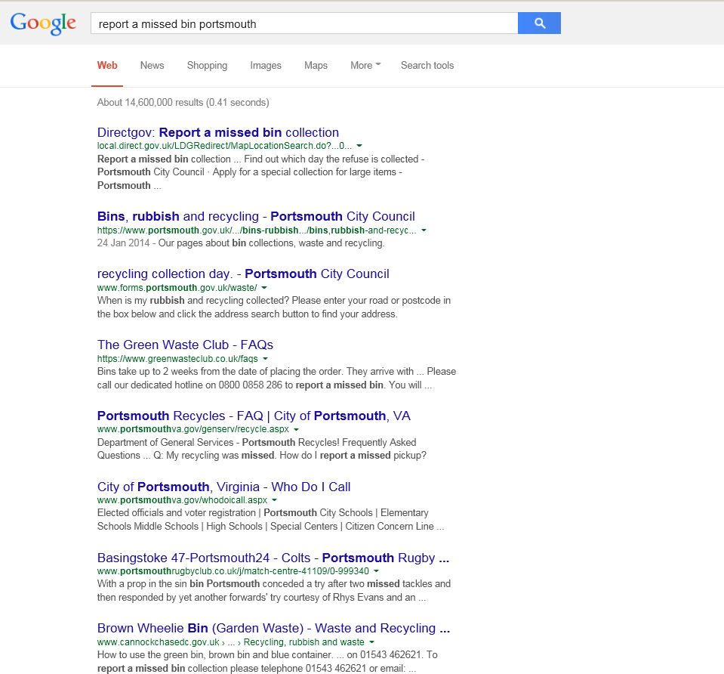
I clicked here

Customer journey: Report a missed bin collection – PORTSMOUTH COUNCIL
How I got to this page: From Google, using search term ‘Report missed bin portsmouth’ & clicking 1st search result
Page on local authority website: Page 2 of 6

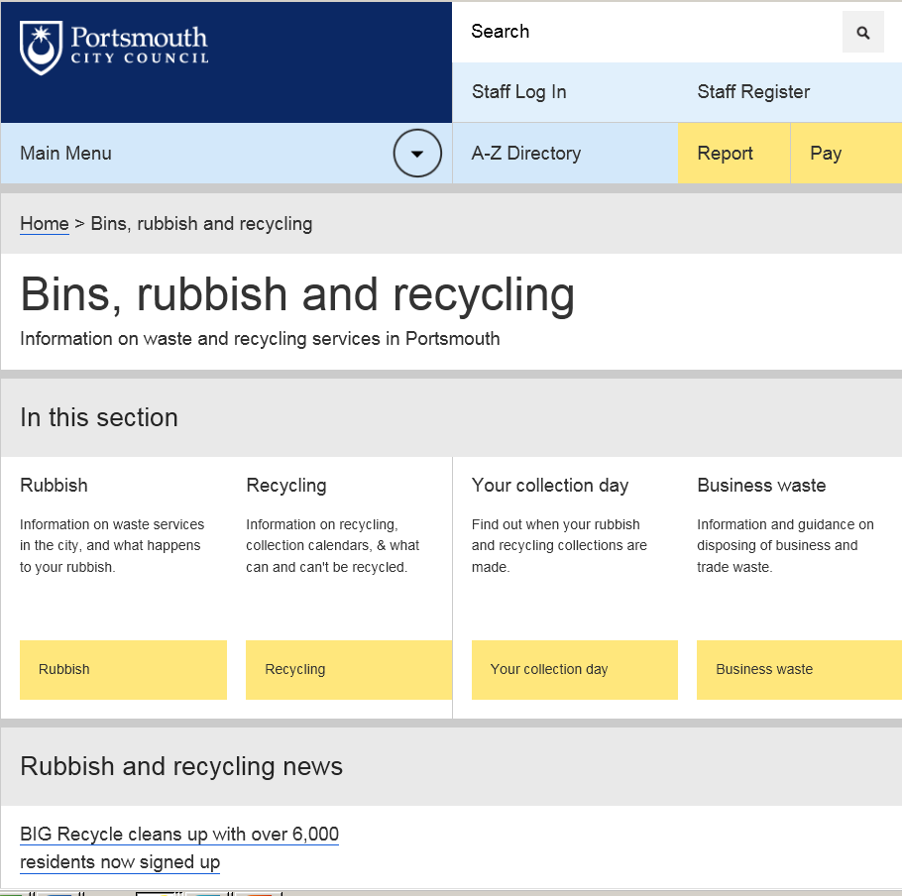
I clicked here

Customer journey: Report a missed bin collection – PORTSMOUTH COUNCIL
How I got to this page: From Google, using search term ‘Report missed bin portsmouth’ & clicking 1st search result
Page on local authority website: Page 3 of 6

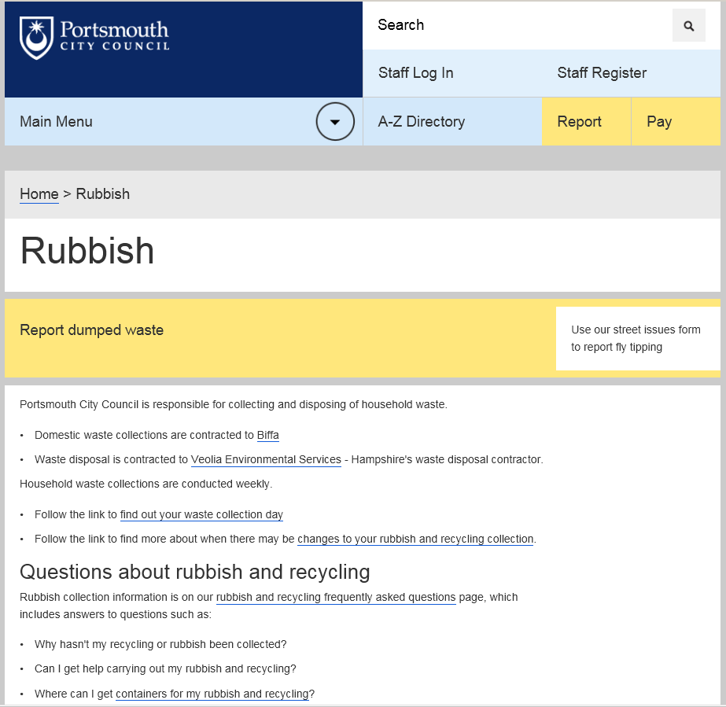
Couldn’t find way to report missed bin here so went back and clicked ‘Your collection day’
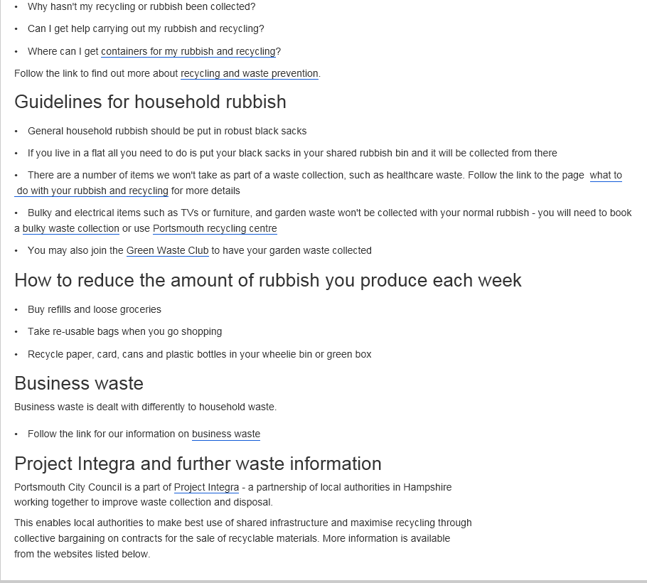

Customer journey: Report a missed bin collection – PORTSMOUTH COUNCIL
How I got to this page: From Google, using search term ‘Report missed bin portsmouth’ & clicking 1st search result
Page on local authority website: Page 4 of 6

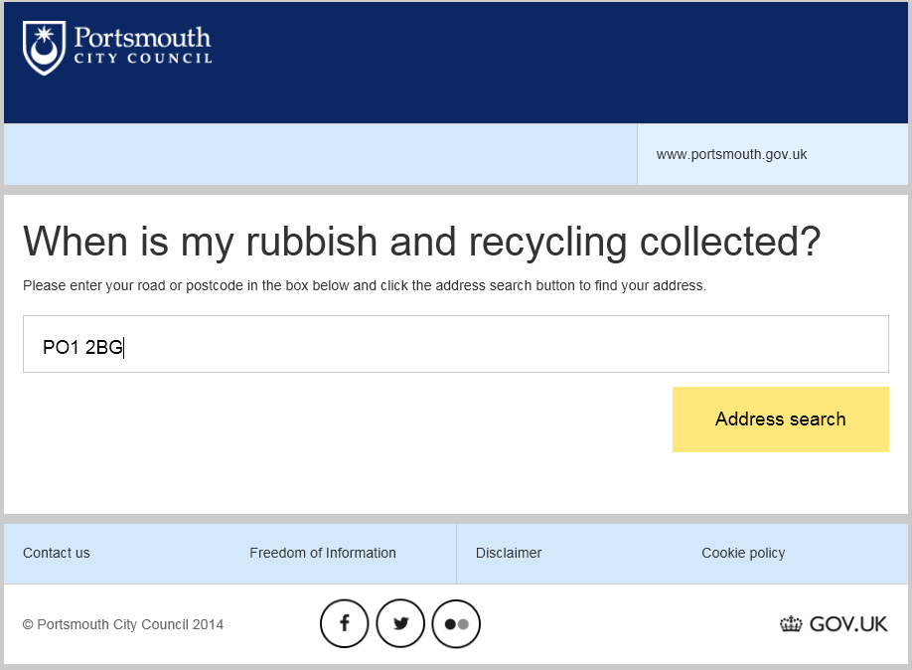
I clicked here

Page 5 of 6

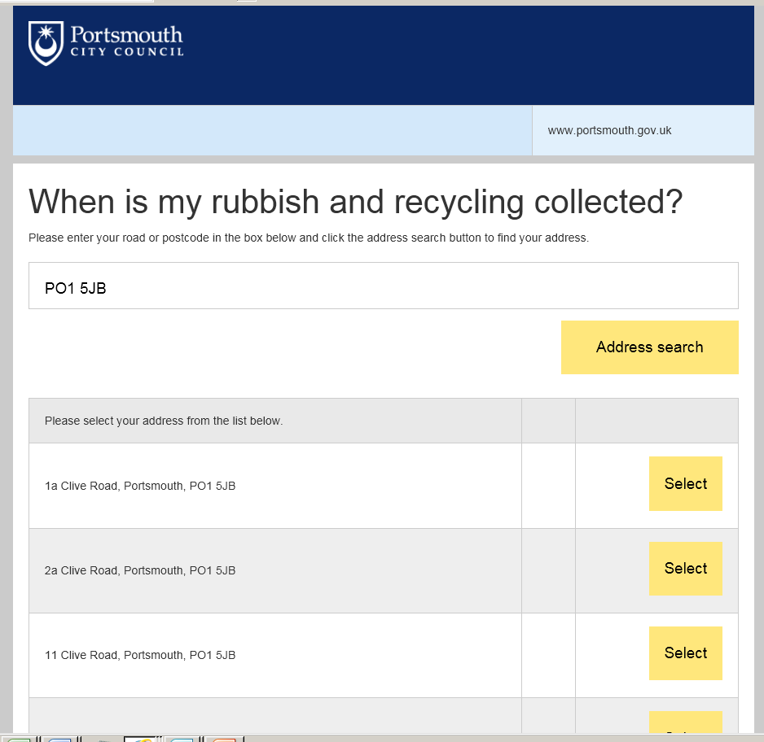
I clicked here

Customer journey: Report a missed bin collection – PORTSMOUTH COUNCIL
How I got to this page: From Google, using search term ‘Report missed bin portsmouth’ & clicking 1st search result
Page on local authority website: Page 6 of 6

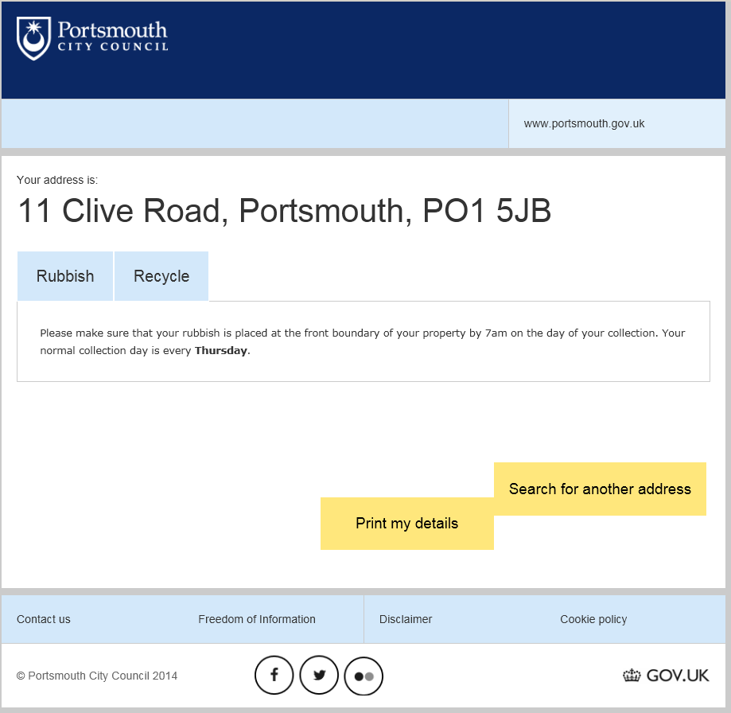

Still can’t find the information I need. I give up and ring the council…

