Customer journey: Report a pothole – OXFORDSHIRE COUNTY COUNCIL
How I got to this page: From Google, using search term ‘Report a pothole oxford’ & clicking 1st search result
Page on local authority website: Page 1 of 4

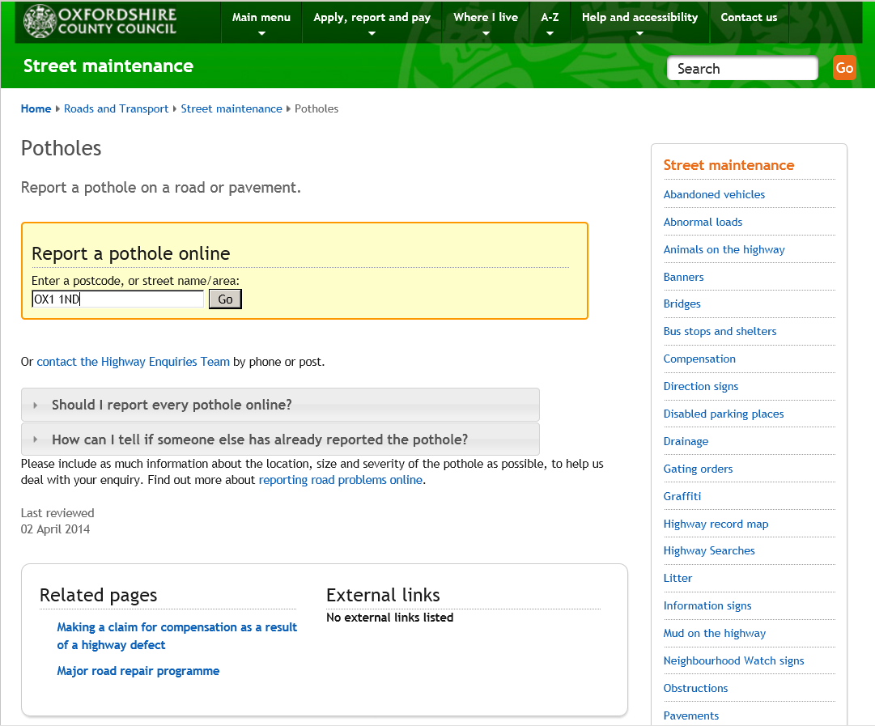
I put in postcode here
Customer journey: Report a pothole – OXFORDSHIRE COUNTY COUNCIL
How I got to this page: From Google, using search term ‘Report a pothole oxford’ & clicking 1st search result
Page on local authority website: Page 2 of 4

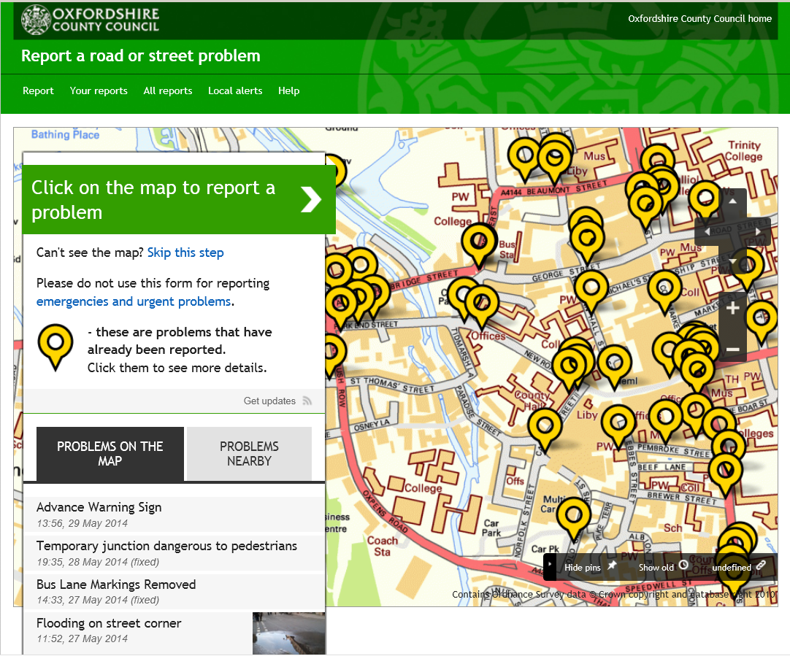

I zoomed in on the map and clicked on the place where my pothole was
Customer journey: Report a pothole – OXFORDSHIRE COUNTY COUNCIL
How I got to this page: From Google, using search term ‘Report a pothole oxford’ & clicking 1st search result
Page on local authority website: Page 3 of 4

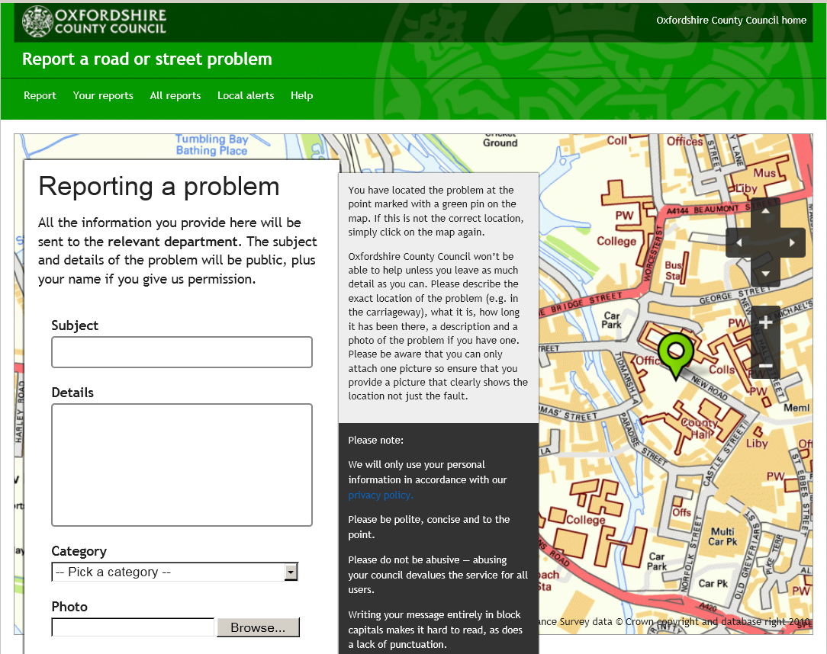
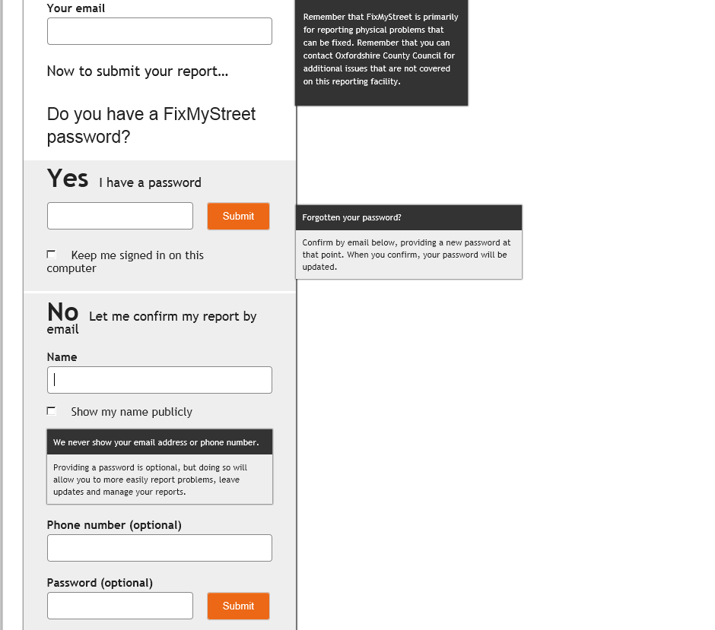
I clicked here

Customer journey: Report a pothole – OXFORDSHIRE COUNTY COUNCIL
How I got to this page: From Google, using search term ‘Report a pothole oxford’ & clicking 1st search result
Page on local authority website: Page 4 of 4

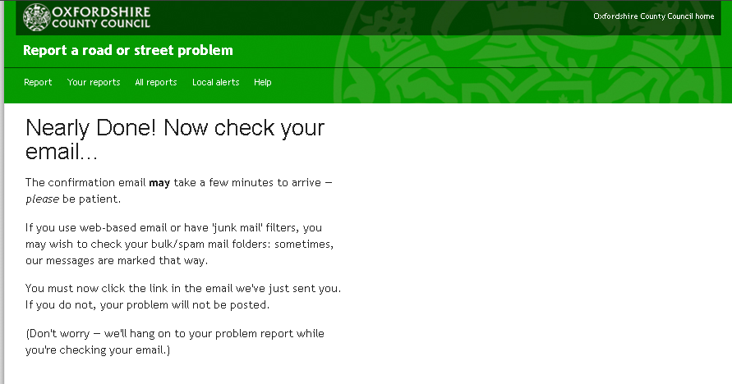

Customer journey: Report a pothole – LEICESTER CITY COUNCIL
How I got to this page: From Google, using search term ‘Report a pothole leicester’ & clicking 1st search result
Page on local authority website: Page 1 of 2

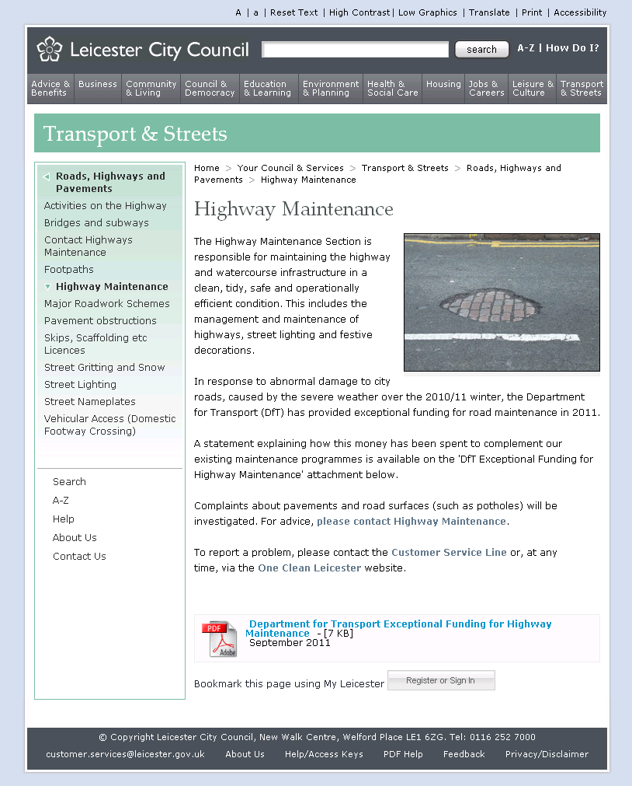
I clicked here
Customer journey: Report a pothole – LEICESTER CITY COUNCIL
How I got to this page: From Google, using search term ‘Report a pothole leicester’ & clicking 1st search result
Page on local authority website: Page 2 of 2

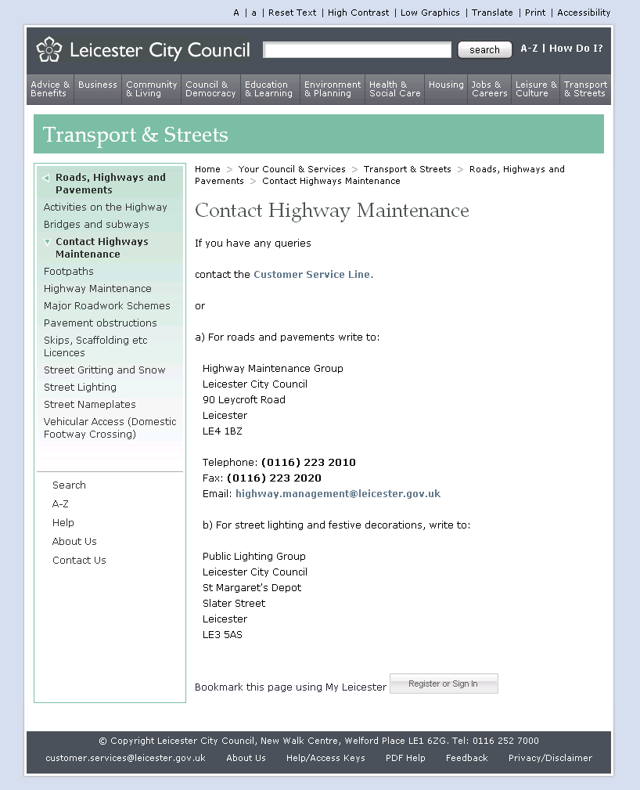
Customer journey: Report a pothole – LONDON BOROUGH OF RICHMOND CITY COUNCIL
How I got to this page: From Google, using search term ‘Report a pothole richmond’ & clicking 1st search result
Page on local authority website: Page 1 of 4

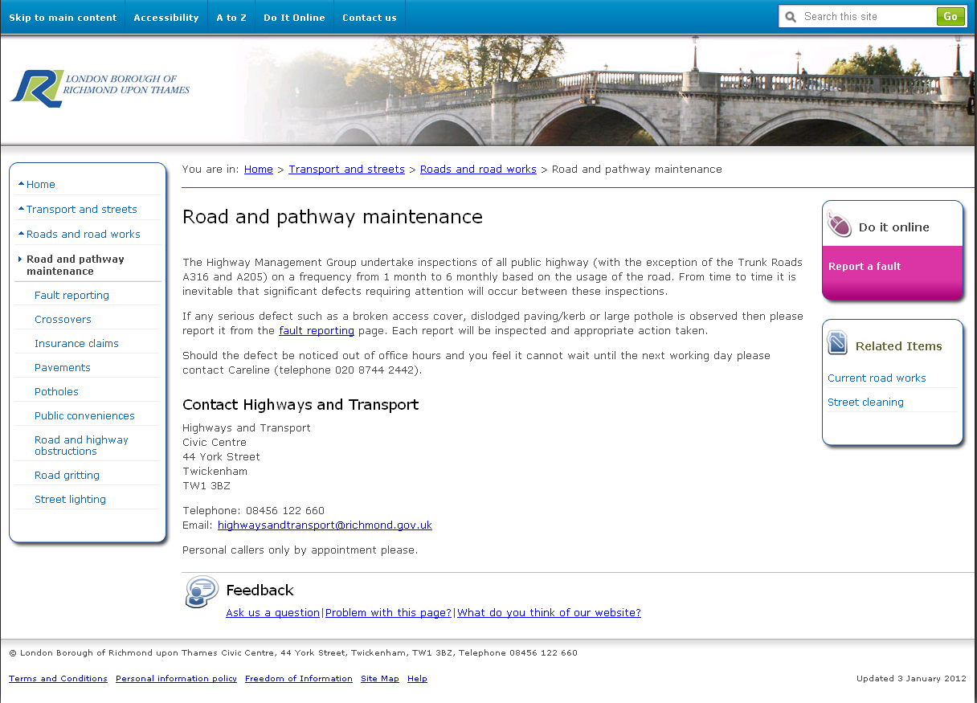
I clicked here

Page 2 of 4

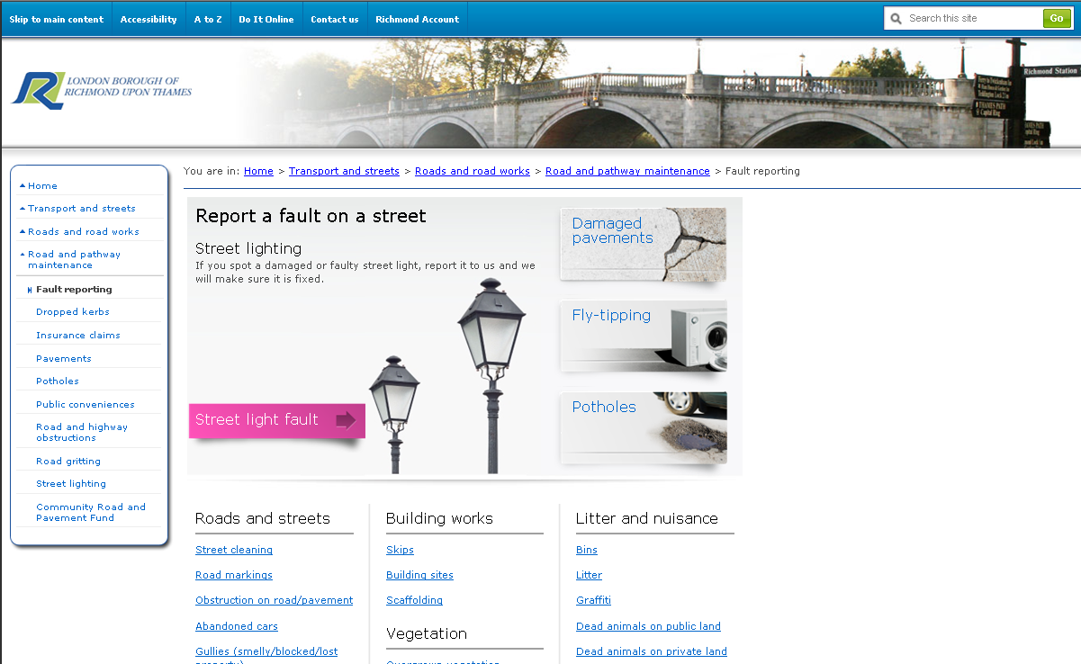

I clicked here
Customer journey: Report a pothole – LONDON BOROUGH OF RICHMOND CITY COUNCIL
How I got to this page: From Google, using search term ‘Report a pothole richmond’ & clicking 1st search result
Page on local authority website: Page 3 of 4

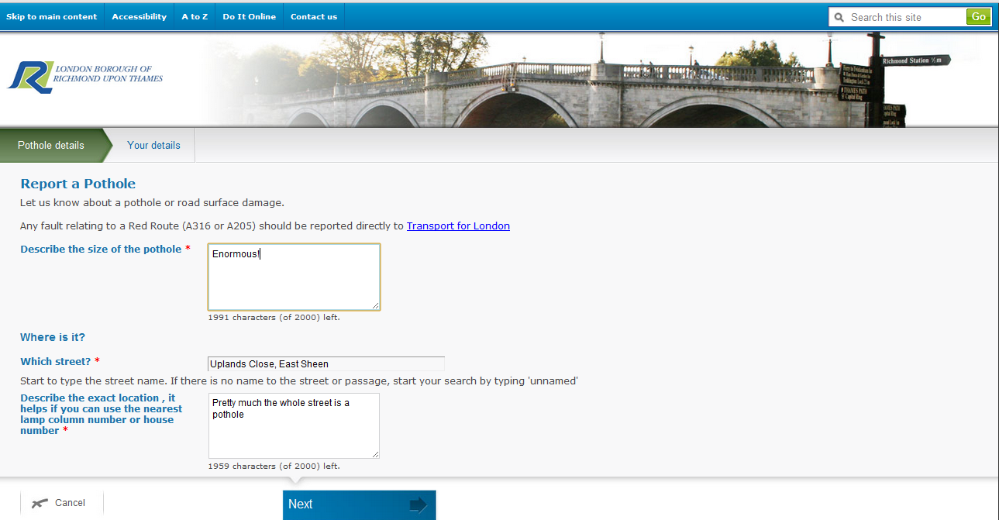

Page 4 of 4

