Customer journey: School term and holiday dates – NORTH YORKSHIRE COUNTY COUNCIL
How I got to this page: From GOV.UK, using the postcode DL7 8AD
Pg on council website: Page 1 of 1
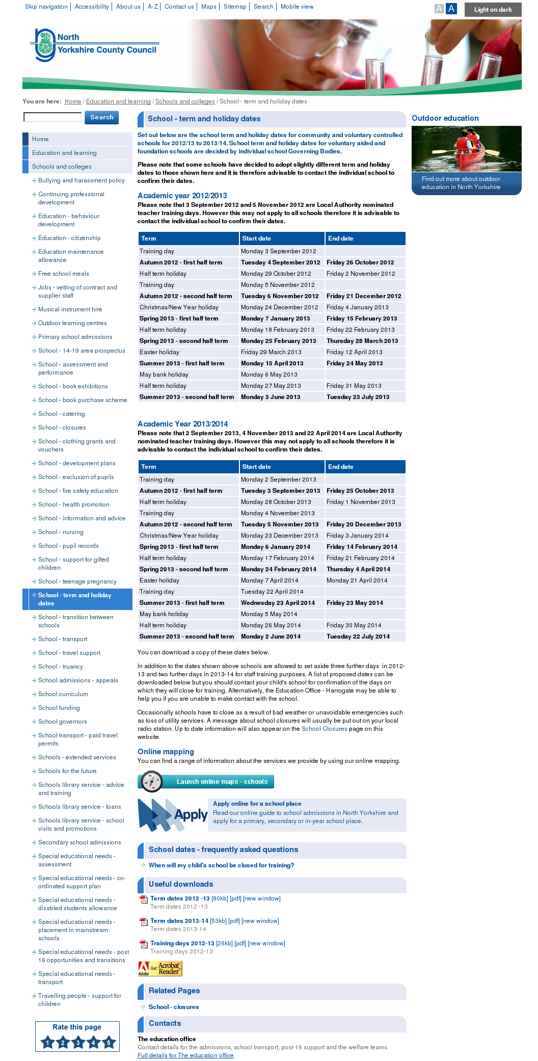

Customer journey: School term and holiday dates – WORCESTERSHIRE COUNCIL
How I got to this page: From GOV.UK, using the postcode WR5 2NP
Pg on council website: Page 1 of 2
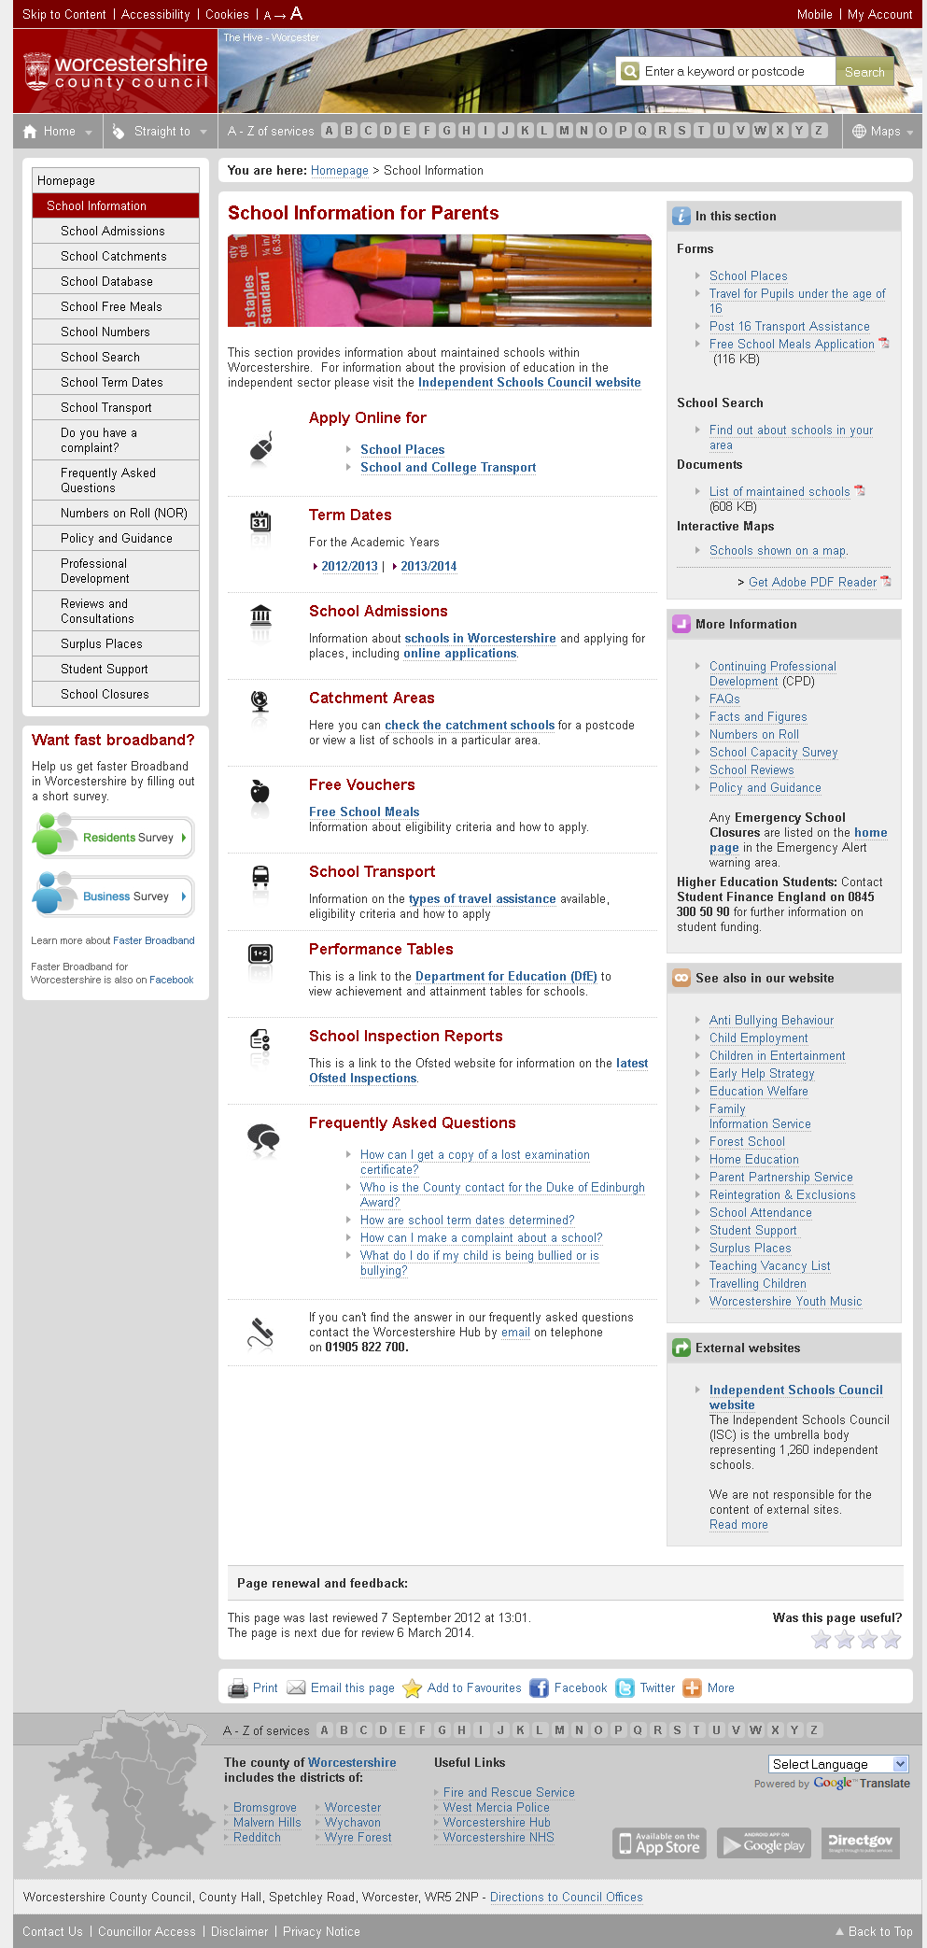

I clicked here

Customer journey: School term and holiday dates – WORCESTERSHIRE COUNCIL
How I got to this page: From GOV.UK, using the postcode WR5 2NP
Pg on council website: Page 2 of 2
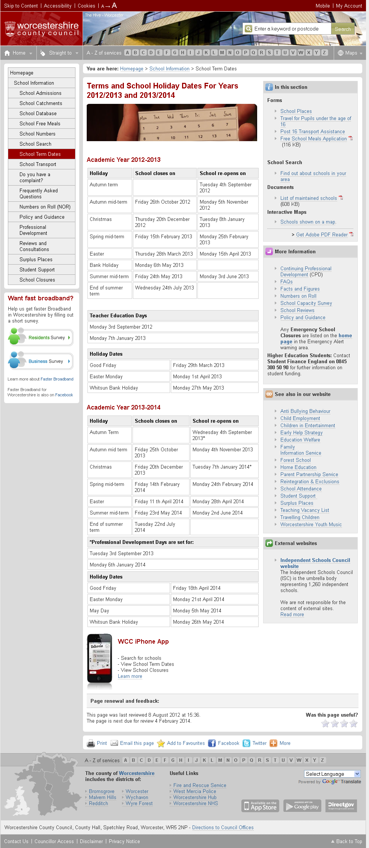

Customer journey: School term and holiday dates – POWYS COUNCIL
How I got to this page: From Google, using search term ‘School term and holiday dates Powys council’
Pg on council website: Page 1 of 2

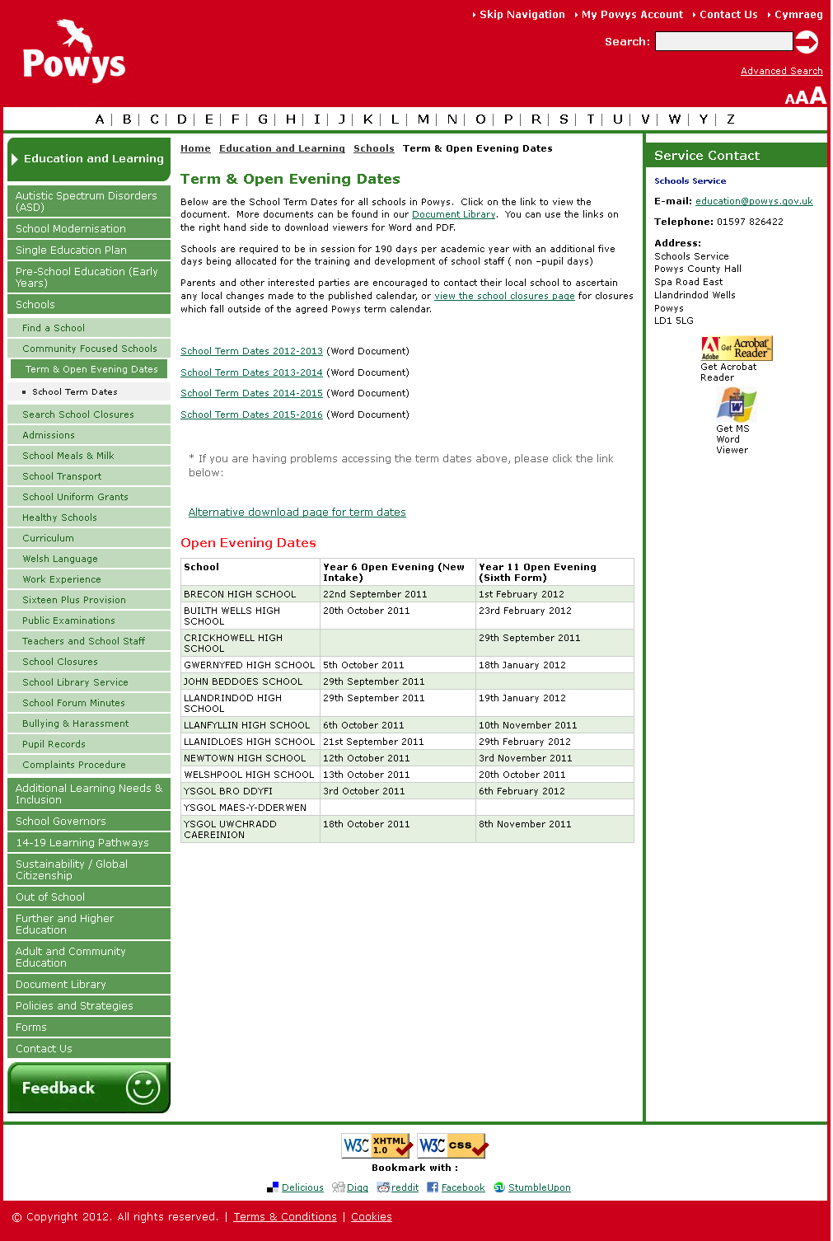
I clicked here

Customer journey: School term and holiday dates – POWYS COUNCIL
How I got to this page: From Google, using search term ‘School term and holiday dates Powys council’
Pg on council website: Page 2 of 2
