Customer journey: Search the register of planning applications – NORTHUMBERLAND
How I got to this page: From GOV.UK, using the postcode NE61 2EF
Page on local authority website: Page 1 of 3

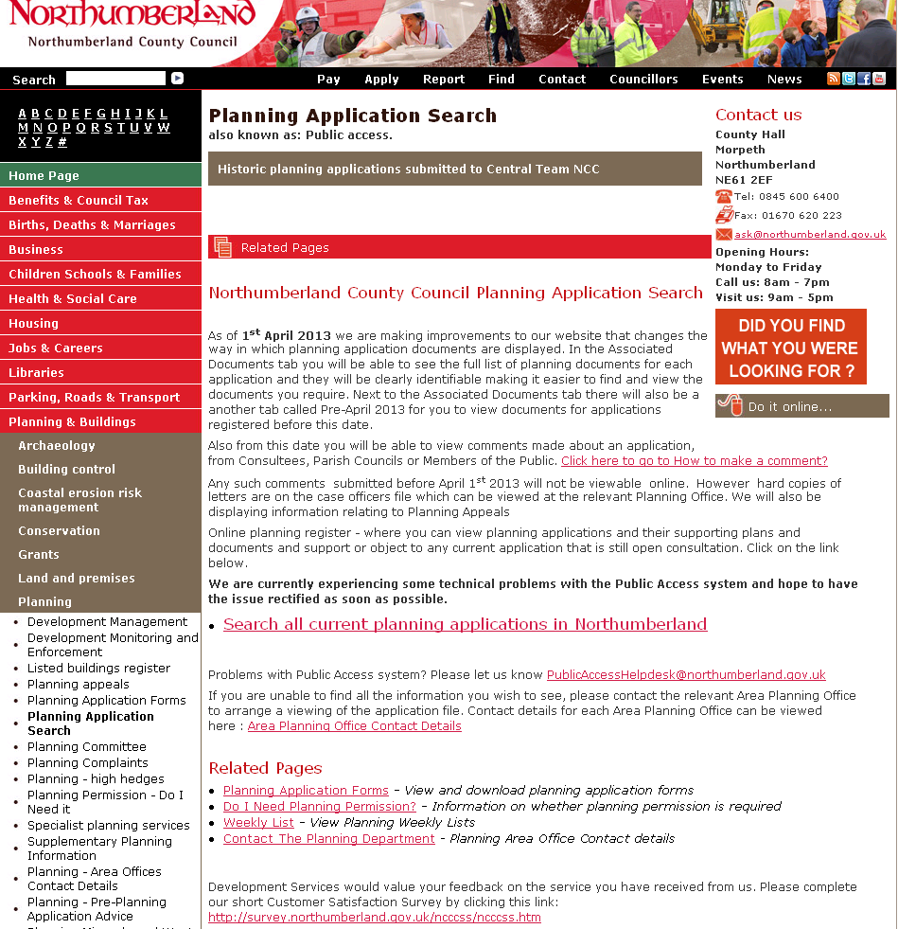

I clicked here

Customer journey: Search the register of planning applications – NORTHUMBERLAND
How I got to this page: From GOV.UK, using the postcode NE61 2EF
Page on local authority website: Page 2+3 of 3

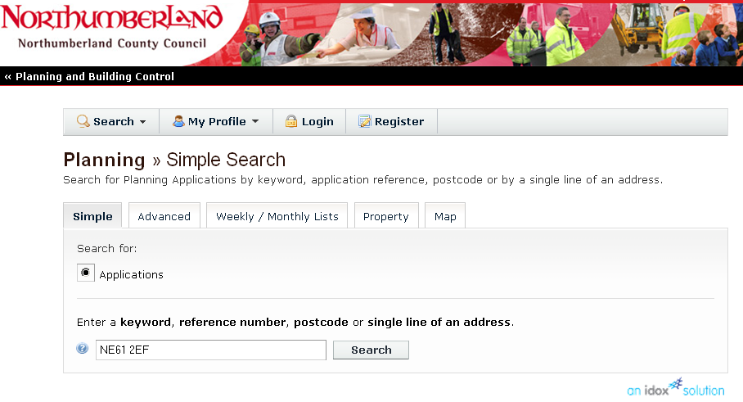

I clicked here

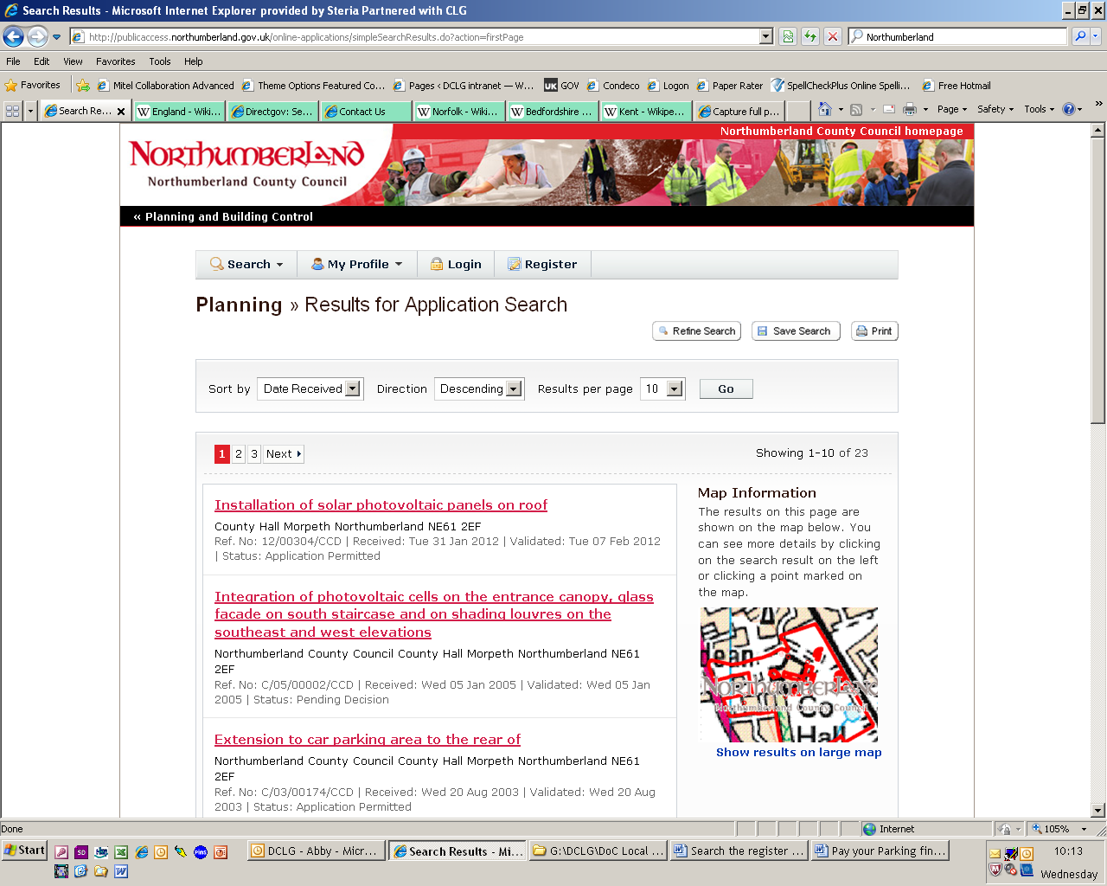
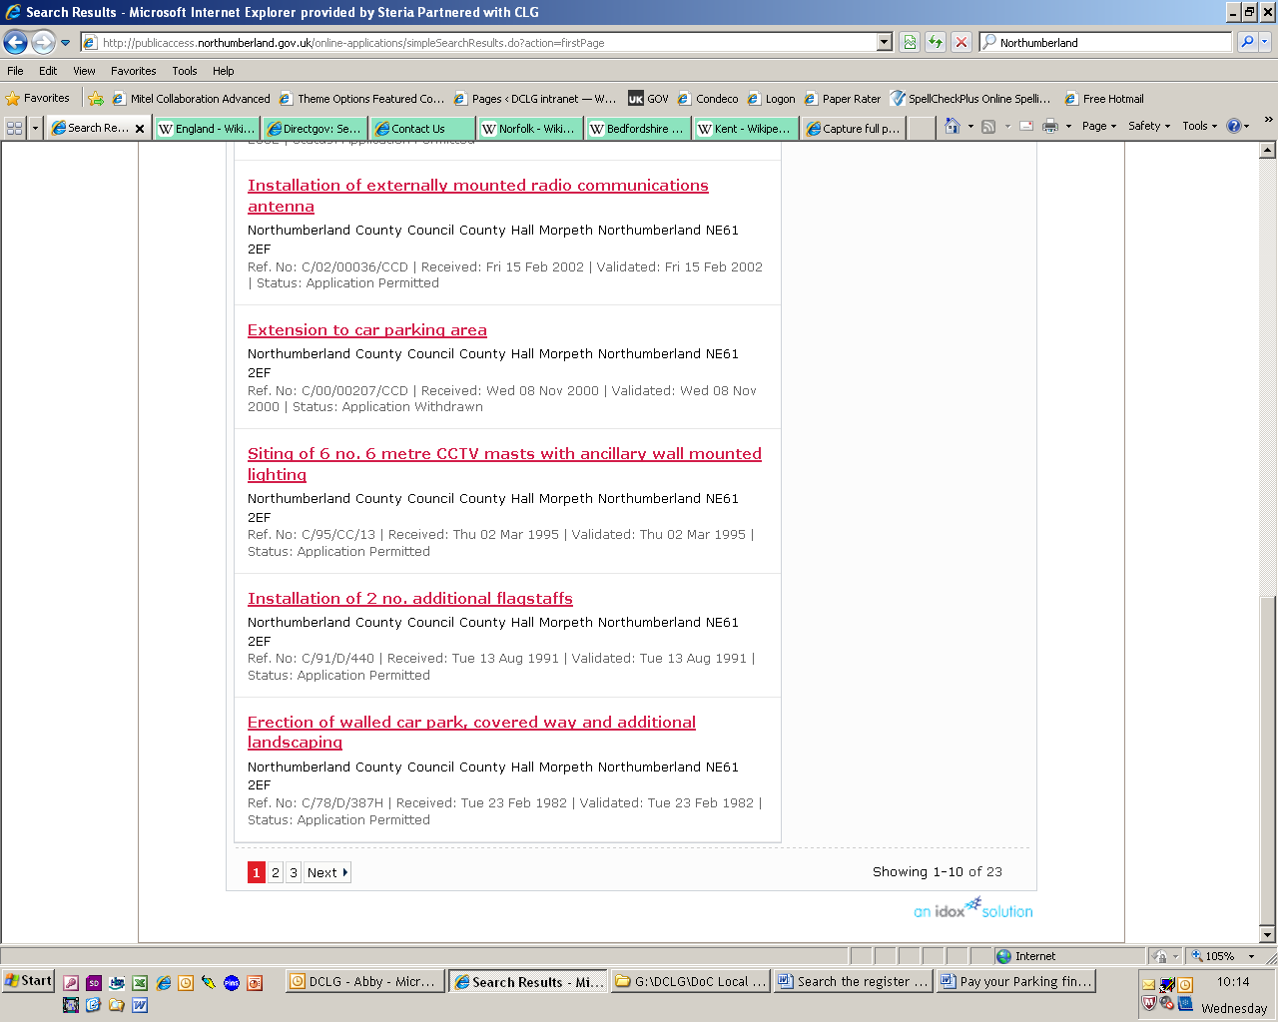
Page 3 of 3

Customer journey: Search the register of planning applications – NORWICH
How I got to this page: From GOV.UK, using the postcode NR2 1NH
Page on local authority website: Page 1+2 of 6

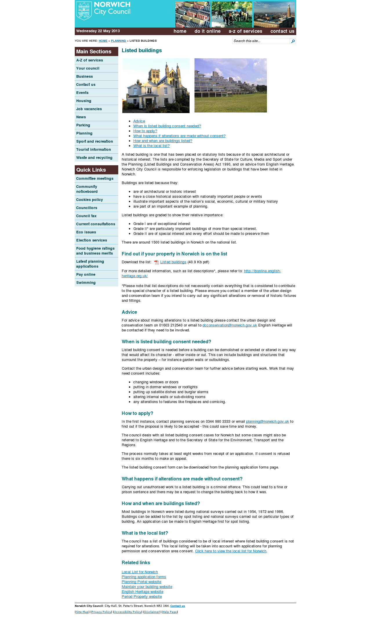

Takes me to the wrong page, so I searched “Search the register of planning applications”

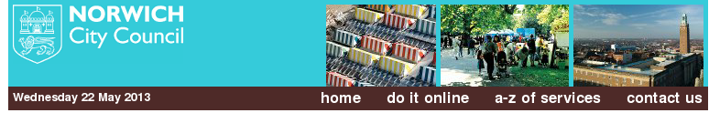
Page 2 of 6

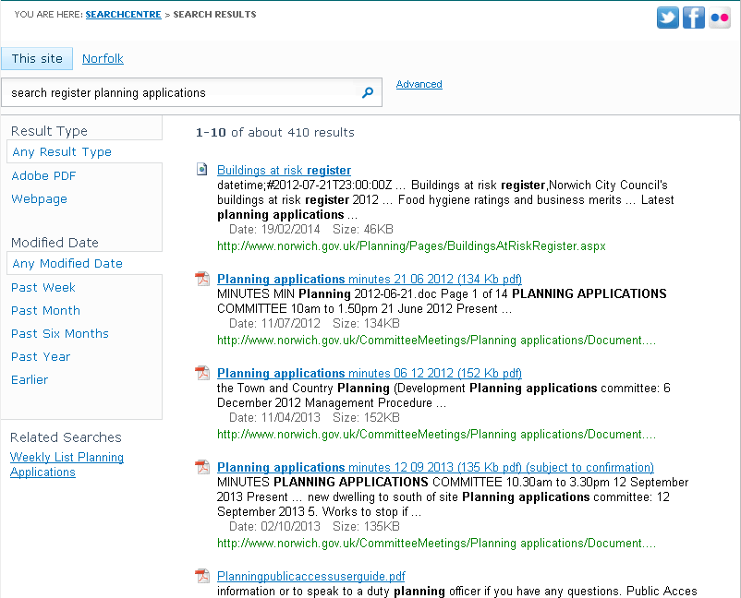

Search only shows documents, not web pages.

Customer journey: Search the register of planning applications – NORWICH
How I got to this page: From GOV.UK, using the postcode NR2 1NH
Page on local authority website: Page 3 of 6

Since I couldn’t find the link in search, I went back a page and clicked on “Planning” on the left hand navigation.

Customer journey: Search the register of planning applications – NORWICH
How I got to this page: From GOV.UK, using the postcode NR2 1NH
Page on local authority website: Page 4+5 of 6

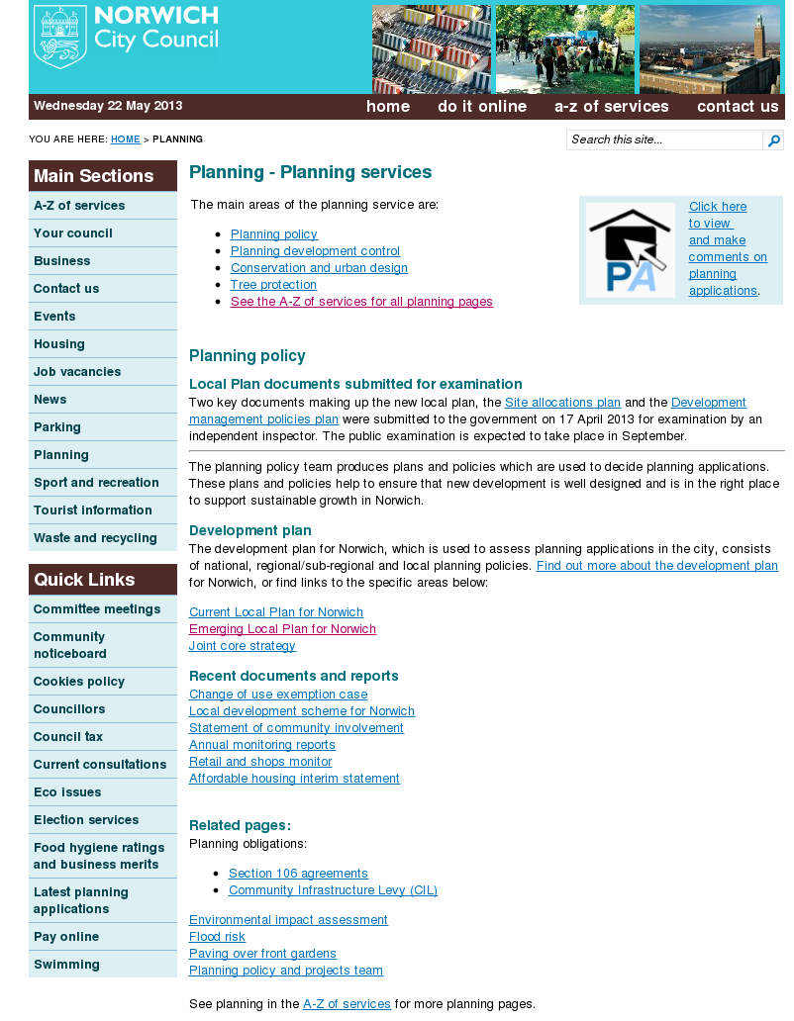

I clicked here

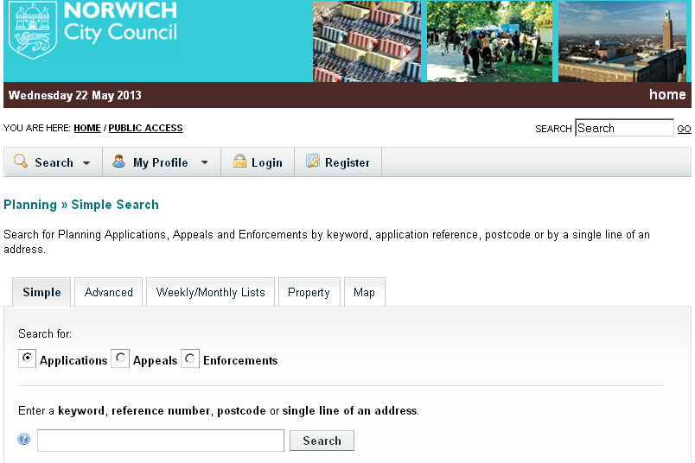
Page 5 of 6

I clicked here

Customer journey: Search the register of planning applications – NORWICH
How I got to this page: From GOV.UK, using the postcode NR2 1NH
Page on local authority website: Page 6 of 6

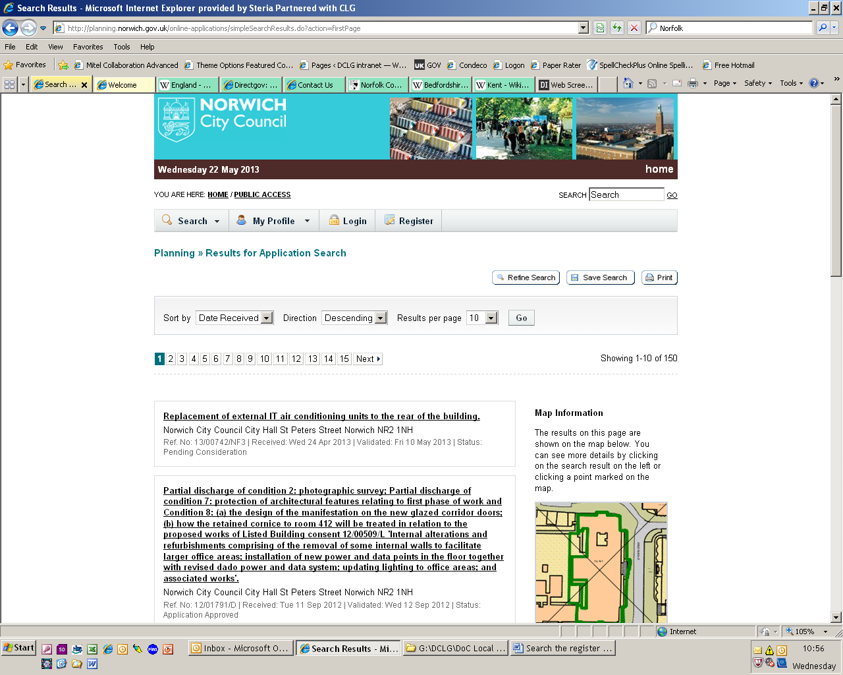
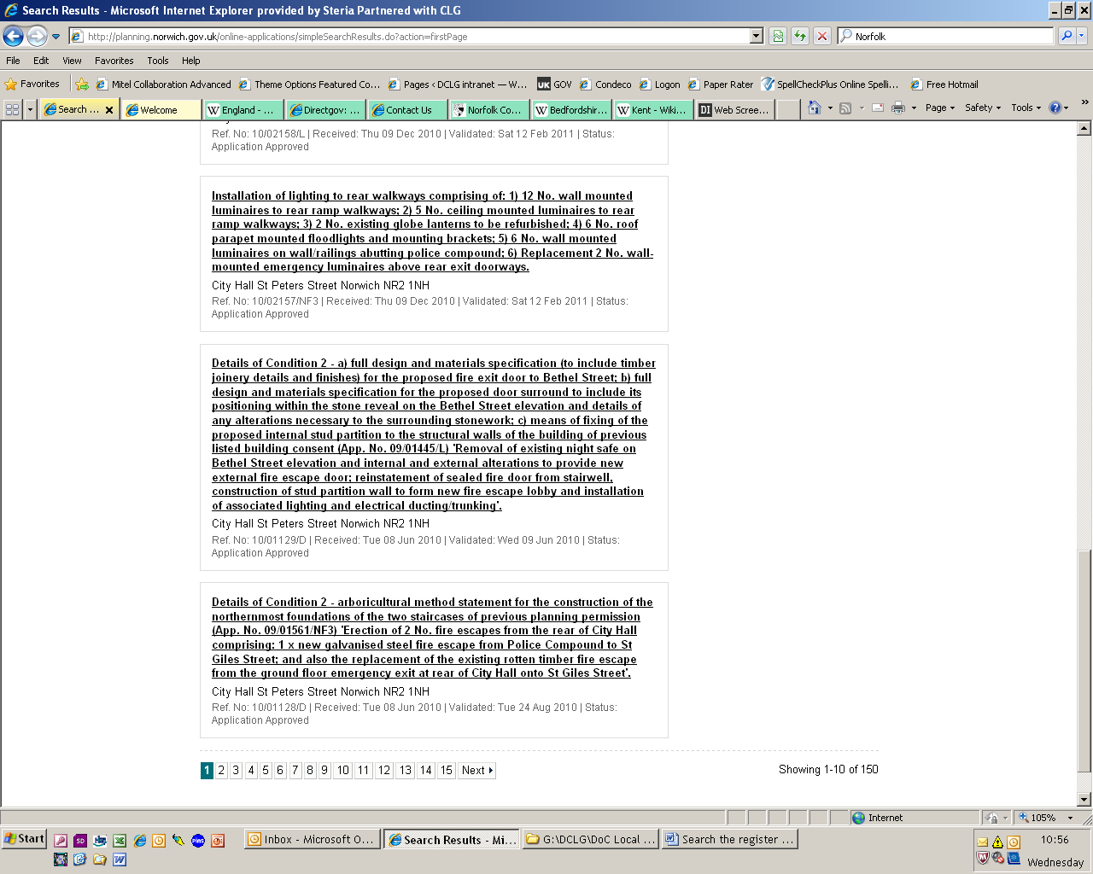

Customer journey: Search the register of planning applications – KENSINGTON + CHELSEA
How I got to this page: From GOV.UK, using the postcode W8 7NX
Page on local authority website: Page 1 of 3

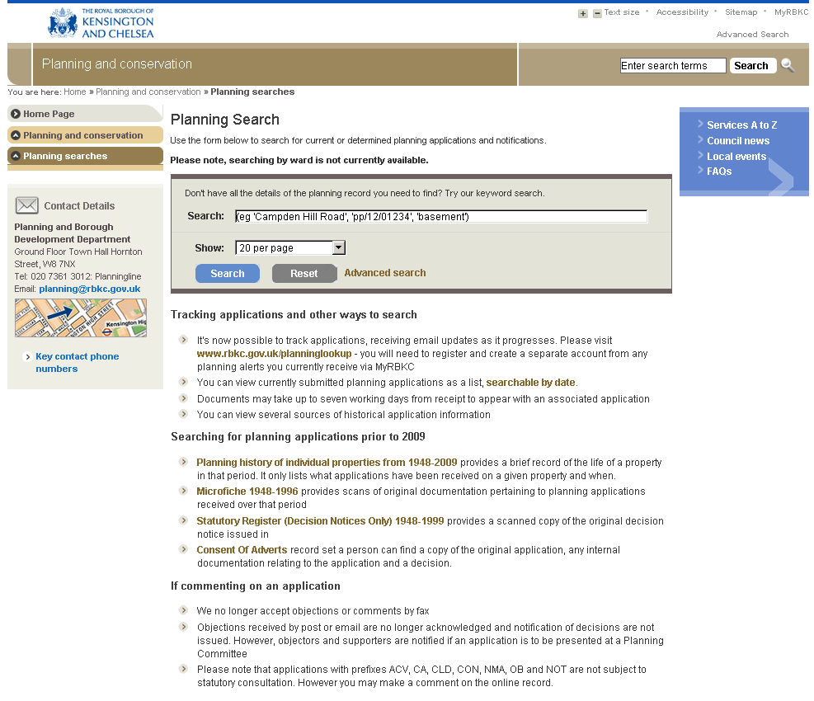
1st: I added the postcode here

2nd: I clicked here

Customer journey: Search the register of planning applications – KENSINGTON + CHELSEA
How I got to this page: From GOV.UK, using the postcode W8 7NX
Page on local authority website: Page 2 of 3
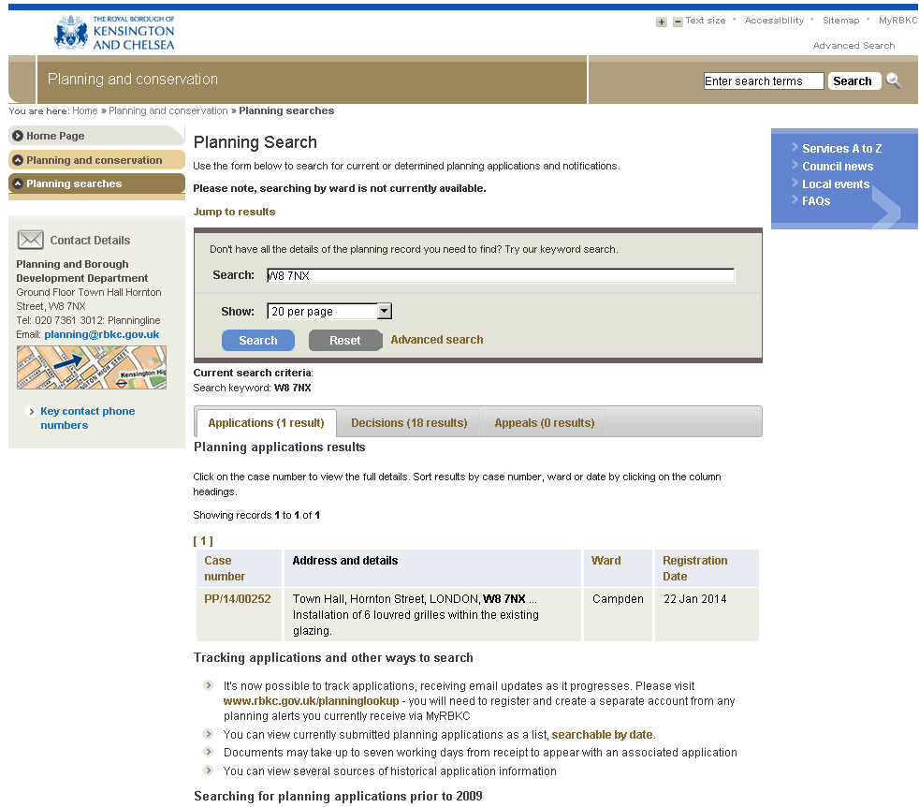
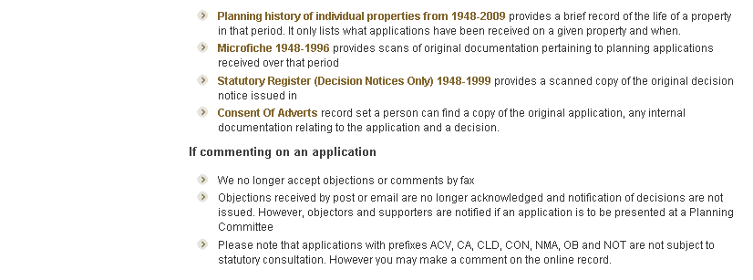
I clicked here

I clicked here

Customer journey: Search the register of planning applications – KENSINGTON + CHELSEA
How I got to this page: From GOV.UK, using the postcode W8 7NX
Page on local authority website: Page 3 of 3

