Customer journey: **Apply for a secondary school place – WARWICKSHIRE**

How I got to this page: From **GOOGLE**, using the search term ‘Apply secondary school place Warwickshire’

Page on local authority website: Page 1 of 3

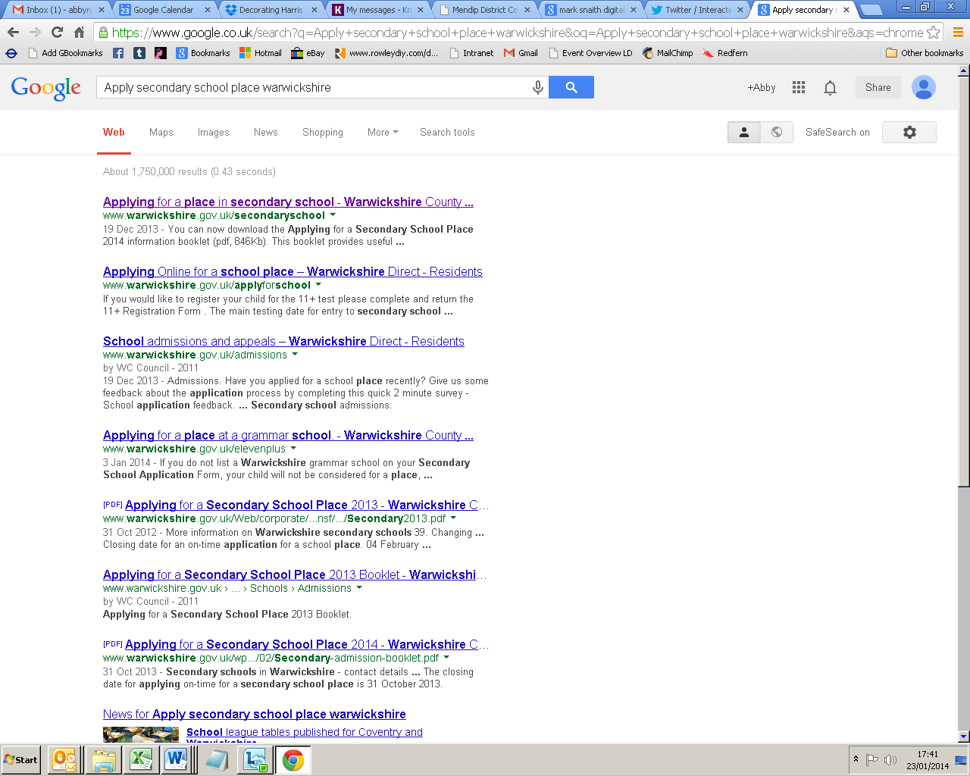

**I clicked here**

Customer journey: **Apply for a secondary school place – WARWICKSHIRE**

How I got to this page: From **GOOGLE**, using the search term ‘Apply secondary school place Warwickshire’

Page on local authority website: Page 2 of 3 (first half of page)

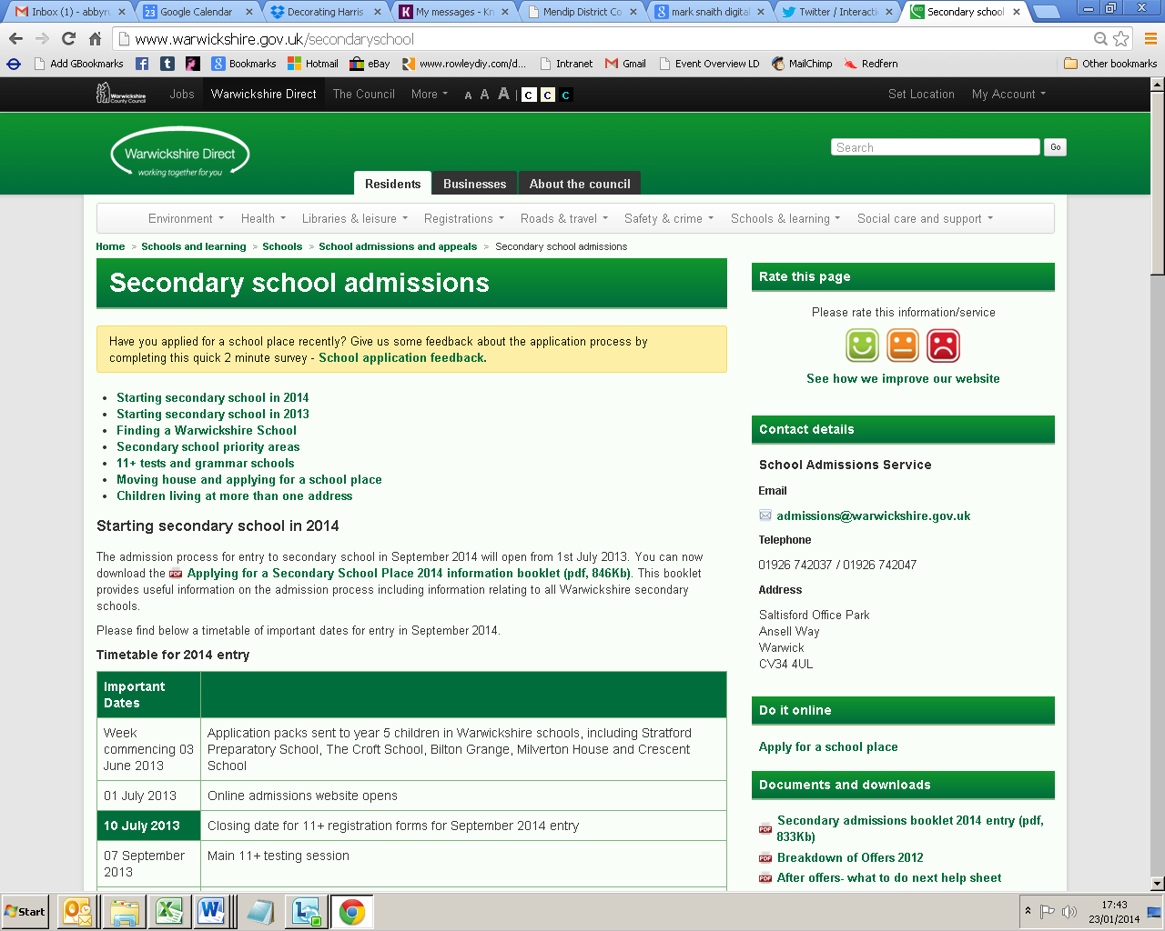

**I clicked here**

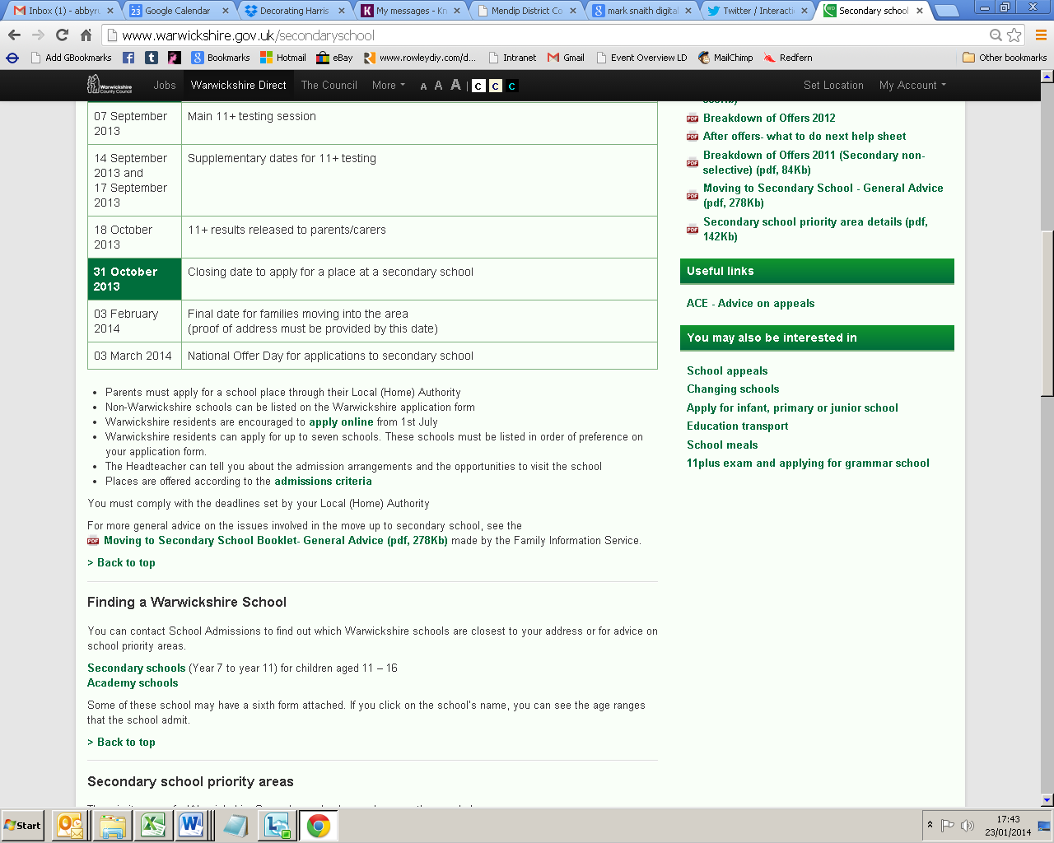

Customer journey: **Apply for a secondary school place – WARWICKSHIRE**

How I got to this page: From **GOOGLE**, using the search term ‘Apply secondary school place Warwickshire’

Page on local authority website: Page 2 of 3 (second half of page)

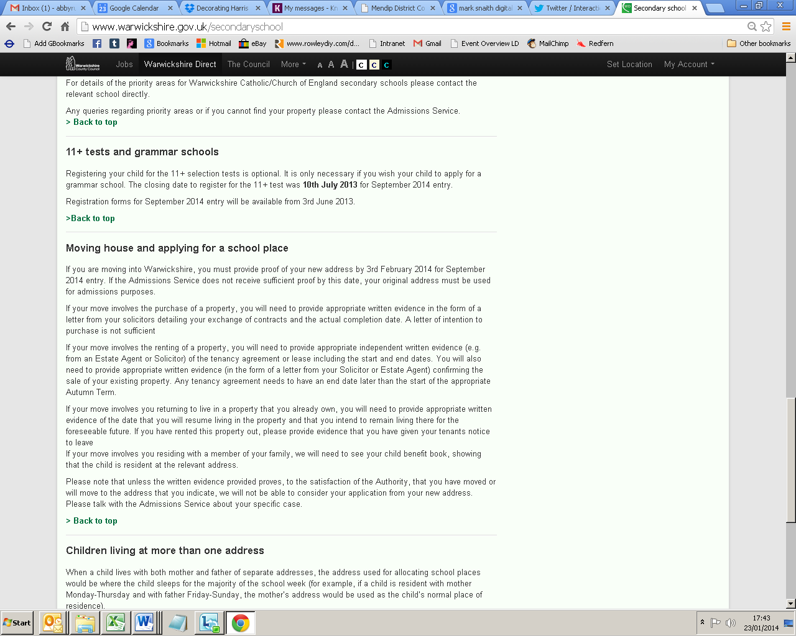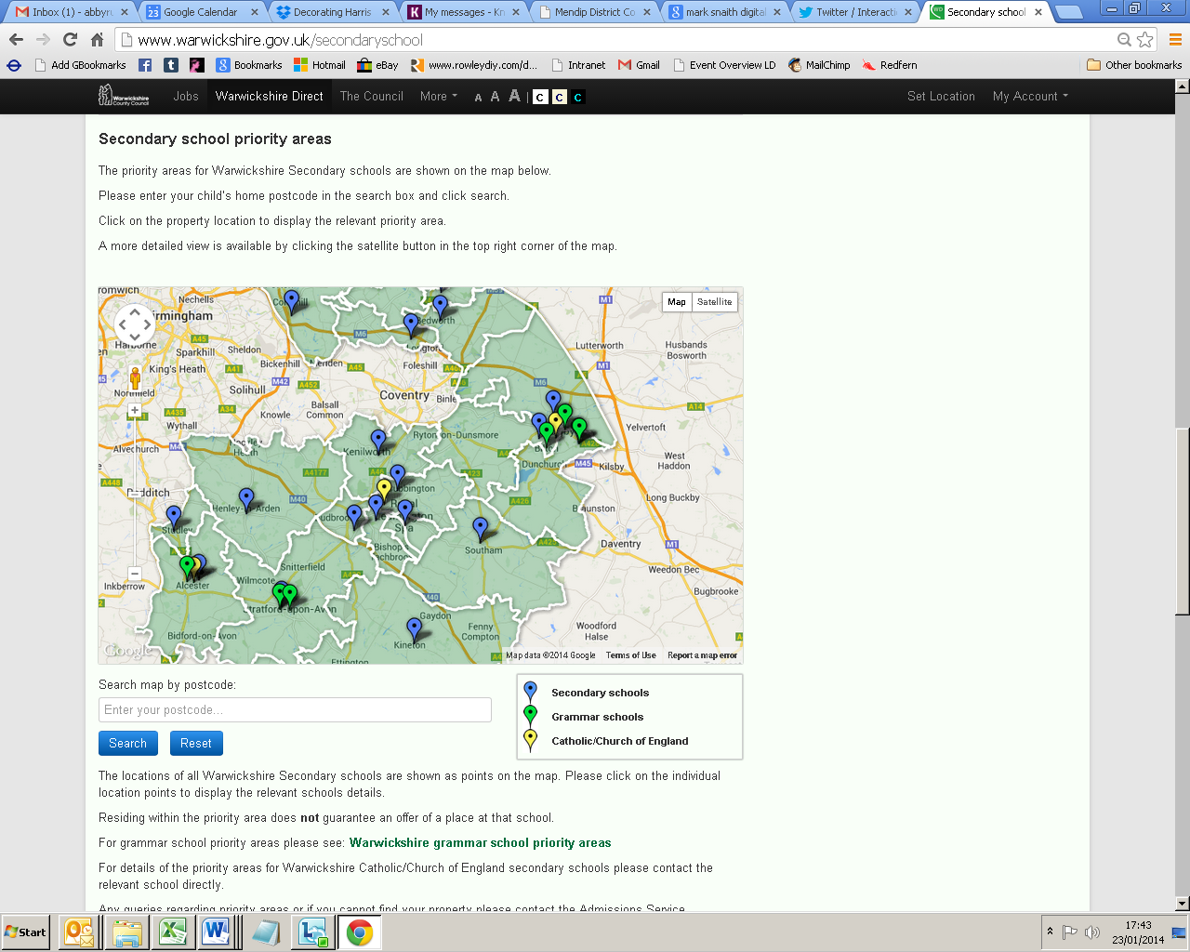

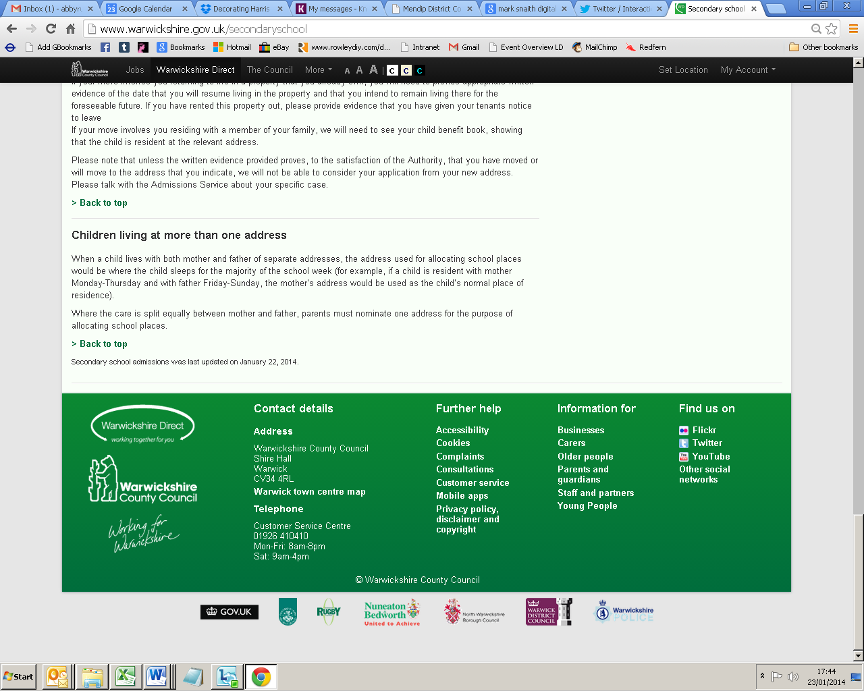

Customer journey: **Apply for a secondary school place – WARWICKSHIRE**

How I got to this page: From **GOOGLE**, using the search term ‘Apply secondary school place Warwickshire’

Page on local authority website: Page 3 of 3

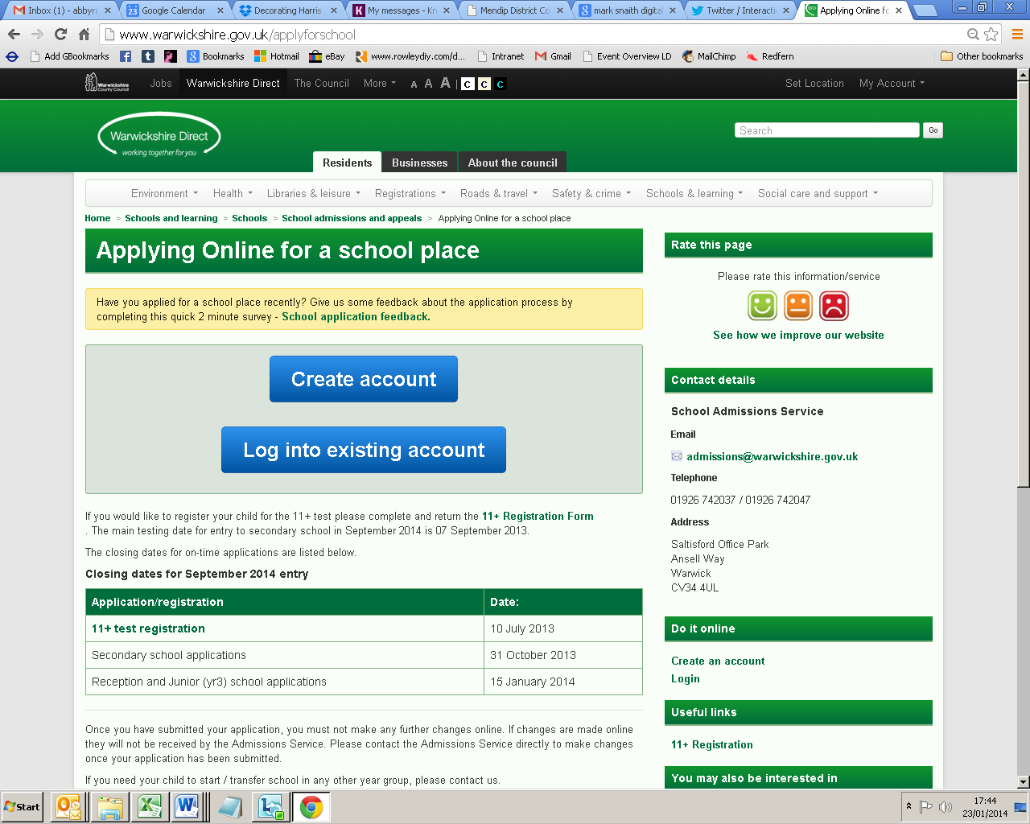

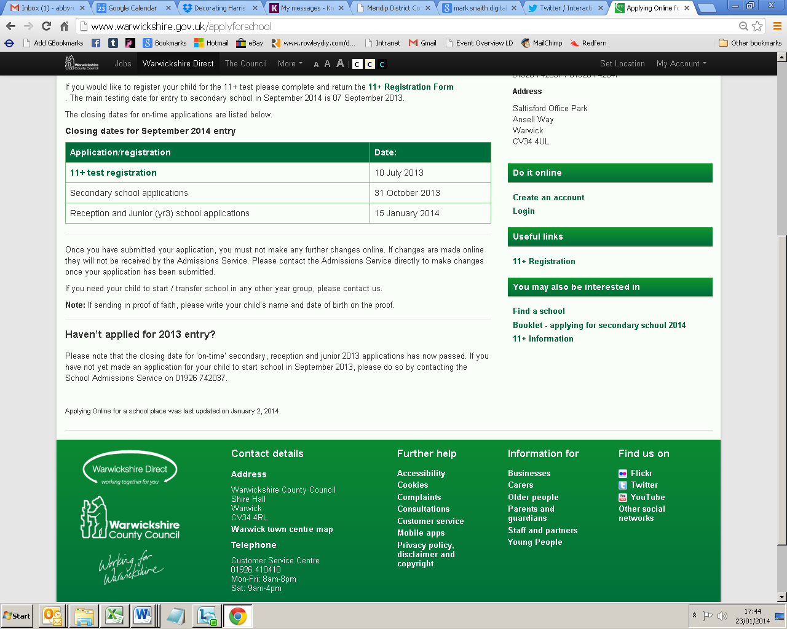

Customer journey: **Apply for a secondary school place – DEVON**

How I got to this page: From **GOOGLE**, using the search term ‘Apply secondary school place Devon’

Page on local authority website: Page 1 of 3

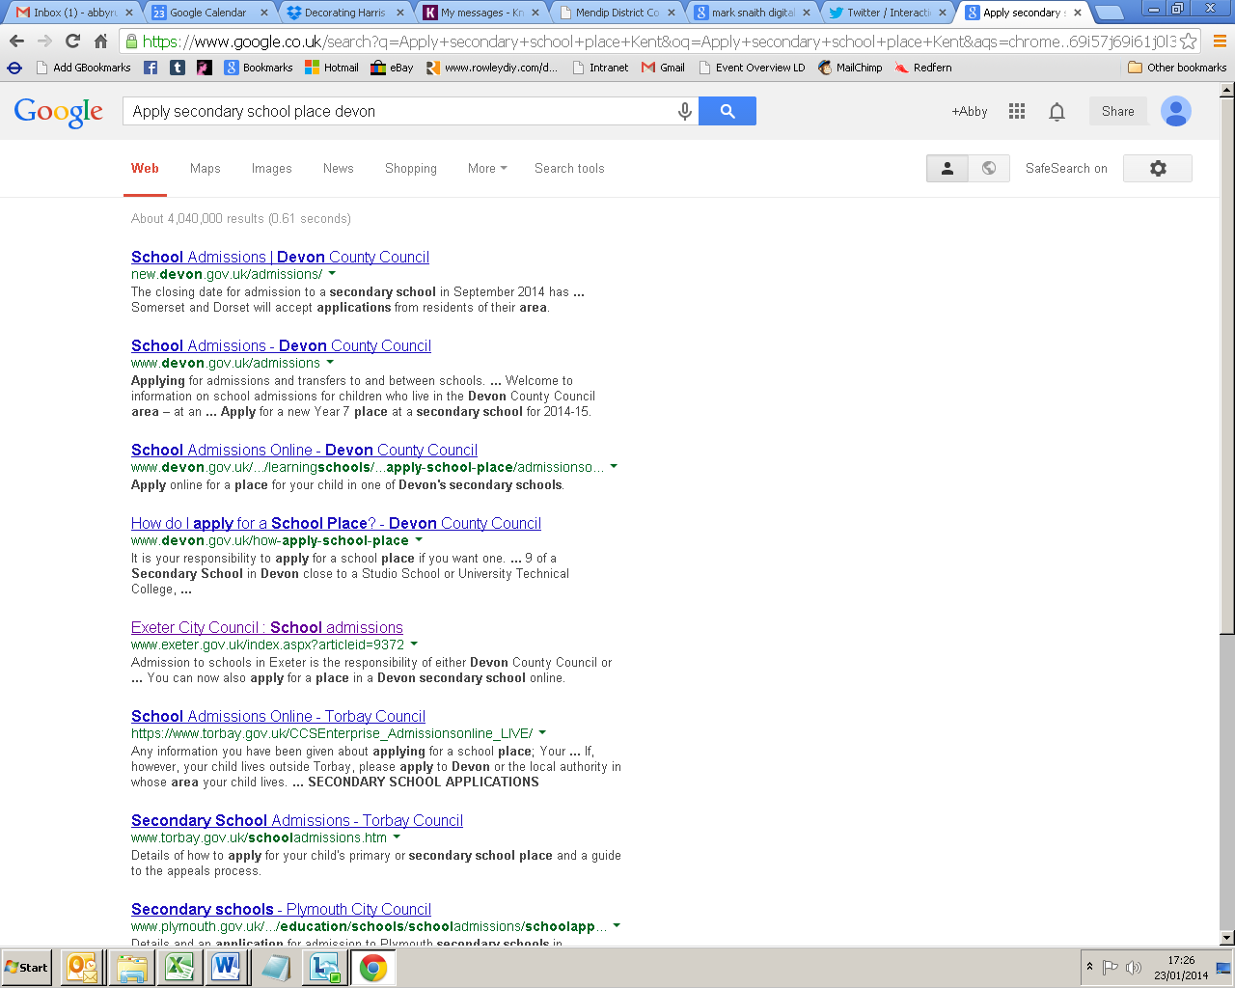

**I clicked here**

Customer journey: **Apply for a secondary school place – DEVON**

How I got to this page: From **GOOGLE**, using the search term ‘Apply secondary school place Devon’

Page on local authority website: Page 2 of 3

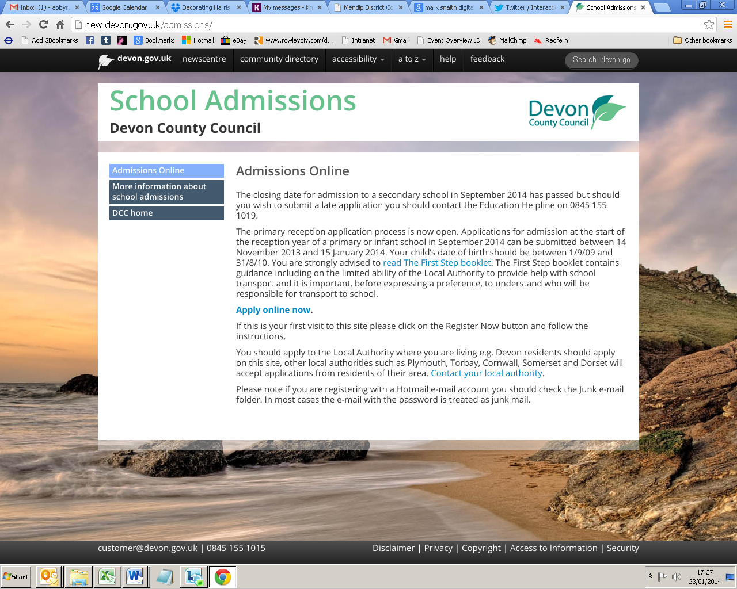

**I clicked here**

Customer journey: **Apply for a secondary school place – DEVON**

How I got to this page: From **GOOGLE**, using the search term ‘Apply secondary school place Devon’

Page on local authority website: Page 3 of 3

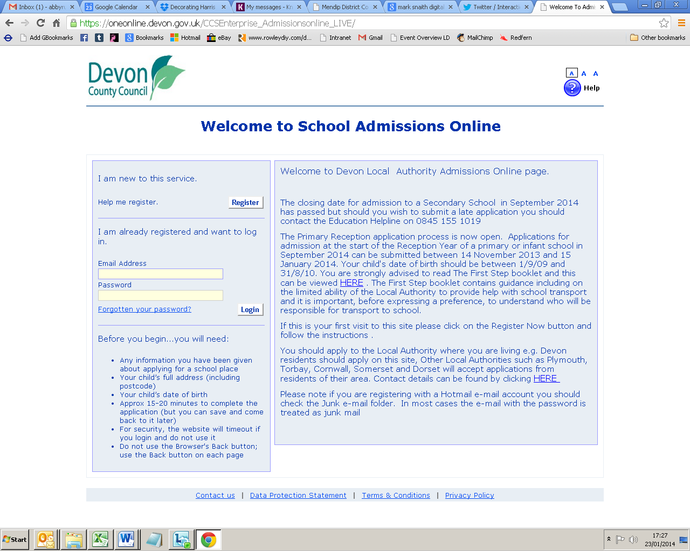

Customer journey: **Apply for a secondary school place – KENT**

How I got to this page: From **GOOGLE**, using the search term ‘Apply secondary school place Kent’

Page on local authority website: Page 1 of 3

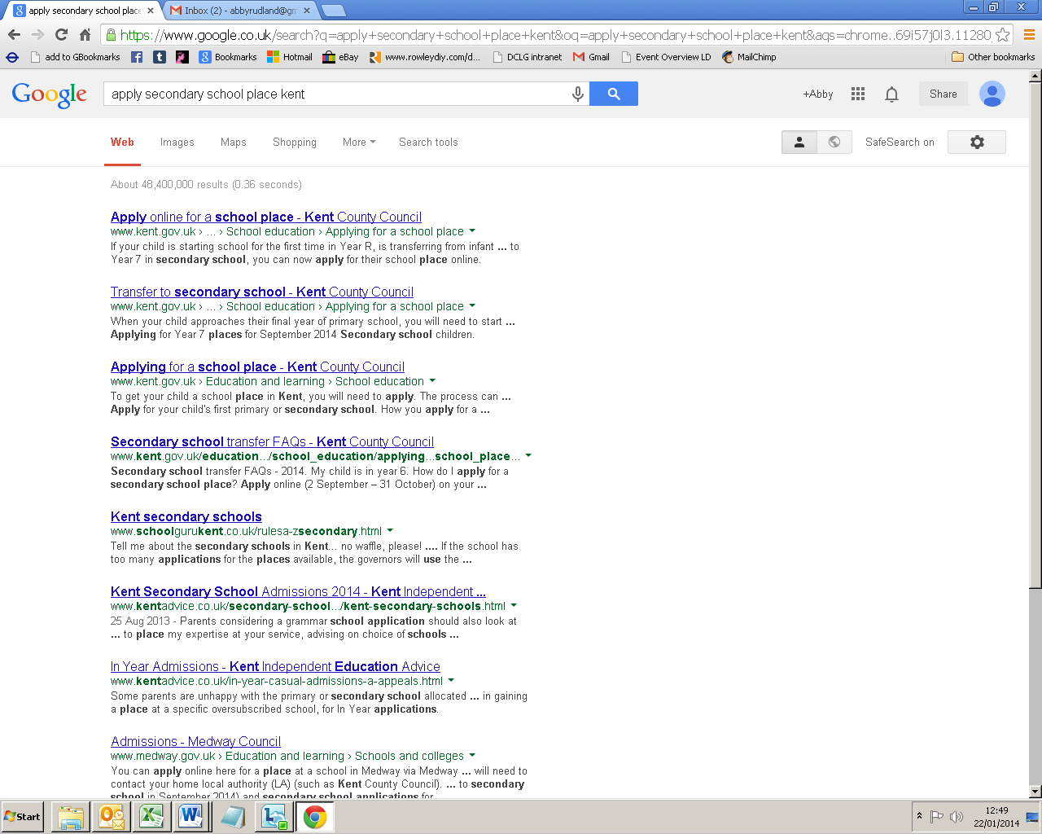

**I clicked here**

Customer journey: **Apply for a secondary school place – KENT**

How I got to this page: From **GOOGLE**, using the search term ‘Apply secondary school place Kent’

Page on local authority website: Page 2 of 3

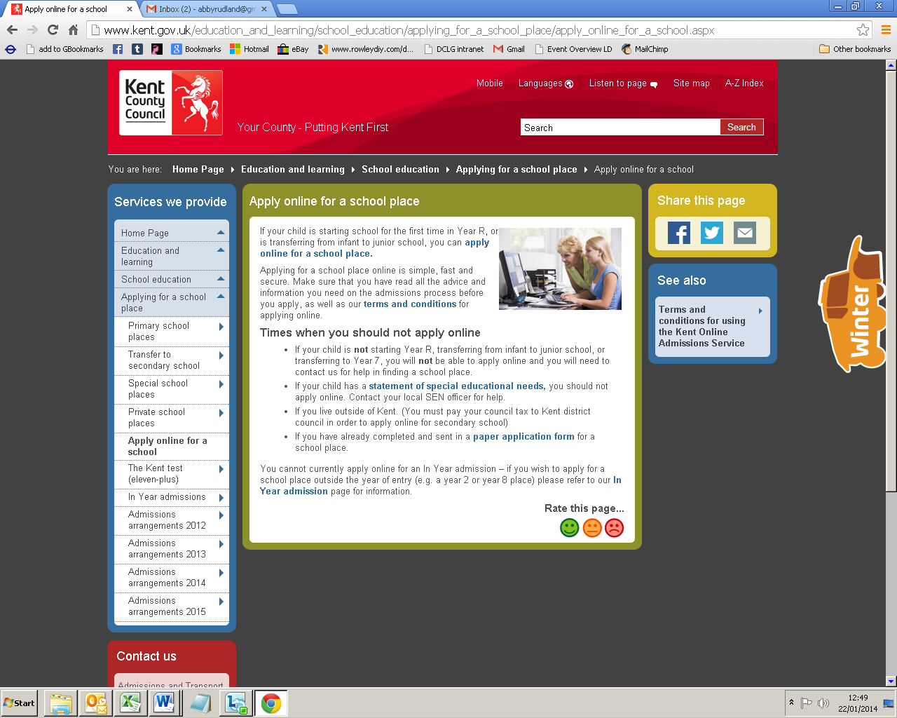

**I clicked here**

Customer journey: **Apply for a secondary school place – KENT**

How I got to this page: From **GOOGLE**, using the search term ‘Apply secondary school place Kent’

Page on local authority website: Page 3 of 3

