Customer journey: **Find my nearest recycling site – NORTHAMPTONSHIRE**

How I got to this page: From **GOOGLE**, using the search term ‘nearest recycling site Northamptonshire’

Page on local authority website: Page 1 of 2

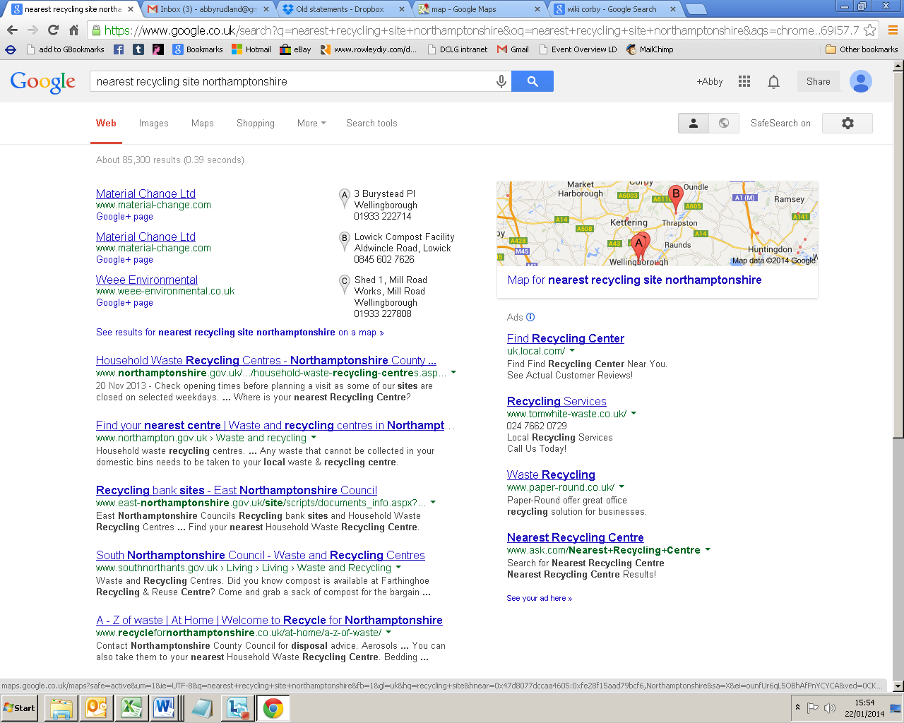

**I clicked here**

Customer journey: **Find my nearest recycling site – NORTHAMPTONSHIRE**

How I got to this page: From **GOOGLE**, using the search term ‘nearest recycling site Northamptonshire’

Page on local authority website: Page 2 of 2

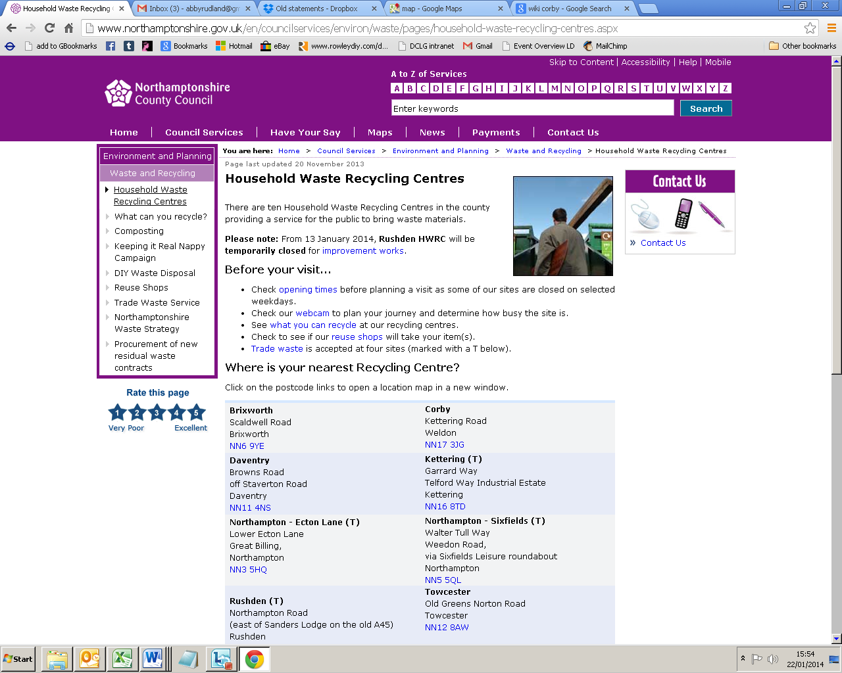

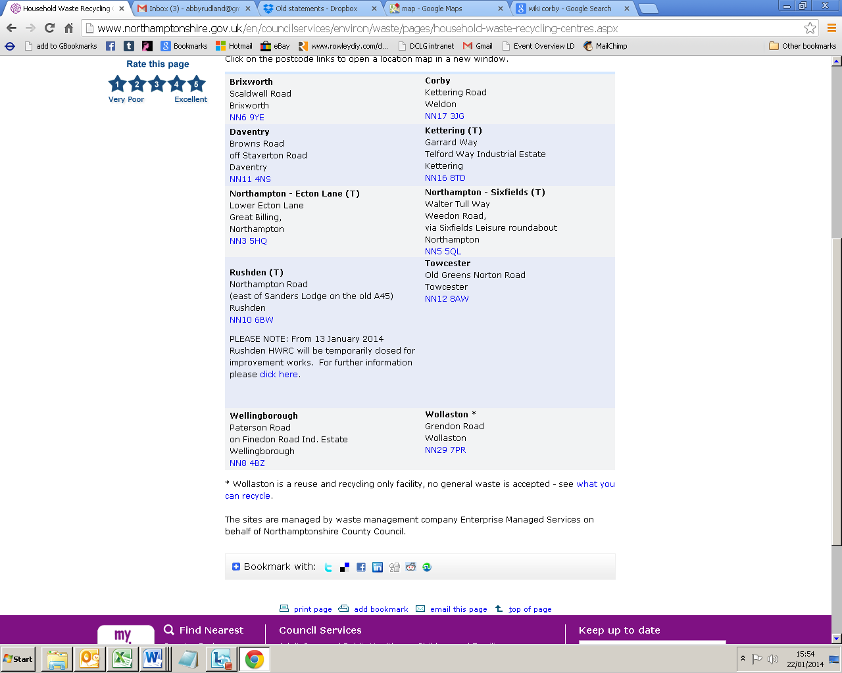

Customer journey: **Find my nearest recycling site – STAFFORDSHIRE**

How I got to this page: From **GOOGLE**, using the search term ‘nearest recycling site Staffordshire’

Page on local authority website: Page 1 of 3

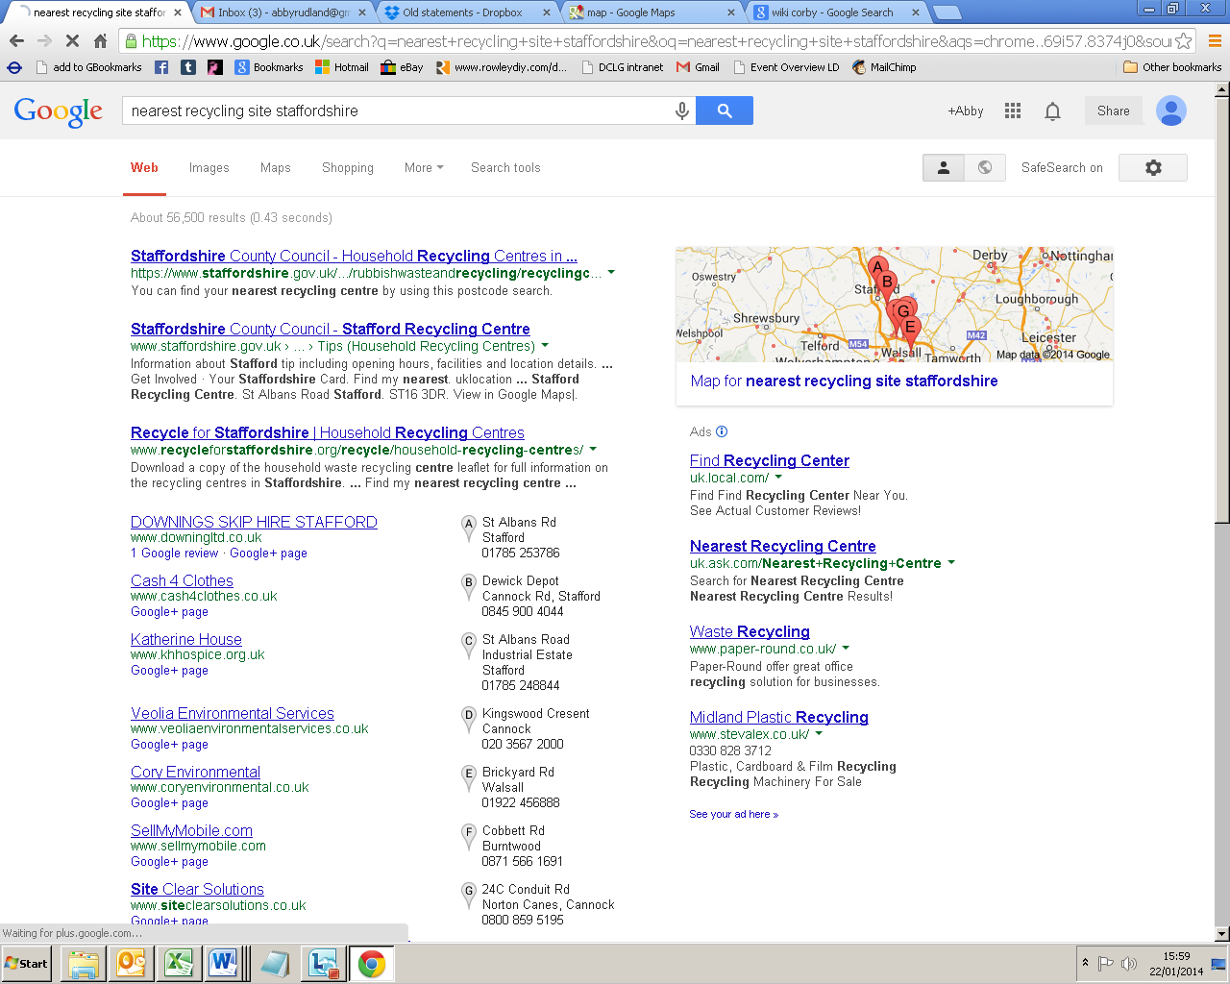

**I clicked here**

Customer journey: **Find my nearest recycling site – STAFFORDSHIRE**

How I got to this page: From **GOOGLE**, using the search term ‘nearest recycling site Staffordshire’

Page on local authority website: Page 2 of 3

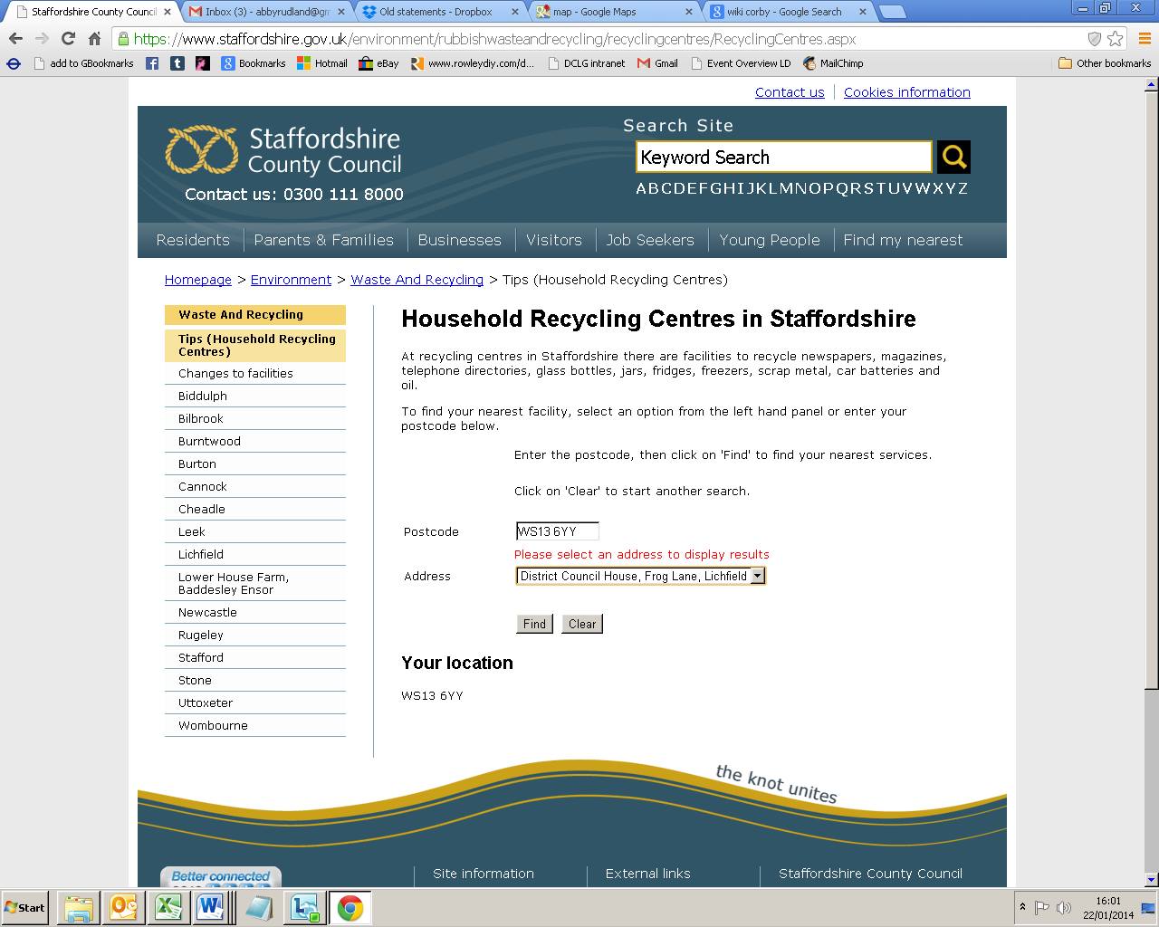

**I put in postcode here**

Customer journey: **Find my nearest recycling site – STAFFORDSHIRE**

How I got to this page: From **GOOGLE**, using the search term ‘nearest recycling site Staffordshire’

Page on local authority website: Page 3 of 3

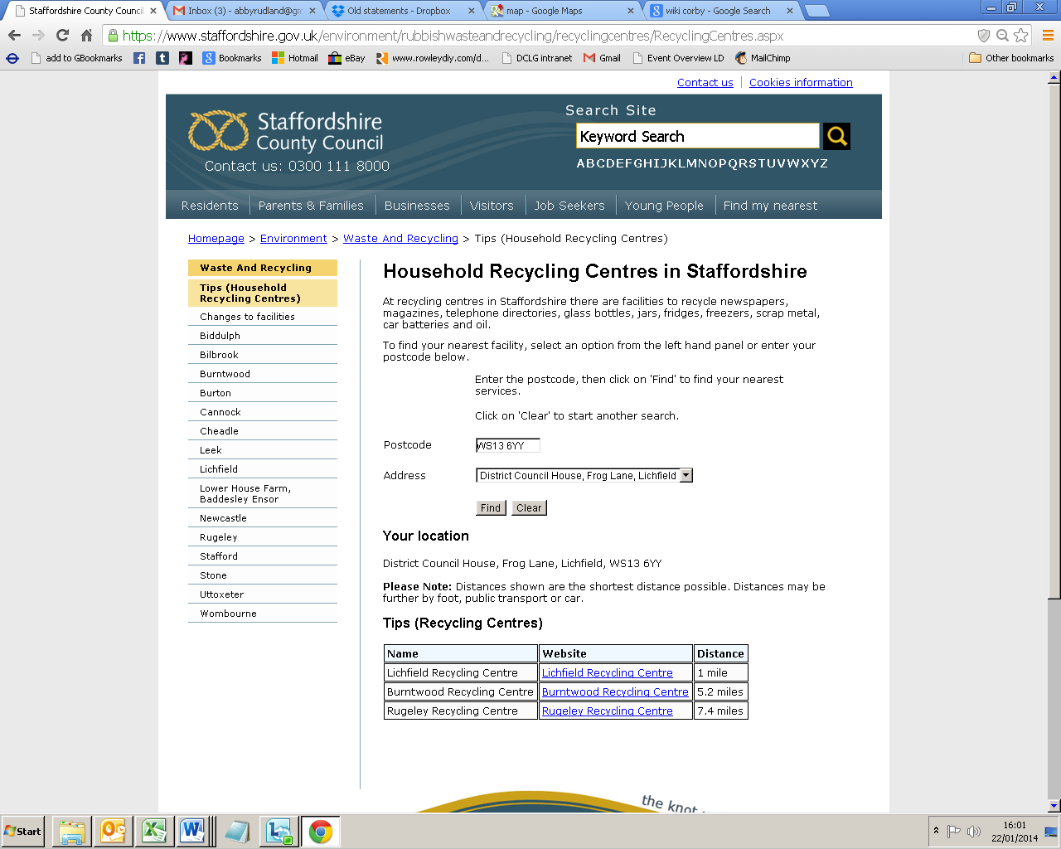

Customer journey: **Find my nearest recycling site – ESSEX**

How I got to this page: From **GOOGLE**, using the search term ‘nearest recycling site Essex’

Page on local authority website: Page 1 of 3

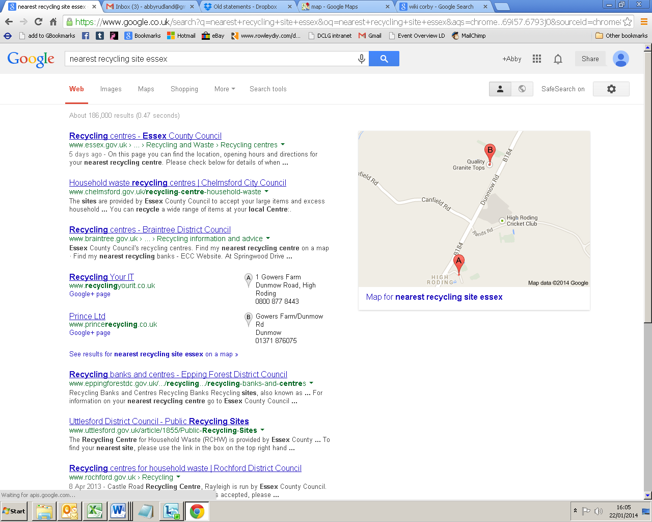

**I clicked here**

Customer journey: **Find my nearest recycling site – ESSEX**

How I got to this page: From **GOOGLE**, using the search term ‘nearest recycling site Essex’

Page on local authority website: Page 2 of 3

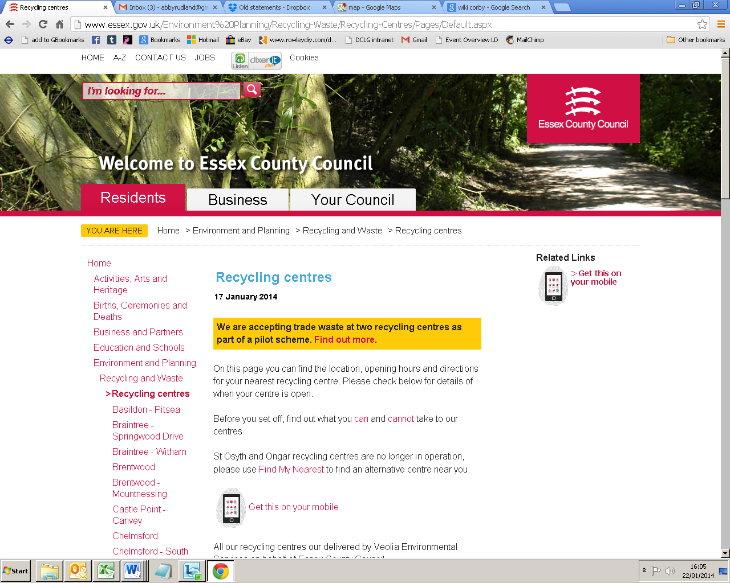

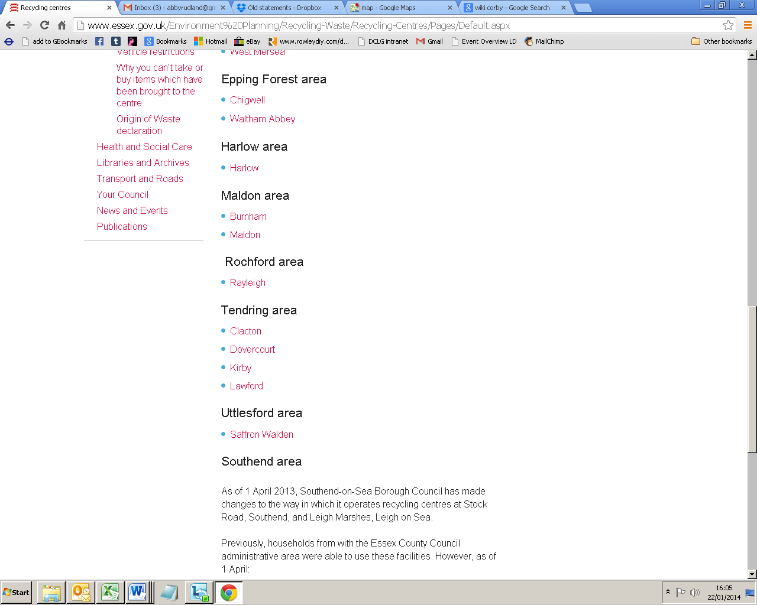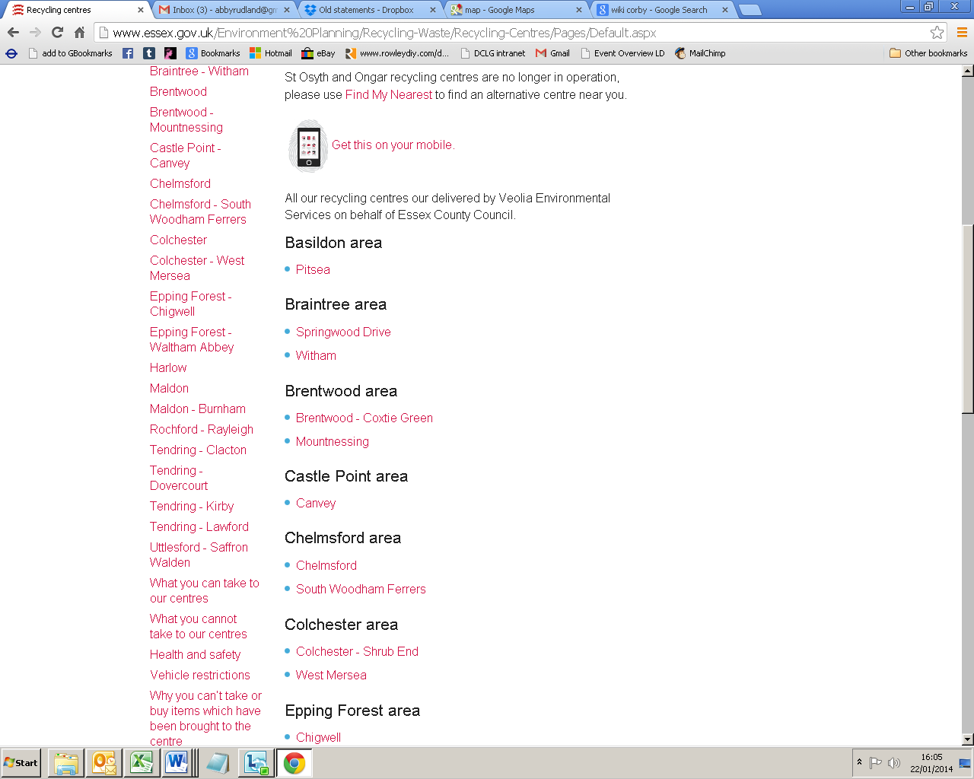

**I clicked here**

Customer journey: **Find my nearest recycling site – ESSEX**

How I got to this page: From **GOOGLE**, using the search term ‘nearest recycling site Essex’

Page on local authority website: Page 3 of 3

