How to change the regular icons in Bforartists
Preface 1
Requirements 1
Quick advice 1
Create the icon graphic 2
Convert the icon graphic to SVG 3
Add icon to the Icon sheet 4
Create the dat files for the icons 6
Add the new icon to the source\blender\editors\datafiles\Cmakelist.txt 7
Add the new icon into the menu 7

Preface
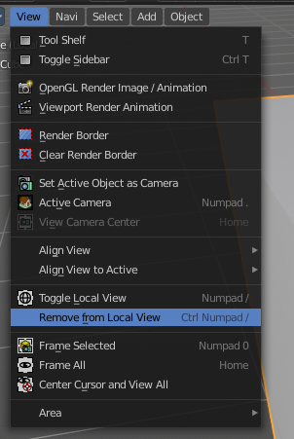

There are two icon types in Bforartists. The big ones in the tool shelf. They got introduced with Blender 2.8. And the small ones all across the rest of the UI.

We will cover the small ones in this tutorial. The ones that can be found in our toolbar at the top for example. Or in the text menus. We have a missing icon in the View menu of the 3D view. So we will use this one for our tutorial.

Requirements

You need the repository.
You need to have Python 2.7x and 3.xx installed.
You need Inkscape.
You need to have Blender installed to convert the icons from svg to dat.

Quick advice

The TL'DR version:

- Add a icon to the blender_icons.svg in release\datafiles
- Add the name of the icon in source\blender\editors\include\UI_icons.h at the very same location than in the blender_icons.svg. Beware of order and grab an empty icon slot from the #ifndef DEF_ICON_BLANK_SKIP parts.
- Run blender_icons_update.py from the console. I have my repository at drive H in folder bforartists. Adjust your paths to your needs.

h:
cd bforartists\bforartists\release\datafiles
python blender_icons_update.py blender_icons.svg
- Compile. This makes the icon available to the Python code.
- Add the icon to the operator in the Python file. We change the view3d.localview_remove_from button in the view menu in this tutorial.

Change

layout.operator("view3d.localview_remove_from")

to

layout.operator("view3d.localview_remove_from", icon = "VIEW_REMOVE_LOCAL")

Create the icon graphic

You can use any bitmap or vectorgraphics software to create the actual icon. But in the end it must be a svg file that can be read by Inkscape.

Inkscape is a open source vector graphics software. It is required to edit the icon sheet in the Bforartists repository. The icons are all stored in a big svg file. It can be found here: https://inkscape.org

We will come to Inkscape later. First let's create our icon. Note that the following is just a suggestion. Everyt working method is allowed.

I use Gimp 2.10 here, and create the icon as a bitmap graphics first, which i convert into a SVG then with Inkscape.

I had a Toggle Local View icon already. Let's use this icon as a base, and modify it.

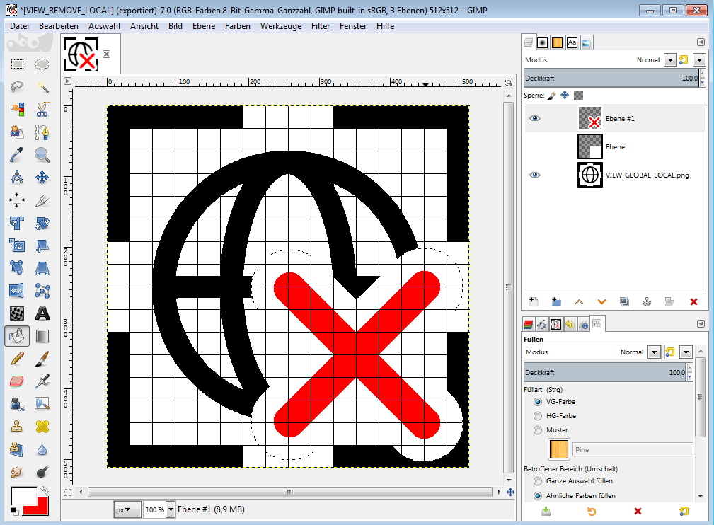
You can create the icon in any size you want. We will resize it later. My bitmap graphics is 512 x 512. I have turned on grid here, and configured it to have the size of 16 x 16 fields, with a raster size of 32 in width and height. 16 pixels the later icon size. And it's a good idea to keep this in mind. The grid also allows you to snap. So grid on!

Make sure that there are no gradients in the icon! For example, the circle select tool creates unfortunately gradients at the border when you fill it. And this makes big trouble with the conversion later. Since Inkscape then tries to add a few dozen more colors and a ton of unnecessary curves for the gradient. When in doubt, change the color mode to indices with the number of colors that you use in the icon. This should remove gradients. Then switch back to rgb.

Back to our icon. Remove is a red cross in most icons. So let's add a red cross here.


Our icon. I have called it VIEW_REMOVE_LOCAL.png. The name of the icon follows some name conventions. Icons are defined with big letters in the code. So i use it for the name here too.

Convert the icon graphic to SVG

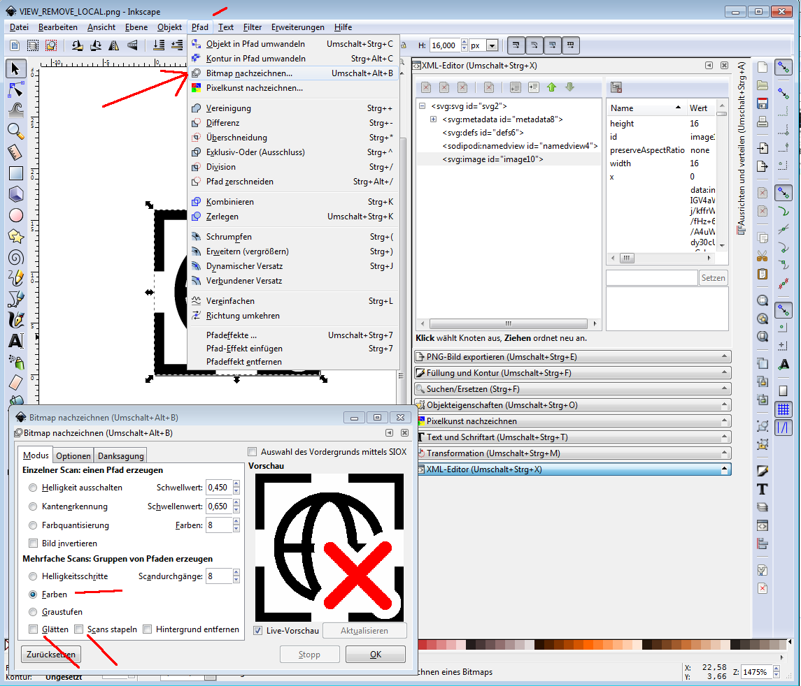
You need to convert the icon graphic to SVG so that we can drop it into the svg icon sheet. Some vector graphic software allows to export as SVG. We have created a bitmap. And we will convert it into SVG now with Inkscape.

Open up the bitmap file in Inkscape. Go to path, redraw bitmap (or something like that, sorry for the german screenshot)

In the dialog, turn on colors, turn off Smooth and Stack scans. Click OK.

This creates a vector graphics.

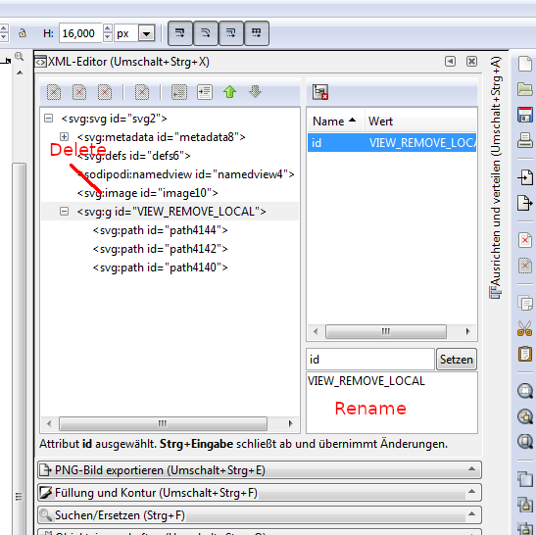
Remove the Bitmap from the file. And rename the vector graphics to have the icon name. This step is not really necessary. But it makes our life much easier with close to 1400 icons in the sheet.

Make sure the size of the vector graphics is 16 by 16 pixels. I have by coincidence already 16 in width and height. It can also be 640 x 640 or 512 x 512. I haven't found the pattern yet at which point Inkscape decides what size to import.

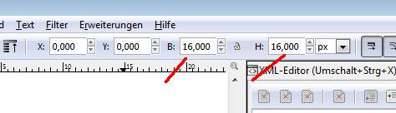

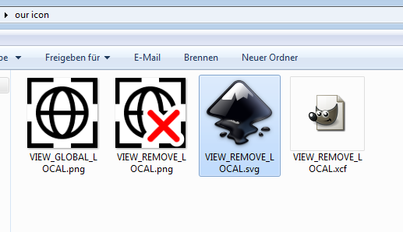

Save the inkscape file with the icon name.

Add icon to the Icon sheet

We have created our icon. Time to add it to the icon sheet. This icon sheet is a svg file that contains all regular icons.

Go to the path with the blender_icons.svg file. And open it with Inkscape. The folder in the repository is release\datafiles .

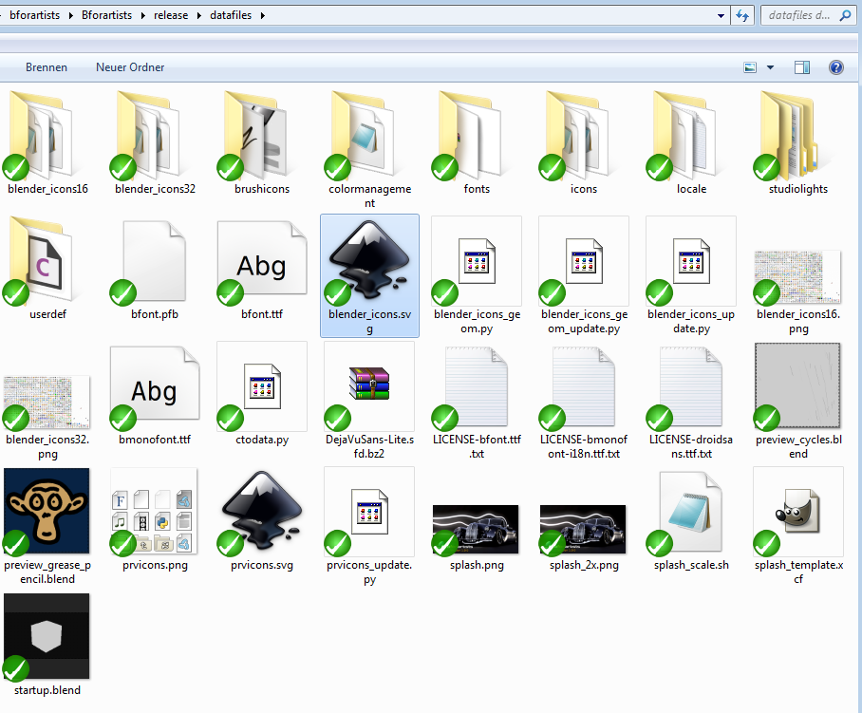
As you can see, there are lots of icons in this file. At the time close to 1400 icons.

The actual icons are in the layer1 group. The other groups is for example the numbers at the sides of the sheet. It's a good idea to click at one of the icons to open the icon group. So that you don't accidentally drop the new icon into a location where it does not belong.

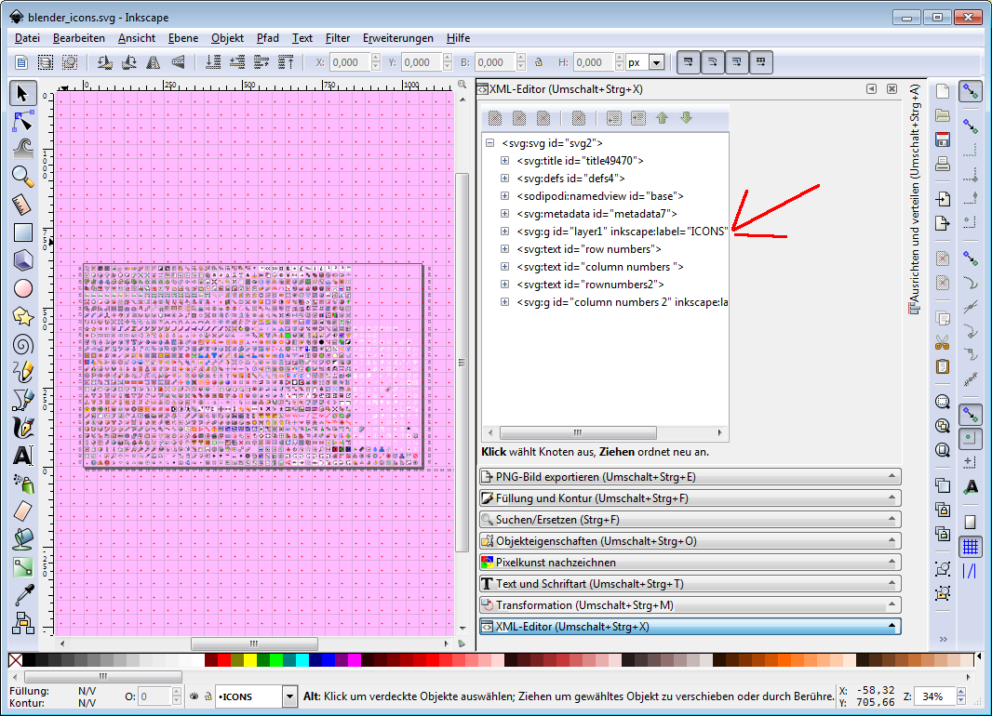

We need to find a location for our new icon. And before we continue we need to open up another file. The H file where the icons are defined for Bforartists.
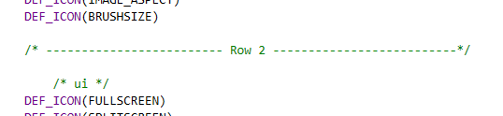
In the repository go to source\blender\editors\include and open the UI_Icons.h file. This is a list of the icons that Bforartists uses to define the icons. The order goes in the image from down left to up right. We have divided this list with separation lines to make the navigation easier.

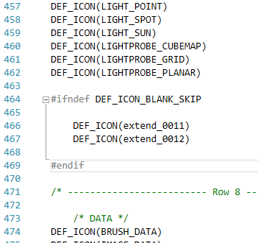
Have a look for #ifndef DEF_ICON_BLANK_SKIP parts

Icons included in this defines are free and the space is available. That's in this case DEF_ICON(extend_0011) and DEF_ICON(extend_0012). You can also have a look in the icon sheet. Row 7 at the very end. There are two gaps ...

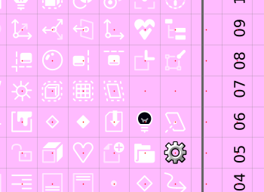

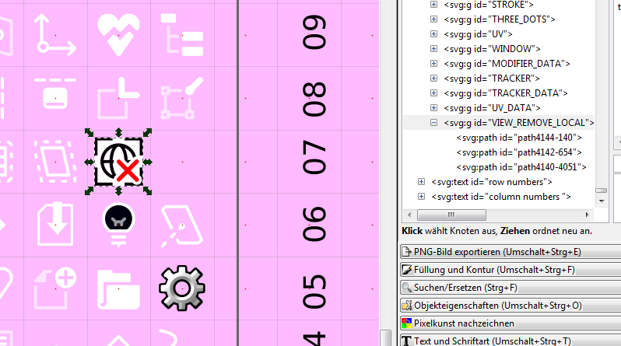
Let's drop our new icon into one of the free slots. Now you will notice why we have resized the svg file to 16 to 16 units. The other icons in the blender_icons.svg are also 16 units tall.

Activate snapping in inkscape if not already activated. That way you can snap the icon at the red dots.

Save the icon sheet file.

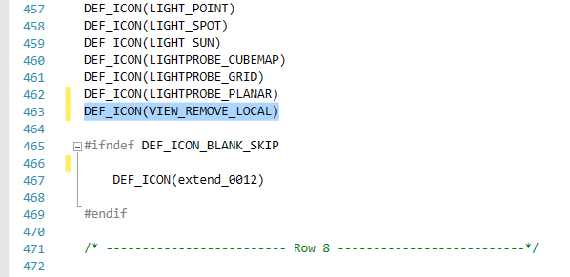
Dropping the icon into the iconsheet was just half the show. Now we need to update the UI_icons.h file too. Beware of the order! We have dropped the icon at the position of DEF_ICON(extend_0011) , Replace the extend_0011 by the name of our icon. And move it out of the define group. This icon should not be skipped anymore.

Save the h file.

Note that the icon is not defined by the name in the svg file. The name in the svg file does not play any role. The icon is defined by the order and name in the UI_Icons.h file!

Create the dat files for the icons
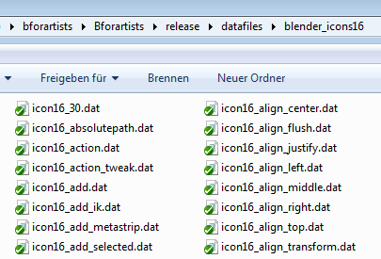
The code does not deal directly with the svg file. It needs the icons in dat format so that it can be compiled into the Bforartists exe. This dat files can be found in the blender_icons16 and blender_icons32 folders in the release\datafiles directory.

To create those dat files we need to run the blender_icons_update.py script , which is included in the release\datafiles folder too.

What this script does is to export the whole svg file to a png file. Then loads this png file into Blender, slices it into the single icons, and exports them as dat files. You can find this intermediate step in the datafiles folder. The two png files with the icons.

This is done in the command line. At Windows this is cmd.exe. Open it. In the command line navigate to the release/datafiles folder. I have the repository at my drive H in the folder bforartists. So i type in the following:

h:
cd bforartists\bforartists\release\datafiles

Then we execute the script by

python blender_icons_update.py blender_icons.svg

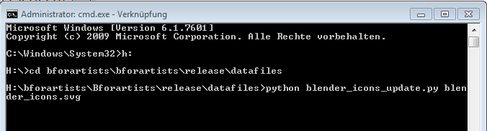

Hit Enter. This starts Blender in the background, and it converts the icon files to the dat files in the blender_icons16 and blender_icons32 folder.

Wait a few moments so that the process can finish, and you will find a new icon in the blender_icons16 and blender_icons32 folder. Our new created icon. Voila.

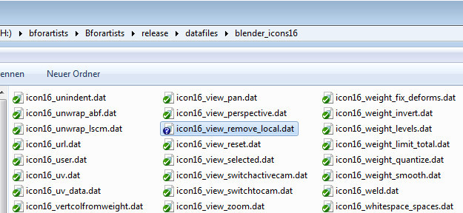

Note that existing icons are overwritten. Also note that the number and naming in the blender_icons16 and 32 folders needs to fit exactly to the number and naming in the UI_Icons.h file. One dat file too many or one dat file missing leads to a compile error.

This can for example happen when you have added a wrong icon name, run the blender_icons_update.py, then correct this name, and run blender_icons_update.py again. The icon with the wrong name will still be in the blender_icons16 and 32 folders. The script does not remove icons, it just add them.

At this point you can already compile and check if everything works.

Add the new icon to the source\blender\editors\datafiles\Cmakelist.txt

There is another location where we need to add the icon. A Cmakelist.txt file. This cmake file holds all icons too.

So go to source\blender\editors\datafiles\Cmakelist.txt, and add it to the list of icons in the set(ICON_NAMES class.

Take care of the order and the position of the new icon in the list. It should be the same than in the UI_icons.h file.

Add the new icon into the menu

Compile if you haven't done it already. This will make the icon available for the Python UI code.
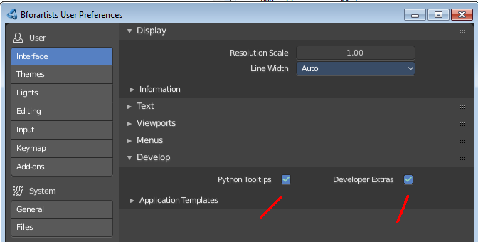
We will now add our new icon to the menu item. Open Bforartists. Activate the developer tools in the preferences if you haven't already. We need the Python Tooltips and the Developer Extras.

Our menu is Python code. We can make our life much easier by starting the search in Bforartists. When you right click at a menu element then you might stumble across a edit source entry. This is what we need.

Switch to Scripting layout. Right click at the menu in the header where we want to add our new icon. And click at Edit Source. The UI script that contains this menu will now load, and it will jump to the first location where this menu is defined.
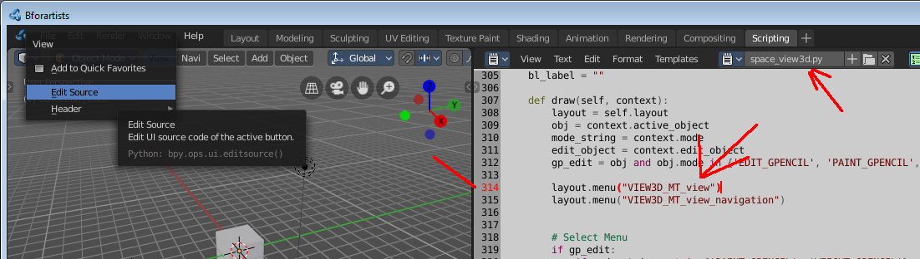

This is not the menu class itself, but here the menu gets referenced. Let's search for the menu class. You can do this in an external editor like VS Code, or in Bforartists directly. The important part here was to find the name of the menu quickly so that we can find the button in the code.

Note that this is the UI file in the compiled exe that loads here. Not the one in the repository. We need to move it into the repository when done.

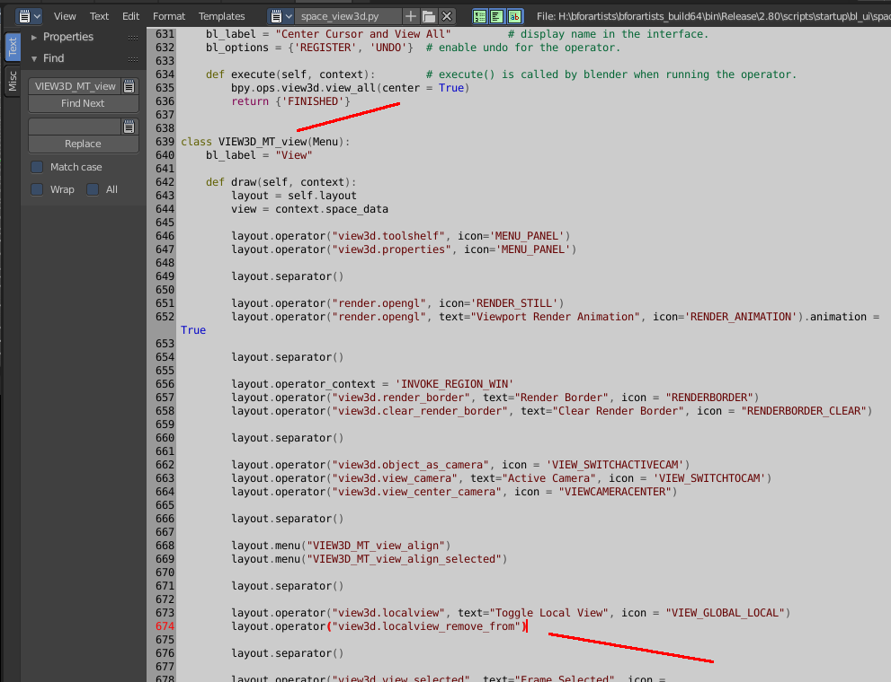

And here we will find our layout operator with the remove from local view button.

Above, in the localview operator, you can see how the term looks like with an icon and text. Let's add the icon part to our operator. The button label is fine, so no need to change this too.

Change

layout.operator("view3d.localview_remove_from")

to

layout.operator("view3d.localview_remove_from", icon = "VIEW_REMOVE_LOCAL")

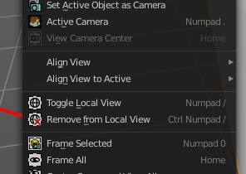
Save the file. Close Bforartists. Reopen Bforartists. And we have a new icon implemented.

What is left to do is to move the modified Python file into the repository. It is currently just In our case it was the space_view3d.py file that we have modified.

Most of the Python UI scripts are in a subfoder in scripts\startup\bl_ui .

For the binary that's 2.80\scripts\startup\bl_ui

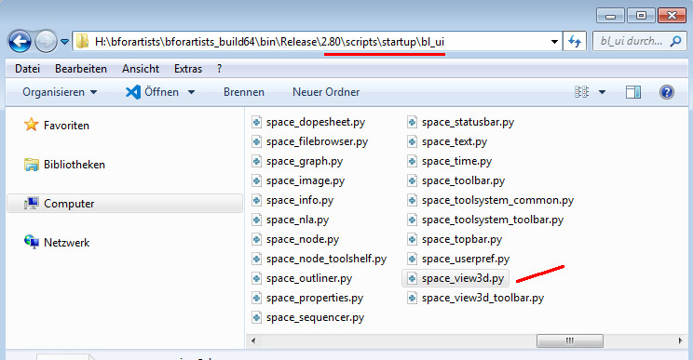

In the repository this can be found in release\scripts\startup\bl_ui

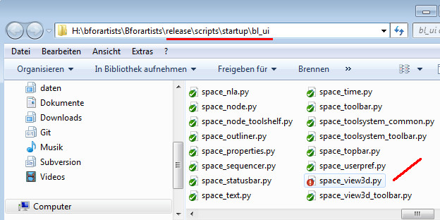

Copy it over, and you are ready to commit your changes.

