Compile Bforartists at Windows 7 with Cmake and Visual Studio 2013
Overview 1
Introduction 1
Outline 1
Tool Requirements 1
Required Tools 1
Building Tools 2
Sourcing Tools 2
Other Tools 2
Optional Tools 2
Downloading the Repository 2
Creating the Binary Folder 3
Installing the Dependencies 4
Updating the Repository 7
Running CMake 7
Cmake Preparation 7
Activate all needed features. 9
Generate 10
Troubleshooting Cmake Errors 11
Cuda 11
Cmake Warning at intern/cycles/kernel/CmakeLists 11
Adding System variables 12
Missing Language Paths in Blender 12
Open EXR 13
Compiling 13
Congratulations! 15

Overview

Introduction
This is a step by step tutorial packed with tips and tricks to help you compile your first Bforaritsts build – opening doors to develop your artistic ideas with the sourcecode.

Outline
To compile, we need to gather the correct tools, materials, blueprints, and then we can build the “house” - which is Bforartists. The following tutorial will explain each process step by step with tips and tricks to make sure you can troubleshoot and build without any errors.

Once you have no errors in the building process, you will be free to work in a Github branch and commit and push new improvements to Bforartists – with set tasks that can be worked on collaboratively and approved to be included in future official releases.
So let’s begin by getting the right tools, then the correct materials and blueprints – then we can use the tools to build our house.
Enjoy!

Tool Requirements

Required Tools
In order to build Bforartists, you need building “tools” like compilers, and sourcing tools for the “materials” and “blueprints” like the repository and libraries, and other third party “resources” that are classified as dependencies.

Building Tools
Microsoft Visual Studio 2013 Community. https://my.visualstudio.com/Downloads?q=visual%20studio%202013&wt.mc_id=o~msft~vscom~older-downloads
Quick Tip: While Microsoft Visual Studio 2015 Community is supported, official builds are still done using 2013. And 2015 made big trouble here. So you better keep your hands away from the 2015 version for now
Cmake: http://www.cmake.org/download/

Sourcing Tools
Git: https://git-scm.com/
Tortoisegit: https://tortoisegit.org/
Quick Tip: You can of course also do everything from the Git command line. But Tortoisegit makes things much easier with a GUI.
TortoiseSVN for the dependencies. http://tortoisesvn.net/index.de.html

Other Tools
Python 2.7 : https://www.python.org/downloads/
Python 3.5 : https://www.python.org/downloads/release/python-353/
CUDA 9.1.85 Developer Tools: https://developer.nvidia.com/cuda-91-download-archive
Quick Tip: Hitting “Next” “Next” “Next” to install the above is generally ok and risk free.

Optional Tools
We need an installed version of Blender in case you want to modify the icons. You need the Windows Installer version, the one with the *.msi ending. Make sure that the path to the Blender.exe is added to the Windows system variables http://download.blender.org/release/
Quick tip: Check out Page 9 to learn how to add System Variables
7Z or a similar zip software that can handle tar.gz archives. http://www.7-zip.org/
Nice to have but not necessary is Grepwin to search the source code: http://stefanstools.sourceforge.net/grepWin.html
Same counts for software like Meld: http://meldmerge.org/ or Atom: https://atom.io/ to have an overview, syntax highlight and document comparison.

Downloading the Repository

So we have downloaded and installed the tools – one after the other. Now it’s time to download the repository (the blueprints) and get the libs (the materials).
1. Choose a location.
Quick Tip: When possible a folder directly at a drive.
I have chosen drive H:\, and have created the folder bforartists, which is our target folder.
2. Open your Browser and navigate to https://github.com/Bforartists/Bforartists . This makes the repository URL recognized by Git.
3. Then right click at our target folder and choose git clone in the rmb menu.
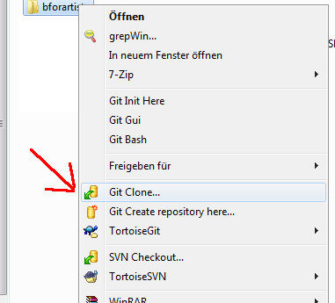
4. We have navigated to the Bforartists Github repository before in step 2. , so Git should have copied the right link into the URL field already. If not, then type in the URL manually. https://github.com/Bforartists/Bforartists
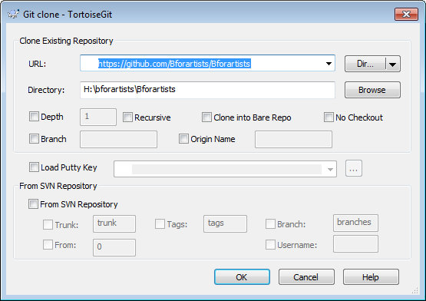
5. Click okay. Git will download the Bforartists repository now.
6. When everything goes well then we have the following result (notice the green tickbox):
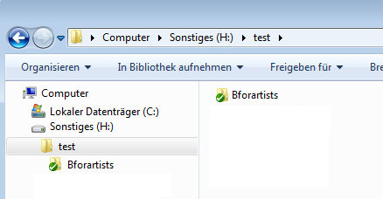

Creating the Binary Folder

On with some more preparations.

We need a folder where Cmake builds the Binaries and where Visual Studio compiles the result. In order to do so, create another folder besides the repository.
You can name this folder however you like. I will call it bforartists_build.

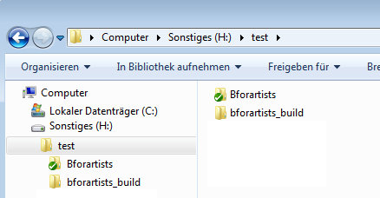

Installing the Dependencies

What is missing now are the dependencies, or “materials”. Bforartists is a fork of Blender, and uses the same dependencies. It doesn't host and update this dependencies though. We use the official dependencies from Blender.
1. Create a folder called lib beside the repository. This name is important, it has to be lib!
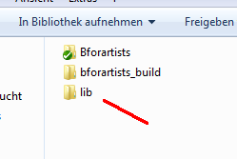
2. Inside the lib folder create a folder called windows_vc12 when you want to build a 32 Bit version of Bforartists. Or a folder called win64_vc12 when you want to build a 64 Bit version. Or both. These Names are important!
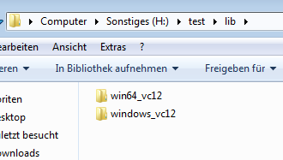
Quick Tip: the 32 Bit version of Bforartists is quickly becoming outdated and not supported officially. It is recommended you build in the 64 Bit version.
3. Now, right click on the win64_vc12 folder, and choose SVN Checkout.
We could also do this by command line.
For 64 Bit :
svn checkout https://svn.blender.org/svnroot/bf-blender/trunk/lib/win64_vc12 lib/win64_vc12

For 32 Bit:
svn checkout https://svn.blender.org/svnroot/bf-blender/trunk/lib/windows_vc12 lib/windows_vc12

But we have SVN installed, so we use SVN Checkout via the right click GUI.
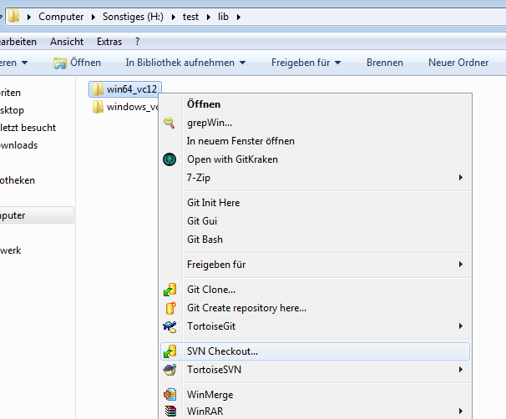
4. Once the check out is open, add the following link to get the correct lib
For the 32 Bit version we need the url:
https://svn.blender.org/svnroot/bf-blender/trunk/lib/windows_vc12
For the 64 Bit version we need the url:
https://svn.blender.org/svnroot/bf-blender/trunk/lib/win64_vc12
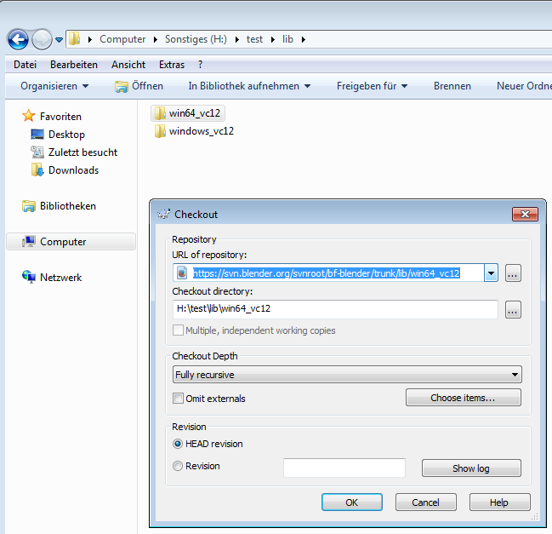
5. Click okay, and the SVN repository with the dependencies should download.
6. After these steps, the downloaded results in the target folder should look like this now:
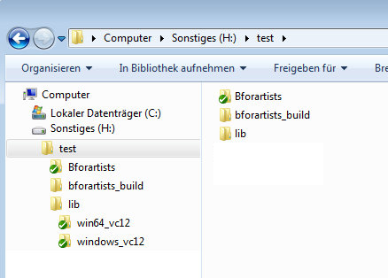 | 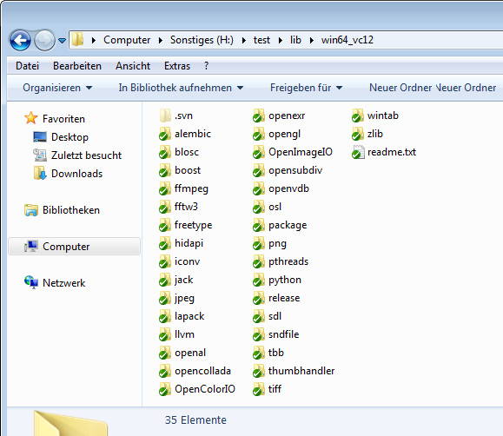
I have installed everything in a folder called test here. Note that the creation of the folder structure for the libs is required so that Cmake finds the libraries automatically. The folder called windows_vc12 contains the 32 bit libraries. The folder called win64_vc12 contains the 64 bit libraries.

Updating the Repository

Before you compile you might want to update the repository (the blueprints) to download the latest changes.
1. First “fetch”. This updates the repository index with branches, changes etc. But does not update the repository. To update the repository you do a “Pull”.
2. So first fetch, then pull. And then your repository should be up to date again.
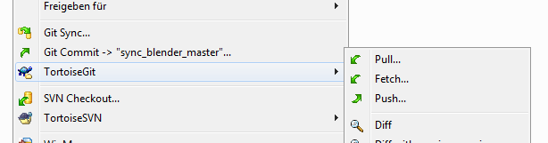

Running CMake

The Materials (Repository and Libraries) and Tools (Compilers) preparation is done using the Sourcing tools (Tools). Next chapter is the compilation itself. Get ready!
We have downloaded everything, we have installed everything. The repository is up to date. Time to fire up Cmake for the first time and create the solution files.

Cmake Preparation
1. Enter the paths to the repository source code, enter the path to the build folder then click on Configure.
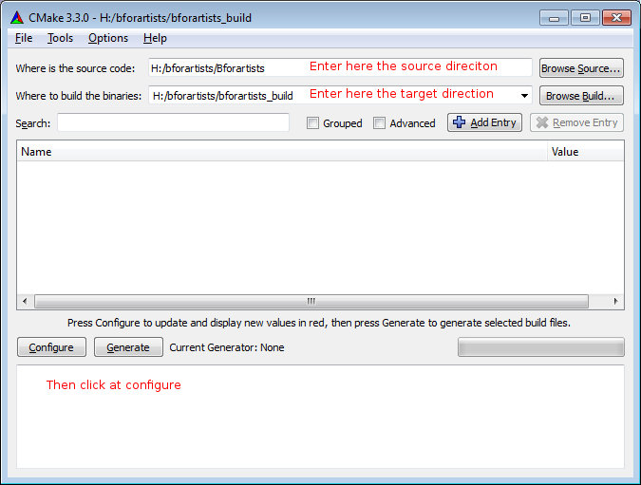
2. A window will pop up asking you what Visual Studio version to use. Choose Visual Studio 12 2013 in the “Specify the Generator for this project” dropdown box to compile the 64 bit version.
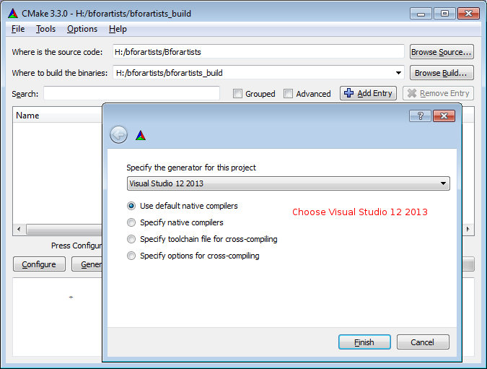
3. Let Cmake run through once. Then click Configure again. The second run will turn the upper window back to normal – where the option toggles are displayed.
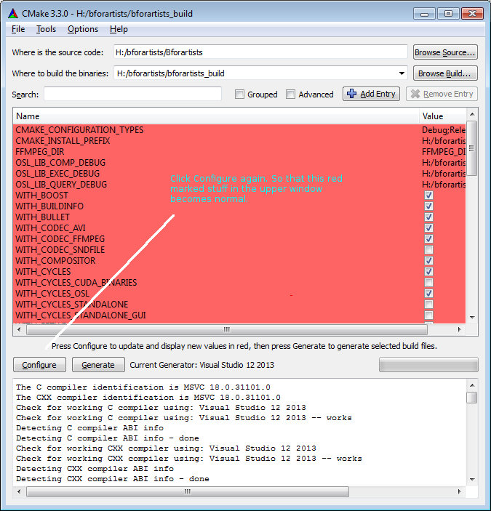
4. Sometimes, if there are incomplete libraries, missing or corrupt dependencies, and/or previous damaged builds, you might get errors in the bottom window. They need to be resolved, let’s move onto the next chapter.
5. If you got no errors, only warnings, then you can proceed to the next steps:

Activate all needed features.
Some features are off by default. Cuda Binaries, Alembic, Open VDB and Open Subdiv needs to be manually activated. We activate Cuda to have GPU acceleration in the software.
Quick tip: the defaults are generally the fastest compiling times, but you can optionally disactivate Cuda Binaries and the former to speed things up – but beware the default is pretty good.
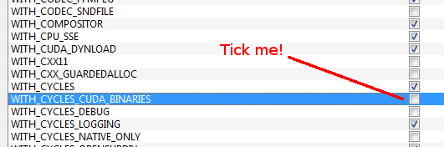

Generate
When all errors are fixed Click on Generate. This will now create the solution files in the bforartists_build folder. And you can open the Blender.sln file in Visual studio.
Quick Tip: Note that the sln file may be called called Blender.sln. Bforartists is a Blender fork. And so big parts of the file structure and the project name is still Blender.
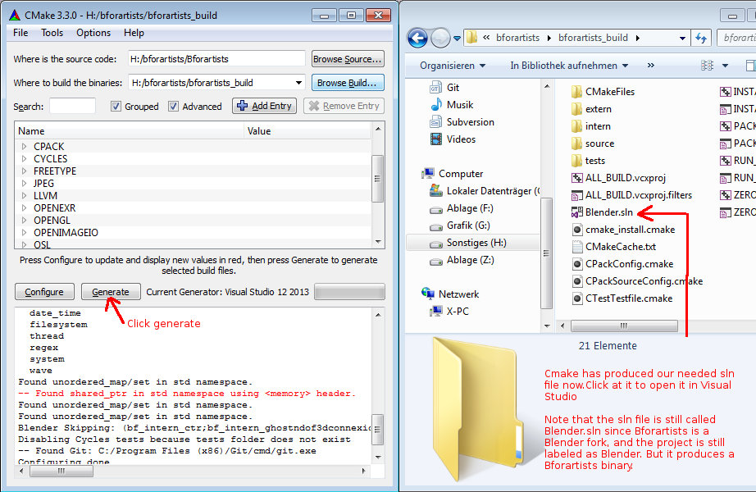

Troubleshooting Cmake Errors

You might get errors when you run Cmake for the first time: missing or corrupt dependencies for example. Make sure you have downloaded and installed all of them. You might also have missing path variables by which the installed software gets recognized by Cmake. These are just some of the errors. Feel free to drop a task in the Github tracker or Forum space for Bforartists asking for help if this step is over your head. We will do our best to help you out.

Cuda
You might get a CUDA_SDK_ROOT_DIR-NOTFOUND warning in the upper section. But Bforartists compiles nevertheless fine. In case you want to fix this, search for nvcc in the C:\Program Files\Nvidia Corporation folder.
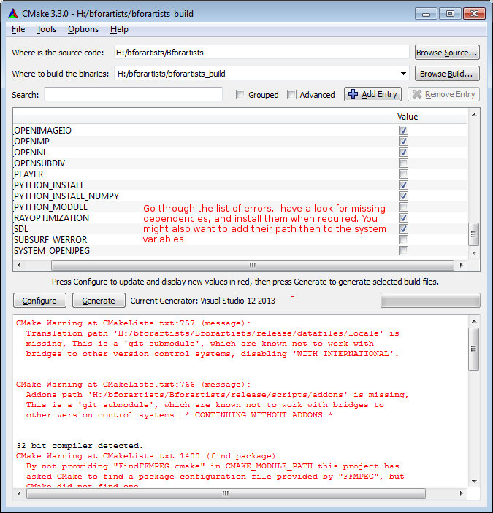

Cmake Warning at intern/cycles/kernel/CmakeLists
Sometimes you will get this warning (and thus cause compiling errors) if you have the incorrect CUDA Developer Tools installed. Uninstall and reinstall the correct version. 9.1.85 is the last tested version for Bforartists 1.0.0

Adding System variables
Some things requires to be added to the system variables.
Here's for example where you add the path to the Blender exe in case it is missing. Windows System control, Advanced system settings -> system properties.
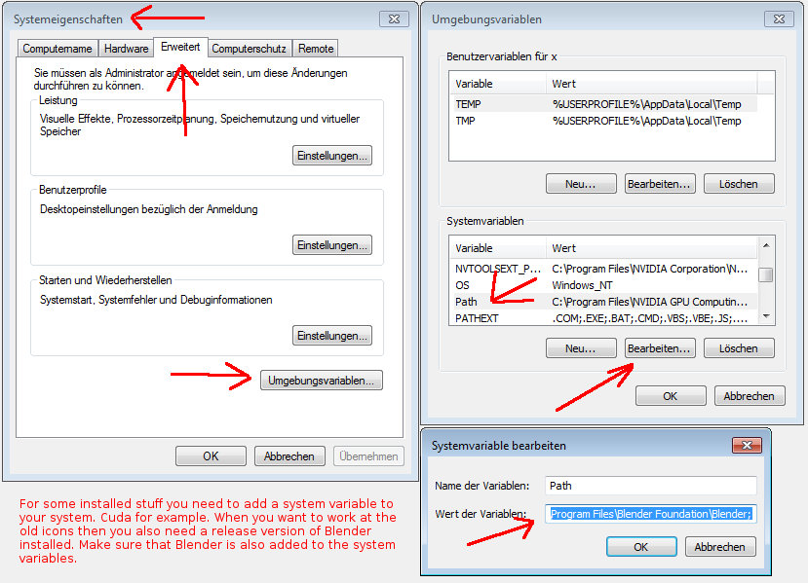

Missing Language Paths in Blender
When you compile Blender, and not Bforartists, then you might have the above errors with the missing language paths. Bforartists does not have this problem anymore, we have unioned everything in one repository. But Blender has. And just for the sake, here's how to fix:
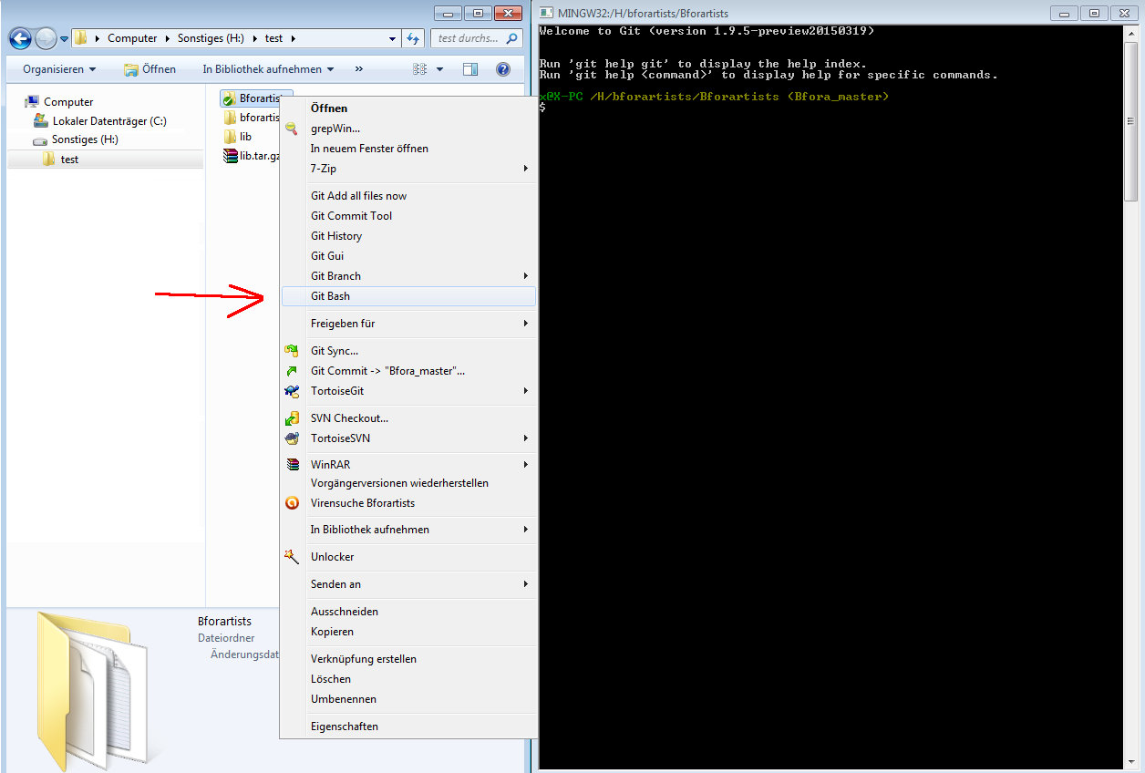
Type in the following commands into the bash, one after another. Wait until the single tasks are finished:
git submodule update --init --recursive
git submodule foreach --recursive git checkout master
git submodule foreach --recursive git pull --rebase origin master
This should download you the needed submodules. And Cmake shouldn't moan anymore
For later, when you want to update the submodules, type in
git pull --rebase
git submodule foreach --recursive git pull --rebase origin master
But this just as a sidenote. As told, Bforartists does not need this step.

Open EXR
Most probably the Openexr libraries are not found on Windows, you can fix them by hand when you want. But it is not necessary. The libraries should nevertheless be found. You can happily ignore the warning. It's just a cosmetic problem in the Cmake GUI. In case you fix them by hand, then don't mix the libs for the 32 bit version with the libs for the 64 bit version.
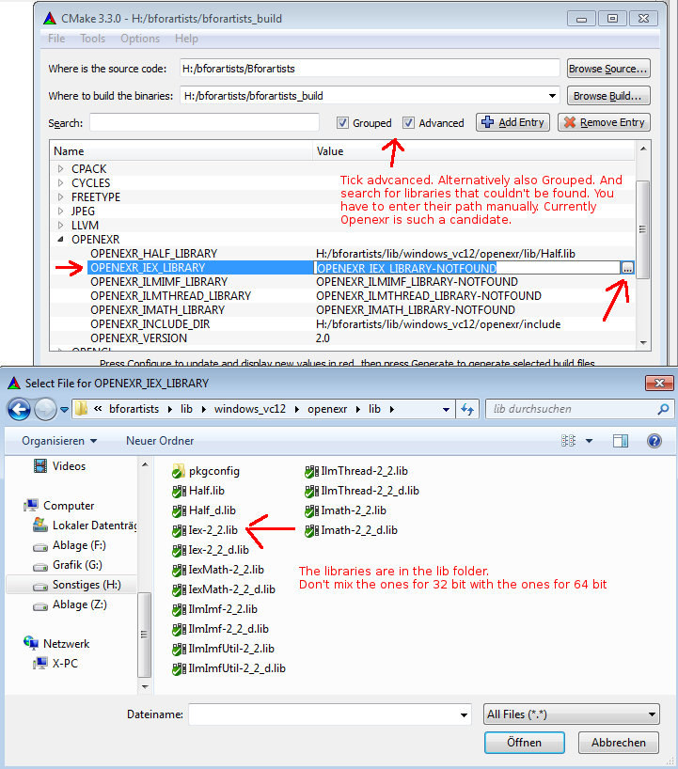

Compiling

Finally we arrive to the compiling part, the best part. Cmake should have produced everything needed in the build folder.
1. Click at the Blender.sln File to open Visual Studio.
2. In VS, change the build type to Release (VS starts usually with Debug, that's of interest for development).
3. Select the Install item in the Solution Explorer, right click on it, and choose Build.
4. Visual Studio should now start the Build process.
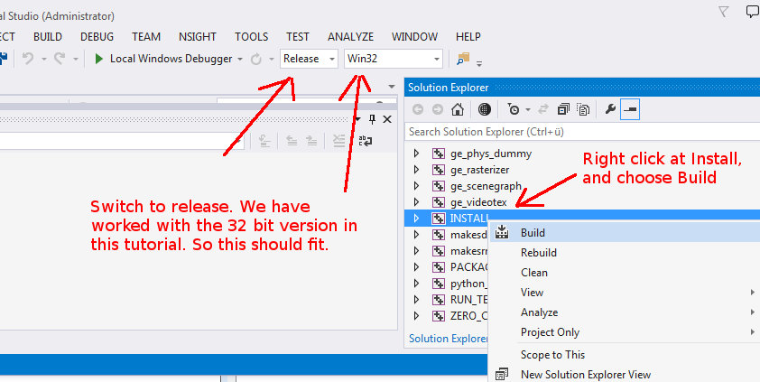
5. When everything works as thought then you should have a result in the bin/Release folder.
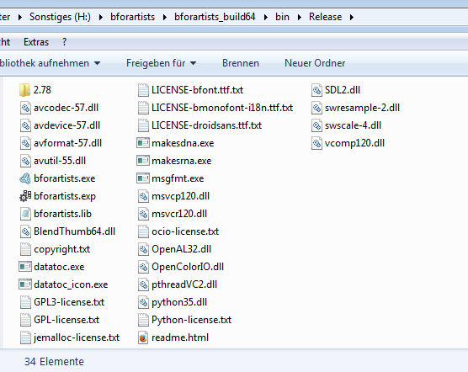

Congratulations!
You have compiled Bforartists for the first time. You should be able to work with the source code now. Double click on the *.exe to run and see that everything is working fine. When it does, you are a winner.

Quick Tip: Now that it’s compiled, you can do Python code changes to the built data, and test it almost live. Don’t forget to copy your python changes in the bin/Release folder back to the Repository or else when you rebuild, you will loose all changes!
For C code changes, you will need to do the changes in the repository before building, then re-build to test. If you get errors on re-build, just delete the old build in the bin/Release folder.

