# PROGRAM 1

1. Write a python program to find the best of two test average marks out of three test’s marks acceptedfrom the user.

### SOURCE CODE

# take inputs

num1 = float(input('Enter first number: ')) num2 = float(input('Enter second number: ')) num3 = float(input('Enter third number: '))

# calculate average

avg = (num1 + num2 + num3)/3

# display result

print('The average of numbers = %0.2f' %avg)

## OUTPUT

Enter first number: 10 Enter second number: 2 Enter third number: 30

The average of numbers = 14.00

1. Develop a Python program to check whether a given number is palindrome or not and also count thenumber of occurrences of each digit in the input number.

### SOURCE CODE

from collections import Counter value = input("Enter a value : ")

if value == value[::-1]: print("Palindrome")

else:

print("Not Palindrome")

counted_dict = Counter(value)

for key in sorted(counted_dict.keys()):

print(f'{key} appears {counted_dict[key]} times');

## OUTPUT

Enter a value : 11 Palindrome

1 appears 2 times

Enter a value : 123332 Not Palindrome

1 appears 1 times

2 appears 2 times

3 appears 3 times

# PROGRAM 2

1. Defined as a function F as Fn = Fn-1 + Fn-2. Write a Python program which accepts a value for N (where N >0) as input and pass this value to the function. Display suitable error message if the condition for input value is not followed.

### SOURCE CODE

def fn(n):

if n == 1: return 0

elif n == 2: return 1

else:

return fn(n-1) + fn(n-2)

num = int(input("enter a number: ")) if num > 0:

print("fn(",num,") = ",fn(num),sep ="") else:

print("error in input")

## OUTPUT

Enter a number : 6 fn(6) = 5

Enter a number : asc Try with numeric value

Enter a number : -3

Input should be greater than 0

1. Develop a python program to convert binary to decimal, octal to hexadecimal using functions.

### SOURCE CODE

def BinToDec(b): return int(b,2)

def OctToHex(o): return hex(int(o,8))

bnum = input("enter the binary number: ") dnum = BinToDec(bnum) print("\nEquivalent Decimal value = ",dnum)

onum = input("enter the octal number: ") hnum = OctToHex(onum)

print("\nEquivalent Hexadecimal value = ",hnum[2:].upper())

## OUTPUT

Enter the binary number : 1010 Equivalent Decimal value = 10

Enter the octal number : 73 Equivalent hexadecimal value = 3B

# PROGRAM 3

* 1. Write a Python program that accepts a sentence and find the number of words,digits, uppercase letters and lowercase letters.

### SOURCE CODE

sentence = input("enter a sentence: ") wordList = sentence.split(" ")

print("this sentence has", len(wordList), "words") digCnt = upCnt = loCnt = 0

for ch in sentence: if '0' <= ch <= '9':

digCnt += 1

elif 'A' <= ch <= 'Z': upCnt += 1

elif 'a' <= ch <= 'z': loCnt += 1

print("This sentence has", digCnt, "digits", upCnt, "upper case letters", loCnt, "lower case letters")

## OUTPUT

enter a sentence :

John went to market

This sentence has 4 words

This sentence has 0 digits 1 upper case letters 16 lower case letters

* 1. Write a Python program to find the string similarity between two given strings

### SOURCE CODE

str1 = input("Enter String 1 \n") str2 = input("Enter String 2 \n")

if len(str2) < len(str1): short = len(str2) long = len(str1)

else:

short = len(str1) long = len(str2)

match_count = 0

for i in range(short_string_length): if str1[i] == str2[i]:

match_count += 1

print("Similarity between two said strings: ") print(match_count/long_string_length)

## OUTPUT

Enter String 1 HAPPY

Enter String 2 GOOGLE

Similarity between two said strings:

0.0

Enter String 1 : SWEET Enter String 2 : SWEET

Similarity between strings "SWEET" and "SWEET" is : 1.0

Enter String 1 : FACE

Enter String 2 : FACEBOOK

Similarity between strings "FACE" and "FACEBOOK" is : 0.6666666666666666

## PROGRAM 4

1. Write a Python program to Demonstrate how to Draw a Bar Plot using Matplotlib.

### SOURCE CODE

import matplotlib.pyplot as plt

# Sample data for demonstration

categories = ['0-10', '10-20', '20-30', '30-40', '40-50']

values = [55, 48, 25, 68, 90]

# Create a bar plot

plt.bar(categories, values, color='skyblue')

# Add labels and title plt.xlabel('Overs') plt.ylabel('Runs')

plt.title('Bar Plot Showing Runs scored in an ODI Match')

# Display the plot plt.show()

## OUTPUT

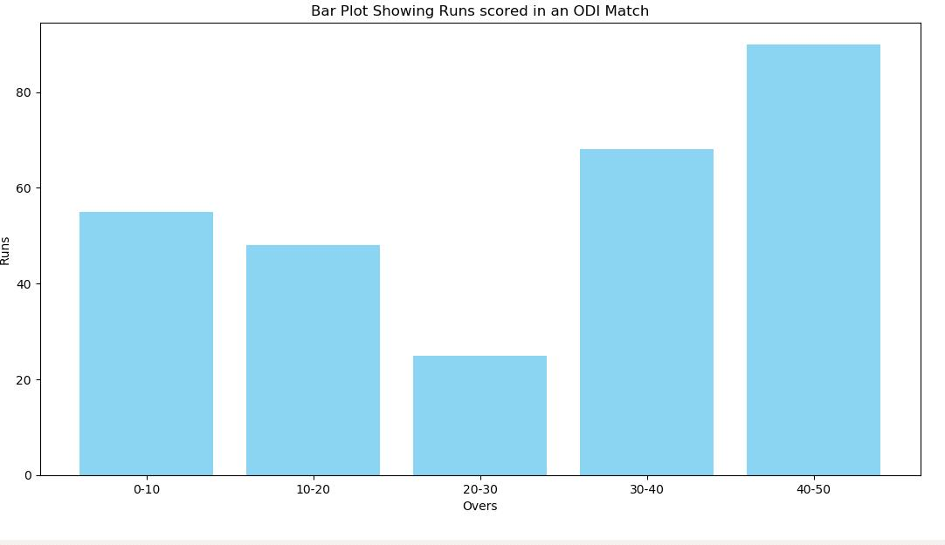

1. Write a Python program to Demonstrate how to Draw a Scatter Plot using Matplotlib

### SOURCE CODE

import matplotlib.pyplot as plt import numpy as np

# BRICS nations data (hypothetical)

countries = ['Brazil', 'Russia', 'India', 'China', 'South Africa']

population = [213993437, 145912025, 1393409038, 1444216107, 61608912]

per_capital_income = [9600, 11600, 2300, 11000, 6500] # Per capital income in USD

# Scale the population for circle size

circle_size = [pop / 1000000 for pop in population] # Scaling down for better visualization

# Assign different colors based on index colors = np.arange(len(countries))

# Create a scatter plot with varying circle sizes and colors

scatter = plt.scatter(population, per_capita_income, s=circle_size, c=colors, cmap='viridis', alpha=0.7, label='BRICS Nations')

# Annotate each point with the country name for i, country in enumerate(countries):

plt.annotate(country, (population[i], per_capita_income[i]), textcoords="offset points", xytext=(0,5), ha='center')

# Add colorbar plt.colorbar(scatter, label='Index')

# Add labels and title plt.xlabel('Population')

plt.ylabel('Per Capita Income (USD)')

plt.title('Population vs Per Capita Income of BRICS Nations')

# Display the plot plt.show()

**OUTPUT**

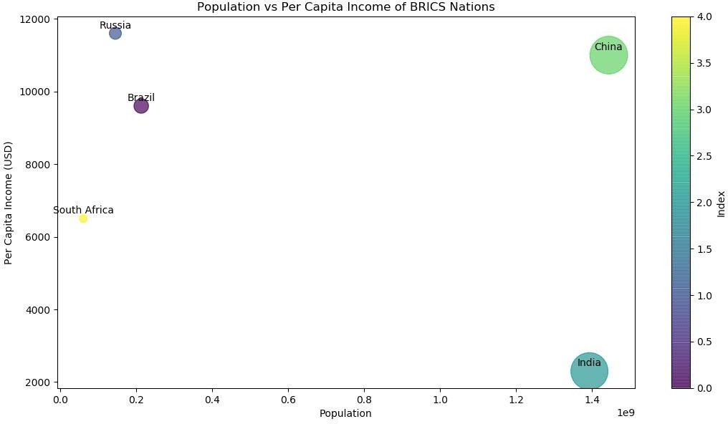

# PROGRAM 5

1. Write a Python program to Demonstrate how to Draw a Histogram Plot using Matplotlib.

### SOURCE CODE

import matplotlib.pyplot as plt import numpy as np

# Generate random student scores (example data) np.random.seed(42)

student_scores = np.random.normal(loc=70, scale=15, size=100)

# Create a histogram plot

plt.hist(student_scores, bins=20, color='skyblue', edgecolor='black')

# Add labels and title plt.xlabel('Student Scores') plt.ylabel('Frequency') plt.title('Distribution of Student Scores')

# Display the plot plt.show()

## OUTPUT

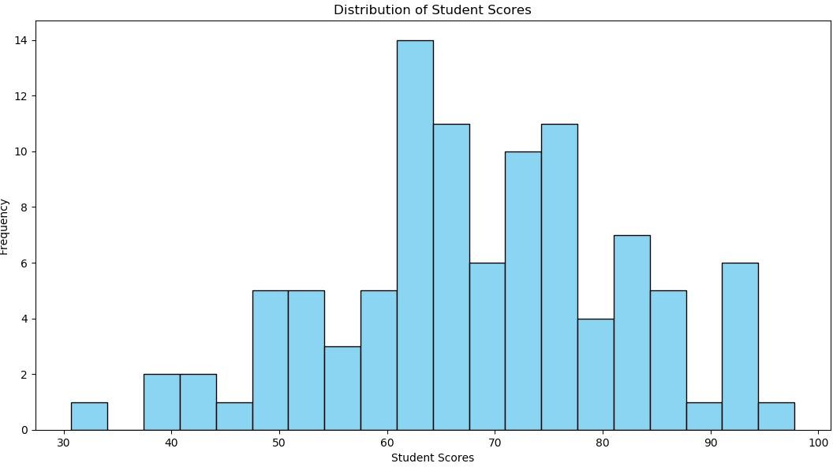

1. Write a Python program to Demonstrate how to Draw a Pie Chart using Matplotlib.

### SOURCE CODE

import matplotlib.pyplot as plt

#Number of FIFA World Cup wins for different countries

countries = ['Brazil', 'Germany', 'Italy', 'Argentina', 'Uruguay', 'France', 'England', 'Spain'] wins = [5, 4, 4, 3, 2, 2, 1, 1] # Replace with actual data

# Colors for each country

colors = ['yellow', 'magenta', 'green', 'blue', 'lightblue', 'blue', 'red', 'cyan']

plt.pie(wins, labels=countries, autopct='%1.1f%%', colors=colors, startangle=90, explode=[0.2, 0.2, 0.2, 0.2, 0.2, 0.2, 0.2, 0.2], shadow=True)

# Add title

plt.title('FIFA World Cup Wins by Country')

# Display the plot

plt.axis('equal') # Equal aspect ratio ensures that the pie chart is circular. plt.show()

**OUTPUT**

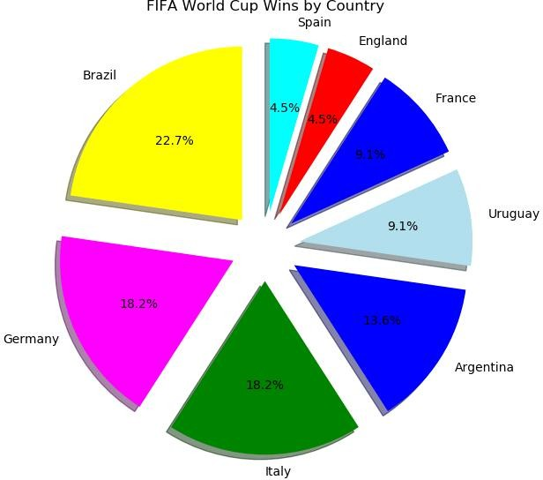

# PROGRAM 6

1. Write a Python program to illustrate Linear Plotting using Matplotlib.

### SOURCE CODE

import matplotlib.pyplot as plt

# Hypothetical data: Run rate in an T20 cricket match

overs = [0,1,2,3,4,5,6,7,8,9,10,11,12,13,14,15,16,17,18,19,20]

runs_scored = [0,7,12,20,39,49,61,83,86,97,113,116,123,137,145,163,172,192,198,198,203]

# Create a linear plot plt.plot(overs, runs_scored)

# Add labels and title plt.xlabel('Overs') plt.ylabel('Runs scored')

plt.title('Run scoring in an T20 Cricket Match')

# Display the plot plt.grid(True) plt.show()

## OUTPUT

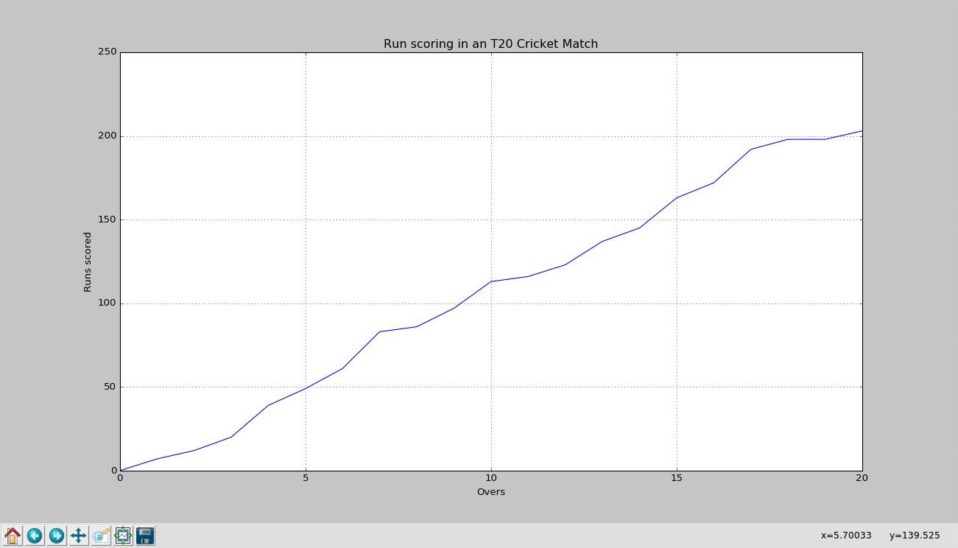

1. Write a Python program to illustrate liner plotting with line formatting using Matplotlib.

### SOURCE CODE

import matplotlib.pyplot as plt

# Hypothetical data: Run rate in an T20 cricket match

overs = [0,1,2,3,4,5,6,7,8,9,10,11,12,13,14,15,16,17,18,19,20]

runs_scored = [0,7,12,20,39,49,61,83,86,97,113,116,123,137,145,163,172,192,198,198,203]

# Create a linear plot

plt.plot(overs, runs_scored, marker='X', linestyle='dashed',color='red', linewidth=2, markerfacecolor='blue', markersize=8)

# Add labels and title plt.xlabel('Overs', color = 'green') plt.ylabel('Runs scored')

plt.title('Run scoring in an T20 Cricket Match')

# Display the plot plt.grid(True) plt.show()

**OUTPUT**

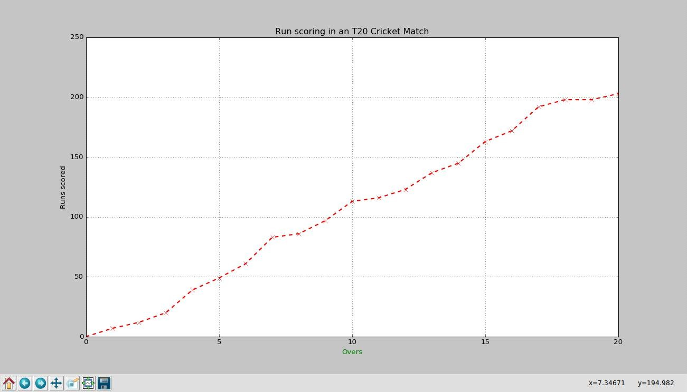

# PROGRAM 7

1. Write a Python program which explains uses of customizing seaborn plots with Aesthetic functions.

### SOURCE CODE

import numpy as np

import matplotlib.pyplot as plt import seaborn as sns

def sinplot(n=10):

x = np.linspace(0, 14, 100) for i in range(1, n + 1):

plt.plot(x, np.sin(x + i * .5) * (n + 2 - i))

sns.set_theme() #sns.set_context("talk")

sns.set_context("notebook", font_scale=1.5, rc={"lines.linewidth": 2.5})

sinplot()

plt.title('Seaborn plots with Aesthetic functions') plt.show()

**OUTPUT**

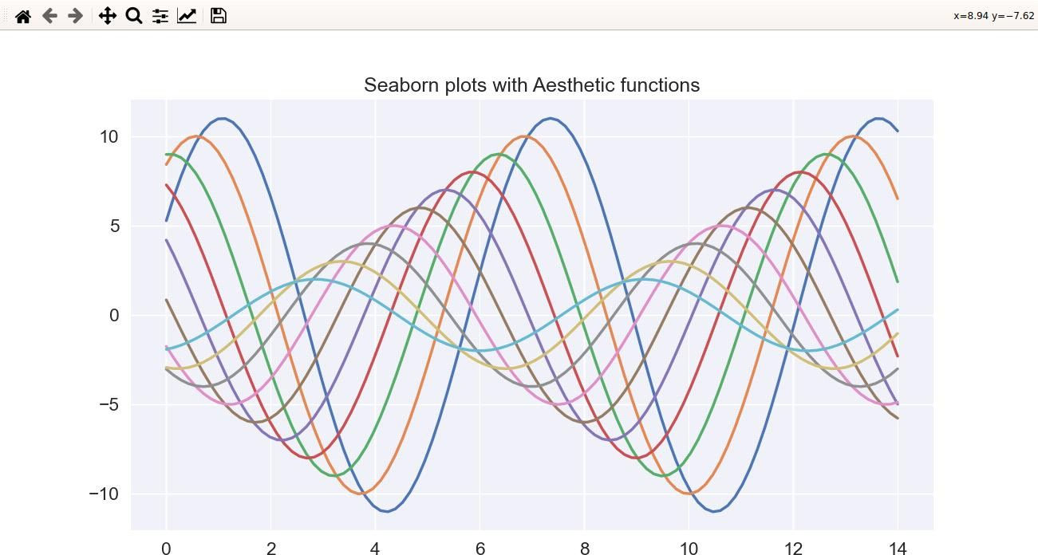

# PROGRAM 8

Write a Python program to explain working with bokeh line graph using Annotations and Legends.

1. Write a Python program for plotting different types of plots using Bokeh.

import numpy as np

from bokeh.layouts import gridplot from bokeh.plotting import figure, show

x = np.linspace(0, 4*np.pi, 100) y = np.sin(x)

TOOLS = "pan,wheel_zoom,box_zoom,reset,save,box_select" p1 = figure(title="Example 1", tools=TOOLS)

p1.circle(x, y, legend_label="sin(x)")

p1.circle(x, 2*y, legend_label="2*sin(x)", color="orange") p1.circle(x, 3*y, legend_label="3*sin(x)", color="green")

p1.legend.title = 'Markers'

p2 = figure(title="Example 2", tools=TOOLS)

p2.circle(x, y, legend_label="sin(x)") p2.line(x, y, legend_label="sin(x)")

p2.line(x, 2*y, legend_label="2*sin(x)",

line_dash=(4, 4), line_color="orange", line_width=2)

p2.square(x, 3*y, legend_label="3*sin(x)", fill_color=None, line_color="green") p2.line(x, 3*y, legend_label="3*sin(x)", line_color="green")

p2.legend.title = 'Lines'

show(gridplot([p1, p2], ncols=2, width=400, height=400))

**OUTPUT**

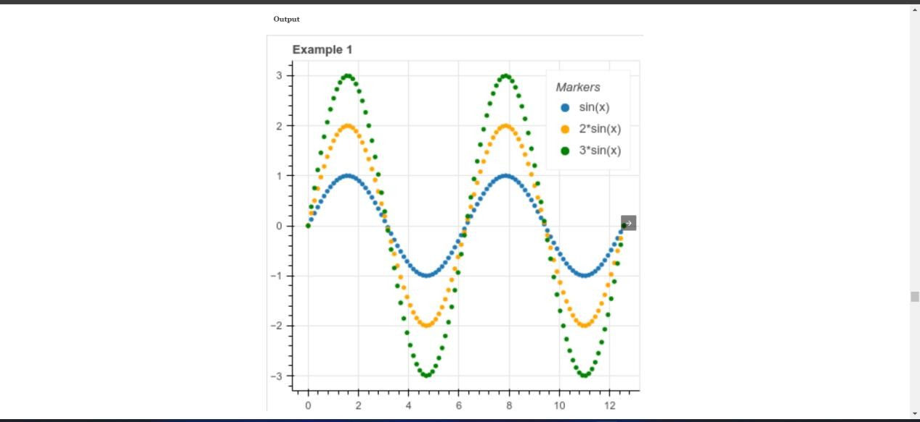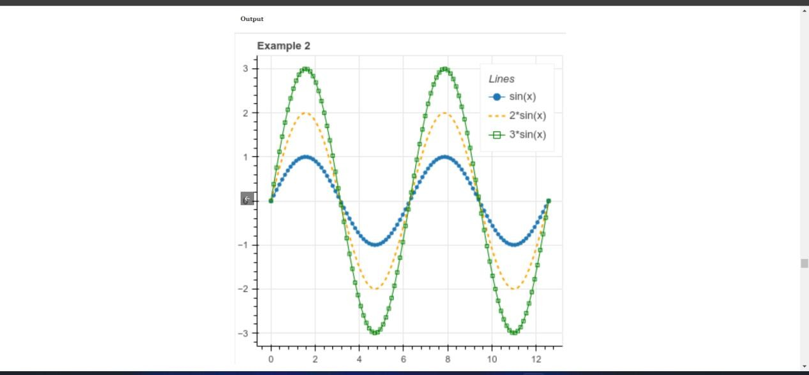

# PROGRAM 9

Write a Python program to draw 3D Plots using Plotly Libraries.

import plotly.express as px

df = px.data.gapminder().query("continent=='Asia'")

fig = px.line_3d(df, x="gdpPercap", y="pop", z="year", color='country', title='Economic Evolution of Asian Countries Over Time')

fig.show()

**OUTPUT**

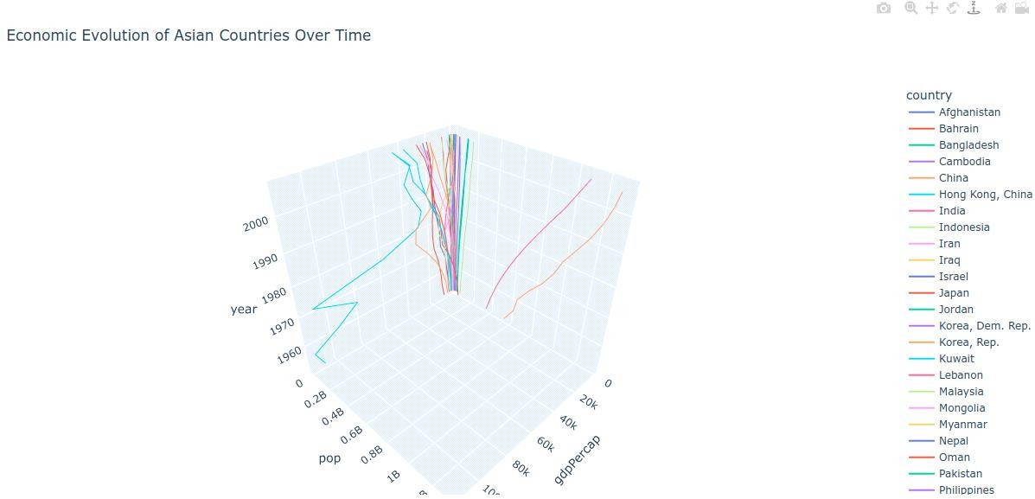

# PROGRAM 10

* 1. Write a Python program to draw Time Series using Plotly Libraries.

import pandas as pd import plotly.express as px

dollar_conv = pd.read_csv('CUR_DLR_INR.csv')

fig = px.line(dollar_conv, x='DATE', y='RATE', title='Dollar vs Rupee') fig.show()

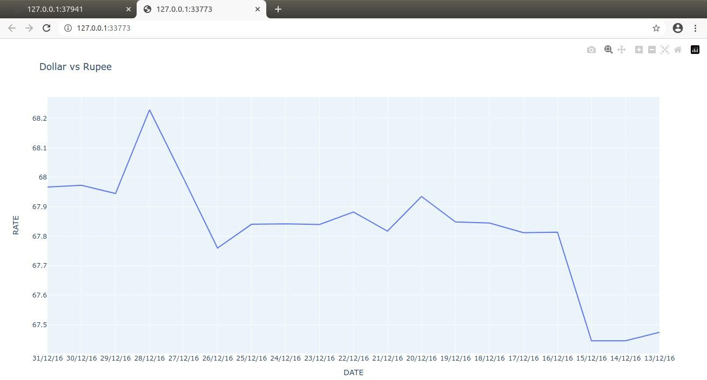

* 1. Write a Python program for creating Maps using Plotly Libraries.

import plotly.express as px import pandas as pd

# Import data from GitHub data =

pd.read_csv('https://raw.githubusercontent.com/plotly/datasets/master/gapminder_with_codes.cs v')

# Create basic choropleth map

fig = px.choropleth(data, locations='iso_alpha', color='gdpPercap', hover_name='country', projection='natural earth', title='GDP per Capita by Country')

fig.show()

