**FLOOD MONITORING AND EARLY WARNING**

**USING IOT**

Term member 411521104012:Bhuvanesh.G

Phase 1 Document Submission

**OBJECTIVES:**

1. Real-Time Flood Monitoring:

Objective: Implement a system that continuously collects and processes data from sensors to provide up-to-the-minute information on flood conditions.

* Monitor water levels, rainfall intensity, and weather conditions in real time.
* Ensure the accuracy and reliability of sensor data.
* Update flood status and conditions on a frequent basis (e.g., every few minutes).

2. Early Warning Issuance:

Objective: Develop a proactive early warning system that alerts relevant authorities and the public about impending flood risks.

* Set predefined thresholds for key parameters (e.g., water level, rainfall) to trigger alerts.
* Generate timely and accurate alerts when these thresholds are exceeded.
* Disseminate alerts through multiple channels, such as mobile apps, SMS, sirens, and local media.

3. Public Safety:

Objective: Prioritize the safety of residents and communities by providing clear and actionable information during flood events.

* Ensure that the public receives timely alerts and instructions on evacuation routes and shelter locations.
* Educate residents on flood preparedness and safety measures.
* Promote community engagement and awareness regarding flood risks and response procedures.

4. Emergency Response Coordination:

Objective: Facilitate efficient coordination among emergency response agencies and organizations.

* Enable seamless communication and data sharing between local authorities, first responders, and relevant stakeholders.
* Provide decision support tools and real-time data for emergency response planning and resource allocation.
* Foster collaboration and joint efforts in managing flood incidents effectively.

5. Data Analysis and Trend Identification:

Objective: Utilize data analytics to identify trends, patterns, and potential long-term changes in flood occurrences.

* Analyze historical flood data to identify recurrent flood-prone areas.
* Use machine learning and predictive analytics to forecast future flood events.
* Support evidence-based decision-making for flood risk reduction and mitigation strategies.

6. System Resilience and Maintenance:

Objective: Ensure the reliability and sustainability of the IoT-based flood monitoring and early warning system.

* Establish regular maintenance schedules for sensors and communication infrastructure.
* Implement redundancy and failover mechanisms to minimize system downtime.
* Continuously assess and upgrade the system to adapt to changing environmental conditions and technological advancements.

These objectives collectively aim to create a comprehensive flood monitoring and early warning system using IoT technologies, prioritizing the safety of communities, effective response coordination, and data-driven flood risk management. By achieving these objectives, the system can significantly reduce the impact of floods on both lives and infrastructure.

**IOT SENSOR NETWORK DESIGN:**

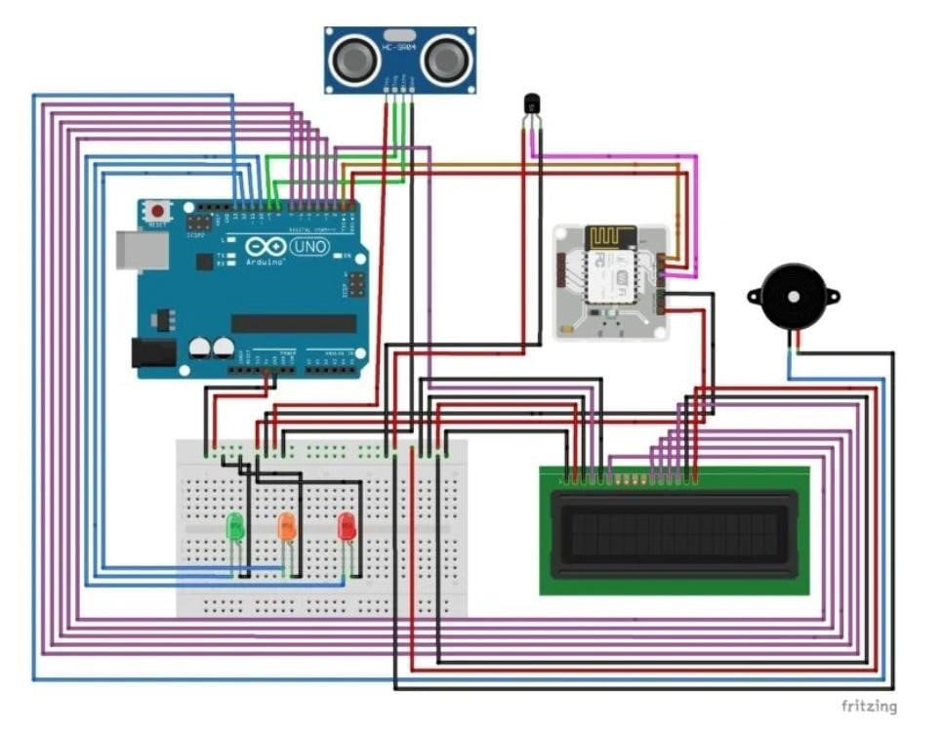

This the plan to deployment of IoT sensor to monitor flood area

**EARLY WARNING PLATFORM:**

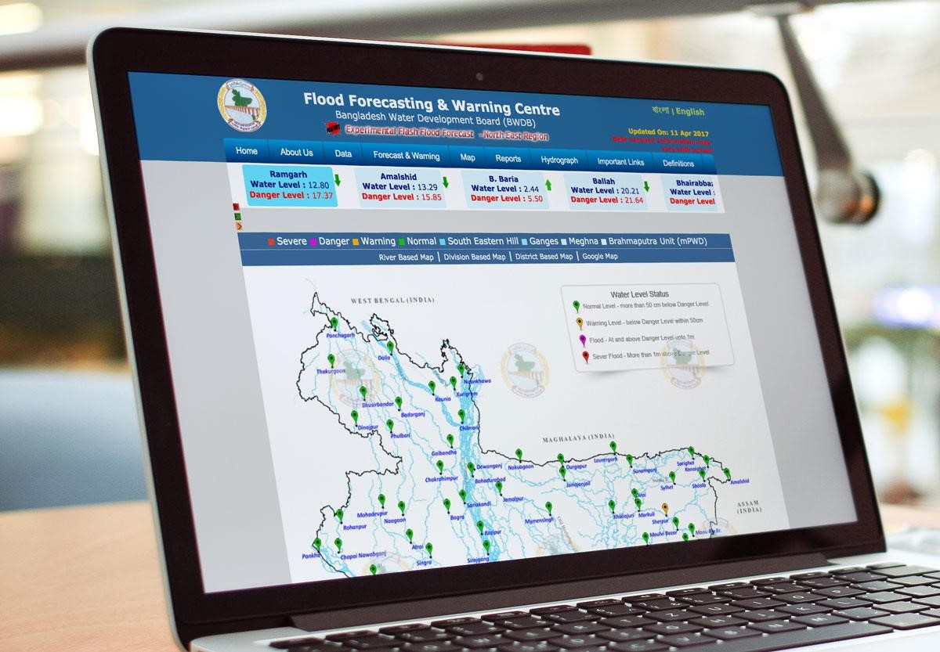

This the design of web platform to display a real time water level and flood warning

**INTEGRATION APPROACH:**

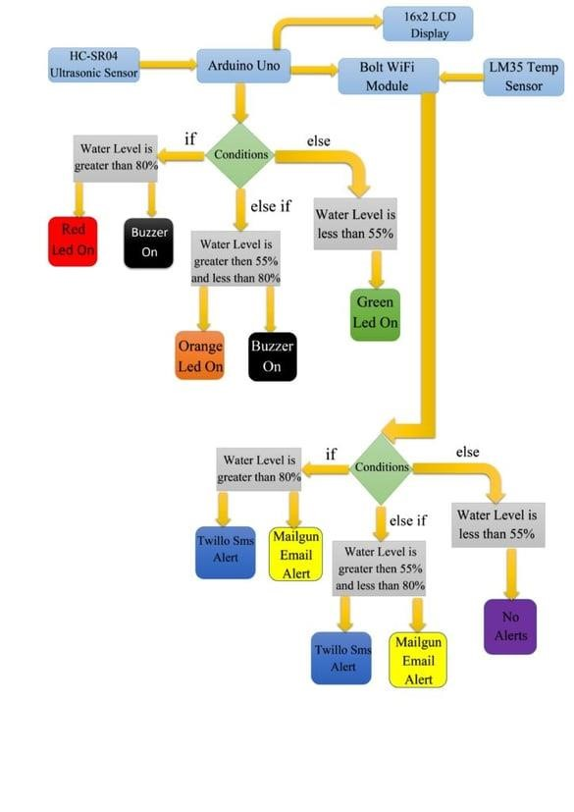

**Sms Alert:**

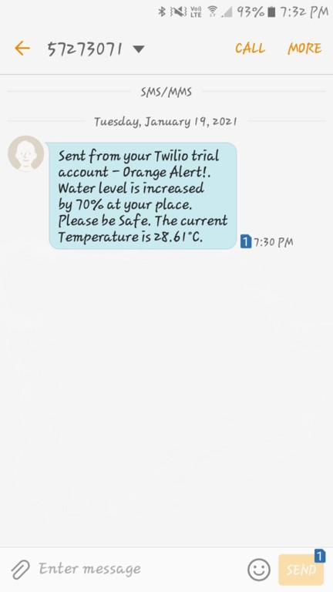

**Email Alert:**

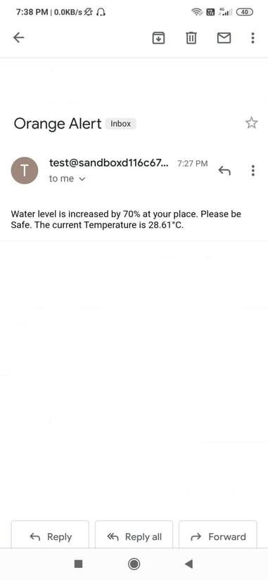

By using boolt-iot wifi module will send data