Green: Green Approximate Computing for Next Generation Sustainability

Heavy computation leads to large amount of energy computation and emission of carbon. Green computing is the only solution to reduce this carbon emission and energy consumption. Green Approximate Computing (GAC) can reduce CPU cycles by employing perforated loop and ONX models. ONX models can be apply on various fields such as Machine Learning, Big data, data science and many more where large amount of data has to be process.

ONX model include batch processing which will process large amount of input data in several parallel batches which will reduce computation time and result into energy efficiency or savings.

To implement this project we have designed ONX based parallel images processing which will process nearly 100 images parallel and then calculate execution time. Same processing will implement using normal single CPU process and then calculate computation time. Both single and ONX based parallel processing time will be compared.

Here as input we are uploading a list of 100 images which application will process using single CPU process and ONX based multiple parallel process and then compare execution time between both techniques.

To implement this project we have designed following modules

1. Upload Image Data: using this module we will upload a folder of images which contains nearly 100 images
2. Image Processing using Normal Technique: this module will read each image and then process using single CPU process and then calculate processing time
3. Image Processing using ONX Batch: this module will create Multi Process parallel processes and then process all images parallel and then compute processing time
4. Comparison Graph: using this module will plot processing time comparison between single and ONX based parallel processing

SCREEN SHOTS

To run project double click on ‘run.bat’ file to get below screen

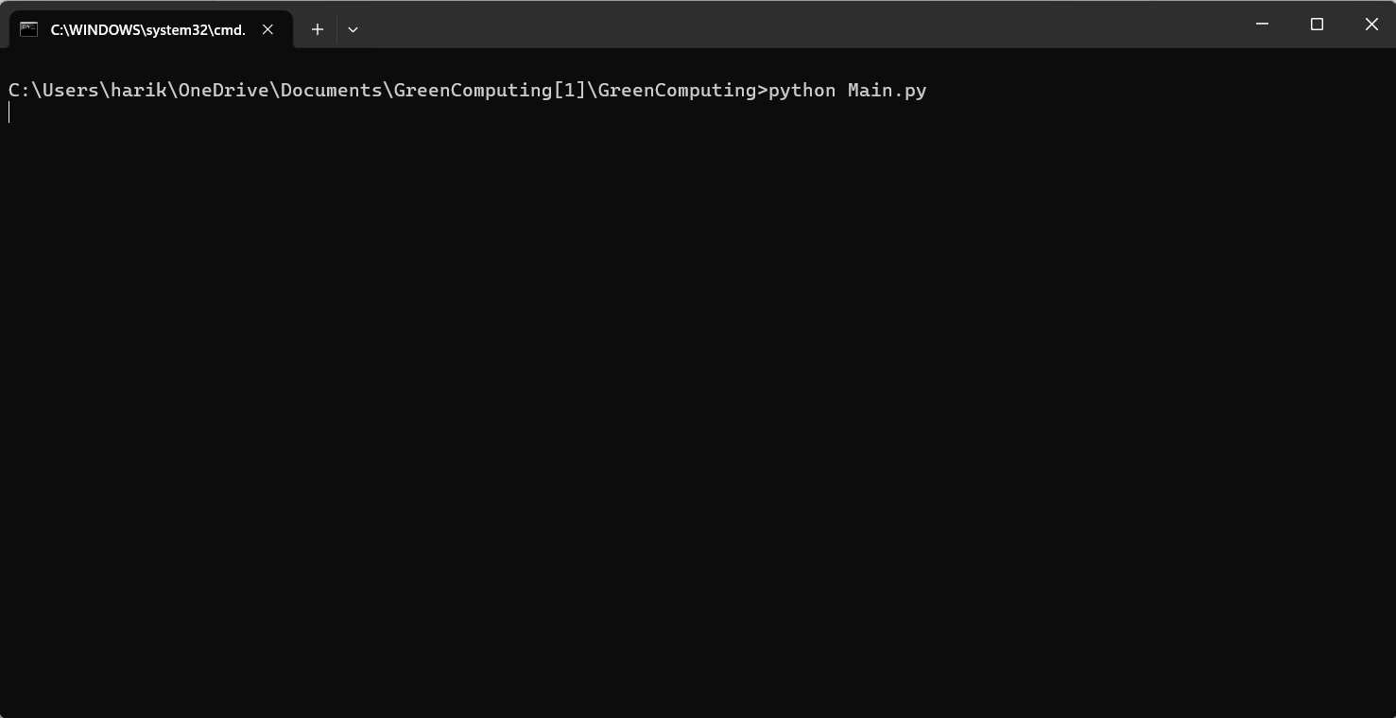

Command Prompt run file



In above screen click on ‘Upload Image Data’ button to upload images folder

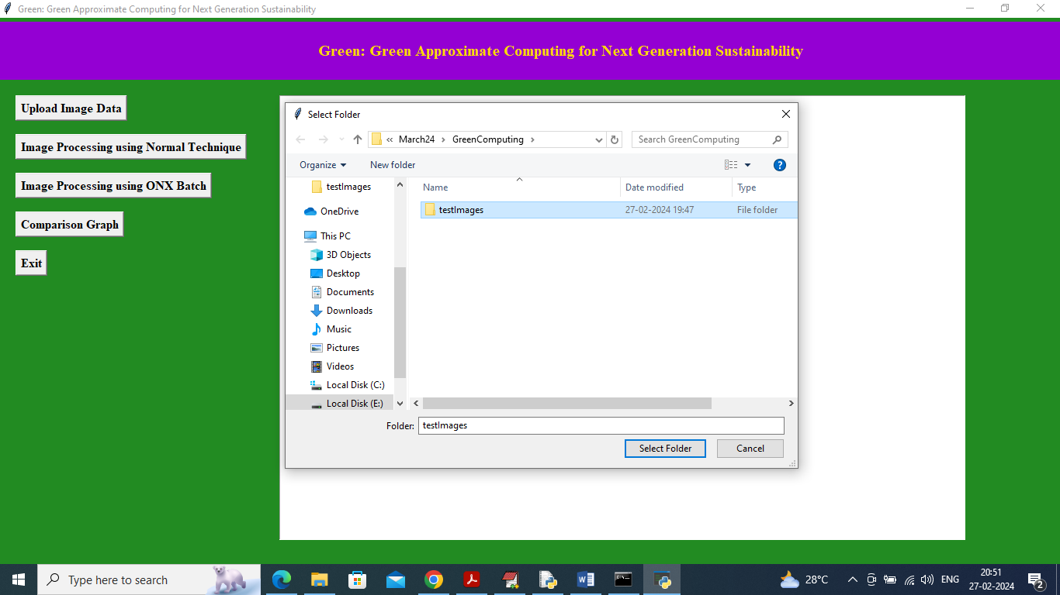

In above screen selecting and uploading a folder image and then click on ‘select folder’ button to load images and get below output



In above screen can see input folder contains 208 images and now click on ‘Image Processing using Normal Technique’ button to process images using single CPU process and get below output



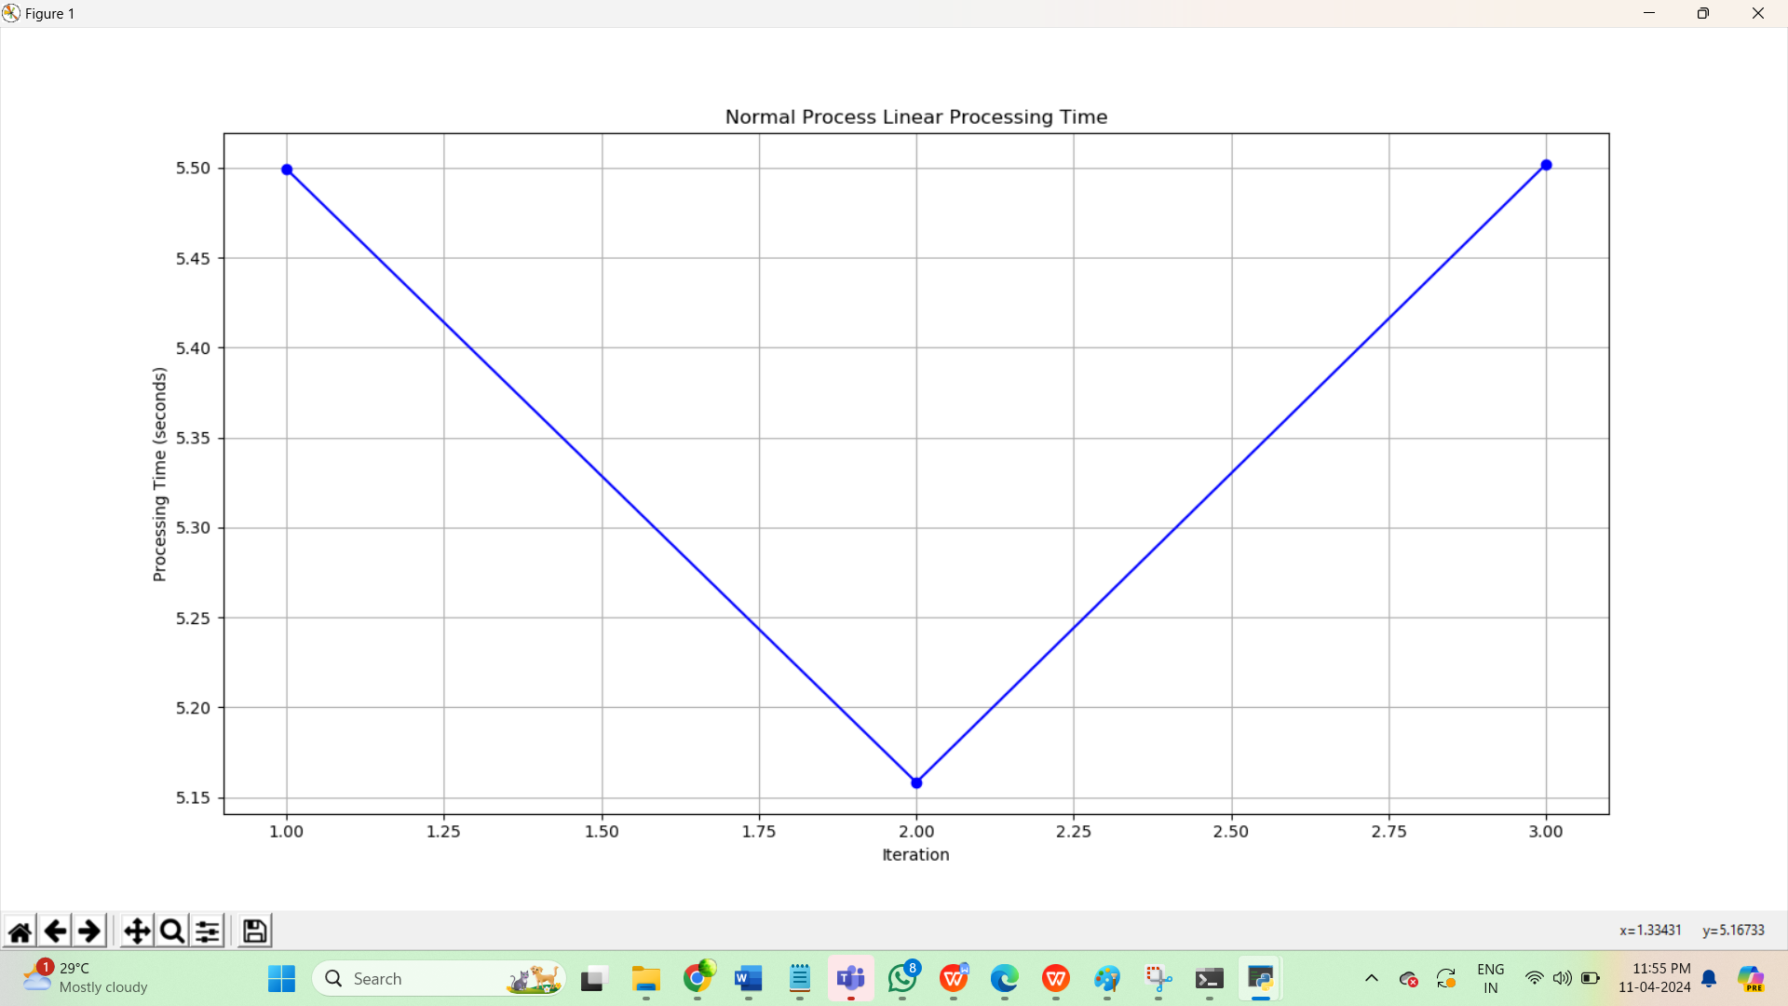

In above screen single CPU process took 5.4992 seconds in the first iteration , 5.1583 and 5.5020 seconds in 2nd and 3rd iterations to process all image and represent them in the form of graph and now click on ‘Image Processing using ONX Batch’ button to process images using ONX batch technique and get below output



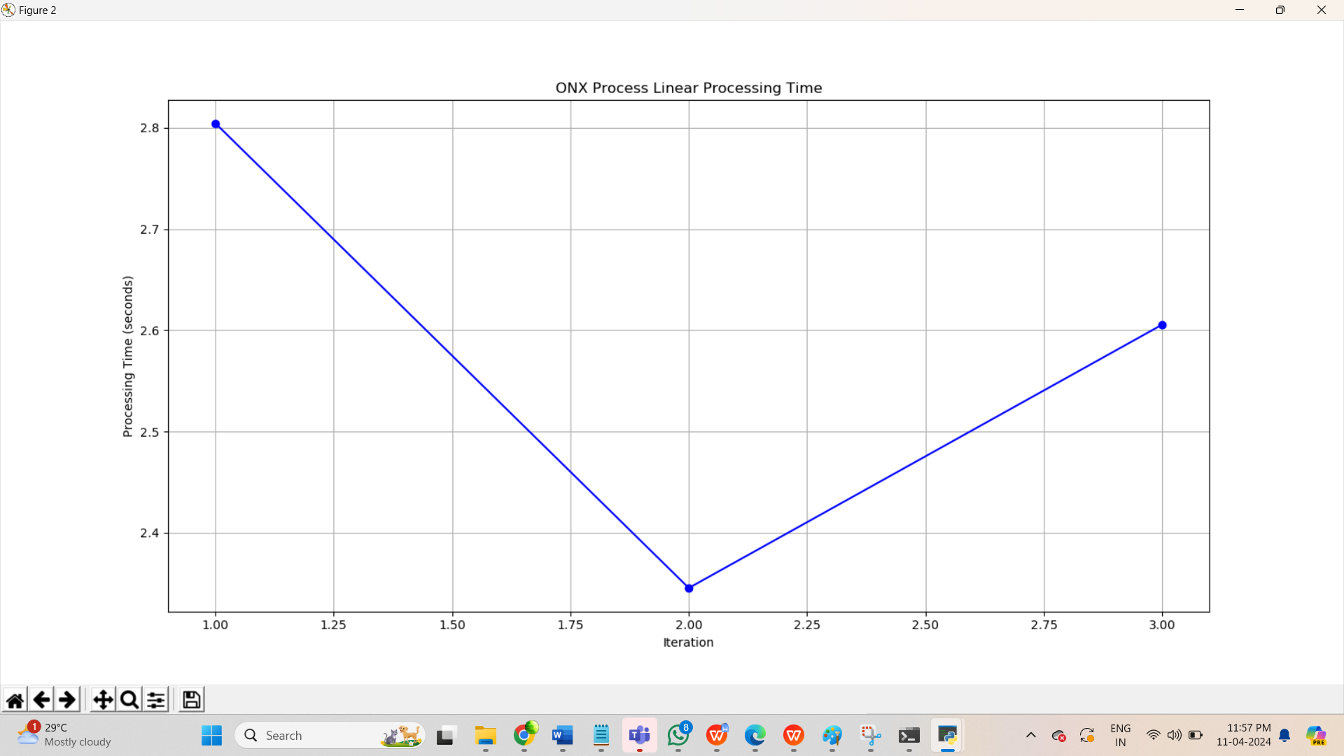

In above screen ONX technique took 2.8045 seconds in the first iteration 2.345 and 2.6056 seconds in the 2nd and 3rd iterations which are lesser than Single process CPU. If processing time reduce then automatically energy will be saved and carbon will be reduce. Now click on ‘Comparison Graph’ button to get below graph

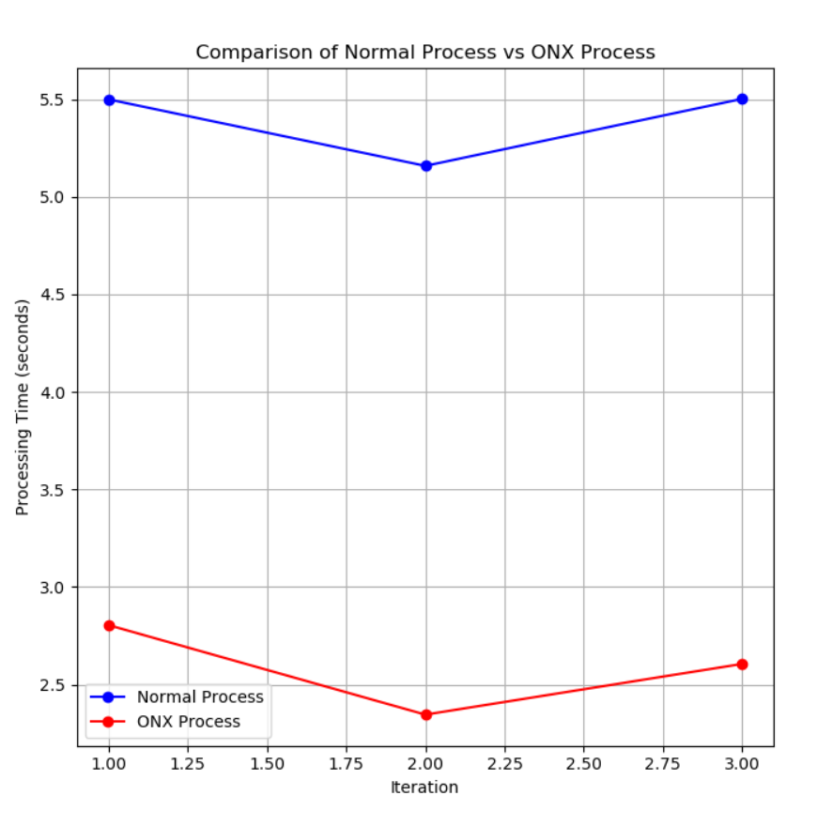

In above graph x-axis represents techniques iterations and y-axis represents processing time and comparison graph represents both techniques so when we compare with normal process vs ONX batch, the ONX batch process took less time.