Briyanian

Bhaarathkumar G

# Restaurant Concept

**Restaurant Name & URL**

Briyanian

Briyanian.com

**Food & drink**

Custom Biryani dishes

*Customization*

**● Meat**

○ Chicken Briyani

○ Mutton Briyani

**● Popular**

○ Hyderabad Briyani

○ Lucknow Briyani

○ Nellore Briyani

**● Special**

○ Dum Briyani

○ Prawn Briyani

**Describe the country, city, and neighborhood where the restaurant and its customers will be located.**

Hosur, Tamilnadu,India

Delivery radius: Hosur Urban Area

**Choose a main target audience that your restaurant is focusing on***.*

* College students
* Busy working folks

**Estimate how much your restaurant's food will cost**

$ - Affordable

**Write an elevator pitch for your restaurant**

Briyanian is a Briyani House Restaurant Located at K.R Town, Hosur. We Deliver a different Varieties of Popular Briyani's We are open around the week and we deliver food Between 7A.M to 10P.M.

**Other Project Ideas**

**Food Delivery For all age**

● Located in Hosur

● $- Affordable

● “Foodit"

● **Problem: Huge Scale Project and the audience are not enough in this locality**

**Pizza for college students**

● Located in Bangalore

● $ - Moderate

● “PizzaMate"

● **Problem: Already too many pizza places that deliver.**

**Coffee For Employees**

● Located in Manglore

● $ - Moderate

● “Cofon"

● **Problem: How would they deliver Coffee? Logistics?**

# Strategy

## Target Audience

The website/app will focus on the following target audiences:

**Roles** (groups of people with similar goals)

* Heavy Eaters
* Foodies
* People who love Non-Veg category Foods
* People who like to have a Weekend lunch
* Bachelors Birthday Treat

**Demographics** (gender, age, education, occupation, marital status, income, location)

● **Gender** - Somewhat more Men than Women

● **Education** - College Education or higher

● **Occupations** - Office managers/secretaries, administrators, small business owners,Students

● **Age** - Early 20s to 45

● **Location** – Around Hosur Town

**Psychographics** (personality, values, attitudes, interests, lifestyles)

* **Personality & Attitudes:**

○ Professional

○ Classy

○ Youthful

* **Values:**

○ Liberal

○ Safety

○ BroadMinded

* **Lifestyles:**

○ Family

○ Take vacations

○ Birthday Party lover

# Strategy

## User Personas

**Abi Raj**

● 22 year old College Student

● Likes to party

● Originally from Hosur

● Often lazy

● “Eat Sleep and break the streak”

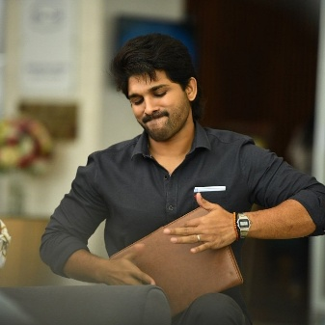

**Arjun Kumar**

● 30 year old Employee

● Likes to Weekend lunch

● Working at Banglore

● Foodie

● “work hard and Enjoy ”

# 

# Strategy

## User Needs

The website needs to enable the user to:

● Find out if the restaurant delivers to their area

● Order food online

● Find out the restaurant open Timings

● Customize the order or pick from a list of Categorized Menu

● Be functional and Fast

● Provide a solid mobile experience since most people will access site from mobile device

● Enable Online Payment

## Client Needs

The website needs to enable the client to:

* To sell food online that will be delivered
* Provide a system for order customization
* To Provide users with card payment
* To Provide Advanced Delivery Services
* To Make App Simple and Easy to use For users
* To Manage the Account Settings of the users
* To Scale the Food items in future

# **Outline of Scope**

## **Content Requirements**

Content (text, images, video) that the user will need.

“The user will be looking for…”

● Describe delivery radius: Around Hosur Town

● Describe delivery speed: “we deliver within the hour”

● Display prices

● Food Category

● Images of menu items

● About Us

● Description about the Food

● FAQ

○ Is the Biryani fresh?

○ What is your delivery Address?

○ How much is the shipping charge?

○ Is there a minimum order?

○ Where to change my profile ?

○ If any Problem can I return the Parcel ?

○ Who can I contact with questions?

## **Functionality Requirements**

Systems that will allow the user accomplish tasks.

“The user will be able to…”

* Choose from Category of items
* Popular
* Special
* Meat
* Or View all the items available
* Add items to shopping cart
* Estimate the cost
* Check out
* Enter payment info
* Enter delivery address
* Advanced Delivery services
* Adding or Reducing the quantity

# Sitemap

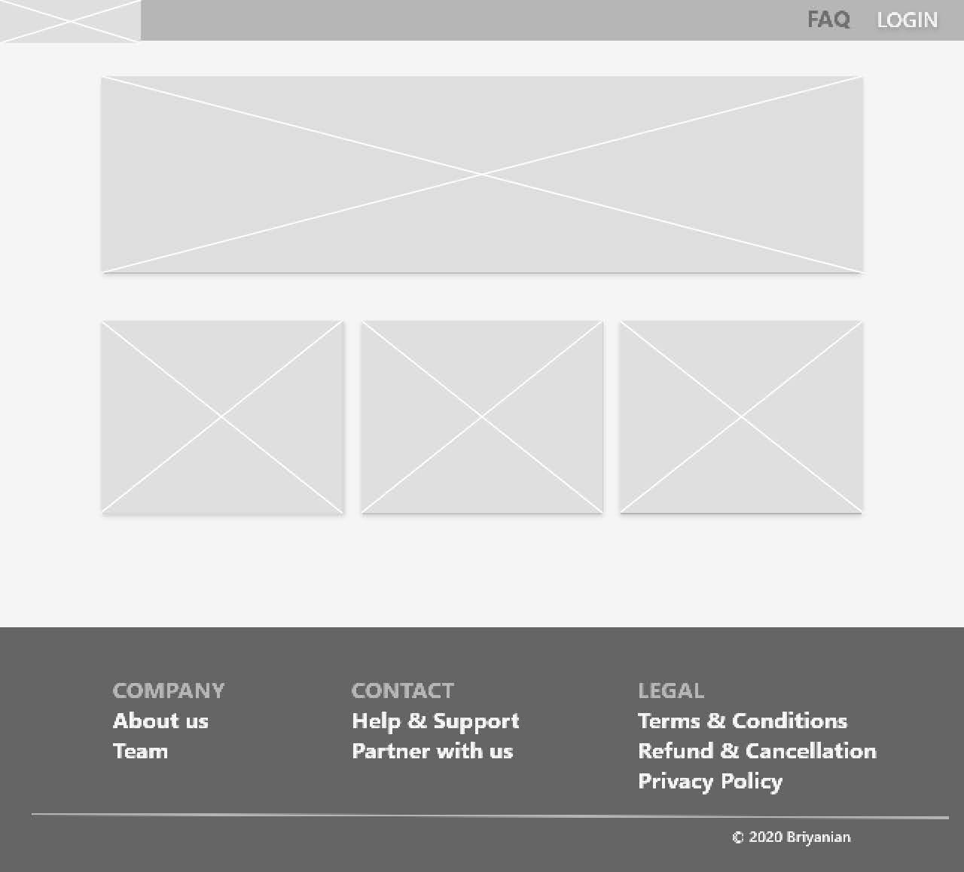

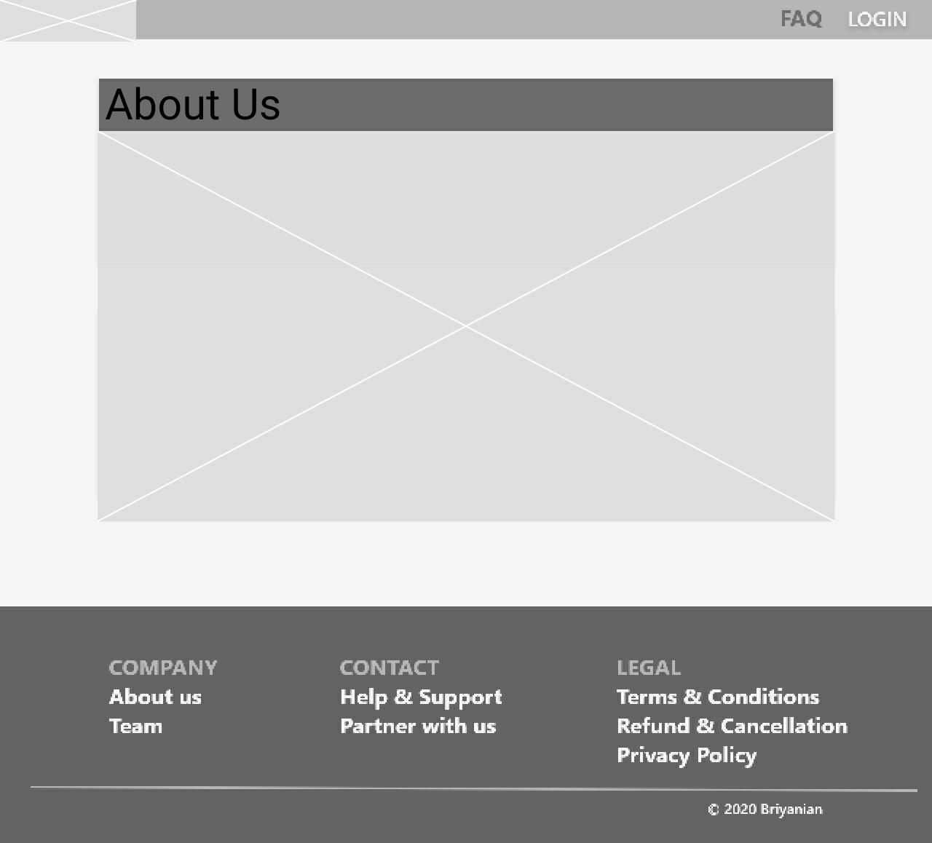



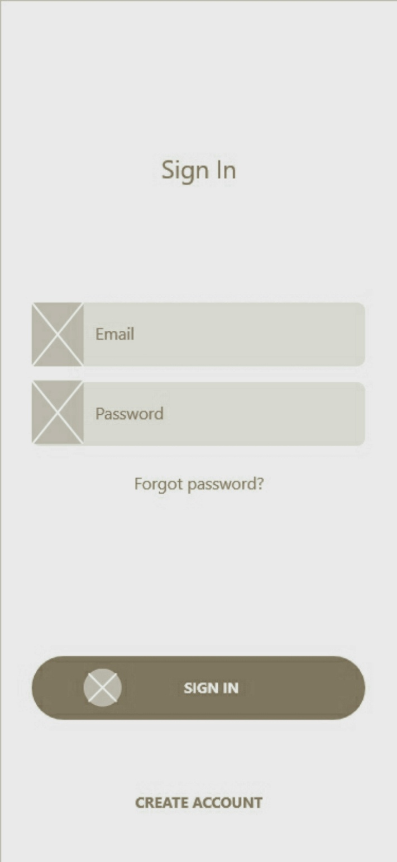

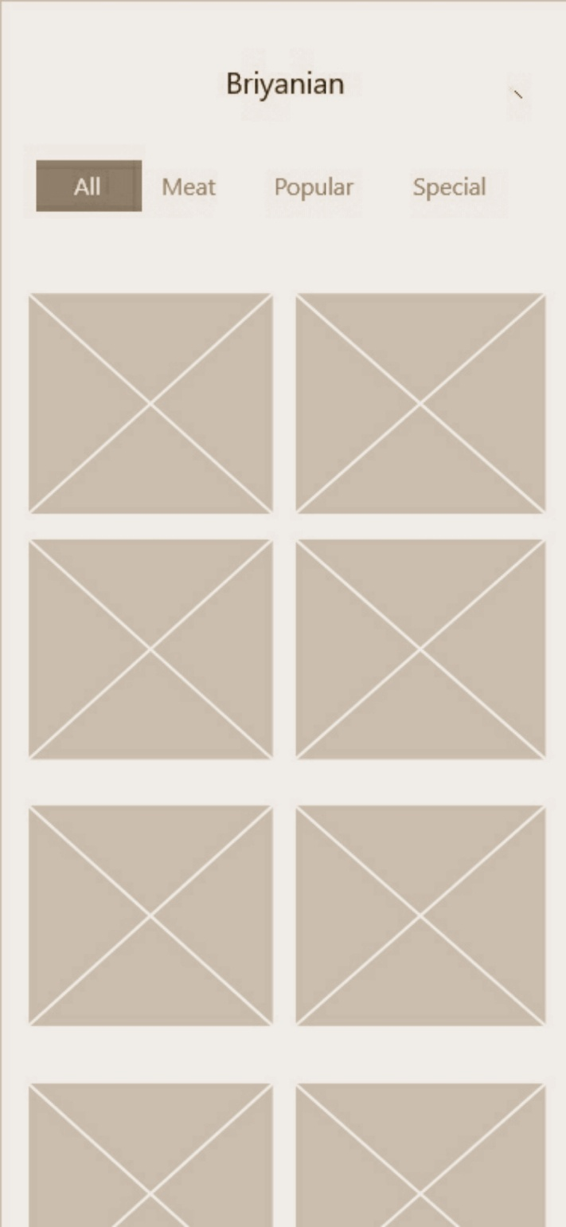

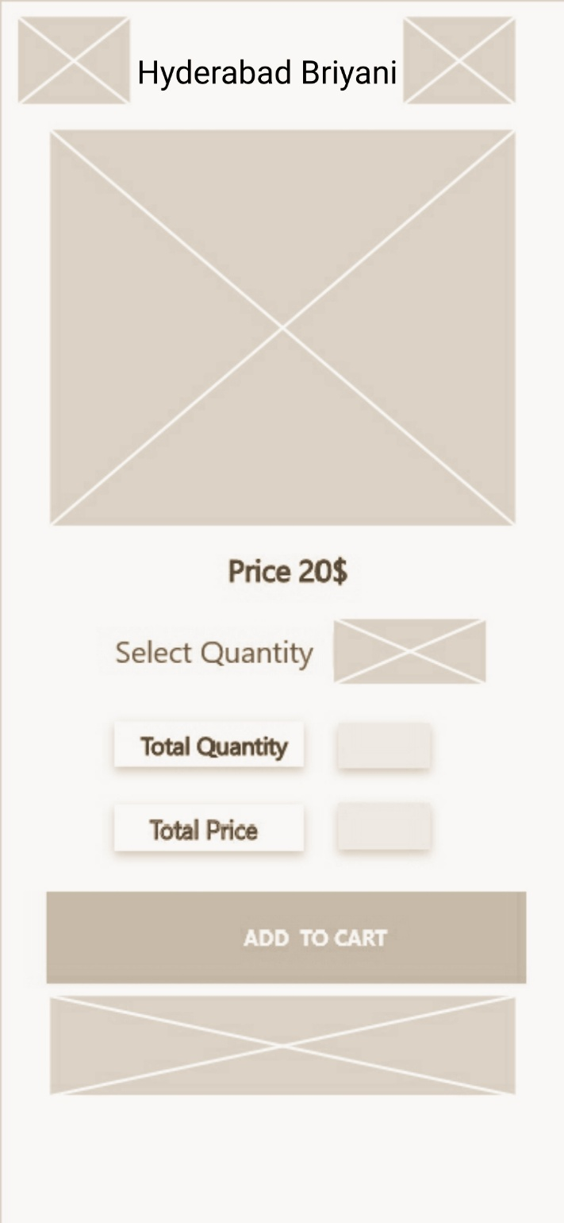

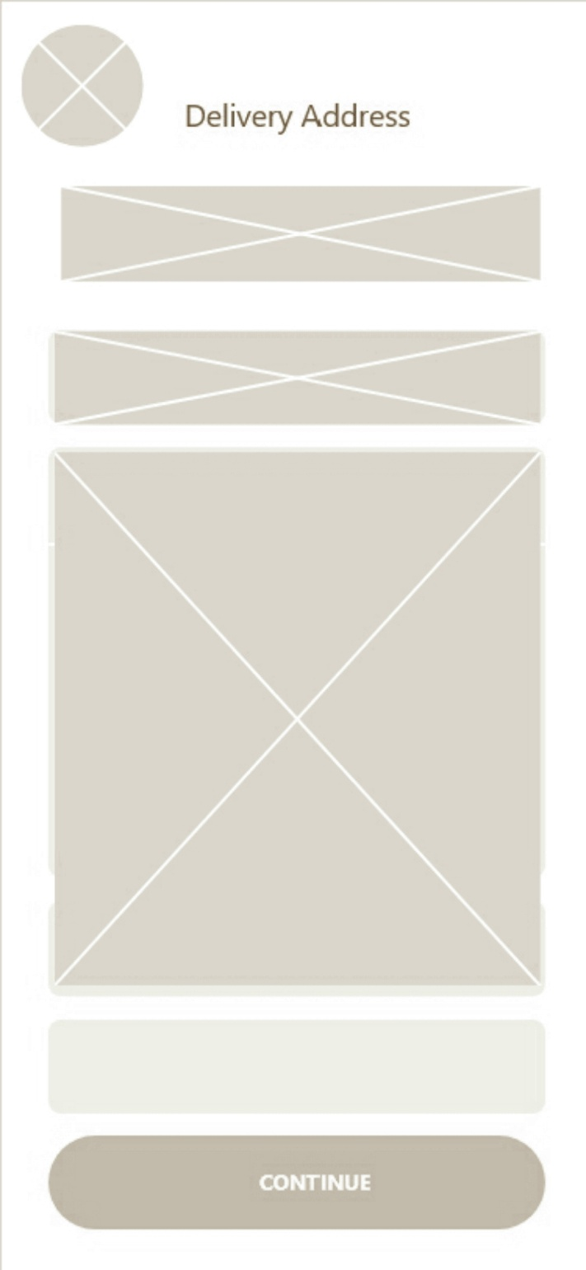

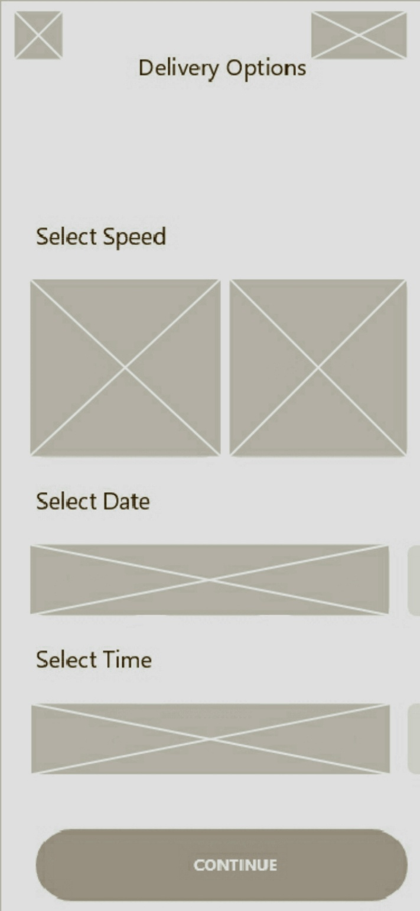



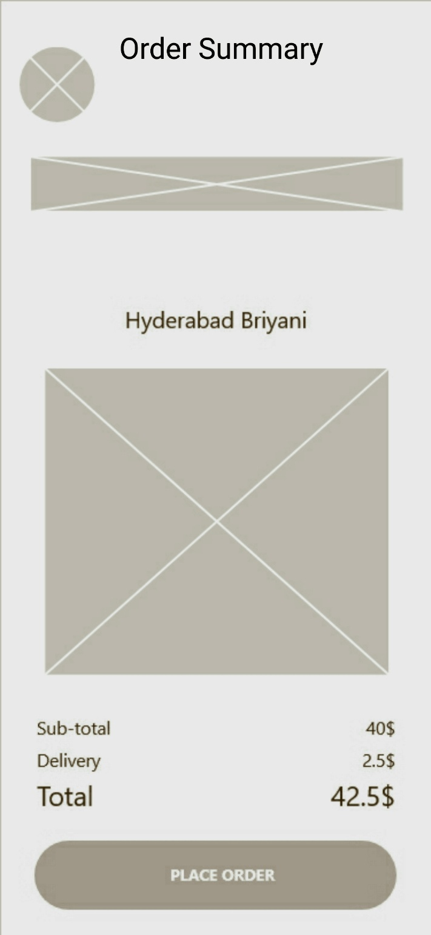

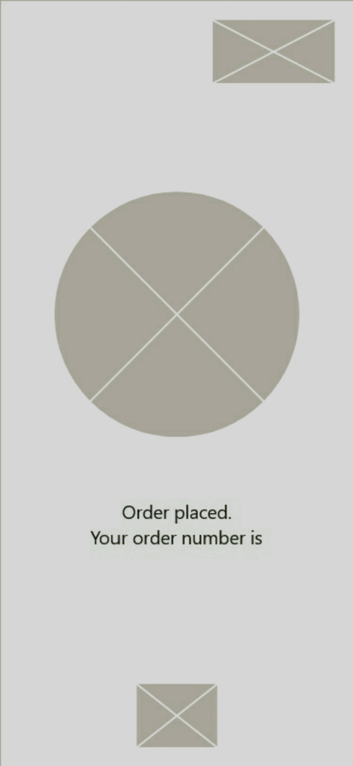

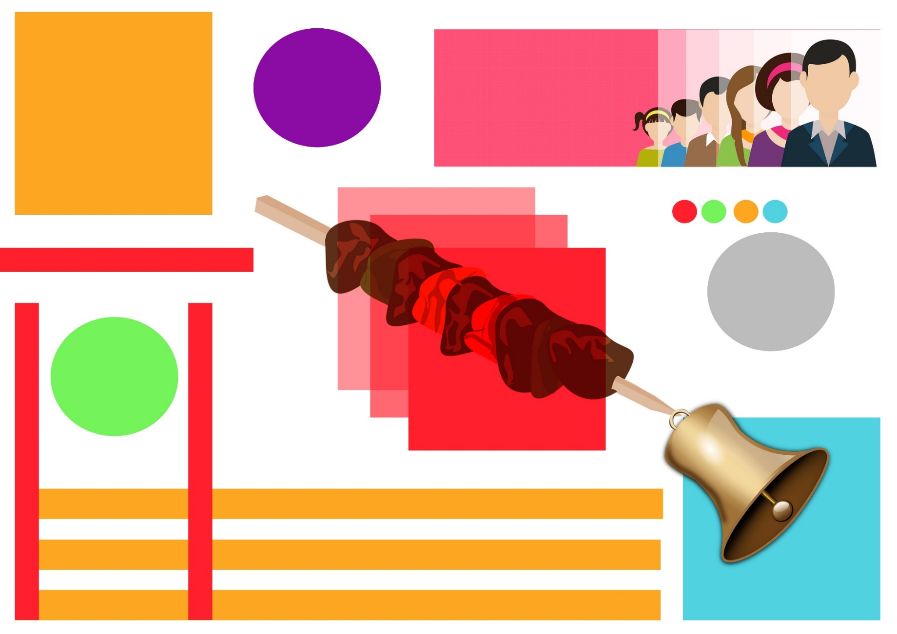

Mood Board

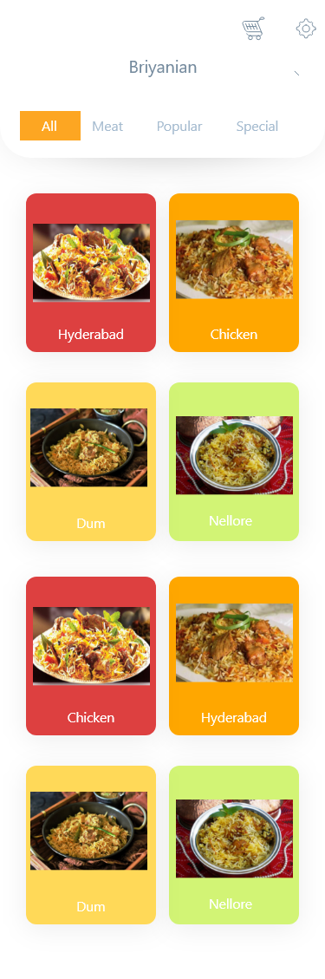Mobile Homepage

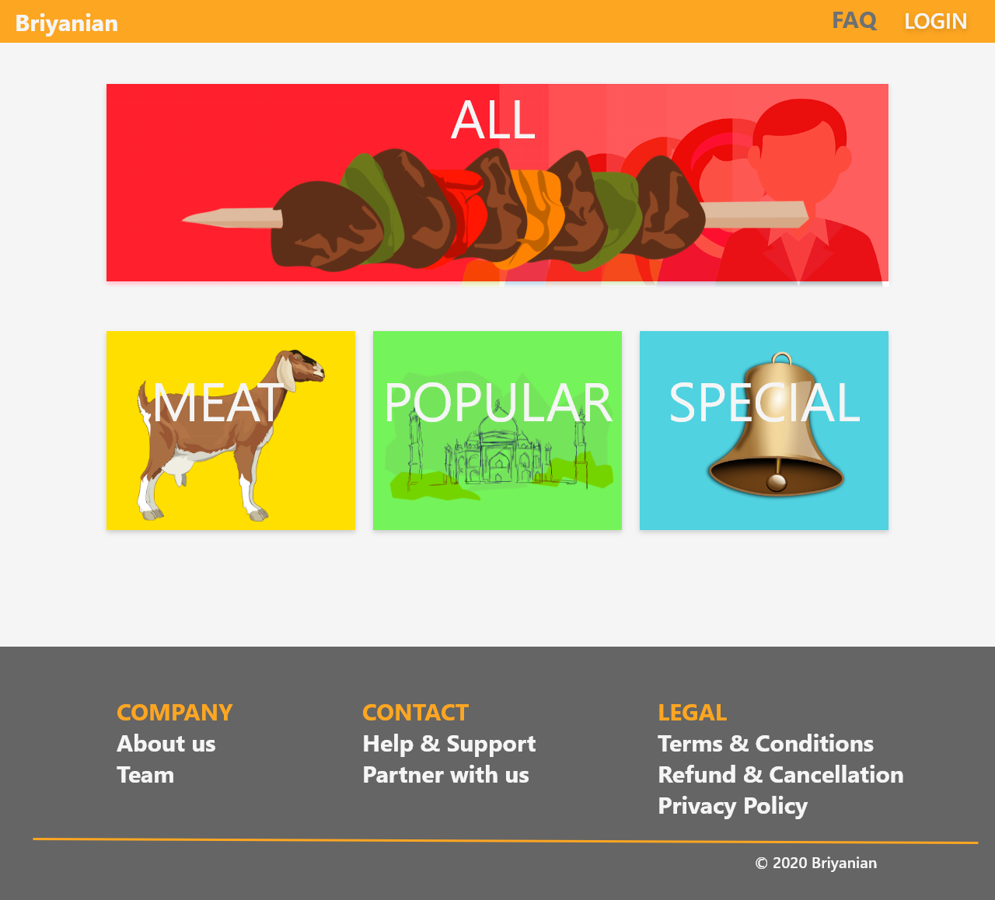

Desktop H

