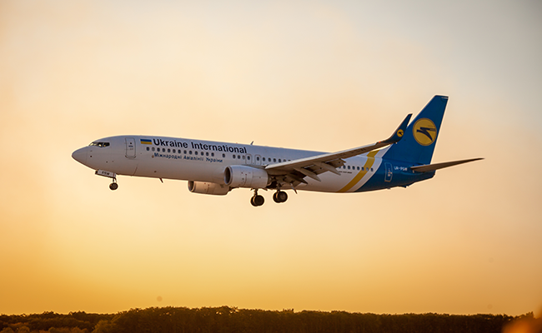The Tragedy of Flight: A Comprehensive crash analysis

**1.Introduction:**

**1.1Overview:** This comprehensive crash analysis is a detailed investigation into the causes of an aviation accident. The goal of an airplane crash analysis is to identify any factors that contributed to the accident, with the ultimate goal of improving safety and preventing future accidents. Accident investigation is a systematic process whereby all of the possible causes of an adverse event are evaluated and eliminated until the remaining causes are identified as applicable to that investigation. Furthermore, during the investigation, if other deficiencies are identified that were not part of this accident, the investigation team should note them and provide this information to the applicable authority, even though it may not become part of the official investigation report. Although many accidents appear to be similar to others, this may be misleading. Therefore, it is imperative that investigators keep an open mind so as not to focus on one aspect and thus overlook another. Because accidents are infrequent, investigators must take every opportunity to obtain training with air carriers, military, aircraft manufacturers and other accident investigators so as to retain currency and acquire the best methods for investigation. Many large air carriers and aircraft manufacturers have established accident investigation resources that should be consulted in support of periodic training. Air carriers and aerodromes conduct periodic emergency exercises, and these also provide an opportunity for the accident investigators to utilize these scenarios for training. In the event of an actual accident or serious incident, these relationships will be useful to the investigators in efficiently determining the causes. Investigation of accidents consists of three phases

a) collection of data,

b) analysis of data, and

c) presentation of findings.

In this analysis, we have specified the problems and compared the amount of accidents happened around the world based on years. The process of conducting an airplane crash analysis typically involves the collection and analysis of a wide range of data, including information about the aircraft and its systems, the operators, and any other factors.

The investigation should include the gathering, recording and analysis of all available information; the issuance of safety recommendations, if appropriate; the determination of the causes, if possible; and the completion of a final report.

* 1. **Purpose:**

The primary purpose of air crash investigators is to determine the cause of the crash and any contributing factors involved in the crash. Investigative authorities also provide recommendations for safe operations. Aircraft accident investigation involves the collection and analysis of various data in order to draw conclusions and make safety recommendations that will prevent aircraft accidents caused by similar causes in the future. Therefore, a properly conducted investigation is a key to prevent future accidents. The purpose of the analysis is to understand the causal factors that trigger substandard safety performance within a particular event, whether the event is an

* accident,
* minor incident, or
* close call.

Aggregating and displaying the most common occurring root causes is important for a couple of reasons:

Management can detect trends in core organizational problems

You can also filter root causes by your Key Performance Indicators (KPIs), which allows you to hone in with greater detail on core issues most important to your company

A "Top Root Causes" dashboard chart is an extremely valuable report, but certainly not one that needs to be monitored on a daily basis. Yet you don't want to ignore it.

Keeping careful tabs on this chart gives aviation safety managers a golden opportunity to address the real reasons your company is constantly exposed to uncontrolled risk, as opposed to simply dealing with the “symptoms” of reported safety issues. The difference between “reasons” and “symptoms” is the same difference between proactive and reactive safety cultures.

# **2.Problem Definition & Design Thinking**:

The most common problems are with the controls, engine, or landing gear. If any of these things fail, it can lead to an accident.

It is important for the airplane to undergo regular maintenance so that such problems can be detected and fixed before they lead to an accident. Also, pilots must be properly trained to deal with such situations. They should know how to troubleshoot the problem and land the plane safely.

Mechanical problems can also cause airplane crashes. These could be due to faults in the engine, landing gear, or any other part of the plane.

In some cases, the problem might not be with the plane but with the air traffic control system. There have been many instances where a technical glitch in the system has led to an accident.

It is important to have proper maintenance and inspection procedures in place so that such problems can be detected and fixed before they lead to an accident.

# **2.1 Empathy Map:**

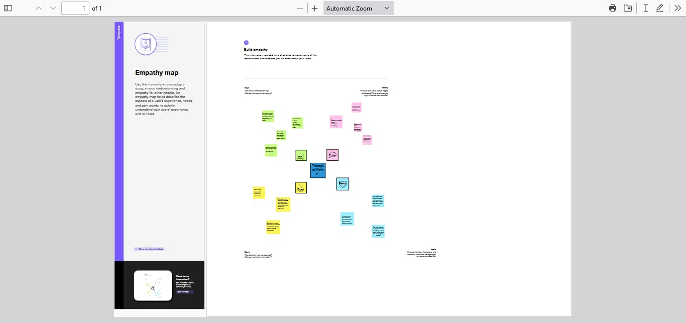

# **2.2 Ideation & Brainstorming Map:**

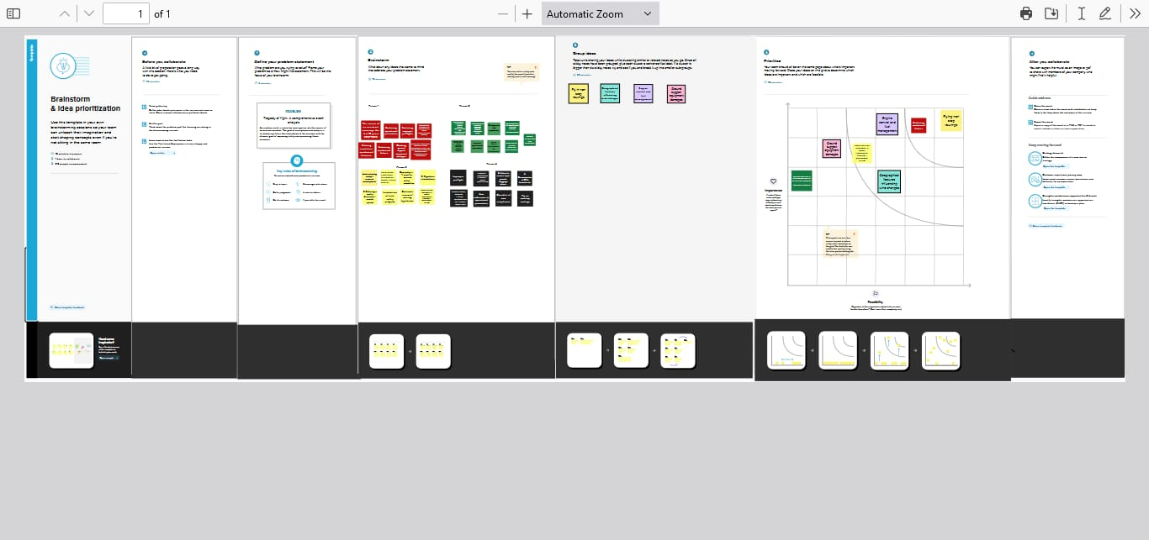

**3. RESULT:**

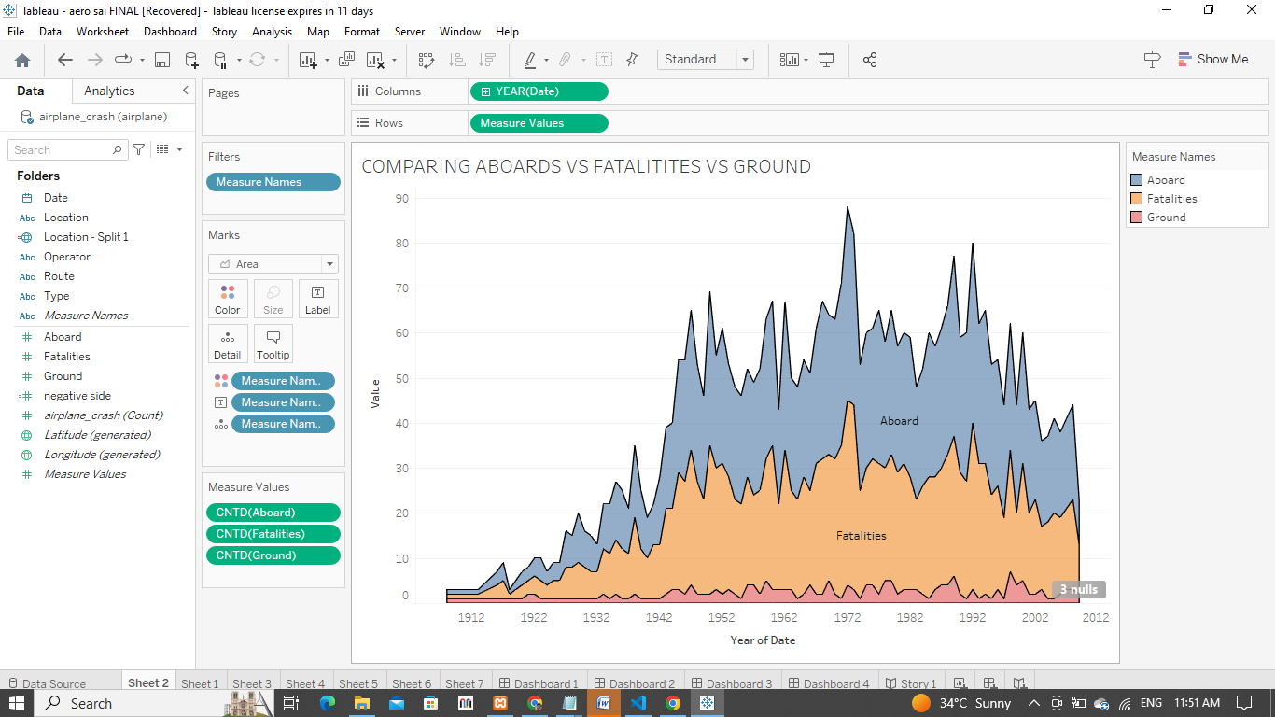

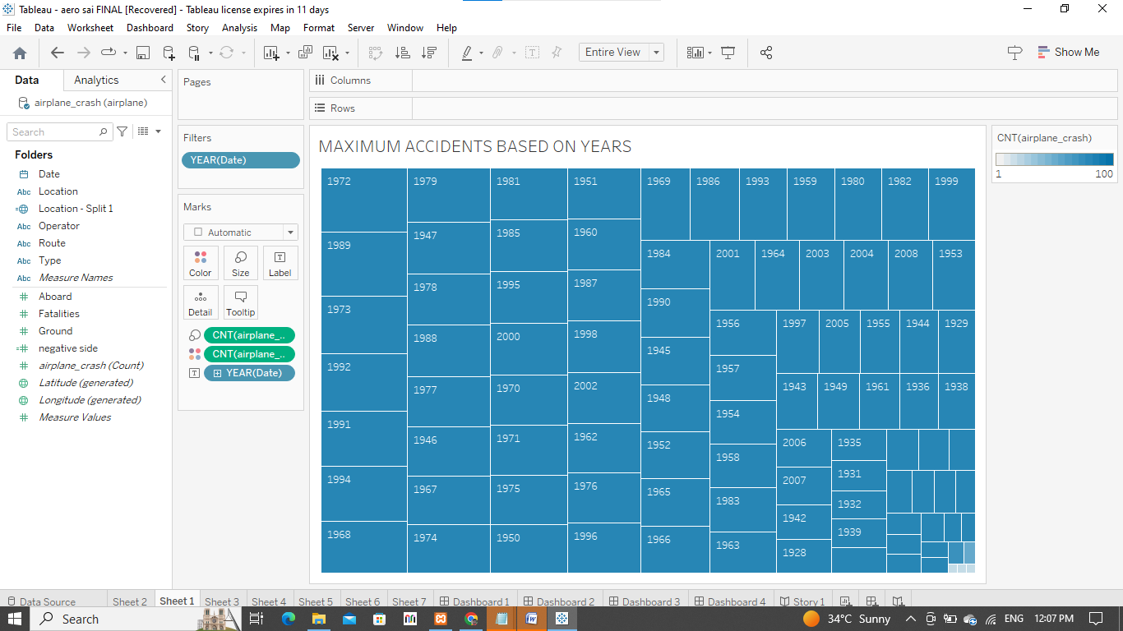

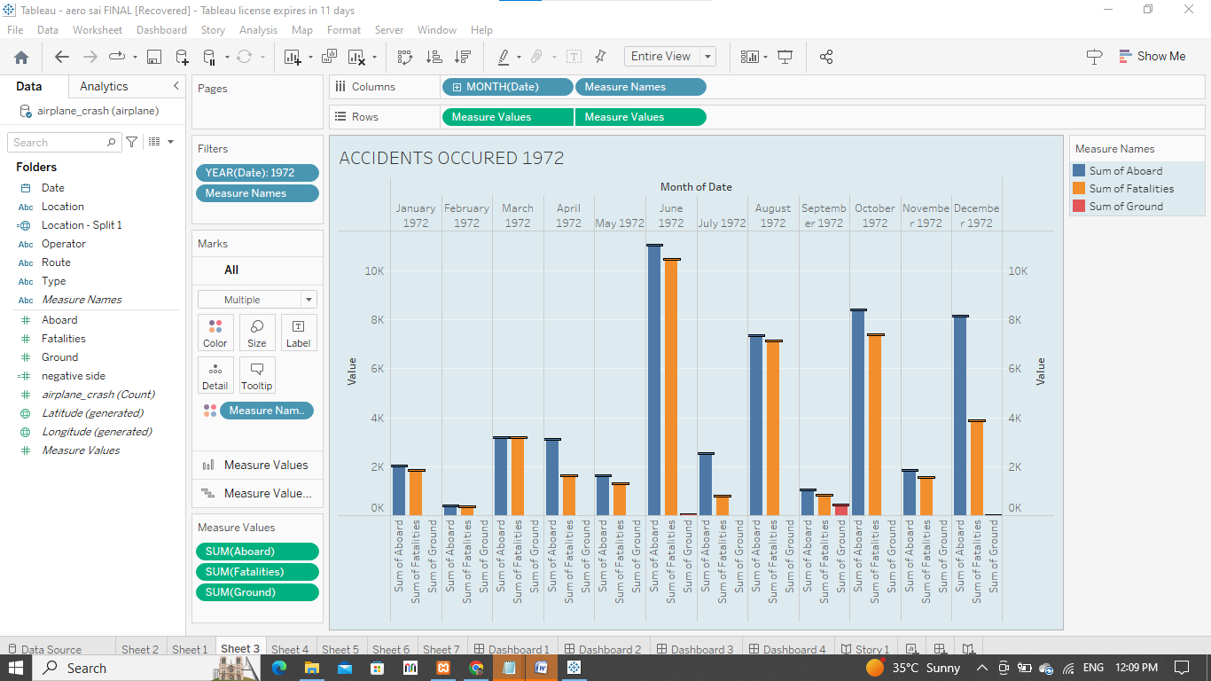

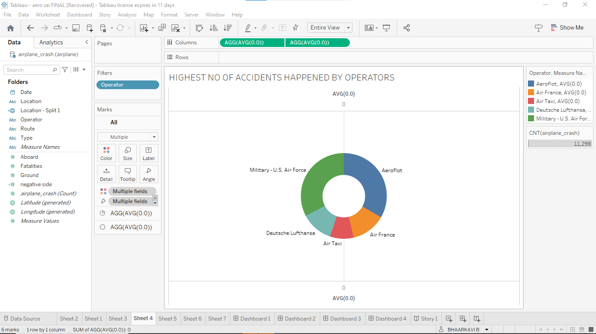

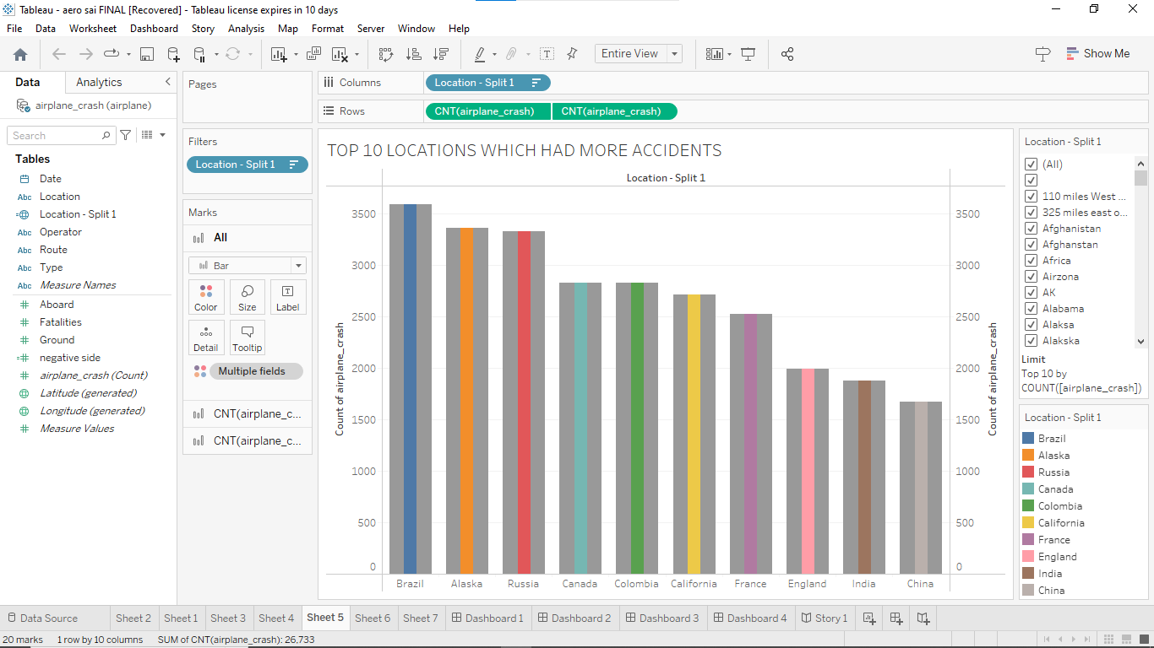

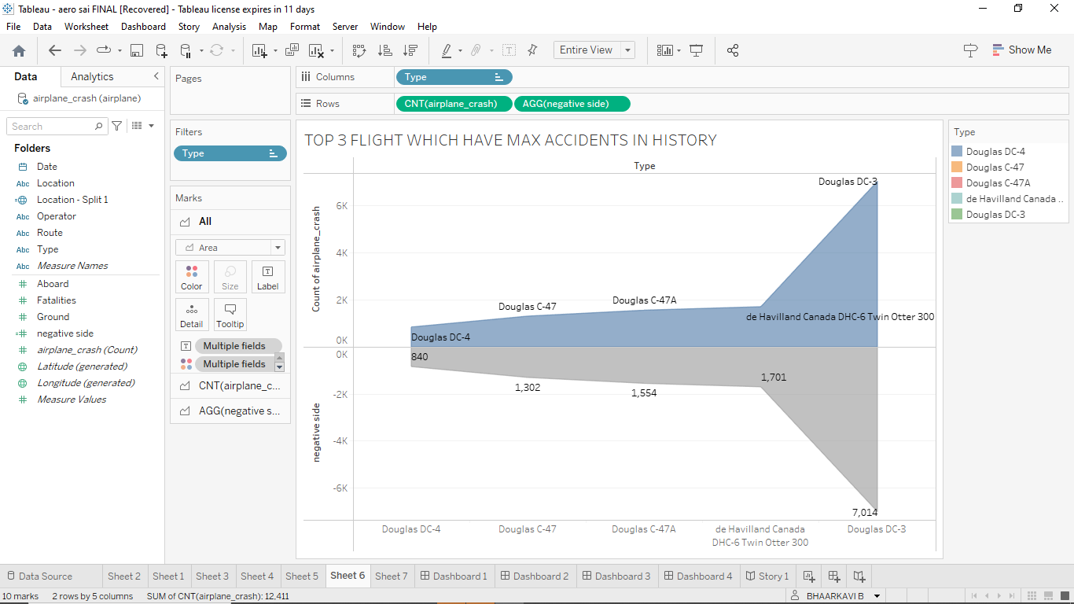

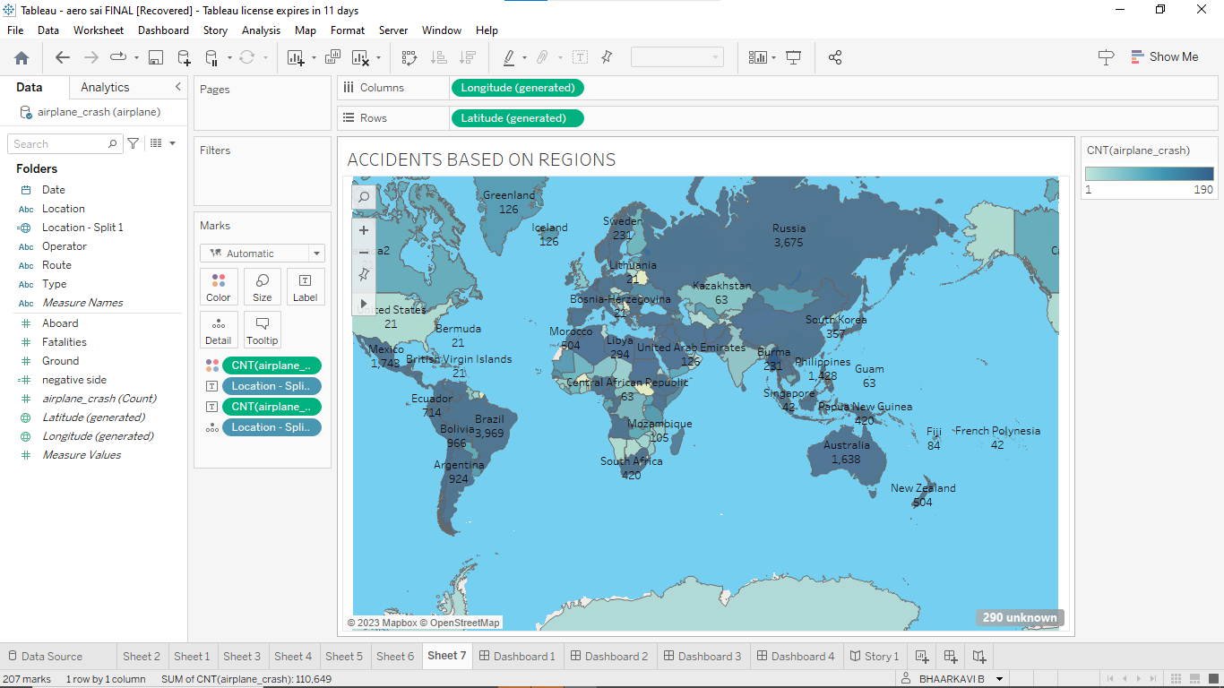

# **4. ADVANTAGES:**

Increases passenger comfort;

Improved flight path control and reduced weather minima;

Systems monitoring displays coupled with diagnostic assistance systems (Electronic Centralized Aircraft Monitor (ECAM)/Engine Indicating and Crew Alerting System (EICAS)) support enhanced pilots’ and maintenance staff’s understanding of aircraft system states. However, when faced with a complex failure event, such as the Airbus 380 engine break-up after take-off from Singapore (2010), the normally ‘simple to understand’ failure information can swamp the crew and either hinder diagnosis or distract the crew from the principle task of FLY THE AIRCRAFT;

Automation can relieve pilots from repetitive or non-rewarding tasks for which humans are less suited, though it invariably changes the pilots’ active involvement in operating the aircraft into a monitoring role, which humans are particularly poor at doing effectively or for long periods. As an example, pilots who invariably fly with Auto throttle (AT) engaged can quickly lose the habit of scanning speed indications. Therefore, when the AT disengages, either by design or following a malfunction, the pilots will not notice or react to even large speed deviations. (Amsterdam B737-800 in 2009)

Good automation reduces workload, frees attentional resources to focus on other tasks but the need to ‘manage’ the automation, particularly when involving data entry or retrieval through a key-pad, places additional tasks on the pilot that can also increase pilot workload. In contrast, poor automation can reduce the operators’ situational awareness and create significant workload challenges when systems fail.

**DISADVANTAGES**:

The datasets have a large amount of data, they have quite a number of unrecorded values, therefore some columns had to be either removed or filled with correct values. Also, while collecting data on location names, there were many typographical errors, so they had to be replaced with correct spelling. In addition, working on two different datasets, comparing results and finding similarities/differences were the biggest challenges throughout the project. Similar findings helped to strengthen the validity of the analysis. However, since both datasets keep track of different records, some of the outcomes, such as location and date, were inconsistent which made it difficult to find correlations.

# **5. APPLICATIONS:**

The aircraft accident or incident is an undesirable event which usually involves the dynamic interplay of human, aircraft and environmental factors. In terms of dependencies, the aircraft is located between the human operating the aircraft and the environment in which the vehicle is moving. Familiarity with these three factors is necessary in order to both prevent an aircraft accident/incident and to assist in determining probable causes when accidents/incidents do occur. No one profession encapsulates all of the factors that can be involved in aircraft accident investigations. Hence, the modern aircraft industry has already consulted not only general engineering disciplines, but also other scientific fields such as psychology, medicine, and biomechanics in their efforts to improve air safety. Therefore, cutting edge aircraft design represents a complex interdisciplinary effort and continues to stand at the pinnacle of engineering design in contemporary civilization. Within the chain of interaction between human, aircraft and environmental factors, the crew, along with other personnel, can influence the likelihood of an accident by both how they perform their duties and how they react to an adverse situation. As such, an aircraft accident occurs when there is an unfavorable combination of these factors, leading to the loss of control and stability of the aircraft. Therefore, one important area of aircraft accident investigation is related to understanding the interrelationships among crew and other personnel, the aircraft, and the environment just before and during the accident. Hence, as stated before, ICAO has defined aircraft accident investigation as a process focused on the circumstances of the accident including gathering, recording and analyzing all available information, and then drawing conclusions to enable them to determine the causes of the accident.

# **6. CONCLUSION:**

By using IBM's Watson Analytics and Congo’s Analytics and comparing two different datasets, this research has discovered some compelling patterns for airplane crashes. The most prominent finding is that crashes and fatalities have decreased while the number of passengers has increased. Furthermore, patterns on each different variable, such as location, operator, and phase of flight, provide us with deeper insights into the airplane crash patterns.

The main objective of this project is to raise awareness of flight safety and better understand its problems and progress, so that aviation industries can continue to improve. We hope that more information and understanding will lead to industry changes that save lives. The Delphi exercise has shown that there is great potential for further improvement of aircraft accident investigation, particularly in the areas of:

Dispatching investigators to the scene of the accident and the process of facilitating coordination and cooperation between investigators within an investigation, Managing the investigation, wreckage analysis, and data management The investigation of human errors, omissions and psychological factors, Examination of data recorders, Examination of in-flight safety occurrences such as aircraft system failures and explosions, Investigating criminal activities as a possible cause for accidents, Managing the amount of time and money spent on investigations. In terms of prospective solutions for improving aircraft accident outcomes, this study emphasizes the importance of recorders and recorded data. Hence, the investigation results could be enhanced through creating and using an advanced database for easier identification of an aircraft’s components, and more importantly, through creating and using comprehensive databases for storing and analyzing aircraft accident forensic data. Furthermore, this study addresses the importance of common video recording of various functions in different aircraft zones and transmitting the data to ground stations for storage as an ultimate measure for improving accident investigation outcomes. This work also indicates that training individual investigator knowledge can also significantly enhance investigation results. The research concludes by showing that aircraft accident investigations can be improved with the application of a global expert system as a tool for storing and analyzing global aircraft accident forensic data, with the option to learn from aircraft accidents using an inference engine to propose possible causes based on any forensic data provided. Such a system will ensure that this database is used to its maximum potential.

# **7. FUTURE SCOPE:**

One solution that could help reduce the number of crashes in future is the technological advancement. For example, the development and implementation of Automatic Dependent Surveillance-Broadcast (ADS-B) technology will help reduce the risk of airplane collisions and weather-related accidents, provide more efficient routes under adverse weather conditions, and improve situational awareness for pilots. Advancement in technology will be the first step in preventing any further flight accidents.

This research there have been several findings which have not only introduced this area for further research but also suggested prospective ways of improving accident survivability. For instance, the expert group opinion of factor within the Delphi study states that the experience of land traffic accident investigation can contribute to considerable increases in air traffic safety. Therefore, the positive practices of road traffic and industry as well could improve air safety. There are studies that have examined the most serious aircraft accidents with respect to crash forces, structural collapse or failure, crash fires and crash related injuries, cause-of-death information, and design features which diminish the chances of survival and increase the risk of injury. This list of possible injuries to a human body in an aircraft is numerous and includes injuries to the eardrum by rapid decompression, burns from fires and suffocation due to inhalation of toxic gas released from burning cabinet trim as well as broken bones, contusions, lacerations, and internal organ injuries, all of which may occur in an accident.

Furthermore, although fire can kill and injure directly through heat, the toxic fumes and smoke produced when material in the aircraft interior burn are more likely to be the direct cause of death. As a consequence, the two major factors in causing fatalities in survivable crashes are a post-crash fire and the inability to quickly exit a damaged aircraft. Thus an obvious avenue for future research is the enhancement of survivability by upgrading aircraft structure and introducing new personal safety accessories. These accessories would reduce the impact forces and mitigate other severe effects such as fire and toxic gases that may impact human health and life during an accident. Since this research is not directly related to accident survivability the specified candidate only expresses his thoughts with respect to improvement of accident survivability that are based on his working experience and the results derived from this research.

# **DASHBOARDS:**

# **DASHBOARD:** C:\Users\Bala C\Downloads\Dashboard 3 (1).pngC:\Users\Bala C\Downloads\dashboard 2.png

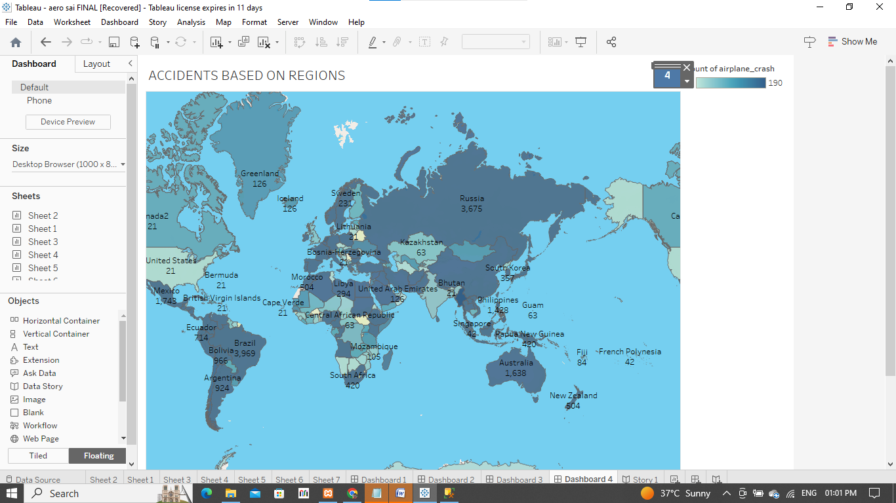

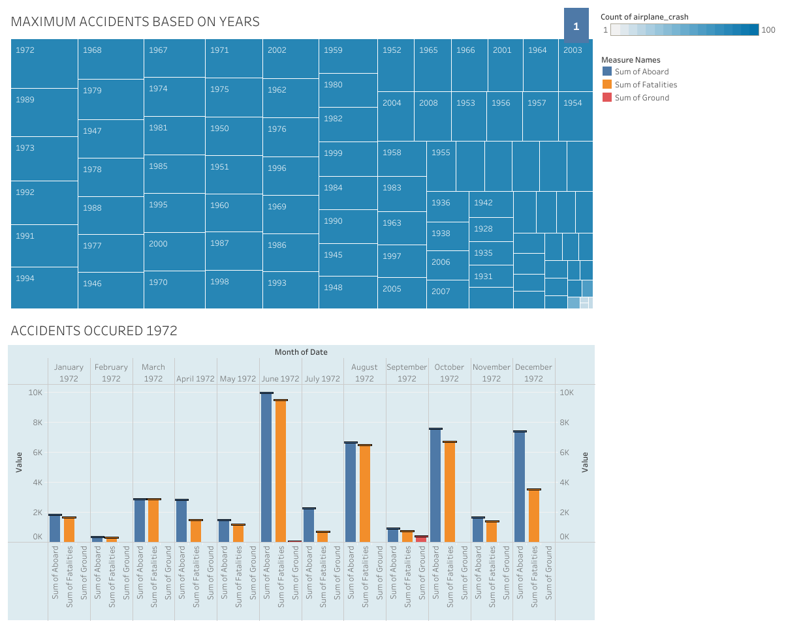

# **STORY:**

# C:\Users\Bala C\Downloads\story 6.pngC:\Users\Bala C\Downloads\story 3.png

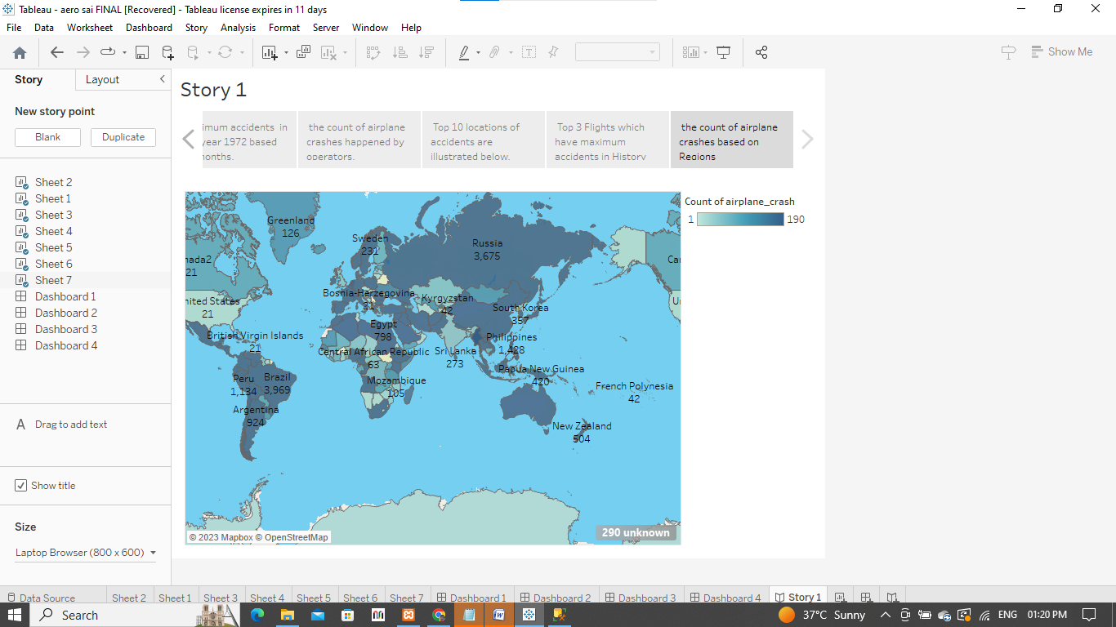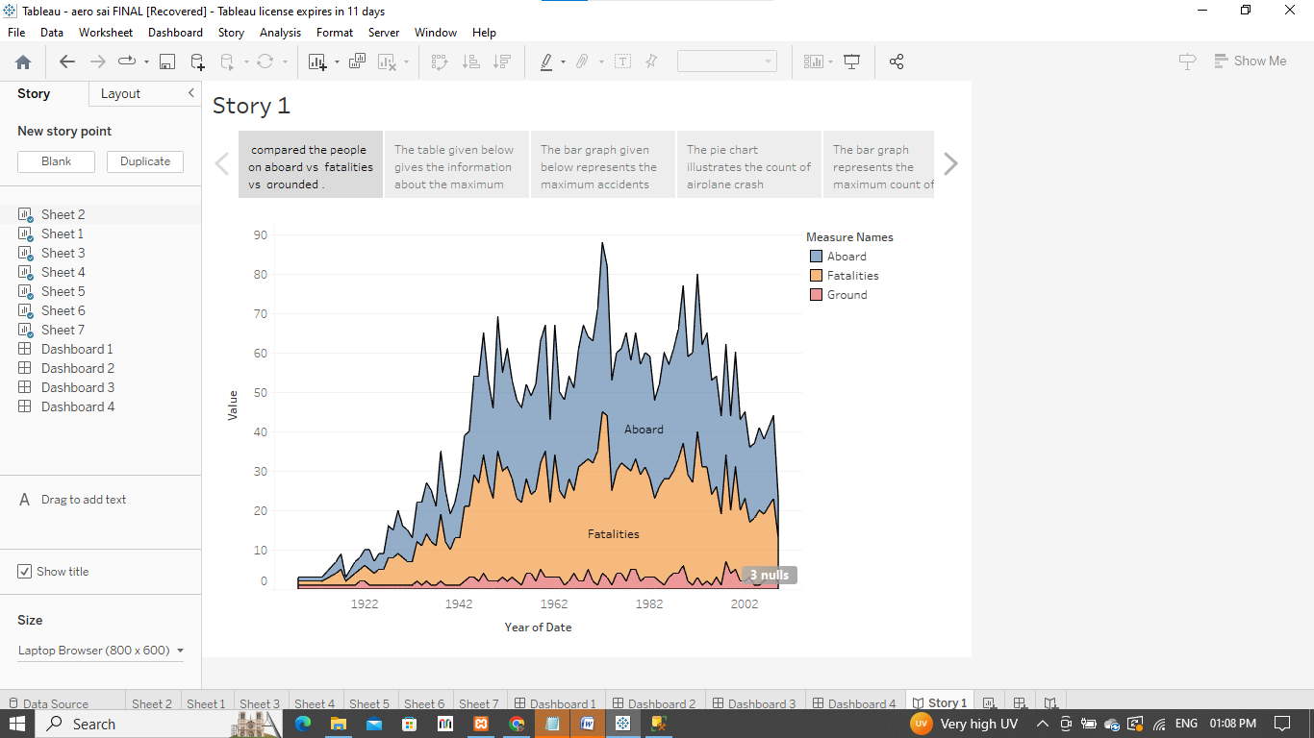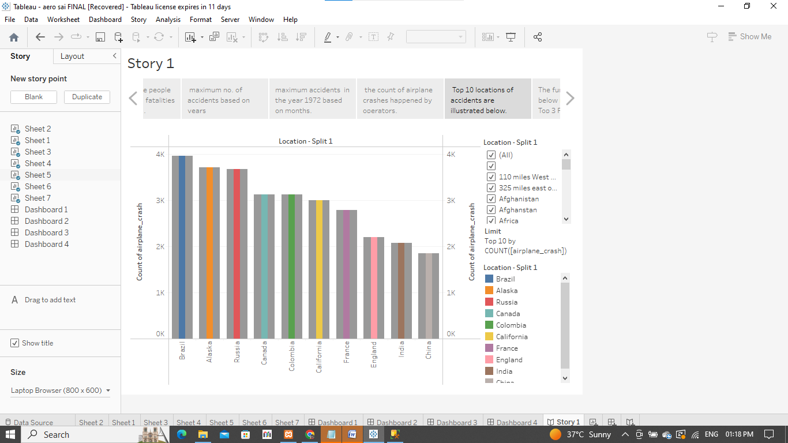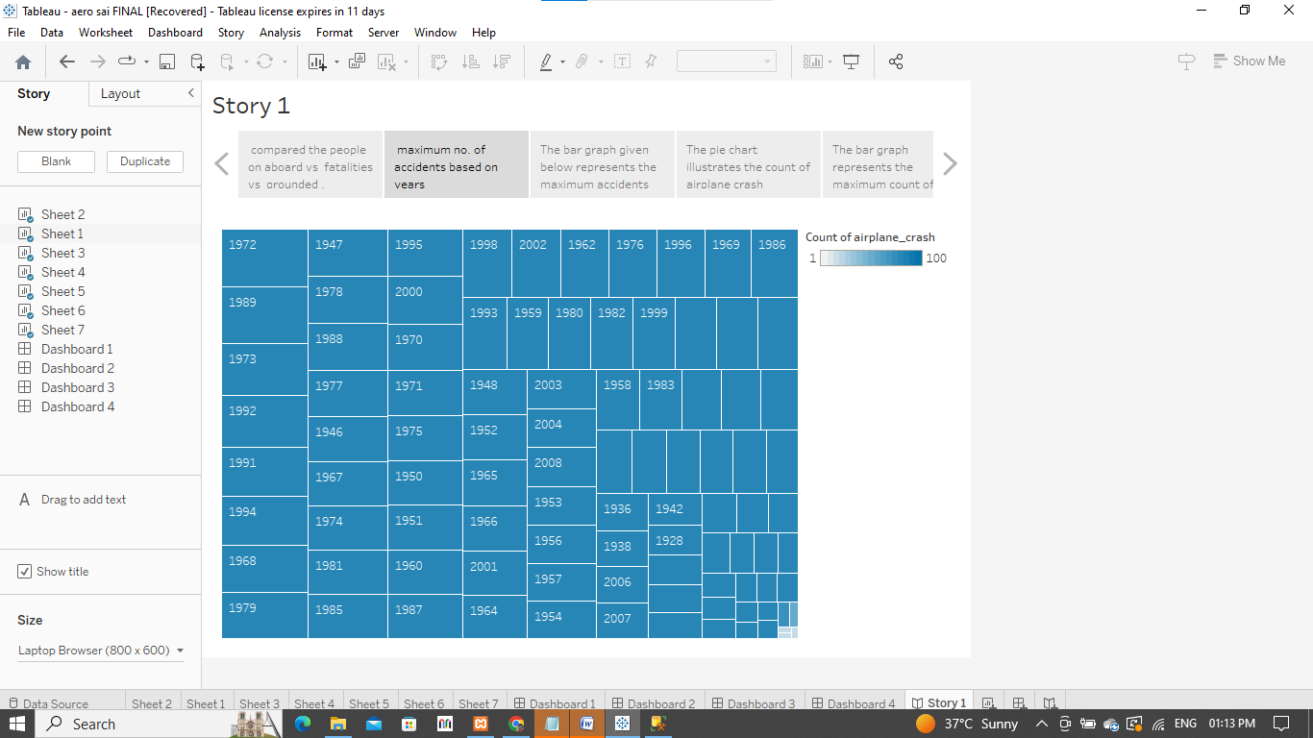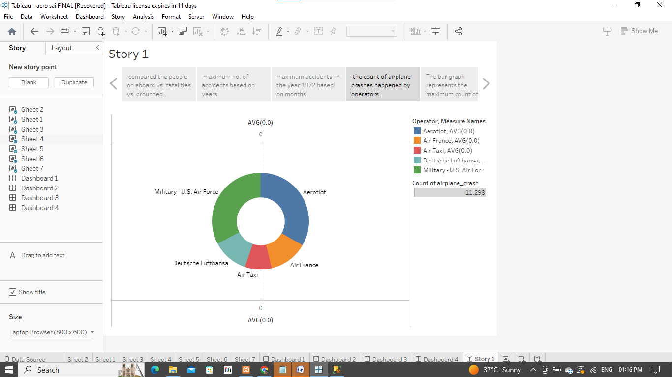

**8. APPENDIX: A. Source Code**

**DASHBOARD**: <div class='tableauPlaceholder' id='viz1680964503893' style='position: relative'><noscript><a href='#'><img alt=' ' src='https:&#47;&#47;public.tableau.com&#47;static&#47;images&#47;ae&#47;aero5&#47;Dashboard1&#47;1_rss.png' style='border: none' /></a></noscript><object class='tableauViz' style='display:none;'><param name='host_url' value='https%3A%2F%2Fpublic.tableau.com%2F' /> <param name='embed_code_version' value='3' /> <param name='site_root' value='' /><param name='name' value='aero5&#47;Dashboard1' /><param name='tabs' value='yes' /><param name='toolbar' value='yes' /><param name='static_image' value='https:&#47;&#47;public.tableau.com&#47;static&#47;images&#47;ae&#47;aero5&#47;Dashboard1&#47;1.png' /> <param name='animate_transition' value='yes' /><param name='display_static_image' value='yes' /><param name='display_spinner' value='yes' /><param name='display_overlay' value='yes' /><param name='display_count' value='yes' /><param name='language' value='en-US' /></object></div> <script type='text/javascript'> var divElement = document.getElementById('viz1680964503893'); var vizElement = divElement.getElementsByTagName('object')[0]; if ( divElement.offsetWidth > 800 ) { vizElement.style.minWidth='1016px';vizElement.style.maxWidth='100%';vizElement.style.minHeight='1014px';vizElement.style.maxHeight=(divElement.offsetWidth*0.75)+'px';} else if ( divElement.offsetWidth > 500 ) { vizElement.style.minWidth='1016px';vizElement.style.maxWidth='100%';vizElement.style.minHeight='1014px';vizElement.style.maxHeight=(divElement.offsetWidth*0.75)+'px';} else { vizElement.style.minWidth='1016px';vizElement.style.maxWidth='100%';vizElement.style.minHeight='1300px';vizElement.style.maxHeight=(divElement.offsetWidth*1.77)+'px';} var scriptElement = document.createElement('script'); scriptElement.src = 'https://public.tableau.com/javascripts/api/viz_v1.js'; vizElement.parentNode.insertBefore(scriptElement, vizElement); </script>

**STORY:** <div class='tableauPlaceholder' id='viz1680964926283' style='position: relative'><noscript><a href='#'><img alt=' ' src='https:&#47;&#47;public.tableau.com&#47;static&#47;images&#47;ae&#47;aero5&#47;Story1&#47;1_rss.png' style='border: none' /></a></noscript><object class='tableauViz' style='display:none;'><param name='host_url' value='https%3A%2F%2Fpublic.tableau.com%2F' /> <param name='embed_code_version' value='3' /> <param name='site_root' value='' /><param name='name' value='aero5&#47;Story1' /><param name='tabs' value='yes' /><param name='toolbar' value='yes' /><param name='static_image' value='https:&#47;&#47;public.tableau.com&#47;static&#47;images&#47;ae&#47;aero5&#47;Story1&#47;1.png' /> <param name='animate_transition' value='yes' /><param name='display_static_image' value='yes' /><param name='display_spinner' value='yes' /><param name='display_overlay' value='yes' /><param name='display_count' value='yes' /><param name='language' value='en-US' /></object></div> <script type='text/javascript'> var divElement = document.getElementById('viz1680964926283'); var vizElement = divElement.getElementsByTagName('object')[0]; vizElement.style.width='1016px';vizElement.style.height='1014px'; var scriptElement = document.createElement('script'); scriptElement.src = 'https://public.tableau.com/javascripts/api/viz_v1.js'; vizElement.parentNode.insertBefore(scriptElement, vizElement); </script>