1. When a player makes a valid move, both players should be able to see the move on the board, .i.e , at any time, both the player boards should be identical. The players should be switched after such a move.

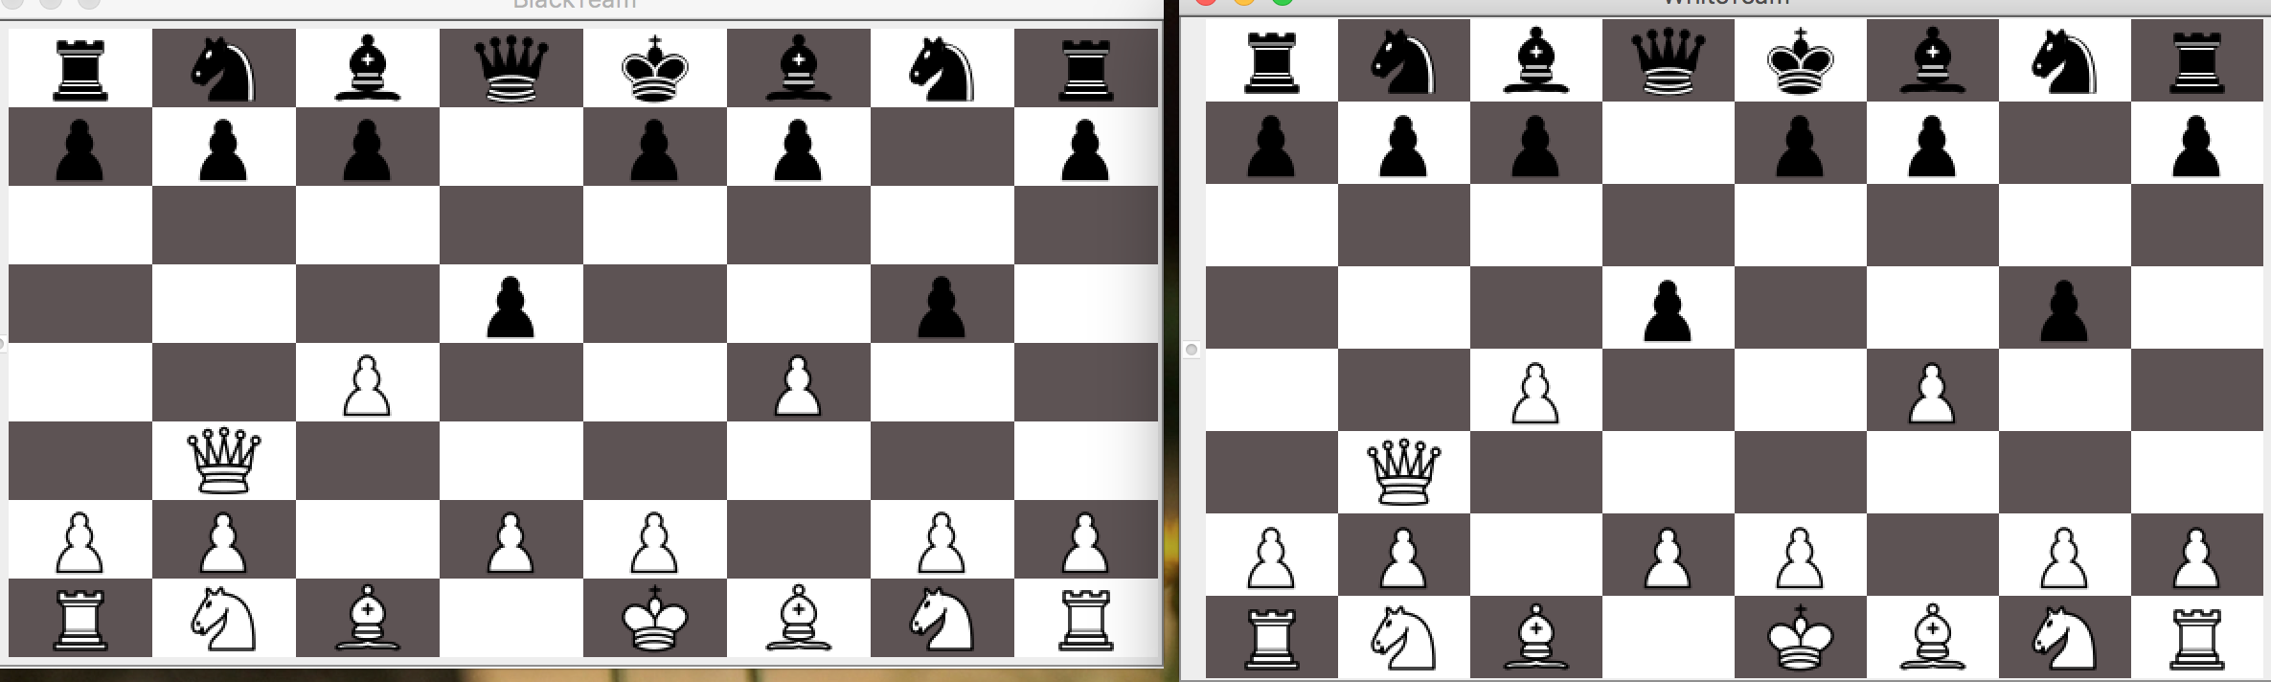

2. When a player is not in turn, he should not be able to make a move.

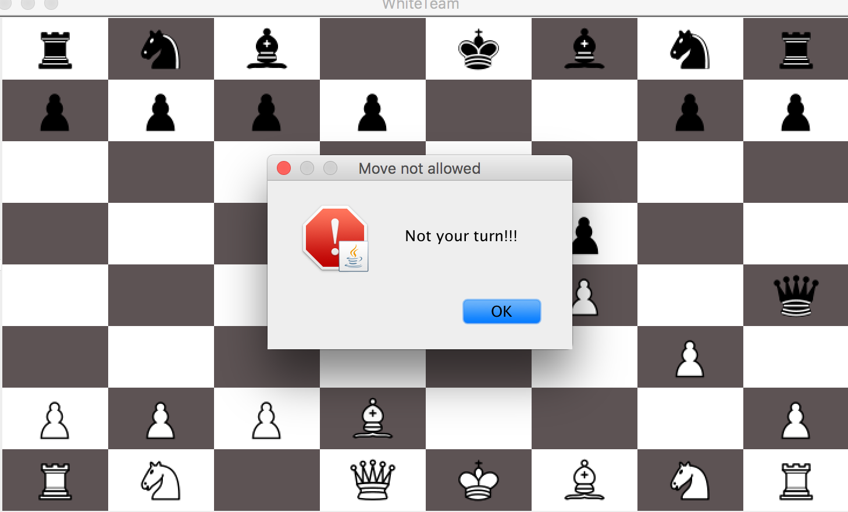

3. A player should not be able to move opponent’s pieces.

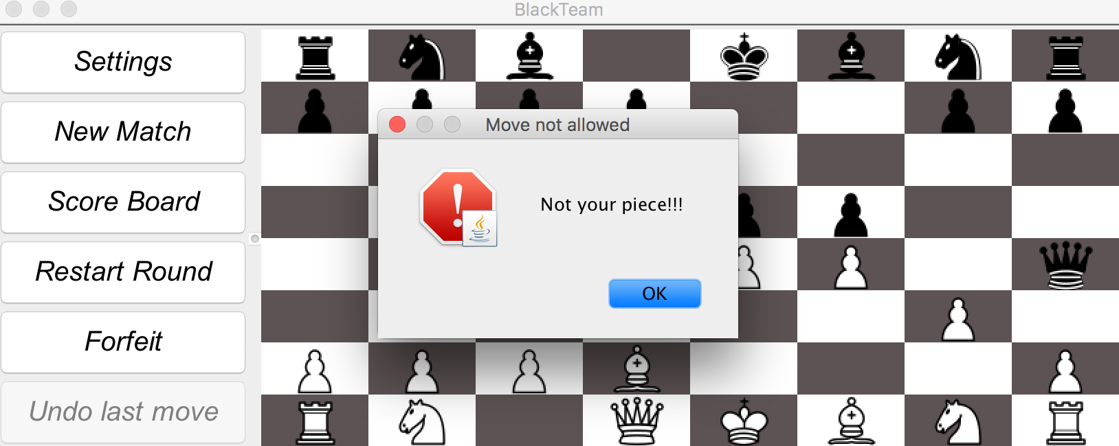

4. Invalid moves should not be allowed. The same player remains in turn on making an invalid move.

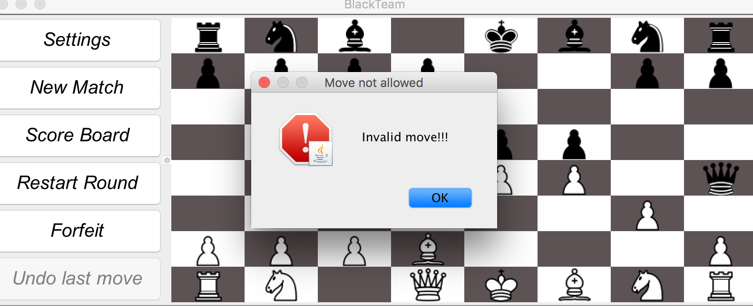

5. Capture move should remove the piece captured from board.

6. When a player is in check, both players should be alerted.

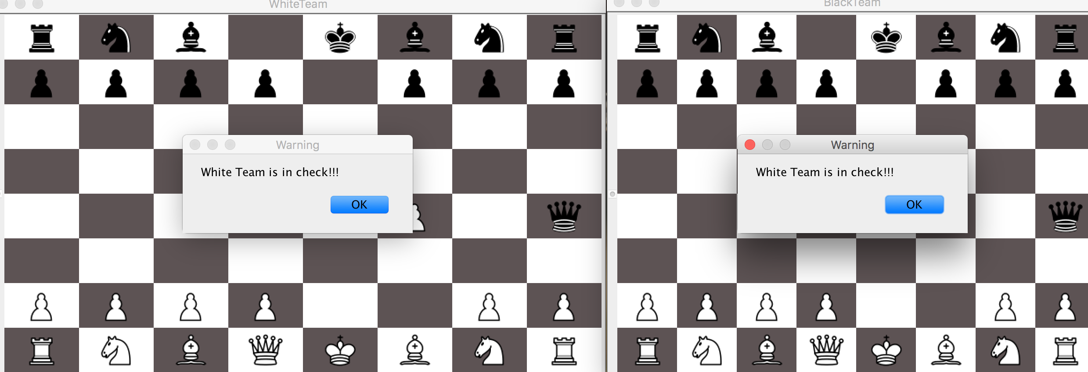

7. On checkmate, the winner should be announced, and both player’s scores should be displayed, and then a new game should be started.

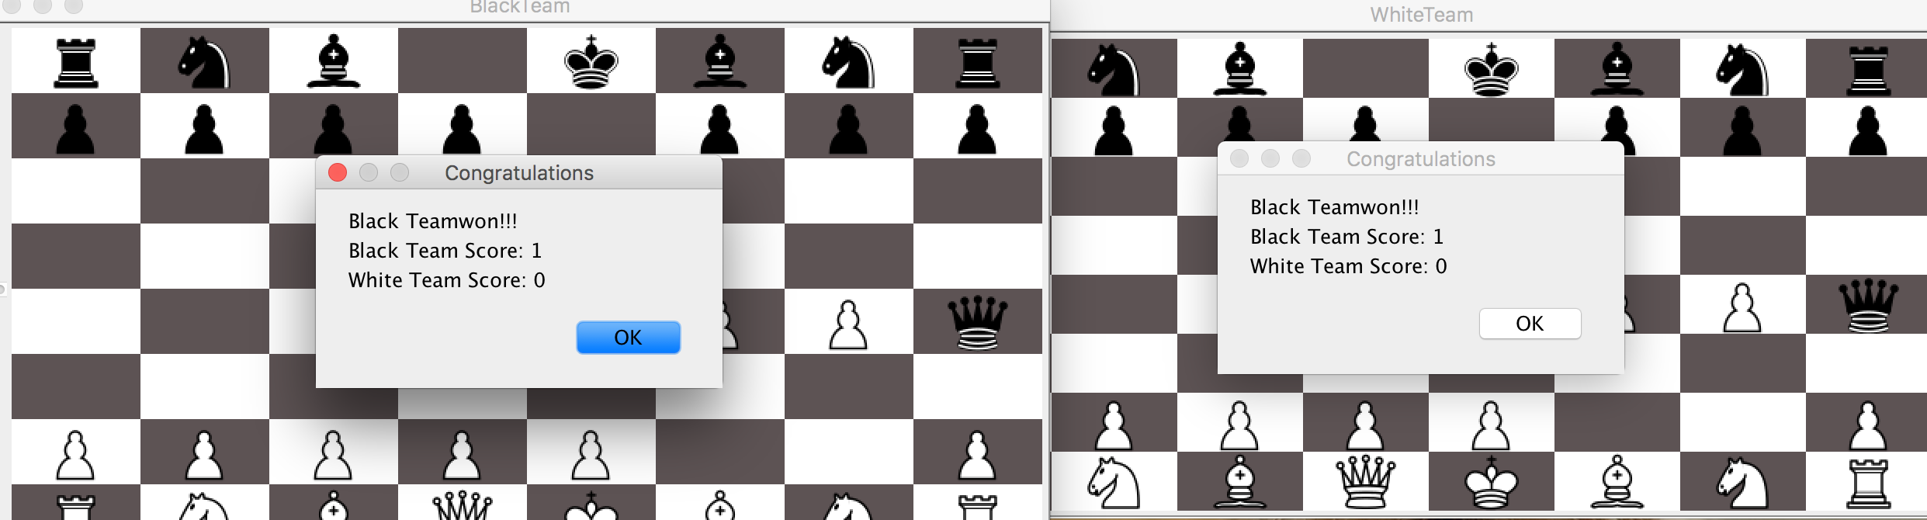

8. Initially, the game should not start until both players are connected.