MOTIONCUT

WEB DEVELOPMENT

Submitted by- BHABYA KUMARI

(8797335136)

bhabya23kumar@gmail.com

Week 1 Task: Business Website Development

Problem Statement: Your task is to design and build a website for a fictional small business. The website should be professional and user-friendly, providing visitors with information about the business, its services, contact details, and potentially, an online store.

1. Homepage

2.Services/Products Page

3. About Us Page

4. Contact Page

SOURCE CODE:

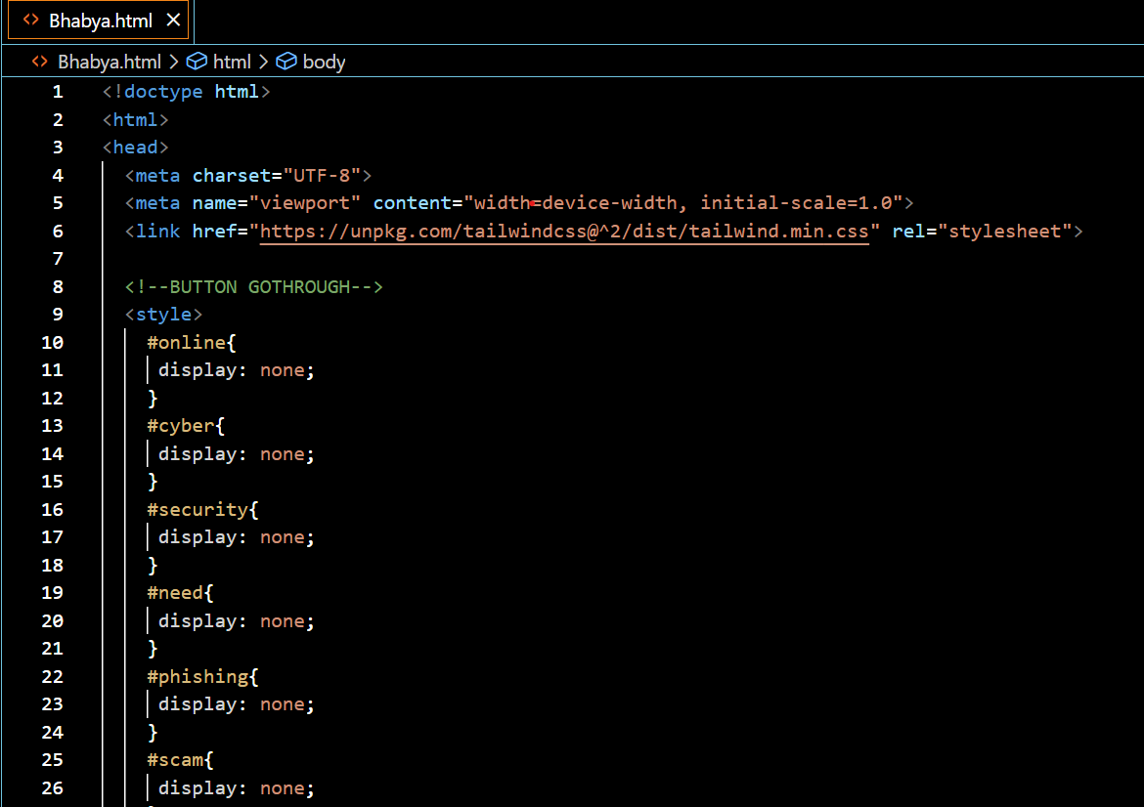

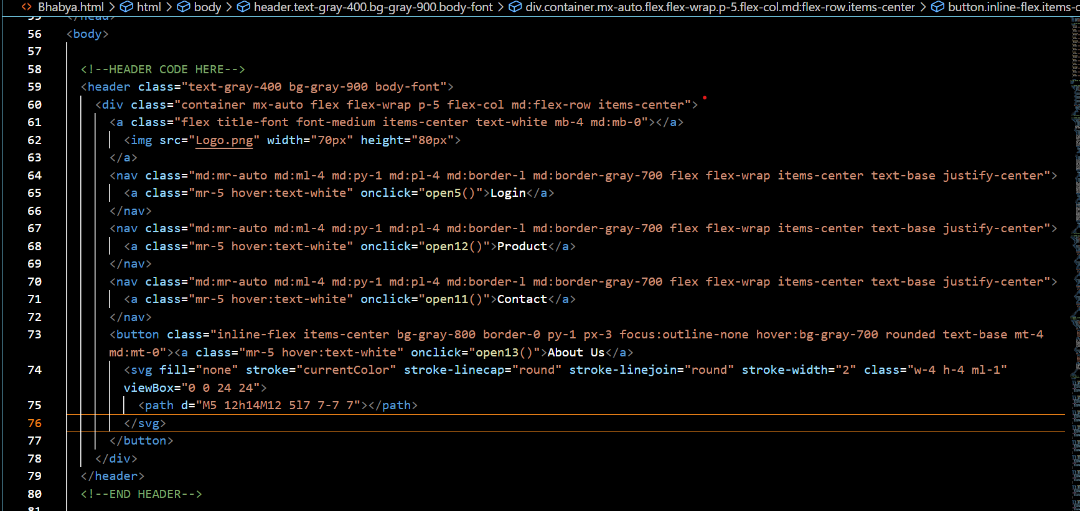

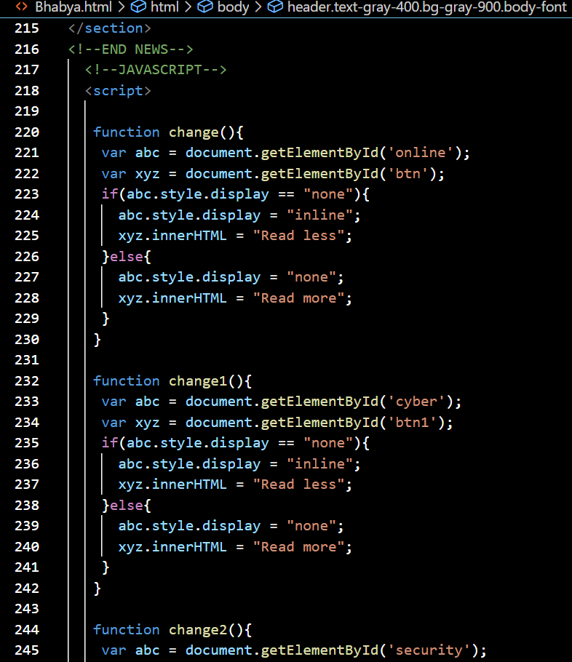

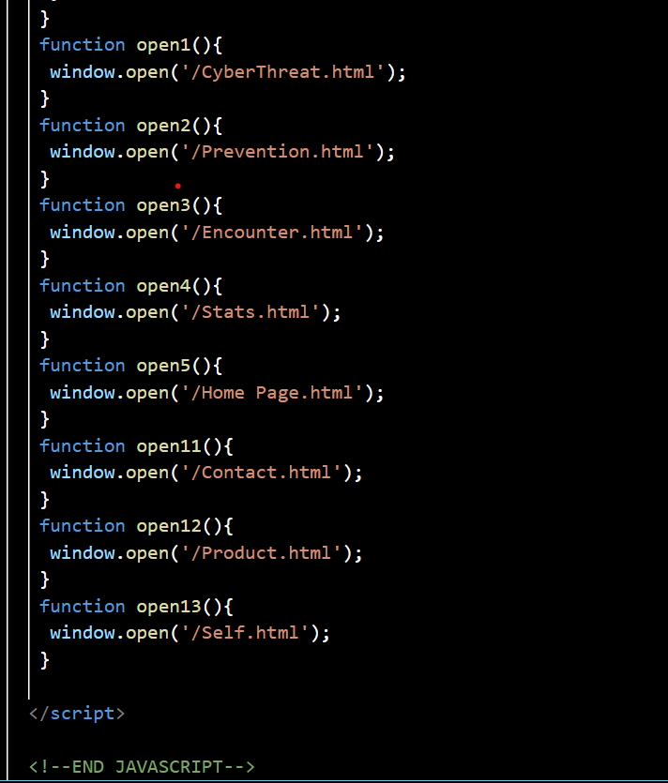

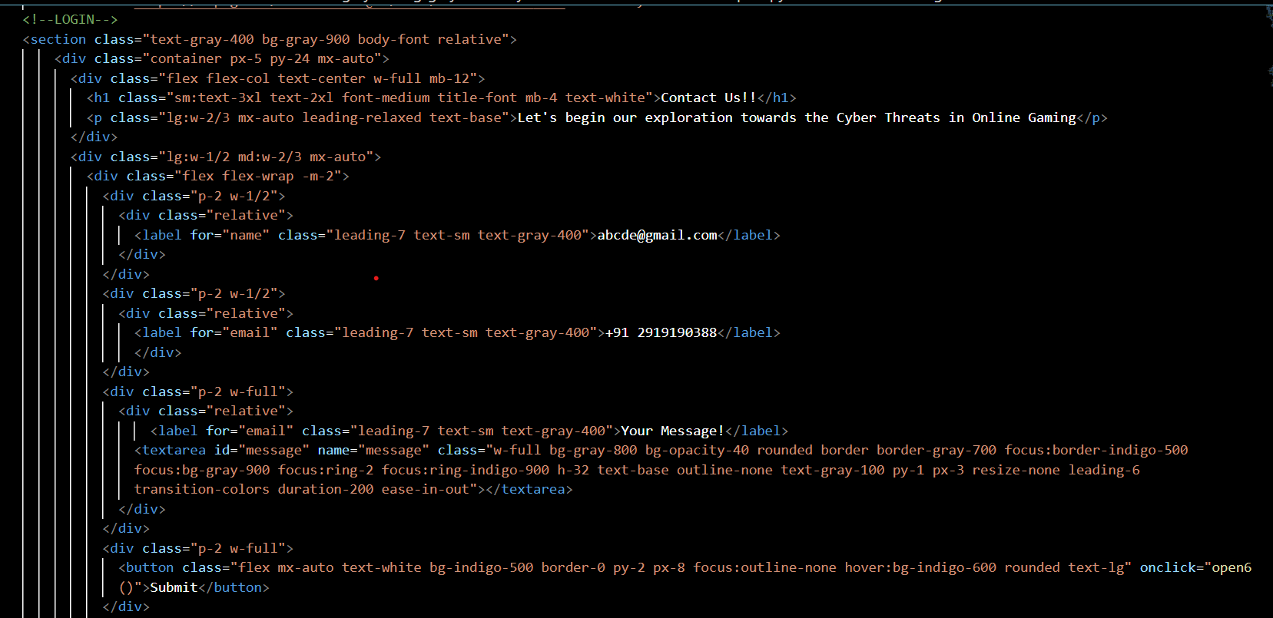

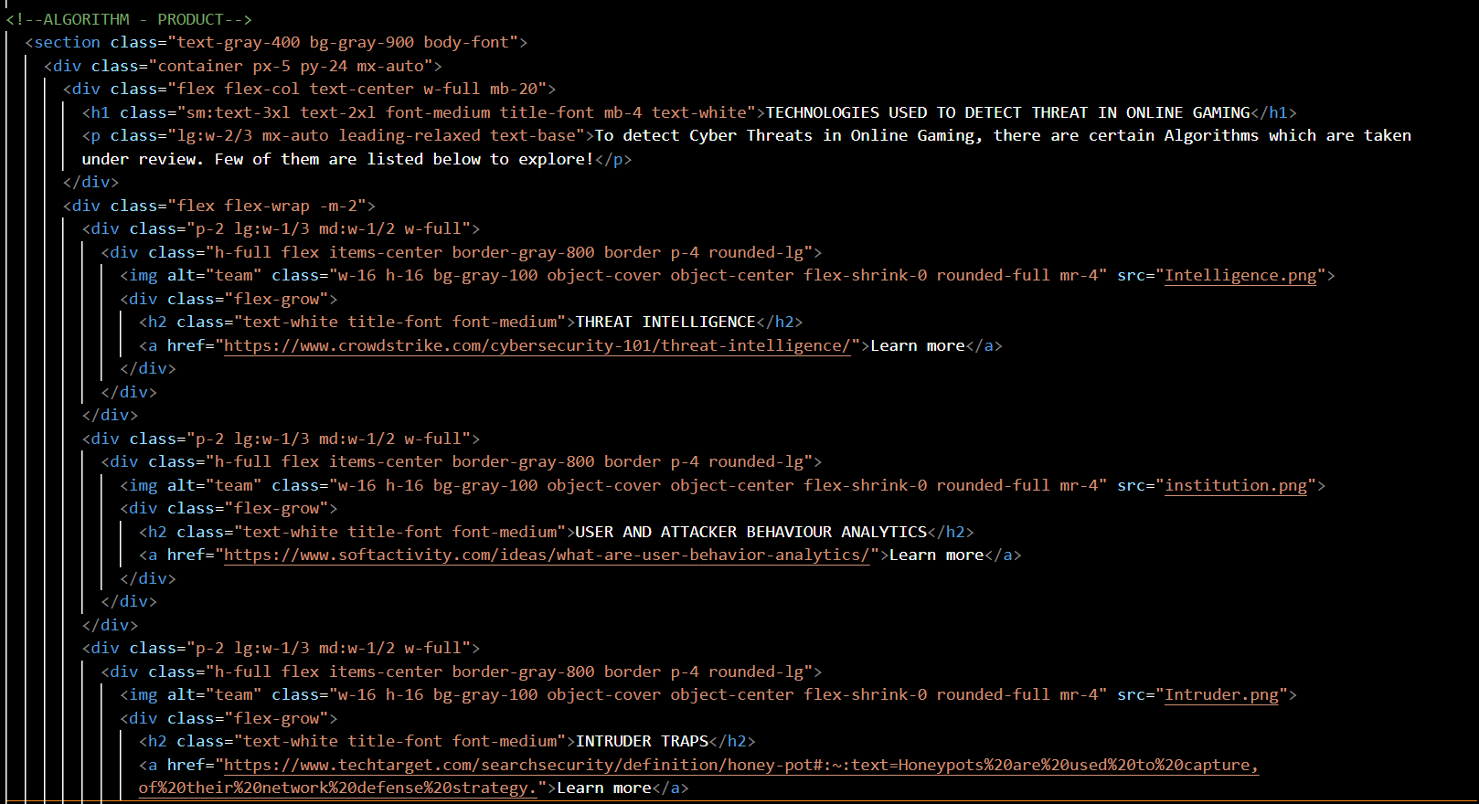

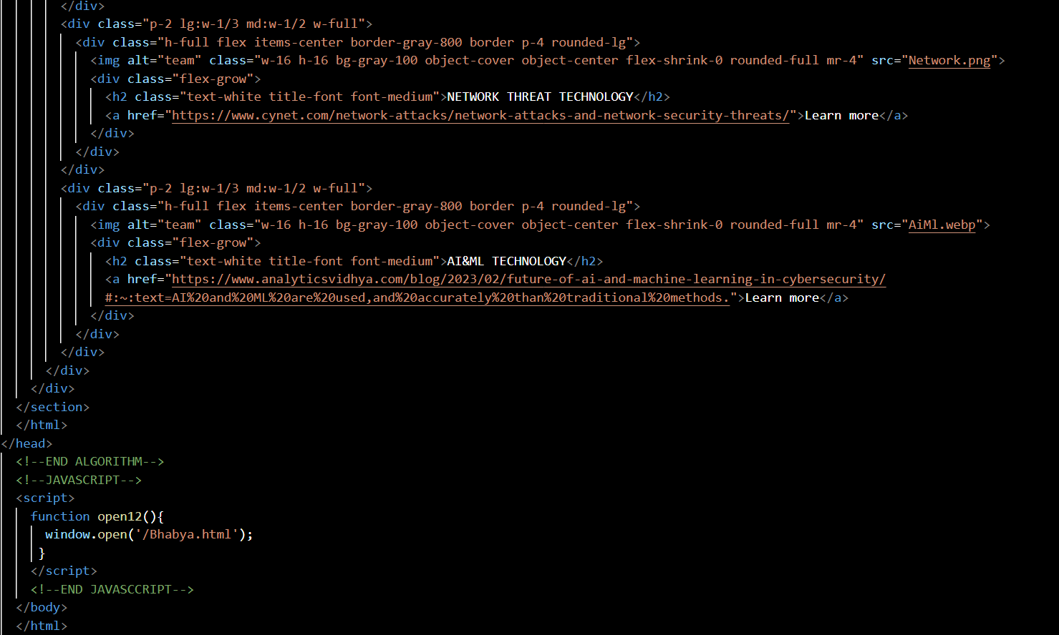

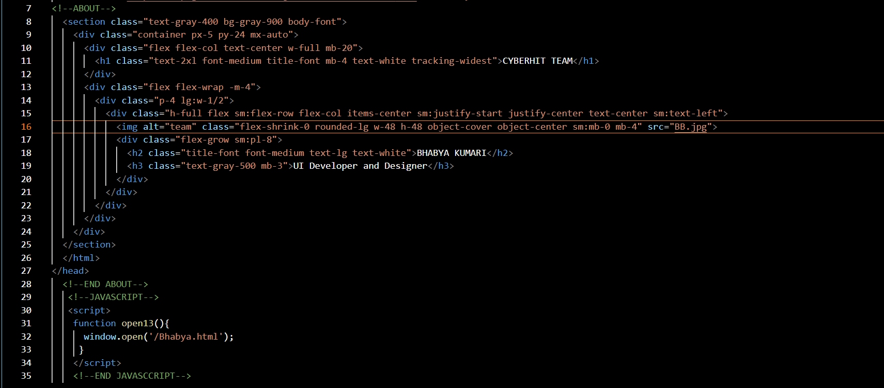

WEBSITE

Home page:

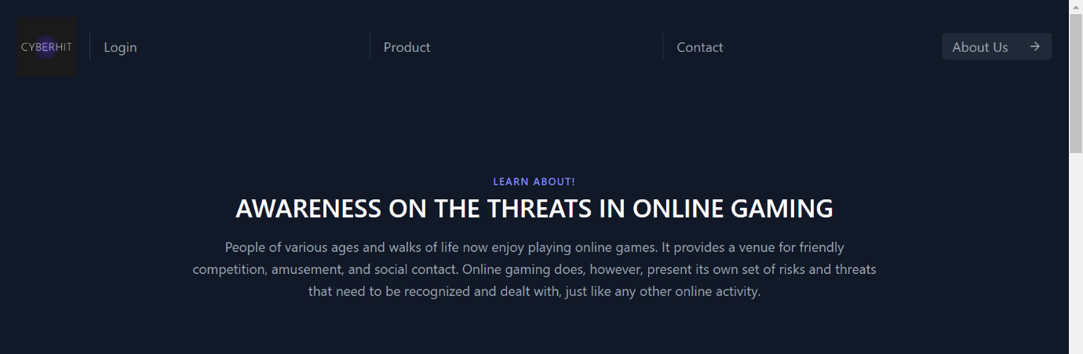

I made a website on the awareness of cyber threats in online gaming. So, in my home page along I provided an content slider as well where user can get an overview before starting any further.

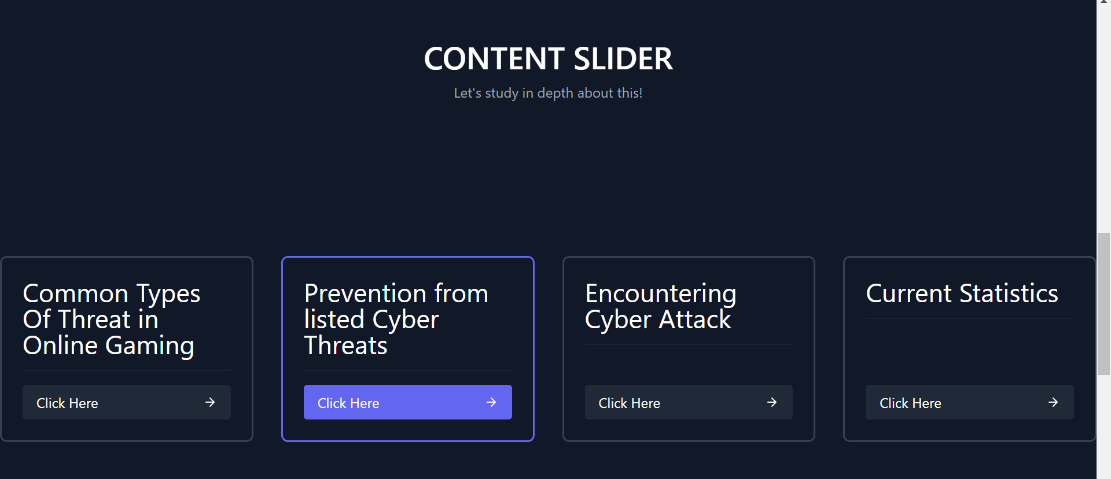

Login Page:

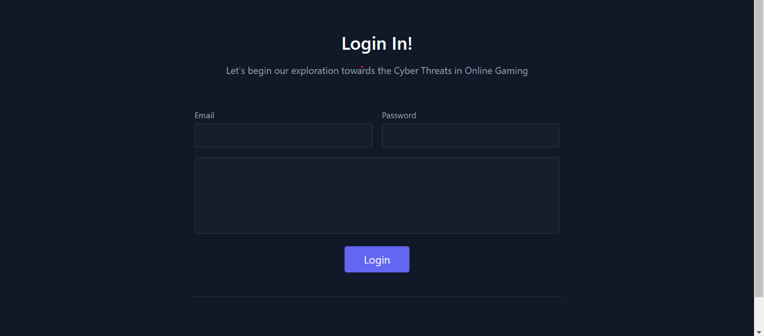

Services Page:

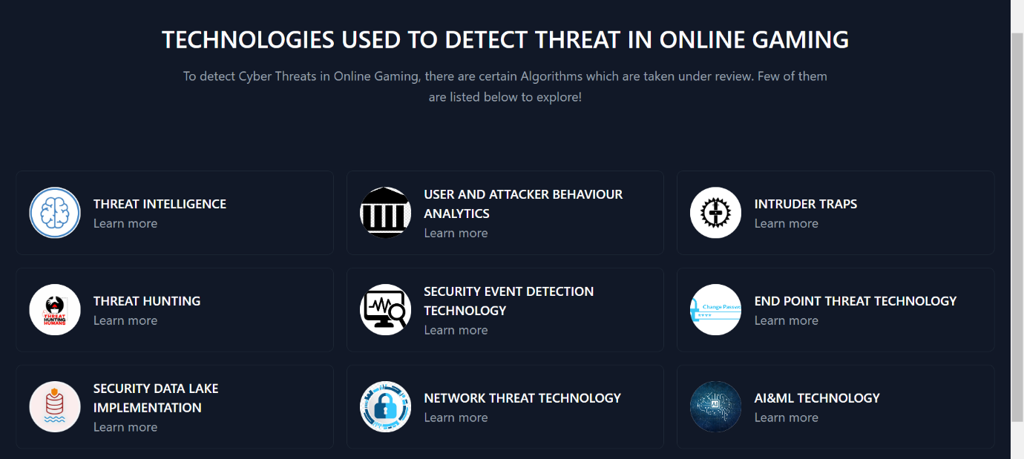

Contact us Page:

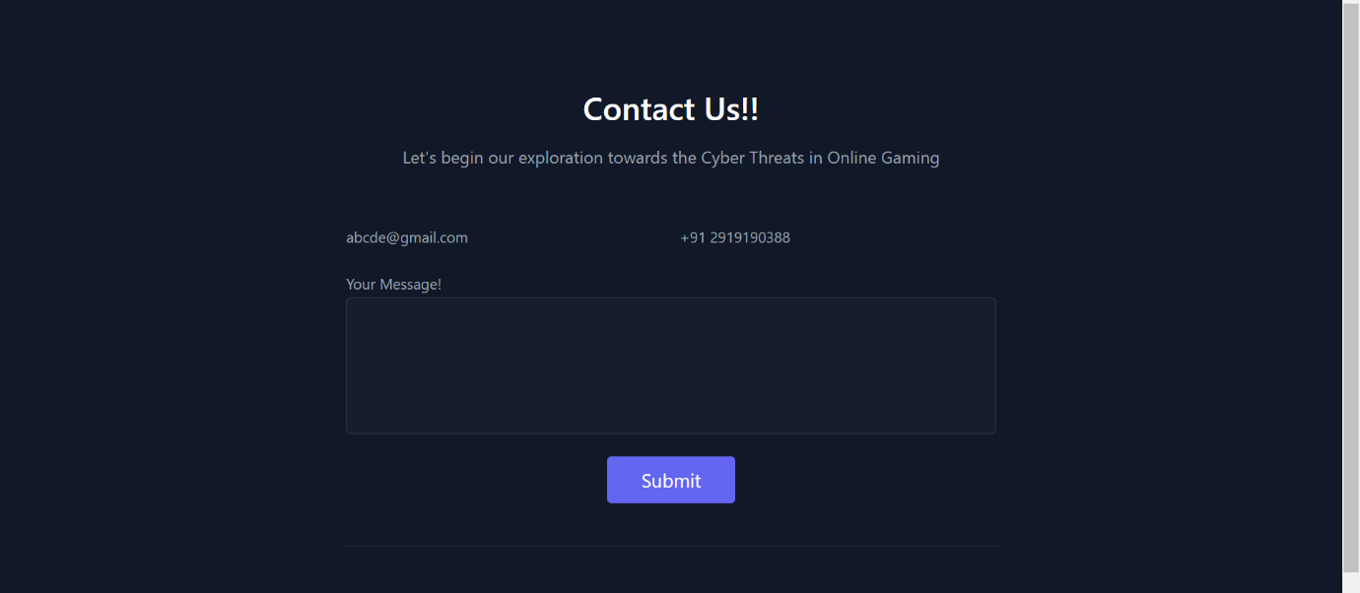

About Me Page:



Extra feature:

Not everybody is familiar with cyber crime and threats associated with it. As my motive was spreading awareness about cyber threat in online gaming and is open for all age group its important to understand the given basic term before going further. This is a continuous of home page.

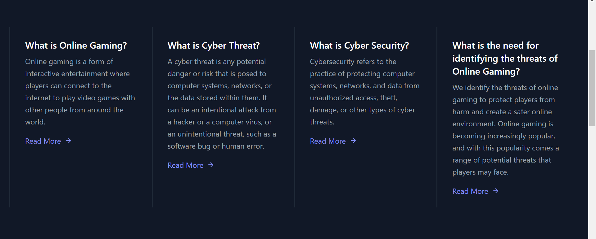

THANK YOU!