

HR-Ref: __________________  
Date: __________________

**Certificate of Internship**

This is to certify that Mr. Bhadresh Mohanty has undergone “Internship” at Maple Capital Advisers, from 15th May 2025 to 17th July 2025.  
  
He has successfully completed his project on ________________________________.  
  
During the Internship, we found him to be a self-starter who is motivated, duty-bound, and hard-working.  
  
We wish him all success in his academic endeavor and life.

Yours sincerely,  
  
For MAPLE CAPITAL ADVISERS

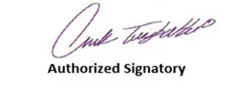

Registered Office:  
Maple Capital Advisers  
2nd Floor, No. 3 Commercial Complex

Panchsheel Park,

August Kranti Marg, New Delhi – 110017

Ph no: 9950341236