**Pneumonia Detection Using CNN**

* **Introduction**
  + The project focuses on developing a deep learning model for the automated classification of chest X-ray images into pneumonia and normal cases.
  + The dataset used in this project consists of chest X-ray images from pediatric patients aged one to five years old, obtained from Guangzhou Women and Children’s Medical center in Guangzhou.
  + The dataset contains a total of 5,863 X-ray images and is divided into training, testing, and validation sets.
* **Reason to choose this topic**
* Personal Interest in Medical Science: I have a strong personal interest in the field of medical science and a passion for contributing to advancements in healthcare and patient care.
  + Integration of ML and Deep Learning: I believe that integrating machine learning (ML) and deep learning can revolutionize medical image analysis, improving disease detection, diagnosis, and treatment.
  + Impact on Early Detection and Treatment: I aim to contribute to the early detection and treatment of diseases like pneumonia by developing a deep learning model for automated classification of chest X-ray images.
  + Continuous Learning and Skill Building: Integrating ML and deep learning into medical science requires continuous learning and skill building. This project provides an opportunity to expand my knowledge and refine my abilities in image classification and model development.
* **Objective of the Study**
  + The main objective of the study is to train a deep learning model that can accurately classify chest X-ray images as either pneumonia or normal cases.
* **Research Questions**
  + How effective is the deep learning model in classifying chest X-ray images as pneumonia or normal cases?
  + What are the performance metrics achieved by the developed model, such as accuracy and loss?
  + How does the deep learning model perform when faced with variations in imaging techniques, such as different X-ray machines or imaging protocols? Can the model handle noisy or low-quality images commonly encountered in real-world clinical scenarios?
  + How can we enhance the interpretability of the deep learning model's decision-making process for pneumonia classification? Are there methods to provide insights and explanations for the model's predictions, aiding healthcare professionals in understanding and trusting the model's output?
* **Importance of the Work**
  + The automated classification of chest X-ray images can assist healthcare professionals in the timely detection and diagnosis of pneumonia cases.
  + Deep learning models offer the potential to improve efficiency and accuracy in disease detection from medical images.
  + This project contributes to the development of automated methods for medical image analysis, which can enhance patient care and treatment outcomes.
  + Universal Healthcare Access: Advancing technology, including ML and deep learning, enables equal access to healthcare, regardless of socioeconomic status. Automated disease detection and remote healthcare services extend medical reach to underserved populations, ensuring everyone has access to quality care.
  + Affordability and Reduced Medical Costs: Integration of technology in healthcare reduces medical costs. ML and deep learning optimize resource allocation, improve workflow efficiency, and enhance treatment planning, ultimately lowering financial burdens on patients and healthcare systems.
  + Reducing Diagnostic Errors: By automating the classification process, we can reduce diagnostic errors and ensure more reliable and consistent results in medical image interpretation.
* **Results**
  + The developed deep learning model achieved high accuracy in classifying chest X-ray images as pneumonia or normal cases.
  + The model's performance was evaluated on the validation and test sets, demonstrating its effectiveness in pneumonia detection.
  + Detailed evaluation metrics such as accuracy, loss, confusion matrix, and classification report are presented.
  + 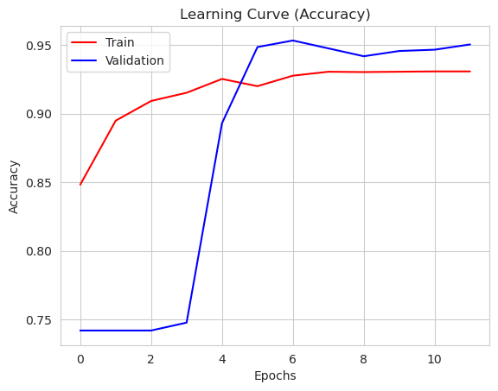 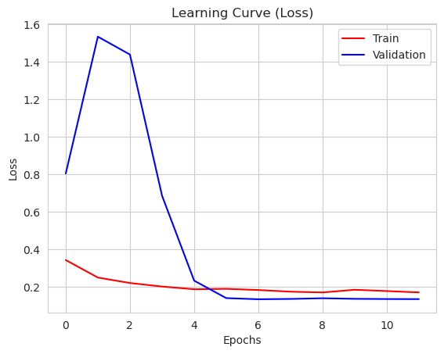
  + 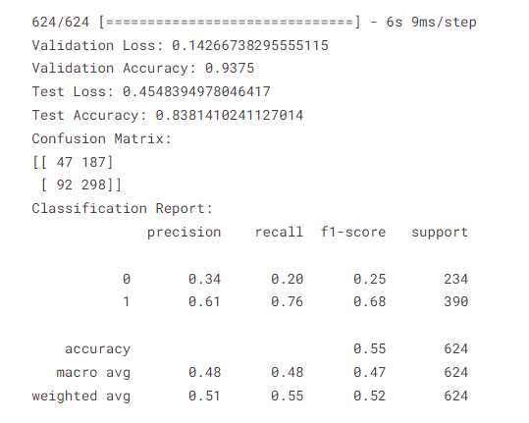
* **Conclusion**
  + The developed deep learning model shows promise in automated classification of chest X-ray images for pneumonia detection.
  + Further research and validation can enhance the model's performance and its applicability in real-world healthcare settings.
* **References**
  + Data: <https://www.kaggle.com/datasets/paultimothymooney/chest-xray-pneumonia>
  + - <https://vijayabhaskar96.medium.com/tutorial-on-keras-flow-from-dataframe-1fd4493d237c>
  + - <https://github.com/mrdbourke/tensorflow-deep-learning/blob/main/03_convolutional_neural_networks_in_tensorflow.ipynb>
  + - <https://www.tensorflow.org/guide/keras/transfer_learning>
  + - <https://www.tensorflow.org/api_docs/python/tf/keras/preprocessing/image/ImageDataGenerator>
  + - <https://keras.io/api/applications/>
  + <https://ieeexplore.ieee.org/abstract/document/9489188/>