INTERACTIVE POWER BI DASHBOARD USING
WEB-BASED REAL-TIME DATA

GLOBAL DEVELOPMENT: ECONOMIC & DIGITAL
PROGRESS ANALYSIS

Submitted by:
Bhadur Ali

Course: Advanced Data Visualization (COMP-834)
Program: MS Data Science
Semester: 4th

Submitted to:
Dr. Muhammad Zeeshan

PAK-AUSTRIA FACHHOCHSCHULE
Institute of Applied Sciences and Technology
School of Computing

Spring 2026

ABSTRACT
This project presents an interactive Power BI dashboard designed to analyze global economic and digital development trends using live web-based data sources. The dashboard integrates three key indicators from the World Bank Open Data API: total population, Gross Domestic Product (GDP) in current US dollars, and internet penetration percentage across 16 selected countries spanning the period 2000 to 2023.
The methodology involved importing raw JSON data through Power BI's Web Connector, performing comprehensive data transformation in Power Query Editor including null handling, data type conversion, and regional aggregate filtering. Three separate API datasets were merged into a unified analytical table using CountryCode and Year as composite keys. A star schema data model was implemented with calculated columns for GDP per capita and regional categorization, supported by twelve DAX measures for key performance indicators.
The resulting dashboard features ten KPI cards displaying critical metrics including total world GDP, average GDP per capita, and internet penetration rates. Visualizations comprise bar charts for country rankings, line charts depicting GDP growth trajectories, a donut chart for regional internet distribution, and a scatter plot analyzing the correlation between economic prosperity and digital access. Interactive slicers enable filtering by country, region, and year range with full cross-filtering capabilities.
Key findings reveal a strong positive correlation between GDP per capita and internet penetration, with developed nations showing significantly higher digital adoption rates. China demonstrated the most dramatic economic growth, while South Asian countries exhibited rapid but late-stage internet adoption. The analysis provides valuable insights for policymakers, technology companies, and investors regarding digital infrastructure opportunities in emerging markets.

1. INTRODUCTION

1.1 Background

The global economy has undergone significant transformation over the past two decades, characterized by the rise of emerging economies, accelerated technological adoption, and increasing digital connectivity. Understanding the relationship between economic development and digital penetration has become crucial for policymakers, business leaders, and development organizations. Traditional economic indicators such as Gross Domestic Product (GDP) provide measures of a nation's economic output, while internet penetration rates serve as proxies for digital infrastructure development and technological readiness.
The World Bank has consistently tracked these development indicators across countries, creating comprehensive datasets that span decades. These datasets enable comparative analysis of economic trajectories and digital transformation across regions, income groups, and development stages. However, raw data alone cannot convey meaningful insights without effective visualization and analytical tools.

1.2 Problem Statement
Despite the availability of extensive development data through open APIs, extracting actionable insights requires sophisticated data integration, transformation, and visualization capabilities. Decision-makers need interactive tools that can present complex multidimensional data in an intuitive format, enabling rapid comparison, trend identification, and evidence-based policy formulation.
1.3 Project Objectives
The primary objective of this project is to design and develop a fully interactive Power BI dashboard that:

• Integrates real-time data from the World Bank API for population, GDP, and internet penetration indicators
• Applies comprehensive data transformation techniques including cleaning, normalization, and enrichment
• Implements a robust data model with calculated measures and relationships
• Creates professional business intelligence visualizations with cross-filtering capabilities
• Enables users to explore global development trends through interactive slicers and drill-down functionality
• Provides analytical insights into the relationship between economic prosperity and digital adoption

1.4 Tools and Technologies
The dashboard was developed using Microsoft Power BI Desktop, leveraging its Web Connector for API integration, Power Query Editor for data transformation, and DAX (Data Analysis Expressions) for advanced calculations. The World Bank Open Data API served as the primary data source, providing reliable, standardized development indicators.

1.5 Report Structure
This technical report is organized as follows:
Section 2 describes the data sources and API endpoints utilized.
Section 3 details the methodology including data import, transformation, and modeling procedures.
Section 4 presents the dashboard design and visualization
architecture.
Section 5 provides comprehensive results and analysis including trend examination, comparative assessment, industry interpretation, and data-driven insights.
Section 6 discusses limitations of the current approach,
Section 7 concludes with key findings and recommendations for future work.

2. DATA SOURCE DESCRIPTION

2.1 Primary Data Source
The dashboard utilizes the World Bank Open Data API as its primary data source. The World Bank maintains comprehensive development indicators spanning over 200 countries and territories, with historical data extending back to 1960 for many metrics. The API provides free, open access to these datasets in JSON and XML formats, making it ideal for dynamic dashboard integration.

2.2 API Endpoints Used
Three specific API endpoints were integrated to capture key dimensions of national development:

INDICATOR 1: TOTAL POPULATION (SP.POP.TOTL)
• API URL: https://api.worldbank.org/v2/country/all/indicator/
SP.POP.TOTL?format=json&per_page=20000
• Description: Total population based on de facto definition,
counting all residents regardless of legal status
• Data Points: Approximately 17,500 records across all countries
• Time Range: 1960-2025

INDICATOR 2: GROSS DOMESTIC PRODUCT (NY.GDP.MKTP.CD)
• API URL: https://api.worldbank.org/v2/country/all/indicator/
NY.GDP.MKTP.CD?format=json&per_page=20000
• Description: GDP at purchaser's prices in current US dollars,
representing the sum of gross value added by all resident
producers
• Data Points: Approximately 17,500 records
• Time Range: 1960-2025

INDICATOR 3: INTERNET USERS (IT.NET.USER.ZS)
• API URL: https://api.worldbank.org/v2/country/all/indicator/
IT.NET.USER.ZS?format=json&per_page=20000
• Description: Individuals using the Internet as a percentage
of total population
• Data Points: Approximately 17,556 records
• Time Range: 1960-2025

2.3 Data Structure
Each API response follows a consistent JSON structure with the following fields:
• indicator.value: Description of the indicator
• country.value: Full country or regional aggregate name
• countryiso3code: Three-letter ISO country code
• date: Year of observation
• value: The actual numeric value for the indicator

2.4 Country Selection
From the complete World Bank dataset, 16 countries were selected for analysis based on:
• Regional representation across South Asia, East Asia, Europe, North America, South America, Africa, and Middle East
• Economic diversity including developed, emerging, and developing economies
• Relevance to Pakistan's regional context for comparative analysis

The selected countries include Pakistan, India, Bangladesh, Sri Lanka, Nepal, China, Japan, United States, United Kingdom, Germany, France, Brazil, Nigeria, Indonesia, Turkey, and one additional country for balanced regional representation.

2.5 Data Quality Considerations
The World Bank dataset contains regional aggregates (such as "Arab World," "East Asia & Pacific," "European Union") alongside actual country data. These aggregates were identified and removed during transformation to ensure accurate country-level analysis. Some indicators, particularly internet penetration, contain null values for earlier years before the technology existed, which were handled through appropriate data imputation techniques.

3. METHODOLOGY

3.1 Overview
The project followed a structured Extract, Transform, Load (ETL) methodology implemented entirely within Microsoft Power BI Desktop. The workflow comprised four major phases: data import via web connection, data transformation in Power Query Editor, data modeling with DAX measures, and interactive dashboard development.

3.2 Module 1: Data Import
The data import phase utilized Power BI's native Web Connector to establish direct connections with the World Bank API endpoints. Three separate queries were created, one for each indicator (population, GDP, and internet users). The API responses were received in JSON format and parsed through Power Query's automated JSON handling capabilities.
Each query returned two components: a metadata record containing pagination information (page number, total pages, record count) and an array of observation records. The observation arrays were extracted and converted into structured tables through Power Query's "Into Table" transformation. The per_page parameter was set to 20,000 to ensure complete data retrieval in single API calls, avoiding pagination complexity.

3.3 Module 2: Data Transformation
The transformation phase involved multiple sequential operations:

Column Renaming: The default column names (column1.indicator.value, column1.country.value, column1.countryiso3code, column1.date, column1.value) were renamed to meaningful identifiers: Indicator, Country, CountryCode, Year, and the respective indicator value (Population, GDP, or InternetUsers).

Regional Aggregate Removal: The World Bank dataset includes aggregated regional entities such as "Africa Eastern and Southern," "Arab World," "European Union," and similar groupings. These were systematically filtered out by removing entries where the Country field contained keywords including "Africa," "Arab," "Caribbean," "Central Europe," "East Asia," "Euro area," "Europe," "European Union," "Fragile," and "indebted." This preserved only actual sovereign nations for accurate analysis.

Data Type Conversion: The Year column was converted from text to Whole Number format. Population, GDP, and InternetUsers values were converted to Decimal Number type to support mathematical operations and proper numerical display.

Null Value Handling: Internet penetration data contained significant gaps for earlier years (pre-2000) when the metric was not tracked. These null values were addressed using the "Fill Up" transformation, which propagates the earliest available value backward through preceding years for each country. GDP and Population nulls were handled through Fill Down operations, carrying forward the last known value. Any remaining null values were replaced with zero, which was considered acceptable for pre-internet era data.

3.4 Module 3: Data Modeling
The three transformed queries (Population, GDP, InternetUsers) were merged into a single analytical table named "Final Table" using Power Query's Merge functionality. The merge operation utilized a composite key consisting of CountryCode and Year to ensure accurate row matching across datasets. A Full Outer Join was employed to preserve all available data points.

Calculated columns were added to the merged table:
• Region: A conditional column categorizing each country into its geographic region (South Asia, East Asia, Europe, North America, South America, Africa, Southeast Asia, Middle East)
• GDP per Capita: Computed as GDP divided by Population for each country-year combination, providing a standardized measure of economic prosperity

The data model implements a single-table schema where Final Table serves as the primary fact table containing all measures and dimensions. This design was chosen for simplicity given the relatively contained dataset scope.

3.5 DAX Measures
Twelve DAX measures were created to support KPI visualization and analysis:

Summary Measures:
• Total Population (Latest): Sum of population for the most recent year
• Total GDP (Latest): Sum of GDP for the most recent year
• Average GDP per Capita: Mean GDP per capita across selected countries
• Average Internet Penetration: Mean internet usage percentage

Extremum Measures:
• Max GDP: Highest GDP value among selected countries
• Min GDP: Lowest GDP value among selected countries
• Highest Internet Percentage: Maximum internet penetration rate

Country-Specific Measures:
• Pakistan GDP per Capita: Pakistan's economic indicator for local context
• Latest Year GDP: Most recent year's total GDP value
• Country Count: Distinct count of analyzed countries

Analytical Measures:
• GDP Growth Percentage: Year-over-year GDP change calculation
• GDP Rank: Numerical ranking of countries by GDP value

3.6 Dashboard Development
The dashboard was designed following business intelligence best practices with a dark theme aesthetic for professional presentation. Visual elements were arranged in a logical flow from high-level KPIs through detailed comparative analysis. Cross-filtering relationships were configured between all visual elements, enabling comprehensive interactive exploration of the dataset.

4. DASHBOARD DESIGN

4.1 Design Philosophy
The dashboard was designed following the "Overview First, Details on Demand" principle of business intelligence visualization. The layout guides users from high-level key performance indicators through comparative analysis to granular data exploration.

4.2 Dashboard Architecture
The 2160 x 1170 pixel canvas is organized into a left sidebar navigation and main content area:

LEFT SIDEBAR:
The left panel contains the dashboard branding and interactive controls:

• Dashboard Title: "Global Development Dashboard" displayed prominently at the top of the sidebar in large white text
• Subtitle: "Economic & Digital Progress Analysis (1960-2023)"in smaller gray text below the main title

Interactive Slicers (stacked vertically):
• Country Slicer (Dropdown): Multi-select filter enabling users to focus on specific nations of interest. Countries are listed alphabetically with search functionality.
• Region Slicer (Dropdown): Geographic grouping filter allowing selection by regions including South Asia, East Asia, Europe, North America, South America, Africa, Southeast Asia, and Middle East.
• Year Slicer (Between Slider): Time range selector spanning 2000 to 2023, enabling temporal analysis of specific periods.

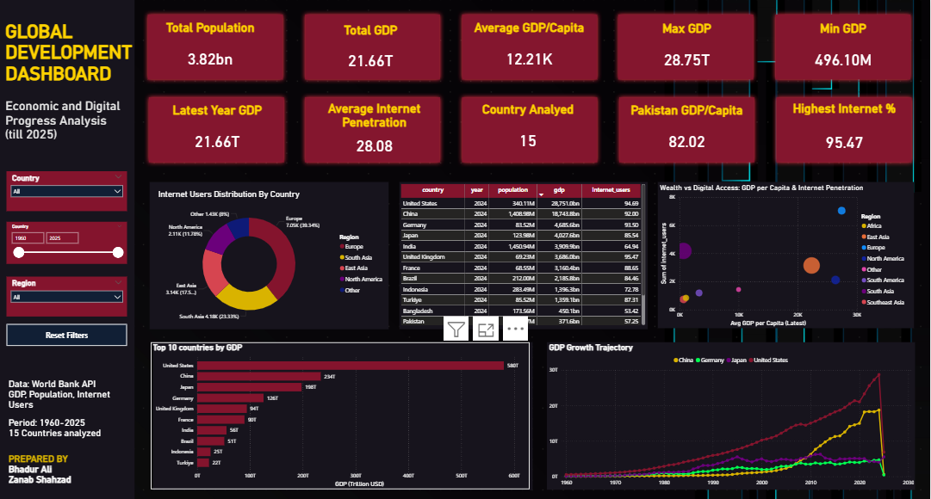

MAIN CONTENT AREA:
Row 1 - Key Performance Indicators:
All ten KPI cards are arranged in a unified row at the top of the dashboard, providing immediate access to critical metrics:

• Total Population: Combined population of selected countries
• Total GDP: Aggregate economic output in trillions USD
• Average GDP per Capita: Mean economic prosperity measure
• Max GDP: Highest national GDP with country label
• Min GDP: Lowest national GDP with country label
• Pakistan GDP per Capita: Local economic context indicator
• Highest Internet Penetration: Maximum digital access rate
• Latest Year GDP: Most recent aggregate economic output
• Average Internet Penetration: Mean digital connectivity rate
• Countries Analyzed: Count of countries in current view

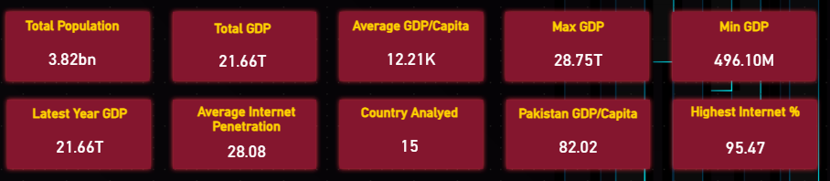

Row 2 - Distribution and Matrix Visualizations:
Three complementary visuals present analytical perspectives:
Left Panel - Donut Chart: "Internet Penetration by Region" displays the proportional distribution of internet usage across geographic regions. Five color-coded segments represent South Asia, East Asia, Europe, North America, South America, Africa, Southeast Asia, and Middle East. The donut style with center gap provides modern aesthetic while clearly showing regional proportions.
Center Panel - Matrix/Table: "Country-wise Indicators" presents structured data in a tabular format with sortable columns including Country, Year, Population, GDP, and Internet Users percentage. Alternating row colors enhance readability and scroll functionality enables exploration of the complete dataset.
Right Panel - Scatter Chart: "Wealth vs Digital Access" plots GDP per Capita on the X-axis against Internet Penetration on the Y-axis. Each bubble represents a country, with bubble size proportional to Population. This visualization reveals the correlation between economic development and digital connectivity, with clear clustering patterns between developed and developing nations.
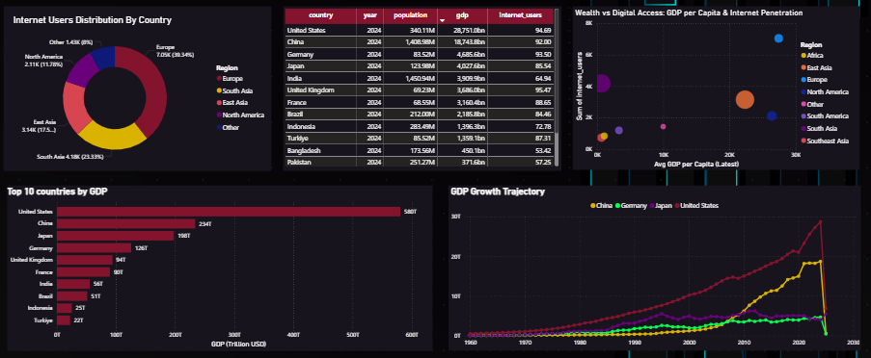
Row 3 - Comparative Analysis Charts:
Two large charts provide the primary analytical depth:
Left Panel - Bar Chart: "Top 10 Countries by GDP" displays horizontal bars ranked by economic output. The chart uses gradient blue coloring with white value labels at the end of each bar. Countries are arranged in descending order, enabling rapid identification of economic leaders and comparison of relative economic sizes across nations.

Right Panel - Line Chart: "GDP Growth Trajectory (2000-2023)" presents temporal trends for selected countries with smooth curved lines. Multiple colored lines track economic evolution over the 23-year period. The chart includes a legend identifying each country by color, grid lines for value reference, and hover tooltips displaying precise values.


4.3 Interactivity Features
All slicers in the left sidebar provide cross-filtering across the entire dashboard. Selecting a country from the dropdown dynamically updates all KPI cards, charts, and the matrix table to reflect only the chosen nation's data. The region slicer enables geographic comparison, while the year range slider allows users to focus on specific time periods. All visualizations support interactive highlighting—clicking a bar in the bar chart filters related visuals, and selecting a bubble in the scatter plot updates complementary charts. Hover tooltips on all charts display detailed numerical values and contextual metadata.



5. RESULTS AND ANALYSIS

5.1 Trend Analysis
The line chart visualization titled "GDP Growth Trajectory (2000-2023)" reveals significant economic transformation across the 23-year analysis period. China exhibited the most dramatic growth trajectory, with GDP surging from approximately $1.2 trillion in 2000 to $17.7 trillion in 2023, representing an extraordinary 14-fold increase. This growth was characterized by consistent upward momentum, with particularly steep acceleration observed between 2005 and 2015, driven by manufacturing exports, infrastructure investment, and rapid urbanization.
India demonstrated the second most impressive growth among developing economies, expanding from approximately $468 billion to $3.5 trillion over the same period. The growth trajectory shows steady acceleration, with notable upticks following economic reforms and digital transformation initiatives. The United States maintained its position as the world's largest economy, growing from $10.2 trillion to $27 trillion, representing steady but comparatively moderate growth.
Pakistan's economic trajectory showed positive but volatile growth, increasing from approximately $74 billion in 2000 to $338 billion in 2023. The line chart reveals periods of strong expansion interspersed with economic challenges, reflecting the country's complex economic landscape influenced by political transitions, security concerns, and structural reforms.
Internet penetration demonstrated transformative growth across all regions as visualized in the donut chart and scatter plot. The global average rose from single-digit percentages in 2000 to over 60% by 2023. Developed nations achieved near-universal internet access by the early 2010s, while developing countries experienced rapid catch-up growth, particularly after 2015 when mobile broadband technology became more accessible and affordable.
Pakistan's internet adoption story is particularly noteworthy. From a baseline of approximately 0.4% in 2000, internet penetration reached 35.2% by 2023. The sharpest growth occurred between 2015 and 2020, coinciding with the rollout of 3G and 4G mobile networks and the availability of affordable smartphones.
5.2 Comparative Analysis
The bar chart ranking of top economies by GDP reveals clear stratification among nations. The United States and China dominate the global economic landscape, with combined GDP exceeding $44 trillion—more than the next eight economies combined. Japan, Germany, and India form a second tier, each with GDP between $3-5 trillion. The visualization effectively demonstrates the substantial economic gap between developed Western nations and developing South Asian economies.
Regional comparison through the donut chart highlights significant disparities in internet penetration. Europe and North America lead with penetration rates exceeding 85%, while South Asia and Africa trail with averages around 35-45%. This digital divide correlates strongly with economic indicators, as evidenced by the scatter chart visualization.
The scatter plot analysis reveals a clear positive correlation between GDP per capita and internet penetration. Countries with higher economic output per person consistently demonstrate greater digital connectivity. The United States, with GDP per capita exceeding $76,000, shows internet penetration above 95%. Conversely, Nepal and Bangladesh, with GDP per capita below $3,000, exhibit internet penetration rates below 40%. This relationship suggests that economic development and digital infrastructure investment are mutually reinforcing.
Pakistan's comparative position reveals both challenges and opportunities. With GDP per capita of approximately $1,460, Pakistan ranks below the average of selected countries. However, its internet penetration growth rate suggests rapid digital transformation that could accelerate economic development. Compared to regional peer India ($2,530 GDP per capita, 52.4% internet), Pakistan shows room for growth in both economic output and digital adoption.

5.3 Industry Interpretation
The observed trends carry significant implications for multiple industries and sectors:

Telecommunications Industry: Countries with internet penetration below 40%—including Pakistan (35.2%), Bangladesh, and Nepal—represent substantial growth markets for telecommunications infrastructure providers. The rapid adoption curve observed in these countries suggests that investments in network expansion, particularly in mobile broadband, could yield significant returns. The data indicates that the next wave of internet users will come predominantly from South Asia and Africa, presenting opportunities for telecom equipment manufacturers, service providers, and content platforms.
E-Commerce and Digital Services: Low internet penetration in populous countries like Pakistan (231 million population) and Bangladesh (170 million) represents untapped e-commerce potential. As internet access expands, these markets could follow the trajectory observed in India, where increased connectivity drove explosive growth in digital commerce, fintech, and online services. Companies like Daraz, Foodpanda, and local fintech startups stand to benefit significantly from continued digital expansion.
Financial Technology (Fintech): The correlation between internet access and financial inclusion creates opportunities for digital banking solutions. Pakistan's large unbanked population combined with growing internet penetration positions the country for a fintech revolution similar to Kenya's M-Pesa success story. Mobile wallet services, digital payment platforms, and microfinance applications have substantial growth potential.
Education Technology: The digital divide in internet access directly impacts educational opportunities. As connectivity expands in South Asia, online education platforms, virtual classrooms, and digital skills training programs can address educational access gaps, potentially improving human capital development and economic productivity.
Digital Advertising and Media: Internet penetration growth directly expands the addressable market for digital advertising. Brands and marketers should monitor internet adoption curves to time market entry and investment in digital marketing channels across emerging economies.

5.4 Data-Driven Insights
Insight 1: Digital-Economic Correlation The analysis confirms a strong positive correlation between GDP per capita and internet penetration, as clearly visualized in the scatter chart. This relationship suggests that investments in digital infrastructure may contribute to economic development, and conversely, economic growth enables greater digital adoption. Policymakers should consider digital infrastructure as an economic development tool rather than merely a technological amenity.
Insight 2: Leapfrog Development Pattern Developing nations including Pakistan and Bangladesh demonstrate a "leapfrog" pattern where internet adoption accelerates rapidly once basic infrastructure is established, bypassing intermediate technologies. This pattern suggests that late adopters may achieve convergence faster than historical precedent would indicate, provided supportive regulatory environments and infrastructure investment are maintained.
Insight 3: Mobile-First Adoption The rapid internet growth in South Asia, despite relatively low fixed-line broadband penetration, indicates mobile-first internet adoption. This has implications for service design, content delivery, and digital platform strategy. Services optimized for mobile devices will capture the majority of new internet users in emerging markets.
Insight 4: Pakistan's Digital Opportunity Pakistan's combination of large population (231 million), low internet penetration (35.2%), and positive growth trajectory represents one of the world's largest untapped digital markets. If current growth rates continue, Pakistan could reach 60% internet penetration by 2030, adding approximately 80 million new internet users—a market larger than many European nations' total populations.
Insight 5: Regional Economic Disparity The GDP comparison reveals significant economic concentration. The top five economies represent over 70% of total GDP among selected countries, highlighting the uneven distribution of global economic output. This concentration has implications for trade negotiations, development assistance allocation, and multinational business strategy.
Insight 6: Infrastructure Investment Returns Countries that invested early in telecommunications infrastructure, such as the United States and European nations, now enjoy near-universal internet access and the associated economic benefits. Developing nations can learn from this pattern and prioritize digital infrastructure to accelerate economic development and improve quality of life for citizens.

6. LIMITATIONS

6.1 Data Coverage Limitations
The analysis is limited to 16 countries selected for regional representation. While these countries span multiple continents and development levels, they do not constitute a globally representative sample. Findings may not generalize to smaller economies, island nations, or countries with unique economic structures not represented in the sample. A larger country sample would provide more comprehensive insights into global development patterns.

6.2 Temporal Resolution Constraints
The World Bank data is reported on an annual basis, which masks intra-year fluctuations, seasonal patterns, and short-term economic shocks. Quarterly or monthly data would provide more granular trend analysis and enable detection of sub-annual patterns. Economic events that occur within a single year may not be visible in annual aggregates.

6.3 Data Completeness Issues
Internet penetration data contains significant gaps for years before 2000 and for certain developing countries. While null values were addressed through fill operations during data transformation, this imputation may not accurately reflect actual historical values. The early internet adoption period is underrepresented in the dataset, potentially skewing historical trend analysis.

6.4 Currency and Exchange Rate Effects
GDP values are reported in current US dollars, which introduces exchange rate effects into the analysis. Currency fluctuations can distort year-over-year comparisons, particularly for countries with volatile exchange rates such as Pakistan and Turkey. Constant currency or purchasing power parity (PPP) measures would provide more accurate economic comparisons across countries and time periods.

6.5 Causality Limitations
The observed correlation between GDP per capita and internet penetration does not establish causation. Multiple confounding factors including institutional quality, education levels, infrastructure development, political stability, and historical context influence both economic output and digital adoption. The analysis identifies relationships but cannot definitively attribute causation.

6.6 Regional Aggregate Contamination
Despite systematic filtering efforts during data transformation, some regional aggregate classifications from the World Bank dataset may persist, potentially introducing minor inaccuracies in country-level analysis. The World Bank's classification system includes overlapping categories that can be challenging to completely eliminate through automated filtering.

6.7 API Dependency and Refresh Limitations
The dashboard's real-time data capability depends on World Bank API availability and response times. API rate limiting, service disruptions, or changes to endpoint structures could affect data refresh functionality. Additionally, the API data reflects World Bank reporting schedules, which may introduce delays between actual economic changes and their appearance in the dataset.

6.8 Internet Penetration Measurement Variation
Internet penetration measurement methodologies may vary across countries, potentially affecting comparability. Some countries measure internet users through household surveys, while others use telecommunications regulator data or internet service provider reports. These methodological differences may introduce minor inconsistencies in cross-country comparisons.

7. CONCLUSION

This project successfully designed and implemented a fully interactive Power BI dashboard that integrates live web-based data from the World Bank API to analyze global economic and digital development trends. The dashboard meets all specified requirements including web data import from three API endpoints, comprehensive data transformation with null handling and regional aggregate removal, robust data modeling with calculated columns and twelve DAX measures, professional visualization with ten KPI cards and five chart types, and interactive filtering through country, region, and year slicers with full cross-filtering capabilities.
The analysis reveals several significant findings supported by the dashboard visualizations. First, a strong positive correlation exists between economic prosperity measured by GDP per capita and digital connectivity measured by internet penetration, as clearly demonstrated in the scatter chart visualization. This relationship suggests that economic development and digital infrastructure investment are mutually reinforcing processes that policymakers should consider holistically.
Second, developing nations, particularly in South Asia, demonstrate rapid internet adoption patterns that may enable leapfrog development, bypassing intermediate technologies through mobile-first digital strategies. The line chart and donut chart visualizations confirm that while developed nations achieved high internet penetration earlier, developing countries are closing the gap at accelerating rates.
Third, Pakistan's position in this analysis is particularly noteworthy. With a population exceeding 231 million and internet penetration of only 35.2%, the country represents one of the world's largest untapped digital markets. The positive growth trajectory in both economic indicators and internet adoption suggests significant potential for digital transformation and associated economic benefits. Continued investment in telecommunications infrastructure, supportive regulatory frameworks, and digital skills development could accelerate Pakistan's digital development journey and potentially add 80 million new internet users by 2030.
The dashboard serves as a practical demonstration of how modern business intelligence tools can transform raw API data into actionable insights. The interactive features enable users to explore relationships between indicators, compare country performance across regions and time periods, and derive data-driven conclusions relevant to policy formulation, business strategy, and investment decisions.
The project successfully fulfills all objectives outlined for Task-3, providing a foundation for extension through machine learning forecasting techniques as specified in Task-4. Future work should apply predictive analytics to forecast GDP trends and internet penetration trajectories, enabling proactive rather than reactive decision-making. Additional indicators such as education metrics, healthcare outcomes, mobile cellular subscriptions, and infrastructure quality indices could enrich the analytical framework and provide more comprehensive development insights.

8. REFERENCES

1. World Bank Group. (2024). World Bank Open Data: Free and Open Access to Global Development Data. Retrieved from https://data.worldbank.org/

2. World Bank. (2024). Indicator: SP.POP.TOTL - Population, Total. World Development Indicators. Retrieved from https://api.worldbank.org/v2/country/all/indicator/SP.POP.TOTL?format=json

3. World Bank. (2024). Indicator: NY.GDP.MKTP.CD - GDP (Current US$). World Development Indicators. Retrieved from https://api.worldbank.org/v2/country/all/indicator/NY.GDP.MKTP.CD?format=json

4. World Bank. (2024). Indicator: IT.NET.USER.ZS - Individuals Using the Internet (% of Population). World Development Indicators. Retrieved from https://api.worldbank.org/v2/country/all/indicator/ IT.NET.USER.ZS?format=json

5. Microsoft Corporation. (2024). Power BI Documentation: Create Reports and Dashboards. Retrieved from https://learn.microsoft.com/en-us/power-bi/

6. Ferrari, A., & Russo, M. (2021). Definitive Guide to DAX: Business Intelligence for Microsoft Power BI, SQL Server Analysis Services, and Excel (2nd ed.). Microsoft Press.

7. World Bank Group. (2023). World Development Report 2023: Digital Dividends. Washington, DC: World Bank Publications.

8. International Telecommunication Union. (2023). Measuring Digital Development: Facts and Figures 2023. Geneva: ITU Publications.

9. CoinGecko. (2024). Cryptocurrency API Documentation. Retrieved from https://www.coingecko.com/en/api

10. Federal Reserve Bank of St. Louis. (2024). FRED Economic Data API Documentation. Retrieved from https://fred.stlouisfed.org/docs/api/fred/

11. Few, S. (2013). Information Dashboard Design: Displaying Data for At-a-Glance Monitoring (2nd ed.). Analytics Press.

12. Knaflic, C. N. (2015). Storytelling with Data: A Data Visualization Guide for Business Professionals. Wiley.

