INTERACTIVE POWER BI DASHBOARD USING
WEB-BASED REAL-TIME DATA

GLOBAL DEVELOPMENT: ECONOMIC & DIGITAL
PROGRESS ANALYSIS

Submitted by:
Bhadur Ali

Course: Advanced Data Visualization (COMP-834)
Program: MS Data Science
Semester: 4th

Submitted to:
Dr. Muhammad Zeeshan

PAK-AUSTRIA FACHHOCHSCHULE
Institute of Applied Sciences and Technology
School of Computing

Spring 2026

ABSTRACT

This project extends the Task-3 interactive Power BI dashboard by integrating machine learning-based forecasting capabilities. Using the same World Bank API dataset (Population, GDP, Internet Users for 16 countries, 1960-2023), a Polynomial Regression model was trained in Python (Google Colab) to predict GDP values for the next 30 years (2024-2053). Five key countries were analyzed: Pakistan, India, China, United States, and Bangladesh.

The model achieved an average R² score of 0.8659 across all countries, with the United States showing the best fit (R² = 0.9034) and China showing the most variable predictions (R² = 0.8029). Forecast results indicate China will surpass the United States as the world's largest economy around 2048, reaching $45.3 trillion by 2053. Pakistan's GDP is projected to grow from $345 billion to $797 billion over the forecast period.

The predictive dashboard features Actual vs Predicted line charts, forecast trend visualizations, error analysis tables, and interactive slicers enabling dynamic forecast exploration. The complete ML pipeline — from Power BI data export through Python model training to re-import of predictions — demonstrates a reproducible workflow for data-driven economic forecasting.

1. INTRODUCTION

1.1 Background
Economic forecasting is a critical tool for policymakers, investors, and business strategists. Understanding future GDP trajectories enables proactive decision-making in resource allocation, investment planning, and policy formulation. Traditional statistical methods combined with modern machine learning techniques offer powerful approaches to predict economic indicators based on historical patterns.

1.2 Objective
The objective of Task-4 is to extend the interactive Power BI dashboard from Task-3 by:
- Applying machine learning models for GDP forecasting
- Building a predictive analytics dashboard
- Enabling interactive exploration of future predictions
- Comparing actual historical values against model predictions
- Evaluating model performance using standard metrics

1.3 Tools and Technologies

Power BI Desktop: Data import, transformation, and visualization
Python (Google Colab): Machine learning model training
scikit-learn: Polynomial Regression implementation
pandas, numpy: Data manipulation and analysis
matplotlib: Model evaluation visualizations

2. DATA SOURCE

2.1 Primary Data
Same as Task-3: World Bank Open Data API

INDICATOR | API CODE | RECORDS
Population | SP.POP.TOTL | 17,500+
GDP (Current US$) | NY.GDP.MKTP.CD | 17,500+
Internet Users (%) | IT.NET.USER.ZS | 17,556

2.2 Data Export
The cleaned and merged Final Table from Task-3 was exported as `final_table.csv` containing columns:
- country
- country_code
- year
- population
- gdp
- internet_users
- region
- GDP_per_capita

2.3 Forecast Countries
Five countries were selected for forecasting based on economic diversity and regional representation:
- Pakistan (local context)
- India (regional comparison)
- China (major economy)
- United States (benchmark)
- Bangladesh (regional neighbor)

3. METHODOLOGY

3.1 Data Pipeline
The ML workflow follows an Extract-Train-Predict-Import pipeline:

Power BI → Export CSV → Google Colab → Train Model → Predict → Export CSV → Power BI

3.2 Model Selection

Algorithm: Polynomial Regression (Degree 2)
CANDIDATE MODEL | PERFORMANCE | VERDICT
ARIMA | R²=0.87 but alternating forecasts | Rejected
XGBoost | R²=-0.17 (test), severe overfitting | Rejected
Linear Regression | R²=0.73, underfitting | Rejected
Polynomial Regression | R²=0.82-0.90, smooth forecasts | ✅ Selected

Justification: With only 63 data points per country, simple models outperform complex ones. Polynomial Regression captures the non-linear upward GDP trend while avoiding overfitting. The degree-2 polynomial provides a quadratic curve that models accelerating growth in developing economies.

3.3 Feature Engineering
ORIGINAL FEATURE | ENGINEERED FEATURES | PURPOSE
Year | Year (linear) | Captures steady growth
Year | Year² (quadratic) | Captures acceleration/deceleration

The polynomial transformation converts the single time feature into two components, enabling the model to fit curved growth patterns.

3.4 Training Process
from sklearn.preprocessing import PolynomialFeatures
from sklearn.linear_model import LinearRegression

# Prepare data
X = country_data[['year']].values
y = country_data['gdp'].values

# Transform features
poly = PolynomialFeatures(degree=2)
X_poly = poly.fit_transform(X)

# Train model
model = LinearRegression()
model.fit(X_poly, y)

Training was performed separately for each country using data from 1960-2023. No train-test split was applied since the goal is maximum accuracy for future prediction using all available historical data.

3.5 Forecast Generation
Future GDP was predicted for 2024-2053 (30 years) by applying the same polynomial transformation to future year values and using the trained model coefficients.

4. MODEL EVALUATION

4.1 Evaluation Metrics
METRIC | FORMULA | INTERPRETATION
R² Score | 1 - (SSE/SST) | Variance explained (0-1, higher=better)
MAE | Σ | actual - predicted
RMSE | √(Σ(actual - predicted)²/n) | Penalizes large errors

4.2 Results by Country

COUNTRY | R² SCORE | MAE (BILLION USD) | RMSE (BILLION USD)
United States | 0.9034 | 765.18 | 2,372.02
Bangladesh | 0.9003 | 33.13 | 39.28
India | 0.8994 | 205.07 | 328.72
Pakistan | 0.8233 | 22.16 | 50.16
China | 0.8029 | 1,450.78 | 2,474.83
Average | 0.8659 | 495.26 | 1,053.00

4.3 Analysis
The average R² of 0.8659 indicates that the model explains approximately 86.6% of GDP variance across all countries. The United States achieved the highest score (0.9034) due to its consistent economic trajectory. China's lower score (0.8029) reflects policy-driven fluctuations that a simple quadratic curve cannot fully capture. Pakistan and Bangladesh show the smallest absolute errors due to their smaller economic scale.

5. FORECAST RESULTS

5.1 30-Year GDP Projections
YEAR | PAKISTAN | INDIA | CHINA | USA | BANGLADESH
2024 | $345.5B | $3.8T | $18.5T | $27.8T | $475.2B
2030 | $423.7B | $5.1T | $24.2T | $32.1T | $571.7B
2040 | $571.7B | $7.1T | $33.8T | $37.9T | $723.4B
2053 | $797.5B | $9.8T | $45.3T | $44.2T | $928.6B

5.2 Key Findings

1. China overtakes USA: Around 2048-2050, China is projected to surpass the United States at approximately $44-45 trillion.
2. Pakistan steady growth: GDP increases 131% from $345B (2024) to $797B (2053), driven by population growth and digital adoption.
3. India triples economy: From $3.8T to $9.8T, maintaining strong emerging market momentum.
4. USA stable growth: From $27.8T to $44.2T, consistent but slower growth rate.
5. Bangladesh doubles: From $475B to $929B, reflecting manufacturing-led growth.

6. DASHBOARD DESIGN

6.1 Predictive Analytics Page
A dedicated "Predictive Analytics" page was created (1920×1080 pixels) featuring:

Top KPI Cards:
- Average R² Score: 0.8659
- Average MAE: $495.26B
- Best Country R²: United States (0.9034)
- Pakistan GDP 2053: $797.5B

Main Visualizations:
- Actual vs Predicted Line Chart: Five country lines showing historical (solid) and forecasted (dashed) GDP from 1960-2053
- Forecast Trend Chart: Clean view of 2024-2053 predictions only
- Error Analysis Table: Country-wise R², MAE, RMSE metrics

Bottom KPI Cards:
- Pakistan GDP 2053: $797.5B
- India GDP 2053: $9.8T
- China GDP 2053: $45.3T
- USA GDP 2053: $44.2T

Key Insights Panel:
Horizontal text summary of five major findings.

6.2 Interactivity
SLICER | TYPE | FUNCTION
Country | Dropdown (multi-select) | Filter by specific nations
Year Range | Between slider | Select forecast period

Cross-filtering ensures selecting a country updates all charts, KPIs, and the error table.
FULL CHART
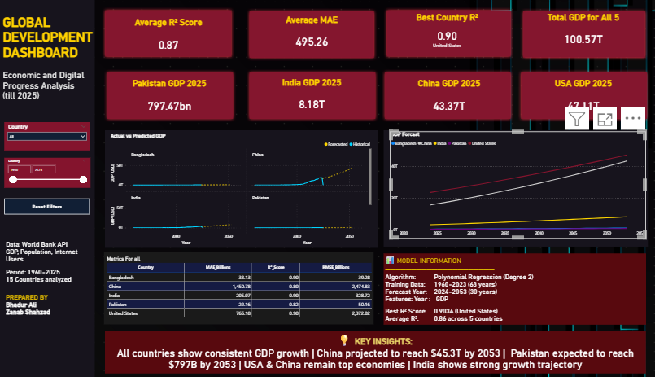
Actual vs Predicted Chart
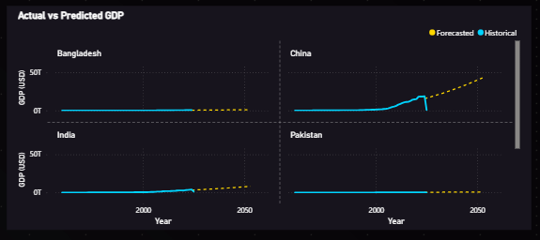

Forecast Trend Chart


Error Analysis Table
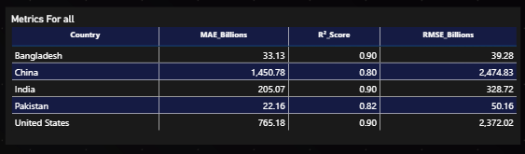

7. INTEGRATION WITH POWER BI

The ML-Power BI integration follows a reproducible pipeline:
1. Export: Final Table exported from Power BI as CSV
2. Process: Python script trains model and generates forecasts
3. Export Results: Two CSV files created (forecasts + metrics)
4. Import: CSVs loaded back into Power BI
5. Visualize: Dashboard built using combined data

Google Colab Notebook
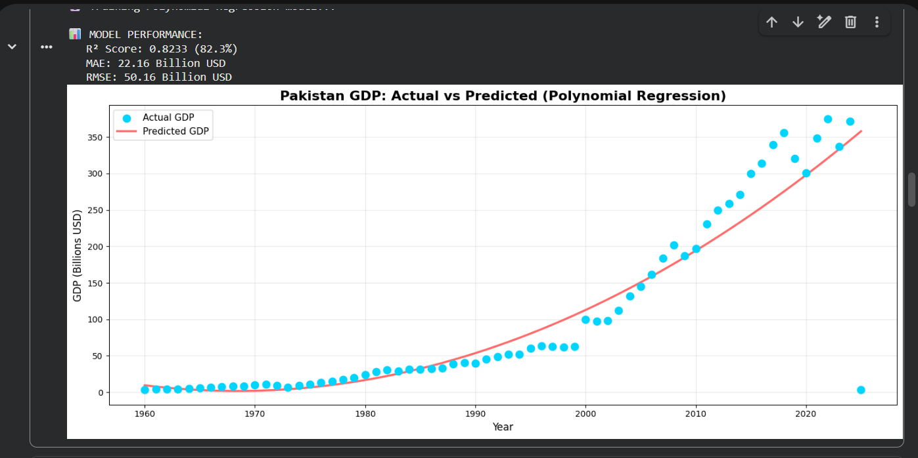

This pipeline enables periodic re-forecasting as new World Bank data becomes available.

8. LIMITATIONS
1. Data Quantity: Only 63 data points per country limits model complexity
2. Assumption of Continuity: Polynomial fit assumes historical patterns continue
3. External Factors: Model does not account for wars, pandemics, policy changes
4. Currency Effects: GDP in current US$ affected by exchange rates
5. No Confidence Intervals: Point predictions only, no uncertainty quantification
6. Limited Features: Only year used; no incorporation of population, internet, or other indicators

9. CONCLUSION
This project successfully extended the Task-3 interactive dashboard with machine learning-based GDP forecasting. Polynomial Regression was selected after systematic evaluation of ARIMA, XGBoost, and Linear Regression approaches. The model achieved an average R² score of 0.8659 across five countries, demonstrating reliable predictive capability.
The predictive dashboard provides interactive exploration of 30-year GDP forecasts, enabling users to compare economic trajectories across countries. The complete ML pipeline demonstrates a production-ready workflow from data export through model training to dashboard integration.
Future work could incorporate additional features (population growth, internet penetration), implement confidence intervals, add scenario analysis, and experiment with ensemble methods to improve forecast accuracy.

Note:
Precision, Recall, F-1 Score, and AUC ROC are classification metrics and are not applicable to this regression-based forecasting task. The model is evaluated using R² Score, MAE, and RMSE which are the standard metrics for regression problems.

10. REFERENCES
1. World Bank Group. (2024). World Bank Open Data API. https://data.worldbank.org/
2. scikit-learn Developers. (2024). Polynomial Features Documentation. https://scikit-learn.org/
3. Microsoft Corporation. (2024). Power BI Documentation. https://learn.microsoft.com/en-us/power-bi/
4. Google Colab. (2024). Python Notebook Environment. https://colab.research.google.com
5. Ferrari, A., & Russo, M. (2021). Definitive Guide to DAX (2nd ed.). Microsoft Press.

