


Title

CarRacingGame(C#Project)

Title: Car Racing Game Subtitle: Mini Project in C# Name: Manish sahni
Roll:92400527312
Name: Saket Kumar Bhagat
Roll: 92400527219


introduction

Introduction
The Car Racing Game isasimpleandinteractivedesktopapplicationdevelopedusing C# and Windows Forms. This game simulatesa basic racing environment where the player controls a car and tries to avoid collisions with enemy vehicles moving on the road. The main goal of the game is to survive as long as possibleand achieve the highest score.
The projectis designedtodemonstratefundamentalconceptsofprogrammingsuchas event handling, real-time updates using timers, and graphical user interface (GUI) design. It provides a practicalunderstandingof how games work using basic logic and animations.


Objectives

Objectives
The mainobjectivesoftheCar RacingGameprojectaretodevelopan interactiveanduser-friendly desktop application using C# and Windows Forms. The project aims to provide a clear understanding of event-driven programming and graphical user interface design.
Another objective is to implement real-time game mechanicsusing timers, where objects move continuouslyandrespondtouserinput.The gamealsofocusesonimprovinglogicalthinkingby handling collision detection and dynamic difficulty levels.


Tools

Tools&Technologies
TheCarRacingGameis developedusingmodernprogrammingtoolsandtechnologiesthat
supportgraphicalinterfacedesignandapplicationdevelopment.
The primary programminglanguage used is C#, which is widely used for developing Windows- basedapplications.The projectisbuiltonthe.NET Framework,which providesessentiallibraries for GUI development and event handling.
Thedevelopmentenvironmentusedis Microsoft VisualStudio,whichoffersfeatureslike code
editing,debugging,andprojectmanagement.
Fordatabasefunctionality(optional),MySQL isusedtostoreandmanagehighscores,allowing data persistence and retrieval.


SystemOverview

SystemOverview
The Car RacingGameis adesktop-basedapplicationdevelopedusingC#andWindowsForms that provides an interactive gamingexperience. The system is designedto simulatea simple racing environment where the player controls a car and avoids collisions with enemy vehicles.

The gamebeginswith a welcomescreen,followedbymodeselection.Oncethegamestarts,the player can control the car using keyboard inputs,while enemy cars move automaticallyfrom the top of the screen toward the bottom. The system continuouslyupdatesthe positionof all game elements using a timer, creating a smooth animation effect.


Userinterface

UserInterface
The user interface of theCarRacingGame is designed to besimple, interactive, andeasy touse. It
Consists of multiple screens that guidet heuserthroughthegameplayprocess.
The game starts with a welcome screen that displays the title of theg ame along with astart button. This screenuses a dark theme to create an attractive and focused entry point for the user. After starting the game, the main game screen appears with a light theme.It displays the road background, player car, enemy cars,and the scorelabel.The player can controlthe car using keyboard keys, making the interaction smooth and responsive.
Button sandlabels areused effectivelyto provideinformationsuchas score, gamestatus,and options likere startor exit. The interface updates in real-time,ensuringthat the gameplayfeels dynamic and engaging.
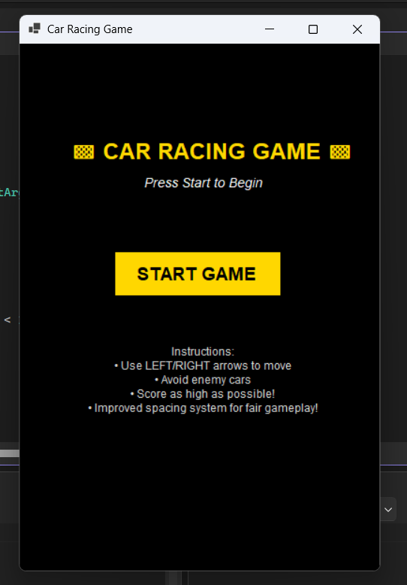


GameComponents

GameComponents
TheCarRacingGameconsistsofseveralkeycomponentsthatworktogethertocreateaninteractive
gameplayexperience.
The playercaristhemaincomponentcontrolledbytheuserusingkeyboardinputs.It canmoveleft and right within the boundaries of the road.
Enemycarsactasobstaclesinthegame.Theymovecontinuouslyfromthetopof thescreentoward
thebottomand reappearatrandompositionsafterleavingthe screen.
Theroadservesasthebackgroundofthegame,providingavisualrepresentationoftheracingtrack.
Itenhancesthe overallappearanceand realismofthe game.
Atimeris used tocontrolthegameloop,which updatesthe positionofallobjectsand ensuressmooth
animation.


GameLogic

GameLogic
The game logic of theCarRacingGame control show thegame functions and responds to user actions.It is mainly handled through a timer that continuously runs in the background,updatingthe positionof all game elements.
Whenthe game starts, the timer beginsexecuting at regular intervals, creating a game loop. In each cycle, the positions of theplayercar,enemycars,androadelementsareupdatedtosimulatemovement. The player controls the car using keyboard inputs,allowing it to move left or right within the game boundaries.At the same time, enemy cars move downward automatically,creatingobstacles for the player.
The speedofthegameincreasesgraduallyasthescoreincreases,makingthegamemorechallenging over time. The system also checks for collisions between the player car and enemy cars during each update.

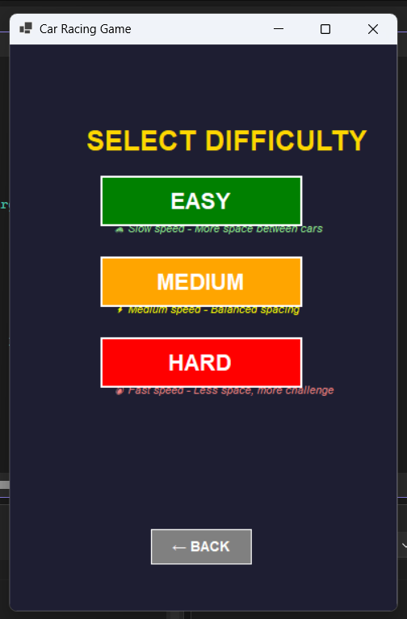


CollisionDetection

CollisionDetection
CollisiondetectionisanimportantpartoftheCarRacingGamethatdetermineswhentheplayerlosesthe
game.Itisusedtocheckwhethertheplayer’scarcomesintocontactwithanyof theenemycars.
In this game,collisiondetectionis implementedby continuouslycheckingthe boundariesof the playercar and enemy cars during each cycle of the game loop. If the rectangulararea (bounds)of the player car intersects with the bounds of any enemy car, a collisionis detected.
Whenacollisionoccurs,thegameimmediatelystops,anda“GameOver”messageisdisplayedonthe
screen.Theplayeristhengivenanoptiontorestartthegameorexittheapplication.
This mechanismensuresfair gameplayandaddschallenge,as theplayermustcarefullycontrolthecarto avoid obstacles.


ScoreSystem

Score System
The score system in the Car Racing Game is designedto track and displaythe player's performance throughoutthe gameplay.Itservesasa primarymeasureofsuccessandencouragesplayerstosurvive longer.
Whenthegamestarts,thescorebeginsatzero. Astimeprogressesandthegameloopcontinuestorun, the score increases automaticallyat regular intervals. This means the longer the player avoids collisions with enemy cars, the higher the score becomes.
The currentscoreisdisplayedonthescreeninreal-timeusingalabelcontrol,allowingtheplayertosee their performanceinstantly. The score value updates continuouslyduring the game loop, providing immediate feedback.

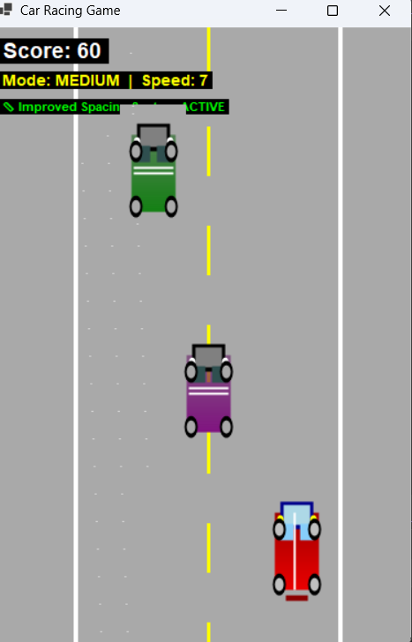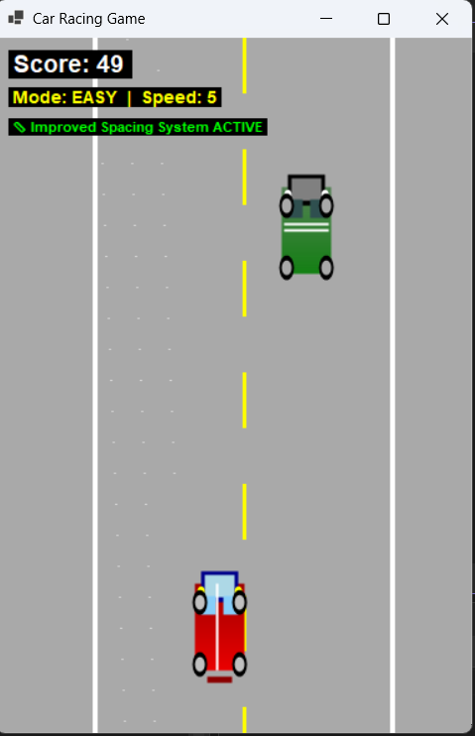


Database

Database
The Car Racing Game includes an optional database feature to store and manage playerscorespermanently.Thisaddsacompetitiveelementtothegamebyallowing players to compare their performance with others.

DatabaseTechnology
DatabaseSystem:MySQLServer
Connector:MySql.Data(OracleOfficialConnector)
Language:SQL(StructuredQuery Language)

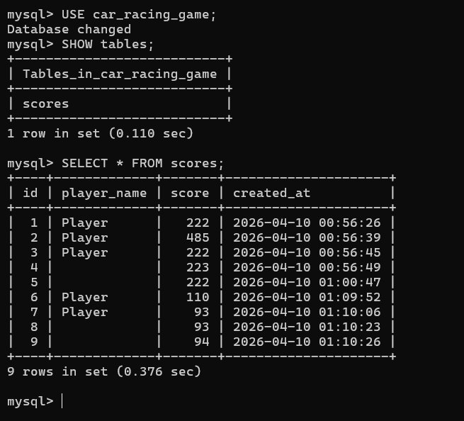


Features

Features
Keyboard Controls – Use Left/Right arrows to move the car Real-TimeGameplay – Cars move continuouslyusinga timer ScoreSystem –Scoreincreasesautomaticallyasyou survive CollisionDetection– Gameendswhenplayerhitsenemycar Restart Option – Play again without closing the game Dynamic Difficulty – Game speed increases with score
RoadBackground – Realisticracingtrackimage
CustomCarImages–Playerandenemycarswithgraphics
Dark&Light Themes– Welcomescreen(dark),Game screen(light)
HighScoreDatabase(Optional)–SavestopscoresusingMySQL

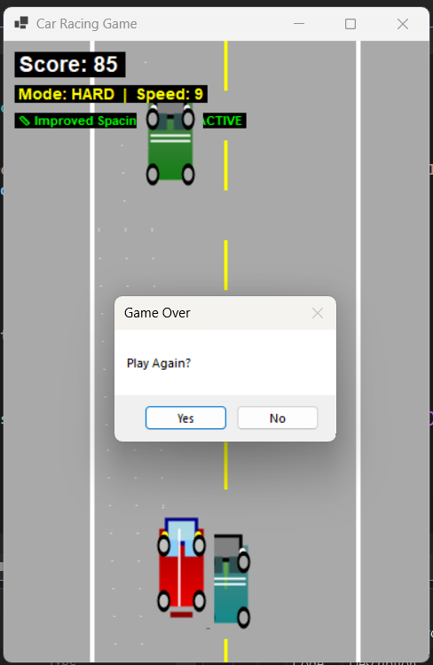
If your car is collision then you can restart game


Advantages

Advantages
Easy to Use–Simple keyboard controls, anyone can play
Beginner Friendly–Great project for learning C# and WindowsForms
Lightweight– Runs smoothly on any computer
No Installation Needed– Justrunthe. exefile
Replay able–Restart option allows unlimited gameplay
Skill Development– Improves hand-eye coordinationand reflexes
Customizable–Easy to add new features, cars,or backgrounds
Data Persistence(Optional)–Scores saved in database for leaderboard
Visual Appeal–Dark/Light themes and custom car images
Teaches Programming Concepts–Timer,events,collisiondetection,GUI


limitations

Limitations
Basic Graphics–No advanced3Dor specialeffects No Sound Effects – Gameplay is completely silent Single Player Only – No multiplayer or online mode
Limited Levels–Endlessgameplaywithnostageprogression
Simple AI–Enemy cars only moves traight down (nointelligentmovement)
Fixed Screen Size– Game window cannotberesized No Power-Ups – No boosts, shields, or special items Basic Collision– No gradual damageormultiplelives
Manual Image Setup– Images must beplaced in correct folder manually
Database Dependency(Optional)–MySQL mustbe installed forscoresaving

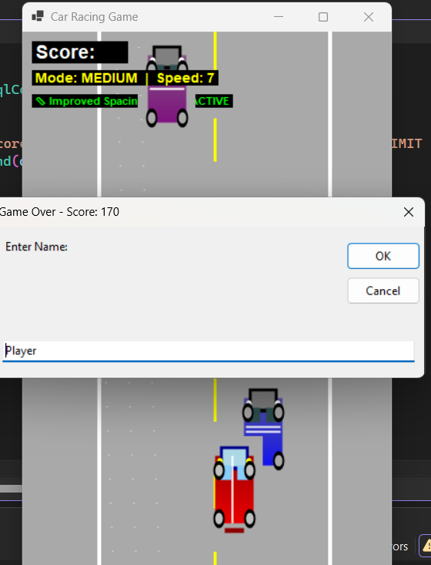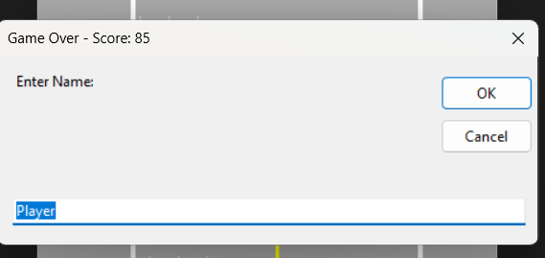


FutureEnhancements

Future Enhancements
SoundEffects– Addenginesounds,collisionnoise,andbackgroundmusic
MultipleLevels–Introduce differentstageswithincreasingdifficulty
Power-Ups– Add speedboosts ,shields,and extralives
MoreEnemyCars – Increase number of obstaclesformorechallenge Intelligent AI – Enemy cars that change lanes to block the player Online Leader board – Global ranking system using web database Car Selection – Allow player to choose different car colors/models Weather Effects – Add rain, fog, or night mode for variety
Mobile Version–Convert to Android/iOSusing Xamarin orMAUI
Achievements &Trophies–Unlock ablerewards for reaching milestones


Conclusion

Conclusion
The Car Racing Game is a successful desktop application developed using C# and Windows Forms.It demonstrates the effective use of key programming concepts such as event handling, timers, collision detection, and graphical user interface design.
The game provide saninter active and enjoy able experience where the player controls a car, avoids enemy vehicles, and scores points by surviving longer. Features like dynamic difficulty, restartoption,and optional database integration for high scores make the game engaging and competitive.
This project help edinunderstand in greal-time application development, problem-solving,andgamelogic
implementation. It servesas a solid foundation for beginners learning C# programming.
The CarRacingGame can befurther enhanced with additional featureslikesoundeffects,power-ups,and
onlineleaderboards,makingitacompleteandprofessionalgamingapplication.



