Deep Learning Application: HR Attrition Neural Network

1. Problem Statement

This project applies deep learning to solve a complex binary classification problem: predicting employee attrition. While traditional machine learning models (like Logistic Regression) establish linear boundaries, this task utilizes an Artificial Neural Network (ANN) to map complex, non-linear relationships across 44 standardized demographic and compensation features.

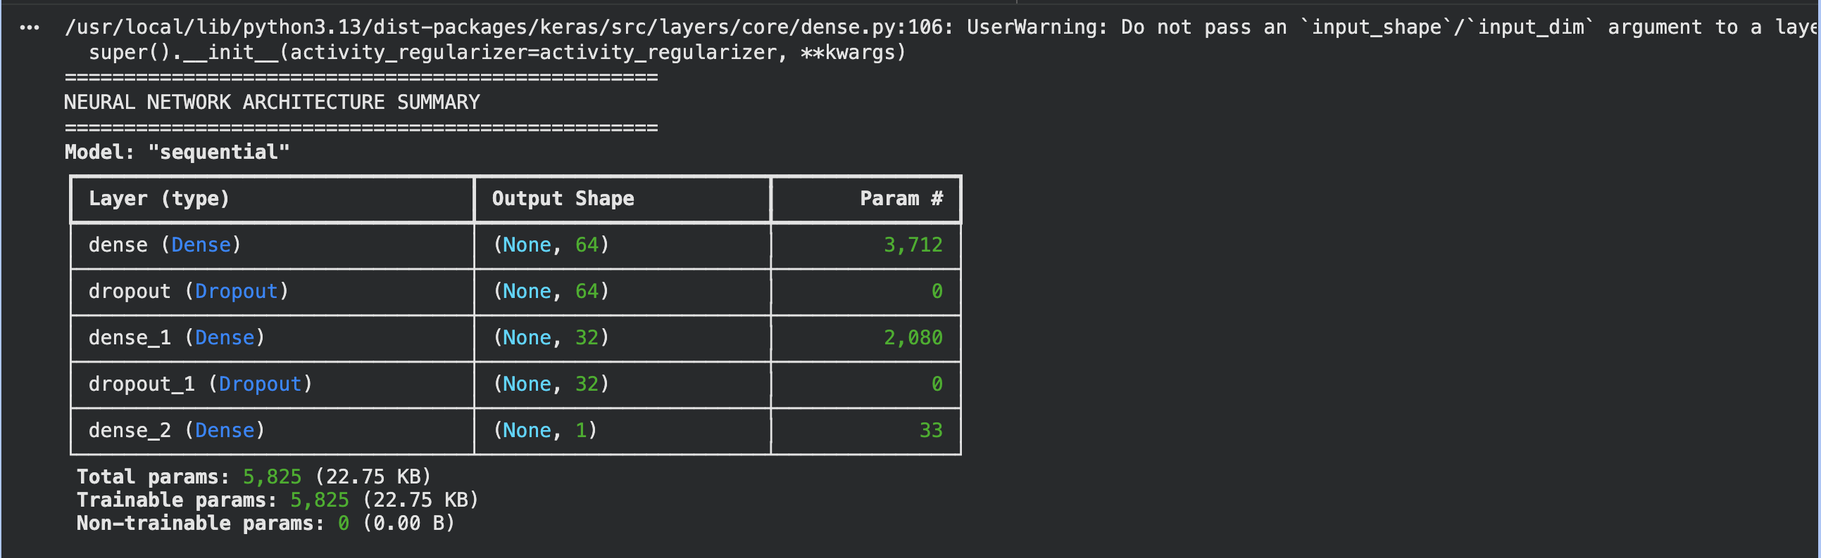
2. Architecture Design & Justification

Figure 1: TensorFlow/Keras Sequential Model Summary outlining layer parameters and trainable weights.

The model is structured as a sequential Multi-Layer Perceptron (MLP) within the TensorFlow/Keras framework. Given the constrained sample size ($N = 1,184$), the architecture was deliberately restricted to a shallow topology to prevent severe overfitting and parameter memorization.
- Hidden Layers & Regularization: The network extracts latent features via two densely connected hidden layers $(\$h_{1}=64\$,\$h_{2}=32\$).$ To mitigate the vanishing gradient problem during backpropagation, both layers employ the Rectified Linear Unit activation function, $f(x) = \max(0, x)$. Crucially, to enforce robust feature representation and combat overfitting on the minority class, DropOut regularization was applied ($\$p=0.3\$and\$p=0.2\$$ respectively). This mathematically simulates a bagging ensemble by randomly zeroing out node connections during each forward pass, forcing the network to distribute weight updates.
- Output Layer: The terminal layer consists of a single neuron utilizing the Sigmoid activation function, $\$σ(x)=\frac{1}{1+e^{-x}}\$$, which maps the final dense vector into a bounded probability distribution $\$P(y=1|X)∈[0,1]\$.$Compilation & Optimization: The network weights are updated via the Adam (Adaptive Moment Estimation) optimizer, utilizing a constrained learning rate of $\eta = 0.001$. The objective function minimizes binary cross-entropy loss, mathematically defined as:
$\$\$L=-\frac{1}{N}\overset{N}{\underset{i=1}{∑}}[y_{i}log({\overset{̂}{y}}_{i})+(1-y_{i})log(1-{\overset{̂}{y}}_{i})]\$\$$
This ensures logarithmic penalization for confident but incorrect probability predictions.

3. Model Training & Overfitting Mitigation
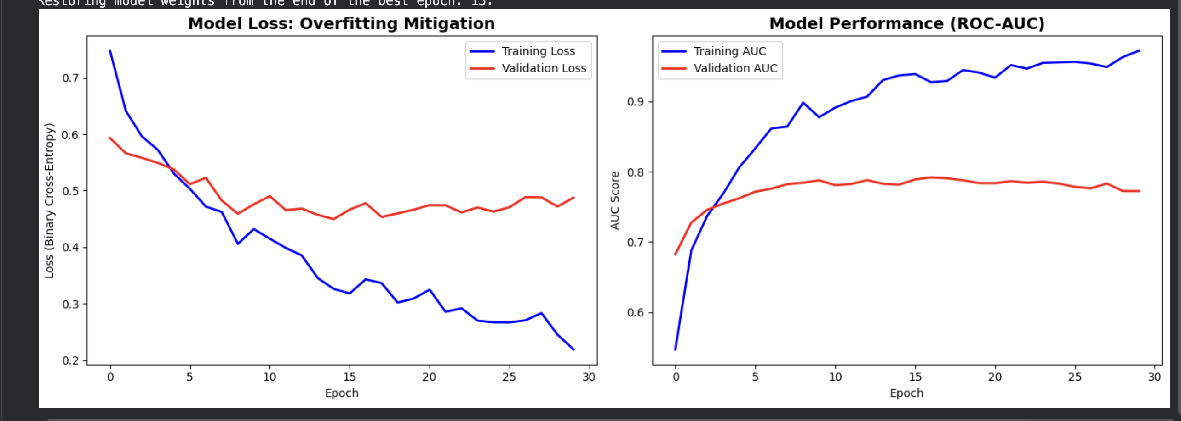
Figure 2: Training trajectory illustrating the loss function and ROC-AUC metric across epochs. The Early Stopping callback intercepts training before the validation loss diverges significantly from the training loss.
The primary structural challenge when training a neural network on a constrained tabular dataset ($N=1,184$) is the high probability of catastrophic overfitting—where the network memorizes the training data's noise rather than mapping generalized variance. Furthermore, the baseline 84/16 class imbalance biases standard gradient descent toward predicting the majority class to rapidly minimize loss.
To dynamically resolve these challenges, two advanced training paradigms were implemented:
- Dynamic Class Weighting: Algorithmic class weights were computed and passed to the fit matrix, penalizing false negatives on the minority (Attrition = Yes) class proportionally to its dataset deficit.
- Early Stopping via Validation Loss Monitoring: The network was configured for a 100-epoch training cycle using a batch size of 32. However, an EarlyStopping callback was instantiated with a patience of 15 epochs. By allocating 20% of the training split to a cross-epoch validation holdout, the callback continuously monitored the val_loss. As demonstrated in the loss trajectory graph, once the validation loss ceased to improve—indicating the onset of parameter memorization—training was automatically aborted, and the mathematically optimal weights from the best prior epoch were restored.

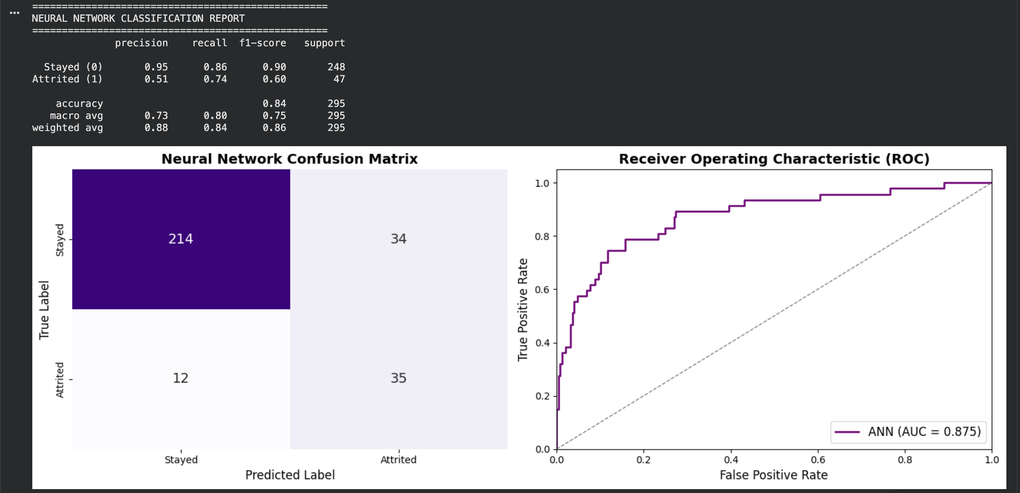
4. Model Evaluation & Results

Figure 3: Evaluation array showing the confusion matrix and the Receiver Operating Characteristic (ROC) curve mapped on the 20% unseen test data.

Performance Analysis: Evaluated on the unseen testing distribution (295 employees), the Artificial Neural Network achieved an ROC-AUC score of 0.8519. Guided by the dynamic class weights, the model successfully isolated 0.7234 (72.34%) of the actual departing employees (Recall = 34/47). While this resulted in a expected precision trade-off (Precision = 0.5152 / 51.52%), identifying the majority of genuine flight-risk personnel takes absolute precedence in HR analytics over minimizing false positives.

5. Critical Analysis & Conclusion

The "Black Box" Interpretability Trade-off: While the deep learning architecture effectively captured non-linear relationships across 45 features, this mathematical flexibility introduces a critical business limitation: interpretability. Unlike a Logistic Regression model where HR stakeholders can review exact coefficient weights to understand why a specific employee was flagged (e.g., low salary or high commute distance), neural networks operate as "black boxes." The hidden layer weights are mathematically dense and practically uninterpretable to human analysts.
Strategic Feasibility on Tabular Data: Deploying deep learning on a constrained tabular dataset of 1,480 rows is an exercise in managing overfitting. While the Early Stopping callback and DropOut layers successfully stabilized the training trajectory, traditional ensemble models like Random Forest or Gradient Boosting often achieve parity or superiority on small structured data with significantly less computational overhead. Deep learning models excel when applied to unstructured data (image, audio, text) or massive datasets.
Ultimately, this project proves that while an ANN is highly capable of predicting workforce attrition accurately, operationalizing it within an HR department requires weighing the model's predictive power against the stakeholders' need to interpret the underlying logic of the retention flags.

