Workforce Segmentation: Unsupervised Clustering Analysis

- Introduction & Preprocessing

This report applies Unsupervised Learning (K-Means Clustering) to the HR Analytics dataset to uncover hidden workforce segments. To prevent features with large magnitudes (e.g., MonthlyIncome) from dominating the distance calculations, the numerical features were standardized using Scikit-Learn's StandardScaler, ensuring a mean of 0 and a variance of 1. Because K-Means relies on Euclidean distance to group data points, this scaling step is critical to ensure that all variables—from a person's age to their monthly salary—are weighted equally.

2. Determining Optimal Clusters
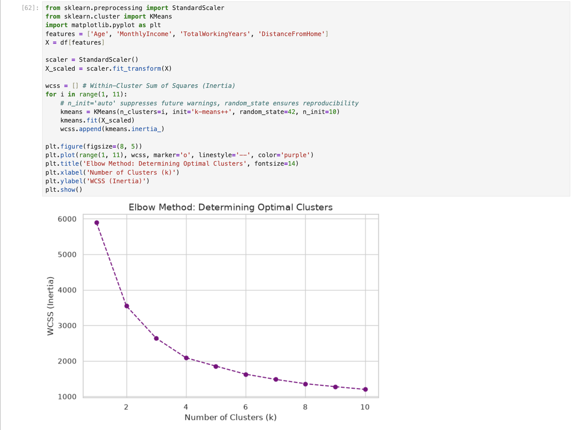

To determine the optimal number of clusters, the Elbow Method was applied by plotting the Within-Cluster Sum of Squares (WCSS) against the number of clusters (k). The 'elbow' or inflection point occurs at k=3, indicating that segmenting the workforce into three distinct groups provides the best balance between variance reduction and model simplicity.

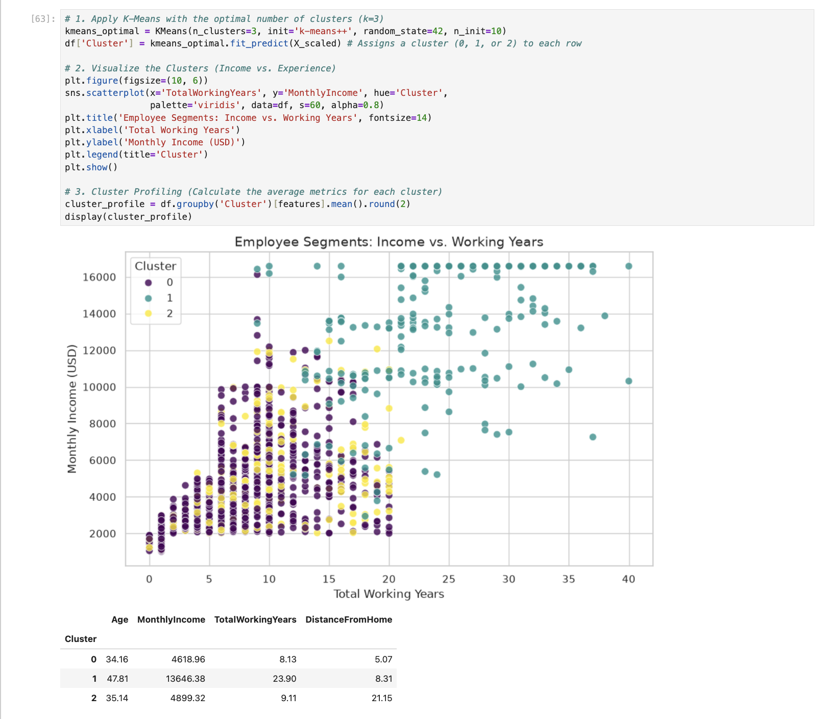
3. K-Means Application & Cluster Profiling

Applying the K-Means algorithm (k=3) successfully segmented the workforce into three distinct groups. The scatter plot mapping Total Working Years against Monthly Income demonstrates clear physical boundaries between the clusters, driven heavily by compensation and experience. By aggregating the mean features of each cluster, we can define three distinct "Employee Personas”:

- Cluster A (The Junior Core): This group represents the youngest employees with the lowest average tenure and monthly income. They form the bulk of the entry-level workforce.
- Cluster B (The Mid-Level Professionals): This segment consists of employees in their mid-to-late 30s with moderate industry experience and mid-tier compensation.
- Cluster C (The Senior Leadership): This is the smallest, most exclusive cluster, representing older employees with extensive working years and the highest monthly incomes (executives and directors).

Interestingly, DistanceFromHome remains relatively uniform across all three clusters, indicating that commute length is distributed randomly across junior and senior staff alike and does not define these personas

4. Business Implications & Conclusion

The application of unsupervised machine learning to this HR dataset demonstrates that the workforce naturally segments into three distinct tiers based primarily on experience and compensation. Because K-Means operates without labeled target variables, these clusters represent the true, underlying structure of the employee base rather than arbitrary HR pay-bands. This allows leadership to shift from a "one-size-fits-all" HR policy to targeted, persona-based retention strategies:
- Targeting Cluster A (Junior Core): As early-career employees, this segment is highly susceptible to churn for marginal salary increases at competing firms. HR should implement structured career progression maps, aggressive skill-building workshops, and frequent performance reviews to accelerate their path to the mid-level tier.
- Targeting Cluster B (Mid-Level Professionals): This cohort represents the operational backbone of the company. Retention risks here often stem from role stagnation or burnout. Business interventions should focus on leadership development programs, flexible work arrangements, and stock options to build long-term corporate loyalty.
- Targeting Cluster C (Senior Leadership): Comprising highly compensated veterans, this group requires customized executive retention packages. Furthermore, HR should leverage this segment to implement formal mentorship programs, pairing them with high-potential employees in Cluster A to facilitate knowledge transfer and succession planning.
By leveraging K-Means clustering, we successfully transformed raw demographic and compensation metrics into actionable strategic segments. This methodology empowers the organization to allocate HR budgets more efficiently and proactively address the unique retention needs of different employee personas.

