Exploratory Data Analysis: Predicting HR Attrition

1. Introduction & Methodology

This report details the Exploratory Data Analysis (EDA) of a pre-processed corporate HR dataset containing 1,480 employee records. The primary objective is to uncover underlying patterns, correlations, and anomalies driving employee attrition. Analytical data aggregations and transformations were performed using the Python Pandas library to summarize baseline statistics across categorical and continuous variables. Matplotlib and Seaborn were subsequently utilized to design annotated univariate, bivariate, and multivariate visualizations, providing a comprehensive diagnostic view of workforce retention dynamics.

2. Initial Statistical Aggregations
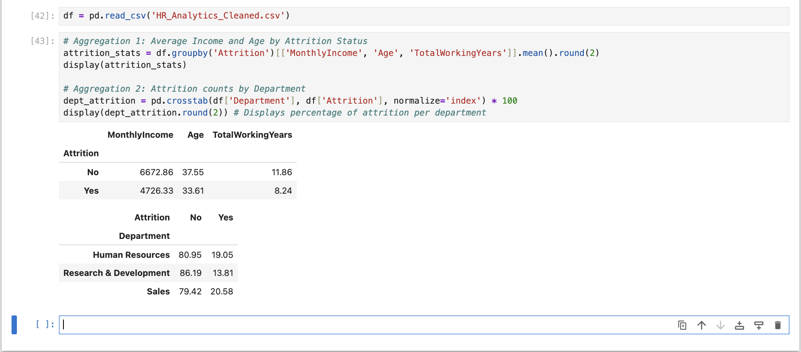

The initial feature aggregations reveal a distinct relationship between compensation, tenure, and employee turnover. Employees who exited the organization (Attrition = Yes) exhibit a noticeably lower average Monthly Income and fewer Total Working Years compared to the retained workforce. Furthermore, percentage-based cross-tabulation by department indicates that the Sales division experiences a proportionally higher attrition rate than Research & Development, suggesting that role-specific pressures, travel requirements, or commission-based compensation structures may heavily influence retention.

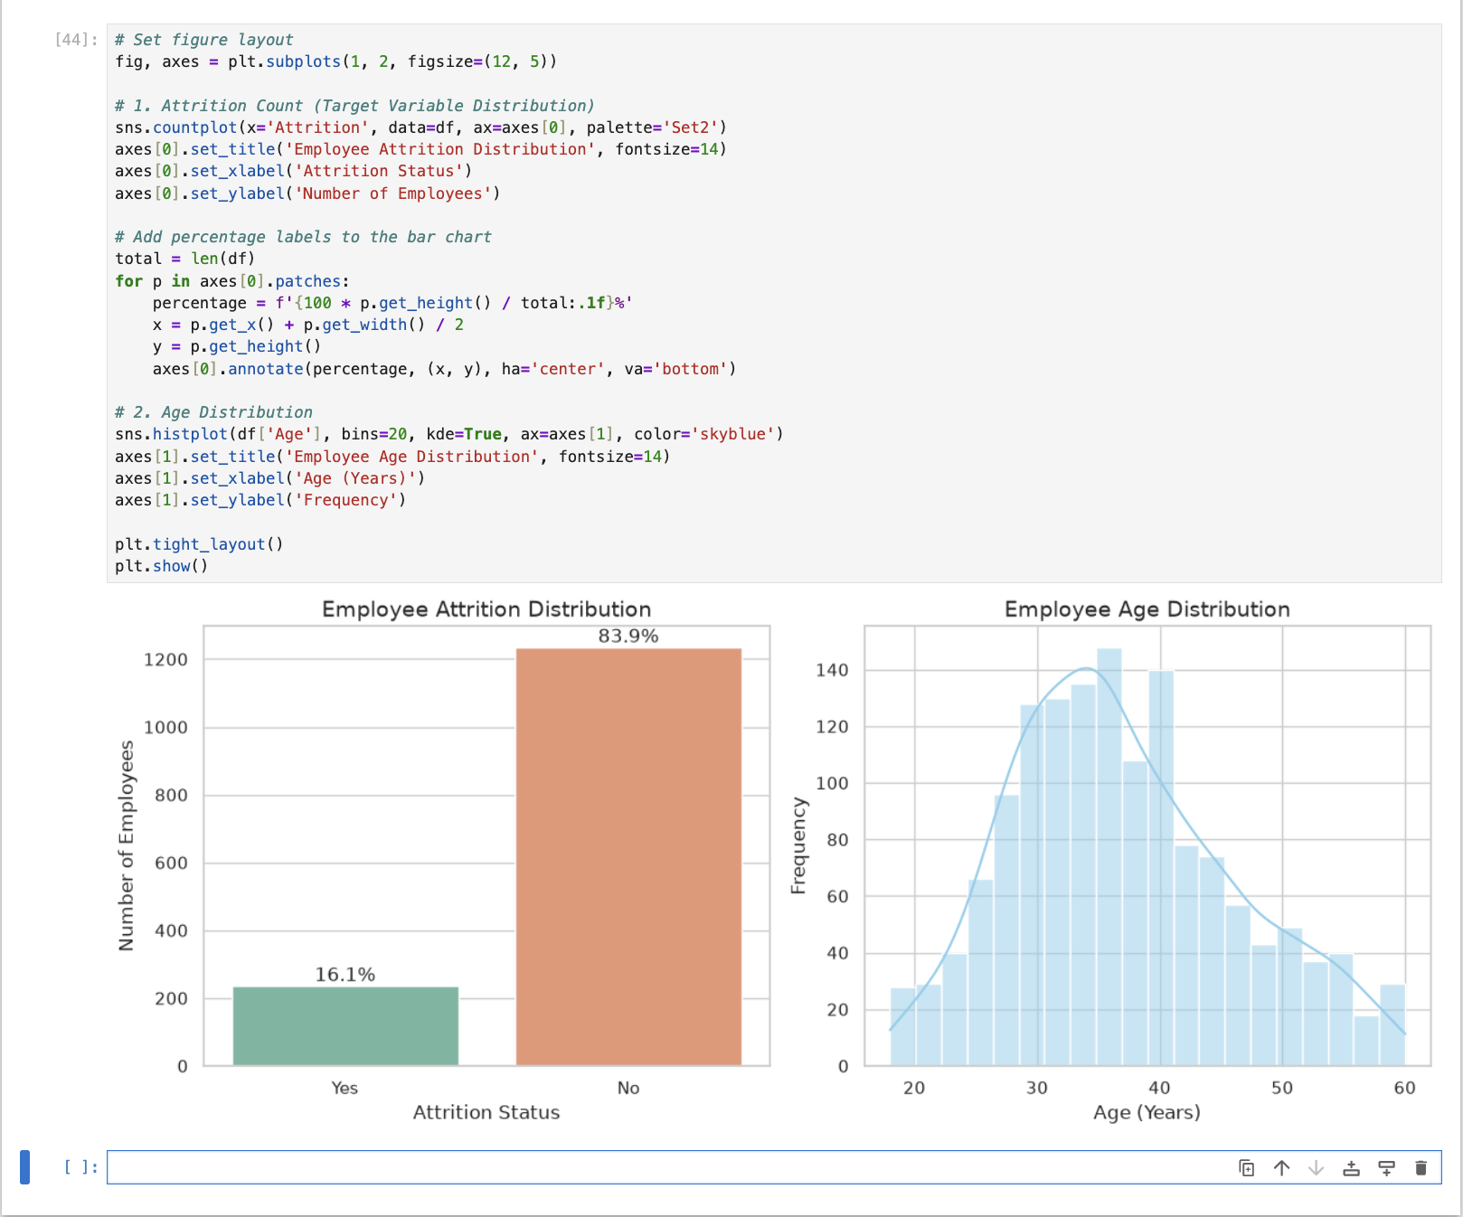
3. Univariate Visualizations

The univariate analysis highlights the baseline distributions of the workforce. The Attrition countplot reveals a significant class imbalance, with approximately 16.1% of employees leaving the company versus 83.9% being retained. This imbalance is typical in HR datasets but dictates that future predictive models will require strict performance metrics (like F1-score rather than simple accuracy) to evaluate attrition correctly. The Age distribution histogram, overlaid with a Kernel Density Estimate (KDE), shows a nearly normal distribution peaking between 30 and 35 years old, indicating a relatively young core workforce.

4. Bivariate & Multivariate Analysis
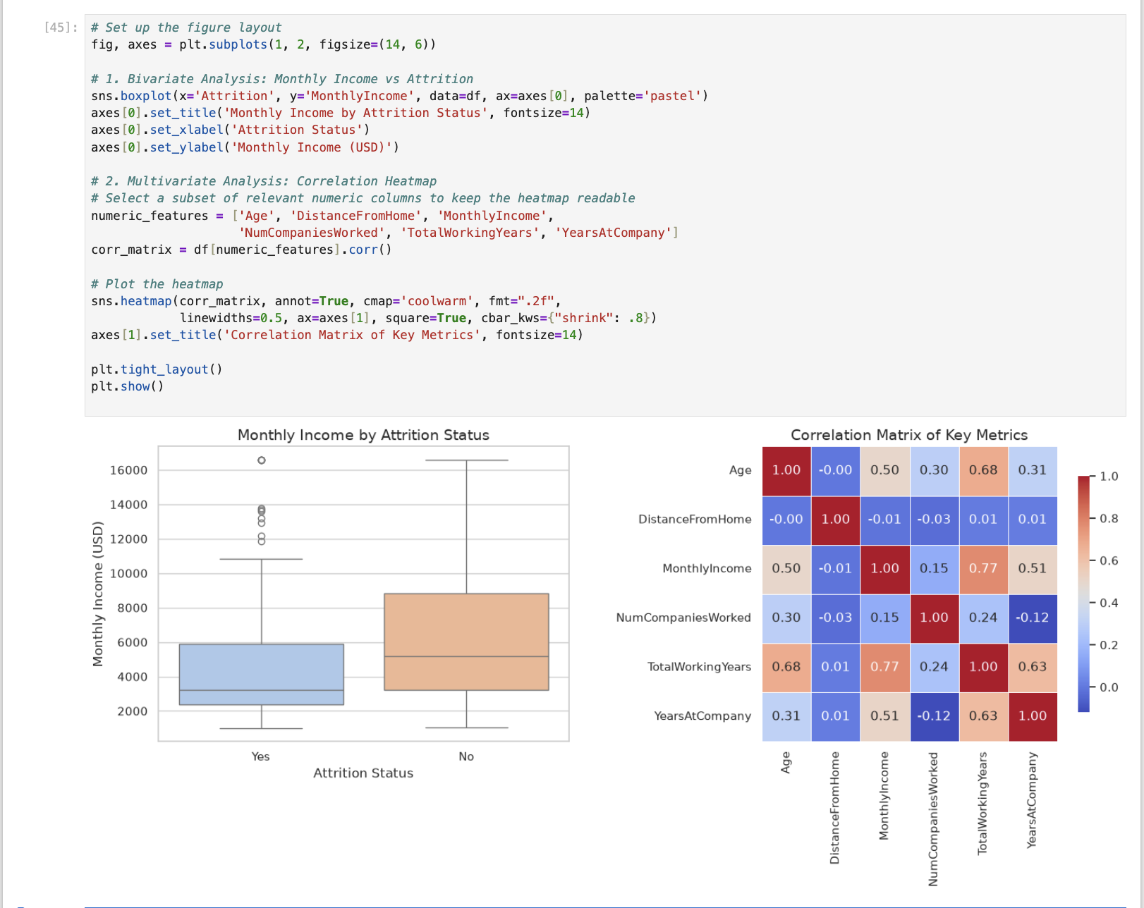

The bivariate boxplot highlights a clear financial anomaly: employees who leave the company ("Yes") have a noticeably lower median monthly income and a tighter interquartile range compared to those who stay. High earners are significantly more likely to be retained.
The multivariate correlation heatmap reveals several logical patterns within the workforce. There is a strong positive correlation (0.77) between MonthlyIncome and TotalWorkingYears, indicating that compensation scales reliably with overall experience. However, the correlation between MonthlyIncome and YearsAtCompany is slightly weaker (0.51), suggesting that long-term loyalty to this specific company does not increase compensation as sharply as total industry experience does. Notably, DistanceFromHome shows near-zero correlation with any other metric, isolating it as an independent variable.

5. Strategic Insights & Conclusion

This Exploratory Data Analysis reveals that financial compensation, role-specific pressures, and career progression are the primary drivers of employee turnover within the organization. The univariate and bivariate analyses demonstrate a stark contrast in median income between retained and departed employees, indicating that competitive compensation is a critical retention lever. Furthermore, the disproportionate attrition rate within the Sales department suggests that commission-based volatility or role burnout may be negatively impacting tenure in that specific division.

A critical finding from the multivariate correlation analysis is the discrepancy between how compensation scales with overall industry experience (TotalWorkingYears) versus internal tenure (YearsAtCompany). This correlation gap implies a potential "loyalty penalty," where internal wage growth lags behind external market rates, inadvertently incentivizing highly experienced employees to leave the organization to secure higher compensation elsewhere.
To improve retention, HR leadership should prioritize a compensation audit to ensure internal pay equity aligns with market standards, particularly for employees with high TotalWorkingYears but stagnant YearsAtCompany. Additionally, targeted retention and wellness programs should be deployed within the Sales department. With the fundamental drivers of attrition now visually and statistically identified, this dataset is fully optimized for the development of machine learning classification models to proactively flag at-risk employees.

