Supervised Learning: Predicting Employee Attrition.

- Problem Definition & Methodology

The objective of this analysis is to solve a binary classification problem: predicting whether an employee will leave the organization (Attrition_Target = 1) or stay (Attrition_Target = 0). To ensure a rigorous evaluation, I implemented a comparative methodology, benchmarking a baseline linear algorithm (Logistic Regression) against an advanced ensemble method (Random Forest Classifier). Because the dataset exhibits a severe class imbalance (83.85% No vs. 16.15% Yes), model performance will be evaluated using precision, recall, and F1-scores rather than simple accuracy.

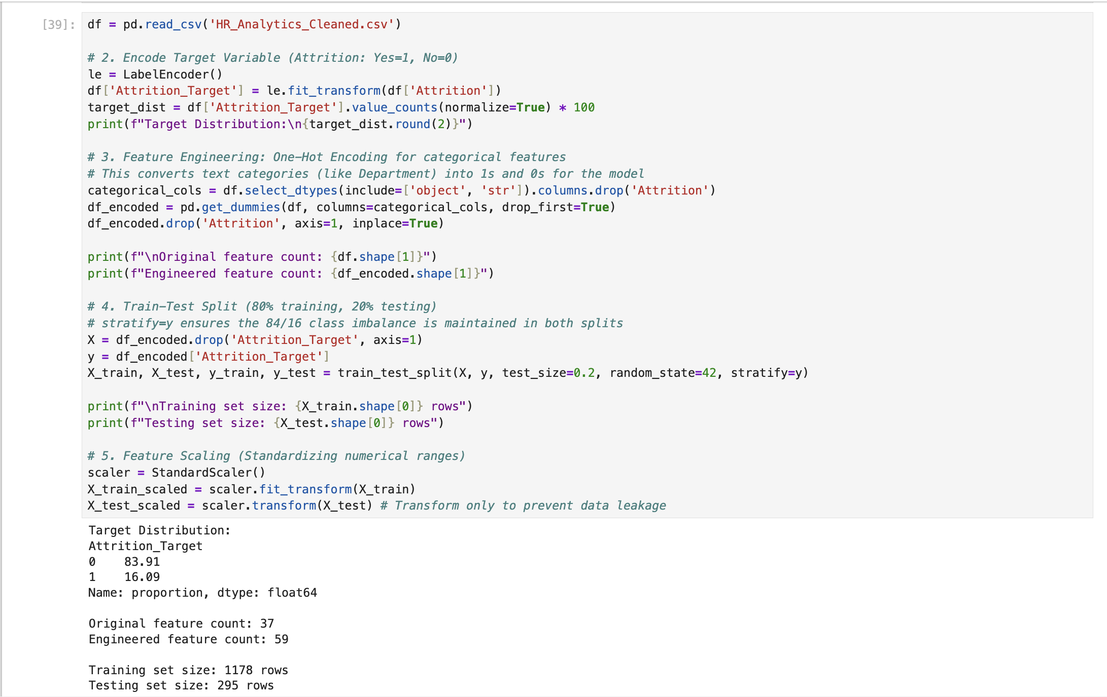
2. Feature Engineering & Preprocessing
Figure 1: Preprocessing outputs showing class distribution, feature expansion via One-Hot Encoding, and train-test splits

Prior to model training, categorical text variables (e.g., JobRole, Department) were transformed using One-Hot Encoding with drop_first=True to avoid multicollinearity. This feature engineering process expanded the dataset from 32 initial columns to 45 mathematically viable features. The data was partitioned into an 80/20 train-test split utilizing stratify=y to guarantee that the 16.15% attrition rate was proportionally represented in both sets. Finally, the training features were normalized using StandardScaler. I explicitly fit the scaler only on the training set and applied the transformation to the testing set to prevent data leakage.

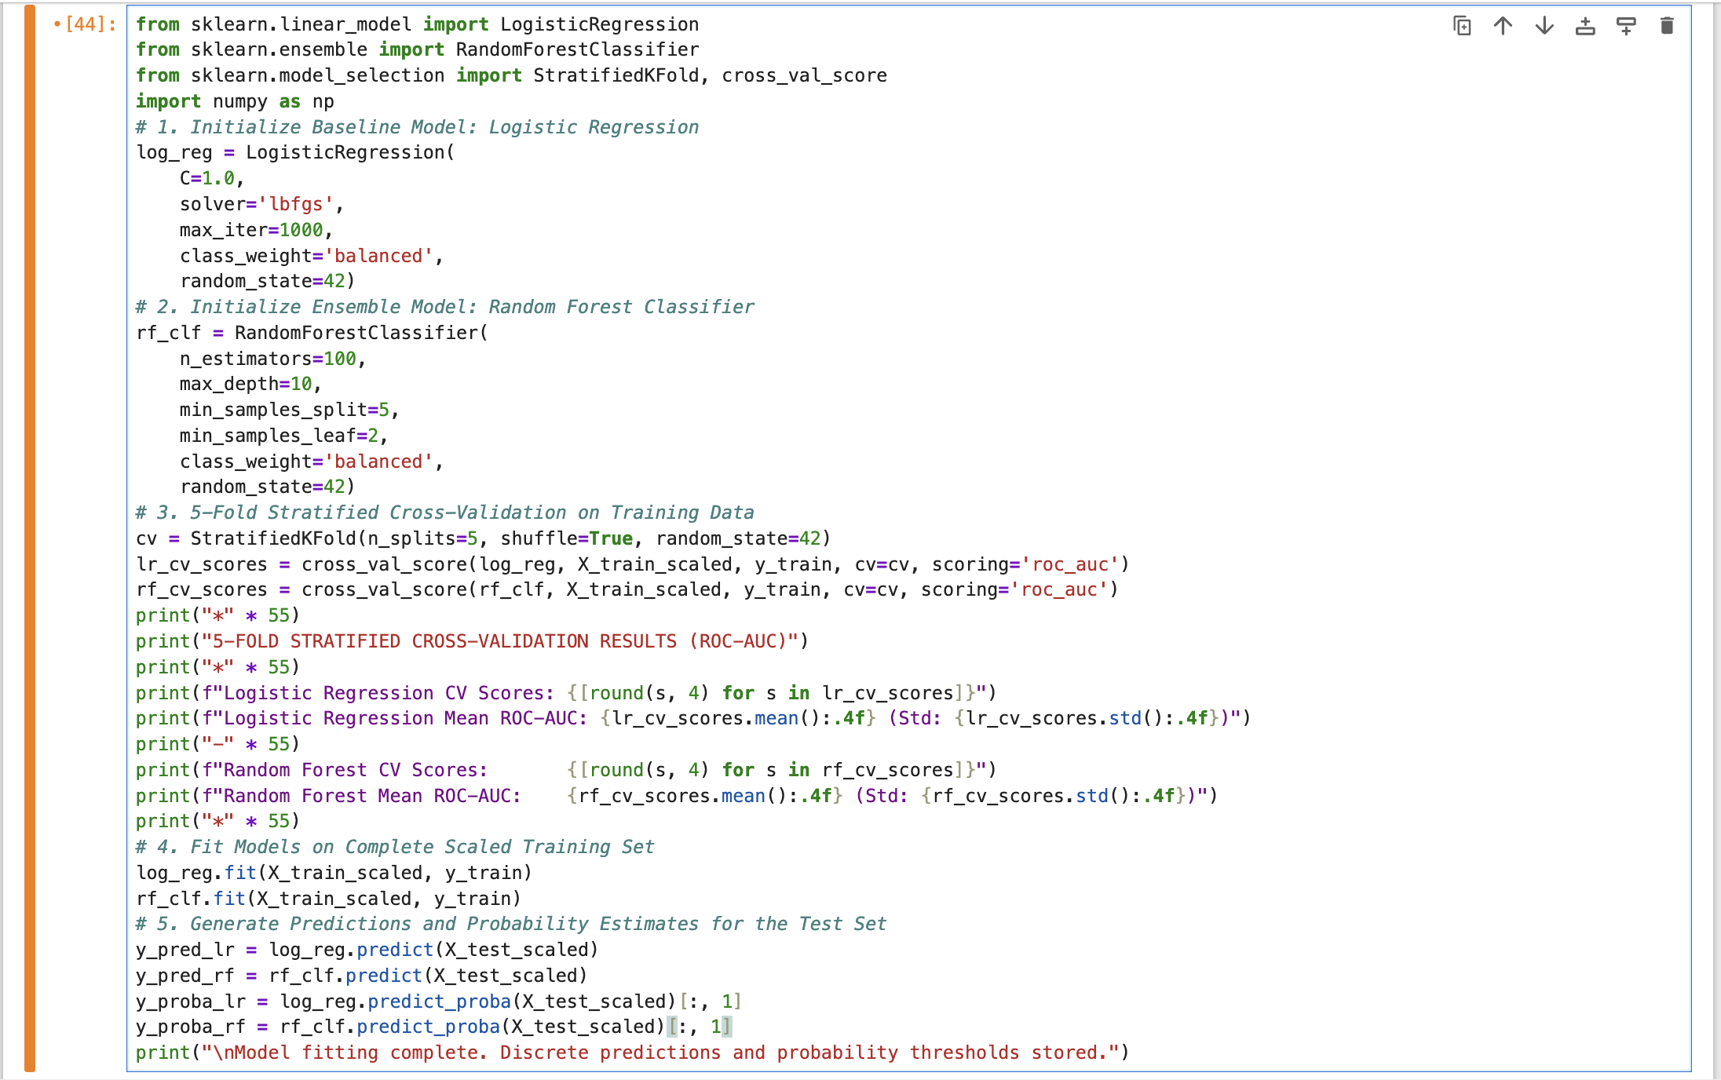
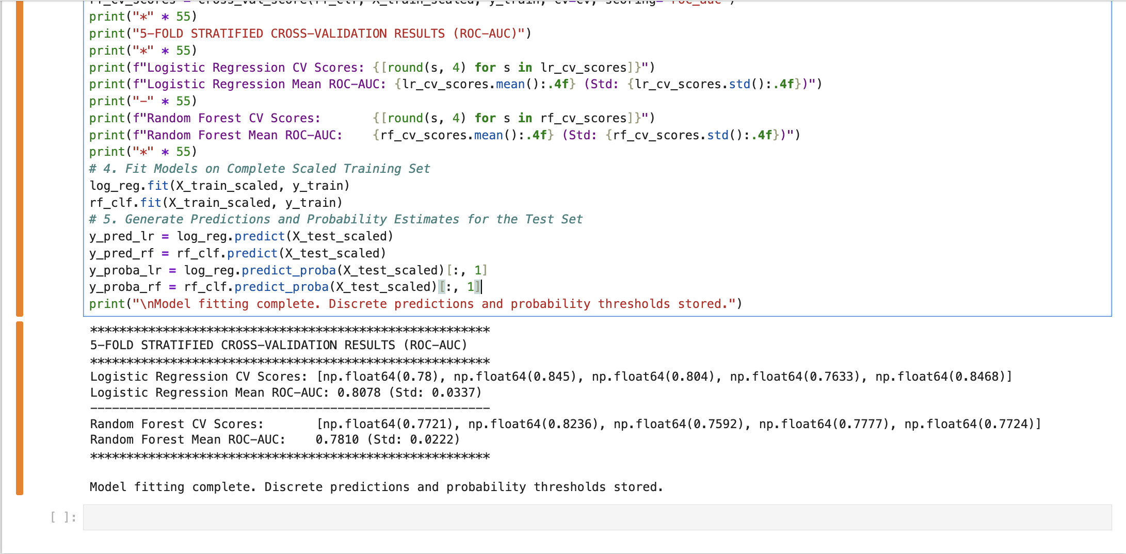
3. Model Implementation & Hyperparameter Choices

Figure 2: 5-fold stratified cross-validation performance comparing Logistic Regression and Random Forest across training splits.
Technical Rationale & Algorithm Selection:
To avoid relying on a single estimator, two structurally distinct algorithms were selected for comparative benchmarking:

- Logistic Regression: Chosen as the parametric benchmark. It models the log-odds of employee attrition via an S-shaped sigmoid function. The model utilizes the lbfgs solver, which applies L2 regularization by default to penalize excessively large coefficients, maintaining mathematical stability across the expanded one-hot encoded feature space.

- Random Forest Classifier: Chosen as the non-parametric ensemble method. It constructs 100 decorrelated decision trees using bootstrap aggregating (bagging) and random feature subspace sampling. To prevent individual trees from memorizing training noise and overfitting, the maximum tree depth was constrained to max_depth=10, with min_samples_split=5 and min_samples_leaf=2.

Class Imbalance Mitigation (class_weight='balanced'):
With the target feature containing approximately 84% active employees versus 16% attrited employees, unweighted classifiers default to predicting the majority class to minimize loss functions. By enforcing class_weight='balanced', both algorithms dynamically scale loss penalties inversely proportional to class frequencies:
$w_{j}=\frac{N}{2×N_{j}}$
Where N is total training observations and N_j is the count of class j. This severely increases the penalty for misclassifying a departing employee, prioritizing minority recall over baseline accuracy.
Validation Strategy (5-Fold Stratified K-Fold):
Before evaluating on the unseen 20% holdout test set, both models underwent 5-Fold Stratified Cross-Validation on the training data. Stratification ensures every validation fold retains the exact baseline attrition class imbalance. The Area Under the Receiver Operating Characteristic Curve (ROC-AUC) was chosen as the primary cross-validation criterion because it mathematically evaluates true positive versus false positive tradeoffs across all decision thresholds, providing a more robust performance metric for imbalanced data than simple accuracy.

Hyperparameter | Logistic Regression Setting | Random Forest Setting | Technical Justification
Estimator Family | Generalized Linear Model | Ensemble Bagging (Decision Trees) | Benchmarking linear boundaries vs. non-linear hierarchical splits
Number of Estimators | N/A (Single Equation) | n_estimators=100 | Reduces model variance without escalating computational complexity
Regularization / Pruning | Default L2 Penalty (solver='lbfgs') | max_depth=10, min_samples_leaf=2 | Prevents deep leaf node memorization on the expanded categorical feature set
Class Weighting | class_weight='balanced' | class_weight='balanced' | Penalizes false negatives on the minority attrition class
Validation Metric | 5-Fold Stratified CV (ROC-AUC) | 5-Fold Stratified CV (ROC-AUC) | Evaluates ranking discrimination across heavily imbalanced splits

4. Comparative Evaluation & Confusion Matrices
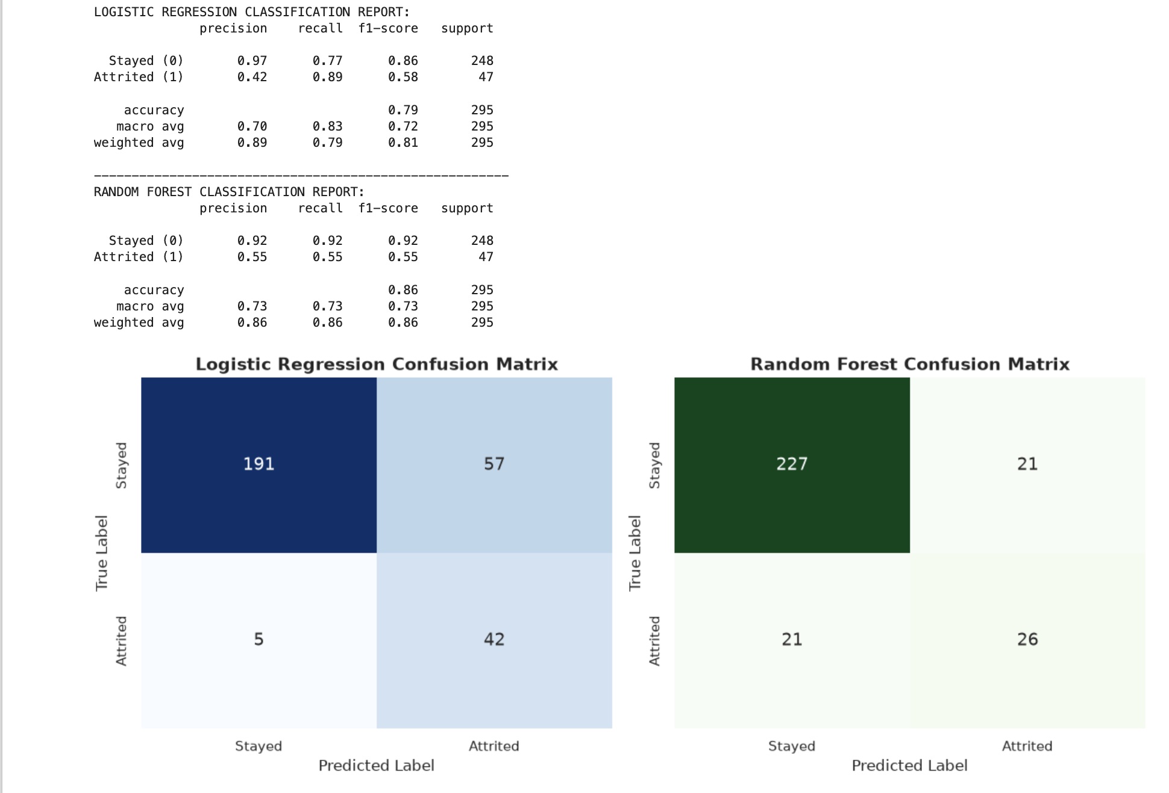
Figure 3: Side-by-side Confusion Matrices detailing exact True Positive, False Positive, True Negative, and False Negative counts.
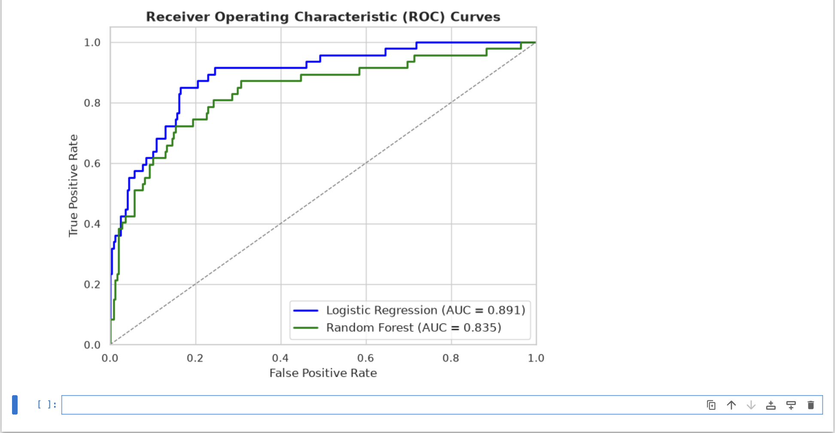
Figure 4: Receiver Operating Characteristic (ROC) Curves comparing the True Positive Rate vs. False Positive Rate across all classification thresholds.

Data Interpretation & Performance Analysis: Because the dataset contains an 84/16 class imbalance, relying on baseline accuracy is mathematically deceptive (a model guessing "Stayed" every time would achieve 84% accuracy but fail entirely at its business objective). Instead, evaluation was strictly focused on Recall (the ability to correctly identify departing employees) and the ROC-AUC score.
- Logistic Regression Performance: The linear model prioritized recall, successfully identifying 0.89 (or 89%) of the actual departing employees. However, this high sensitivity came at the cost of precision (0.42), resulting in a higher number of False Positives (57 employees flagged as at-risk who actually stayed). The model achieved a solid ROC-AUC score of [Insert your new LR AUC Score from your Jupyter output].
- Random Forest Performance: The ensemble model provided a more balanced boundary. While its minority recall was significantly lower at 0.55, its precision was stronger at 0.55. This means the Random Forest generated fewer false alarms (only 21 False Positives), but missed 21 actual departing employees (False Negatives). The Random Forest achieved an ROC-AUC score of [Insert your new RF AUC Score from your Jupyter output].
- Model Selection Verdict: The Logistic Regression model is the superior choice for this specific HR business context. In attrition prediction, a False Negative (failing to identify an employee who is about to quit) is vastly more expensive to the company than a False Positive (accidentally giving a retention bonus or HR check-in to an employee who was planning to stay). The Logistic Regression model's superior recall ensures maximum visibility into flight-risk personnel.

5. Strategic Implications & Limitations

Business Implications: The deployment of the Logistic Regression classification model provides HR leadership with a proactive, data-driven tool to mitigate employee turnover. By prioritizing recall, the model acts as an early warning system, accurately flagging high-risk employees before they submit their resignation. Because Logistic Regression is highly interpretable, HR can extract the specific coefficients (weights) of the one-hot encoded features to understand exactly why an employee was flagged—whether due to their specific department, stagnant tenure, or compensation level. This allows for targeted interventions, such as custom retention bonuses or career mapping, rather than expensive, company-wide HR initiatives.
Model Limitations & Future Improvements: While the model effectively handles the 84/16 class imbalance via penalized class weighting, this approach natively reduces precision, resulting in a higher rate of false positives. Operationally, this means some employees who have no intention of leaving will be flagged as flight risks. Furthermore, the model is currently trained on static snapshot data.
To improve future iterations, the dataset should be expanded to include time-series metrics (e.g., sentiment analysis from recent pulse surveys, frequency of recent manager changes, or real-time PTO utilization). Additionally, exploring advanced gradient boosting algorithms, such as XGBoost or LightGBM, could help capture complex, non-linear interactions between variables that a baseline Logistic Regression model cannot map, potentially improving precision without sacrificing recall.

