HR Analytics Data Cleaning and Preprocessing

Introduction

This report outlines the data ingestion, exploration, and cleaning processes applied to an HR Analytics dataset. The dataset contains corporate employee records, compensation details, and retention metrics. The objective of this workflow is to resolve missing values, handle duplicate entries, and mitigate extreme outliers to prepare the data for downstream predictive modeling and dashboard visualization.

All data manipulation and statistical evaluations were conducted using Python, leveraging the Pandas library for structural transformations and Seaborn for visual outlier detection. By establishing a rigorous preprocessing pipeline, this project not only demonstrates foundational data hygiene practices but also guarantees that subsequent HR attrition models and business intelligence dashboards are built upon a reliable, variance-optimized foundation.

Phase 1: Exploratory Data Analysis (EDA):
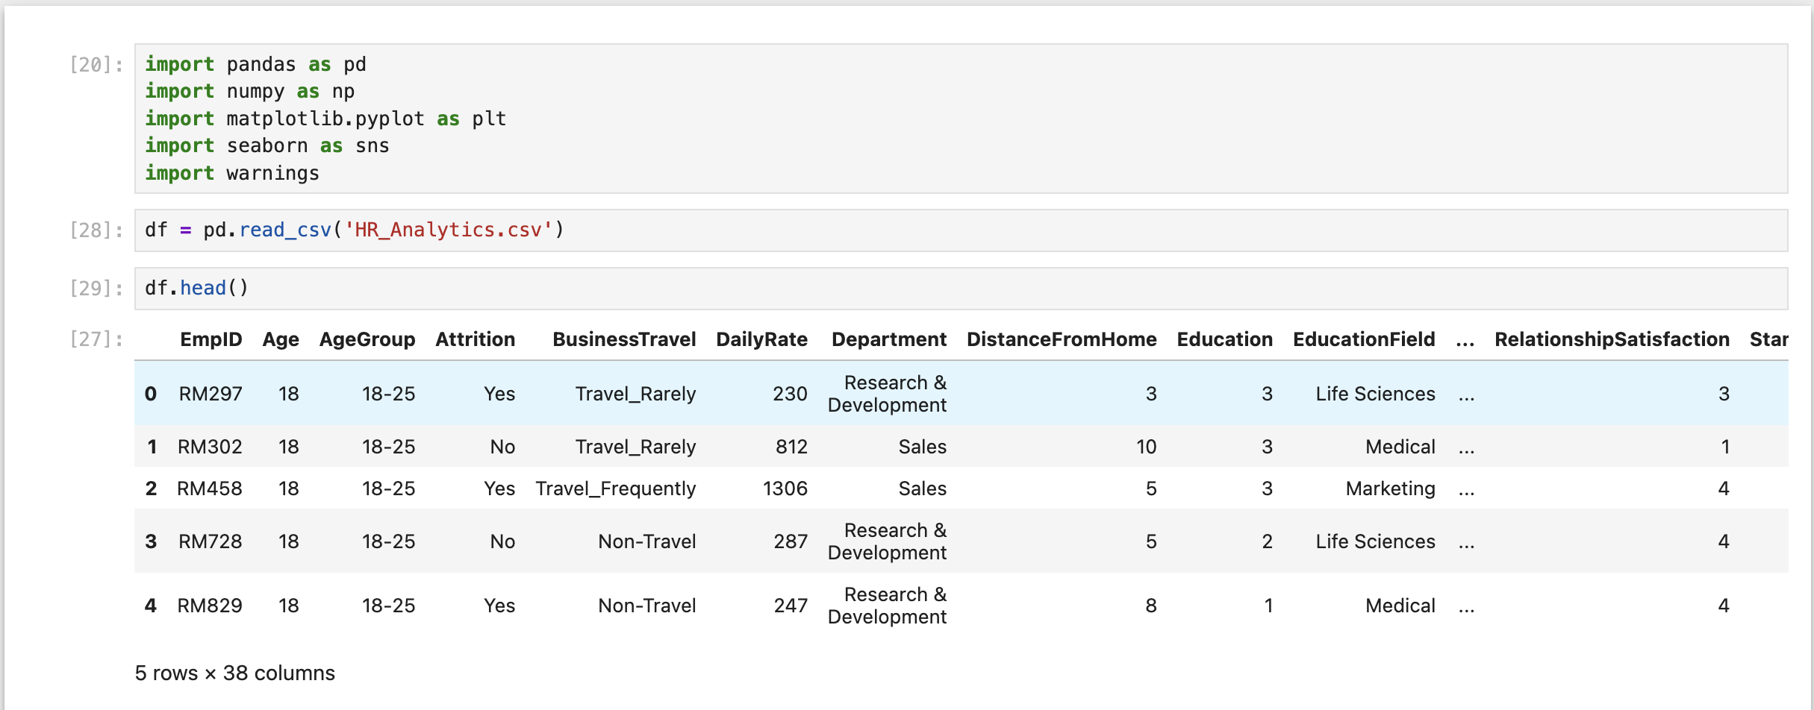
df.head():
Figure 1: Initial data inspection showing a mix of numerical and categorical employee attributes.

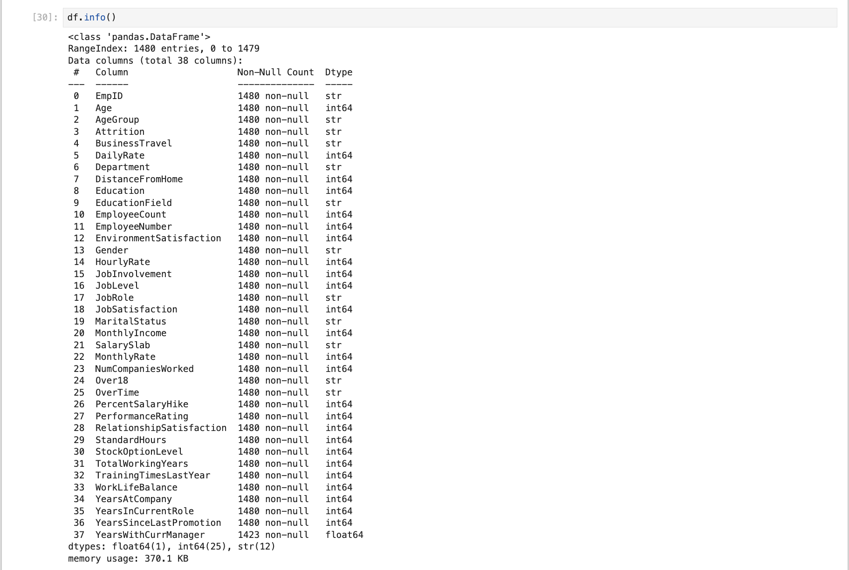
df.info():
Figure 2: The dataset contains 1,480 rows and 38 initial columns

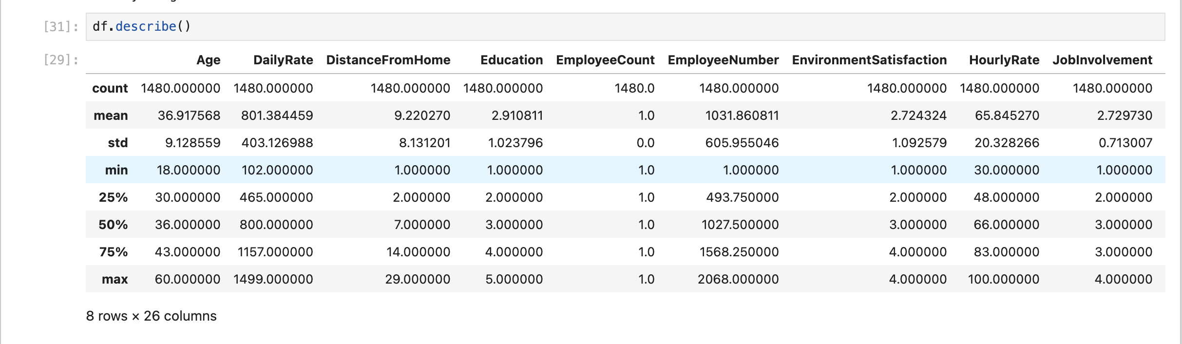
df.describe()
Figure 3: Statistical summary revealing zero-variance columns

Phase 2: Data Cleaning and Preprocessing

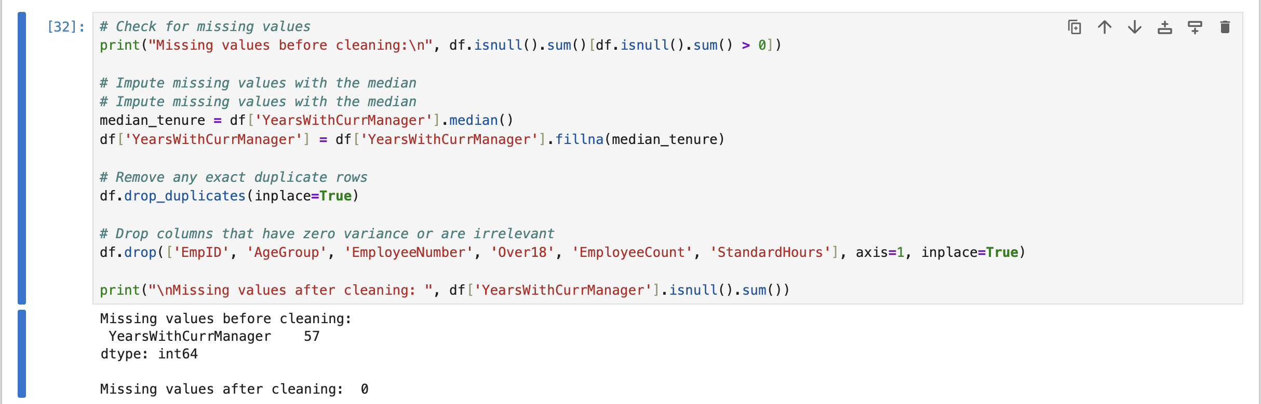
Missing values & Dropping columns

Figure 4: Code execution dropping 6 irrelevant or zero-variance columns. Missing values in the 'YearsWithCurrManager' column were resolved using median imputation.

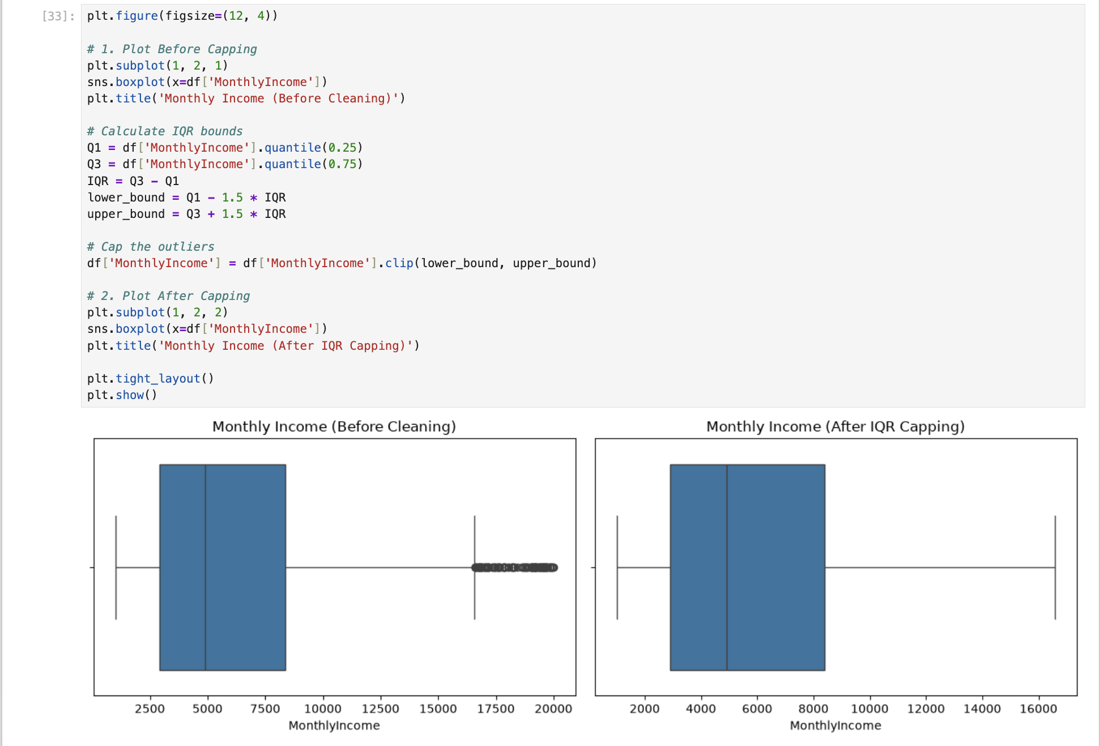
Boxplots
Figure 5: Outlier detection and handling for Monthly Income. The left plot shows heavy right-skewed outliers. The right plot demonstrates the distribution after applying Interquartile Range (IQR) capping.

Phase 3: Impact on Subsequent Analysis

The preprocessing methodology applied in this workflow fundamentally transforms the raw dataset into a robust, high-fidelity asset primed for advanced predictive modeling and business intelligence visualization. By systematically addressing structural flaws, missingness, and extreme values, the data is now optimized for both algorithmic stability and analytical accuracy.

- Dimensionality Reduction and Noise Elimination: The removal of zero-variance features (such as StandardHours, Over18, and EmployeeCount) and non-predictive identifiers (EmpID, EmployeeNumber) directly combats the curse of dimensionality. Zero-variance features contribute zero information gain to machine learning algorithms. Retaining them would only introduce computational overhead and risk confusing variance-dependent models like Principal Component Analysis (PCA) or K-Means clustering. Furthermore, stripping unique identifiers ensures that algorithms cannot memorize individual records, thereby preventing overfitting and forcing the model to learn generalized patterns regarding employee attrition.
- Preservation of Statistical Power via Robust Imputation: The decision to resolve the 57 missing entries in the YearsWithCurrManager column using median imputation, rather than listwise deletion, preserved nearly 4% of the dataset. In a concentrated corporate dataset of 1,480 records, maintaining data volume is crucial for model training. Deleting those rows could have inadvertently introduced survivorship bias if the missing data correlated with a specific employee cohort (e.g., recent hires). Utilizing the median rather than the mean ensured that the imputation remained mathematically robust and unaffected by highly tenured outliers, preserving the feature's natural distribution.
- Algorithmic Stabilization through Outlier Capping: Extreme compensation values in the MonthlyIncome feature can severely distort the objective functions of predictive models. Distance-based algorithms (such as K-Nearest Neighbors and Support Vector Machines) and gradient descent-optimized models (like Logistic Regression) are disproportionately penalized by unscaled outliers. By applying the Interquartile Range (IQR) bounding method, the extreme values belonging to top-earning executives were mathematically capped. This approach preserves the hierarchical ranking of employee salaries without allowing the absolute magnitude of a few outliers to skew classification boundaries or regression slopes.
- Business Intelligence Readiness: Ultimately, these transformations ensure that when this dataset is fed into visualization tools like Tableau or used to train an Attrition Prediction Model, the resulting insights will be statistically sound. The sanitized data is now strictly representative of true workforce trends, enabling reliable, data-driven strategic decision-making for HR stakeholders.

