CODE COVERAGE FOR ALL FILES

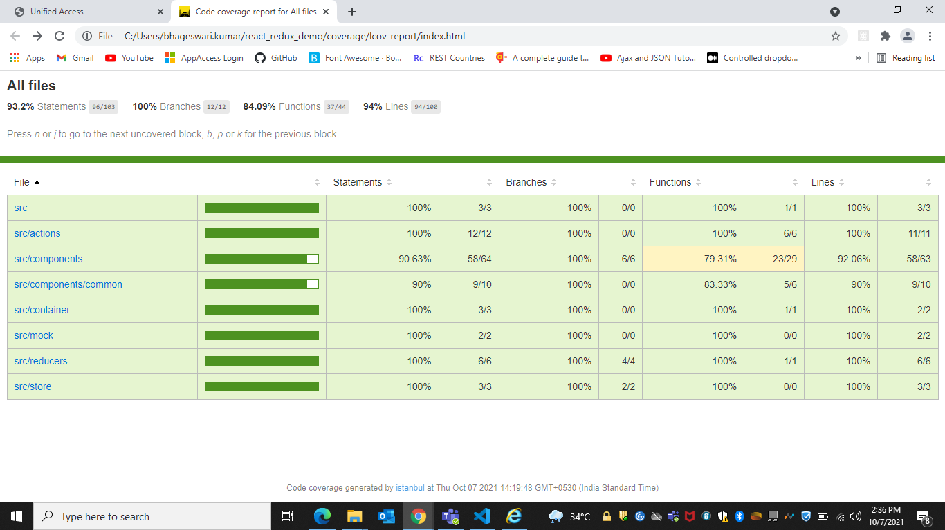

TEST CASES IN TERMINAL

