# **ASSIGNMENT # 3 – REMOTE CALCULATOR**

# **TASK:**

Create RMI program in which server performs basic arithmetic operations. The server should provide following methods for remote invocation:

int add(int a, int b)

int subtract(int a, int b)

double multiply(int a, int b)  
double divide(int a, int b)

# **Client Files:**

## CalculatorInterface.java

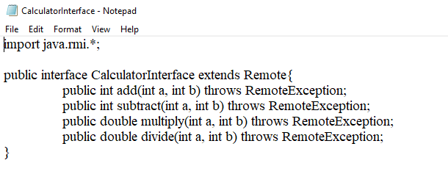

## Client.java

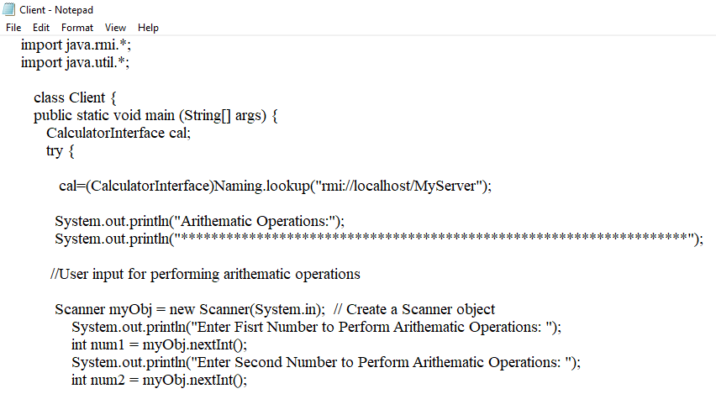

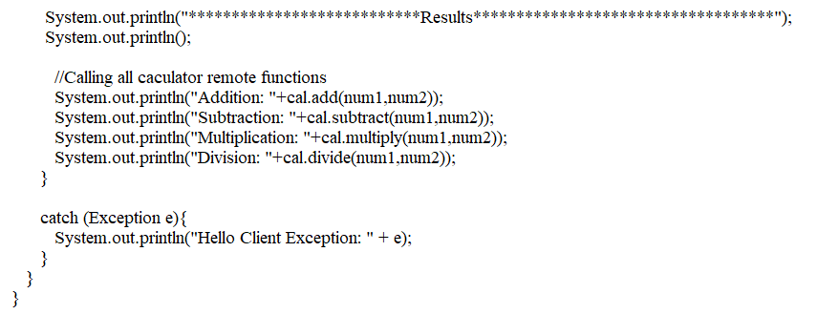

# **Server Files:**

## CalculatorInterface.java



## CalculatorImp.java

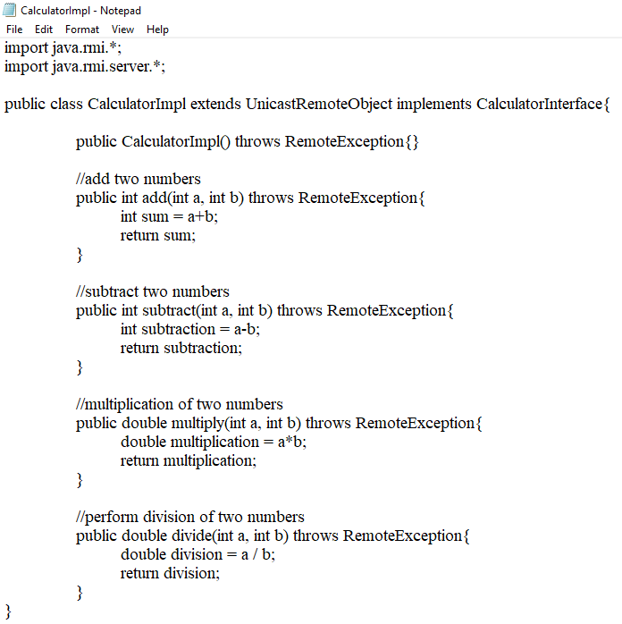

## Server.java

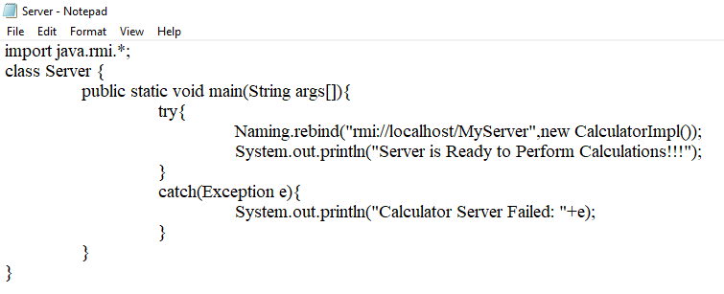

# **OUTPUT:**

## Compile all Java File and Start RMI Registry:

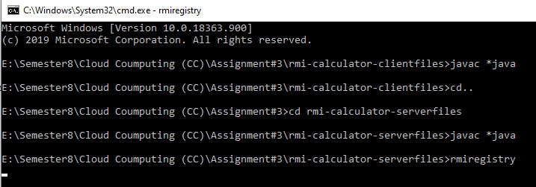

## Run Server Class:

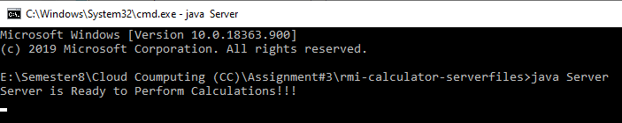

## Run Client Class:

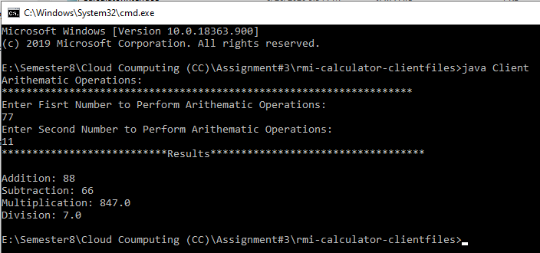

# **GitHub Code Link:**