ELK

PREREQUISITES
kubectl get nodes
Create namespace:
kubectl create namespace observability

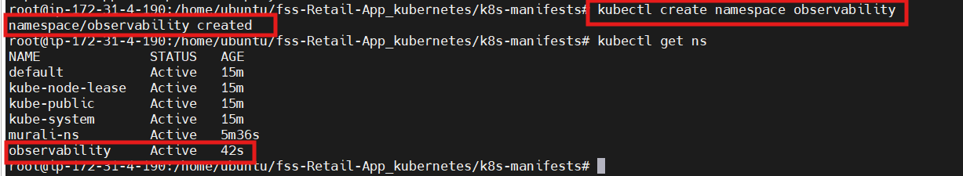

PART 1: LOGS → ELK STACK ON EKS

STEP 1️⃣ Elasticsearch
- Create a file called deployment-elasticsearch.yaml and paste below script inside the file

apiVersion: apps/v1
kind: Deployment
metadata:
name: elasticsearch-deployment
namespace: observability
spec:
replicas: 1
selector:
matchLabels:
app: elasticsearch
template:
metadata:
labels:
app: elasticsearch
spec:
containers:
- name: elasticsearch
image: docker.elastic.co/elasticsearch/elasticsearch:8.11.0
env:
- name: discovery.type
value: single-node
- name: xpack.security.enabled
value: "false"
- name: ES_JAVA_OPTS
value: "-Xms512m -Xmx512m"
ports:
- containerPort: 9200

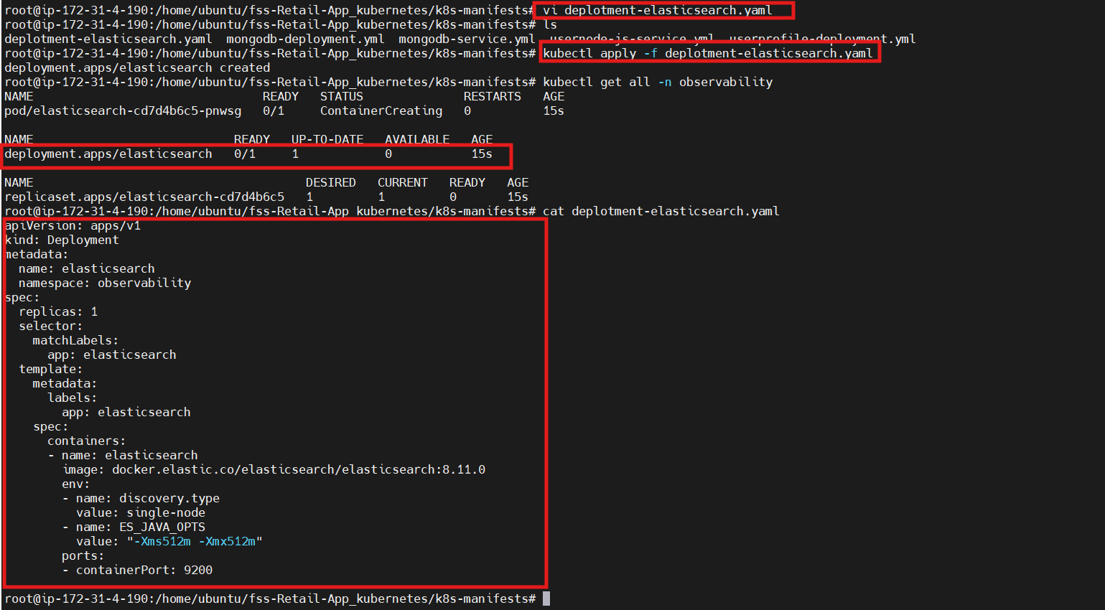

- Create a file called svc.elasticsearch.yaml and paste below script inside the file

Elasticsearch Service YAML (ClusterIP)
apiVersion: v1
kind: Service
metadata:
name: elasticsearch
namespace: observability
spec:
type: ClusterIP
selector:
app: elasticsearch
ports:
- name: http
port: 9200
targetPort: 9200
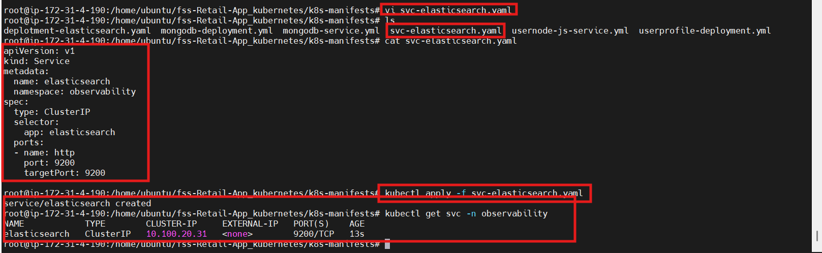

Note: Elasticsearch should not be exposed publicly. It is accessed internally by Logstash and Kibana.

STEP 2️⃣ Logstash (Collect Pod Logs)
- Create a file called configmap-logstash.yaml and paste below script inside the file

apiVersion: v1
kind: ConfigMap
metadata:
name: logstash-config
namespace: observability
data:
logstash.conf: |
input {
file {
path => "/var/log/pods/**/0.log"
start_position => "beginning"
}
}
filter {
json {
source => "message"
}
}
output {
elasticsearch {
hosts => ["http://elasticsearch:9200"]
index => "k8s-logs"
}
}
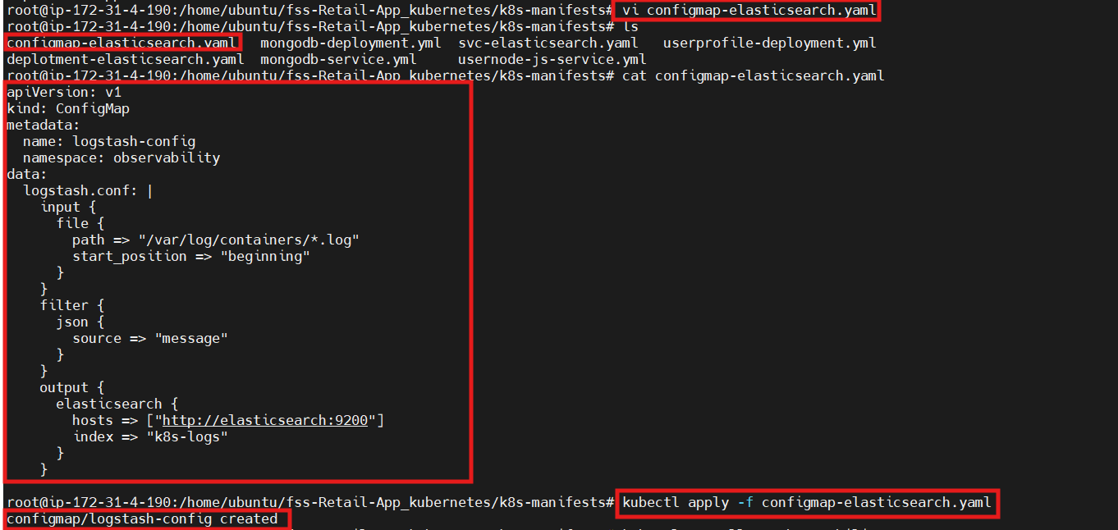

- Create a file called deployment-logstash.yaml and paste below script inside the file

apiVersion: apps/v1
kind: Deployment
metadata:
name: logstash-deployment
namespace: observability
spec:
replicas: 1
selector:
matchLabels:
app: logstash
template:
metadata:
labels:
app: logstash
spec:
containers:
- name: logstash
image: docker.elastic.co/logstash/logstash:8.11.0
volumeMounts:
- name: varlog
mountPath: /var/log/pods
- name: config
mountPath: /usr/share/logstash/pipeline
volumes:
- name: varlog
hostPath:
path: /var/log/pods
- name: config
configMap:
name: logstash-config
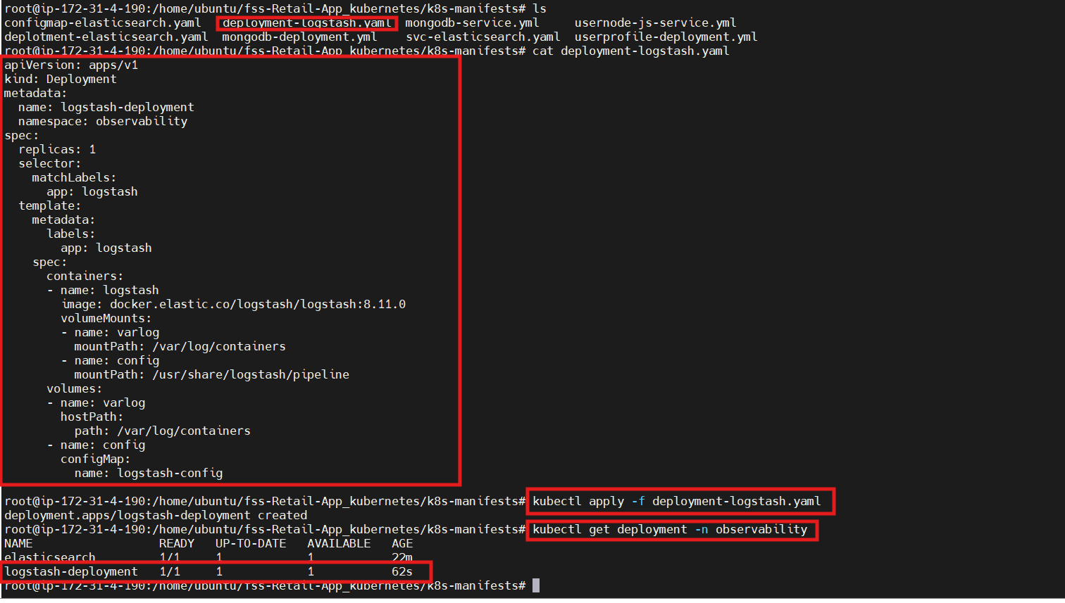

A Service is NOT required for this Logstash deployment.

Why Service is NOT required for Logstash (in your case)
Let’s look at what your Logstash is doing 👇
input {
file {
path => "/var/log/pods/**/0.log"
}
}

✔ Logstash behavior here
- Reads logs directly from node filesystem
- Uses hostPath: /var/log/containers
- Does NOT receive network traffic
- Does NOT expose any port
👉 Because of this:
❌ No inbound traffic
❌ No clients connecting to Logstash
❌ No port listening
Kubernetes Service is unnecessary

STEP 3️⃣ Kibana
- Create a file called deployment-kibana.yaml and paste below script inside the file

apiVersion: apps/v1
kind: Deployment
metadata:
name: kibana-deployment
namespace: observability
spec:
replicas: 1
selector:
matchLabels:
app: kibana
template:
metadata:
labels:
app: kibana
spec:
containers:
- name: kibana
image: docker.elastic.co/kibana/kibana:8.11.0
env:
- name: ELASTICSEARCH_HOSTS
value: "http://elasticsearch:9200"
ports:
- containerPort: 5601
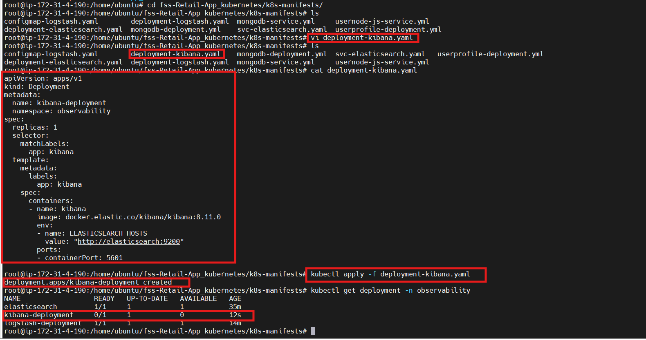

Kibana Service YAML (LoadBalancer)
- Create a file called svc-kibana.yaml and paste below script inside the file

apiVersion: v1
kind: Service
metadata:
name: kibana
namespace: observability
spec:
type: LoadBalancer
selector:
app: kibana
ports:
- name: http
port: 5601
targetPort: 5601

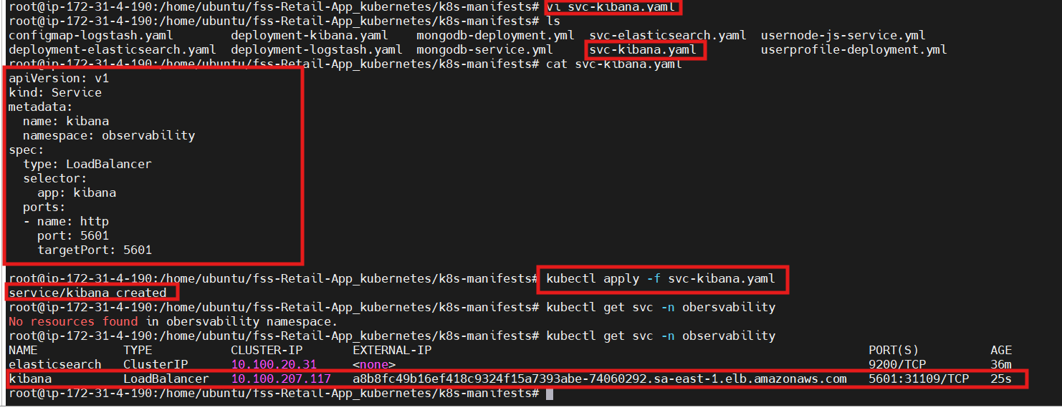

STEP 3 – Install Filebeat (Recommended)
Create file:
📄 filebeat.yaml
apiVersion: v1
kind: ConfigMap
metadata:
name: filebeat-config
namespace: observability
data:
filebeat.yml: |
filebeat.autodiscover:
providers:
- type: kubernetes
node: ${NODE_NAME}
hints.enabled: true

processors:
- add_cloud_metadata: {}
- add_host_metadata: {}
- add_kubernetes_metadata: {}

output.elasticsearch:
hosts: ["http://elasticsearch-svc:9200"]

---
apiVersion: apps/v1
kind: DaemonSet
metadata:
name: filebeat
namespace: observability
spec:
selector:
matchLabels:
app: filebeat
template:
metadata:
labels:
app: filebeat
spec:
serviceAccountName: default
containers:
- name: filebeat
image: docker.elastic.co/beats/filebeat:8.11.0
args: ["-c", "/etc/filebeat.yml", "-e"]
env:
- name: NODE_NAME
valueFrom:
fieldRef:
fieldPath: spec.nodeName
volumeMounts:
- name: config
mountPath: /etc/filebeat.yml
subPath: filebeat.yml
- name: varlog
mountPath: /var/log
volumes:
- name: config
configMap:
name: filebeat-config
- name: varlog
hostPath:
path: /var/log
Apply:
kubectl apply -f filebeat.yaml

How to create connecter in Kibana

Configure Encryption Key in Kibana
You must update your Kibana deployment config.
Since you’re running Kibana in Kubernetes, this means:
👉 Add environment variable in Kibana Deployment.

STEP 1 — Generate Encryption Key
On your terminal:
openssl rand -base64 32
Example output:
Gk3kD1A7sdf23...==
Copy this value.

WHY THIS IS REQUIRED
Kibana stores:
- Slack webhook URLs
- Email passwords
- API tokens
These must be encrypted on disk.
So Kibana refuses to enable alerting until you define an encryption key.

Add These Environment Variables
Inside the container env section, add:
env:
- name: XPACK_ENCRYPTEDSAVEDOBJECTS_ENCRYPTIONKEY
value: "PASTE_YOUR_GENERATED_KEY_HERE"
Example:
env:
- name: XPACK_ENCRYPTEDSAVEDOBJECTS_ENCRYPTIONKEY
value: "Gk3kD1A7sdf23...=="
⚠️ Must be minimum 32 characters.
Save and exit.

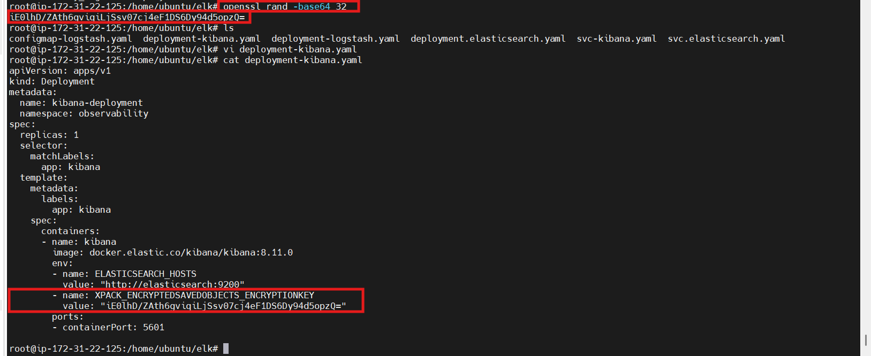

Add Slack Connector in Kibana
In Kibana:
→ Stack Management
→ Connectors
→ Create connector
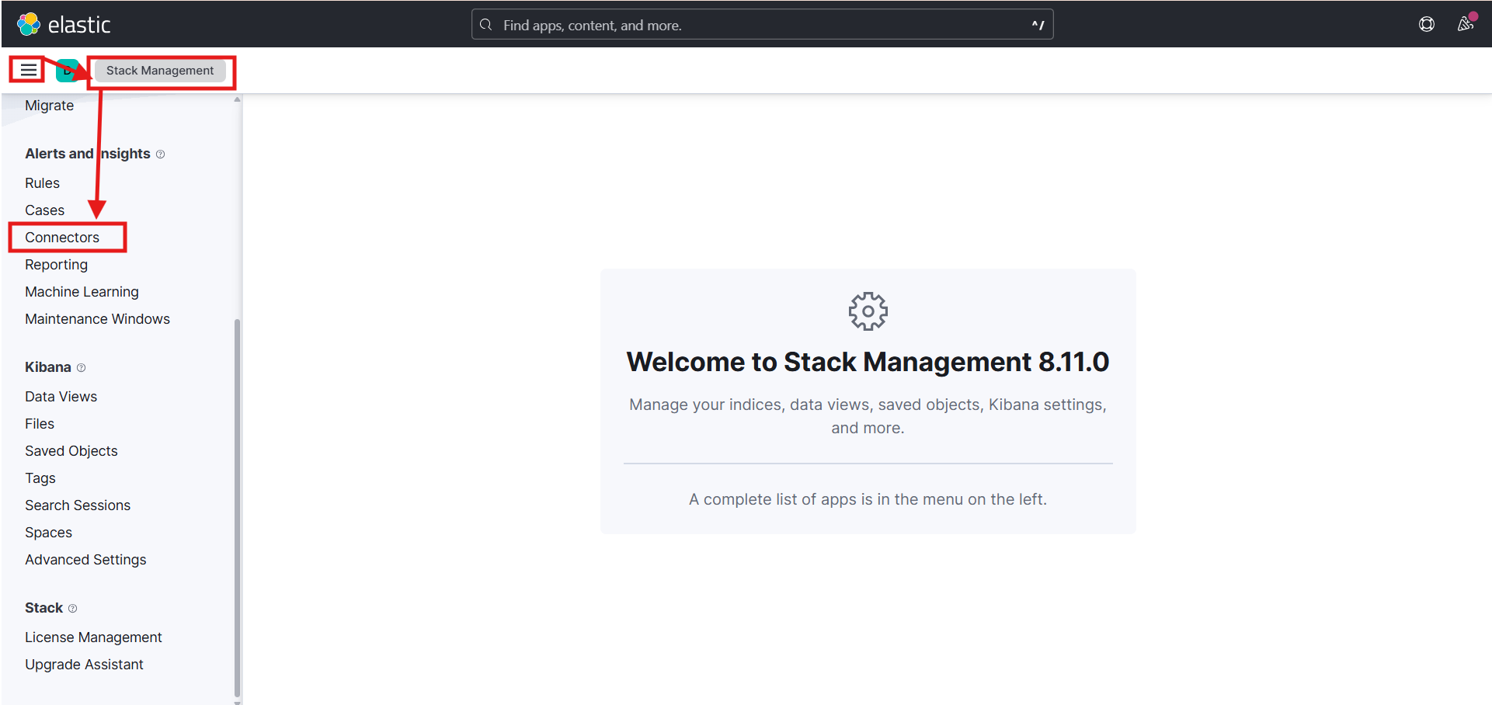

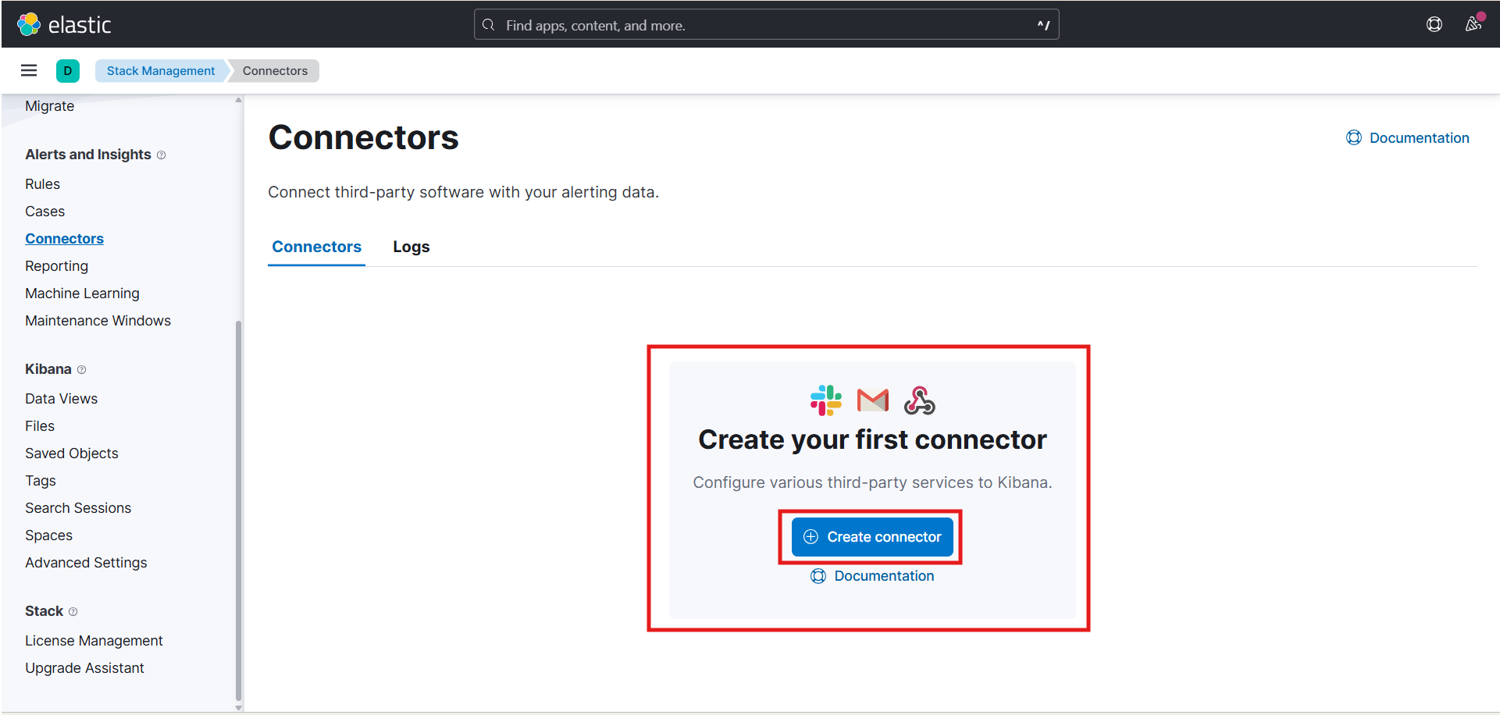

How to create alert rules
